Wendy Bronson
Module 3.2 Assignment: GitHub Pages
August 23rd, 2026

Figure 1 HTML Validation
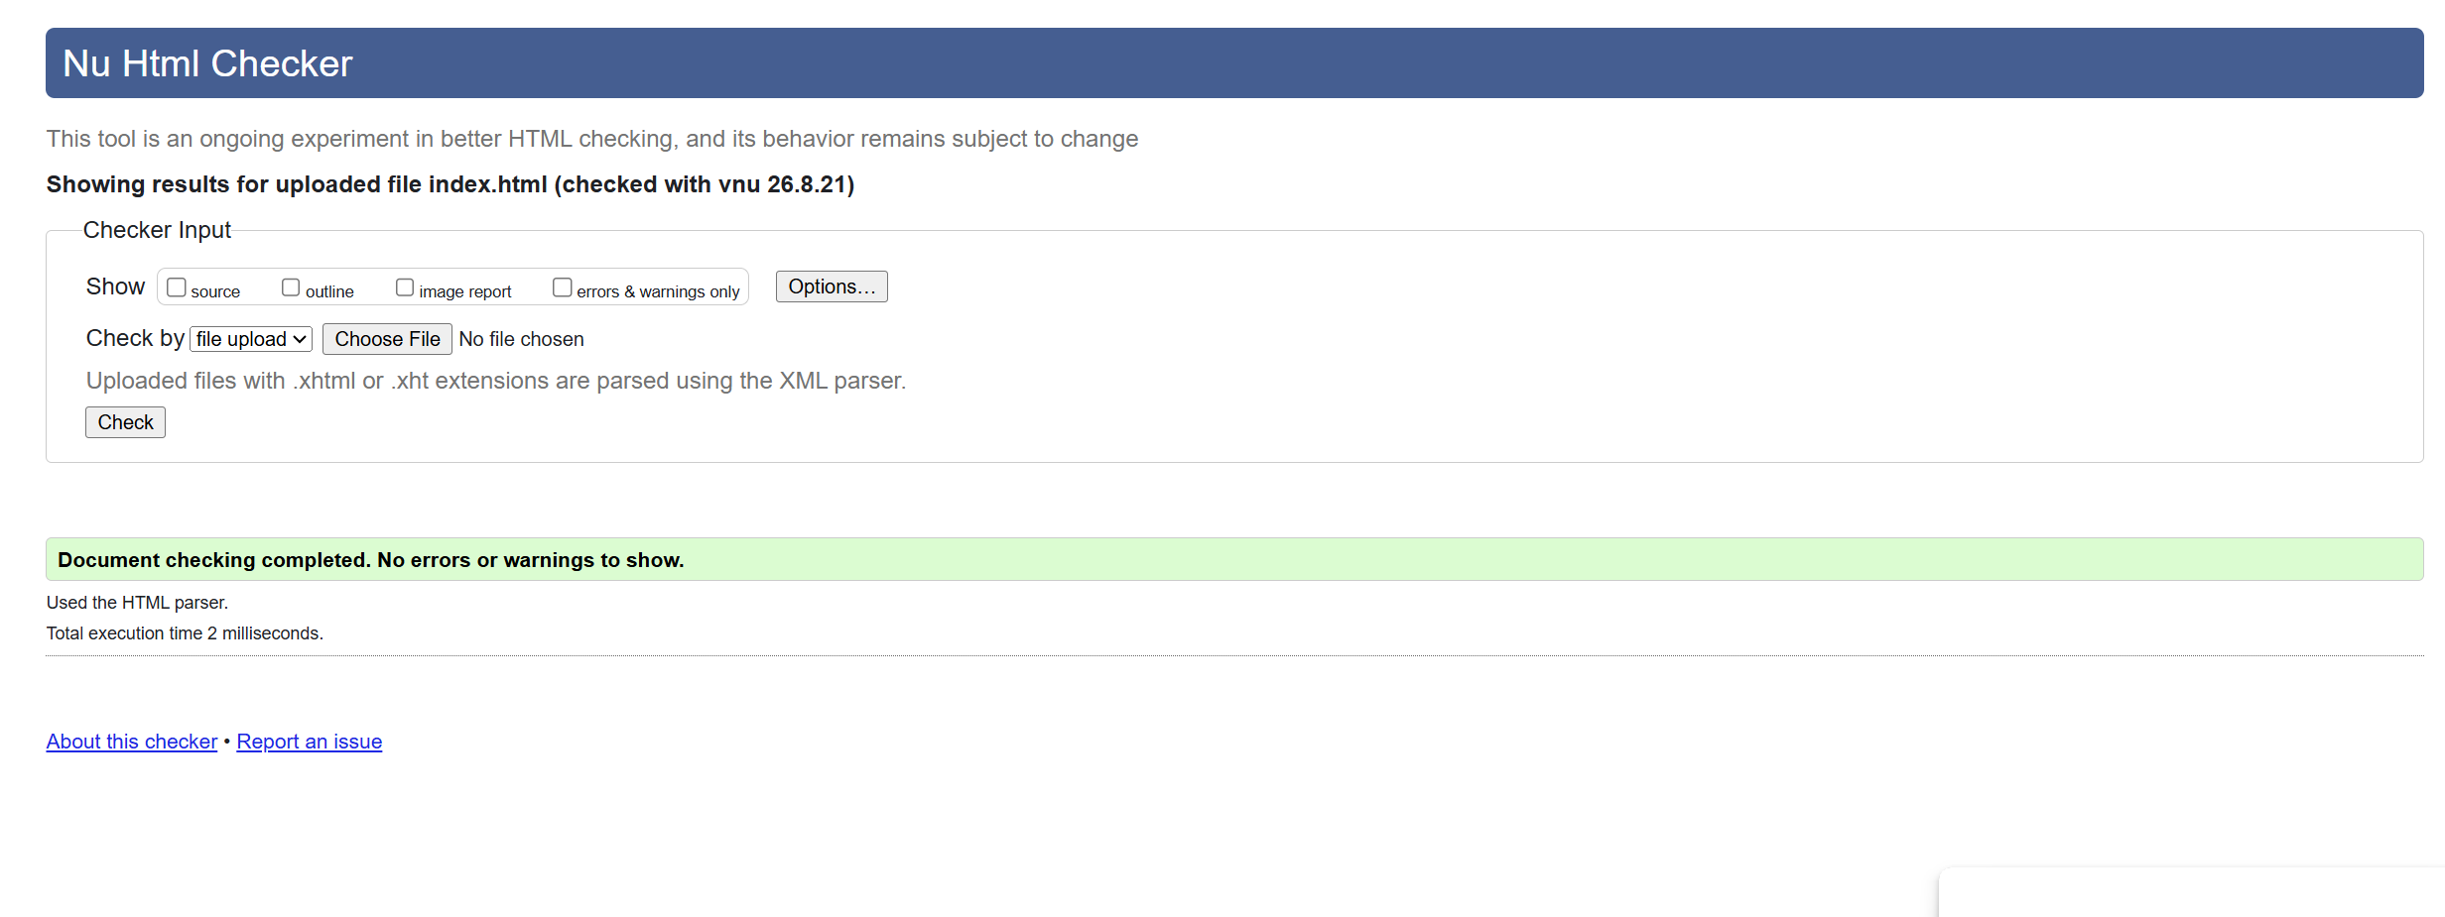

Figure 2 CSS Validation
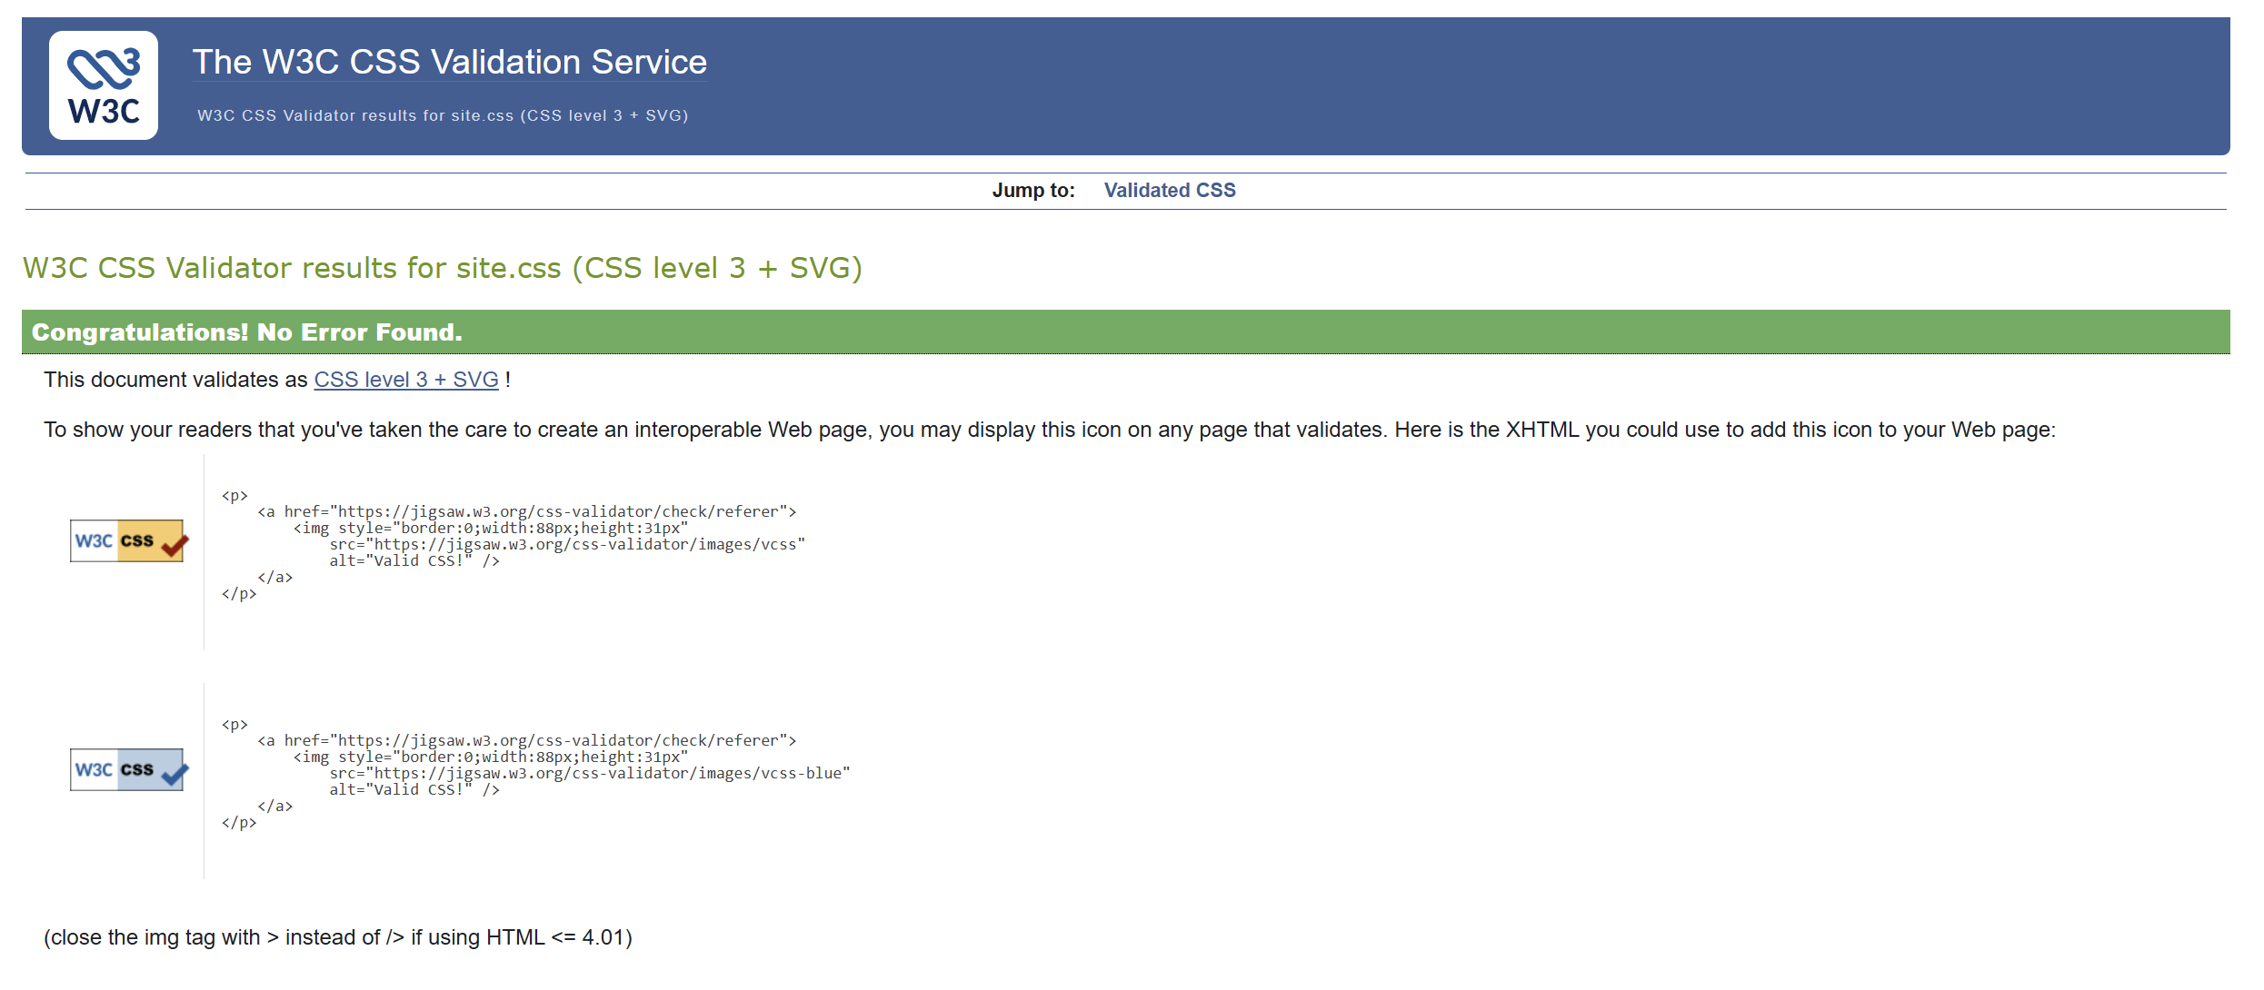

Figure 3 Landing Page
