Wendy Bronson
Module 1
Assignment 1.3 Building a Web Page Exercise Part 1
August 10th, 2026

Figure 1Initial HTML validation results showing errors
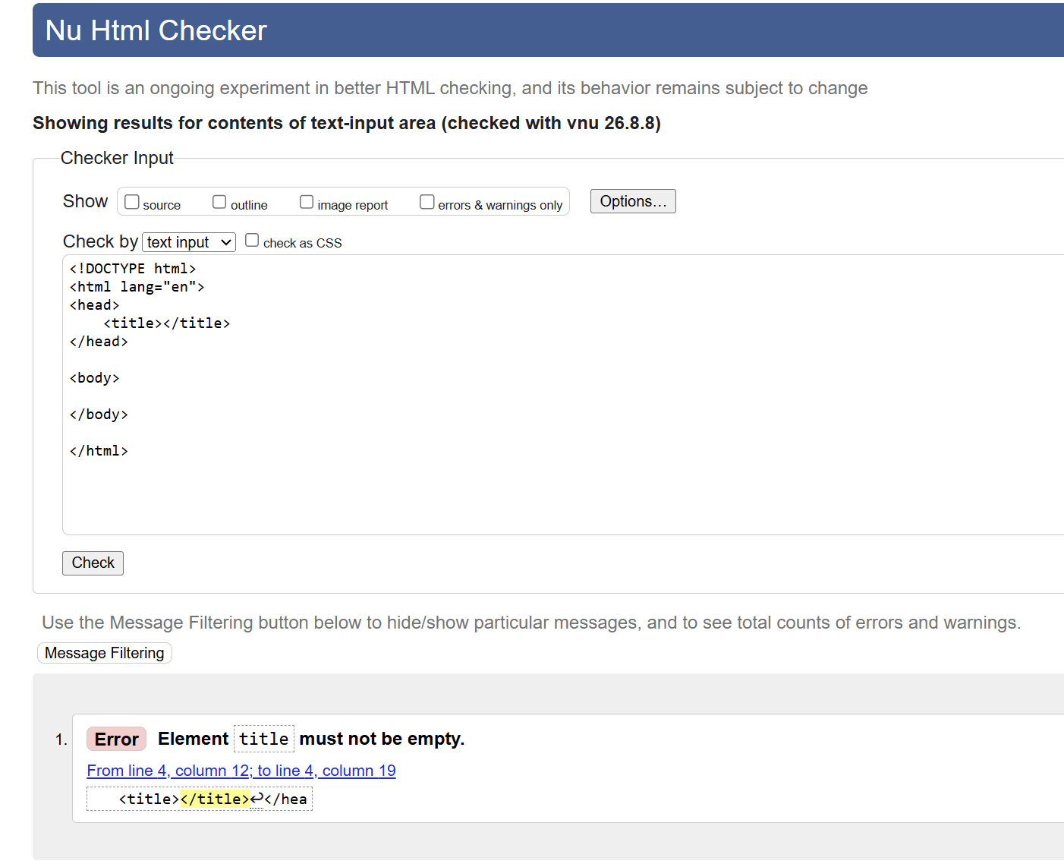
Figure 2 Corrected HTML validation results: 0 errors.
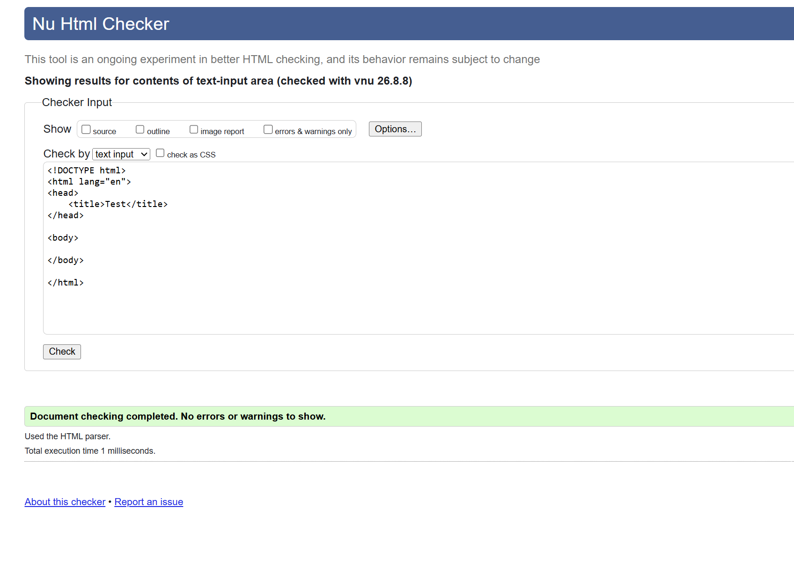

Figure 3 Final HTML validation results after adding the required heading, weather information, and page title.
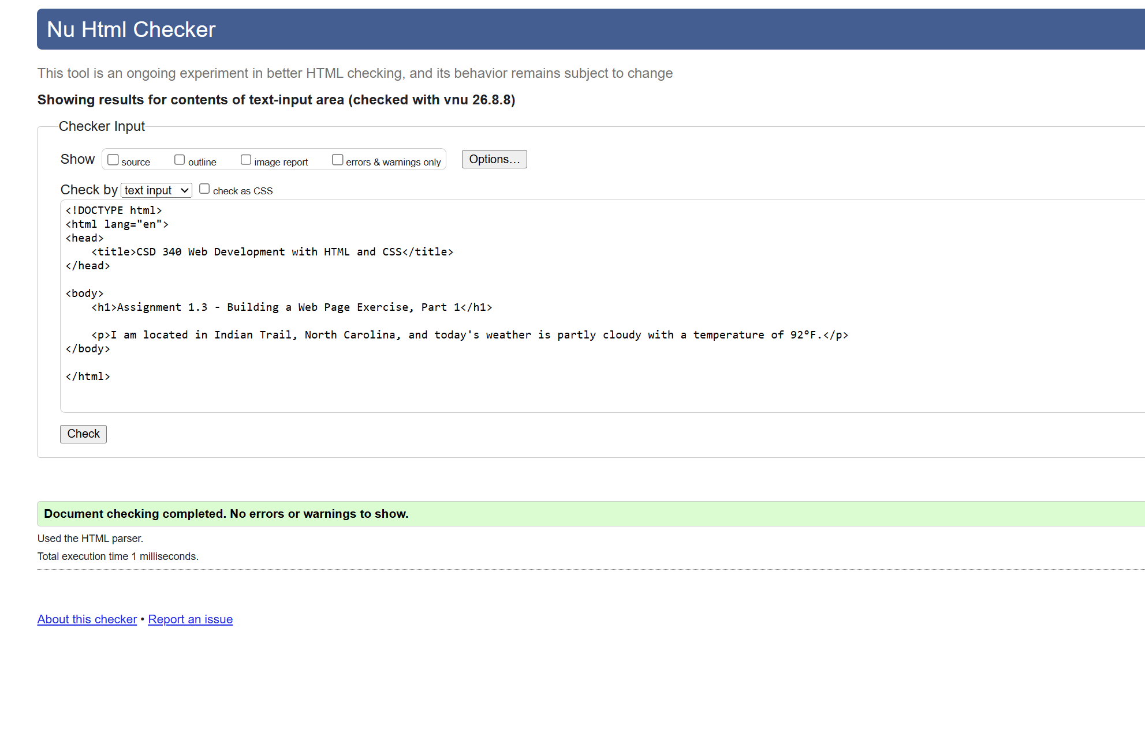
Figure 4 Completed Assignment 1.3 web page displayed in the browser.
