Wendy Bronson
CSD340-300H Web Development with HTML and CSS
Module 6.3 Assignment: BioSite Development
September 9, 2026

- GitHub and Local Directory
https://github.com/Wendybronson/bioSite.git

- Modify README.md:

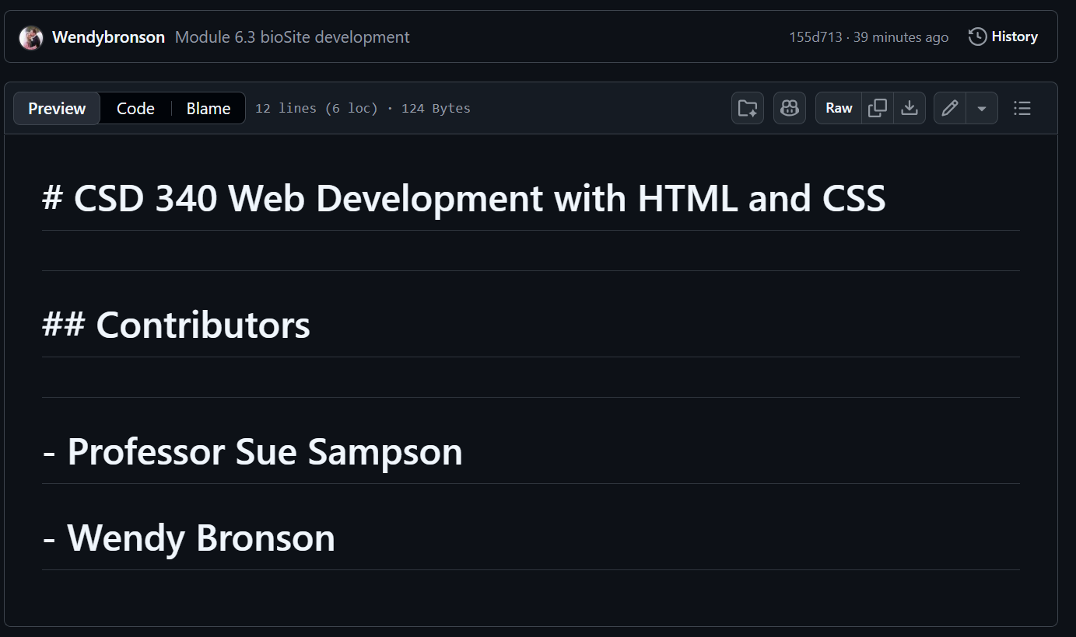

- Project Development:
Figure 1 index.html for bioSite Project W3C's validator
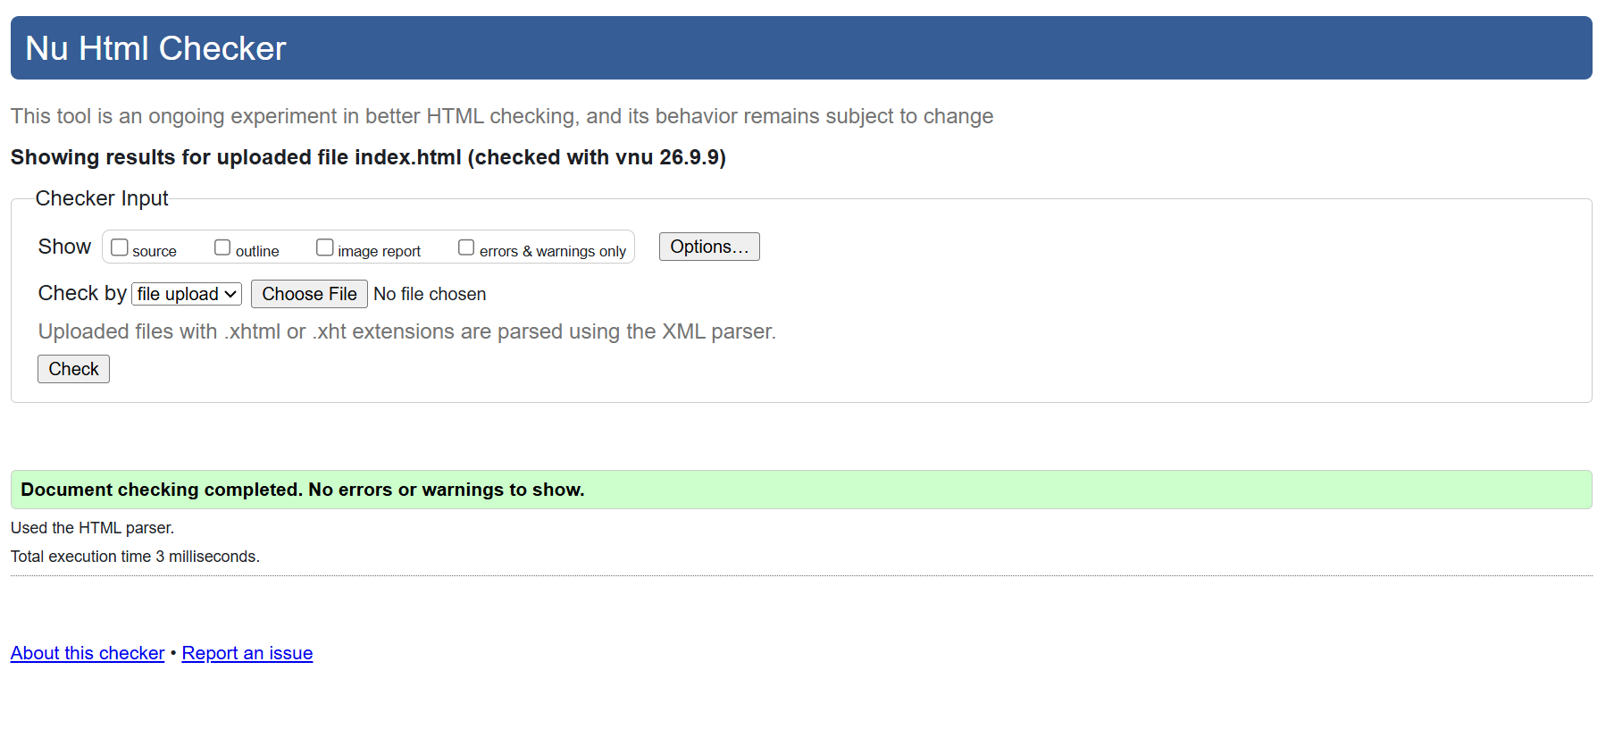

Figure 2 about.html W3C's validator
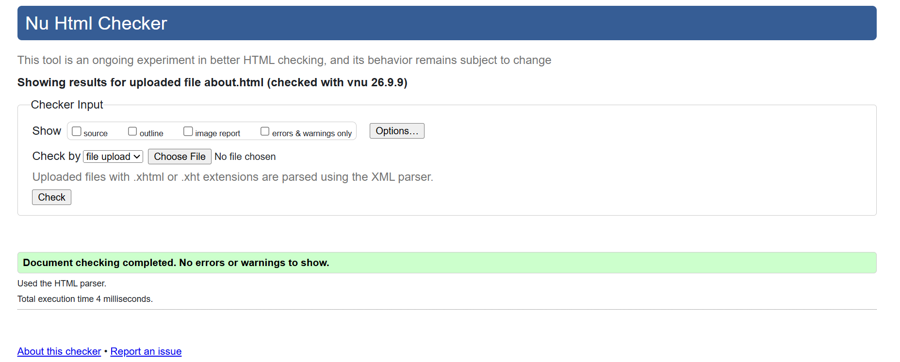

Figure 3 hobbies.html W3C's validator
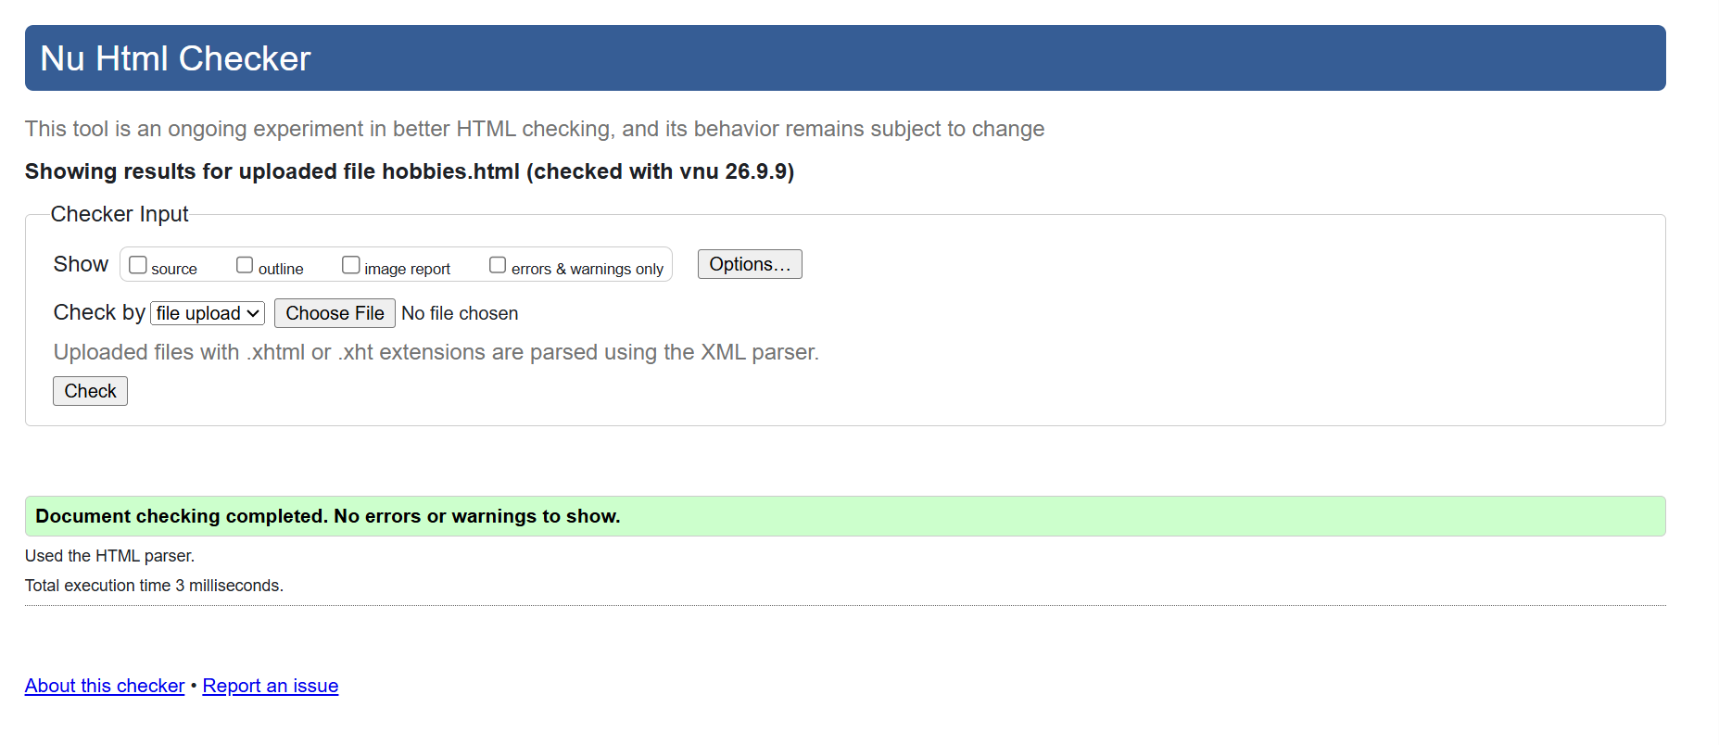

Figure 4 site CSS W3C's validator
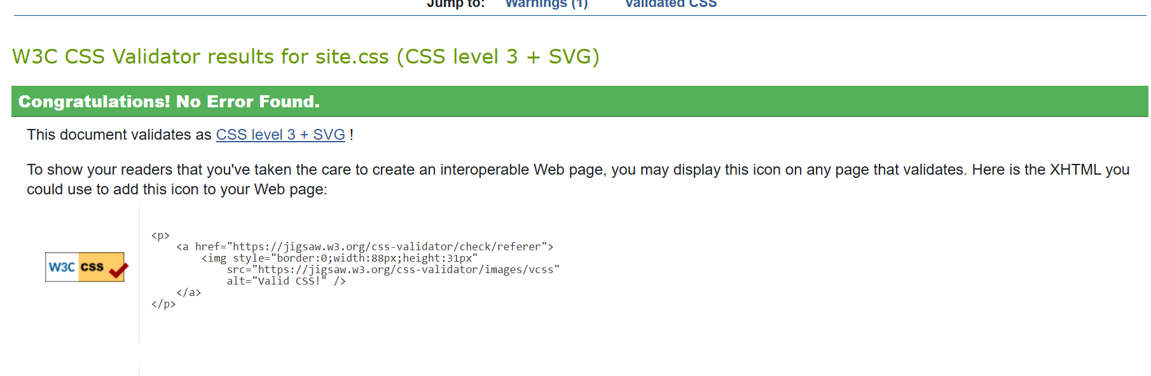

Biosite link: https://wendybronson.github.io/bioSite/

