Module 1.2 GitHub Repository Setup
Web Development with HTML and CSS
Wendy Bronson
Git repository: https://github.com/Wendybronson/csd-340.git
Figure 1 GitHub Repository Setup -Local Directory Setup
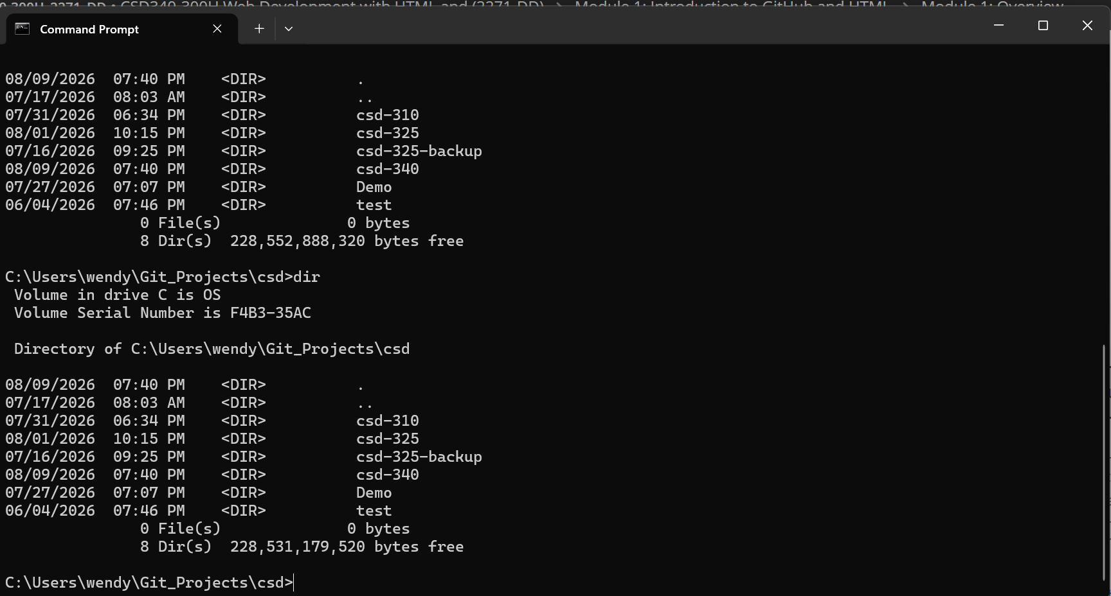

Figure 2 Modify README- Repository Landing Page GitHub
