Wendy Bronson
Module 7.2 Oriented Classes and Thinking Instructions
September 11, 2026
CSD402-300H Java for Programmers

Figure 1Module-7 directory
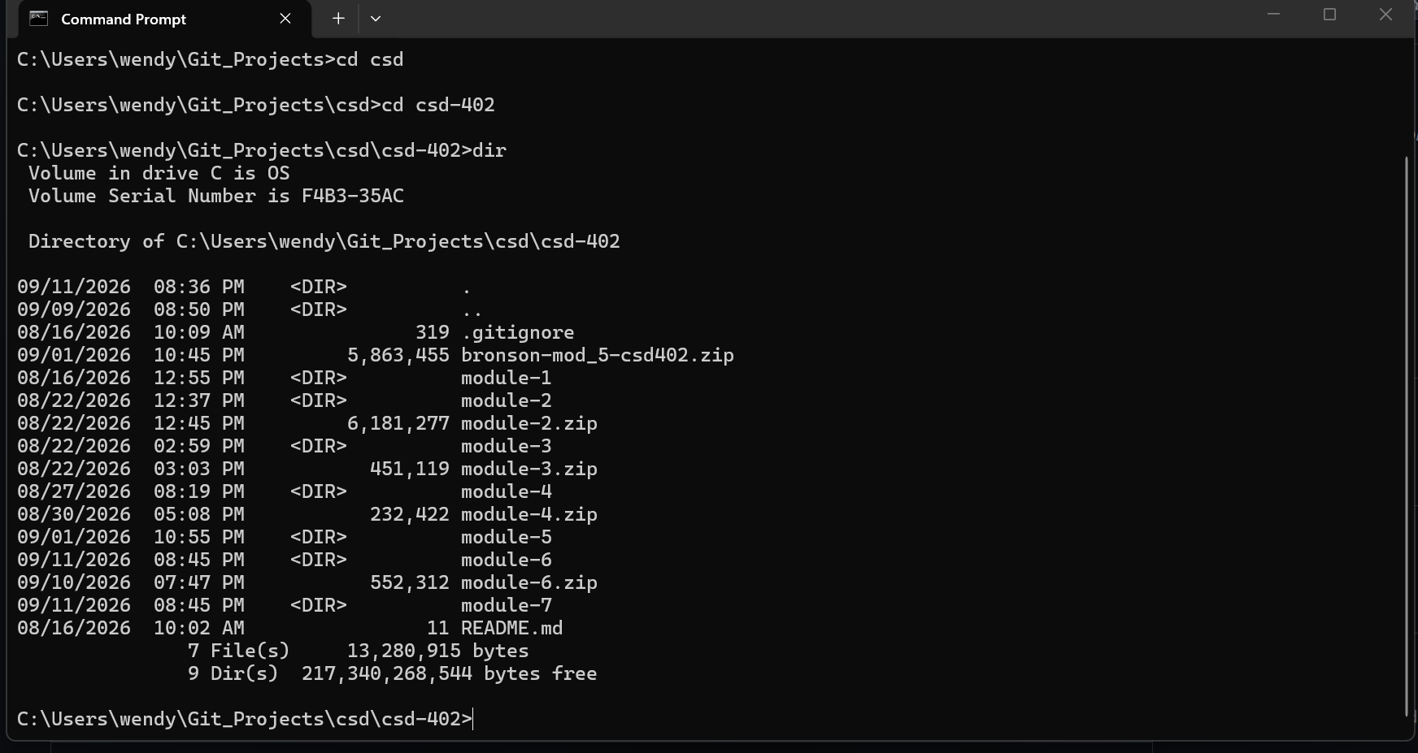
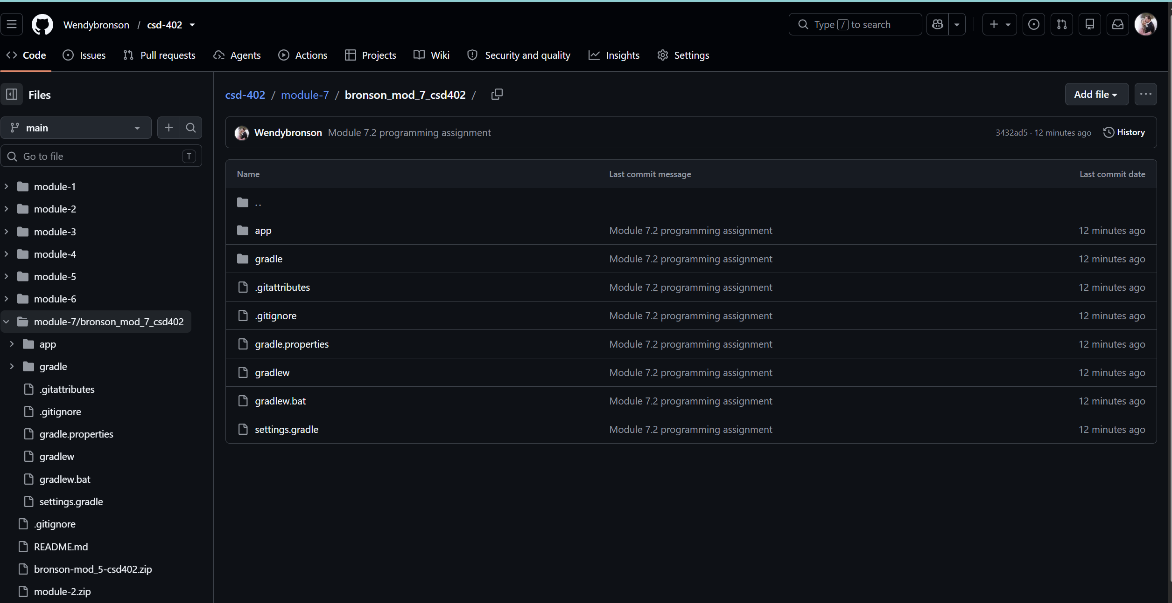
The URL: https://github.com/Wendybronson/csd-402.git

