Wendy Bronson
CSD-402 Java for Programmers
Module 10.2
10/03/2026

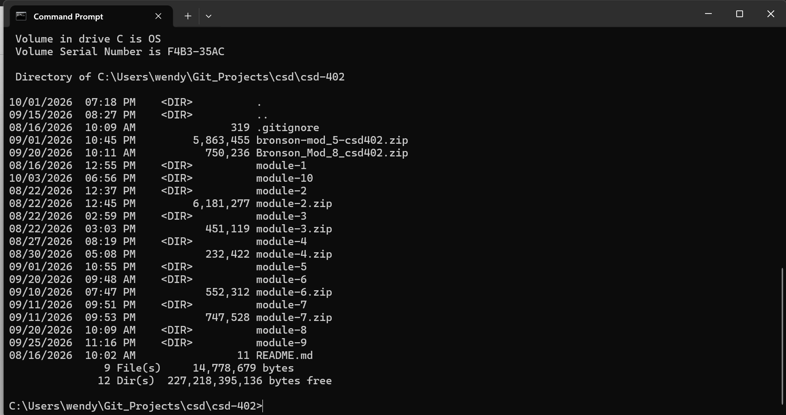
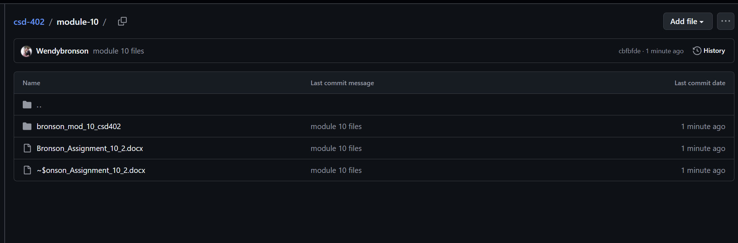
URL: https://github.com/Wendybronson/csd-402.git

