Wendy Bronson
Module 8.2: Programming Assignment
CSD402 Java for Programmers
September 20, 2026

Module 8 Directory created:
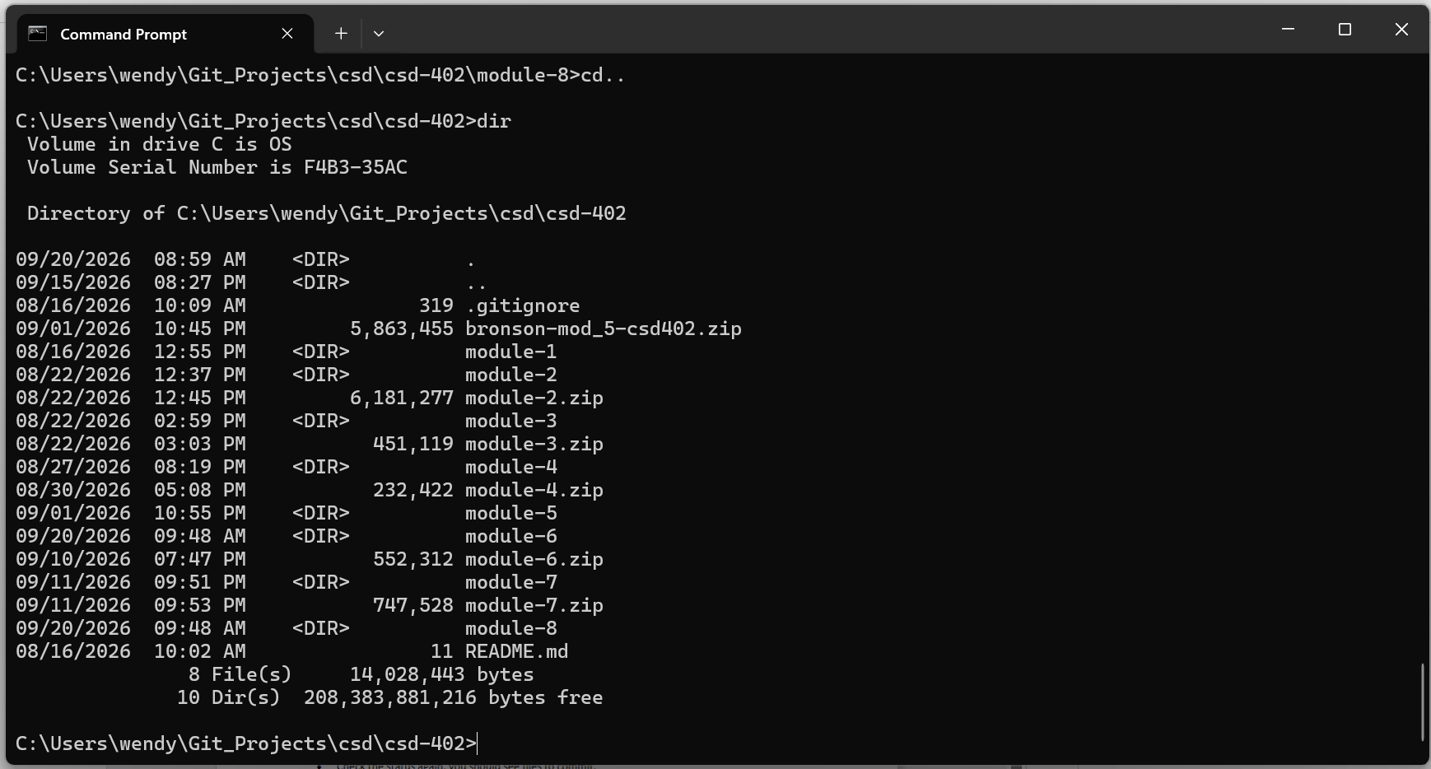
GitHub Module 8 screenshot:
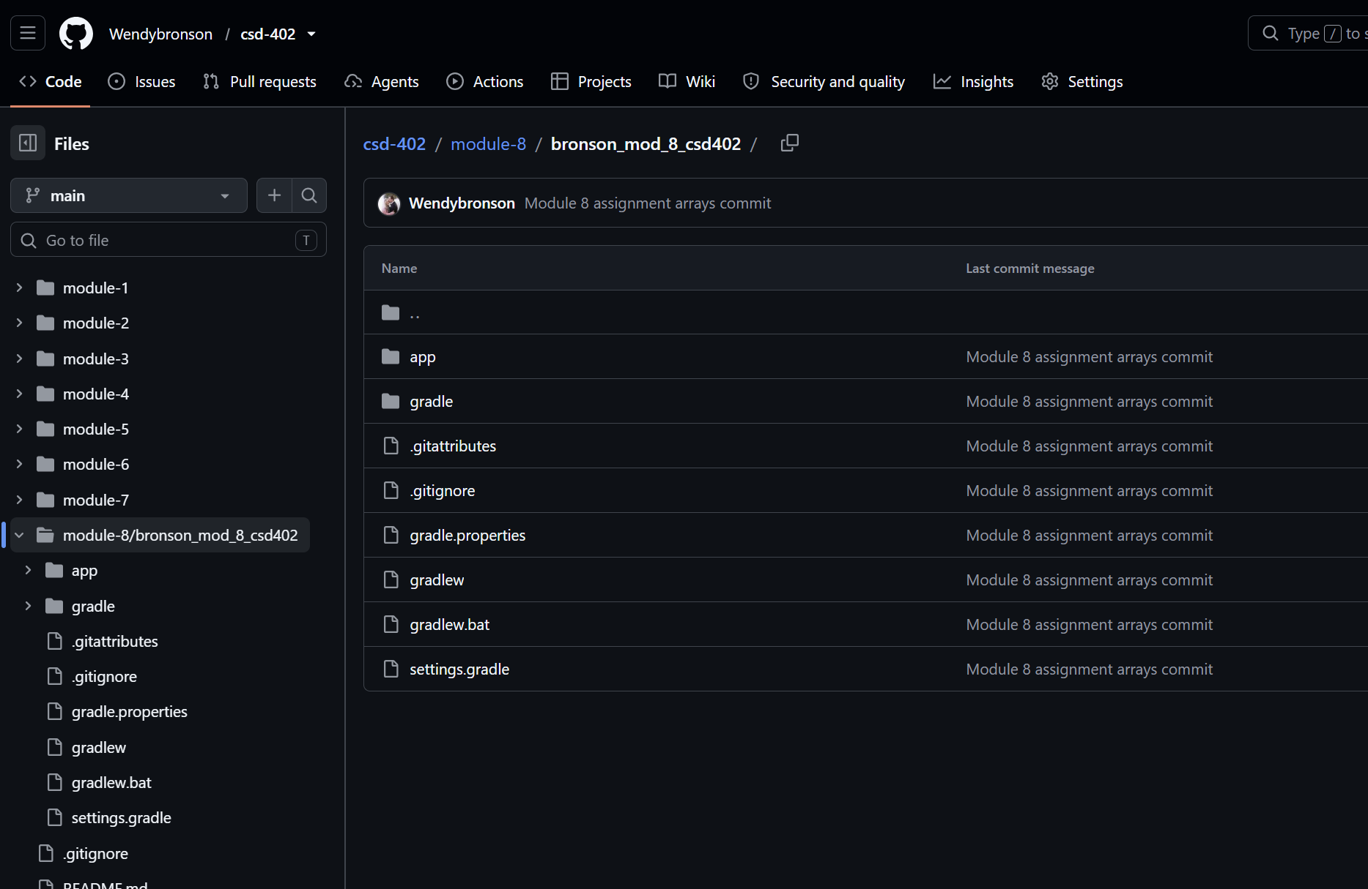

URL: https://github.com/Wendybronson/csd-402.git

