Wendy Bronson
Module 9.2: Programming Assignment
September 25, 2026

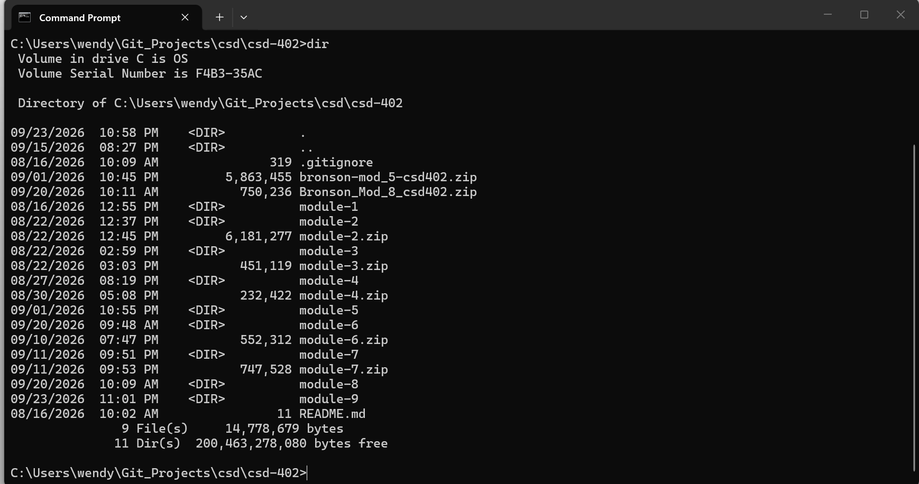
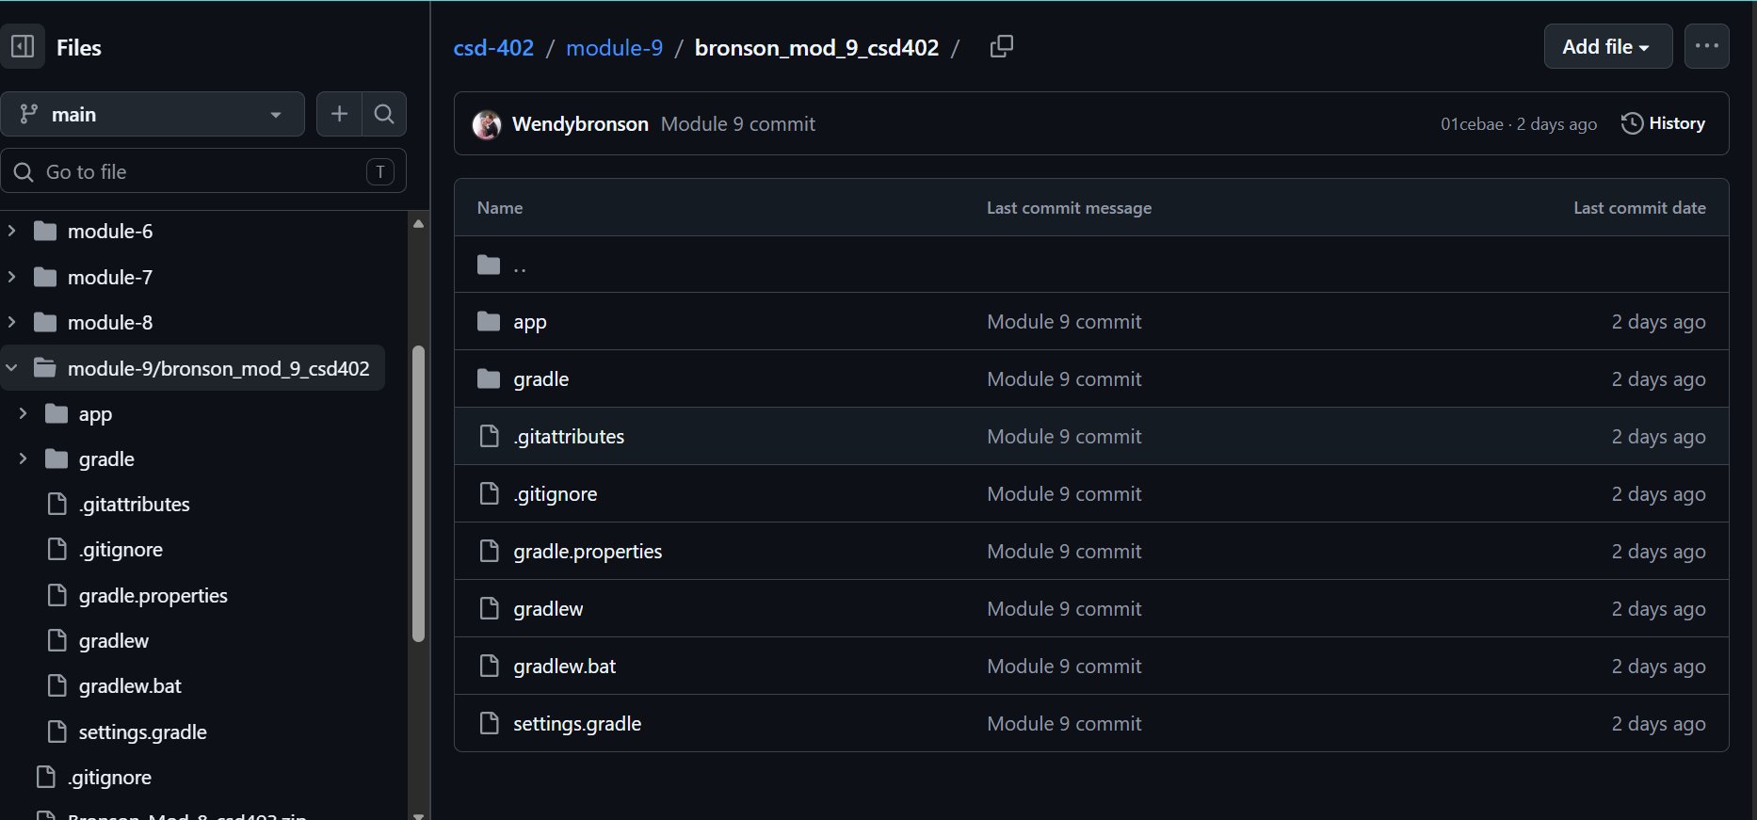

URL: https://github.com/Wendybronson/csd-402.git

