Wendy Bronson
CSD420
October 25, 2026
Module 1.3 Programming Assignment
JavaFX Random Playing Cards

JavaFx Cards Screenshots:
Figure 1JavaFX application displaying four randomly selected card
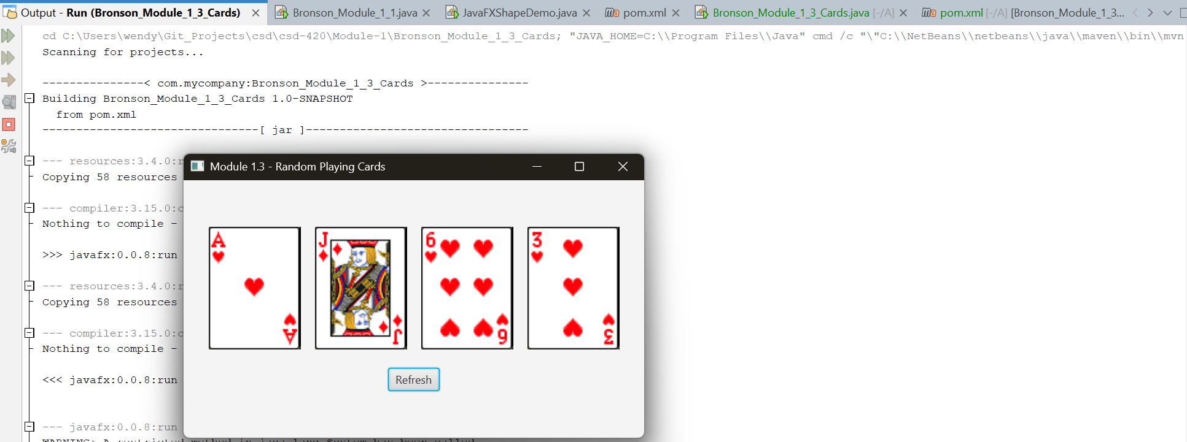
Figure 2 New playing cards displayed after selecting Refresh
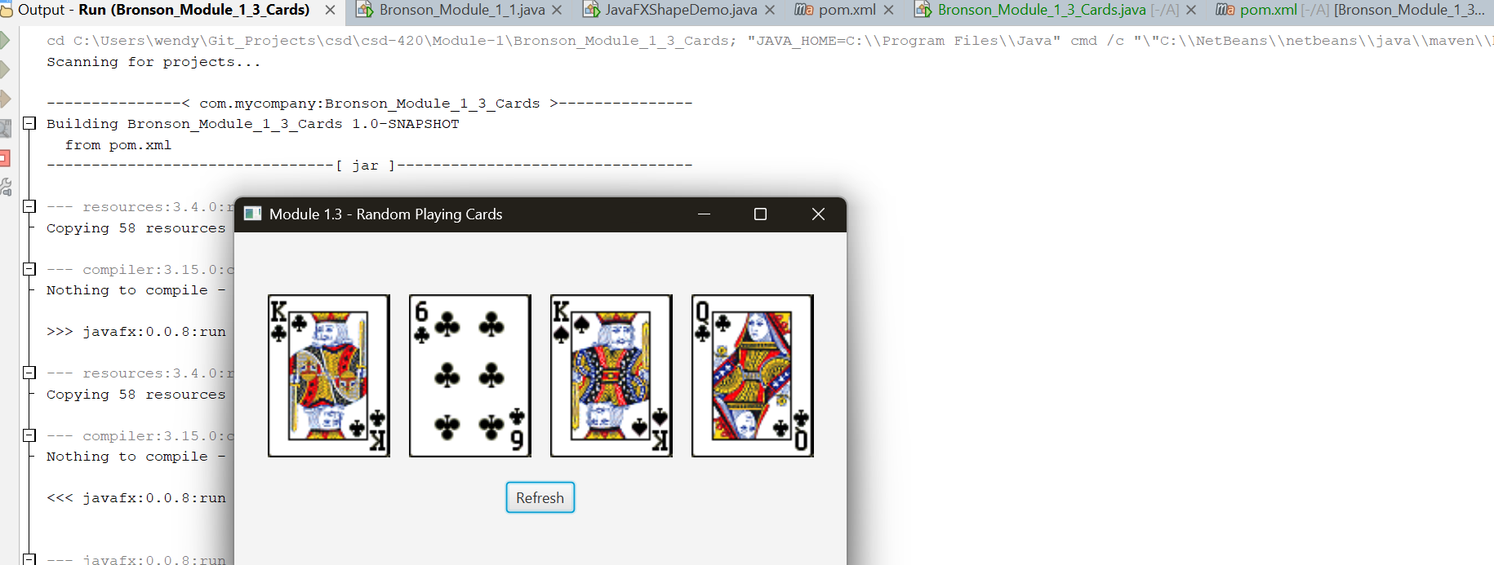
Figure 3 New playing cards displayed after selecting Refresh
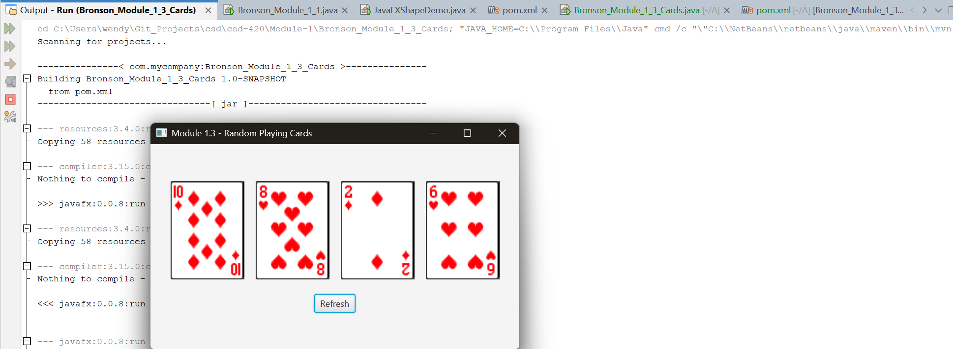
NetBeans Screenshots:
Figure 4 Additional JavaFX Application Screenshot
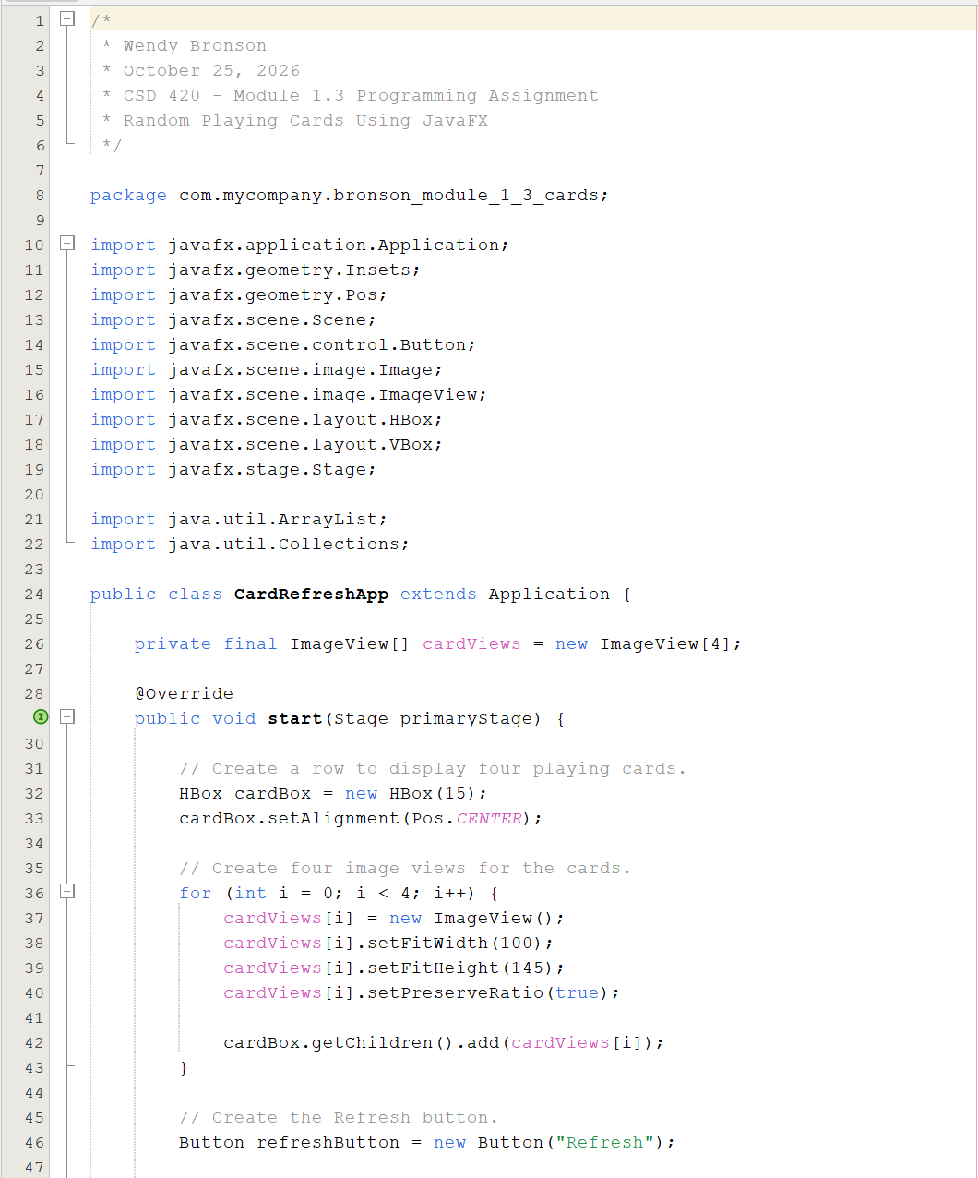
\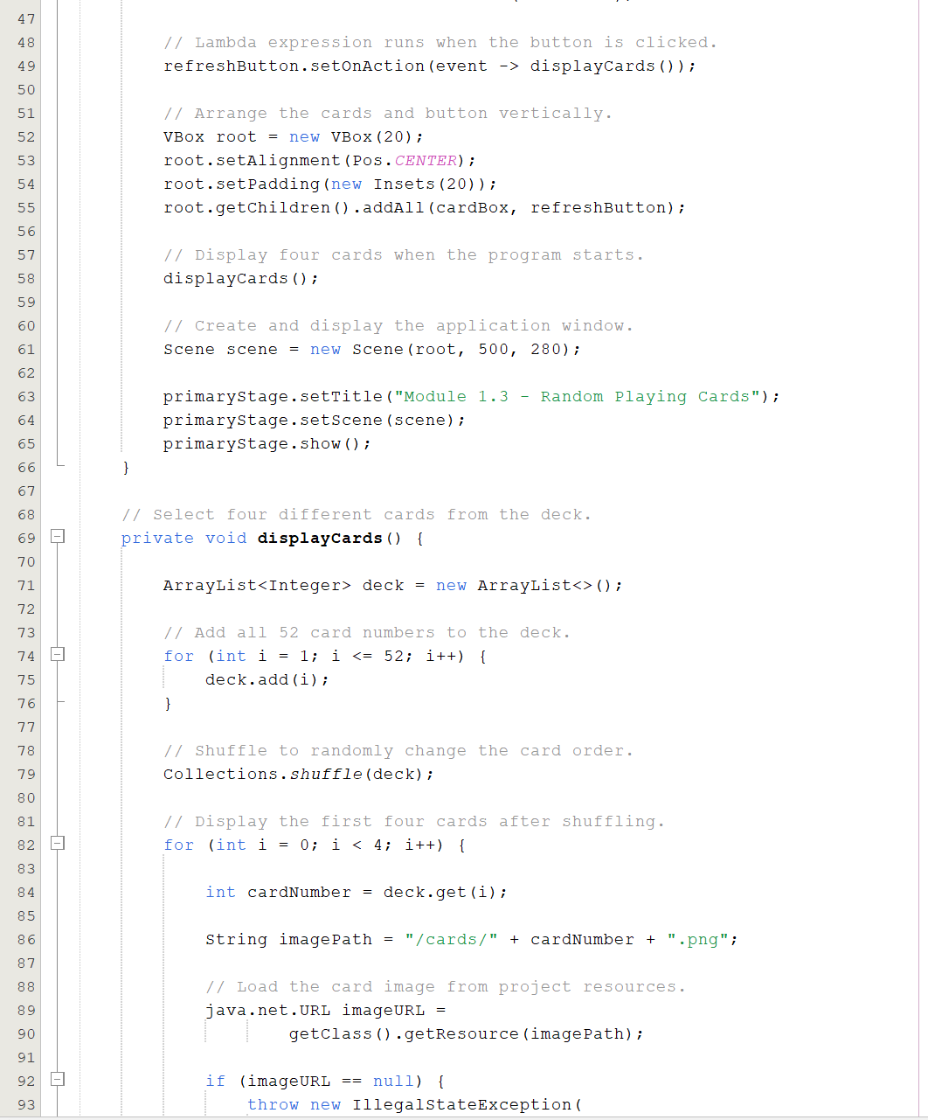
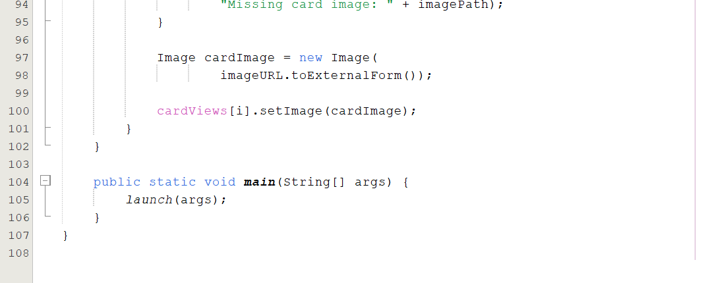
Directory confirmation:
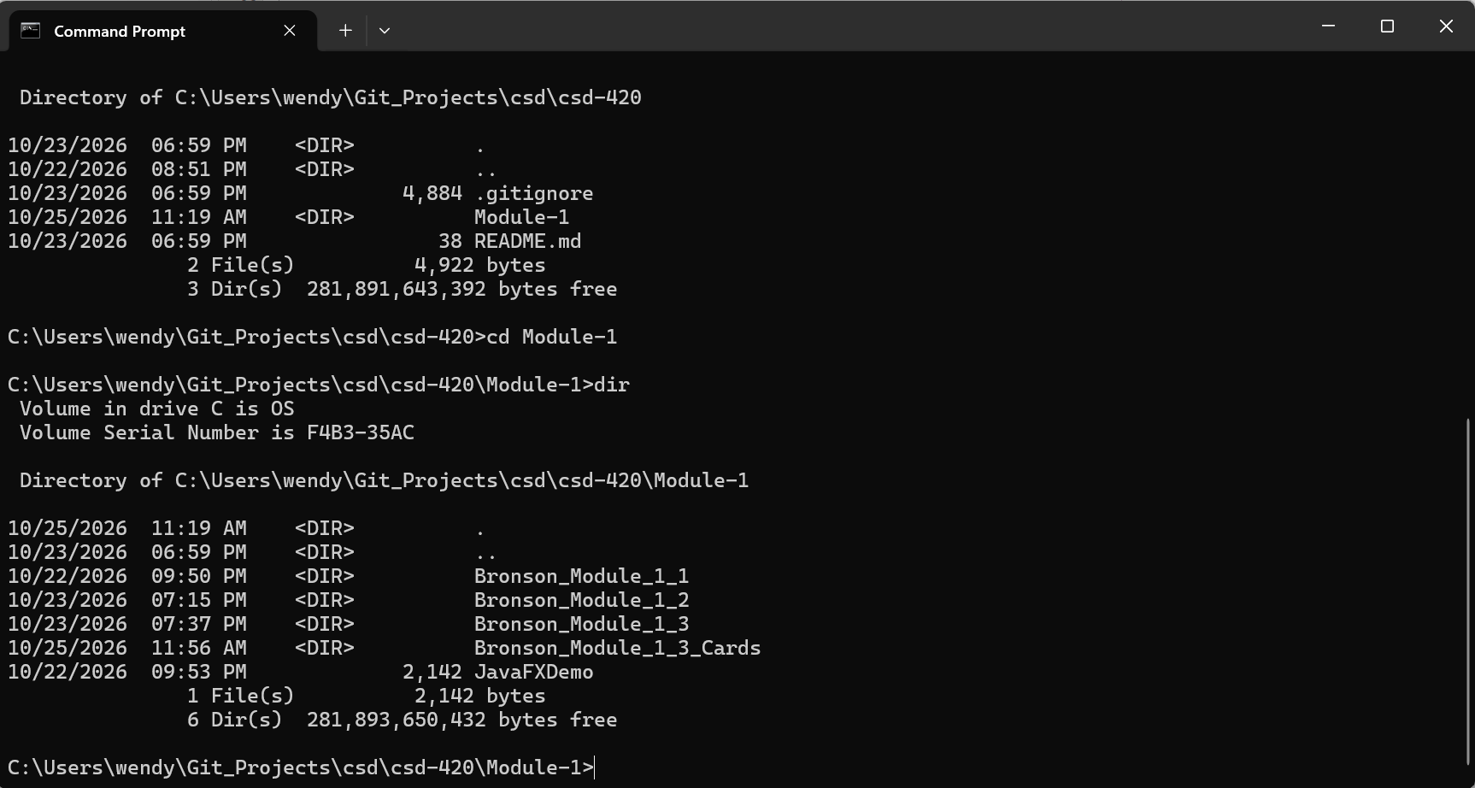
GitHub URL: https://github.com/Wendybronson/csd-420.git

