Wendy Bronson
CSD420
Module 1.2 Assignment GitHub
10/23/2026

GitHub Repository
: https://github.com/Wendybronson/csd-420.git

Screenshot of GitHub Repository:

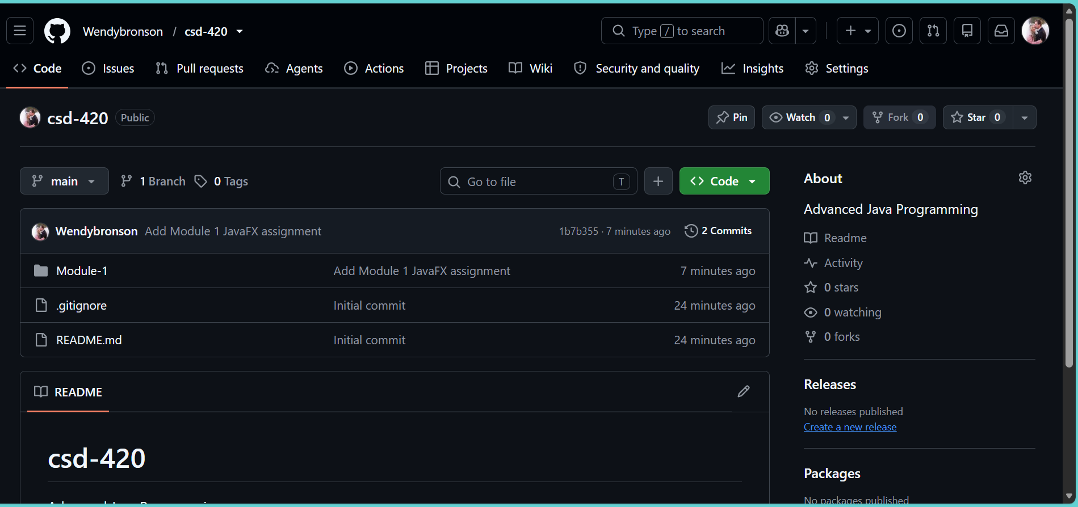

Screenshot of the local directory:
