Wendy Bronson
Module 2.2 Programming Assignment
November 1, 2026
CSD-420

Figure 1Java and JavaFX screenshot
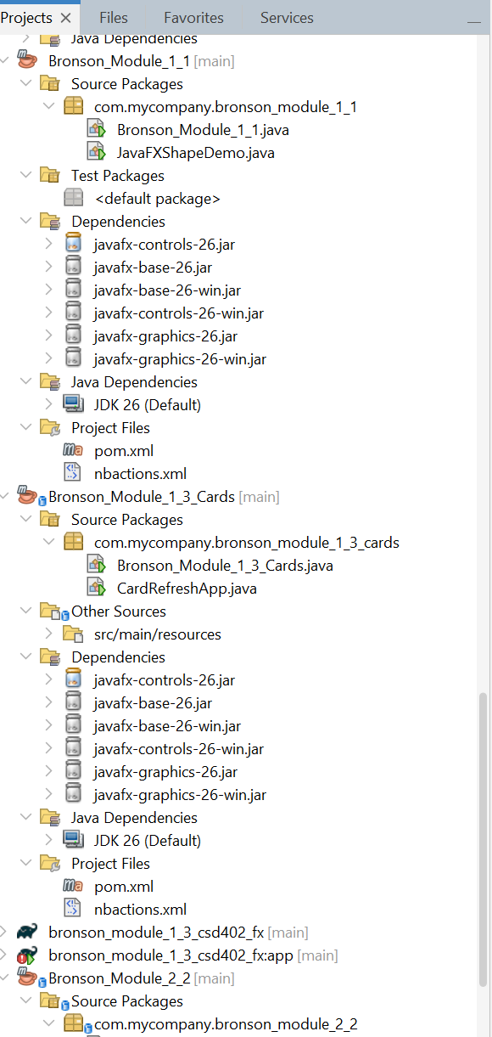
Figure 2 JavaFX Module 1.1 proof
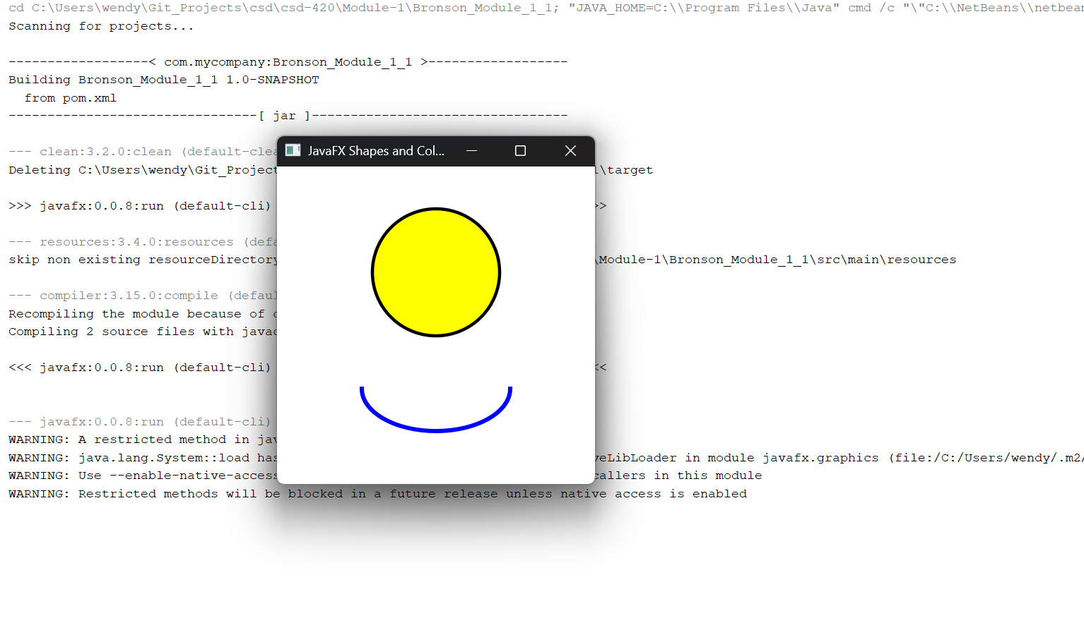

Figure 3 Write and Appending Data
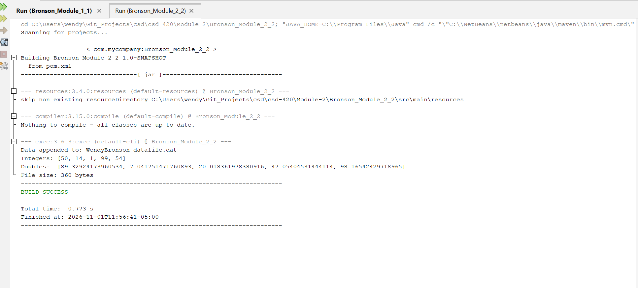

Figure 4 ReadData screenshot showing all sets:

