Wendy Bronson
Module .2 Programming Assignment
November 7, 2026
CSD-420

Figure 1Java and JavaFX screenshot
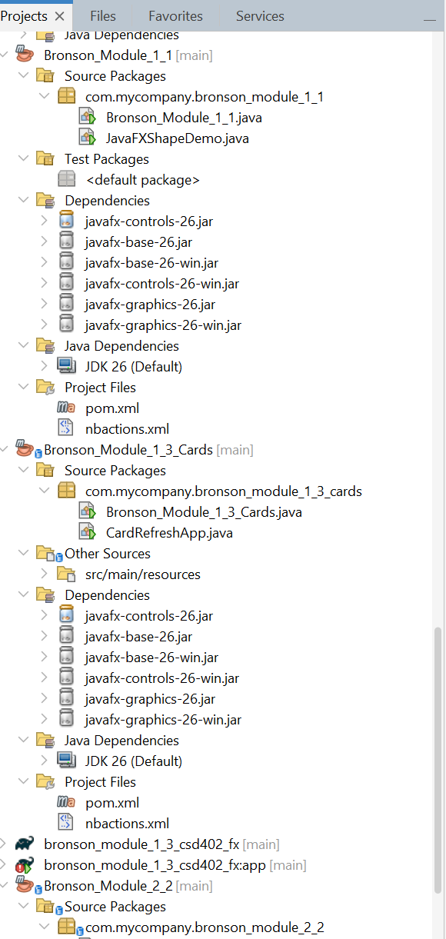
Figure 2 JavaFX Module 1.1 proof
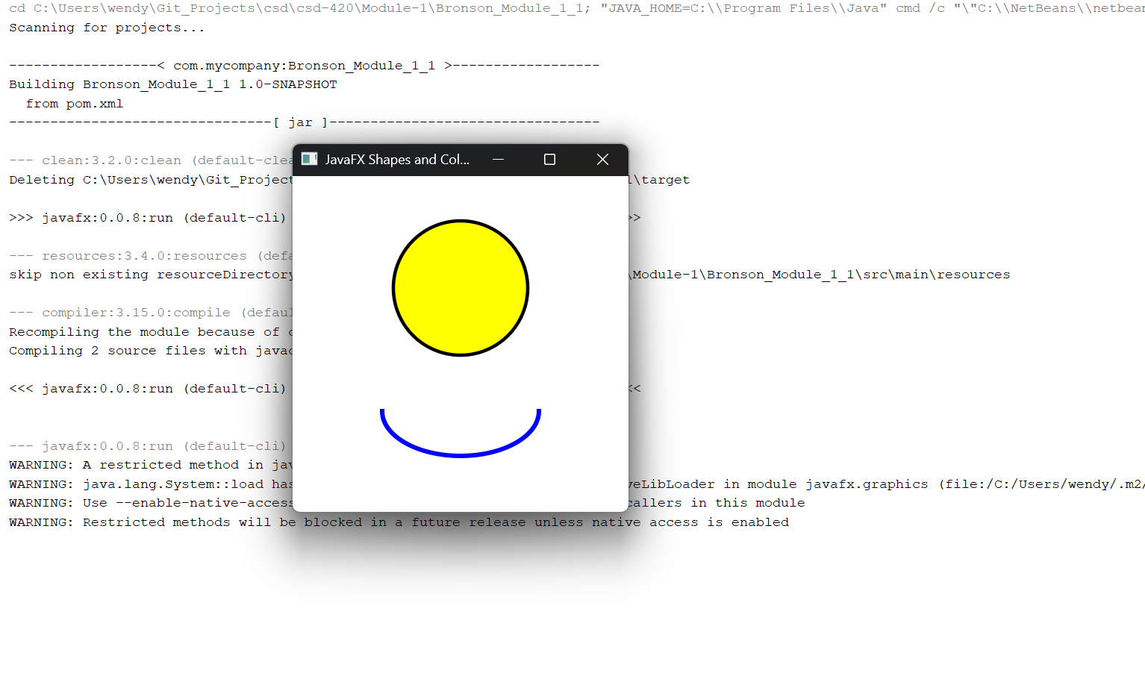

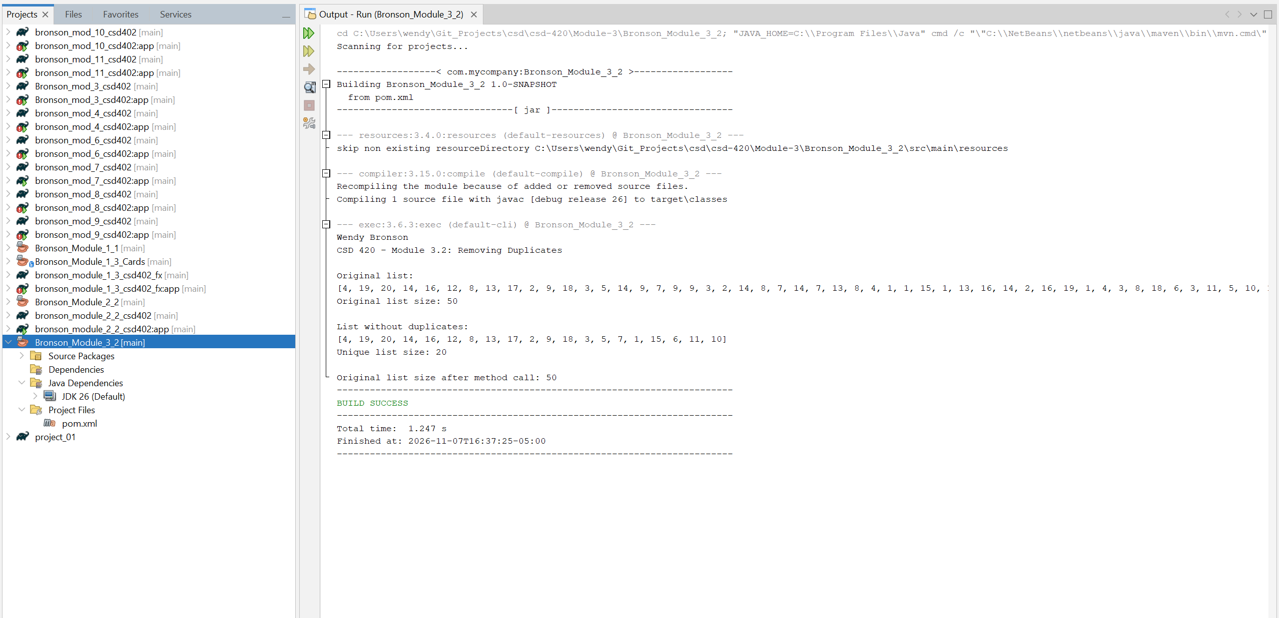
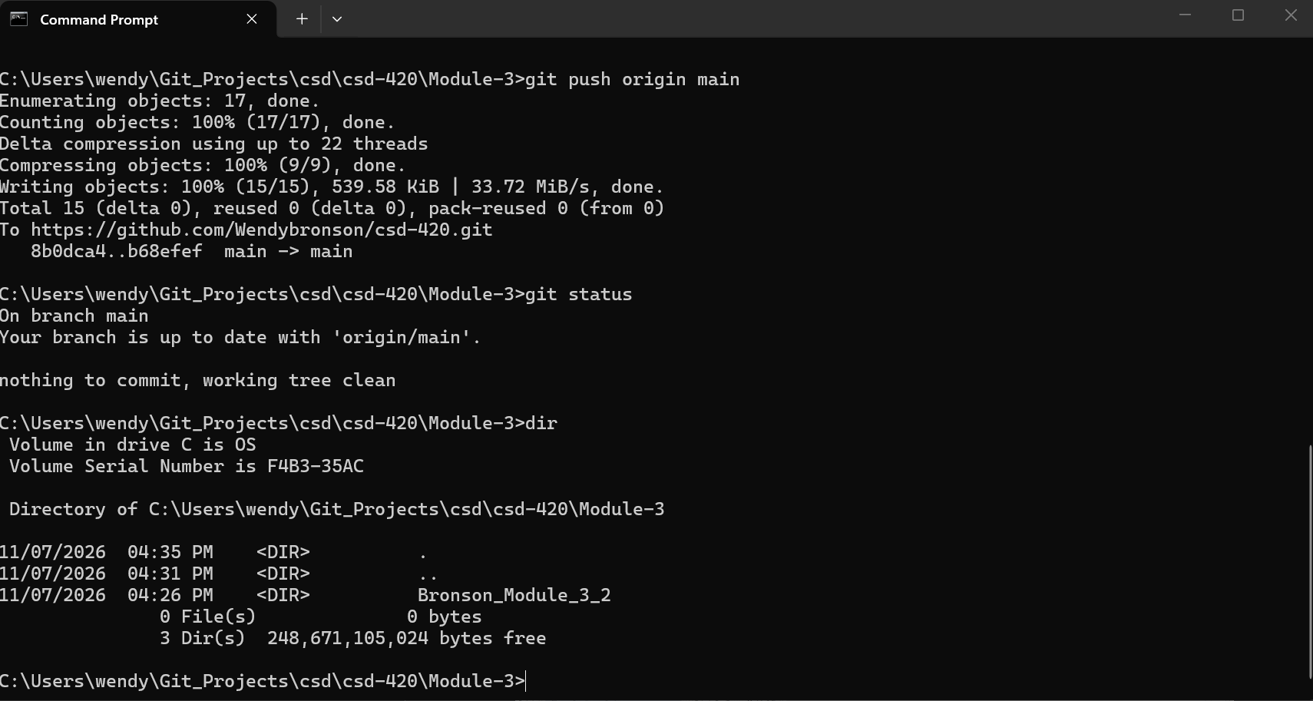
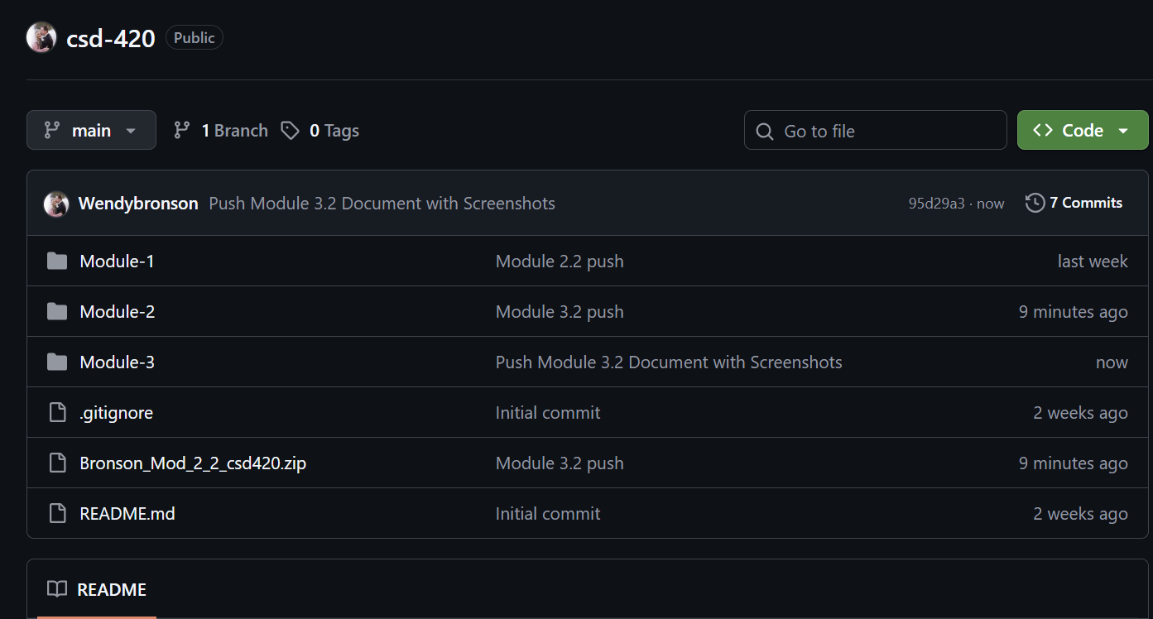
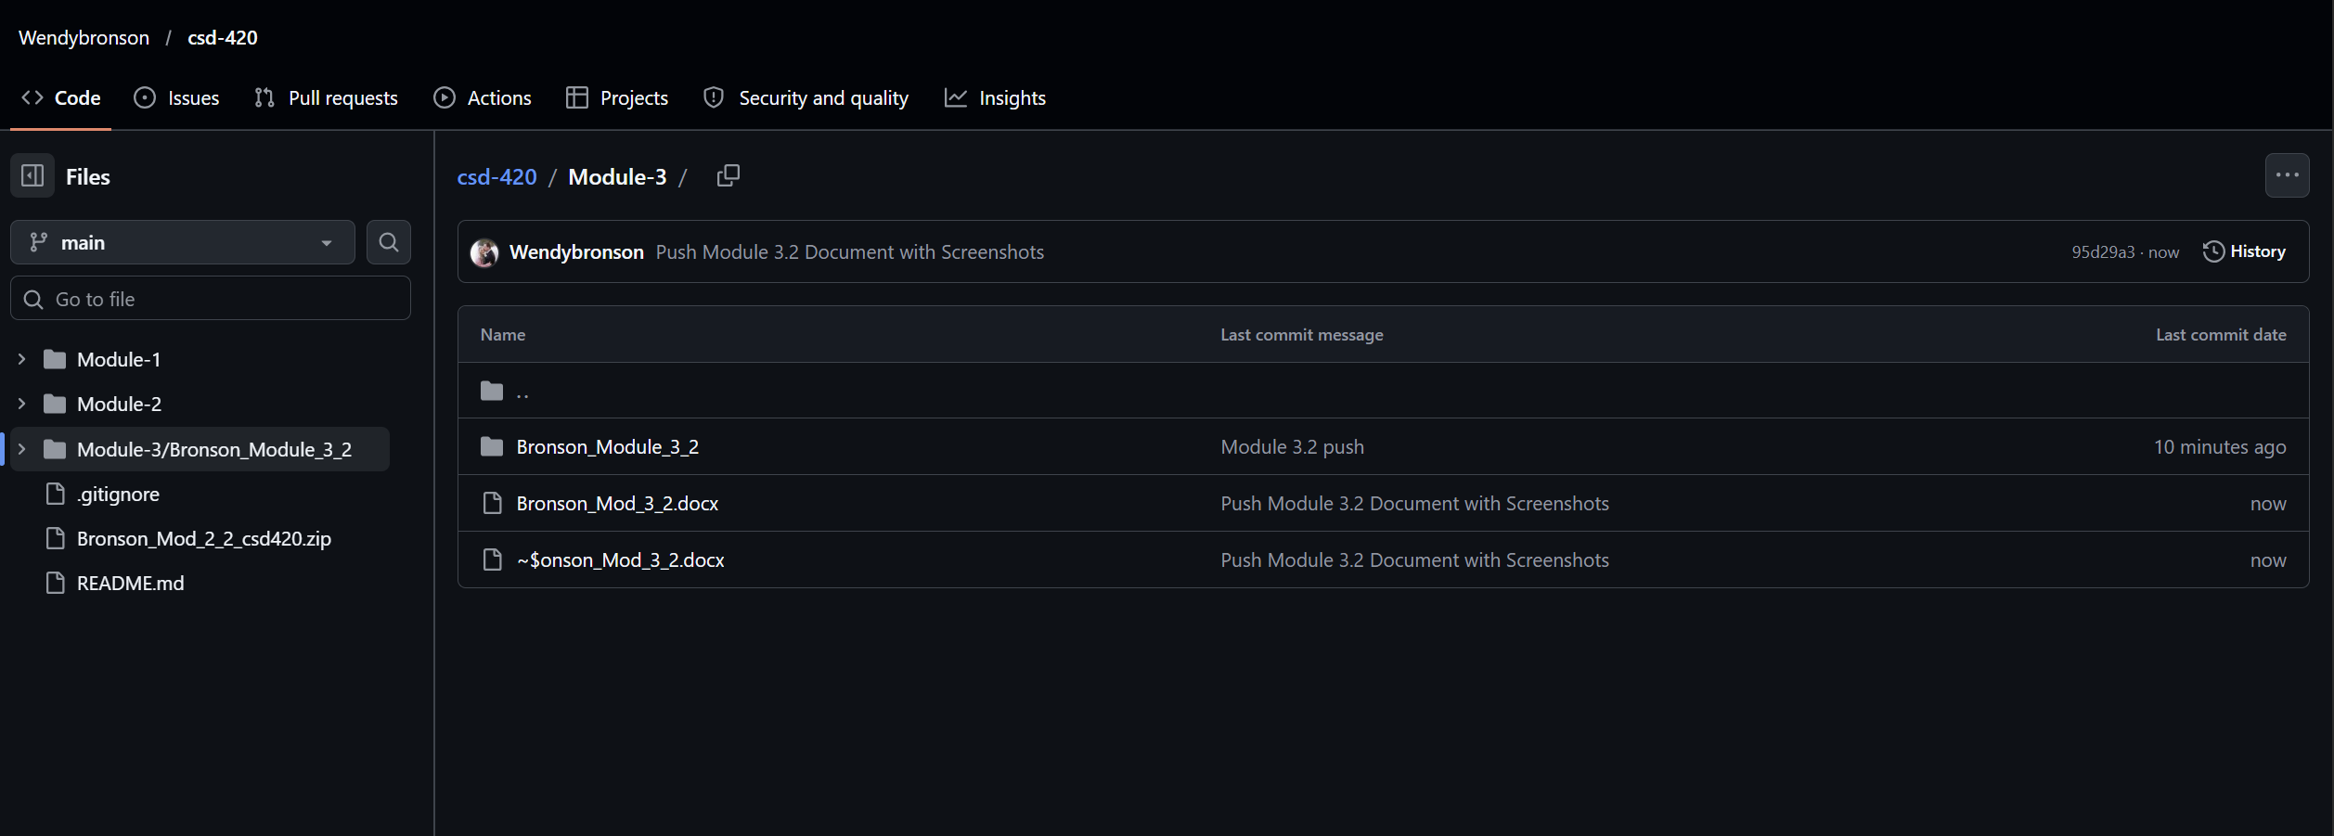
GitHub URL: https://github.com/Wendybronson/csd-420.git

