1 - Time

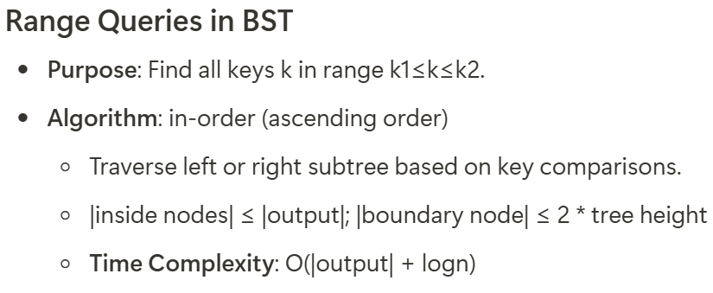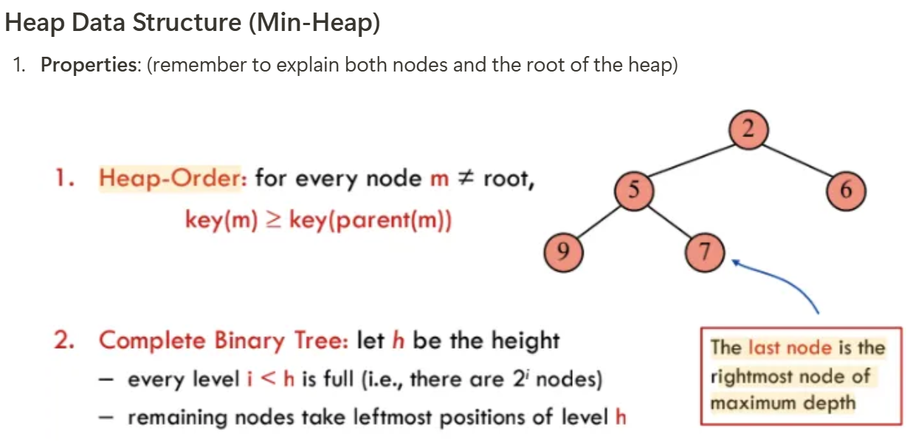

8 - Graph Algorithms sometimes modify adjacency list 