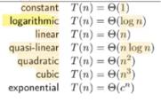
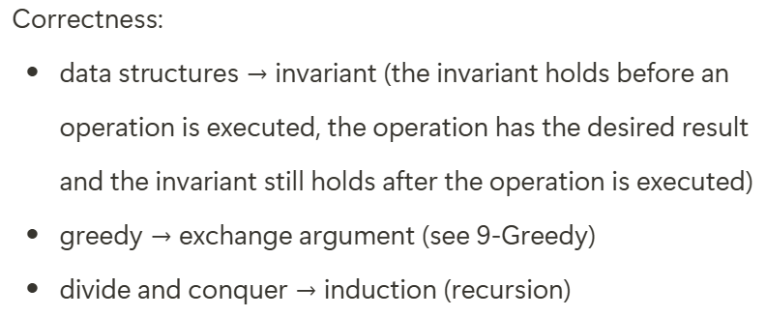
1 - Time

2 – Lists initialize -> O(1)
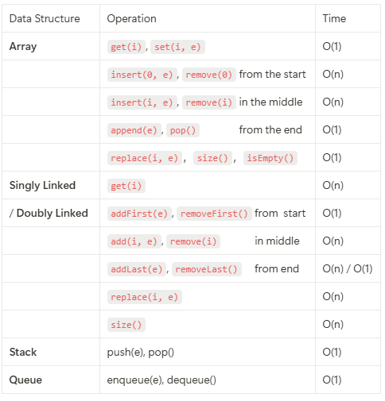
3 – Trees Preorder, Inorder, Postorder → O(n) 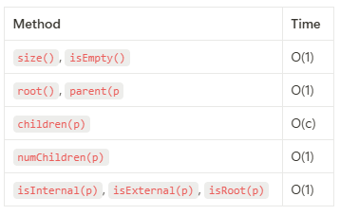
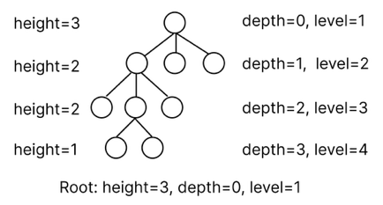

4 - Binary Search Tree should consider h’s best & worst case
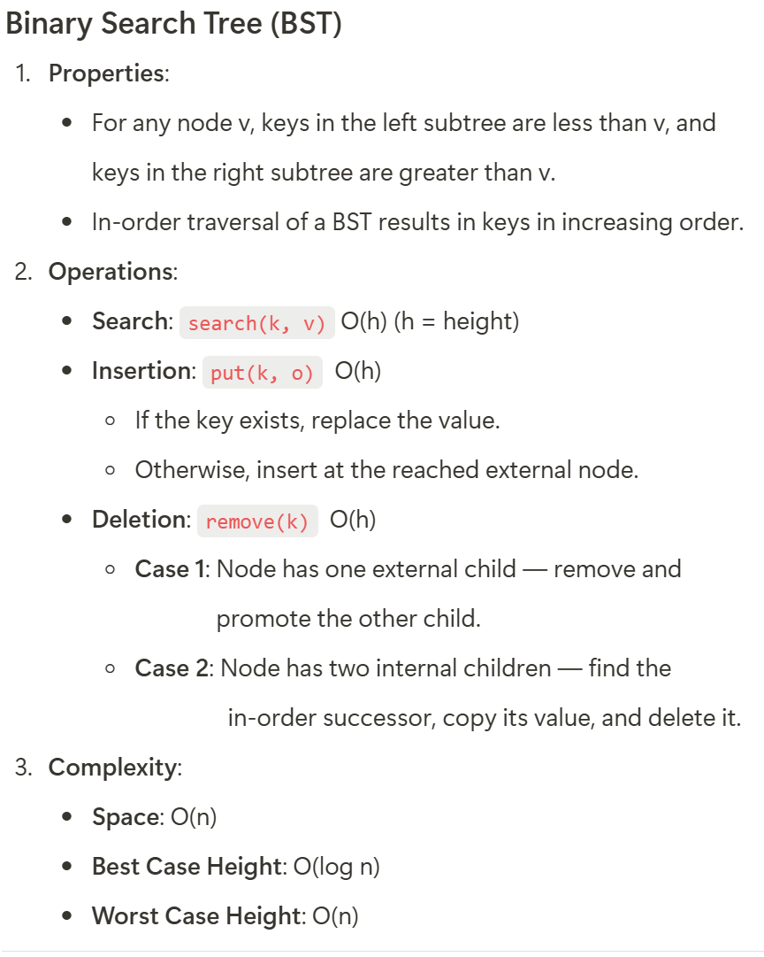
Range Queries
(to find all keys k stored in T such that k1 ≤ k ≤ k2.):
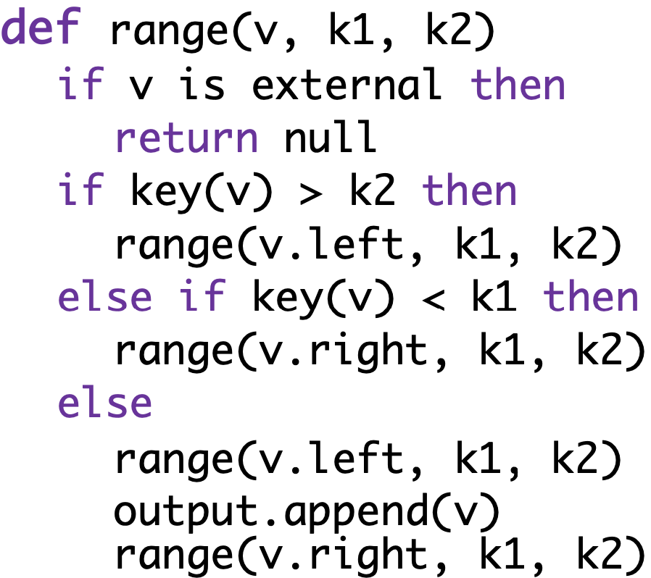
time complexity: O(|output| + h)

AVL all operations in O(log n).

Index-based searching in AVL: select(i) returns the ith smallest key (assume no duplicate keys)
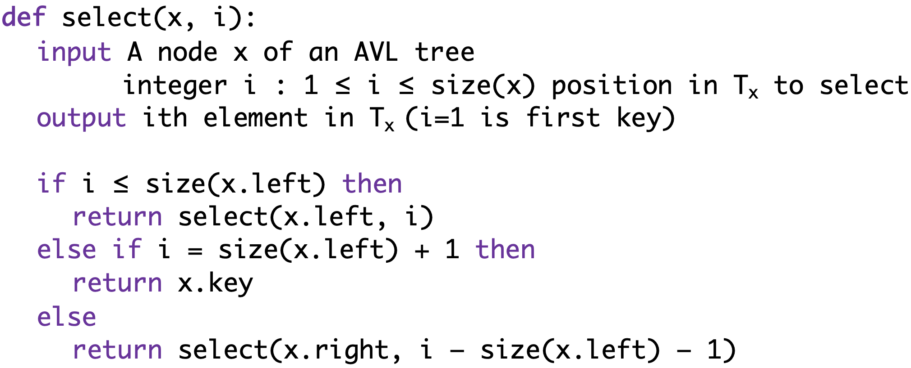

trinode restructuring
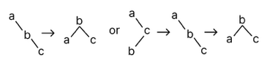

5 - Priority Queues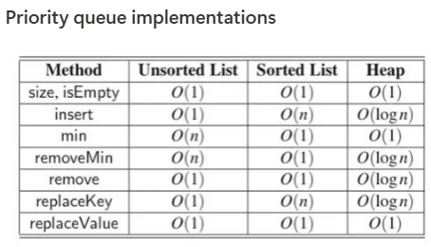
- Selection sort: for each i in the list, find the min value s after i, swap s and i.

- Insertion sort: for each i in the list, shifts a chunk of consecutive larger numbers before i to i, then insert i at the start of the consecutive larger numbers. 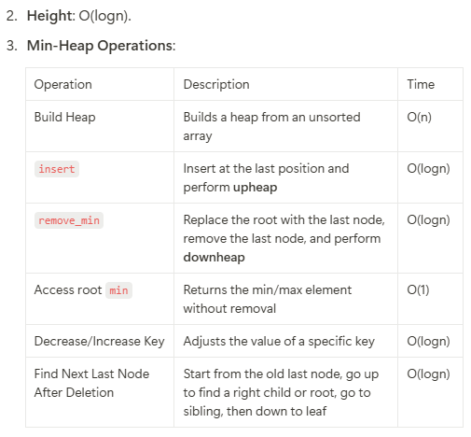Heap to array: root is at 0, last node is at n-1. For the node at index i, its left child is at index 2i+1, its right child is at index 2i+2, its parent is at index ⌊(i-1)/2⌋.

Use heapify to build heap in O(n): build heap from bottom to up, downheap the internal node when adding it.
Time complexity proof: every internal node goes downheap in a unique path, there are n-1 edges in a complete binary tree, so O(n).

6 - Hashing
- Unordered key list: O(1) for insert, O(n) for get and delete.
- Order key list: waste of space.
- Goal: want hashmap of all O(1) operations.

- Maps n keys to the range [0, N-1], the expected number of collisions is at most the load factor a = n/N.
- Use polynomial evaluation function as the hash function when the order of permutation matters.

Separate chaining(an array of linked lists): load factor is the average number of keys per bucket, If the hash function distributes keys uniformly, the expected time per operation is O(1 + a), but normally worst case running time is O(n).

linear probing(place key to next empty slot, circularly):
If the load factor is less than 1, put/get would run in O(1).
P(next slot is empty, success) = 1-a, P(next slot is filled, fail) = a, the expected number of trials until the first success is 1/p, therefore the average number of probes you must make before hitting an empty slot is 1/(1-a). So with a ≤ 0.5, you expect about 2 probes per operation.
Deletion leaves a DEFUNCT marker, so that we don’t break the chain when finding a key.

Cuckoo Hashing (two slots to put a key, evict the key to its another slot if filled): O(1) for get and remove, O(n) for put.

To detect an eviction cycle: use a counter to count how many times this key was evicted, has a cycle if evicted enough time; or keep a flag for each key, flag it when we evicted it, unflag all when successfully put.

7 – Graphs 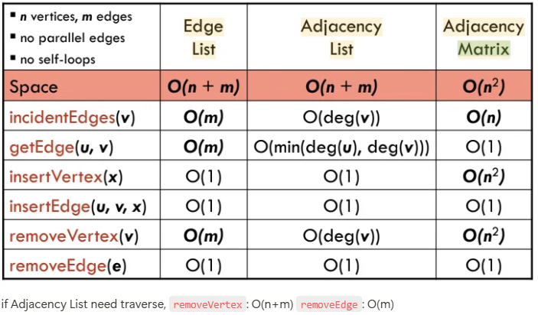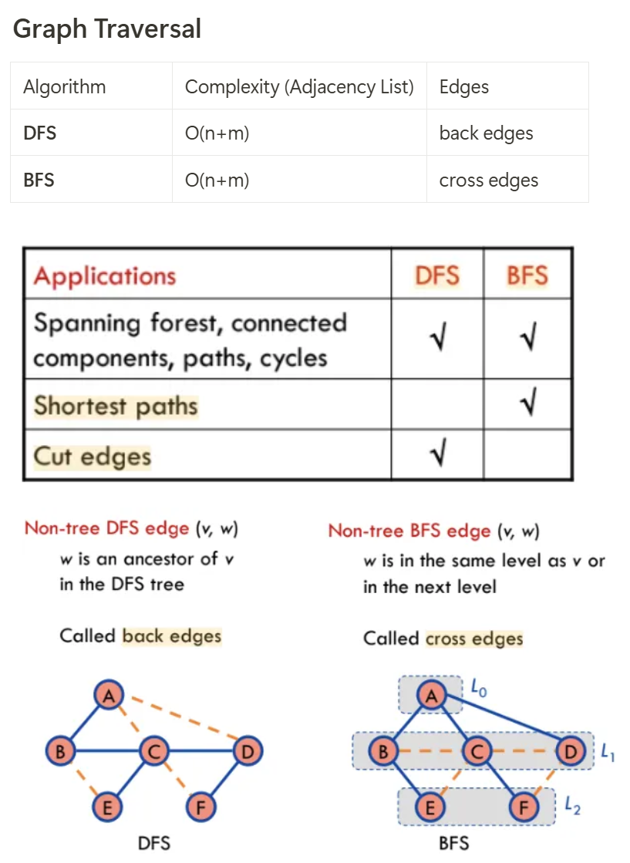
BFS can find bipartiteness and shortest path (if all weight = 1). DFS can find cut edges (for (u,v), is a cut edge if low[v] < level[u], where low[v] is the lowest level that v can reach by going down a path and a back edge) and cycles.

Topological sort can return a list in the order of dependency and fills prerequisites for any scheduling tasks.
Every Directed Acyclic Graph can be topologically sorted, A topological order is a linear ordering of vertices so that for every edge (u,v), u appears before v.
Run DFS to check the cycle and record finished time of each vertex, build the sorted list on the fly in decreasing finish-time order, O(n+m) running time.

Strongly Connected Components (SCCs): In a directed graph G, a strongly connected component is a subset C where every vertex in C can reach every other vertex in C:

We can then collapse each SCC into a single node, then get a compressed DAG. DFS-based algorithms of SCC have O(n+m) running time and can return all compressed nodes.

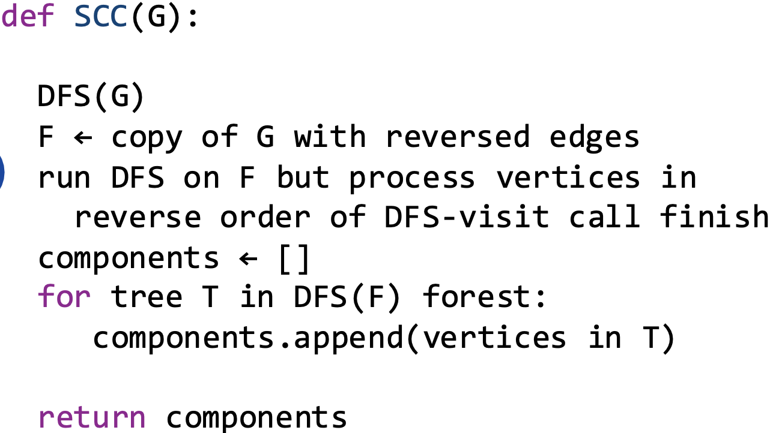

8 - shortest path and MST

A subpath of a shortest path is itself a shortest path.

Dijkstra’s Algorithm: Compute the shortest path from a start vertex s to every other vertex in a graph with nonnegative edge weights. Always pick the not-yet-settled vertex with the smallest accumulated distance from s. Use a heap to store (v, D[v]) for v in G, and update D[v] and decrease key when we relax edge. O(m log n) with a binary heap, or O(m + n log ⁡n) with a Fibonacci heap.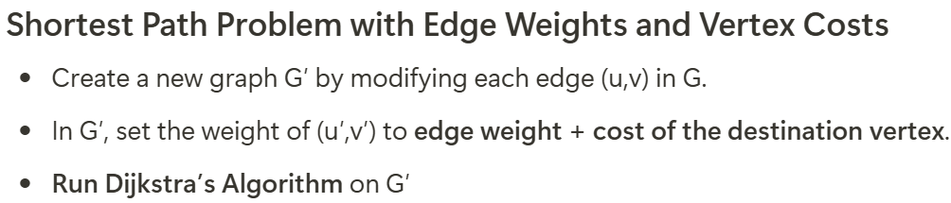

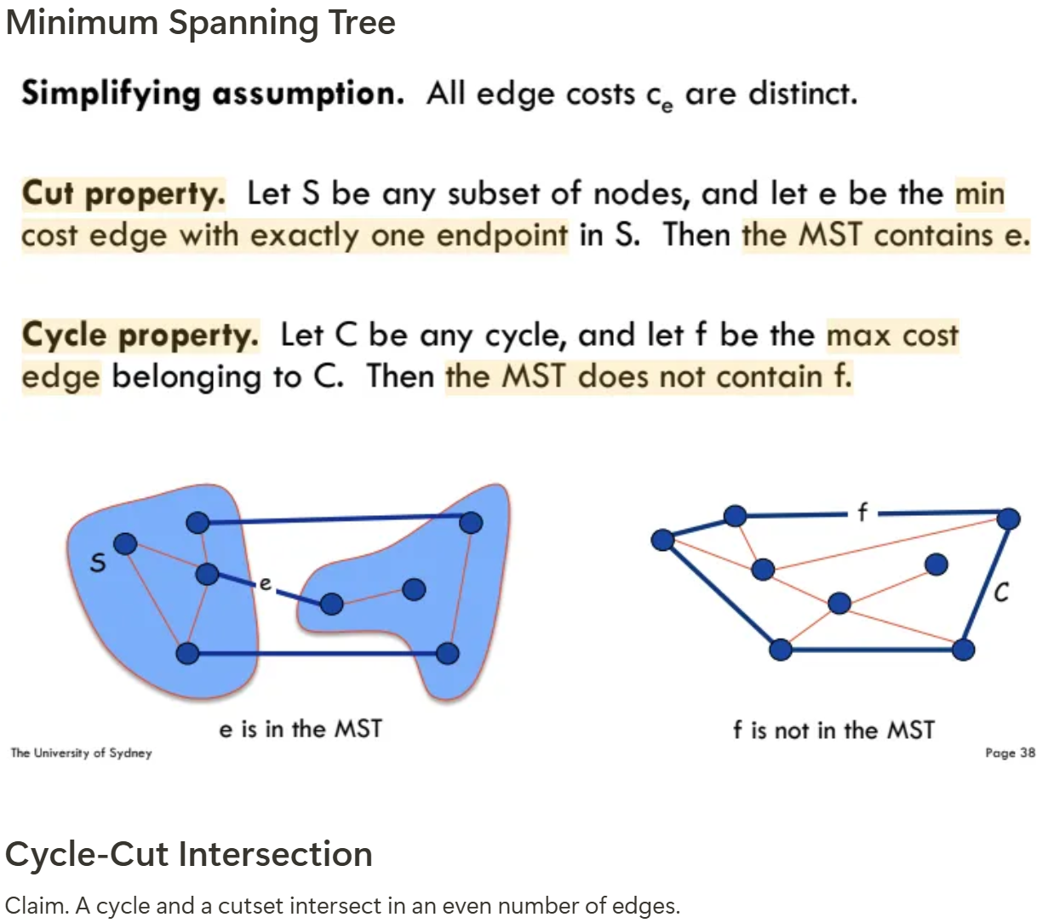
Cycle-cut intersection claim:
A cycle and a cutset intersect in an even number of edges.

Fibonacci heap: amortize O(1) insert; O(1) Find‐min; O(1) Merge (union) two heaps; amortized O(1) Decrease‐key; amortized O(log⁡n) Extract‐min (delete‐min).

Prim’s Algorithm(grow a tree): start with any random vertex v, always expand the lightest edge until all nodes are expanded. O(m log n) with a binary heap, or O(m + n log ⁡n) with a Fibonacci heap. Prove by cut property.

Tree-based implementation of union-find(with path compression):
initialize every vertex v to be the root of a singleton tree, each root contains a variable ‘size’ indicating the current size of this tree, initialized to be 1. If we want to add an edge (u, v), we do a = find(u), b = find(v), and check if a != b. (During a find(u), follow parent pointers up to the root, then set each visited node’s parent directly to the root. find(u) return the root of the tree u is in) If a != b, we do union(a, b), which compares the size of a, b, and moves the tree with smaller size to the other tree. If a.size < b.size, append a to be the direct child of b, and update ‘size’ of b to be b+a.
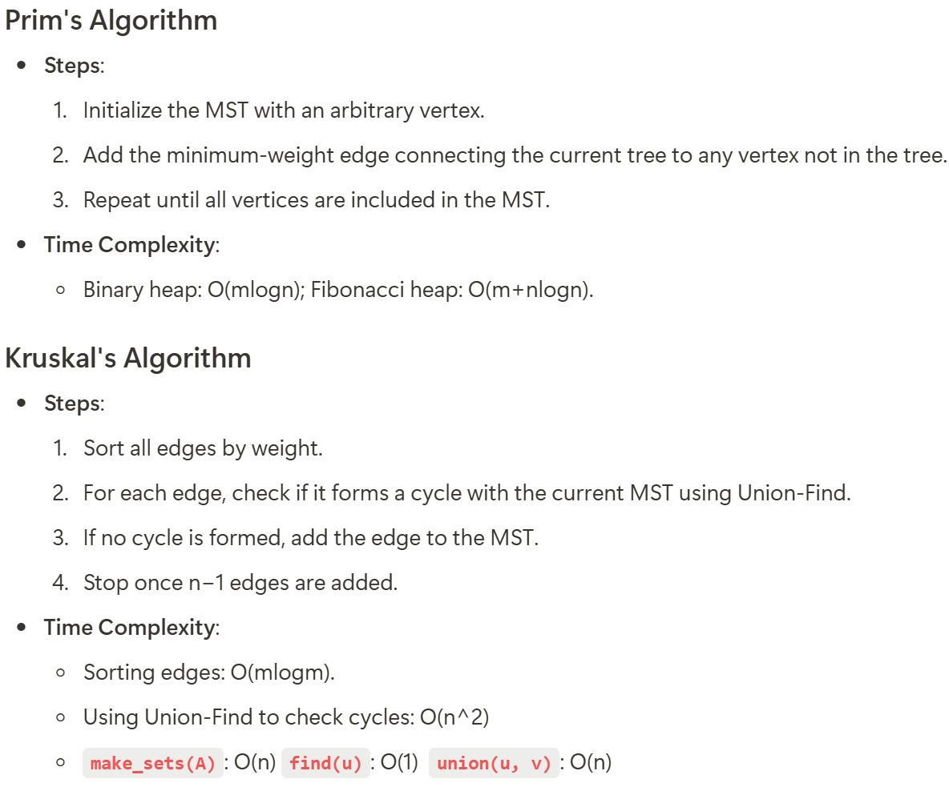
Running time of tree-based implementation of union-find is O(m a(n)) for m finds/union operations. a(n) is the Inverse Ackerman function. For α(n) to be larger than 4, you need n to be much larger than the number of subatomic particles in the universe, therefore it is a constant in practice.

9 -Greedy Algorithms
Greedy algorithm: always pick the best choice. Heuristic: benefit-to-weight ratio (bi/wi)

Allocating classrooms: Sort all lectures by increasing start time. Maintain a min-heap (priority queue) of end-times, one node per active classroom. For each lecture in start-time order, look at the earliest finishing classroom (the top of the heap): If that classroom is free (its finish time ≤ current lecture’s start time), assign the lecture there (pop and push the new finish time). Otherwise, allocate a new classroom (push its finish time). The heap size at the end is the total rooms needed. O(n log n)

Text compression(Huffman Coding): sort the frequency fi of all distinct symbols in text T in increasing order. Initialize a min priority queue Q containing every distinct symbol i as a singleton tree. In each iteration, pop two smallest subtrees fi and fj from Q, merge them f = fi + fj, put it back to Q. At the end, the last tree in Q is the desired encoding tree. O(n log n)
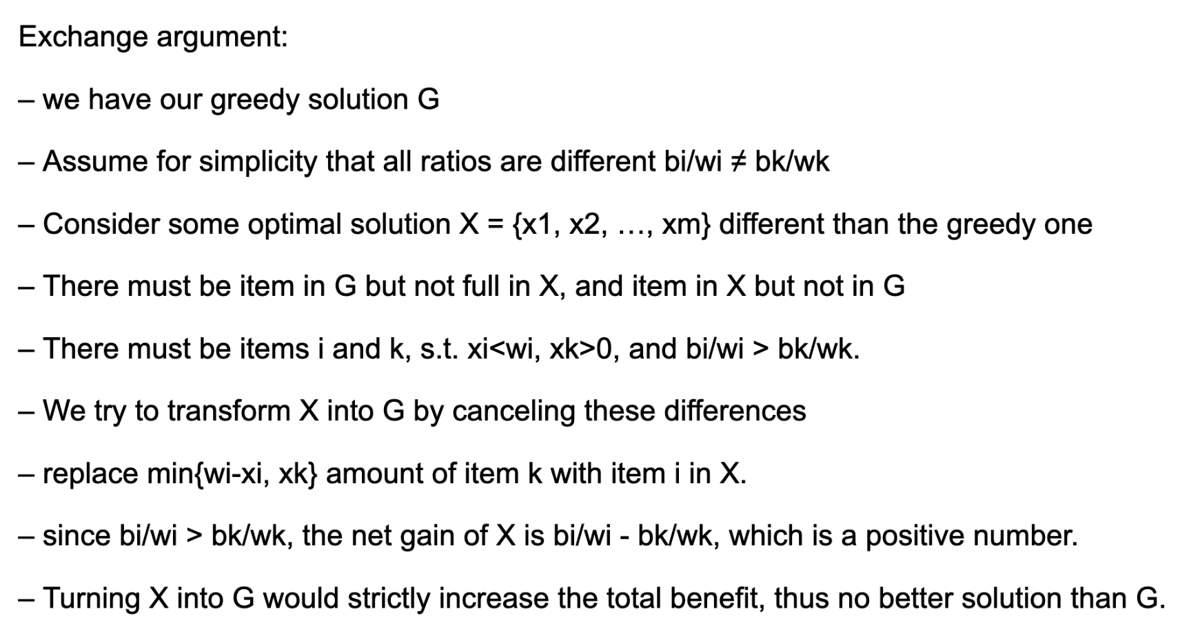

10 - Divide and Conquer I
Quick sort:
1. Choose a random element from the list as the pivot. Partition the elements into 3 lists:
(i) less than, (ii) equal to and (iii) greater than the pivot
2. Recursively sort the less than and greater than lists
3. Join the sorted 3 lists together

Harmonic number:
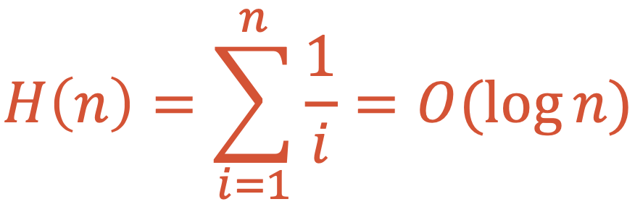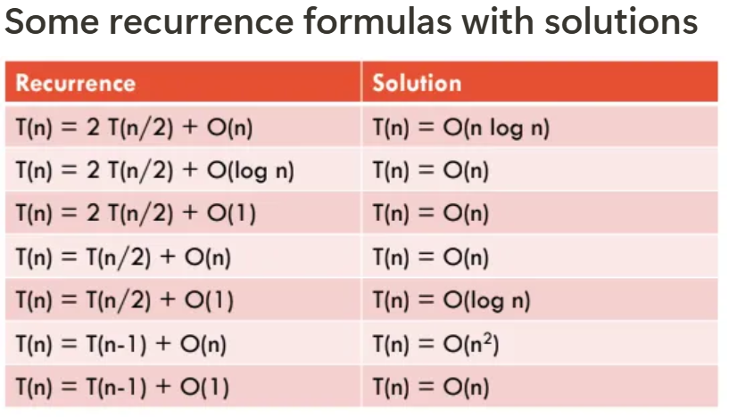
11 - Divide and Conquer II
Maxima-set algorithm
(Definition: A point is maximum in a set if all other points in the set have either a smaller x- or smaller y-coordinate.):
Recur each left and right MS from the base case.
1. Find the highest point p in the Right MS
2. Compare every point q in the Left MS to this point. If q.y > p.y, add q to the Merged MS
3. Add every point in the Right MS to the Merged MS

Geometric series:
Let r be positive real and k a positive integer:
If r > 1:
If r < 1:
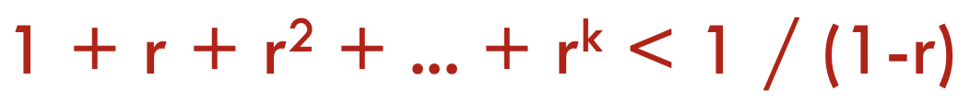
Change base Log rule:
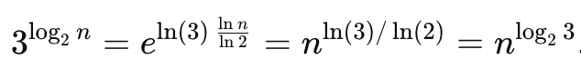
Unrolling:
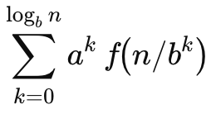
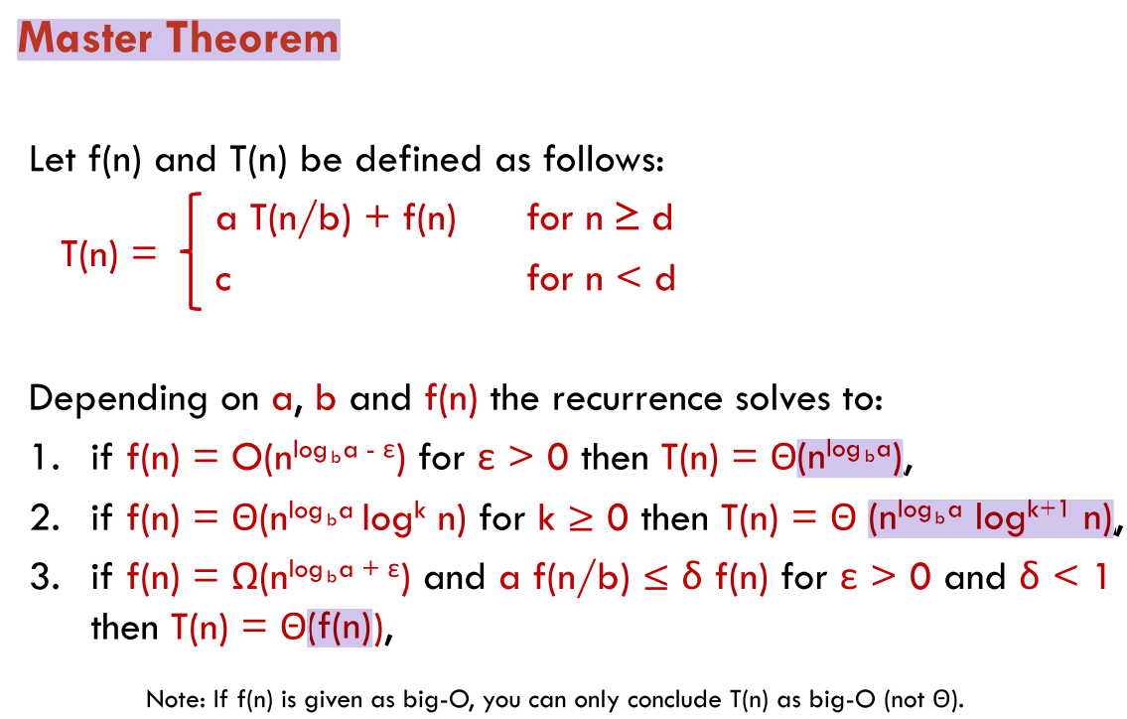

Find k^th smallest element in unsorted array A in O(n):

1. Divide find the median ( floor(𝑛/2) th element for simplicity) and split array on the halves, ≤ and > than the median
2. Recur
if k ≤ 𝑛/2: find k^th element on smaller half
if k > 𝑛/2: find (k- 𝑛/2 )th element on larger half
3. Conquer return value of the recursive call

Tree traversal

(pre-order)
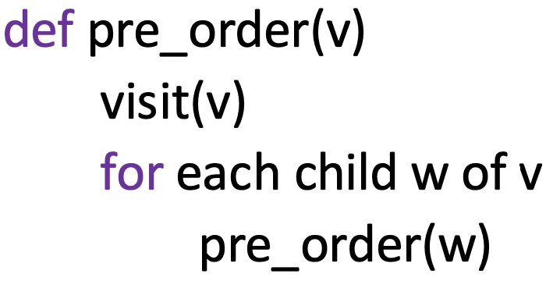

(post-order)
Useful when you need information from all subtrees before handling the parent
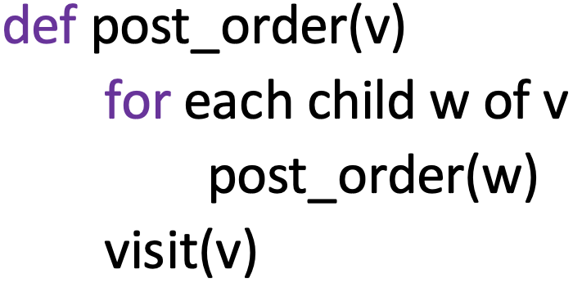

(inorder - for binary tree)
