Conclusion

1 - Set Theory

Set
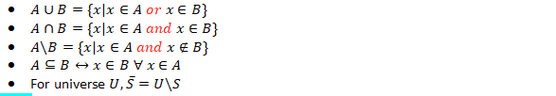
*complement of S -> U\S

Double Containment Proof
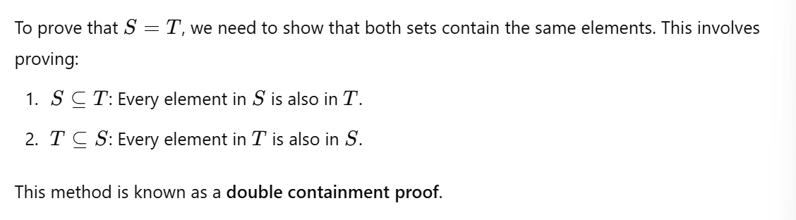

2 - Sets, Functions and Sequences

Cartesian Product of Sets
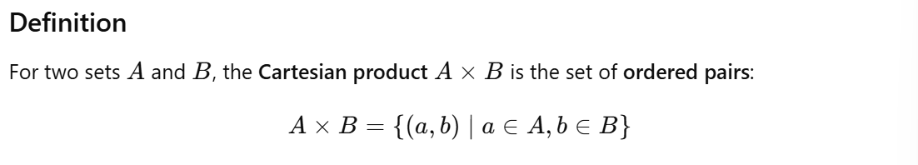
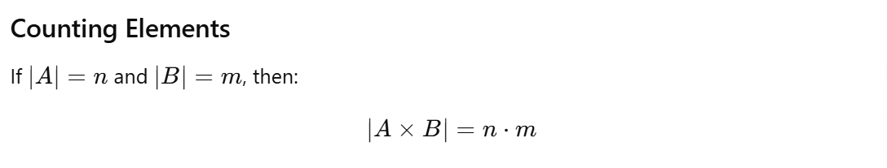

Function Terminology
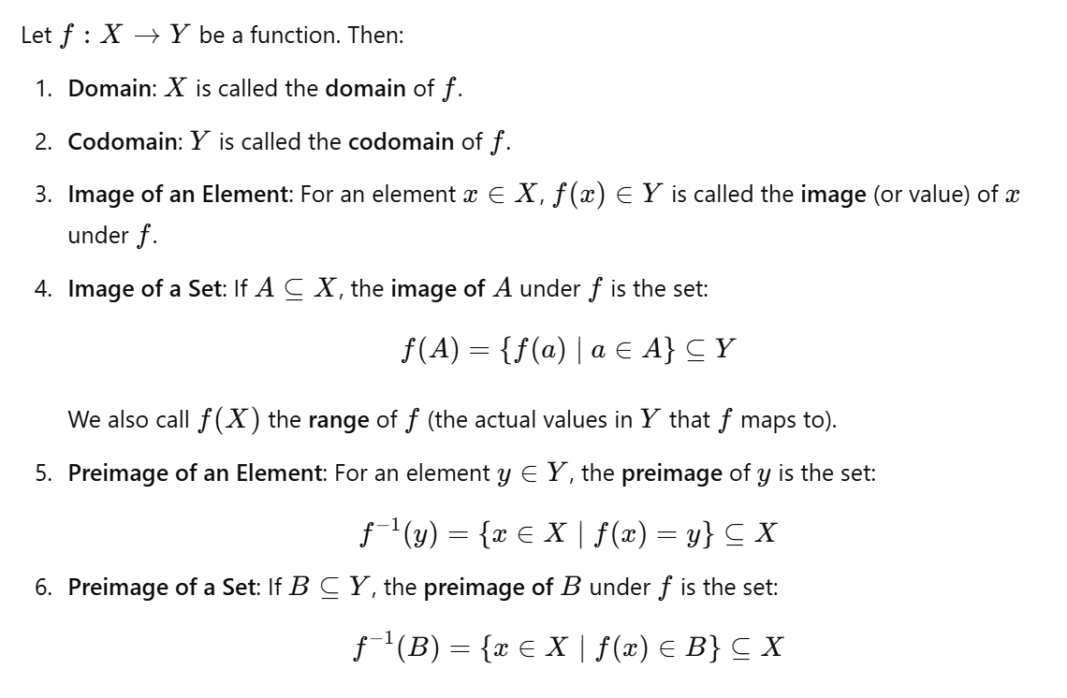

Types of Functions
- Surjective (Onto) Functions
- Injective (One-to-One) Functions
- 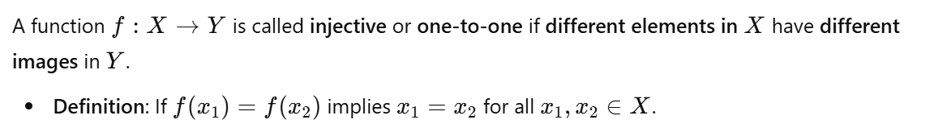
- Bijective (One-to-One Correspondence) Function
- 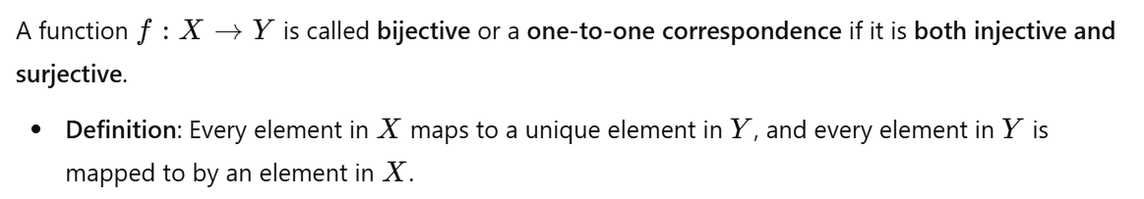

Proving or Disproving Properties of f: X→Y
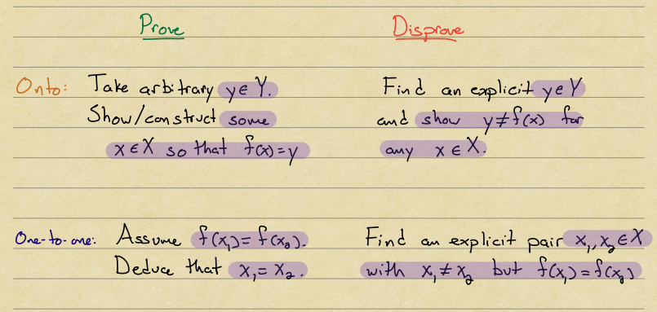

Functions and Finite Sets
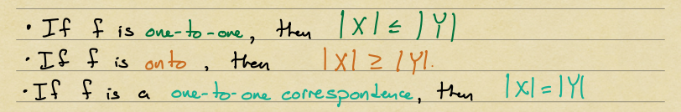

3 - Divisibility, Prime numbers, Euclidean Algorithm

Divisibility Definition
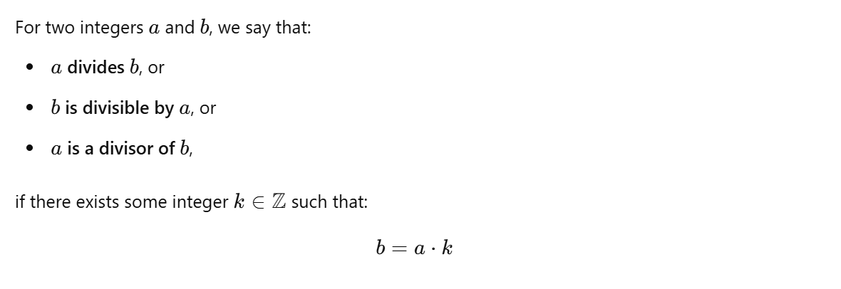

Quotient Remainder Theorem
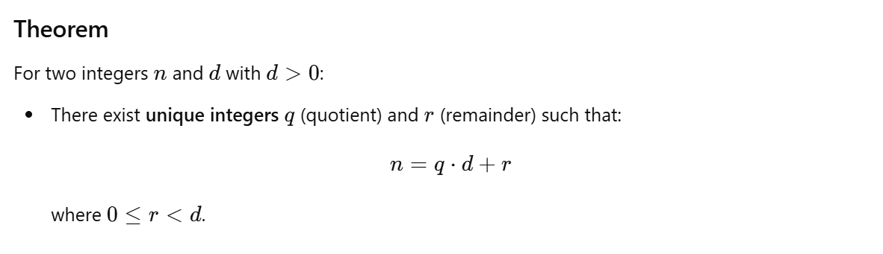

Modular Arithmetic
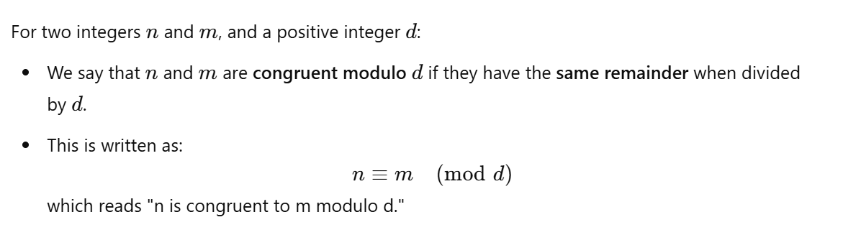
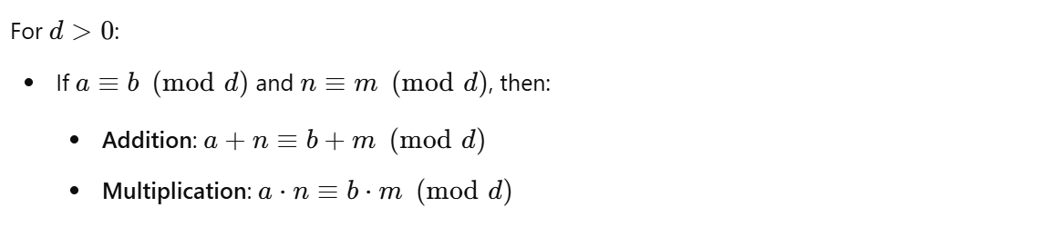

Fundamental Theorem of Arithmetic (FTA)
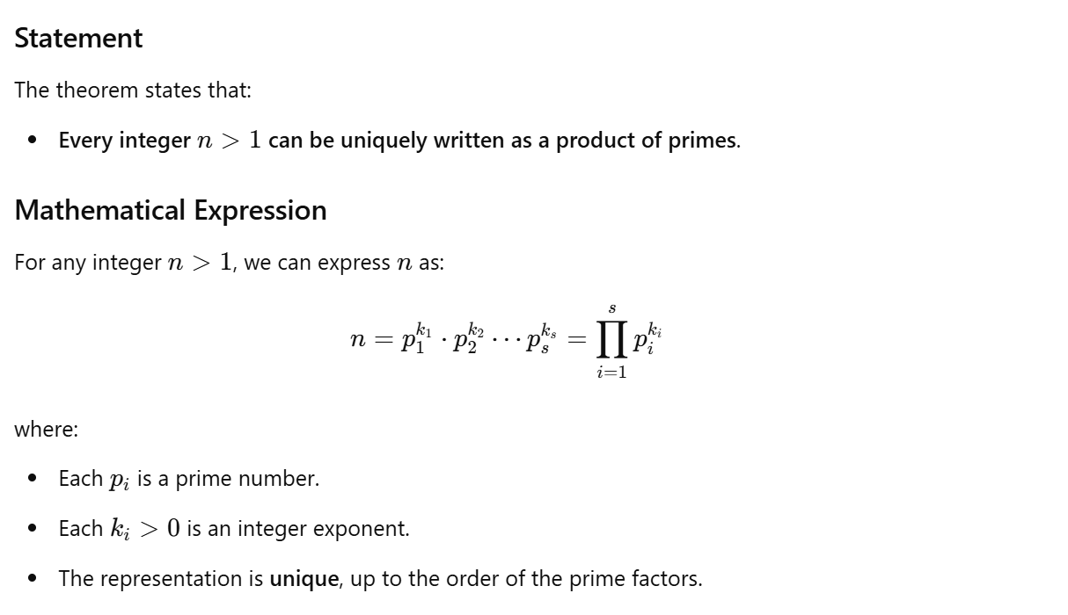

Greatest Common Divisor (GCD)
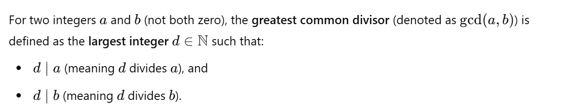

Least Common Multiple (LCM)
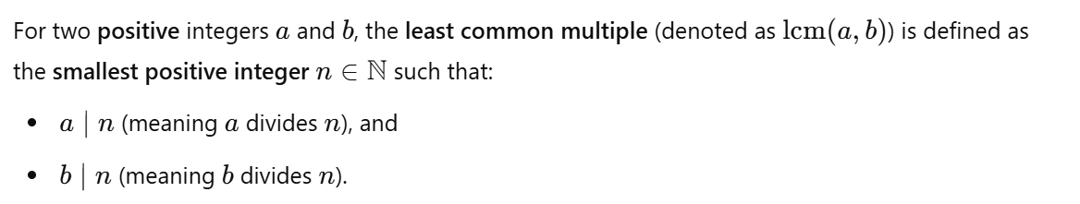

Euclidean Algorithm
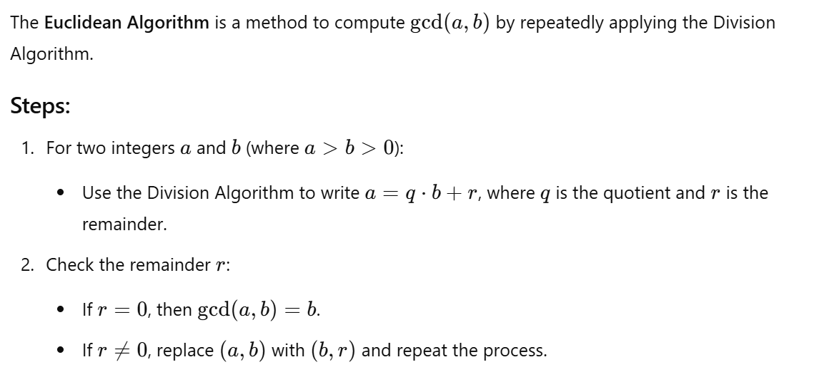
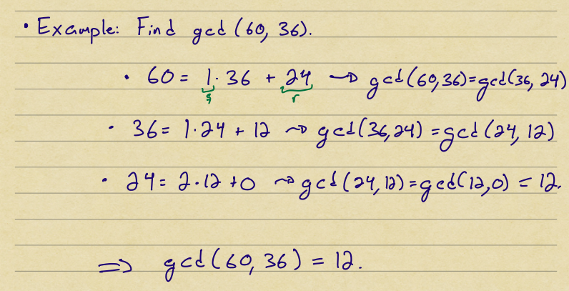

Base b Expansions
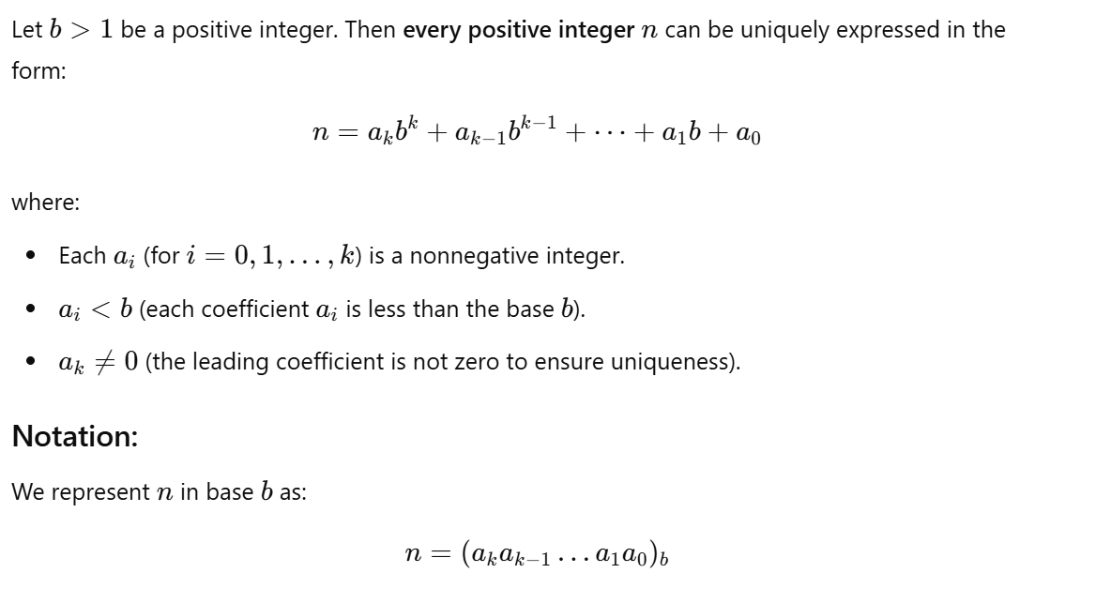
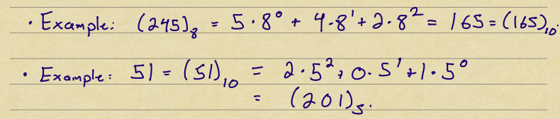
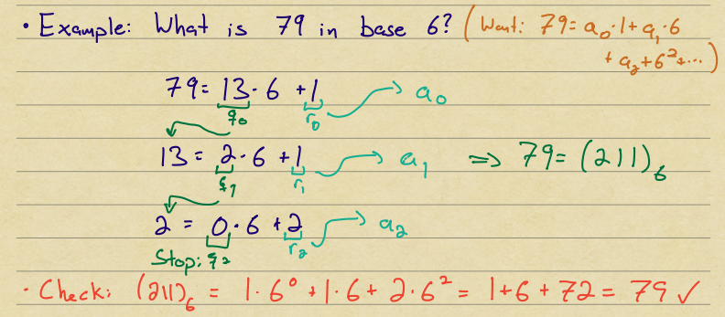
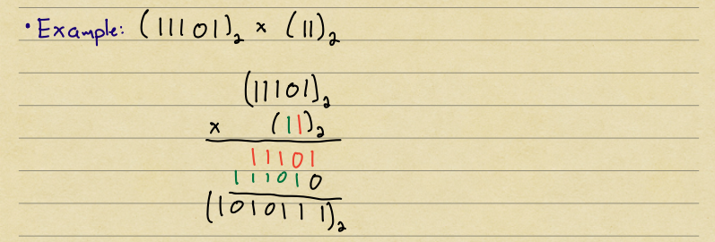

4 - Counting, choosing k items from n

Summary
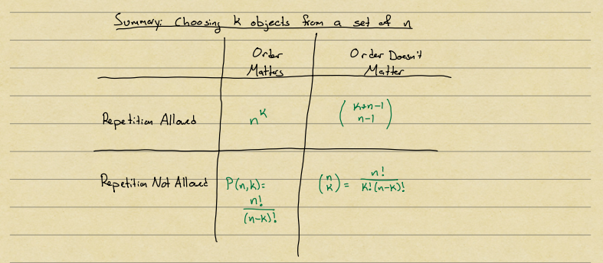

5 - Binomial Theorem, Inclusion-Exclusion and Catalan numbers

Inclusion-Exclusion principle

Pigeonhole Principle


Proof
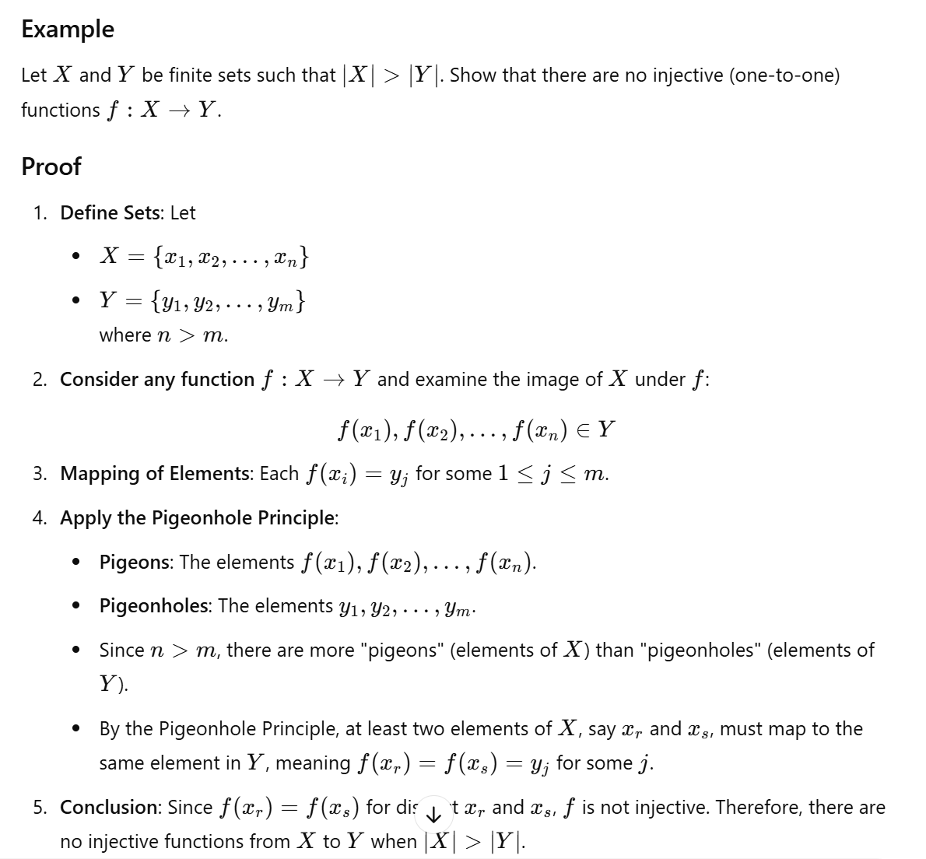

The Binomial Theorem
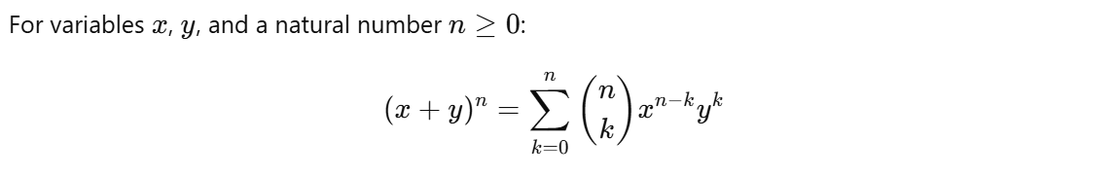

Pascal's Identity
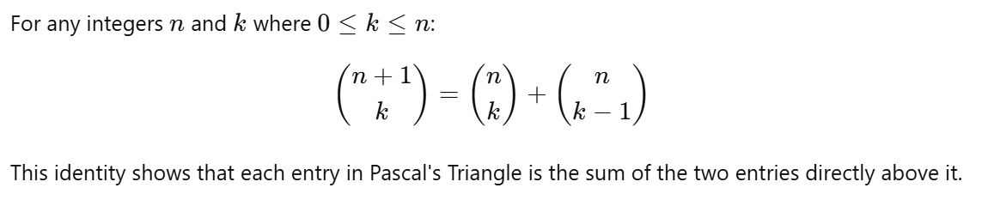

Catalan Numbers
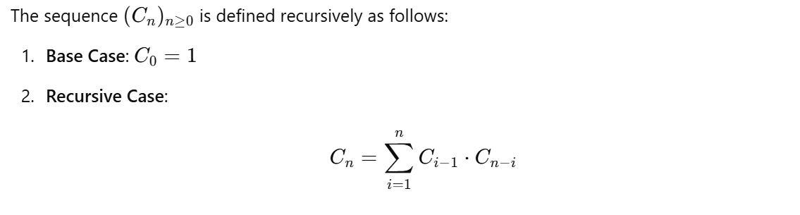


Proof

6: Probability

Distributions of Random Variables
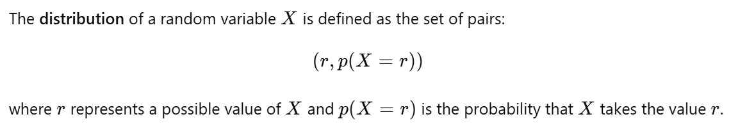

Conditional Probability


Independent Events
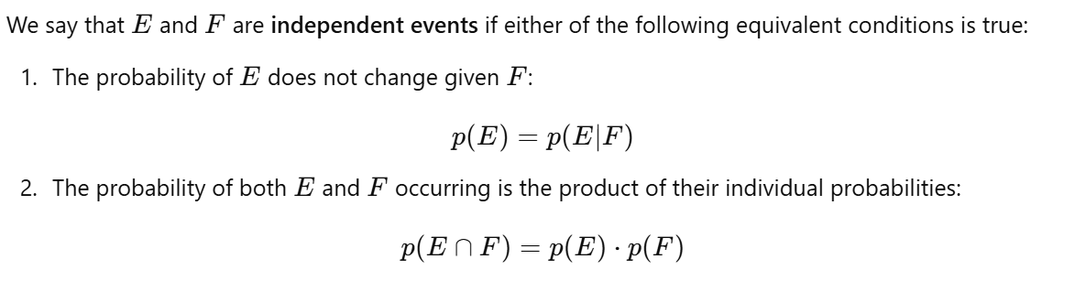

Complementary Events
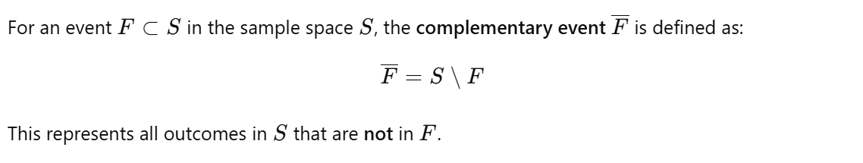

Bayes' Theorem (in cheatsheet)


Expected Value


Variance




Standard Deviation
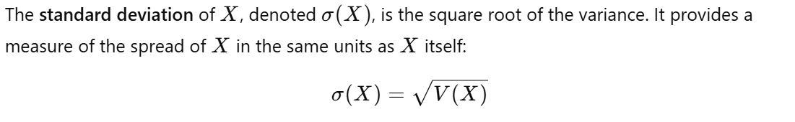

Properties for Independent Random Variables
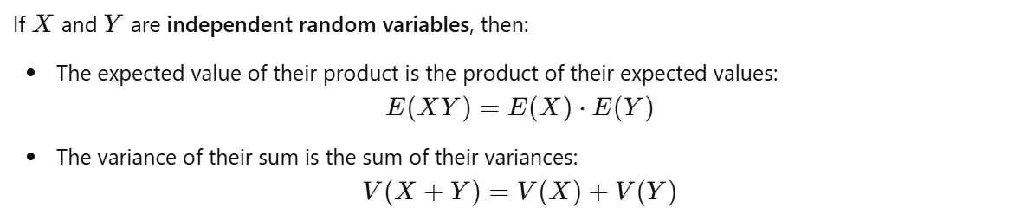

7 - Basics on Graph Theory

Simple Graph
A simple graph is a graph that has no loops (edges connecting a vertex to itself) and no parallel edges (multiple edges connecting the same pair of vertices).

Degrees of Vertices

Incidence

Adjacency


Handshake Theorem
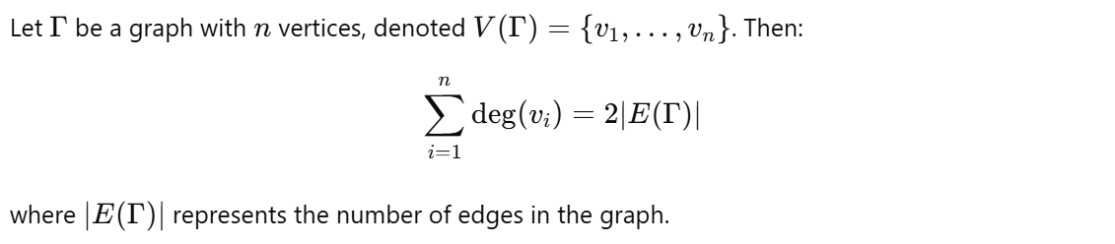

Corollary
For any graph Γ, there must be an even number of vertices with odd degree.

Directed Graphs

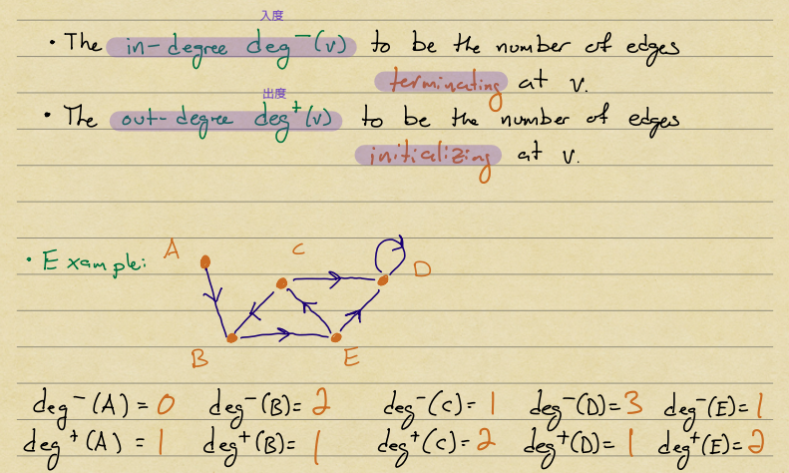

Handshake Theorem for Directed Graphs


Complete graphs
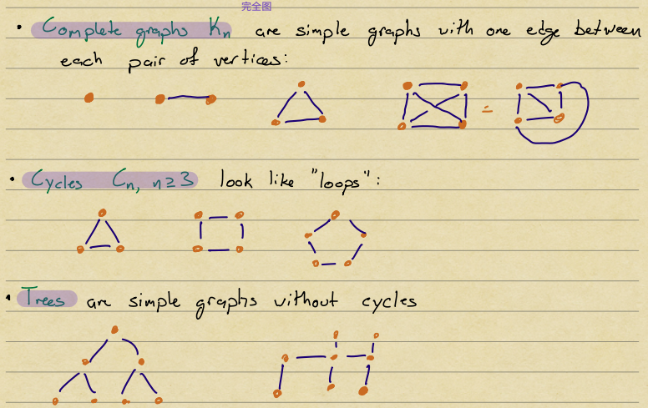

Euler Circuit
A path of nonzero length (having at least one edge) is called:
- Simple: if it does not repeat any edge. 每条边恰好一次
- Circuit: if it begins and ends at the same vertex. 闭合路径
- Euler Circuit: if it is a simple circuit that contains every edge of the graph.
Let Γ be a connected graph. Then Γ has an Euler circuit if and only if every vertex has an even degree.

Isomorphic Graphs
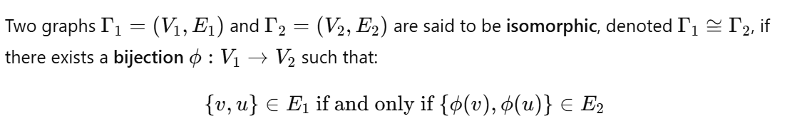
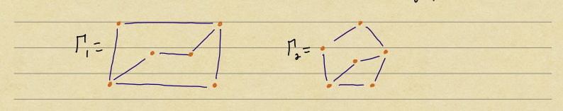

Graph Invariants
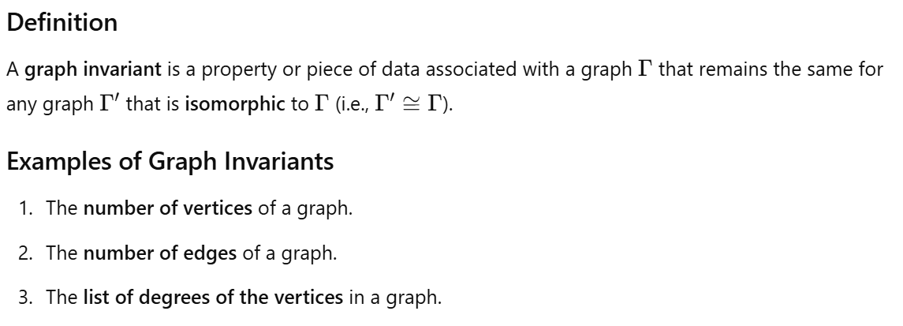

Adjacency Matrices
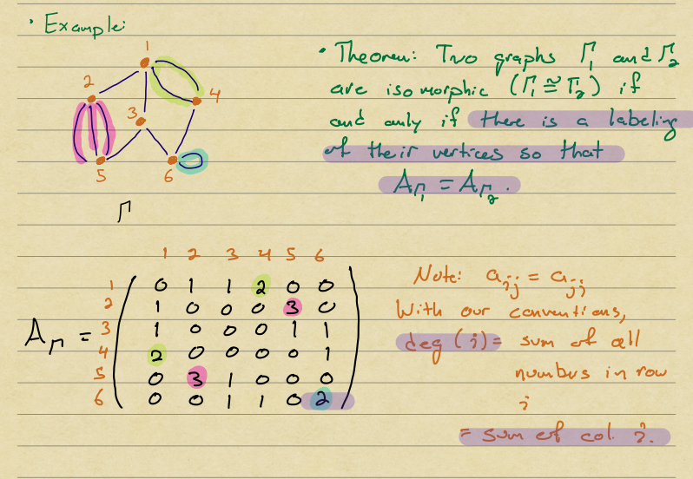

Path on Graphs
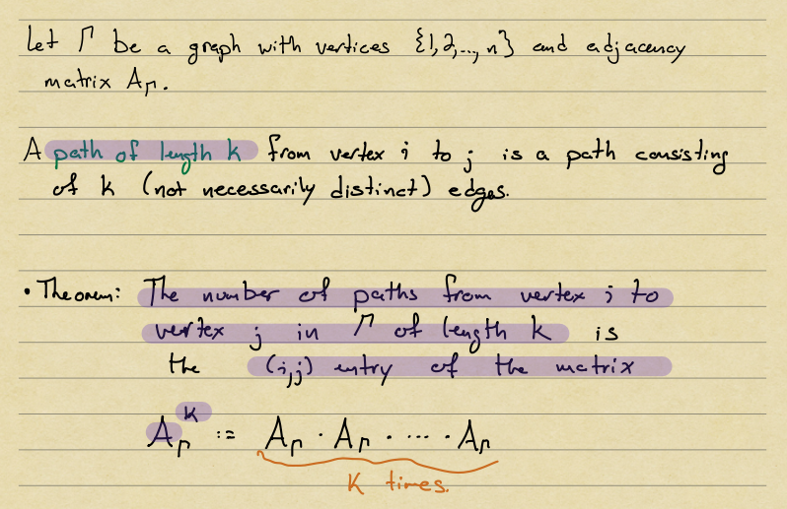
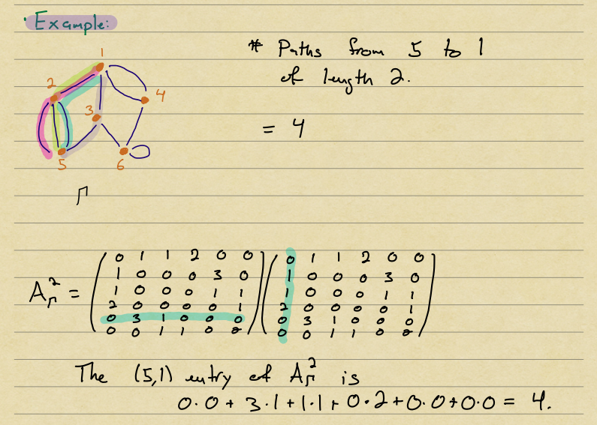

8 - Equivalence Relations, Closures

Relation
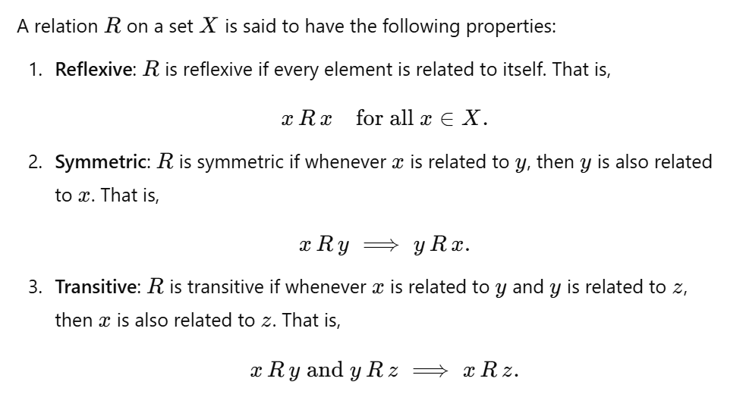

Equivalence Class
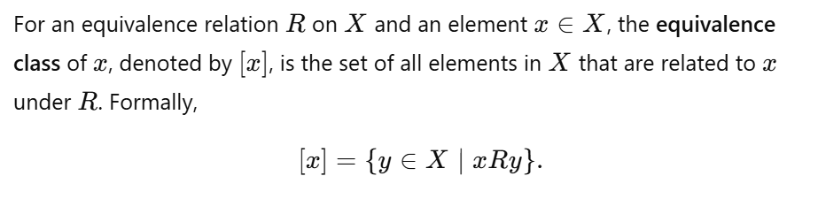

Complementary Relation (not important)
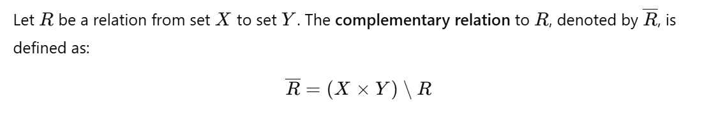

Composition of Relations (not important)
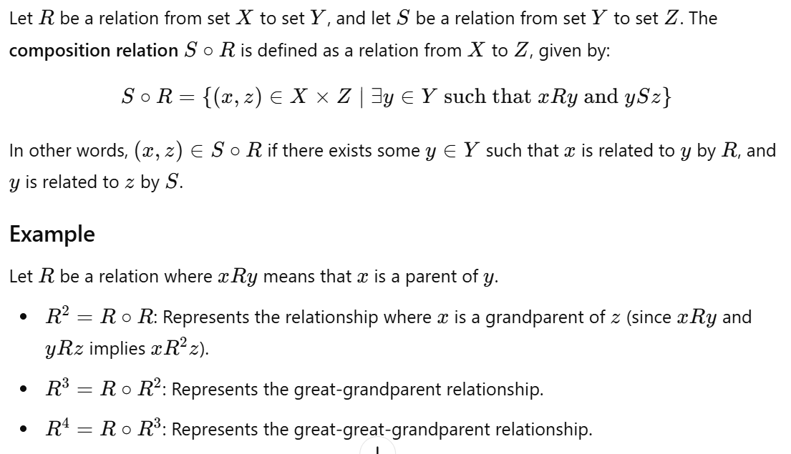
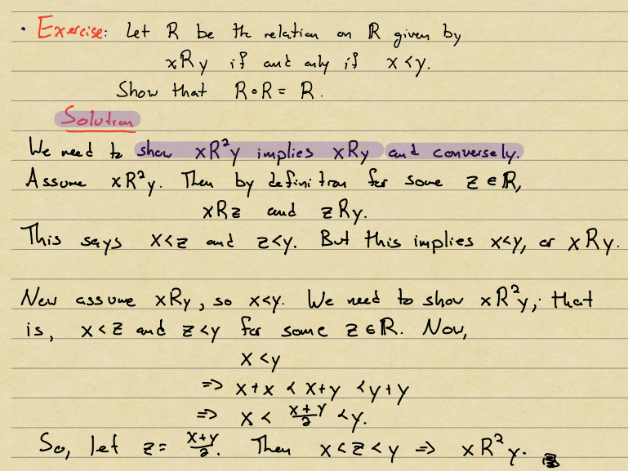

Partitions of Sets
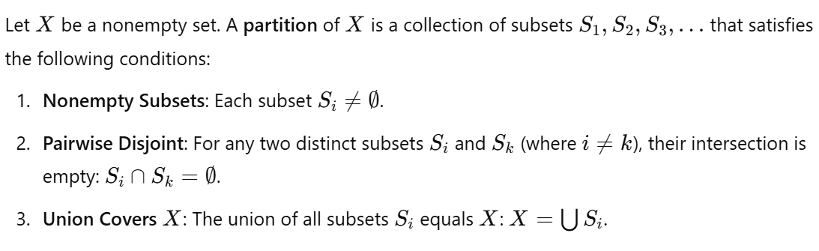
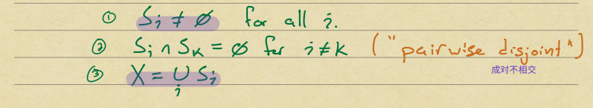
*Z = S1 U S2 U S3

Equivalence Classes and Partitions
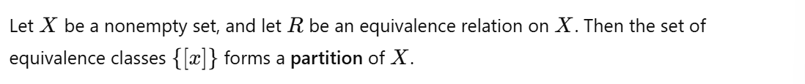
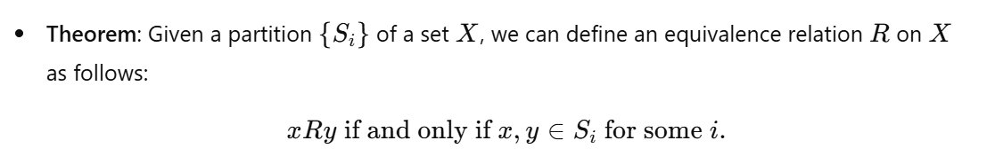

Anti-Symmetric
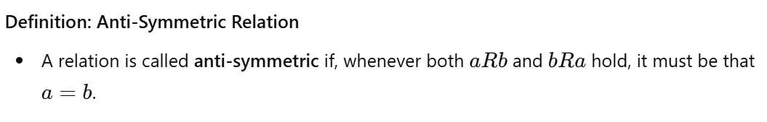

Partial Order
- Reflexive
- Anti-symmetric
- Transitive
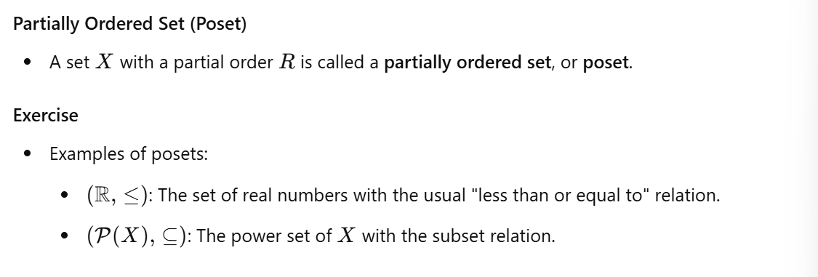

Total Order
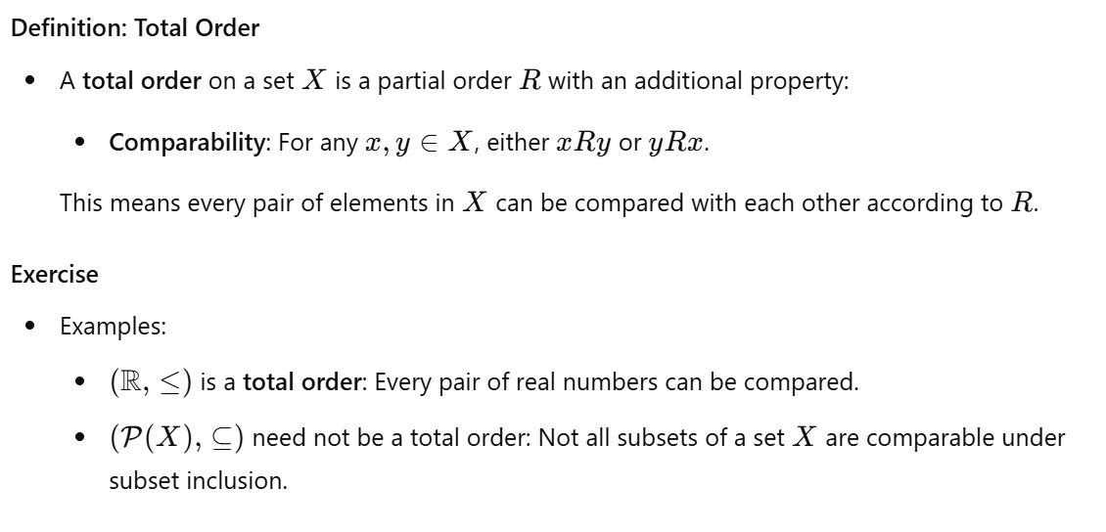

Reflexive Closure
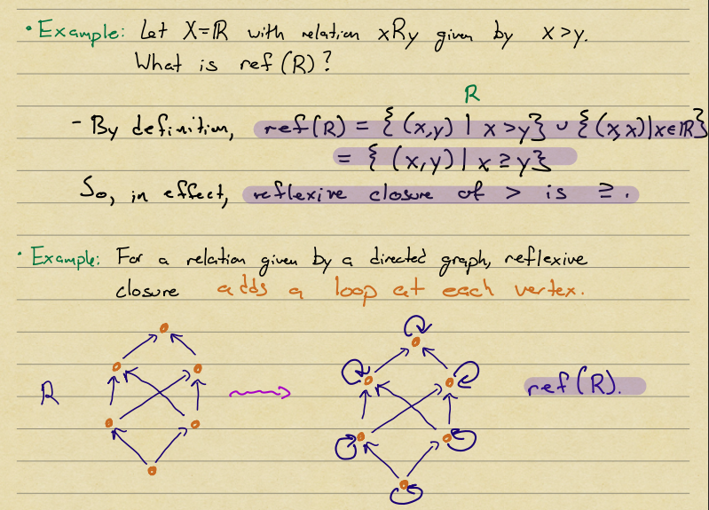

Symmetric Closure
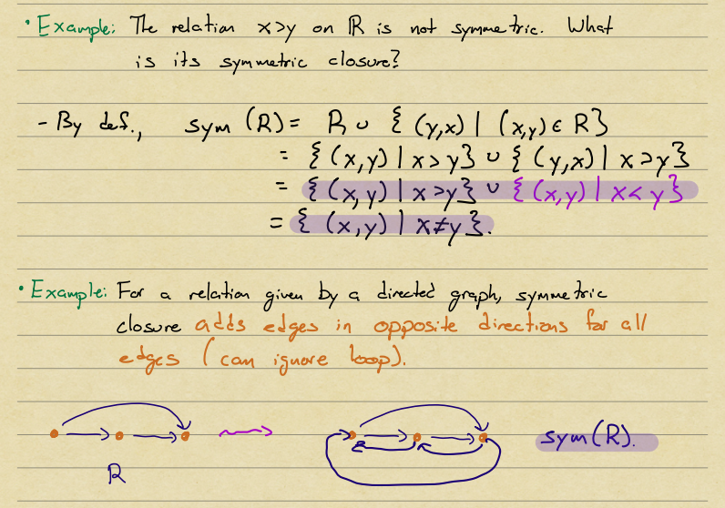

Transitive Closure
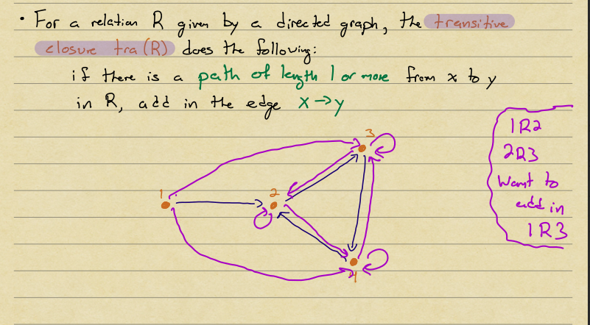

Connectivity Relation
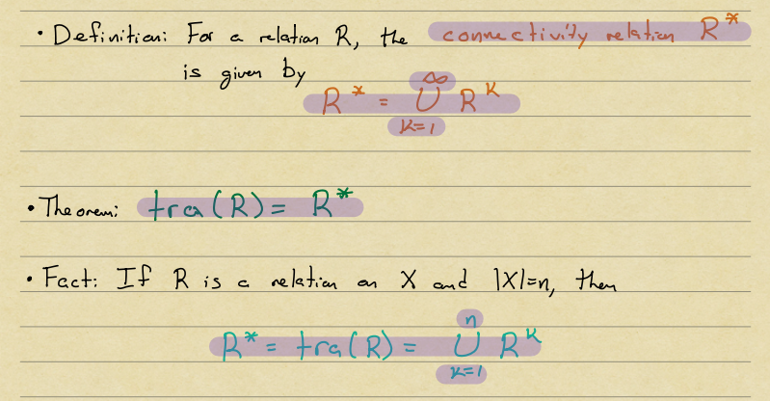

9 - Propositional Logic

Negation, Conjunction, Disjunction
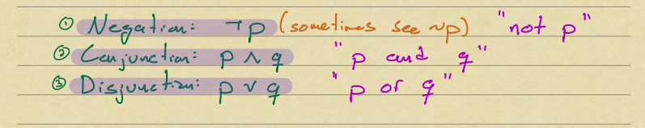


Contradictions and Tautologies
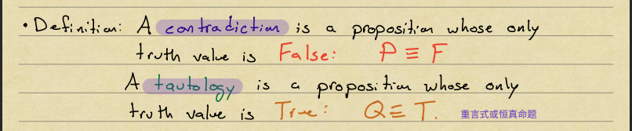

Conditionals
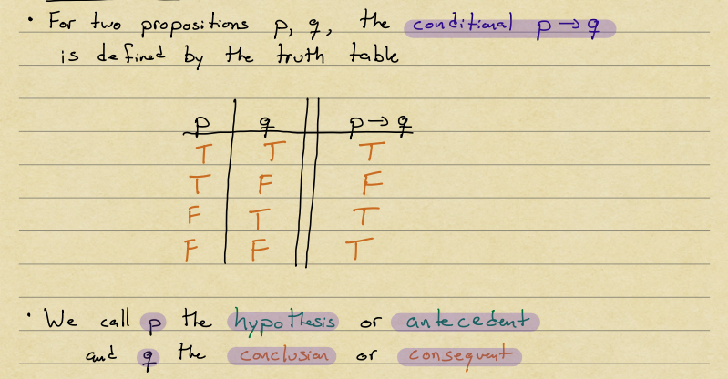

Constructions on Conditionals
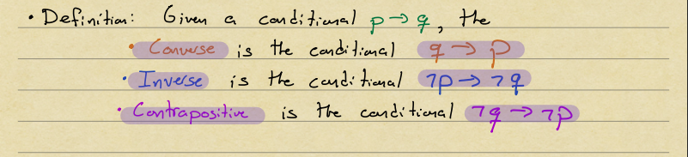

Biconditional
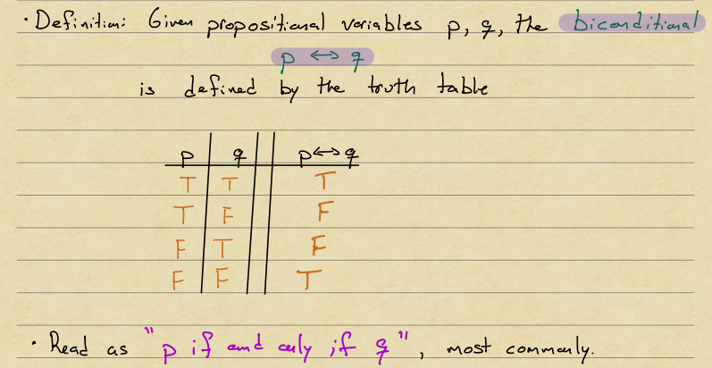

Satisfiability
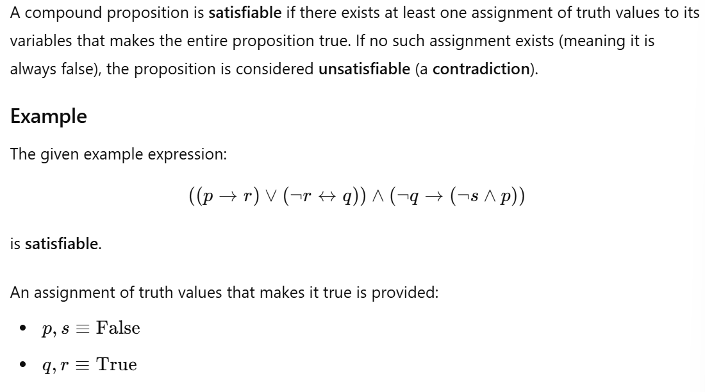

Predicates
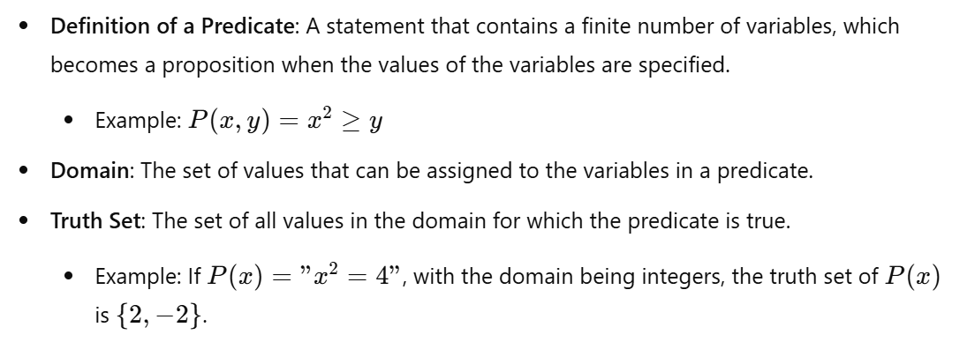

Universal quantifier

Existential quantifier

Negating Multiple Quantifiers
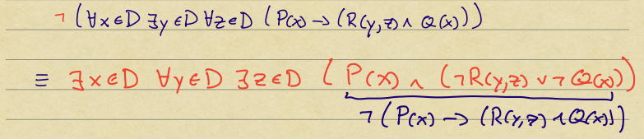

Valid and Invalid Arguments
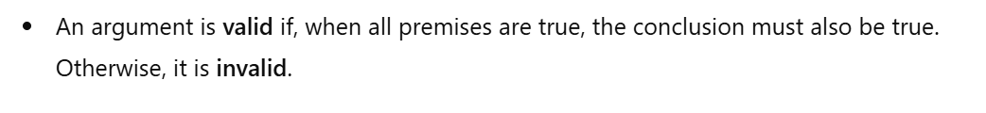

10 - Quantifiers, Predicates, and Proofs

Basic Logical Inferences
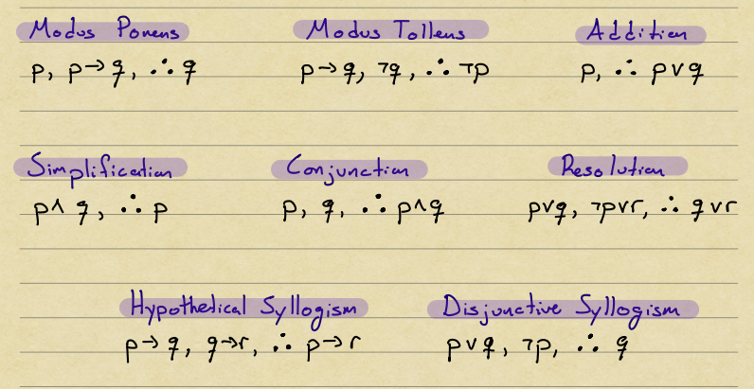
*Premise

Logical Inferences for Quantifiers
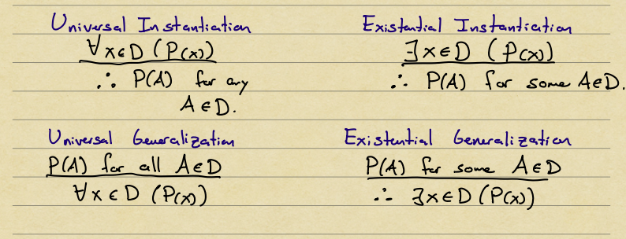

Direct Proof

Proof by Contrapositive
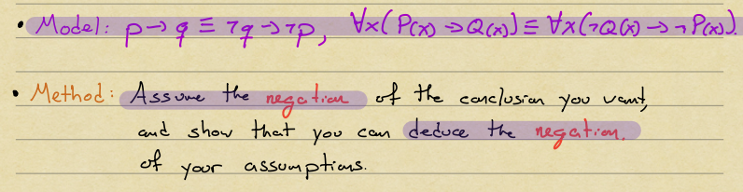
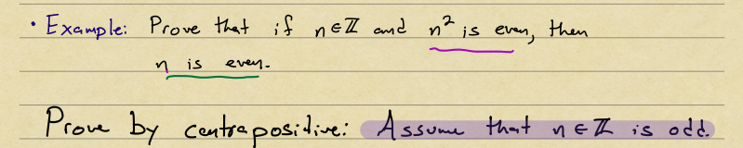

Proof by Contradiction
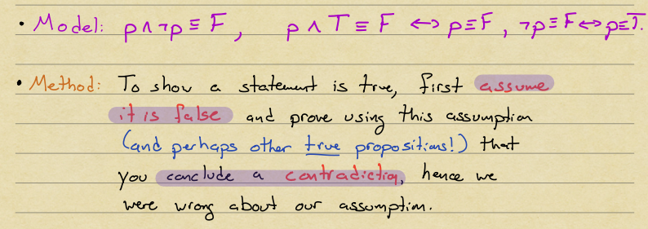
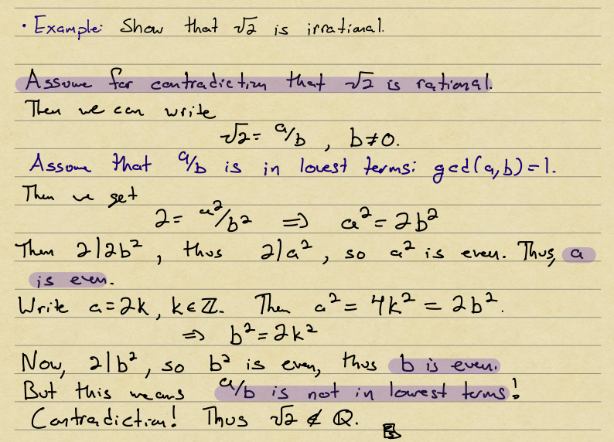

11 - Induction, Recursion, and O-notation

Induction Example
Base case: for ...
Inductive step: Assume ... Then...
Conclude: Thus..., by induction

Strong Induction
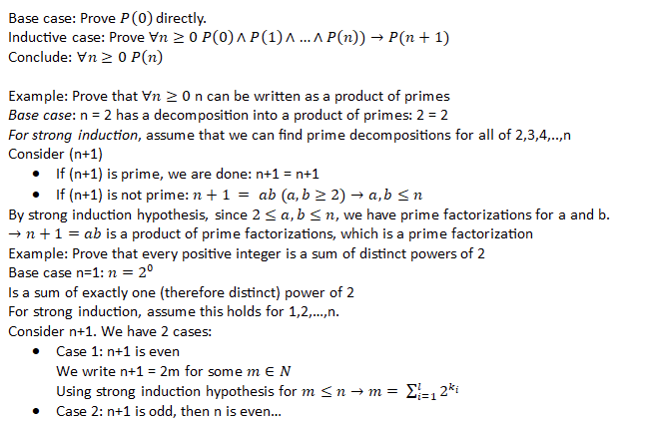

Big-O Notation
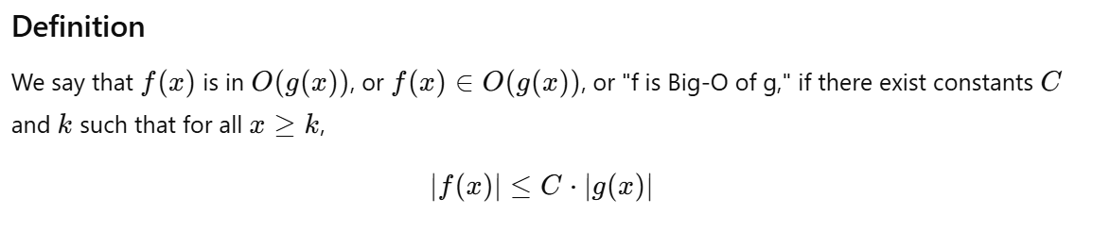

12 - Running times, Complexity Theory, and Models of Computations
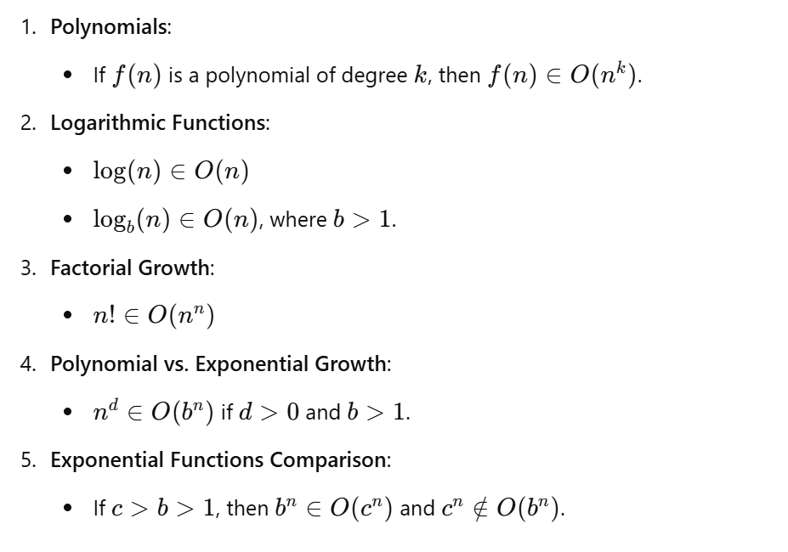

Phrase-Structure Grammar
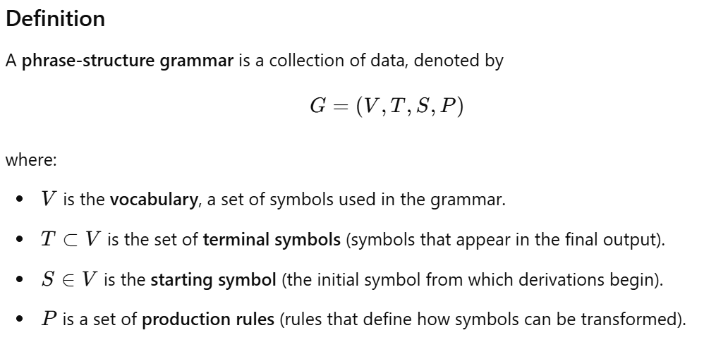

Finite-State Machine
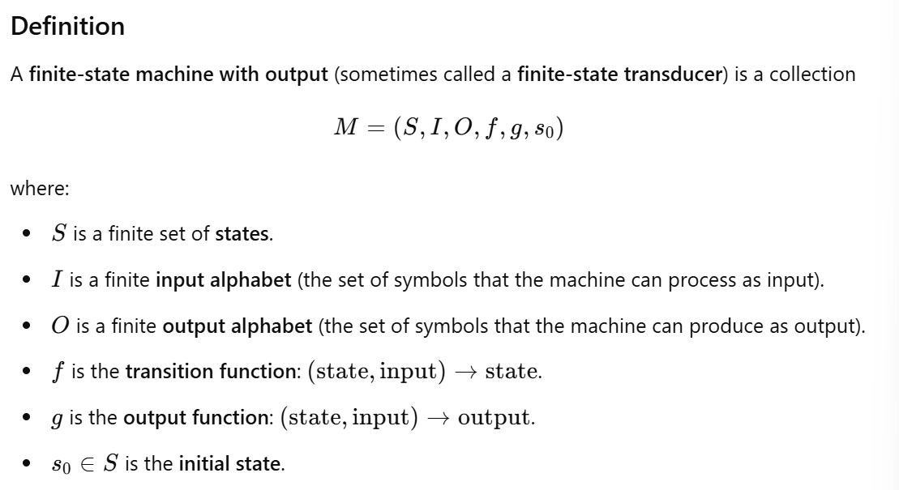

State Diagrams
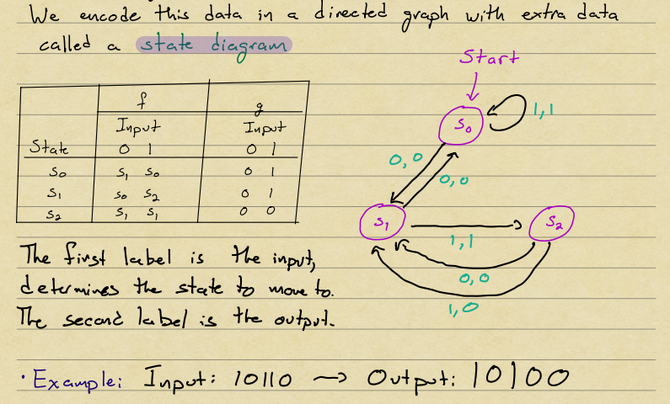
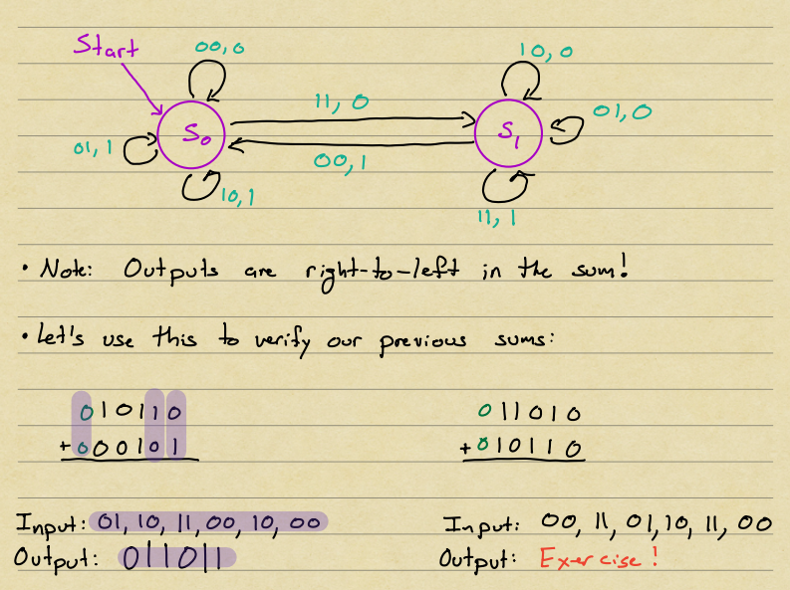

13 - Finite State Automata and Regular Languages

Finite-state Automaton
