**(a) Describe the three primary cloud service models in cloud computing: Infrastructure as a Service (IaaS), Platform as a Service (PaaS), and Software as a Service (SaaS). Provide specific examples of how each model can be applied in the context of software development.**

1. Infrastructure as a Service (IaaS):

IaaS provides the basic infrastructure on which you can build your applications, including virtual machines, storage, networking, and other fundamental resources. With IaaS, users have control over the operating system, applications, and middleware, but do not need to manage the underlying hardware.

Examples in Software Development:

AWS EC2: You can rent virtual machines to run your development and production environments.

Google Compute Engine: Provides virtual servers where you can install and configure the software stack required for your development needs.

Application Example:

A software development team can use IaaS to set up their development environments, ensuring they have consistent environments for testing, building, and deploying their applications without needing to invest in physical hardware. Developers can also scale resources based on project requirements.

2. Platform as a Service (PaaS):

PaaS is a cloud computing service model that provides a platform allowing customers to develop, run, and manage applications without dealing with the complexity of infrastructure management. It includes hardware, operating systems, and middleware for application development.

Examples in Software Development:

Google App Engine: A platform where you can deploy web applications without worrying about the underlying infrastructure.

Microsoft Azure App Services: Allows developers to deploy web applications or APIs without managing the infrastructure.

Application Example:

A team of developers can use PaaS to build and deploy applications more efficiently. For instance, they can focus on coding without worrying about servers, load balancing, or scaling, which are automatically managed by the platform.

3. Software as a Service (SaaS):

SaaS delivers fully functional applications through the internet, which users can access without having to worry about installation, maintenance, or infrastructure management. These applications are hosted and managed by the service provider.

Examples in Software Development:

GitHub: A SaaS for version control and code collaboration that hosts repositories and provides features like pull requests, issue tracking, and CI/CD pipelines.

Jira: A project management tool for tracking and managing software development tasks, bugs, and workflows.

Application Example:

In a software development context, teams can use SaaS applications like GitHub for source code management, Jira for issue tracking, and Slack for team communication. These services simplify collaboration and reduce the burden of infrastructure management.

**(b) What is Docker? Describe a scenario where you would use containerization technologies such as Docker in software development. How does containerization contribute to the development and deployment process of software in this scenario?**

What is Docker?

Docker is an open-source platform that automates the deployment, scaling, and management of applications in lightweight, portable containers. Containers package the application and its dependencies, ensuring consistency across different environments (development, staging, production) regardless of the underlying infrastructure.

Scenario for Using Docker in Software Development:

Suppose you are developing a web application that relies on a specific version of a web framework, a particular database, and other system dependencies. Without Docker, developers may face issues with compatibility when transitioning the application between development and production environments.

How Docker Contributes to the Development and Deployment Process:

Environment Consistency: By using Docker, the application and all its dependencies are packaged together in a container. This ensures that it behaves the same way on the developer’s local machine, staging servers, and production systems.

Isolation: Docker containers isolate the application from the host system, reducing conflicts between dependencies and allowing developers to run multiple applications with different environments on the same machine.

Easy Deployment: With Docker, you can easily deploy applications by using the same Docker images across various stages of the deployment pipeline (testing, staging, production). The image used for development will be identical to the one used in production.

Scalability: Docker allows easy scaling of applications. You can quickly create multiple containers of the same application, enabling horizontal scaling.

Example:

You are working on a microservices-based application with several services running in separate containers. For example, one container might run the frontend (React), another runs the backend (Node.js), and another runs the database (MySQL). Docker makes it easy to develop and deploy these services consistently across different environments.

**(c) Deploy n8n (n8n.io) with Docker and capture a screenshot of http://127.0.0.1:5678. Please explain the Docker command in detail.**



Explanation of the Docker Command:

docker run: This is the Docker command to start a container.

-d: This flag runs the container in detached mode, meaning it runs in the background.

-p 5678:5678: This flag maps port 5678 on the host machine to port 5678 on the Docker container. It means you can access the n8n interface by going to http://127.0.0.1:5678 on your web browser.

--name n8n: This assigns the name n8n to the container for easy reference.

n8nio/n8n: This is the official Docker image for n8n.

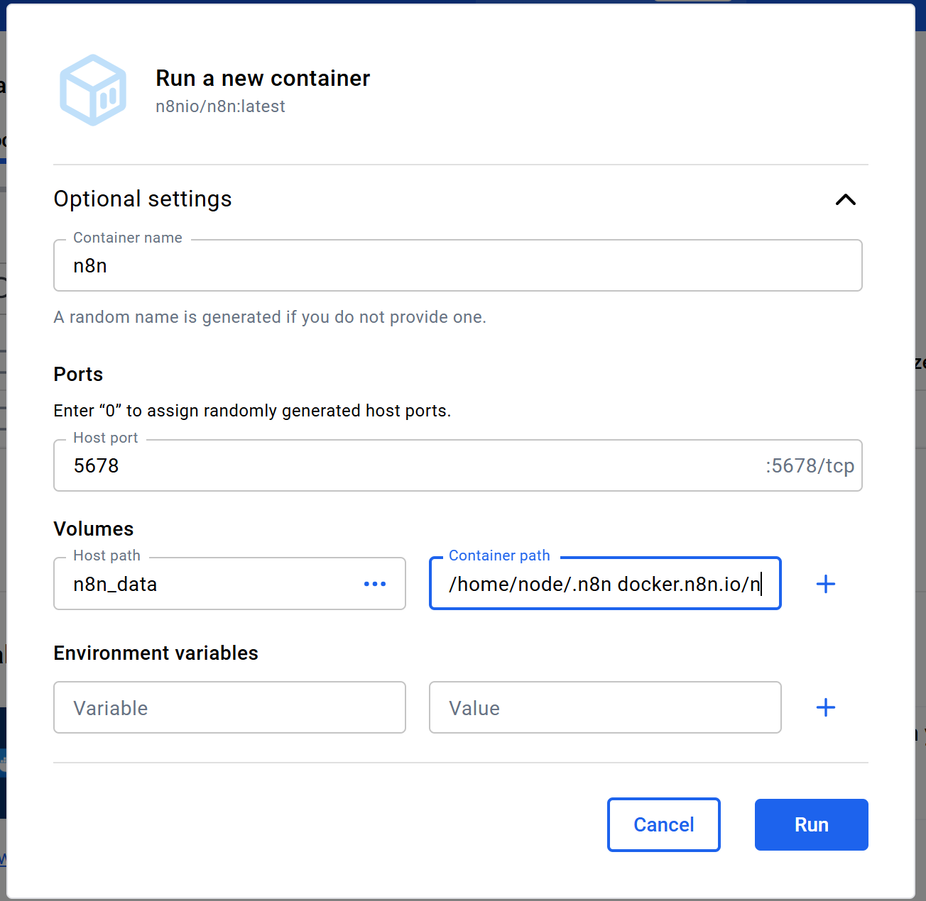

The screenshot of http://127.0.0.1:5678:

