- Hello-minikube
- Create a minikube cluster
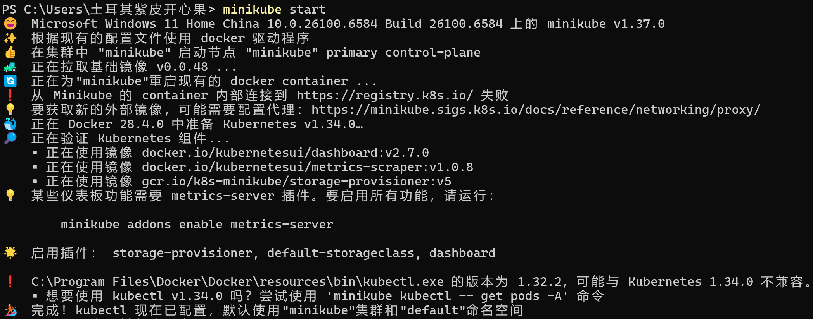
- Open the Dashboard
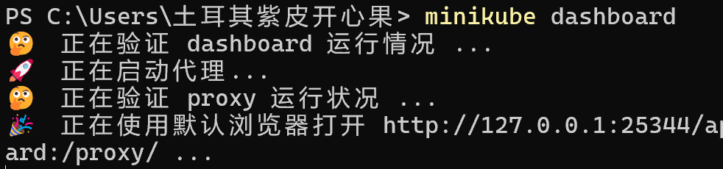
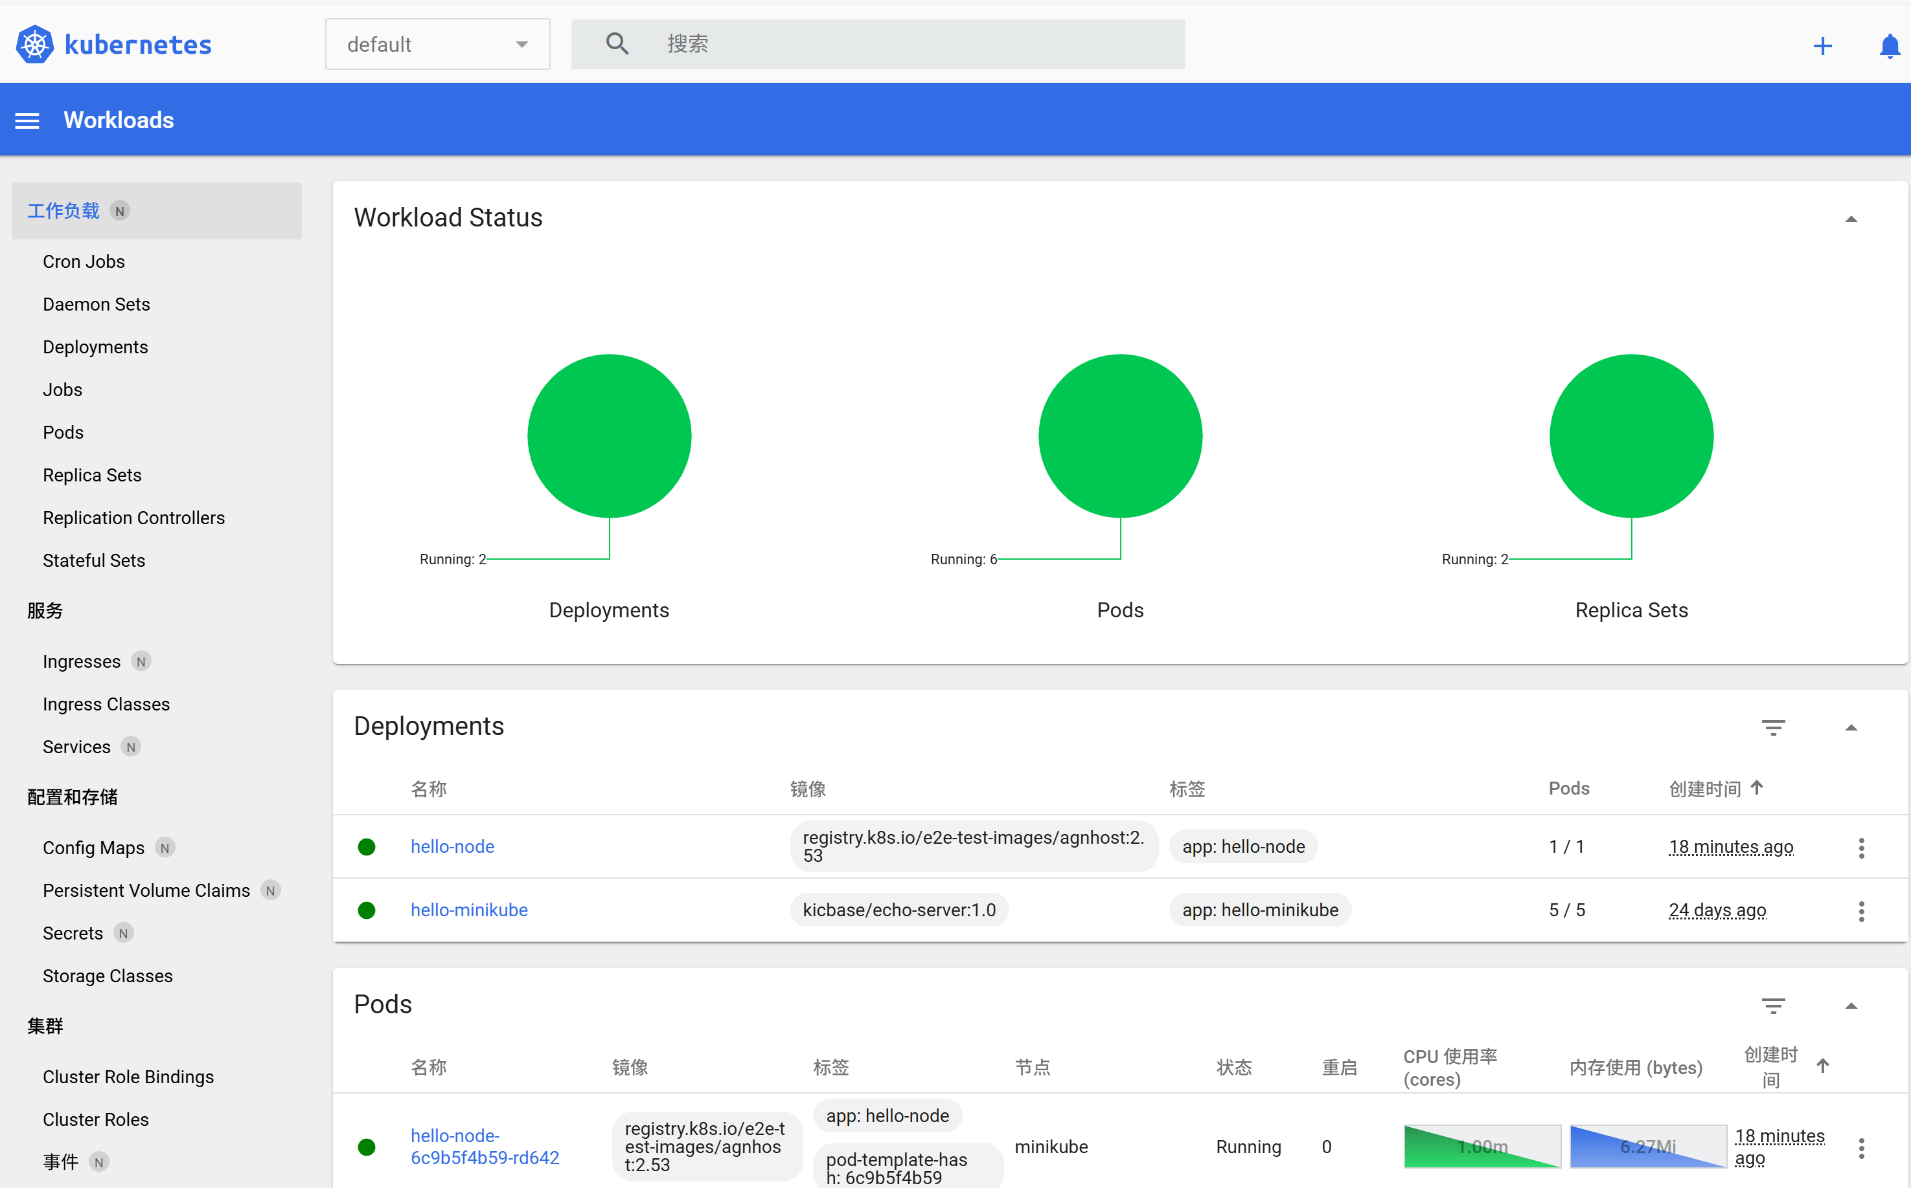
- Create a Deployment
3.1Use the kubectl create command to create a Deployment that manages a Pod.
3.2View the Deployment
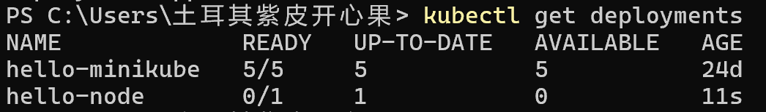
3.3View the Pod
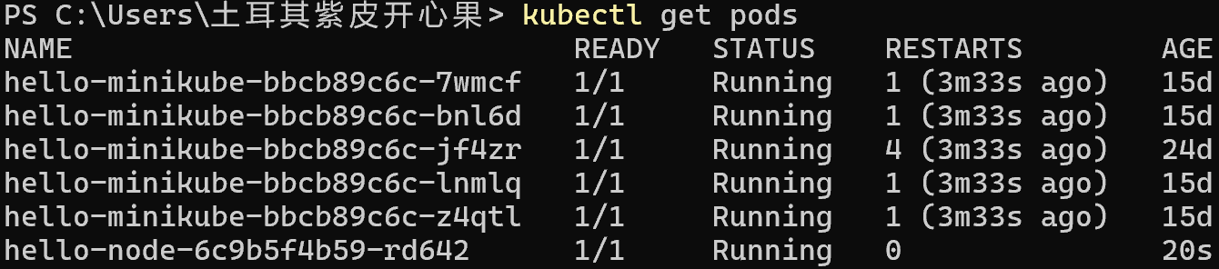
3.4View cluster events
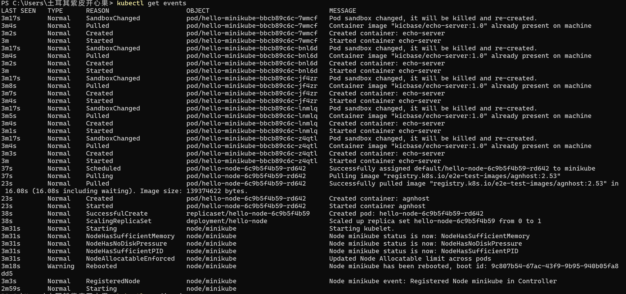
3.5View the kubectl configuration
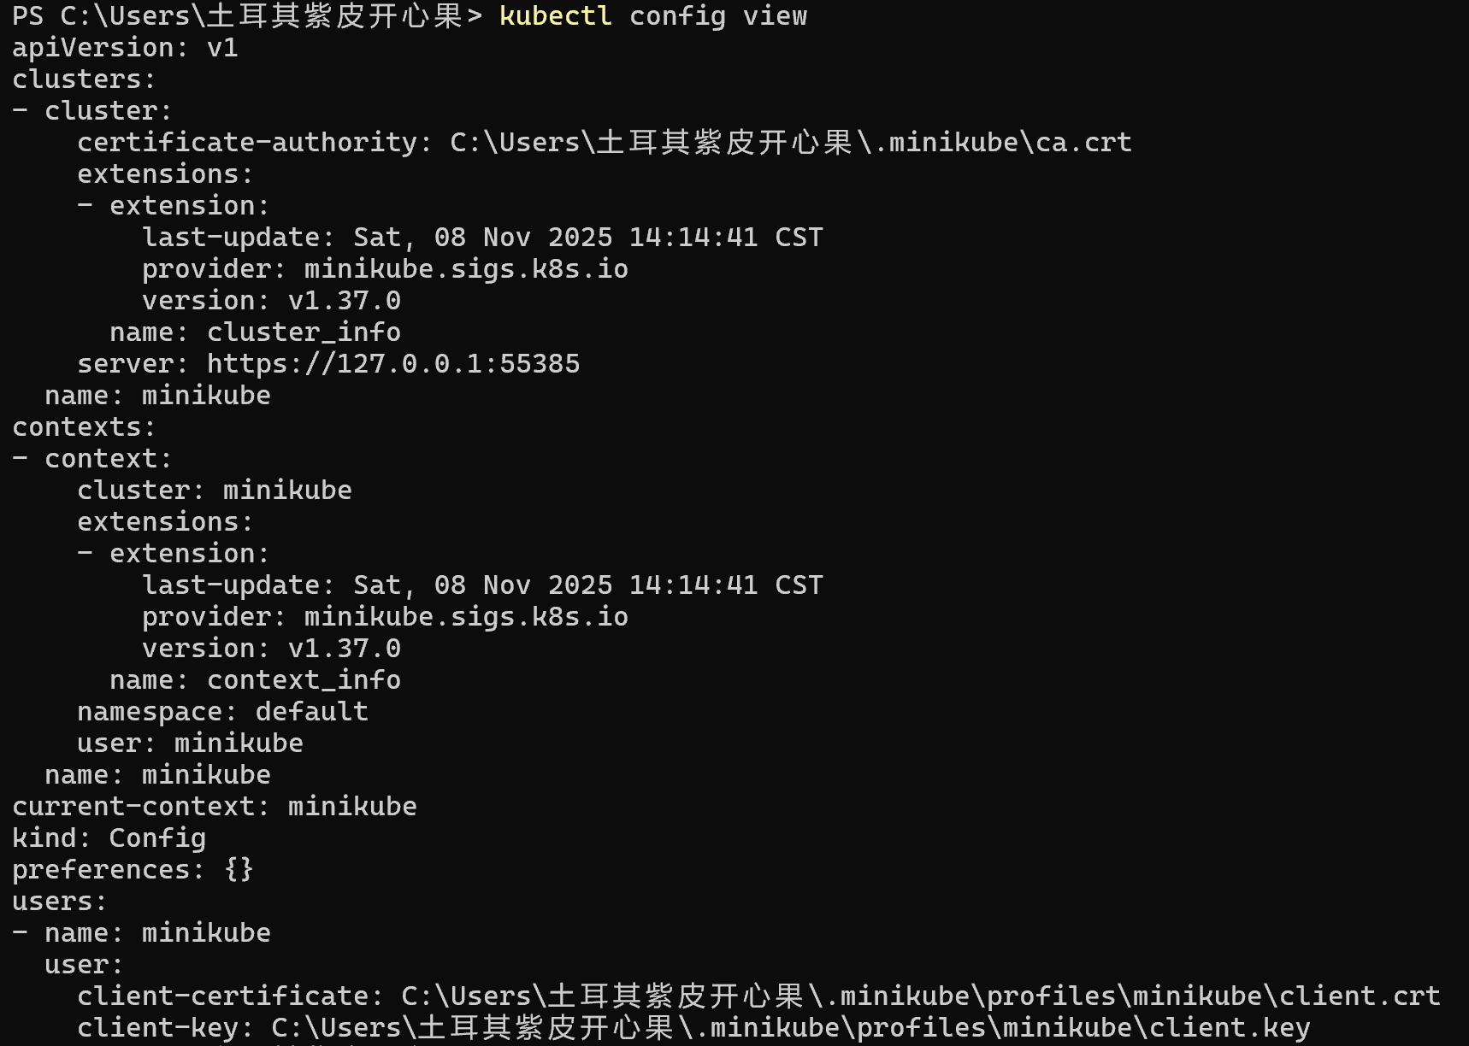
3.6View application logs for a container in a pod

- Create a Service
4.1Expose the Pod to the public internet using the kubectl expose command
4.2View the Service you created
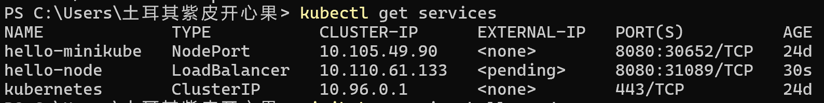
4.3 opens up a browser window that serves your app and shows the app's response
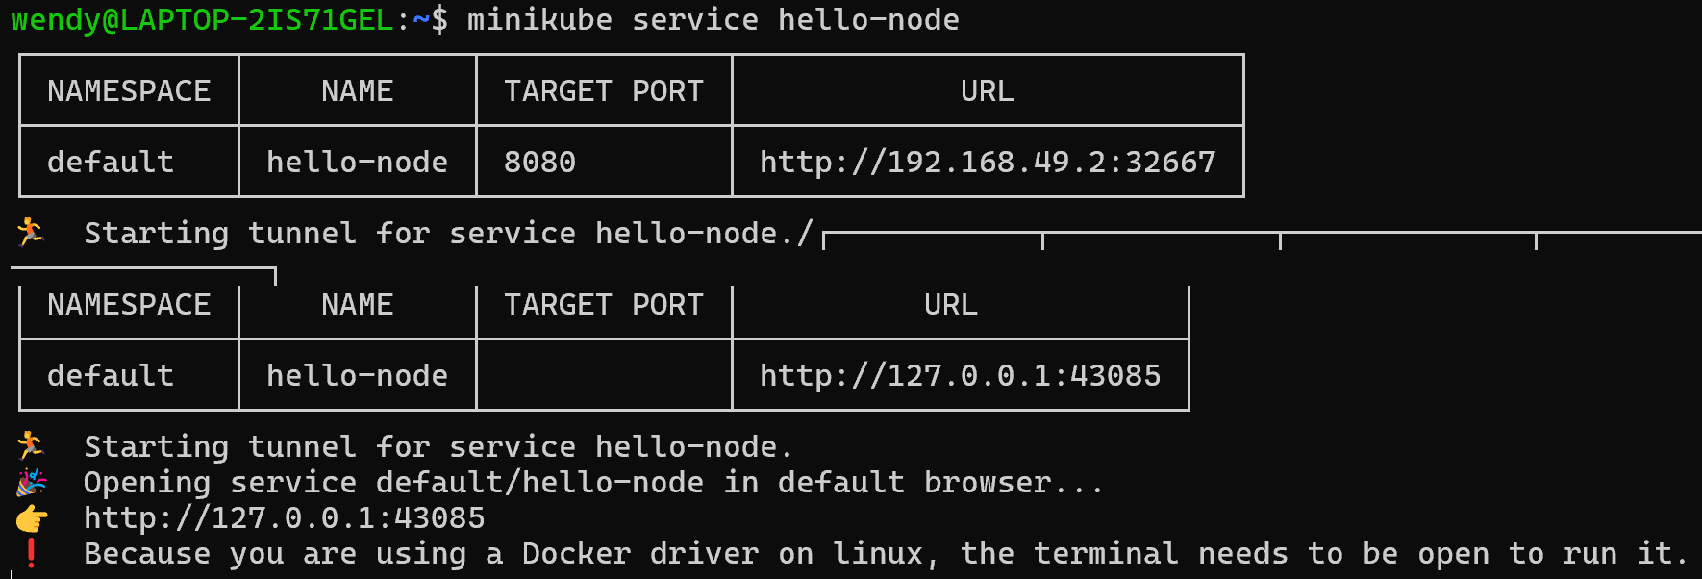
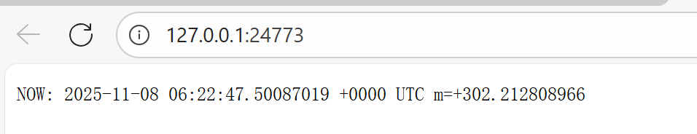
- Enable addons
5.1List the currently supported addons
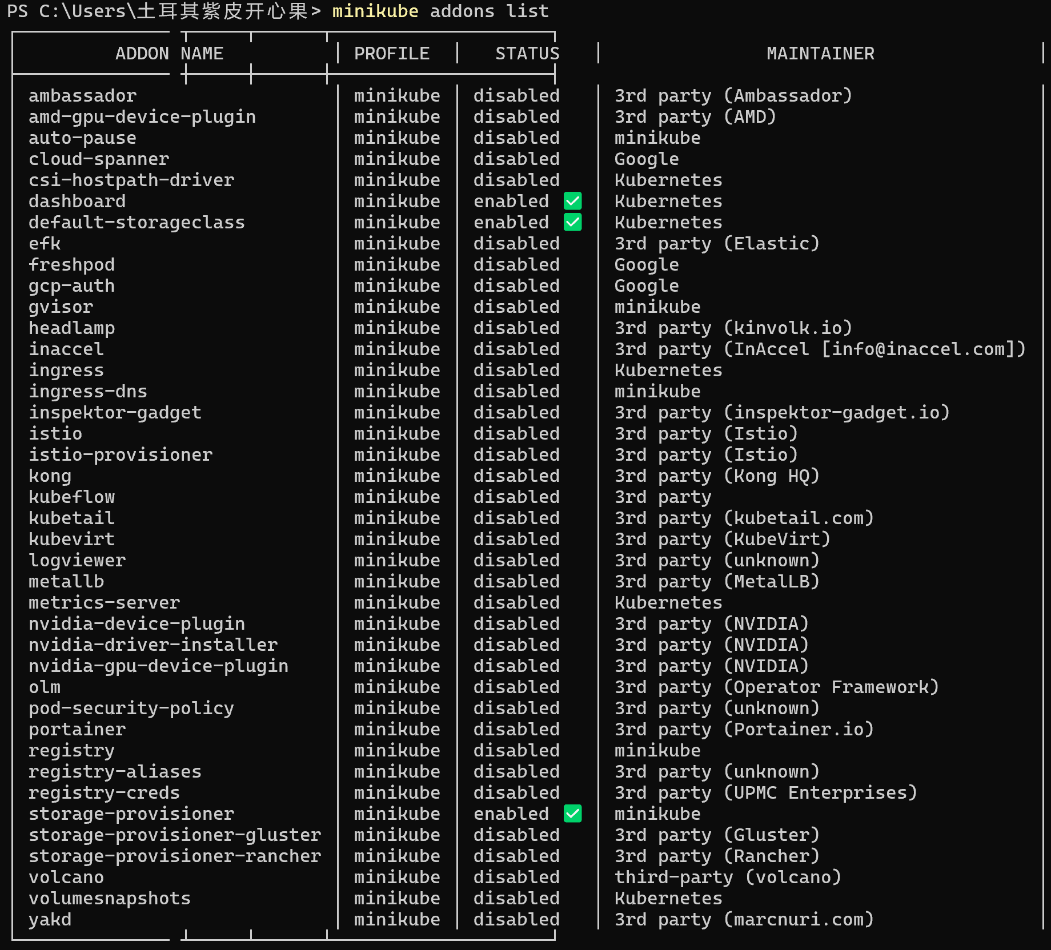
5.2Enable an addon
5.3View the Pod and Service you created by installing that addon
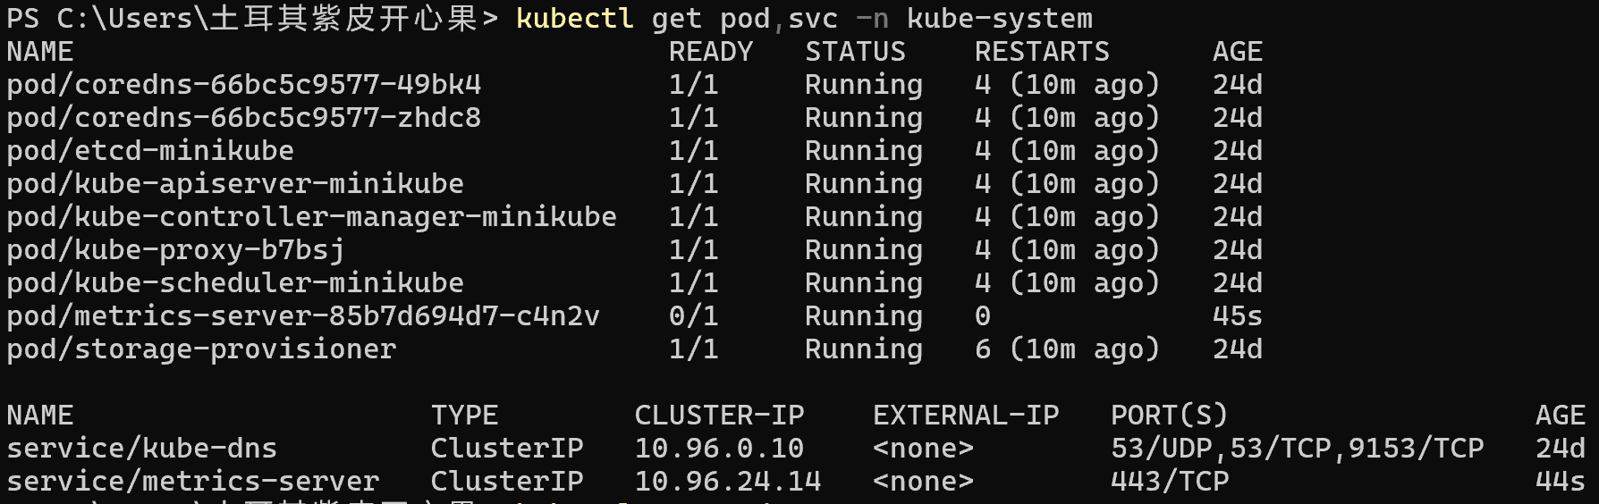
5.4Check the output from metrics-server
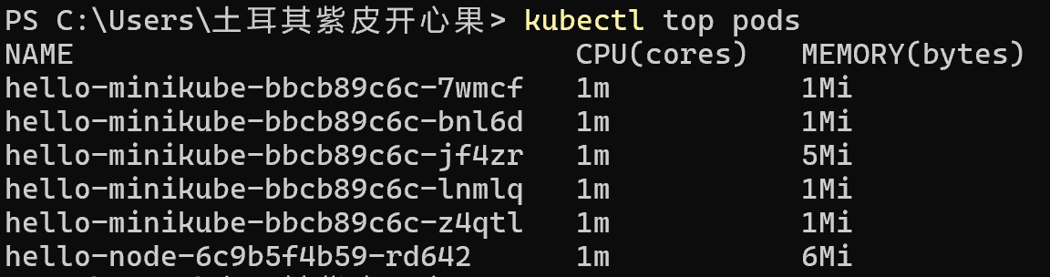
5.5Disable metrics-server
- Clean up
Clean up the resources：
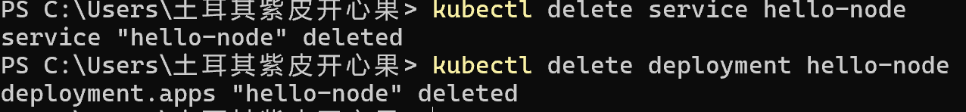
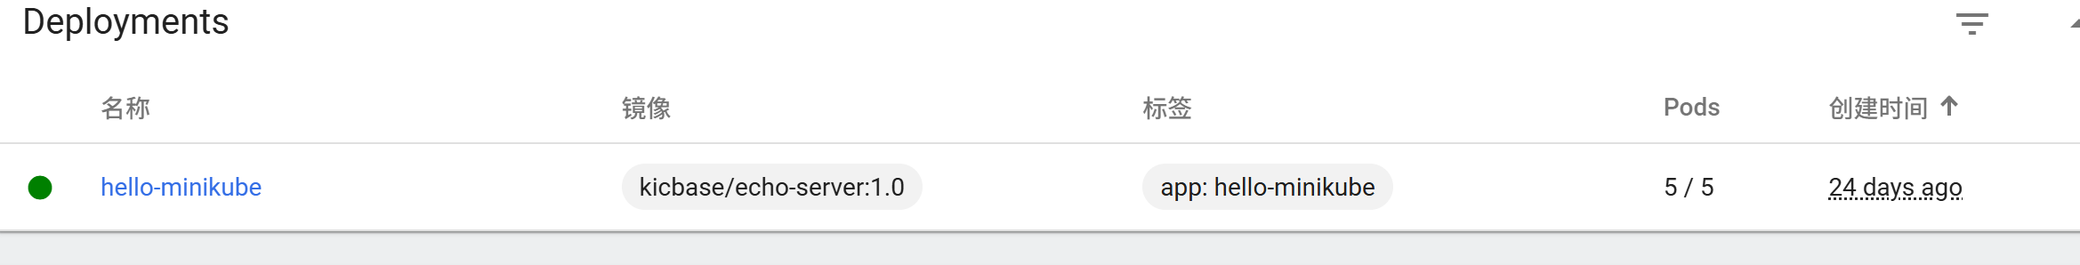
Stop the Minikube cluster
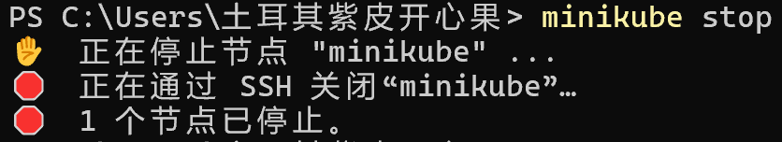
- Deploy an App/deploy-intro
- Deploy an app
1.1deploy our first app on Kubernetes with the kubectl create deployment command
1.2To list your deployments use the kubectl get deployments command
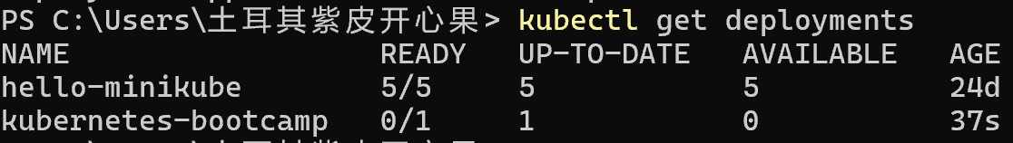
- View the app
2.1open a second terminal window to run the proxy
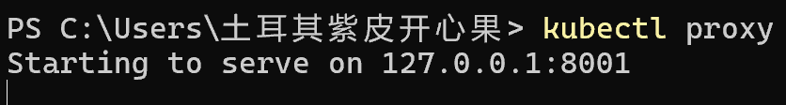
2.2You can see all those APIs hosted through the proxy endpoint. For example, we can query the version directly through the API using the curl command
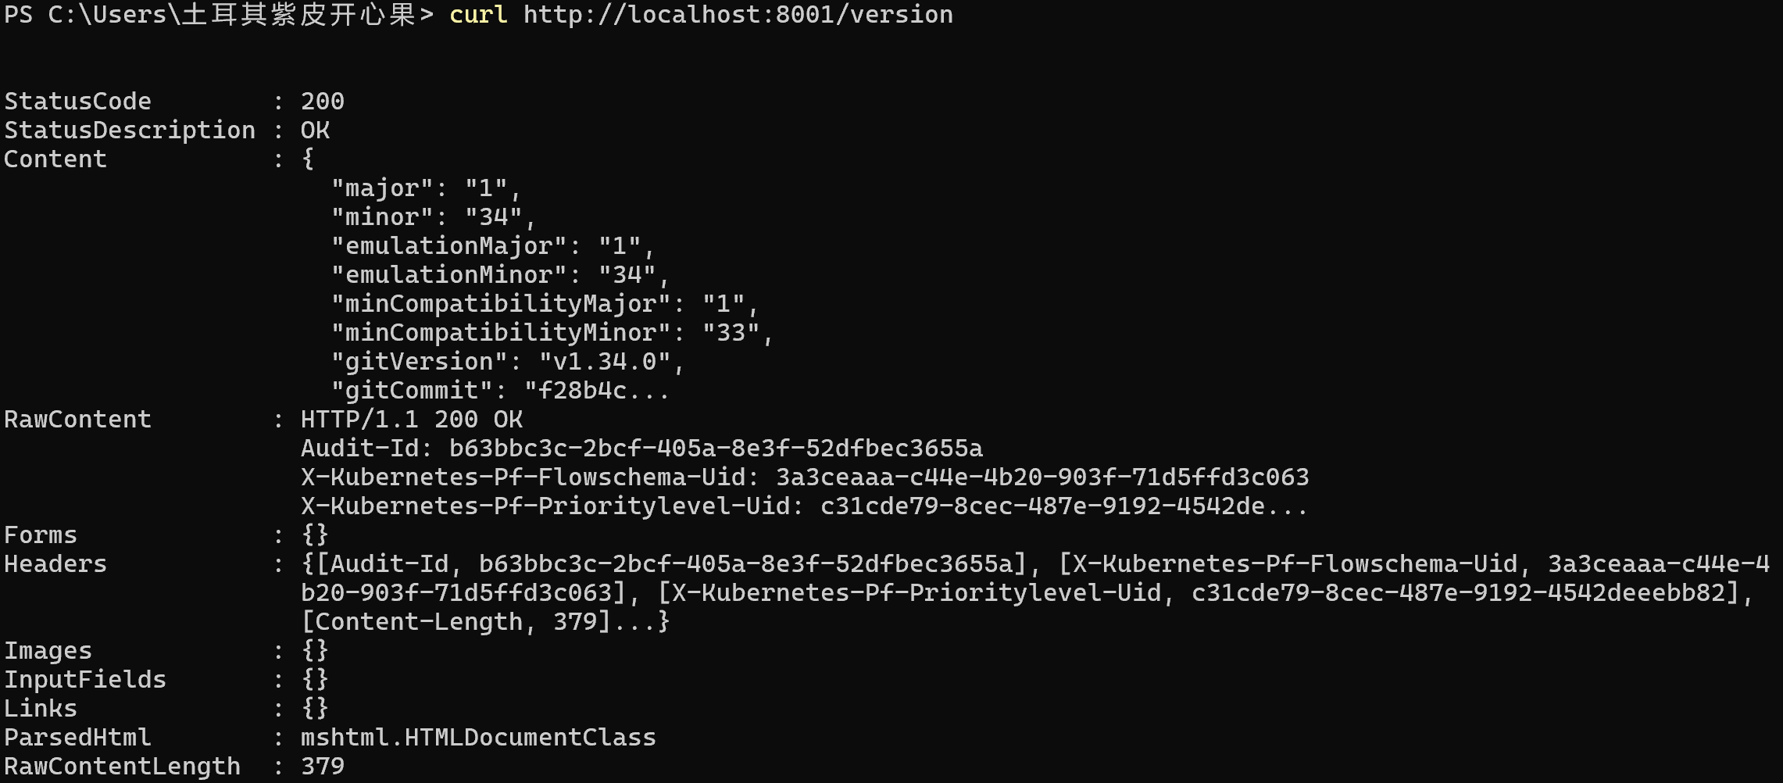
2.3get the Pod name, store it in the environment variable POD_NAME
2.4access the Pod through the proxied API, by running

- Explore You App/explore-intro
3.1 Check application configuration
3.1.1 verify that the application we deployed in the previous scenario is running
3.1.2view what containers are inside that Pod and what images are used to build those containers
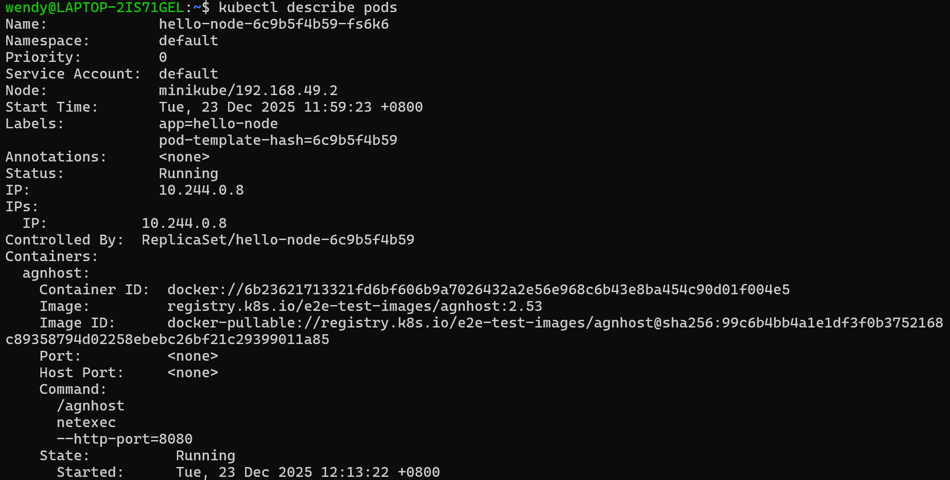
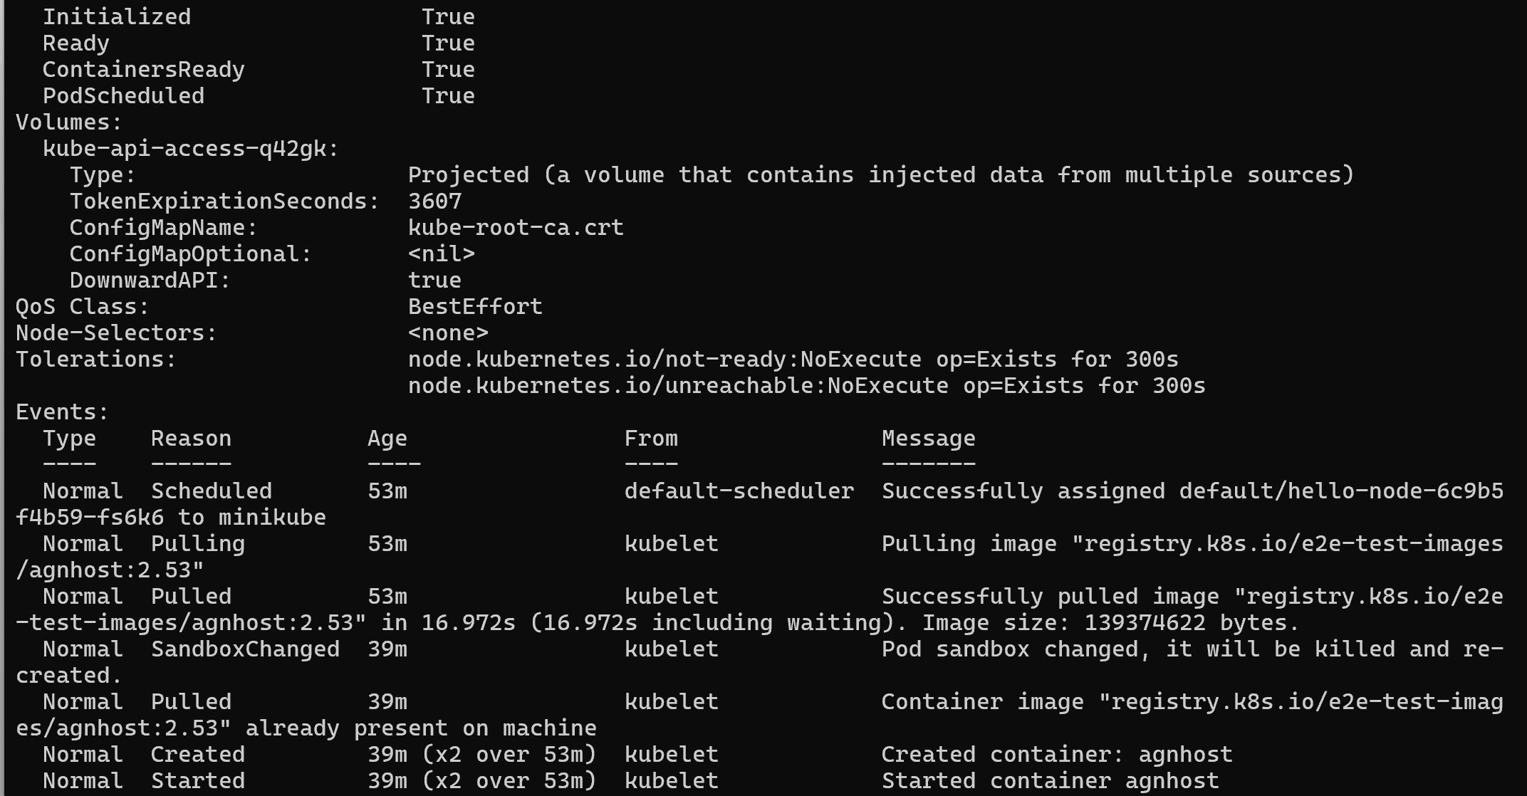
3.2 Show the app in the terminal
3.2.1 run a proxy in a second terminal
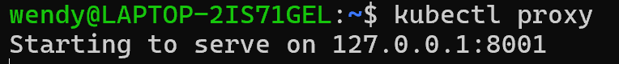
3.2.2 get the Pod name and store it in the POD_NAME environment variable
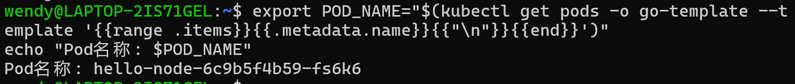
3.2.3 see the output of our application
3.3 Executing commands on the containe
3.3.1 list the environment variables
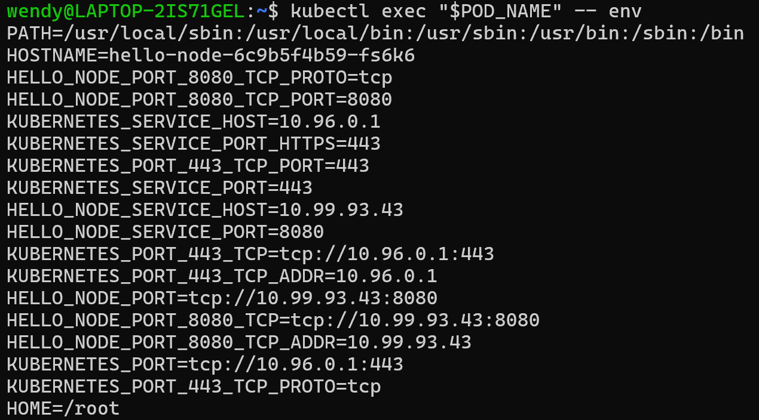
3.3.2 start a bash session in the Pod’s container
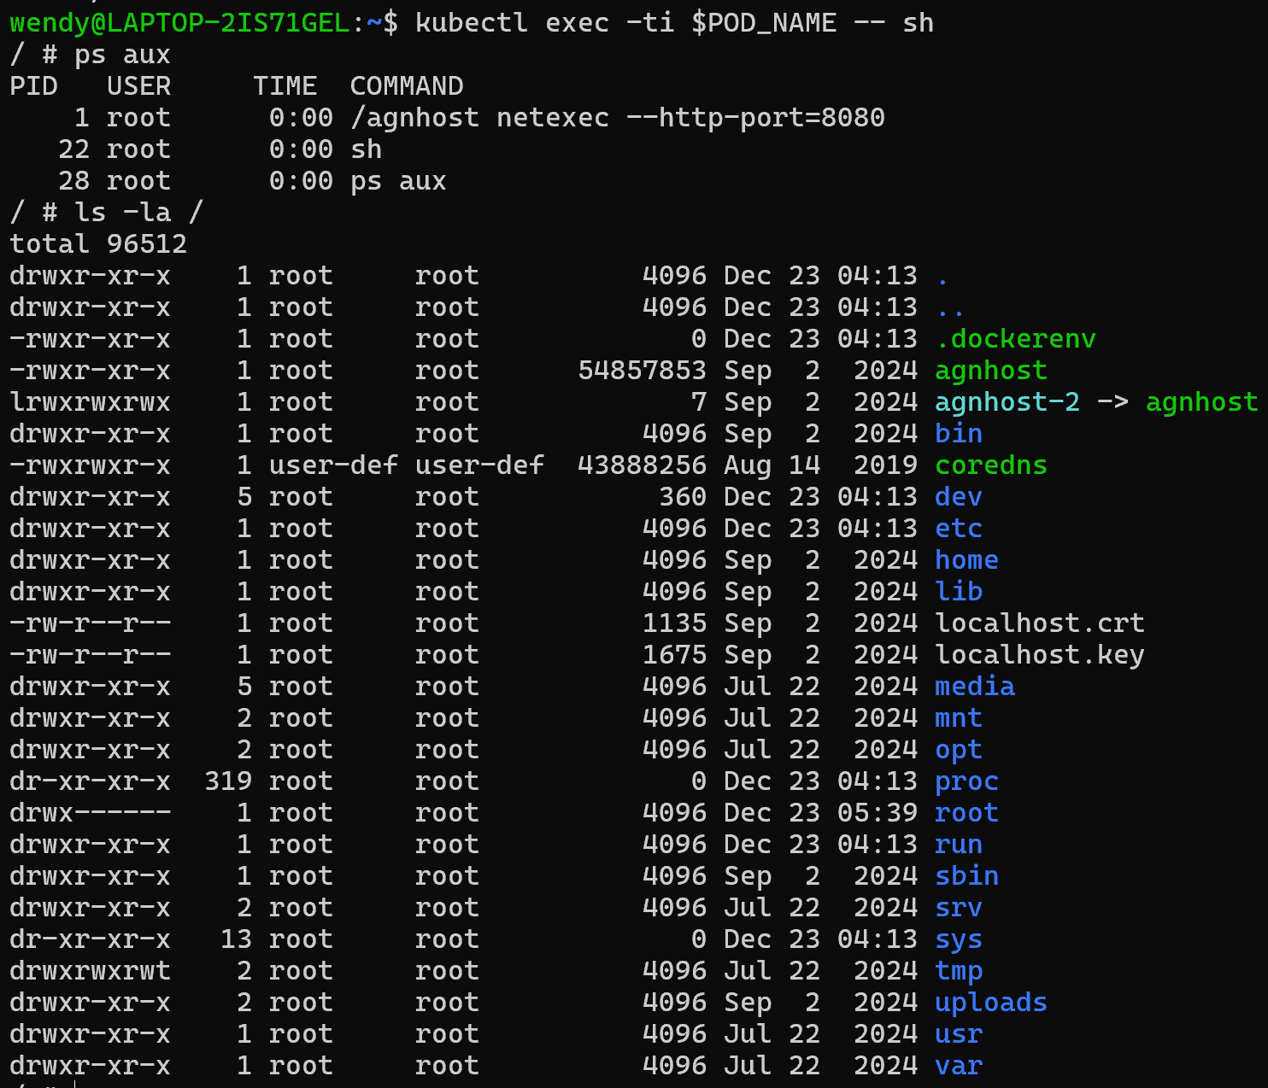
3.3.3 an open console on the container where we run our NodeJS application
3.3.4 check that the application is up by running a curl command
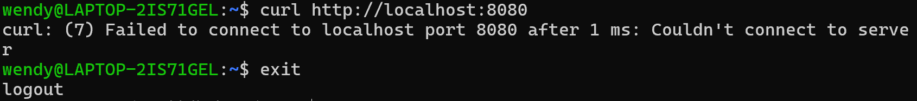
- Expose App Publicly
Step1: Creating a new Service
- look for existing Pods
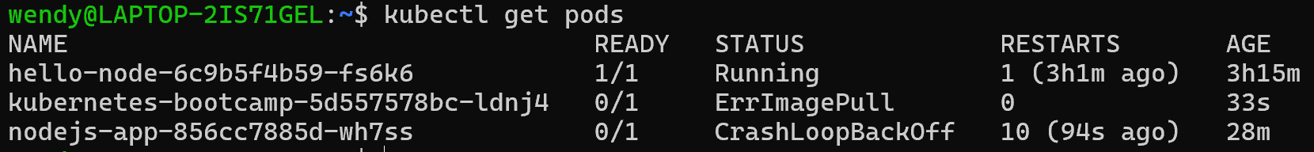
- list the current Services from our cluster
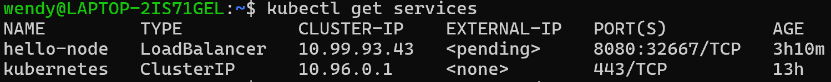
- expose the deployment to external traffic
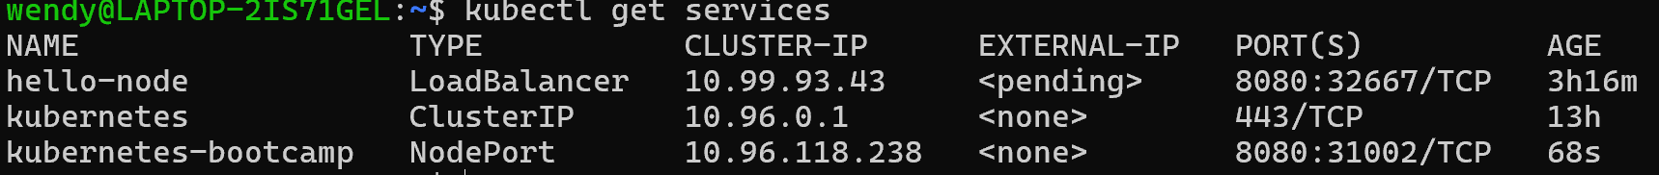
- find out what port was opened externally
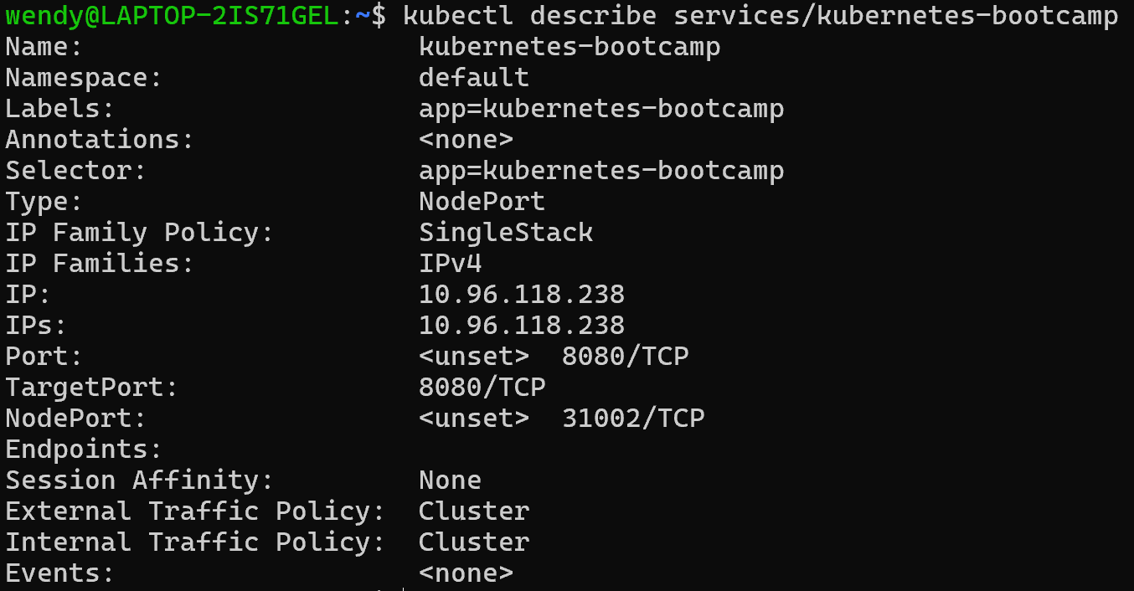
- Create an environment variable called NODE_PORT
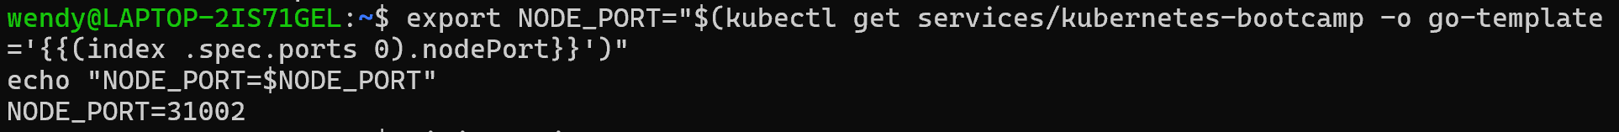
- test that the app is exposed outside of the cluster using curl
Step 2: Using labels
- see the name (the key) of that label
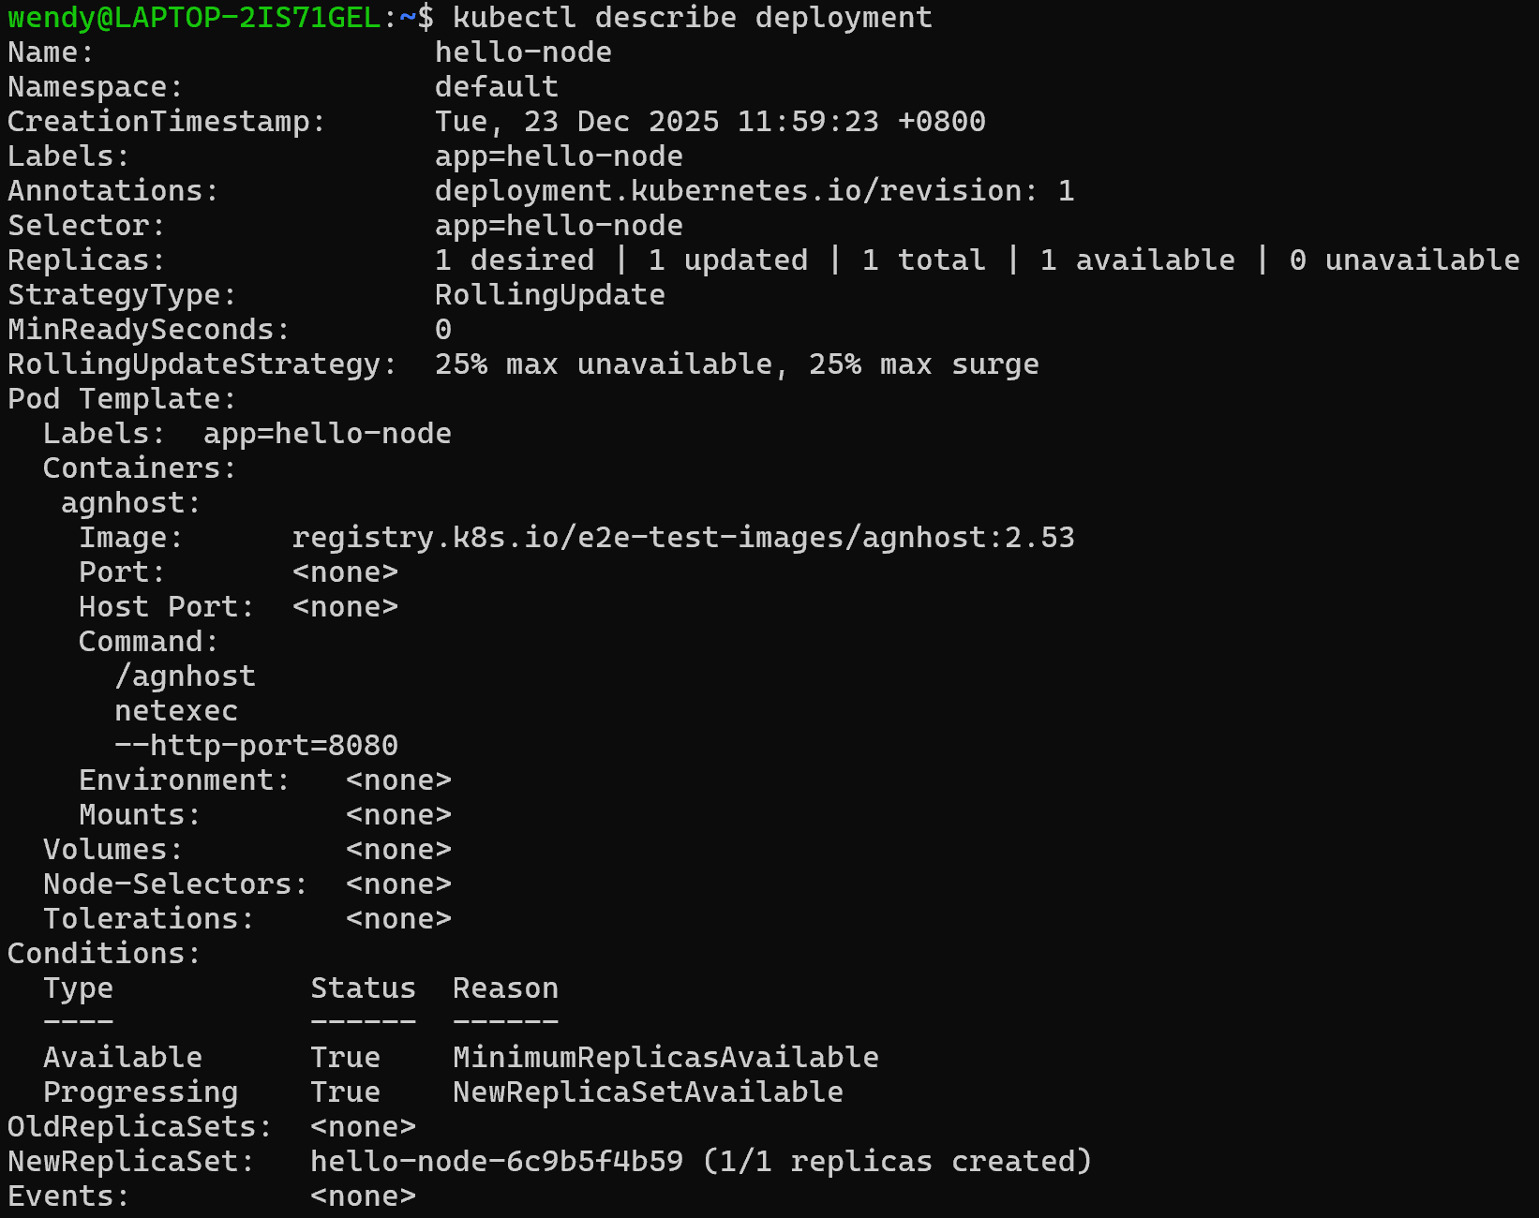
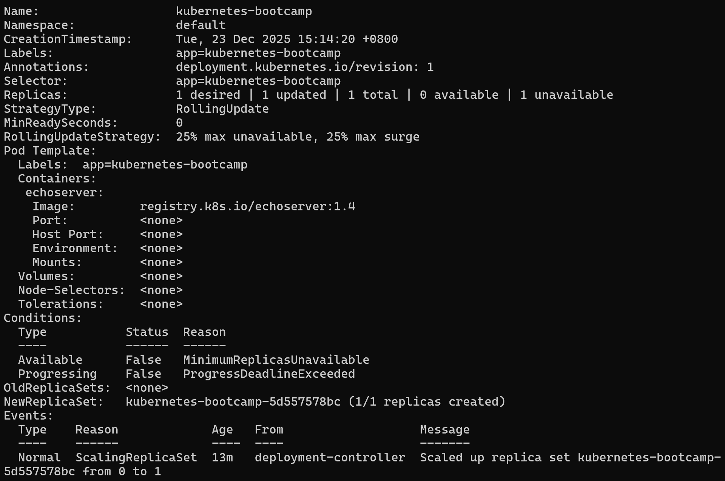
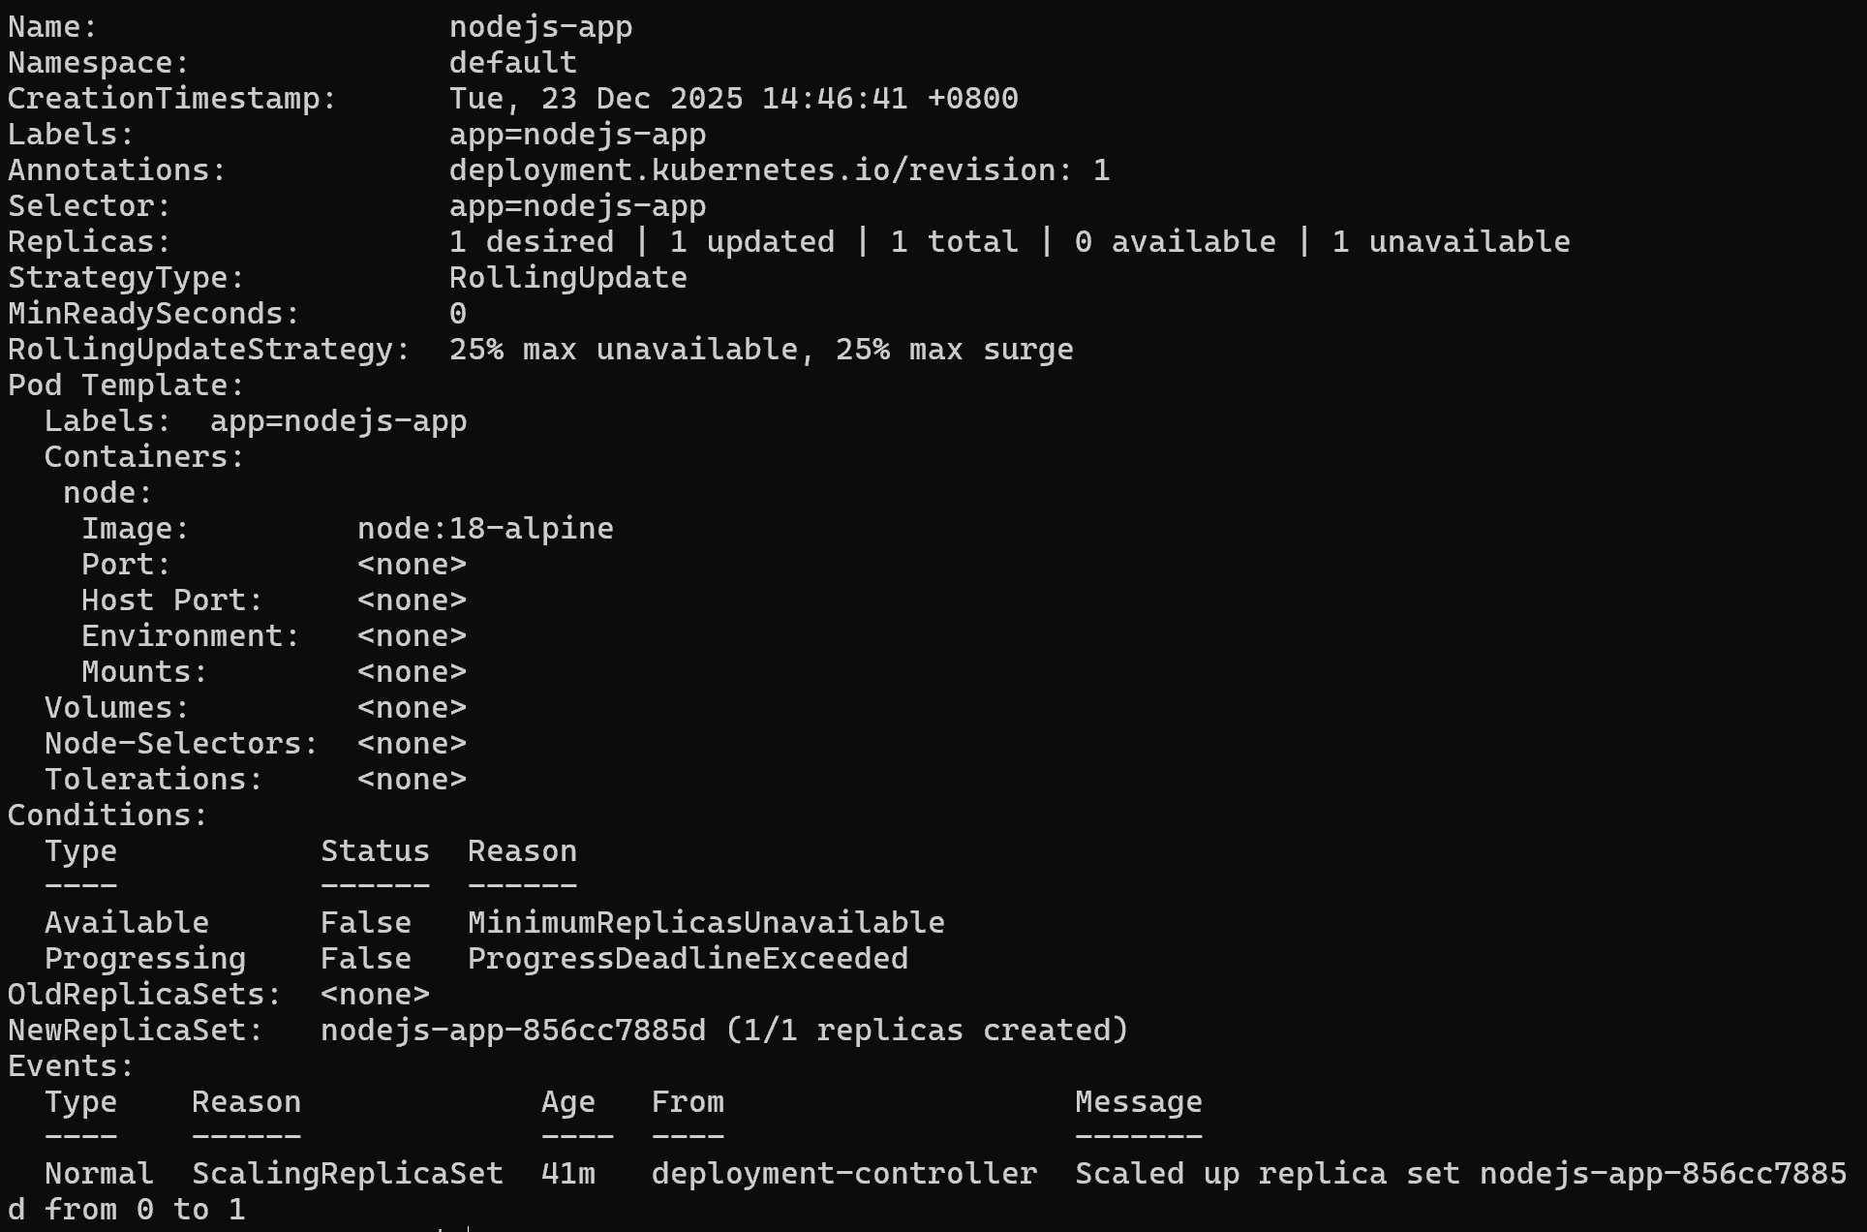
- use this label to query our list of Pods
list the existing Services
- Get the name of the Pod and store it in the POD_NAME environment variable
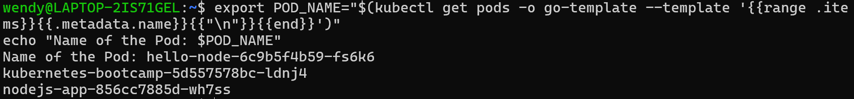
- apply a new label
- check it with the describe pod command
- query now the list of pods using the new label
Step 3: Deleting a service
- delete Services
- Confirm that the Service is gone
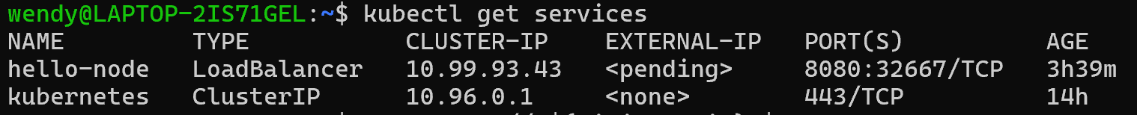
- confirms that our Service was removed
- confirm that the app is still running with a curl from inside the pod

- Scale App
5.1 Scaling a Deployment
5.1.1 list your Deployments
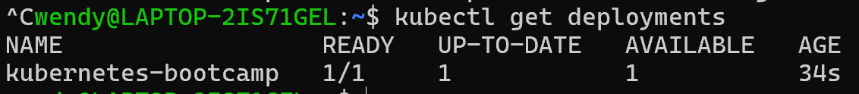
5.1.2 see the ReplicaSet created by the Deployment
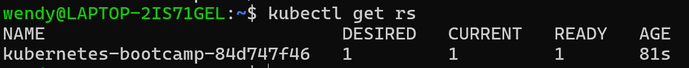
5.1.3 scale the Deployment to 4 replicas
5.1.4 list your Deployments once again
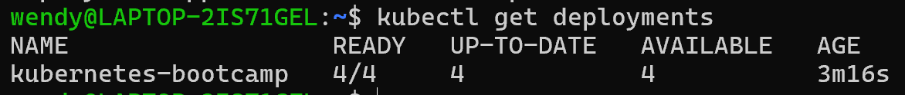
5.1.5 check if the number of Pods changed
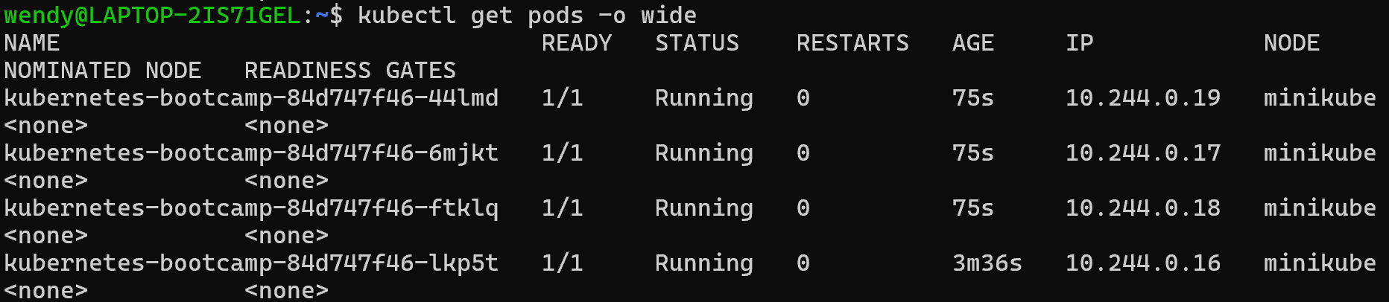
5.1.6 The change was registered in the Deployment events log. To check that, use the describe subcommand:
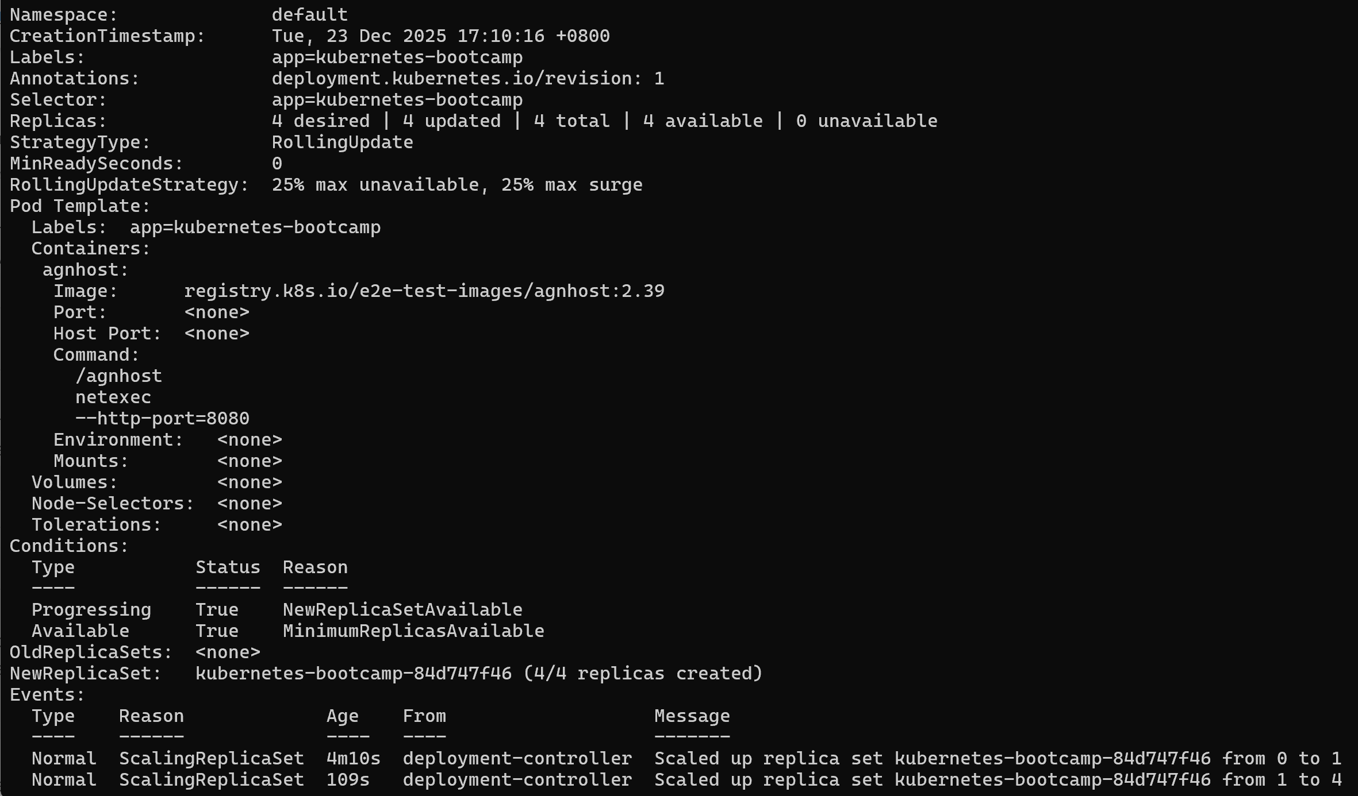
5.2 Load Balancing
5.2.1 check that the Service is load-balancing the traffic
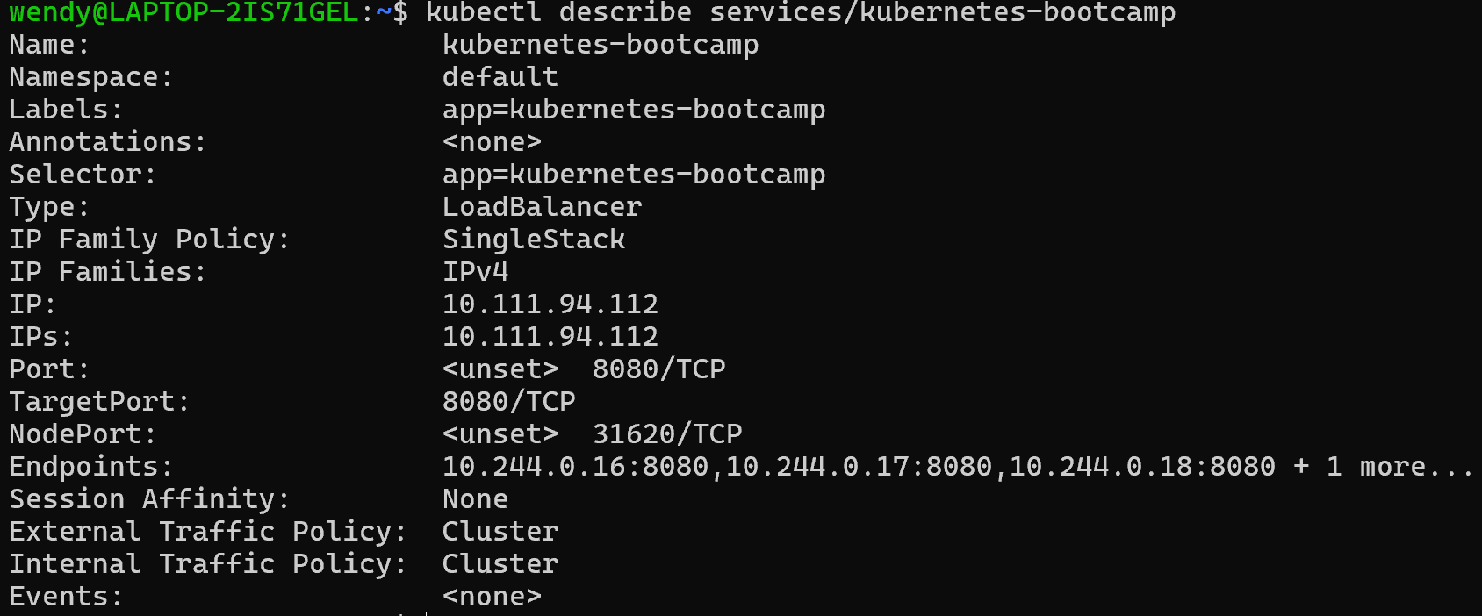
5.2.2 Create an environment variable called NODE_PORT
5.2.3 do a curl to the exposed IP address and port
5.3 Scale Down
5.3.1 scale down the Deployment to 2 replicas
5.3.2 List the Deployments to check if the change was applied
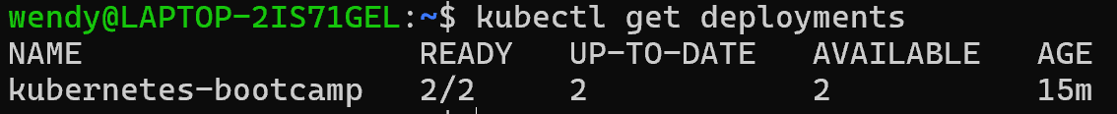
5.3.3 The number of replicas decreased to 2
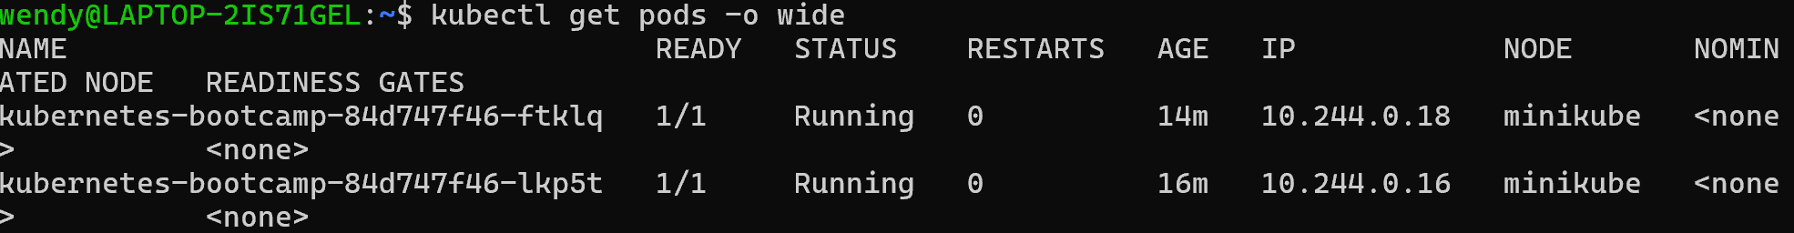

- Update App
6.1 Update the version of the app
6.1.1 list your Deployments
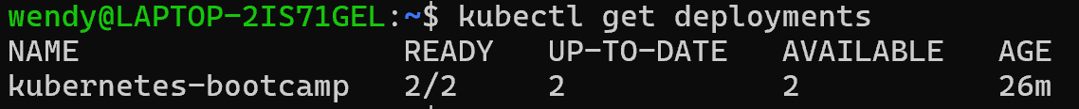
6.1.2 list the running Pods
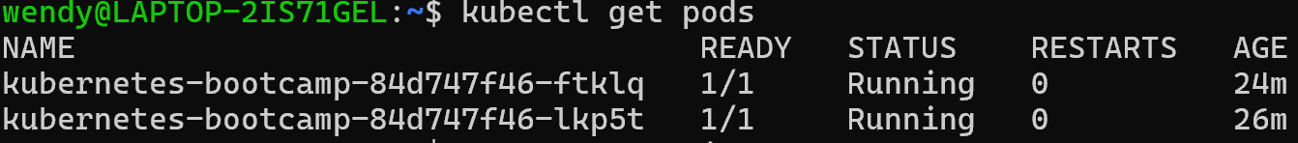
6.1.3 view the current image version of the app
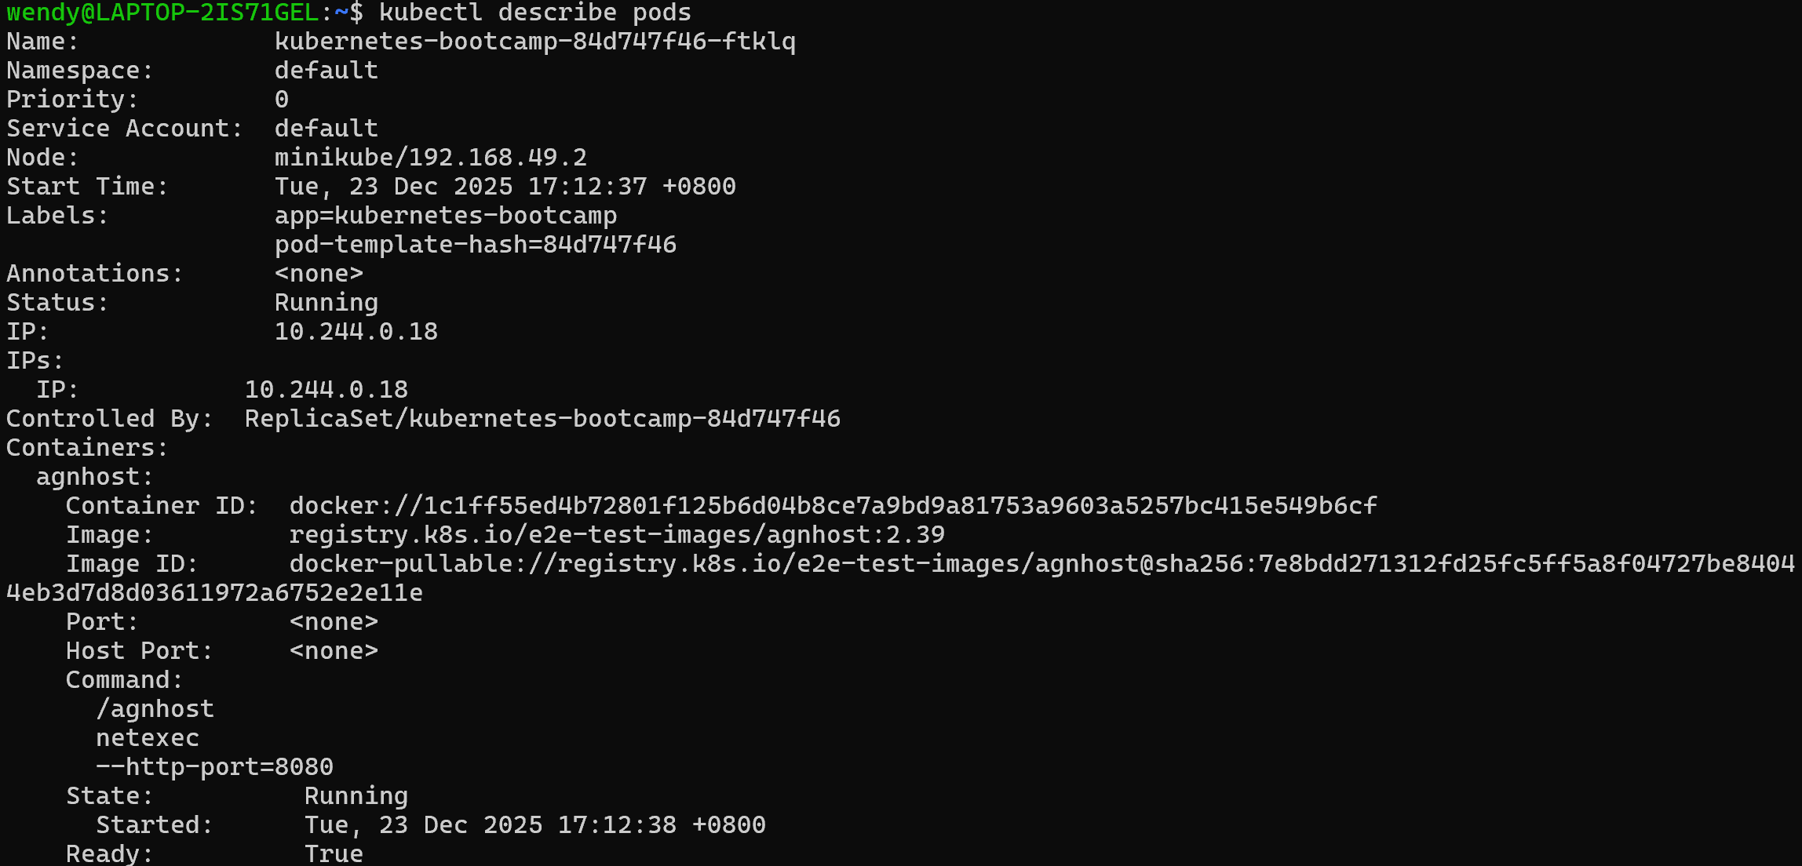
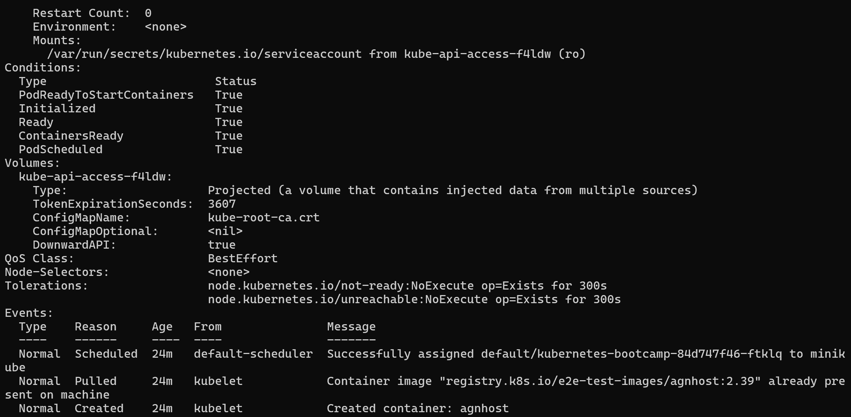
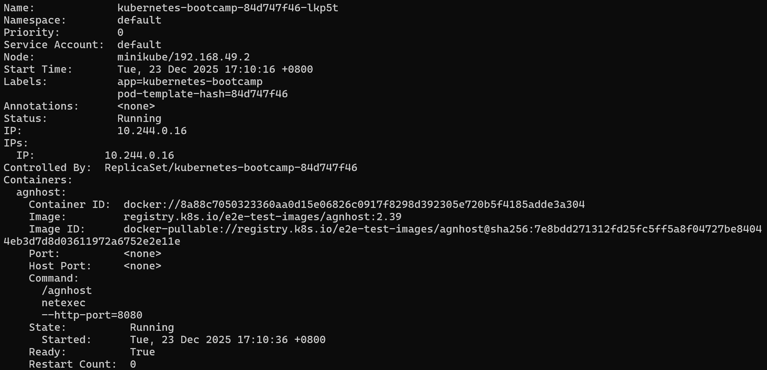
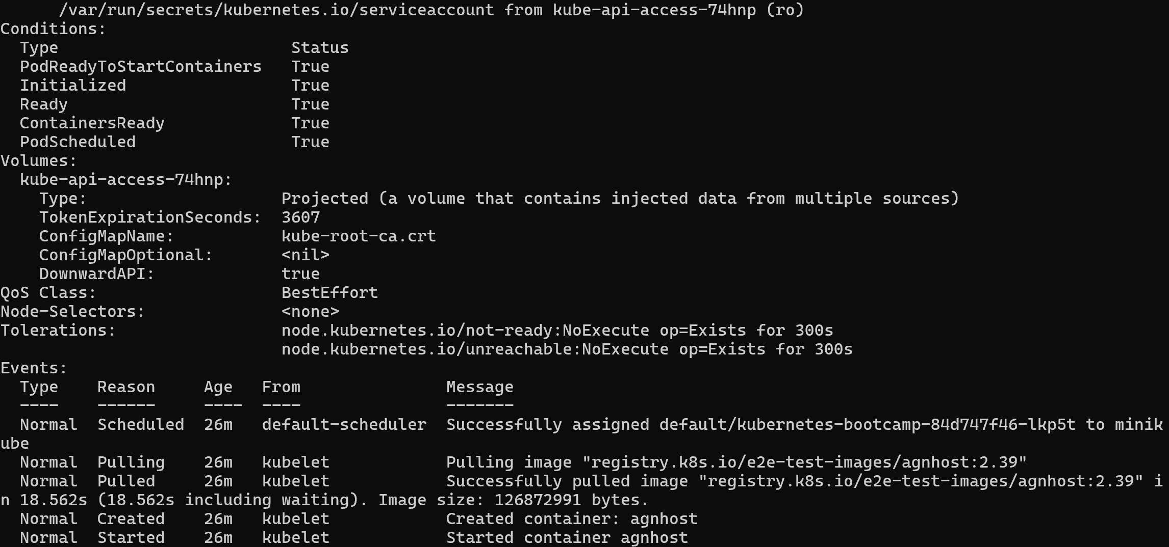
6.1.4 update the image of the application to version 2
6.1.5 Check the status of the new Pods, and view the old one terminating with the get pods subcommand
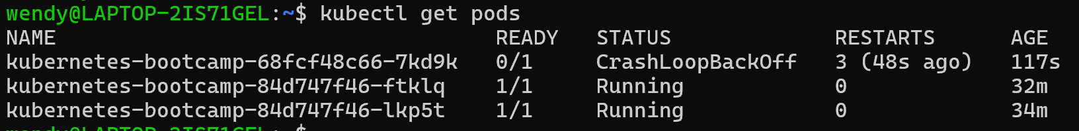
6.2 Verify an update
6.2.1 check that the service is running
6.2.2 Create an environment variable called NODE_PORT
6.2.3 do a curl to the exposed IP and port
6.2.4 confirm the update
6.2.5 view the current image version of the app
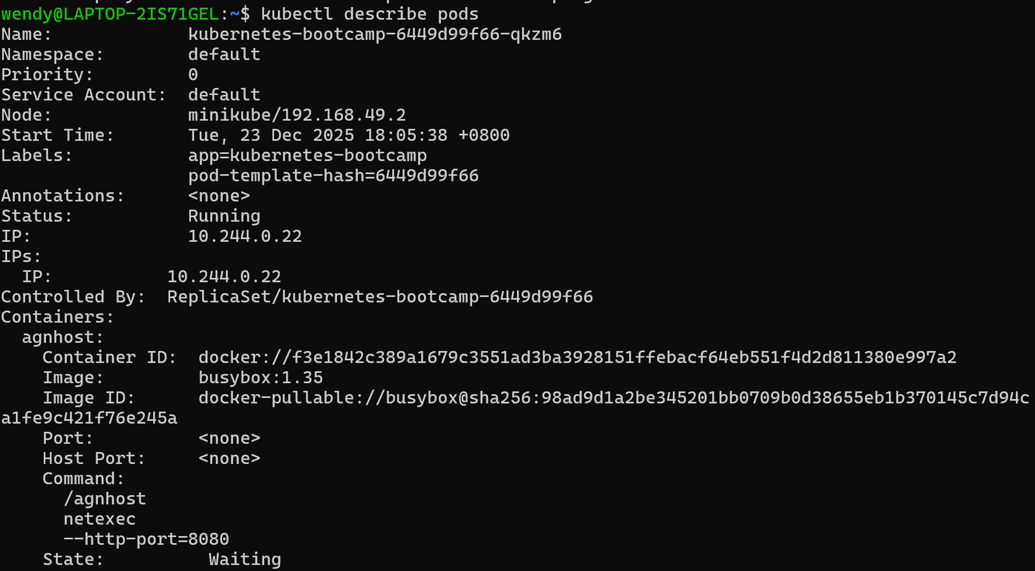
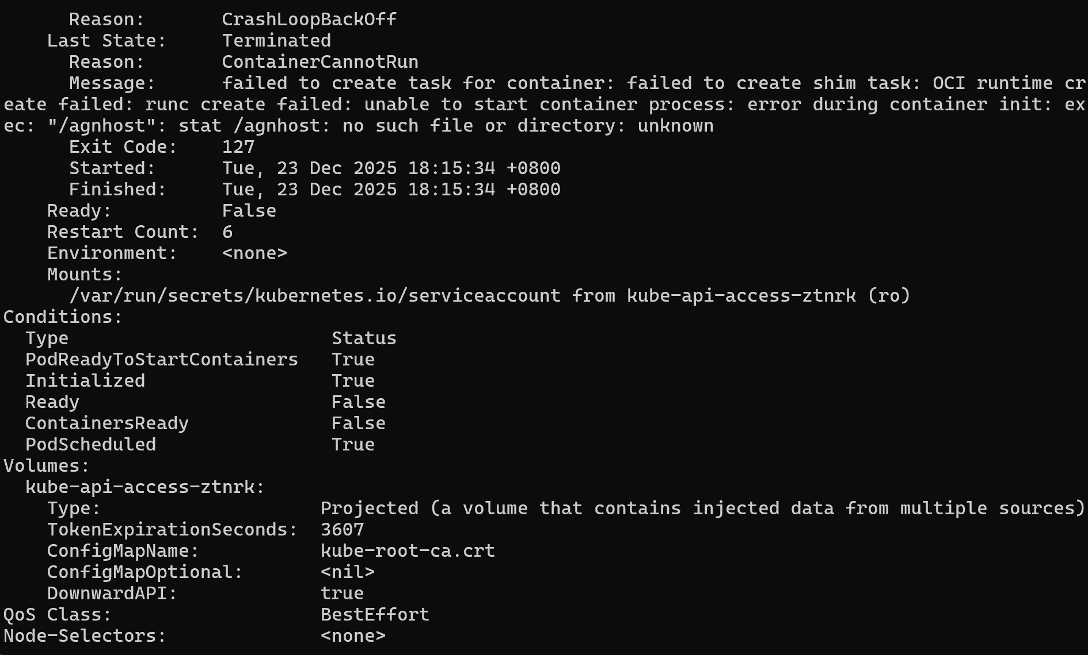
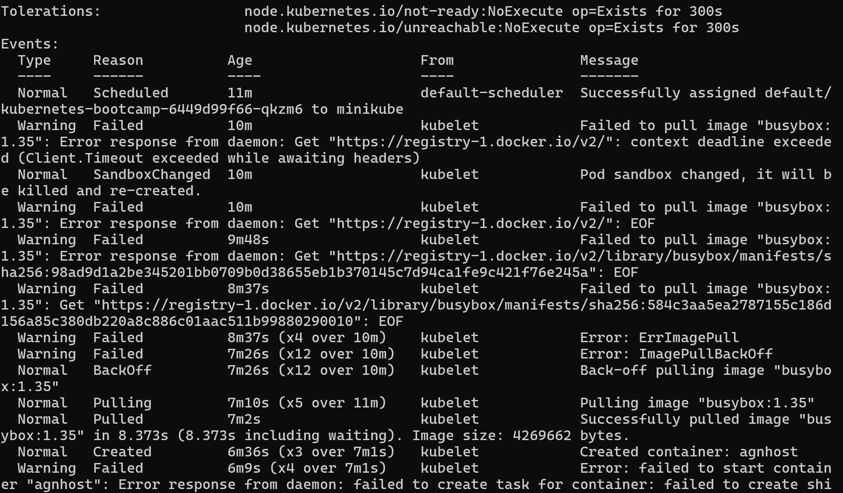
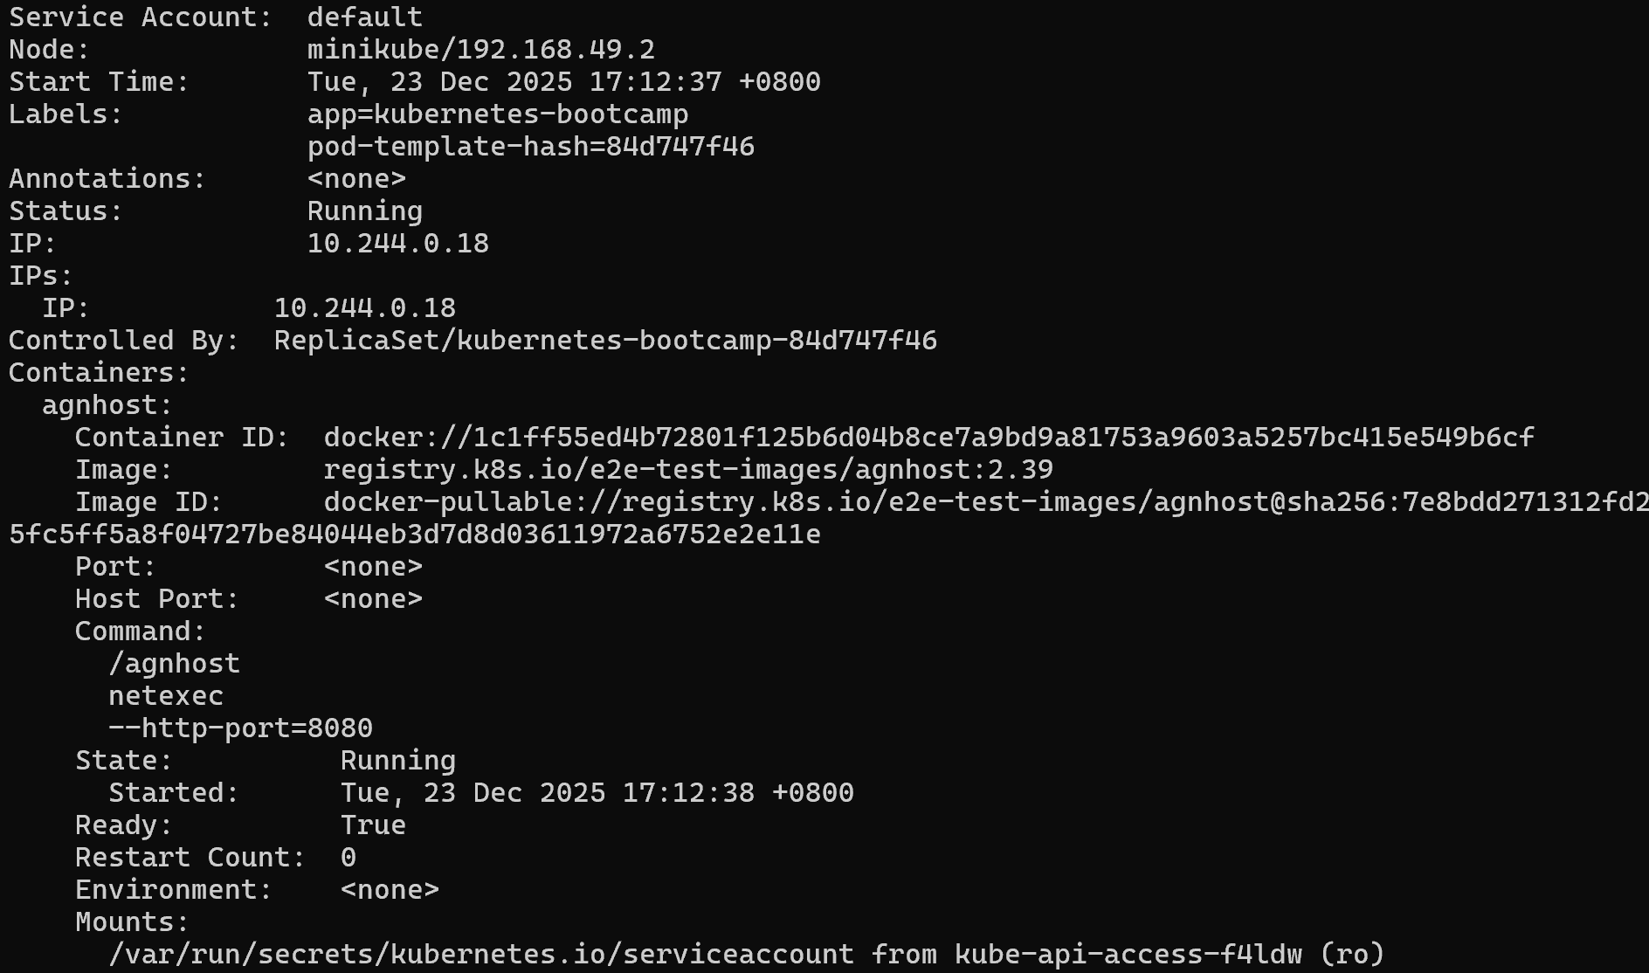
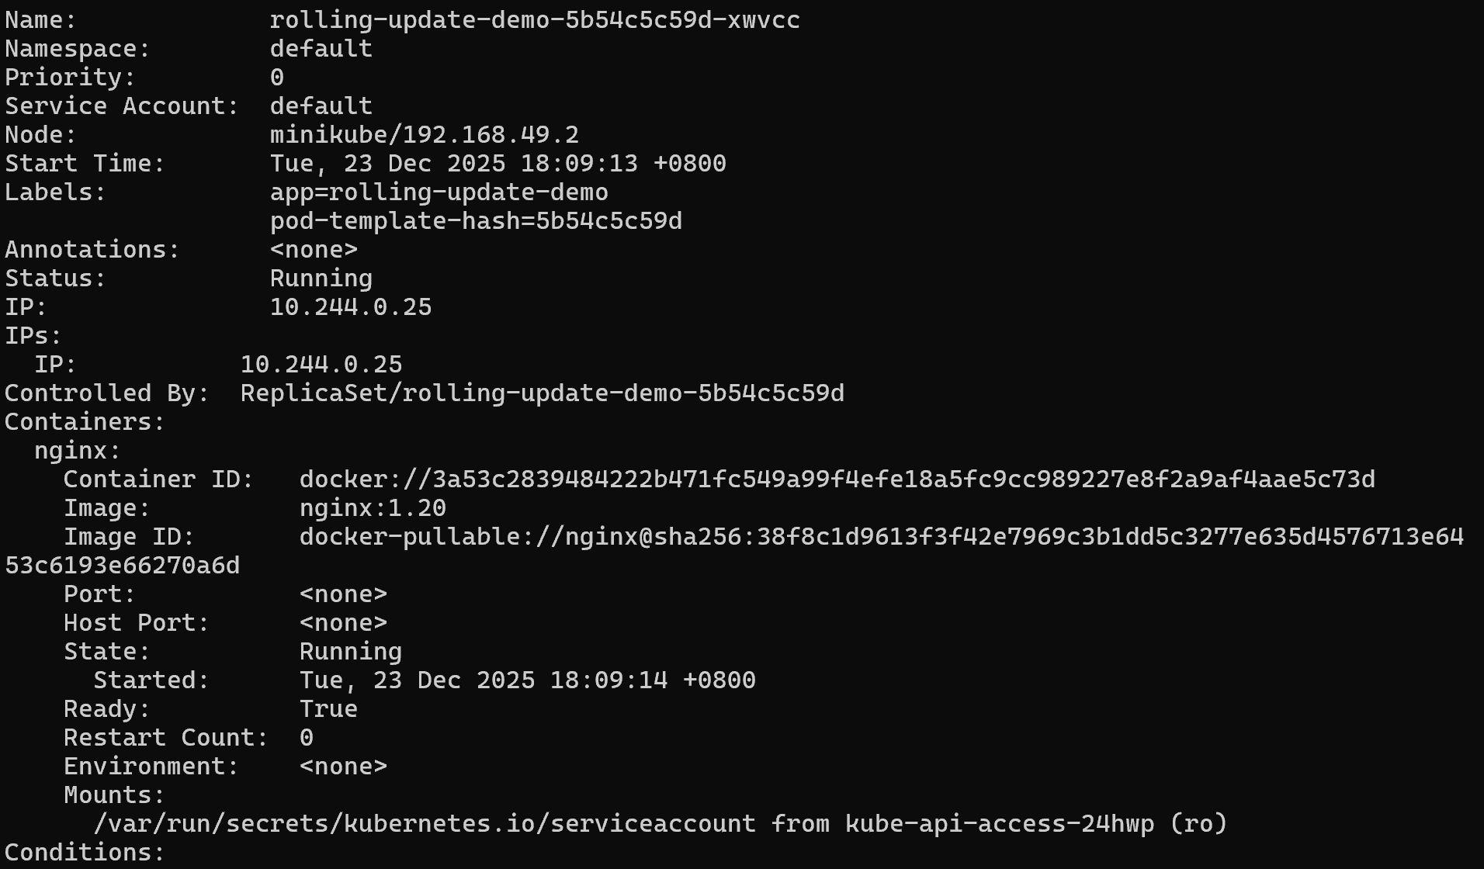
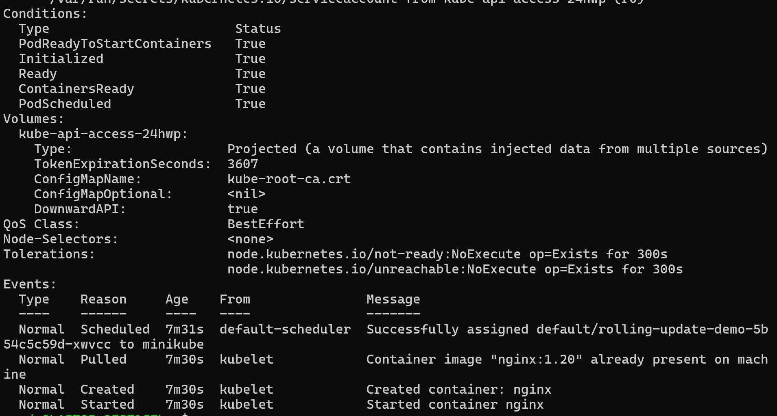
6.3 Roll back an update
6.3.1 try to deploy an image tagged with v10
6.3.2 see the status of the deployment
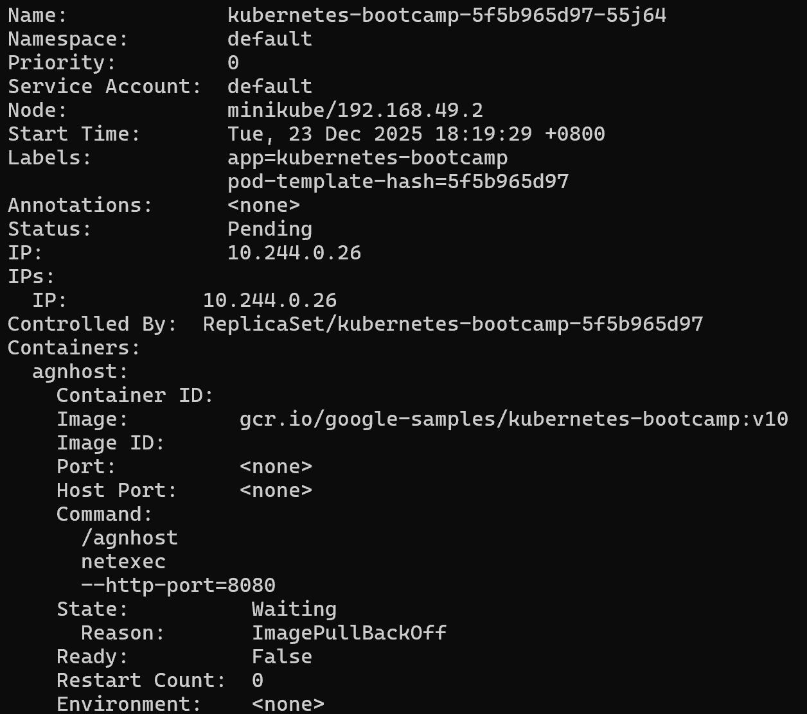
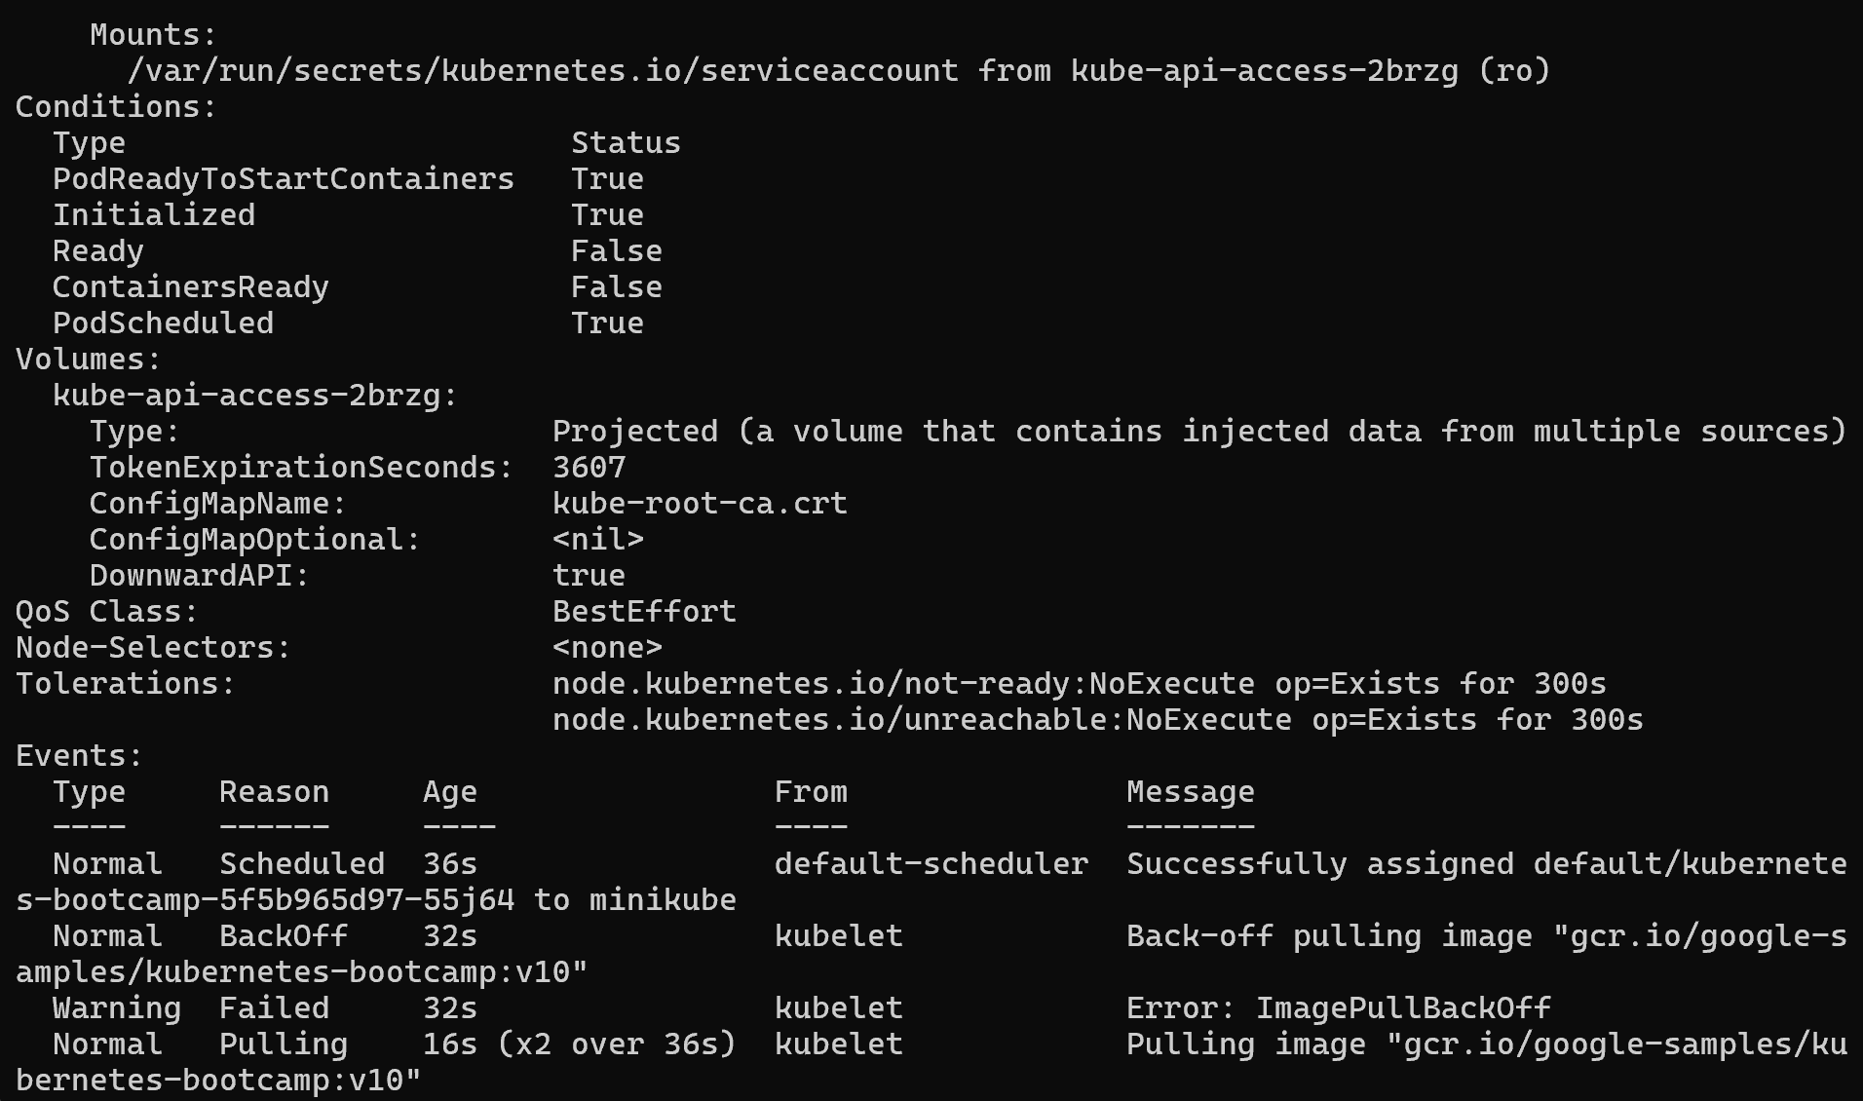
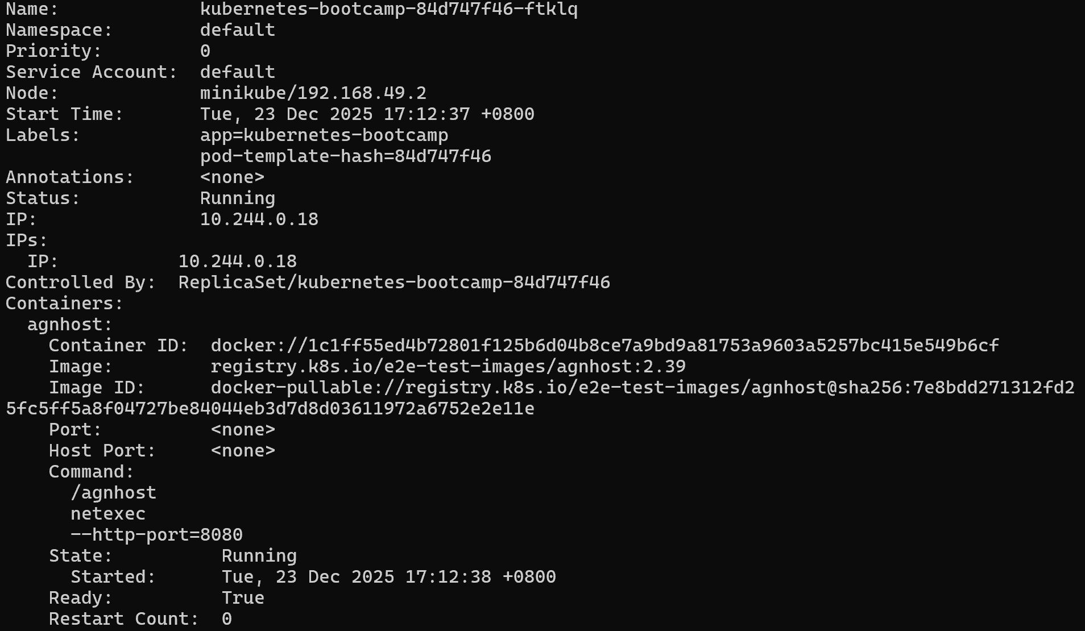
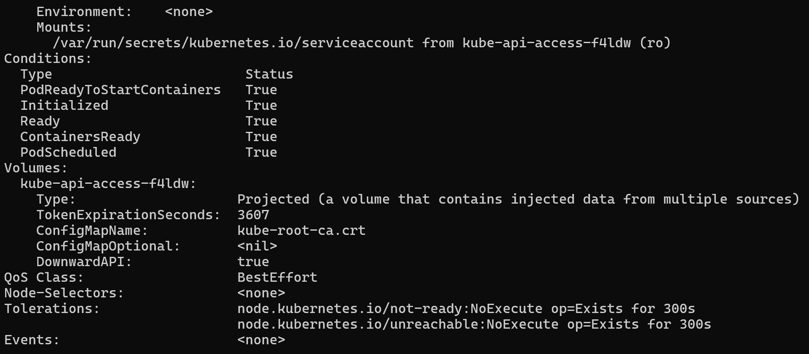
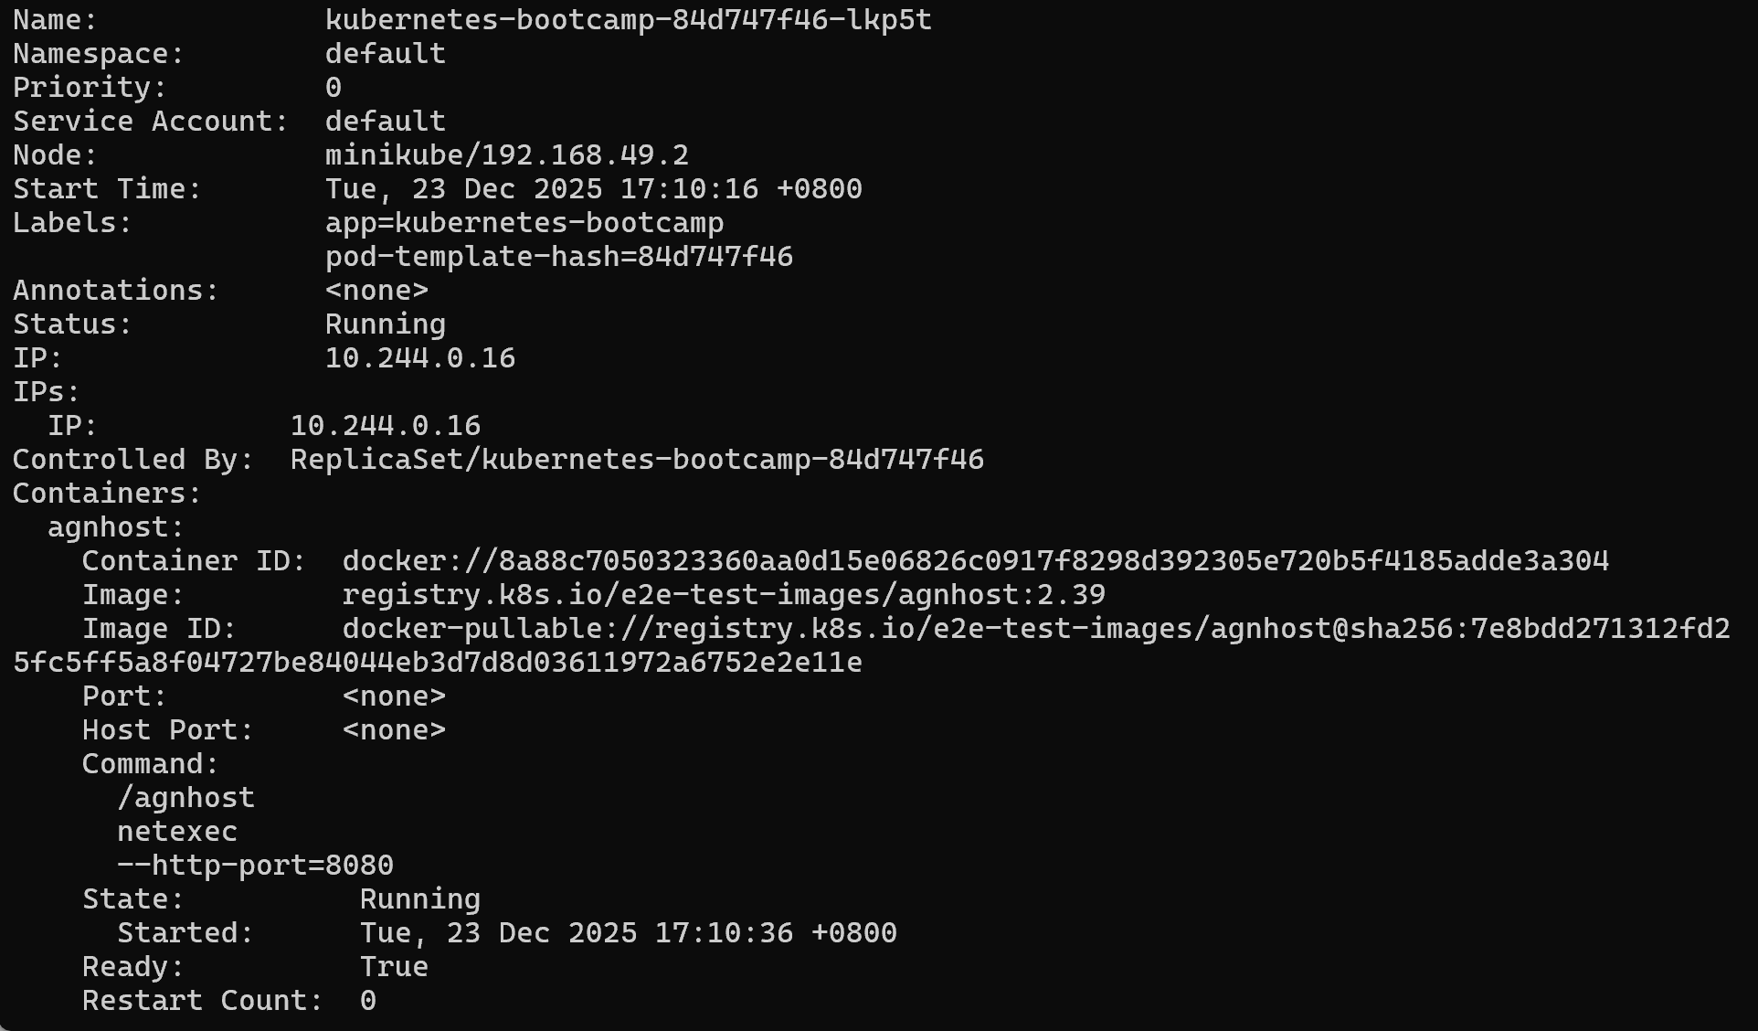
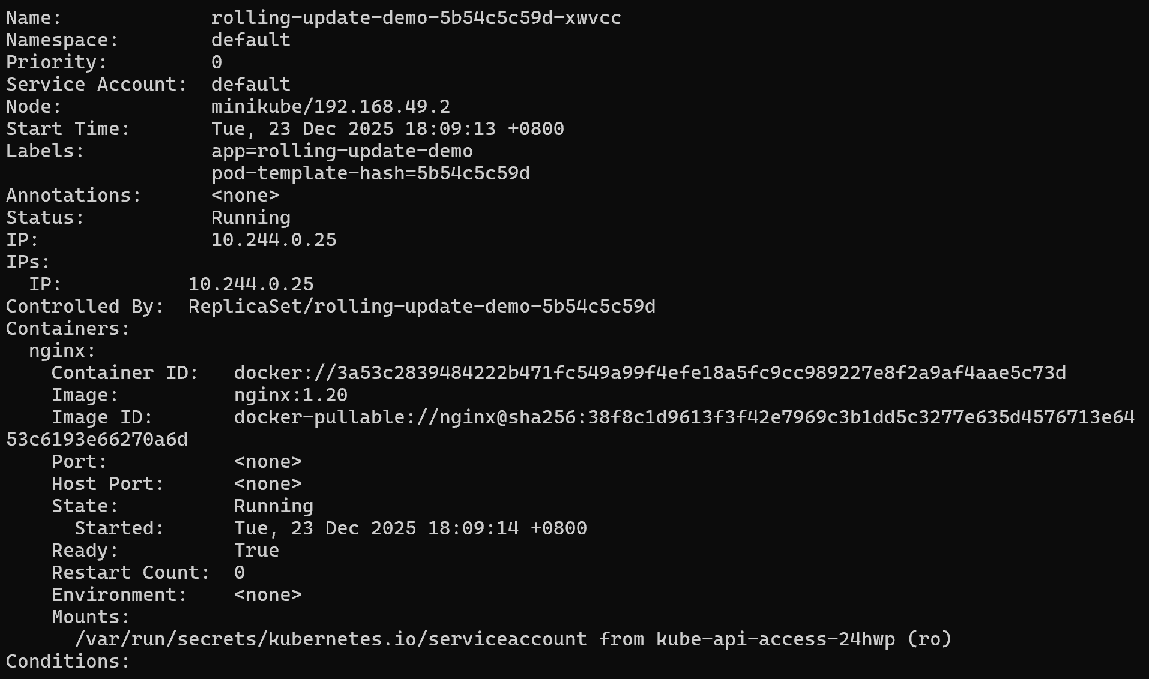
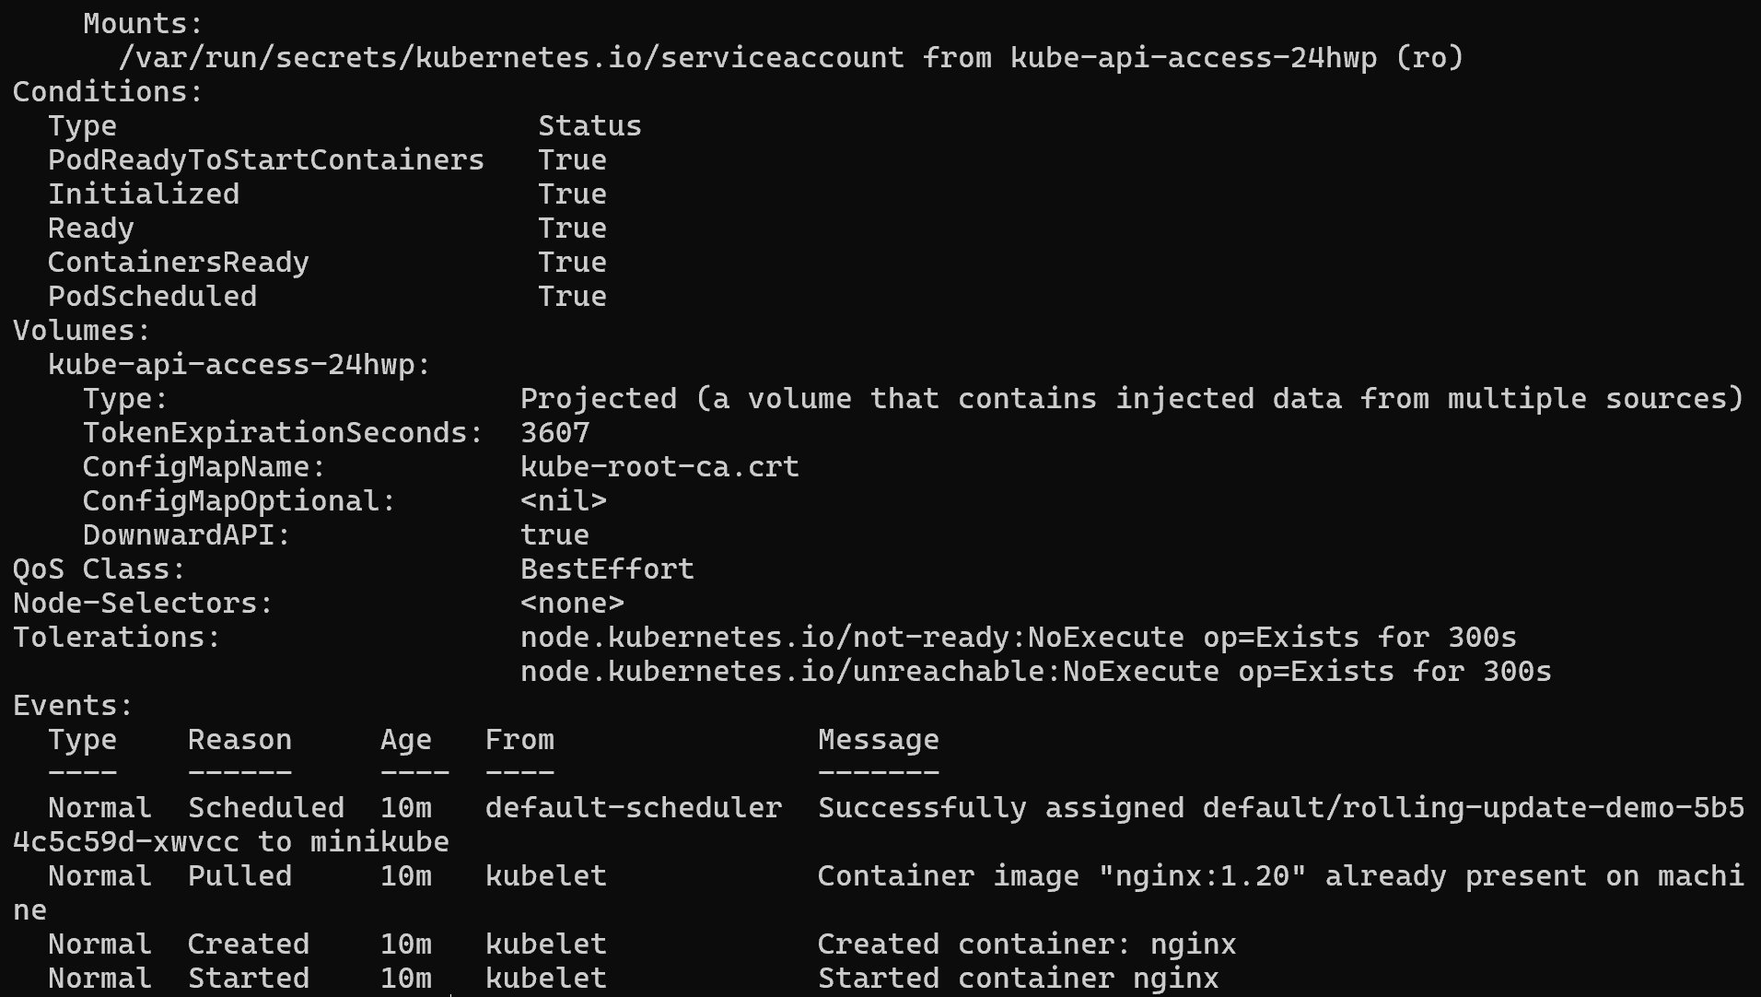
6.3.3 Run the get pods subcommand to list all Pods
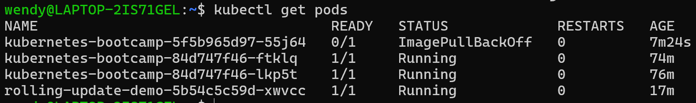
6.3.4 get more insight into the problem
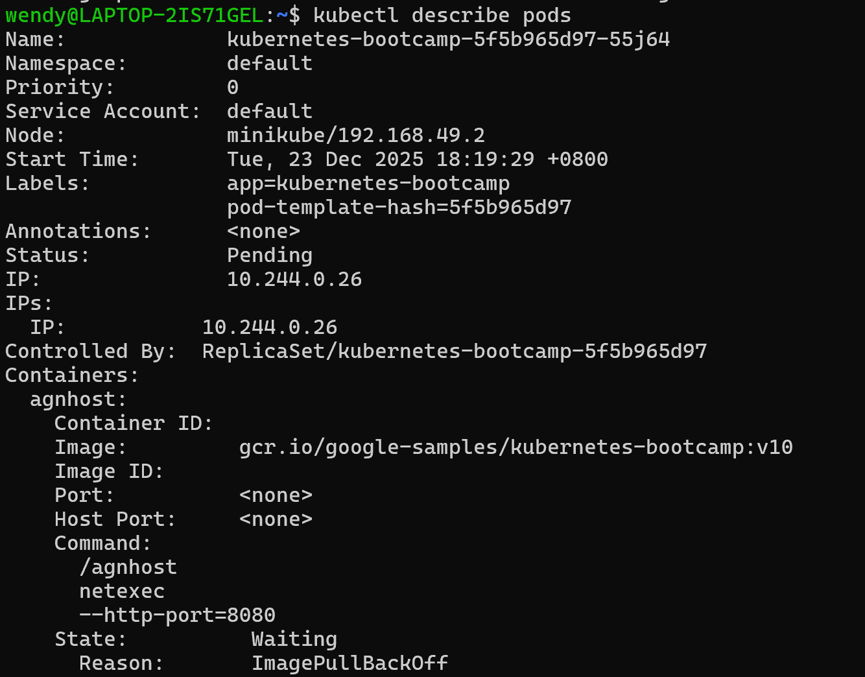
6.3.5 roll back the deployment to your last working version
6.3.6 list the Pods again
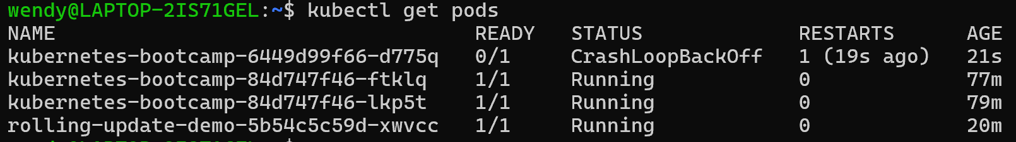
6.3.7 check the image deployed on the running Pods
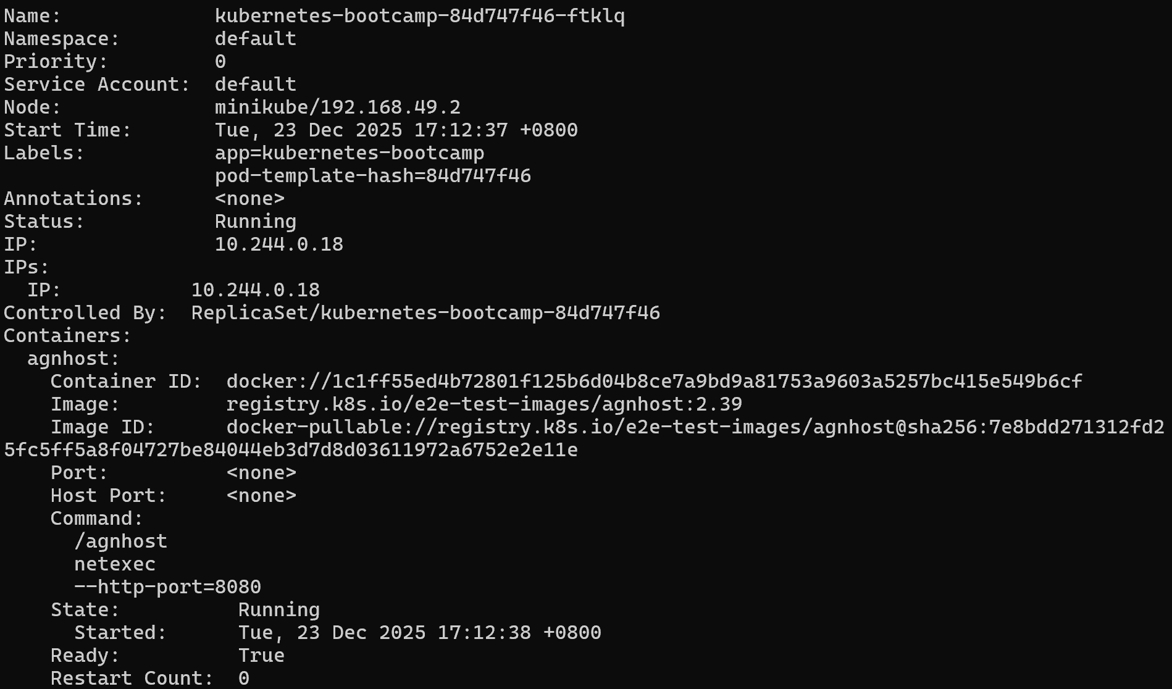
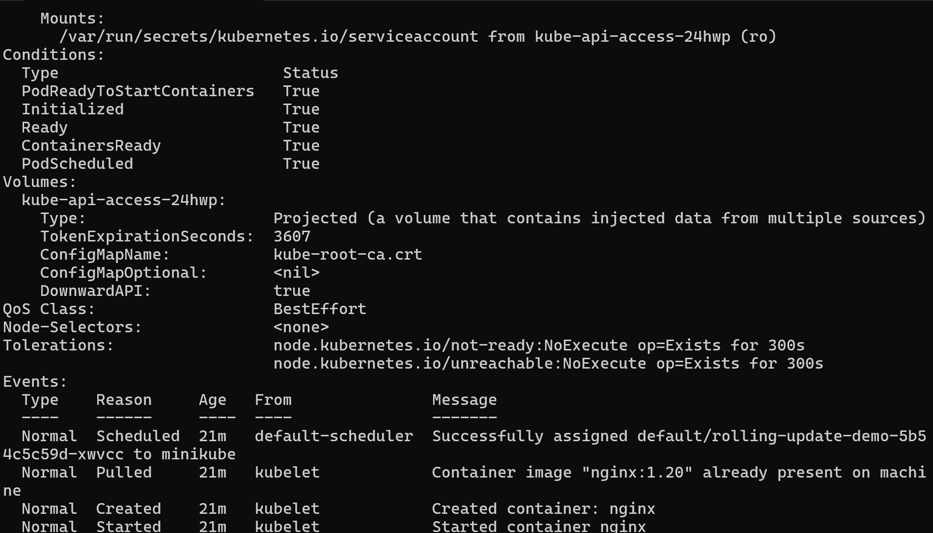
6.3.8 clean up your local cluster

