Lab 4:

- Install docker Desktop:
1.1Open terminal, and run: wsl --install
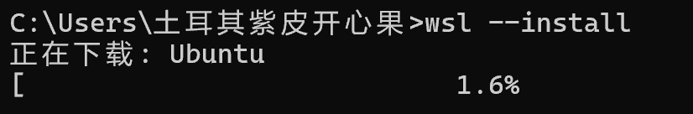
1.2Download Docker Desktop and install it.
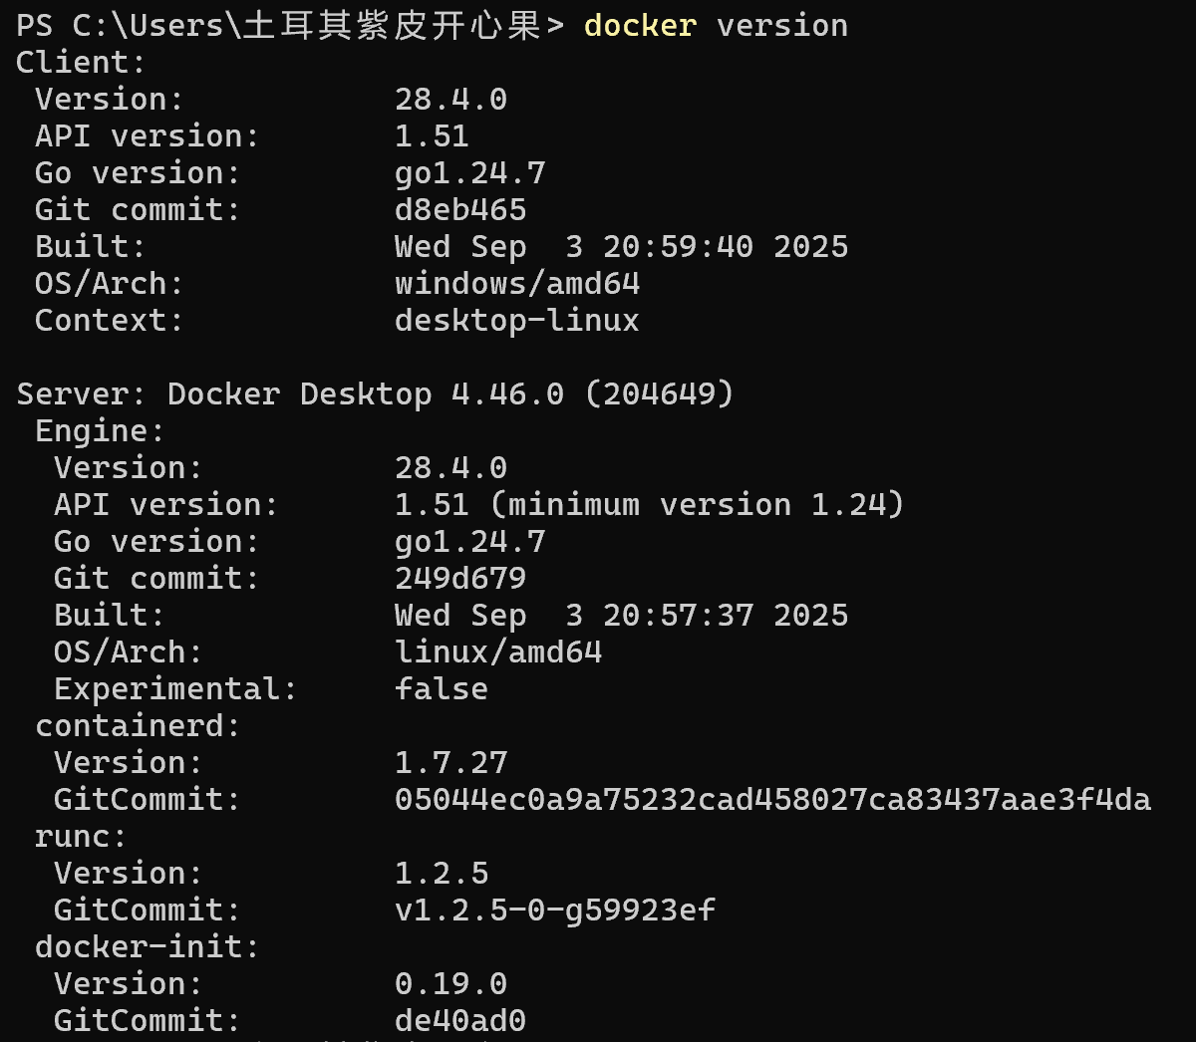
1.3You have to register it before use.
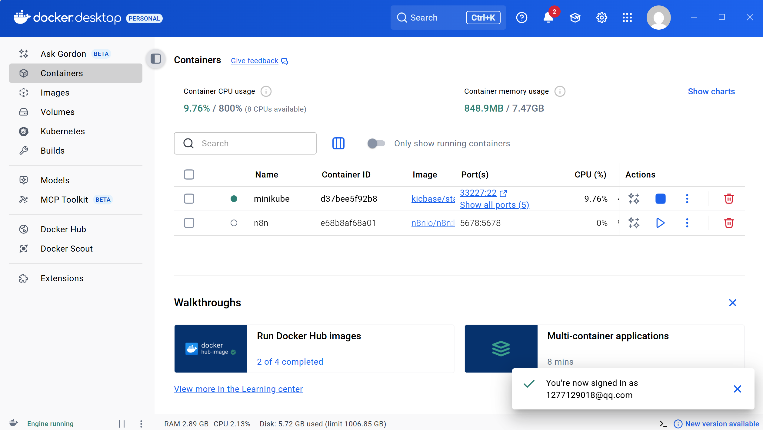
2.Install gitea using docker on your computer.
2.1 Environment Preparation：
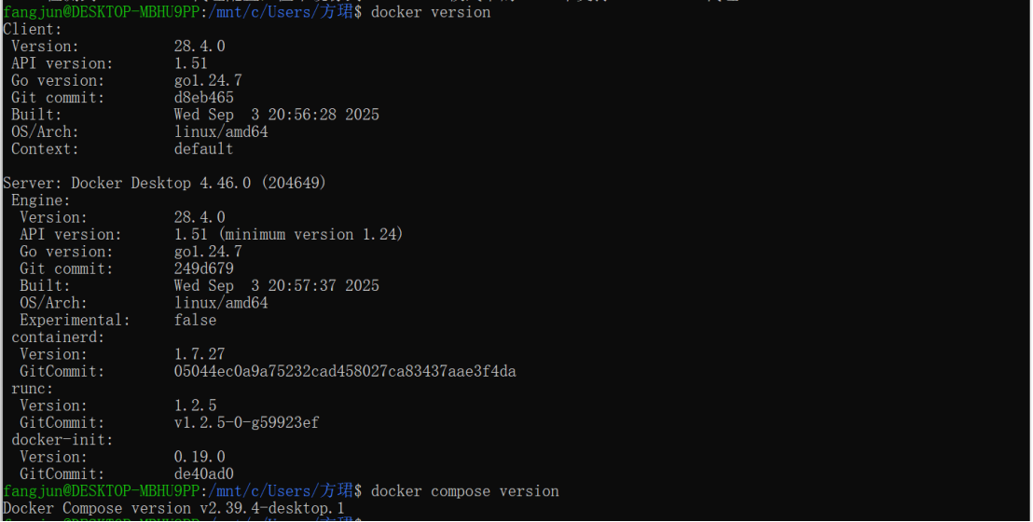
2.2Create project directory structure：
2.3Create file docker-compose.yml:
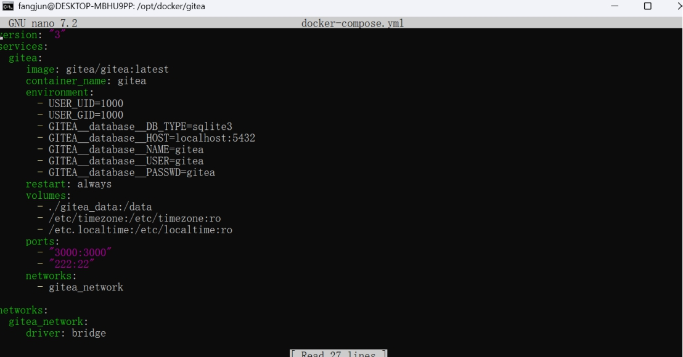
2.4:Start Gitea Container
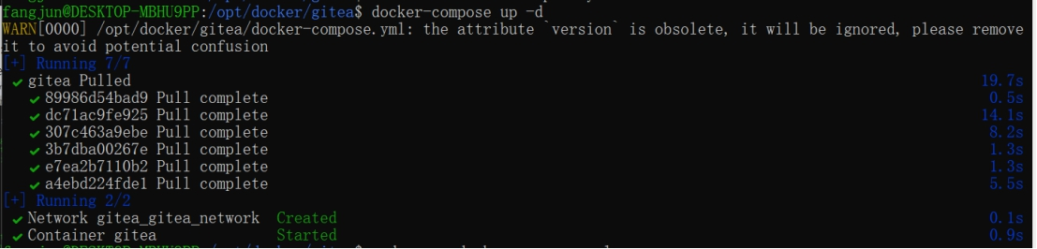

2.5Initial Gitea Setup Accessed http://localhost:3000
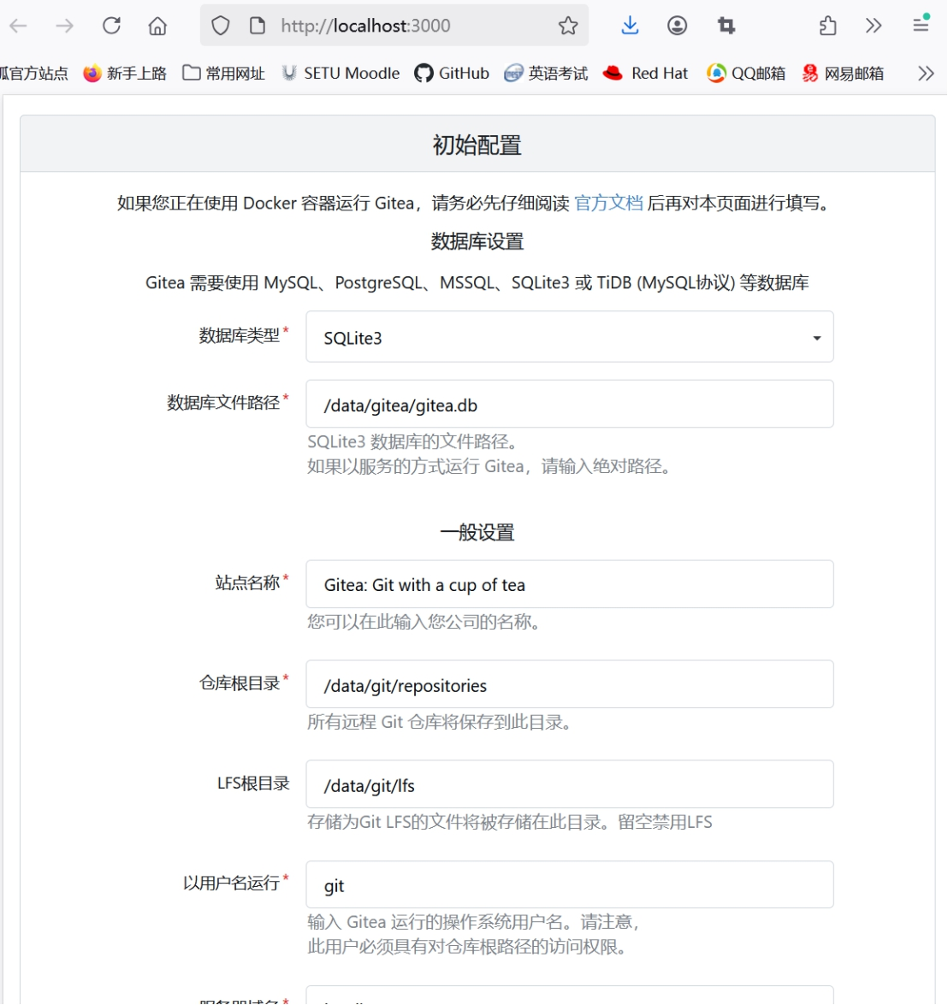

a. Does it support LFS? prove it.
LFS_START_SERVER = true
LFS_JWT_SECRET = uF4yx7UshRnf-2bLc1dzDeyvUED-7xQMwuiZ47_-uWs

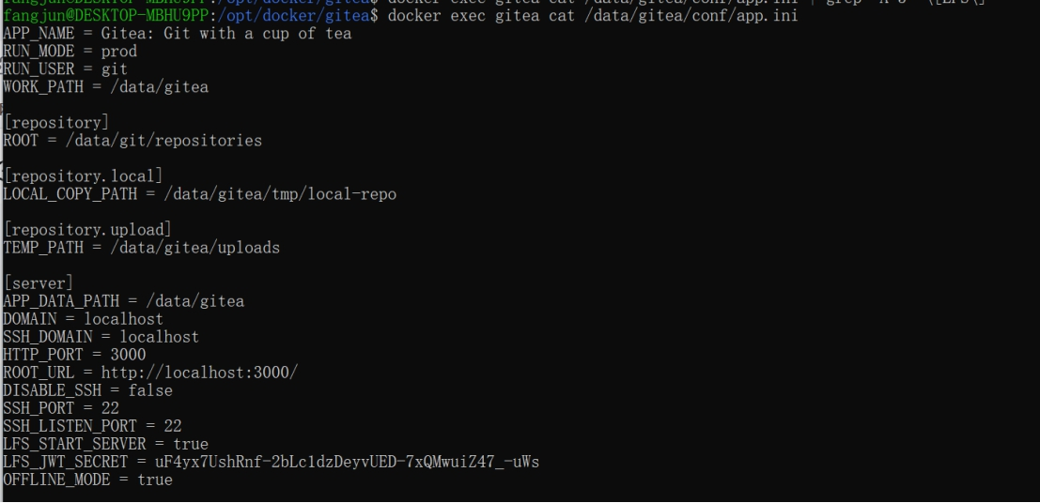

b. Create a repo with a large file (1G+)
- Create a repo with a large file (1G+)
Create New Repository: http://localhost:3000/admin/large-file-test.git
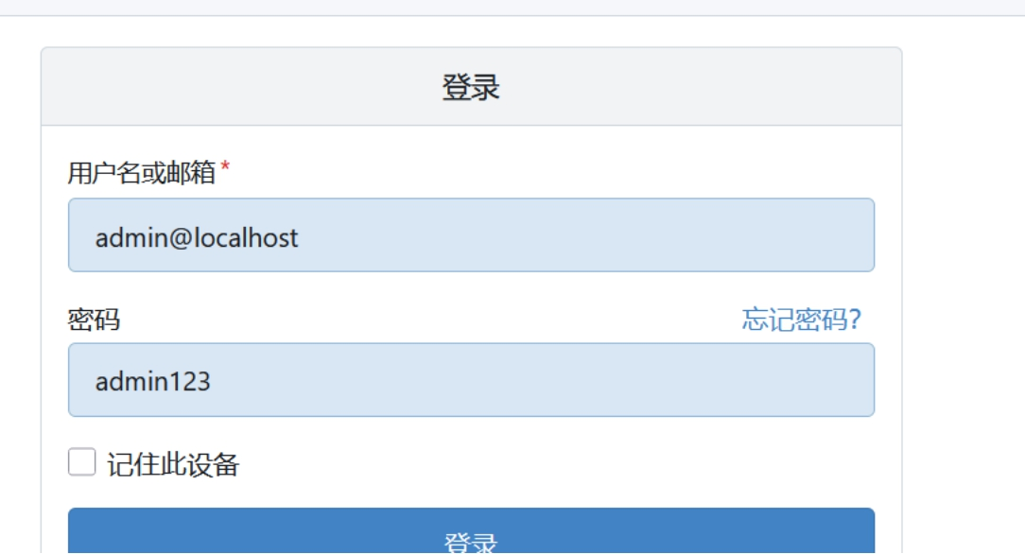
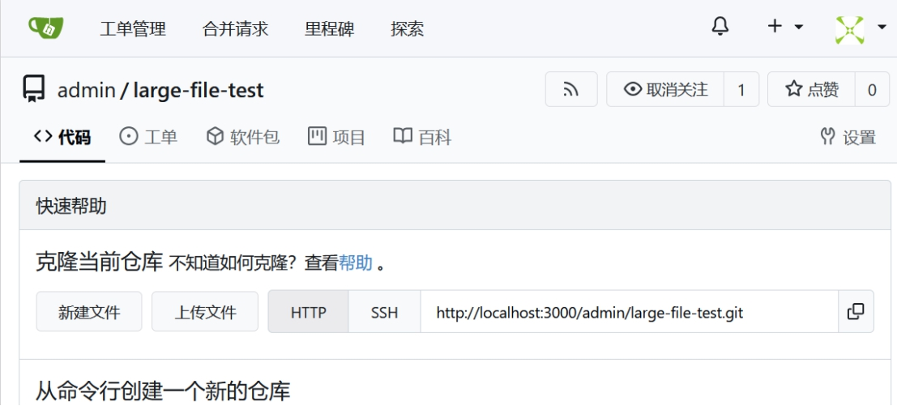
git clone http://localhost:3000/admin/large-file-test.git
# Initialize Git LFS
# Track large files
# Create and add 1GB+ test file
dd if=/dev/zero of=test.largefile bs=1M count=1200
git add .gitattributes test.largefile
git commit -m "Add 1.2GB test file via LFS"
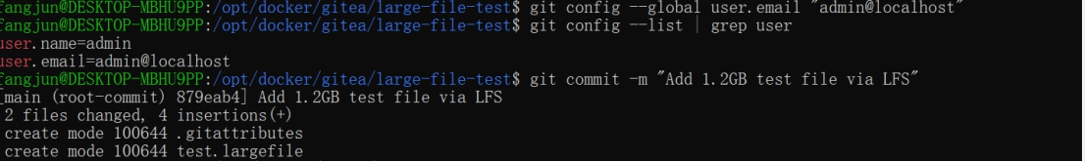
git push origin main
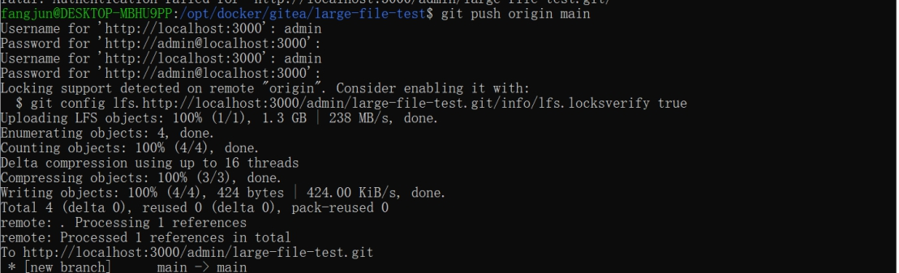
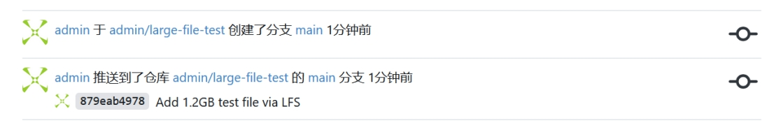

c. Create a repo for this module and commit your work to this repo.
Step 1: Create New Repository: academic-website
Description: "Personal academic website project"
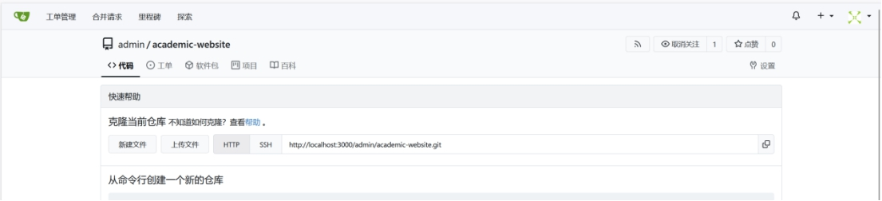
Step 2: Add Website Files
git clone http://localhost:3000/admin/academic-website.git
cd academic-website
# Copy all website files to repository
cp -r /path/to/website/* .

# Initial commit
git add .
git commit -m "Initial commit: Academic website with al-folio theme"
git push origin main
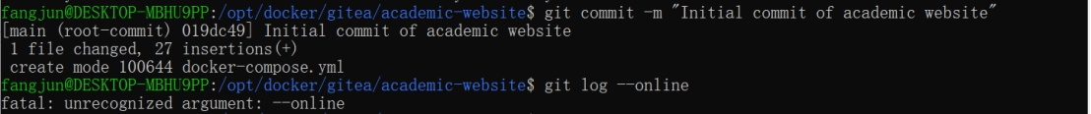
http://localhost:3000/admin/academic-website/commits/commit/1bfe053857c98e839d8173de46c94e9a55ad4f5e

d. [optional] Backup all data to an external harddrive/USB stick and restore it from another computer.
Install Dependencies
# Ubuntu/Debian
sudo apt update
sudo apt install git sqlite3

Download and Install Gitea Binary
wget -O gitea https://dl.gitea.com/gitea/1.21.0/gitea-1.21.0-linux-amd64
chmod +x gitea
sudo mv gitea /usr/local/bin/

Create System User
sudo adduser --system --group --disabled-password --shell /bin/bash --home /home/git --gecos 'Git Version Control' git

Create Configuration Directory
sudo mkdir -p /etc/gitea
sudo chown root:git /etc/gitea
sudo chmod 770 /etc/gitea

