Before begin:This lab exercise will give you hands-on experience with Knative for building, deploying, and managing serverless, cloud-native applications on Kubernetes.

1.Installing Knative Serving using YAML files

1.Install the Knative Serving component
Network timeout issue, using the 'offline file installation' method

1.Install the required custom resources
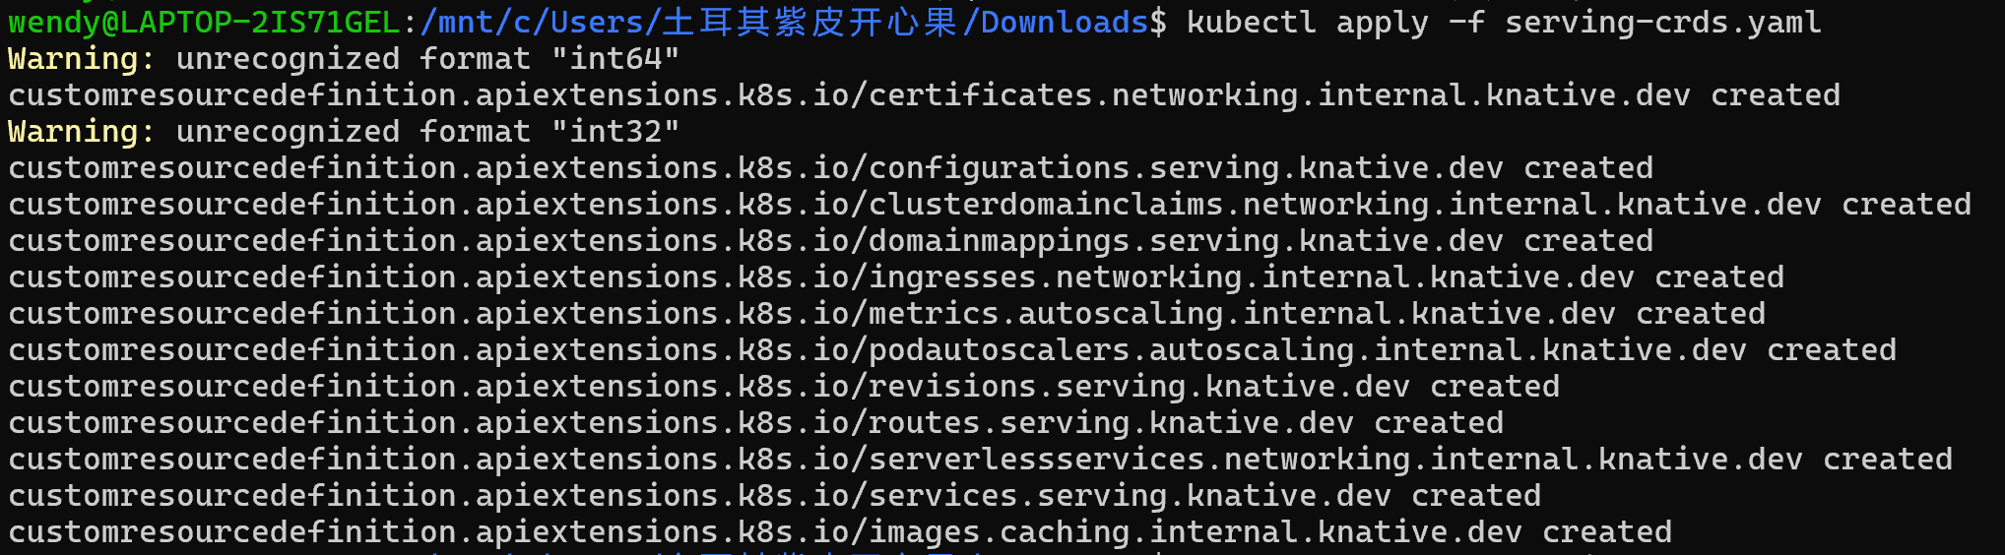
2.Install the core components of Knative Servin
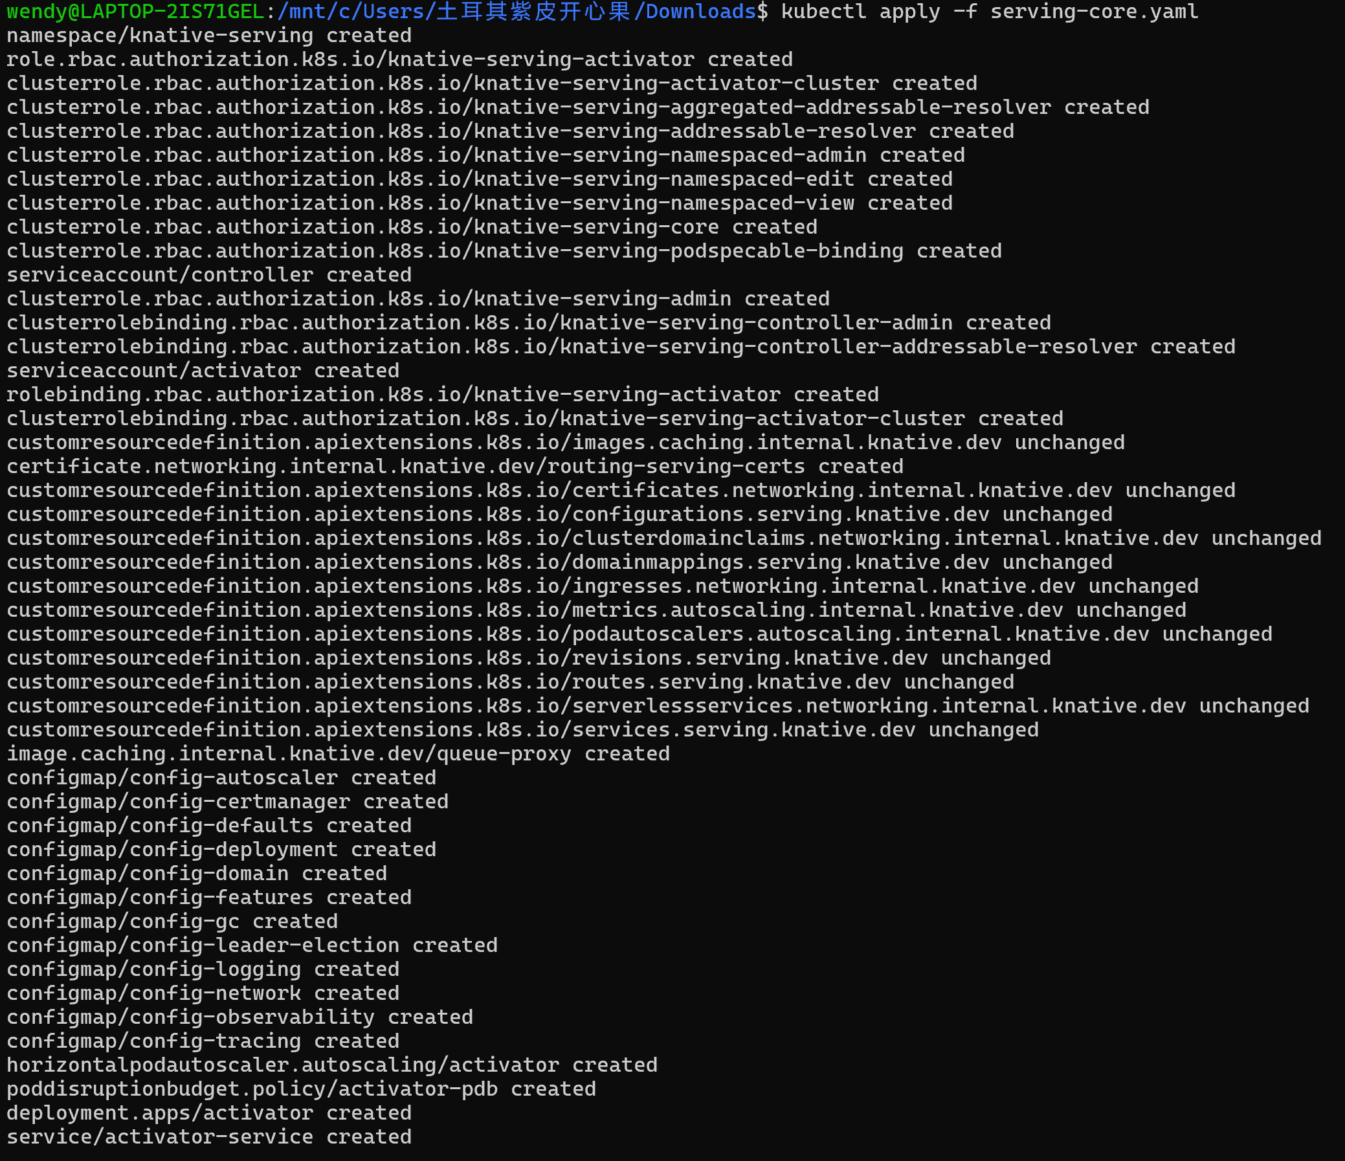

2.Install a networking layer----Kourier
1.Install the Knative Kourier controller
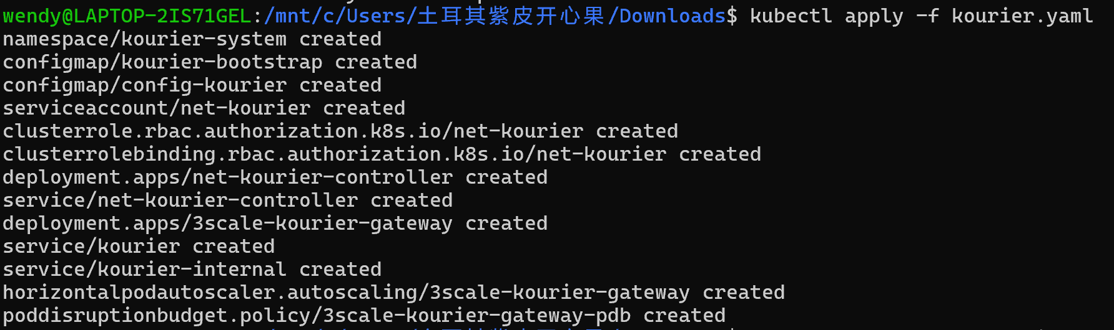
2.Configure Knative Serving to use Kourier by default
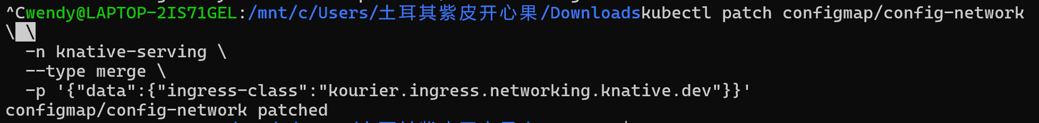
3.Fetch the External IP address or CNAME

3.Verify the installation
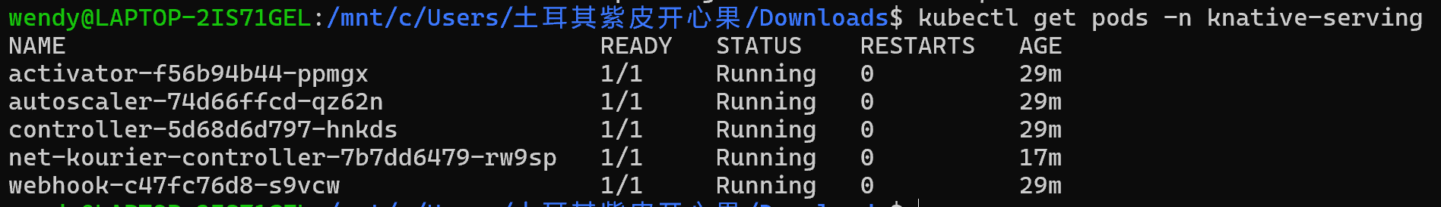

4.Configure DNS
configure DNS to prevent the need to run curl commands with a host header

5.Install optional Serving extensions
1.Configure Knative to use a domain reachable from outside the cluster:
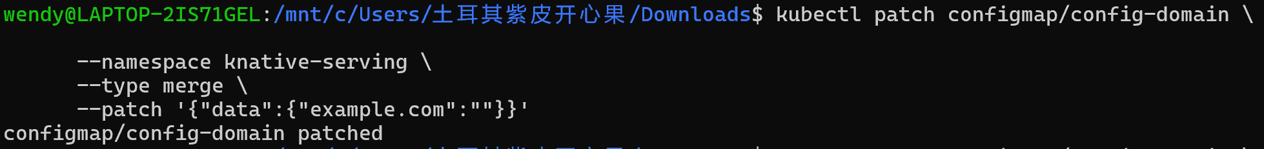
2.After starting your application, get the URL of your application:
3.Instruct curl to connect to the External IP or CNAME defined
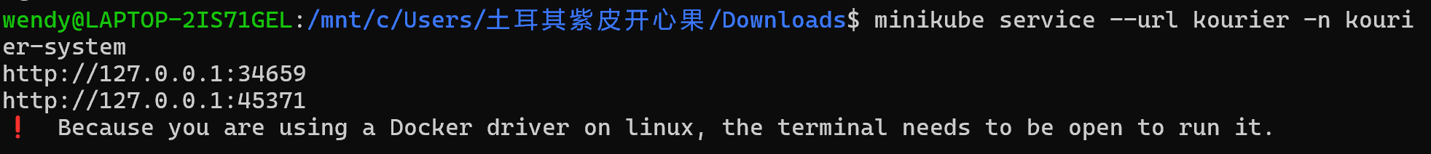

6.Install optional Serving extensions
Install the components needed to support HPA-class autoscaling

2.Knavtive Eventing setup

1.Install the Knative Eventing component
1.Install the required custom resource definitions (CRDs)
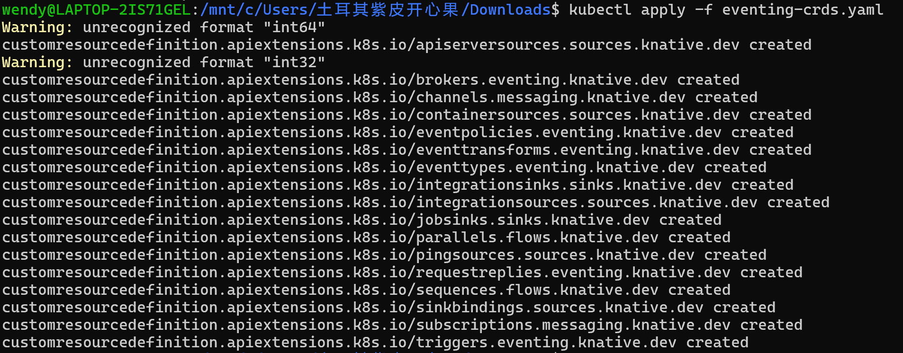
2.Install the core components of Eventing
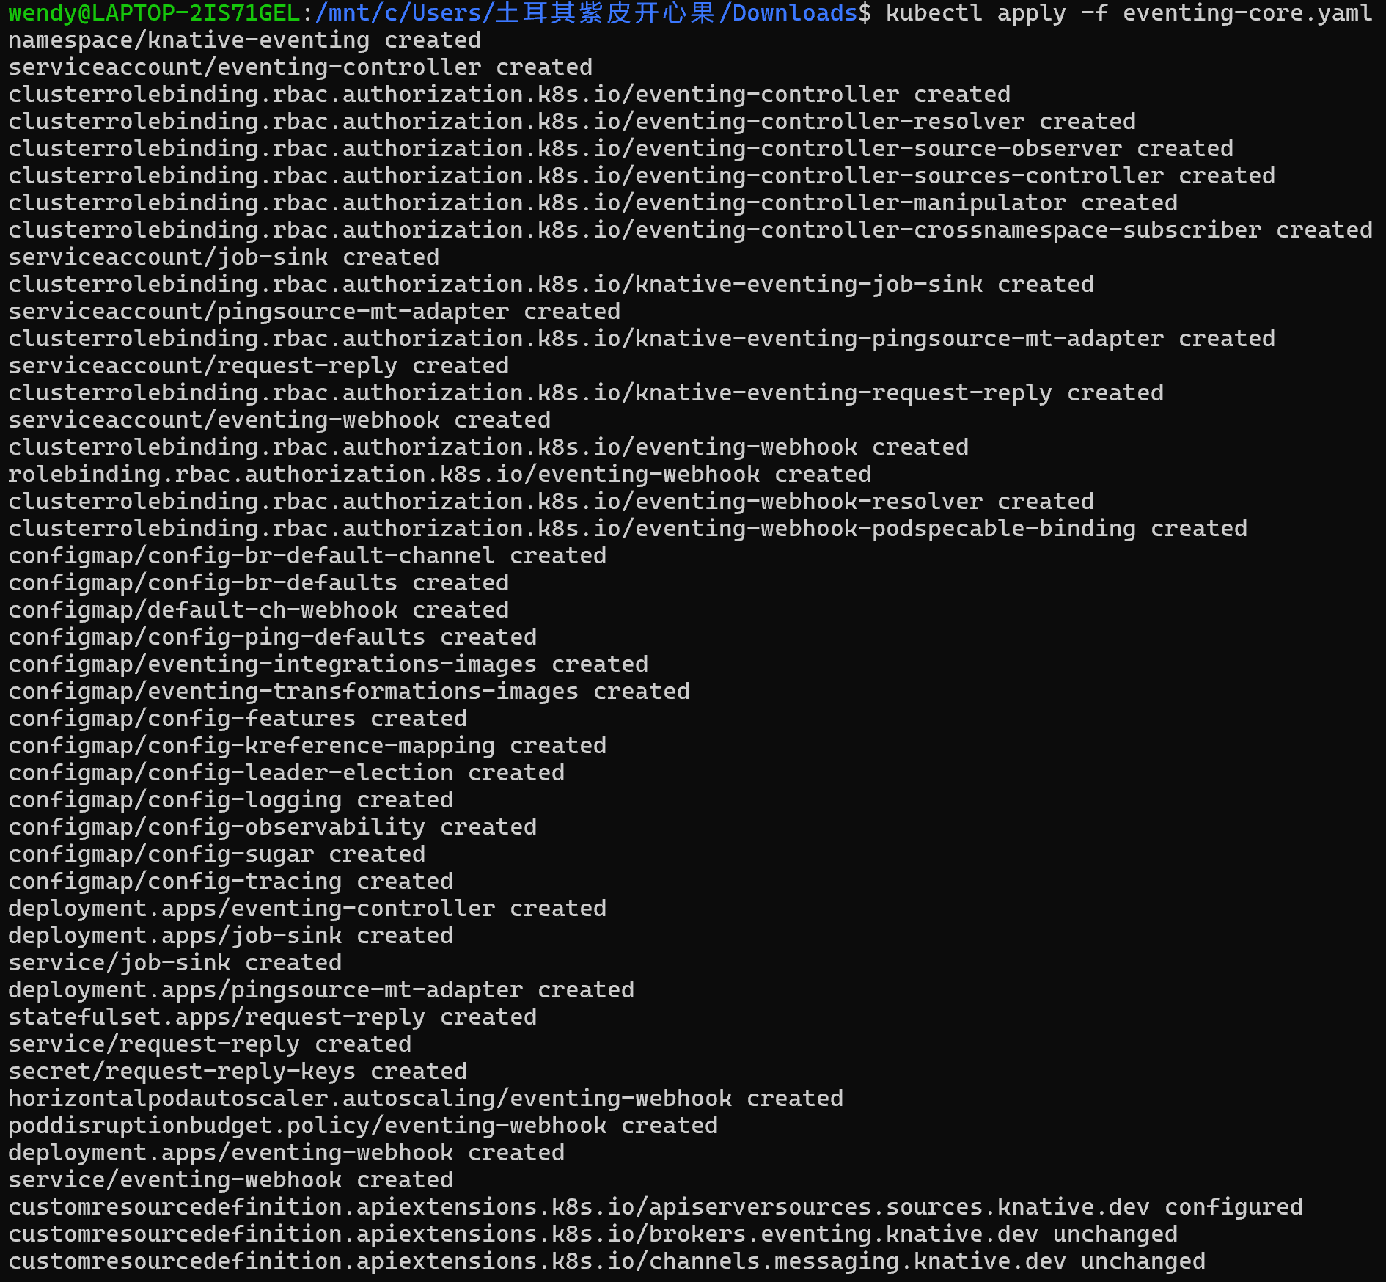
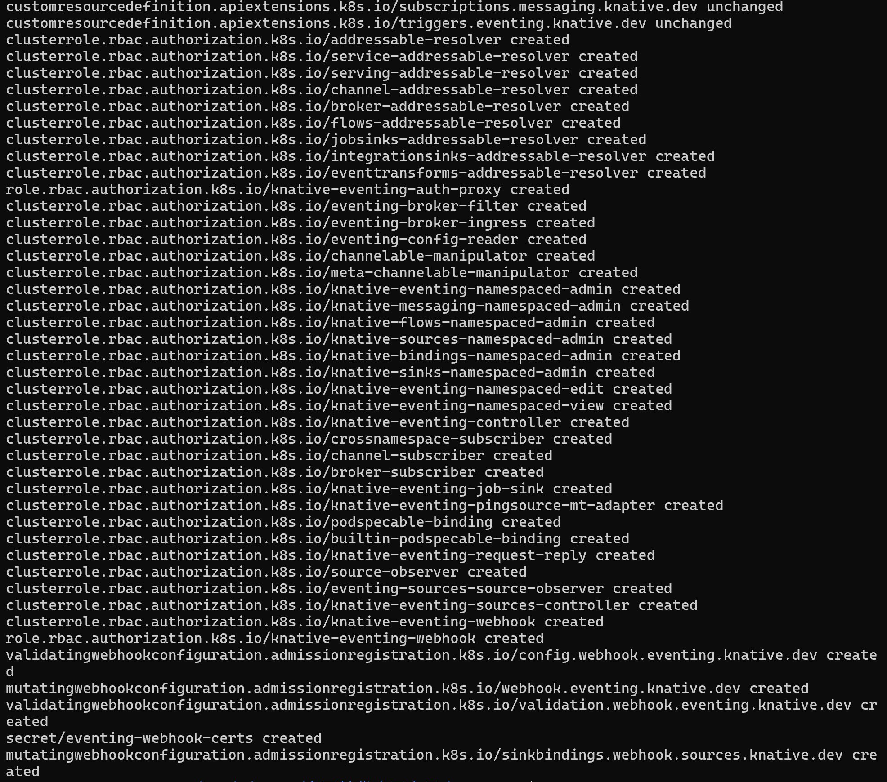

2.Verify the installation
Monitor the Knative components until all of the components show a STATUS of Running or Completed
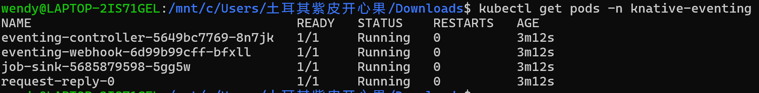

3.Optional: Install a default Channel (messaging) layer
Install an in-memory implementation of Channel
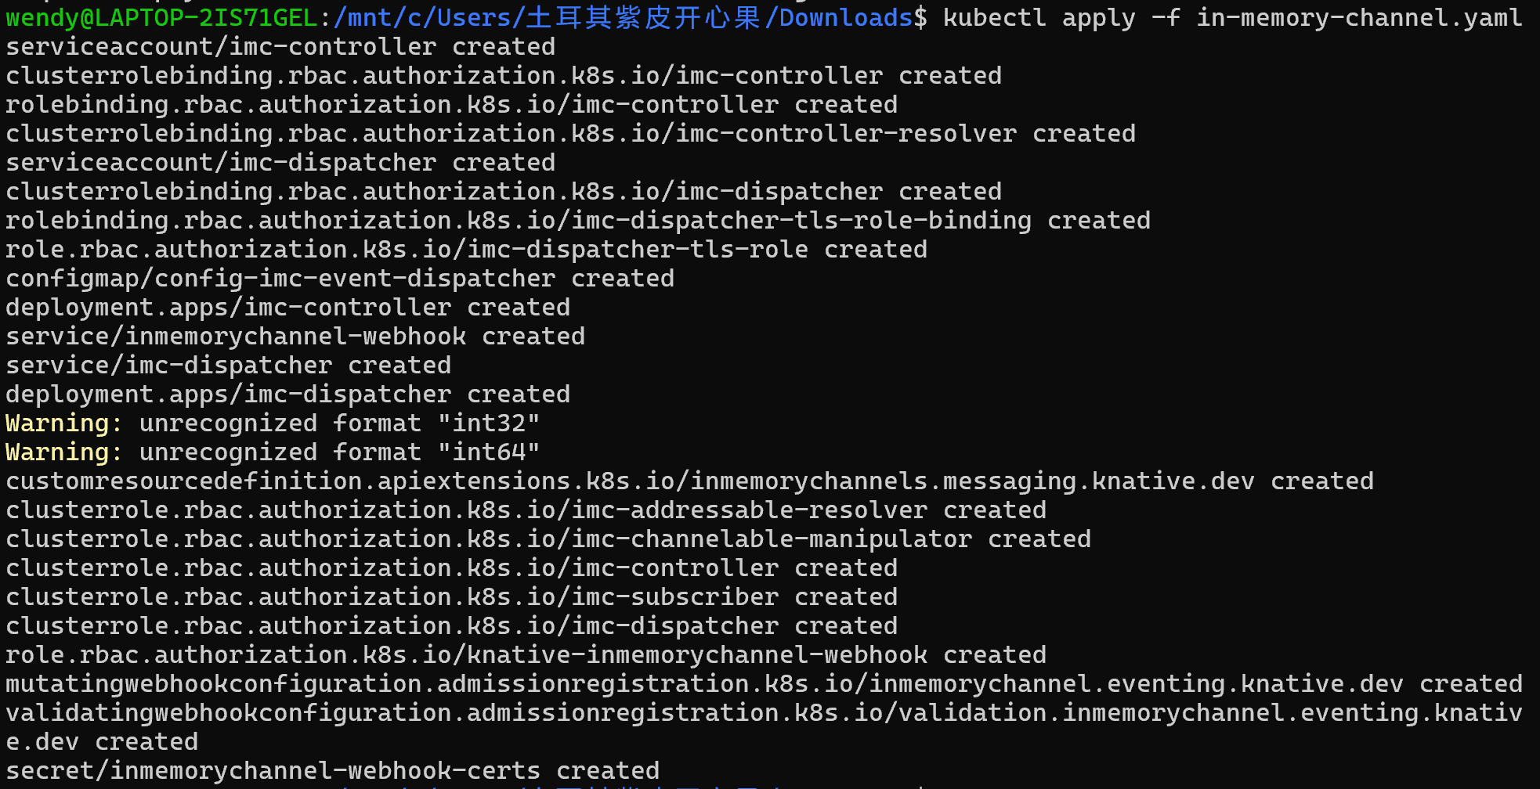

4.Optional: Install a Broker layer
Install this implementation of Broke
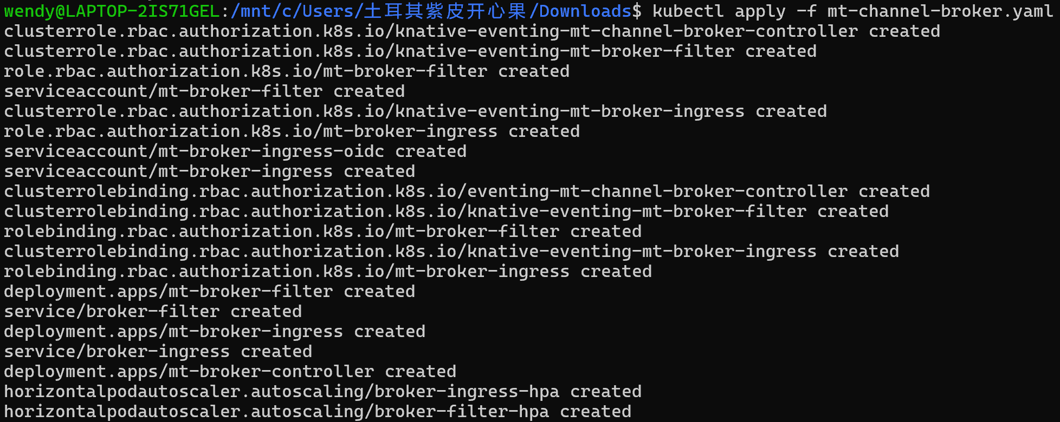
Create a default Broker instance
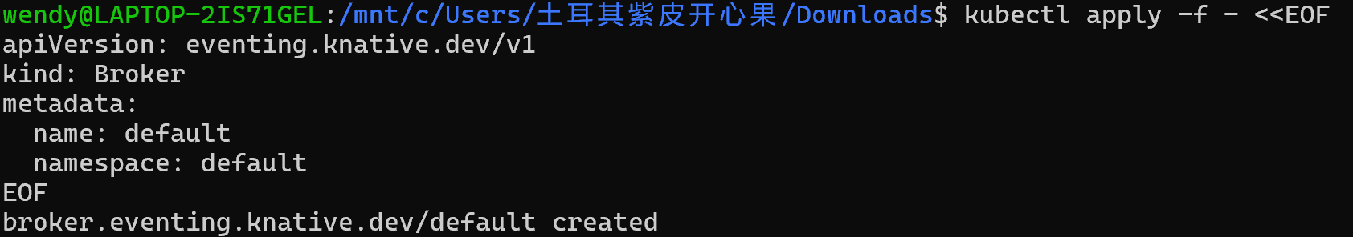
Verify Broker

5.Install optional Eventing extensions
1.Install the Kafka controller
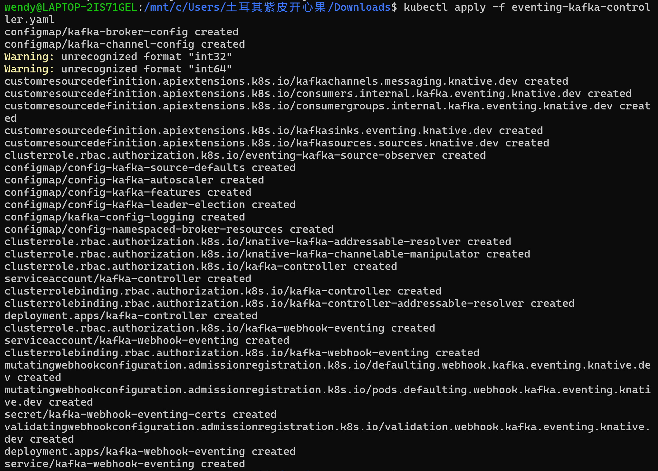
2.Install the Kafka Sink data plane
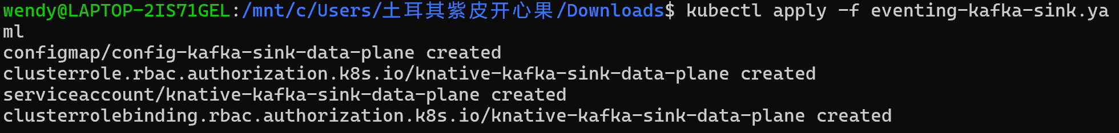

Knative Functions
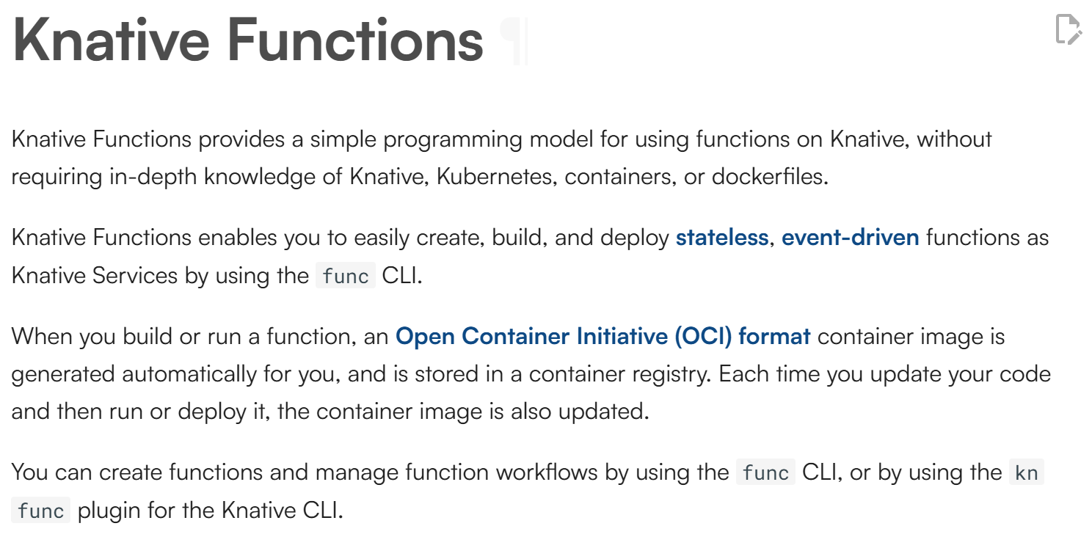
Knative Serving
Deploy the Service by running the command
hello the service already exists,Create a new service with a different name:
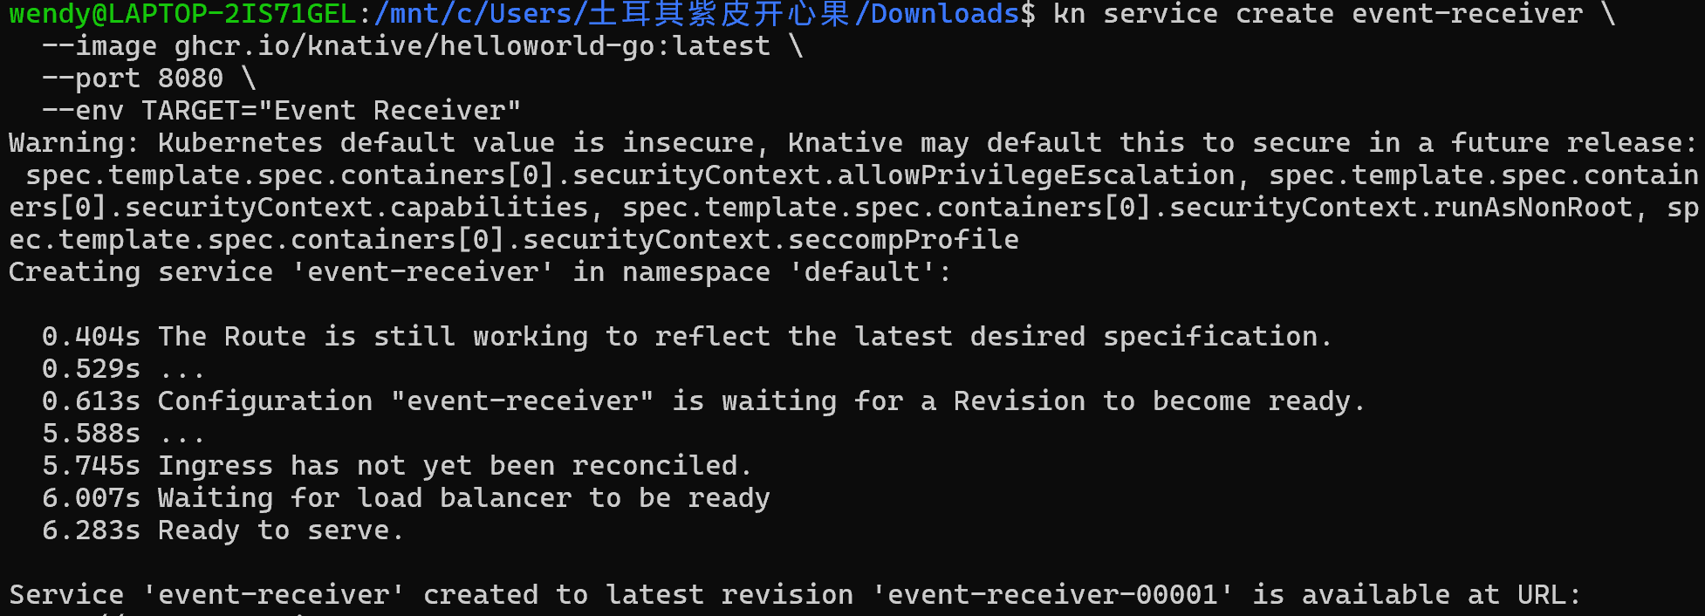
Knative Eventing
