Deploying a Predictive Model with KServe on Minikube

1. Install and configure KServe on a local Kubernetes cluster (Minikube)
1.1Install missing dependencies
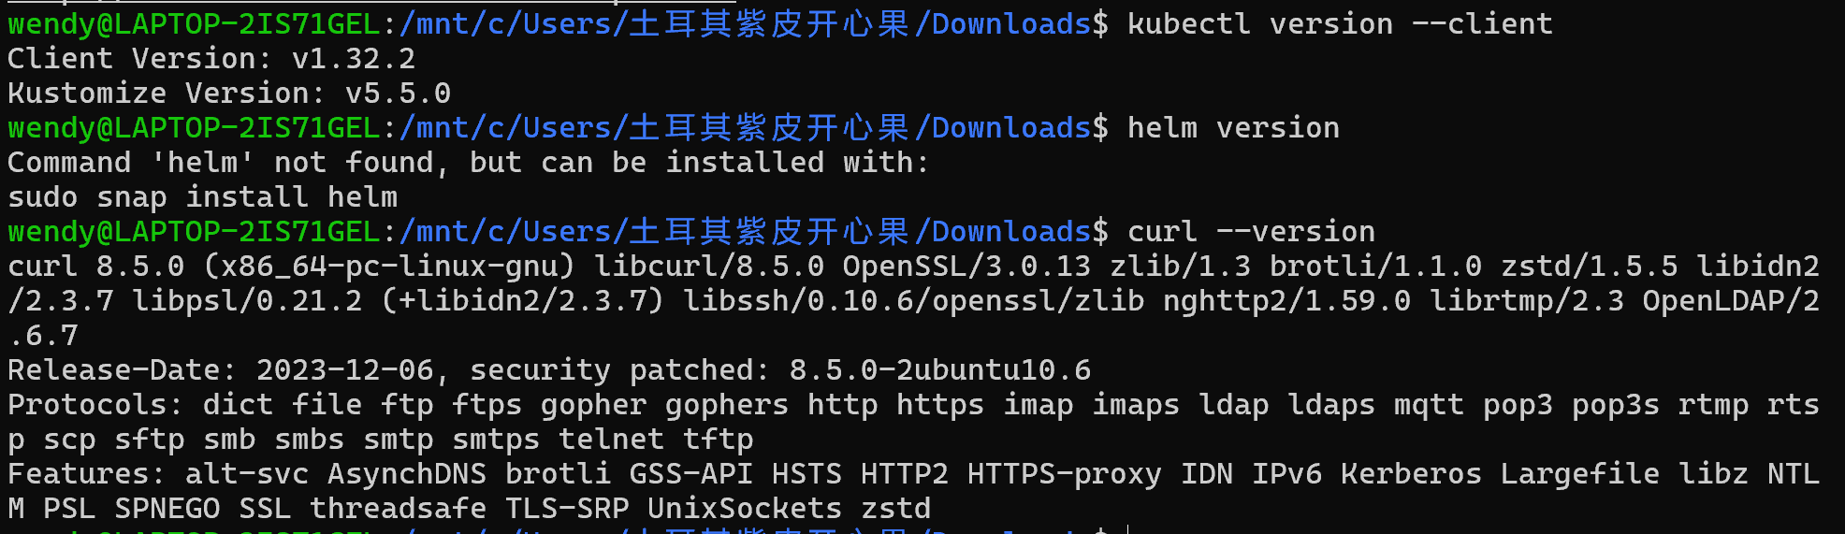
Install helm
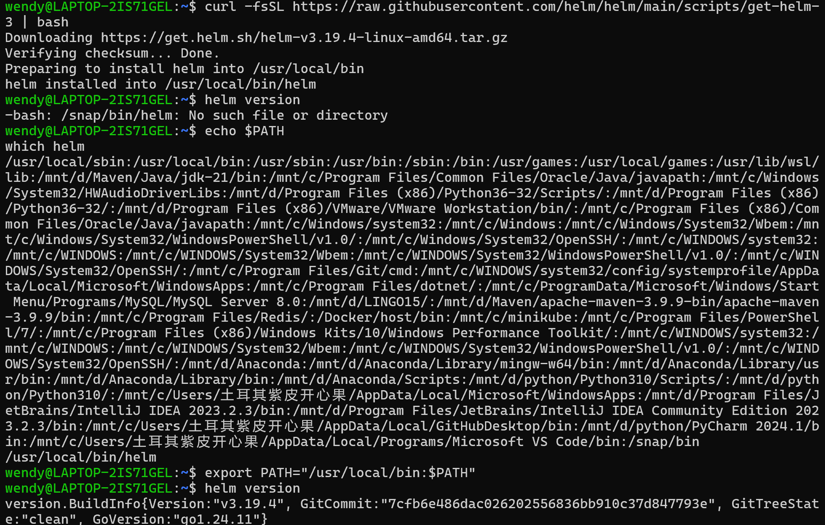

1.2Install KServe Quickstart Environment
1.2.1 Quick Install----Predictive AI
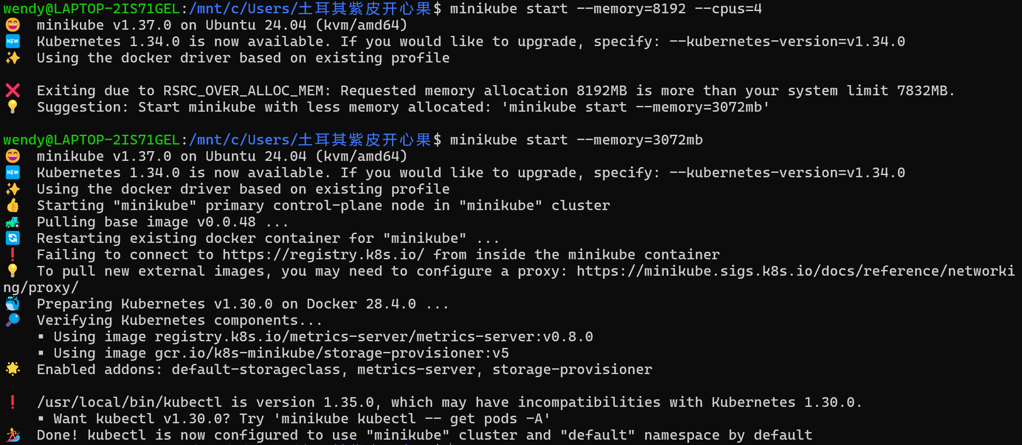
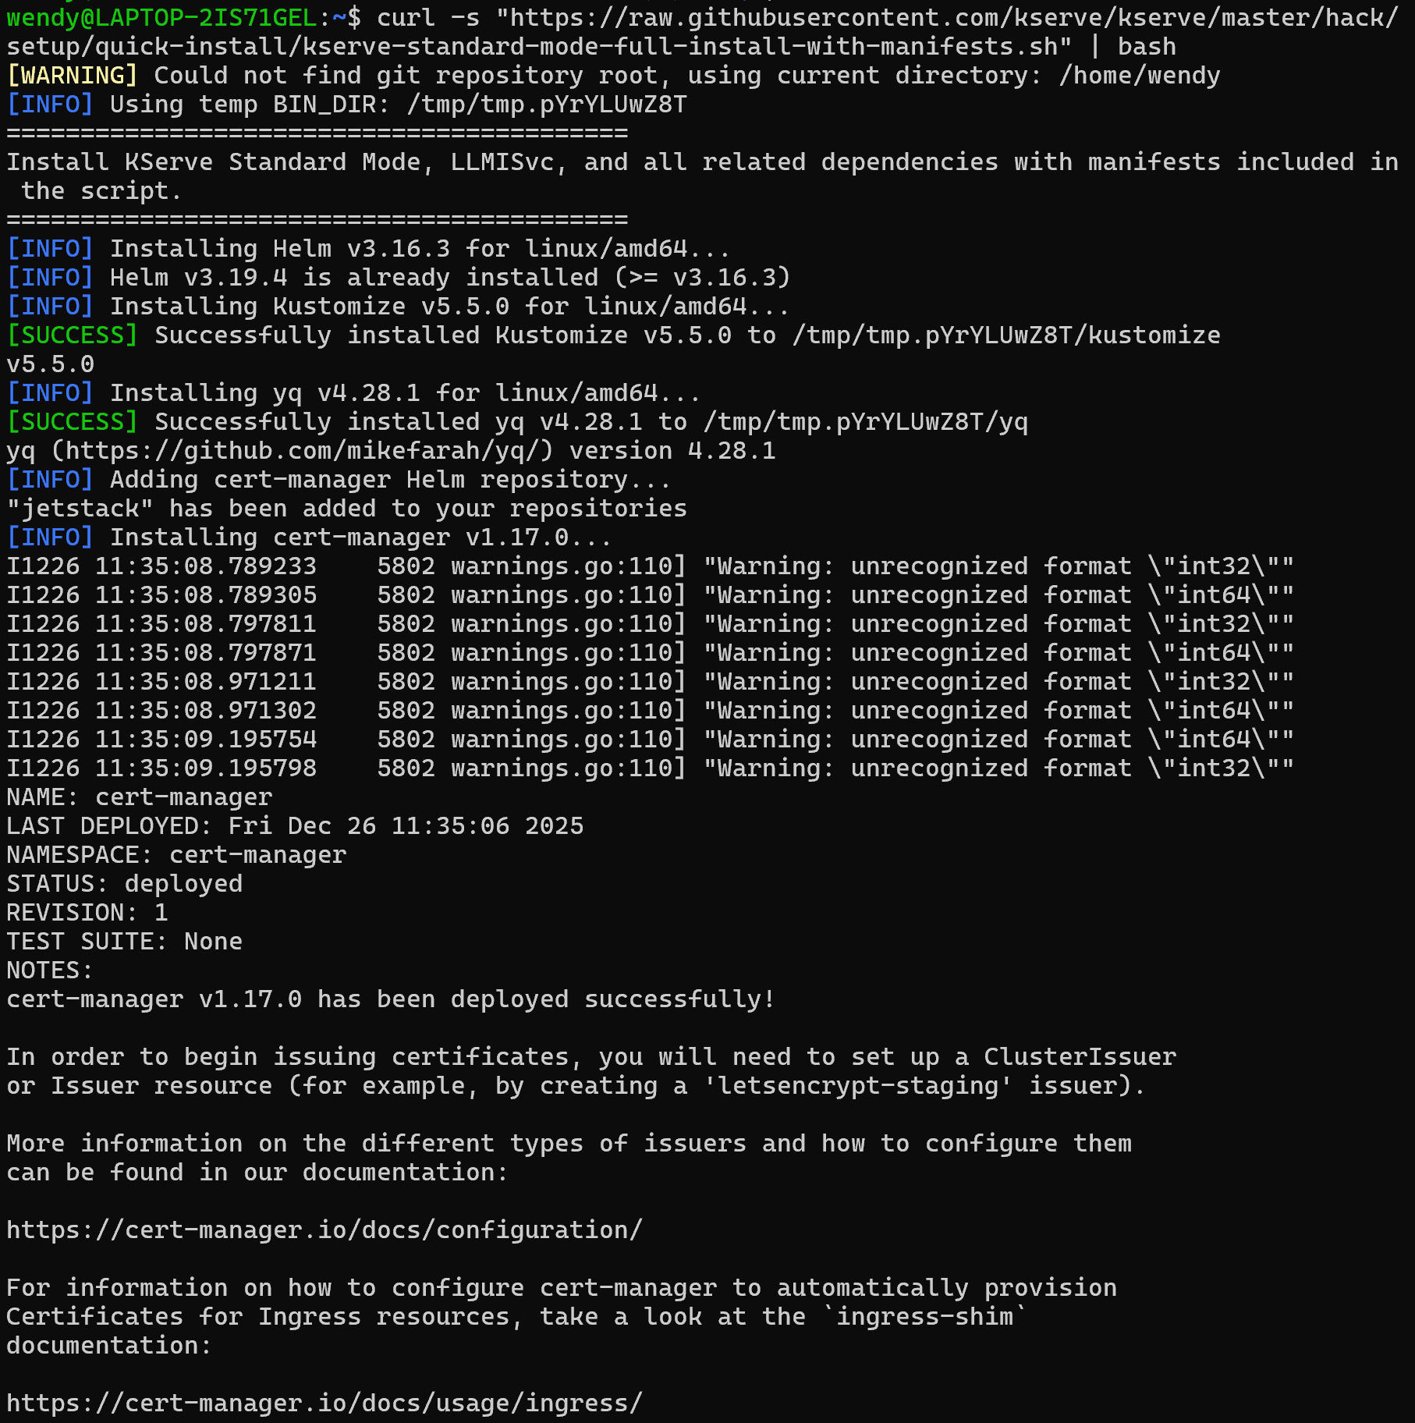
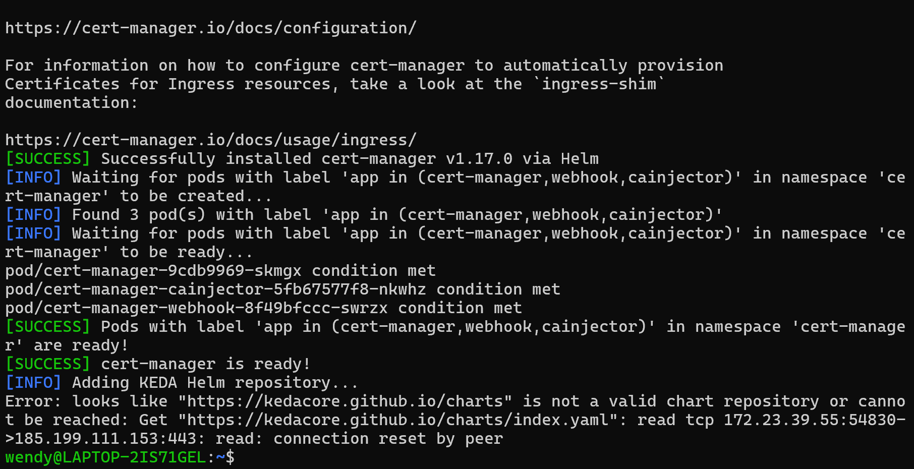
1.2.2Verify Installation----After installation, verify all components are working:
2. Deploy a predictive model using a KServe InferenceService
2.1.Create a namespace
2.2.Create an InferenceService----yaml
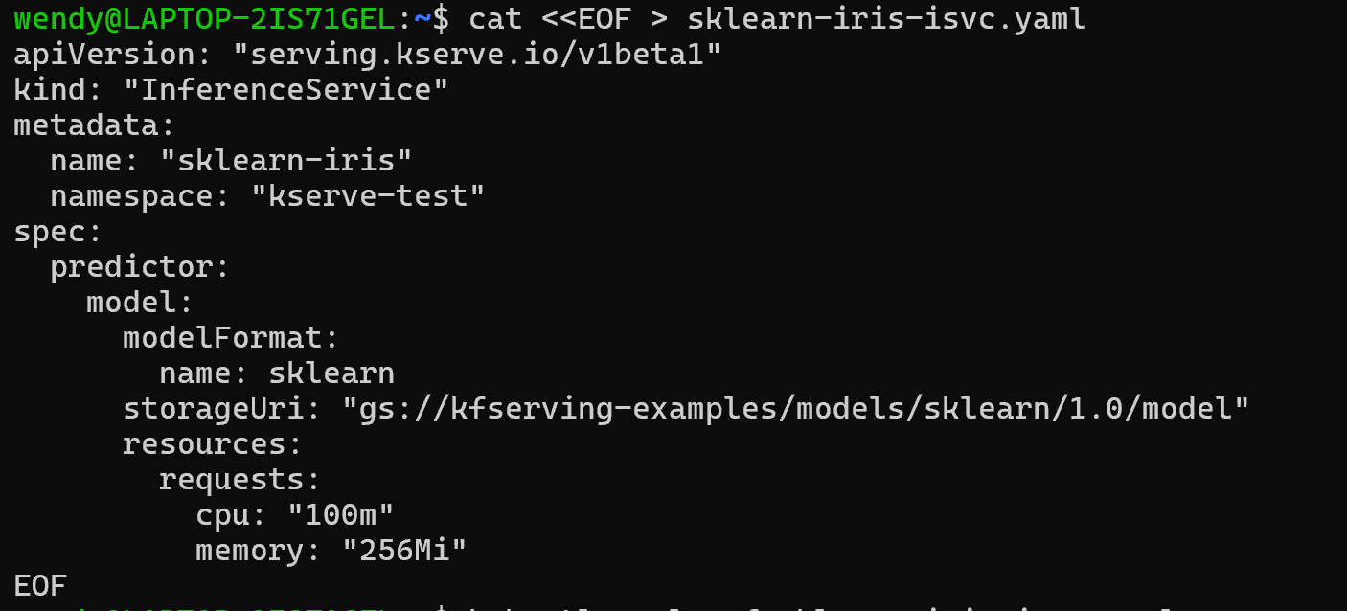
2.3.Check InferenceService status
2.4. Determine the ingress IP and ports
2.5. Perform inference
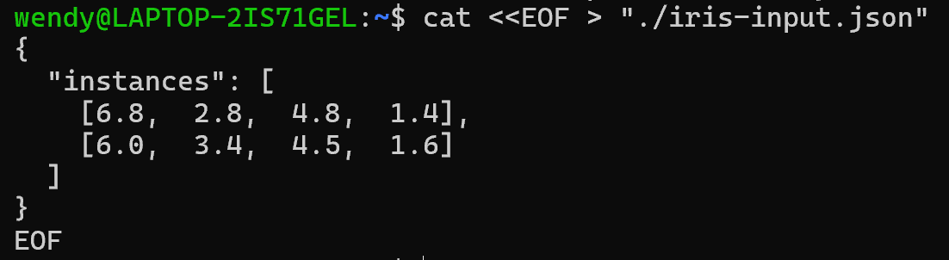

3. Monitor the status of the service and debug common issues
Check InferenceService Status:
Monitor Pod Status
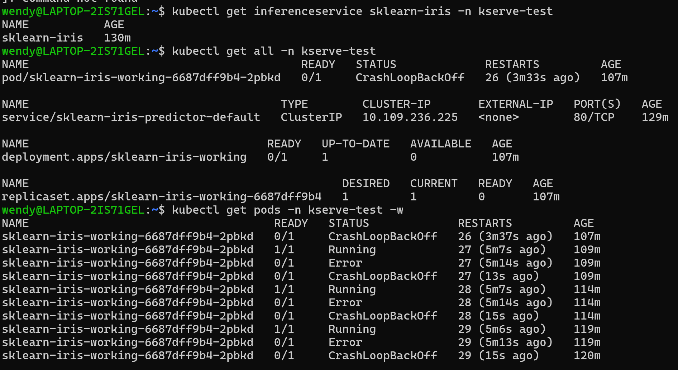
Check Logs for Debugging
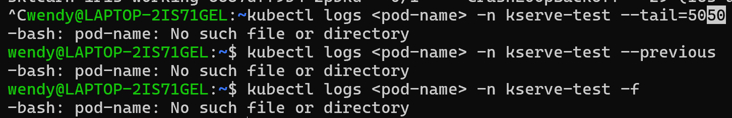
4. Find out how to reach the InferenceService from outside the cluster.
Methods for External Access
Port Forwarding (Recommended for Development)
Service Discovery Patterns
Internal Cluster Access
Method | Pros | Cons | Use Case
Port Forwarding | Simple, no config needed | Temporary, single connection | Local development
Minikube Tunnel | Simulates LoadBalancer | Requires separate process | LoadBalancer testing
NodePort | Direct node access | High port numbers, security | Quick external access
Ingress | Host-based routing, TLS | Complex setup | Production-like setup

5. Send inference requests and interpret results
Preparing Inference Requests
KServe supports two main request formats
Instances Format (Legacy):
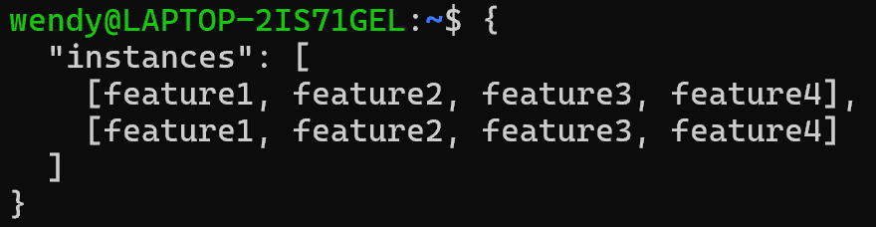
Inputs Format:
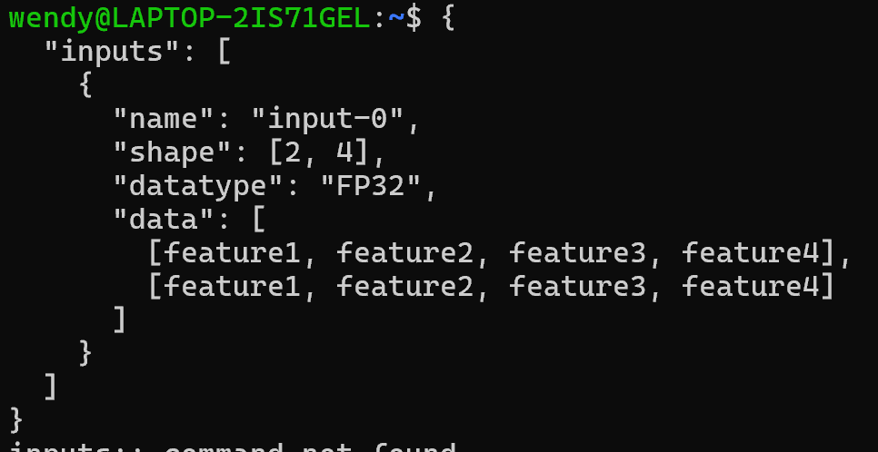
Sample Data Preparation
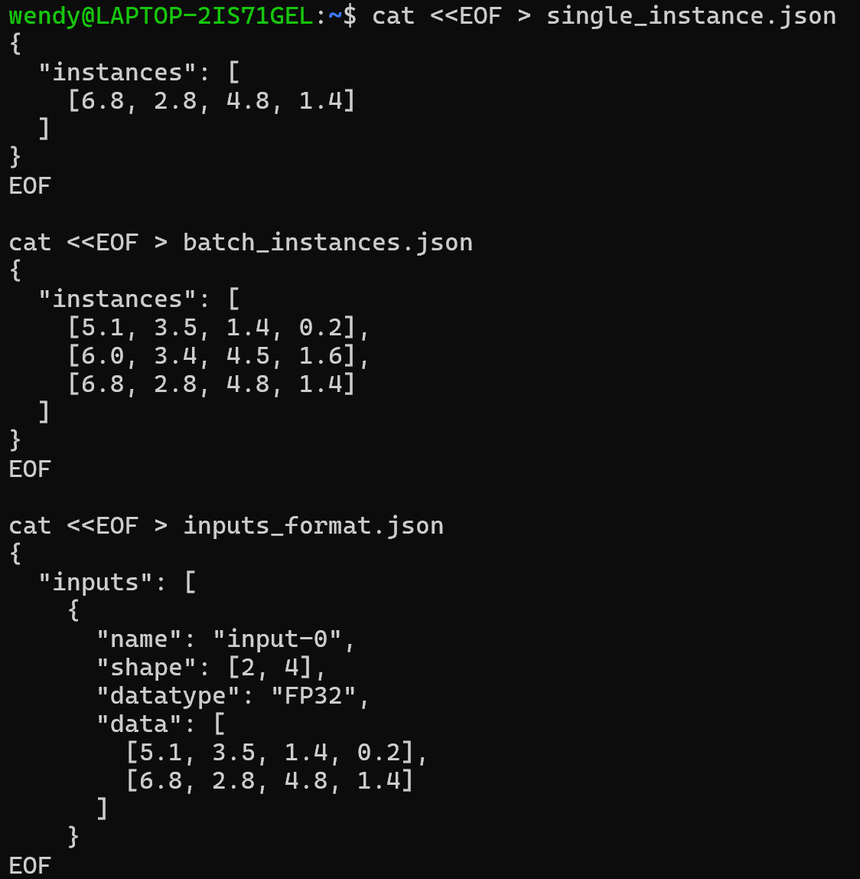
Sending Inference Requests
Basic Inference Request
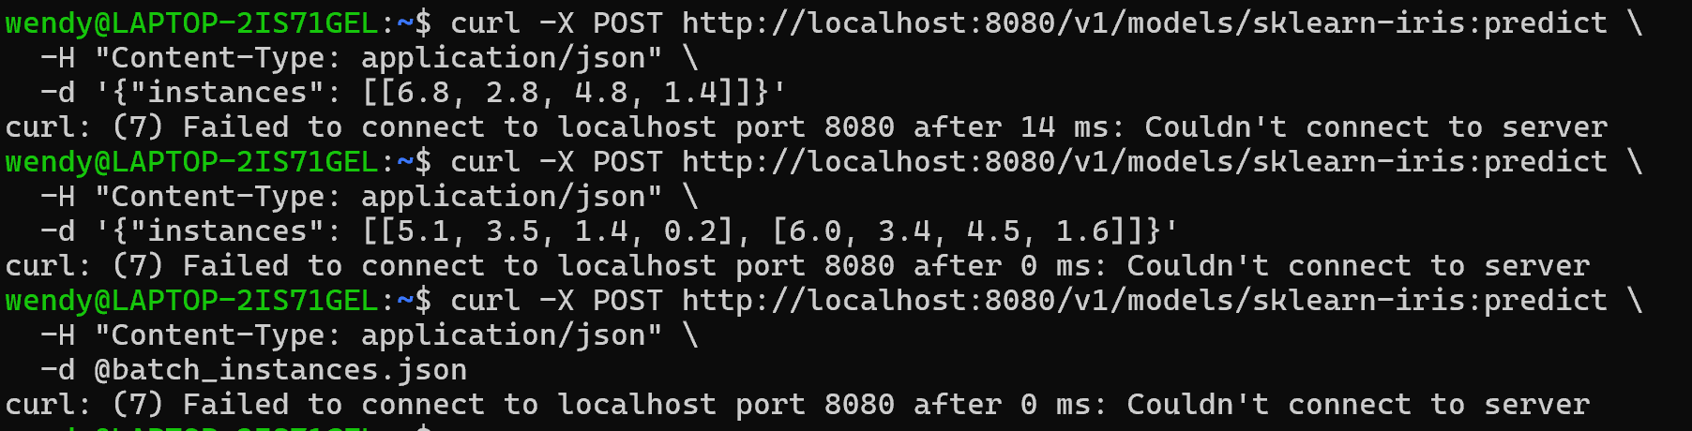

Interpreting Results
Understanding Iris Dataset Classes
The Iris dataset has three classes:

0: Iris Setosa

1: Iris Versicolour

2: Iris Virginica

Advanced Inference Patterns
Custom Headers and Parameters
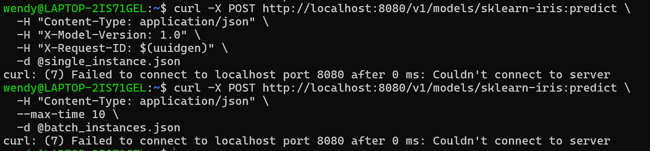

Troubleshooting Inference Issues
Problem: Empty or null predictions
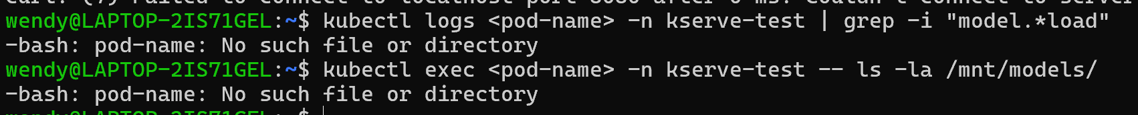
Problem: Wrong prediction values
Problem: Timeout errors

Summary
This experiment successfully demonstrated:

1.Comprehensive Monitoring: Established procedures for checking KServe service status, diagnosing common issues like webhook failures and container crashes.

2.Multiple External Access Methods: Implemented and tested port forwarding, Minikube tunnel, NodePort, and Ingress configurations for accessing InferenceService from outside the cluster.

3.Complete Inference Workflow: Developed end-to-end inference request patterns, including request preparation, sending predictions, and interpreting results for the Iris classification model.

The experiment confirmed that KServe provides a robust, production-ready platform for serving machine learning models, with proper monitoring, external access capabilities, and standardized inference interfaces.

