I. Creating the Lighthouse Virtual Machine on Google Cloud
1. Create a Free Instance
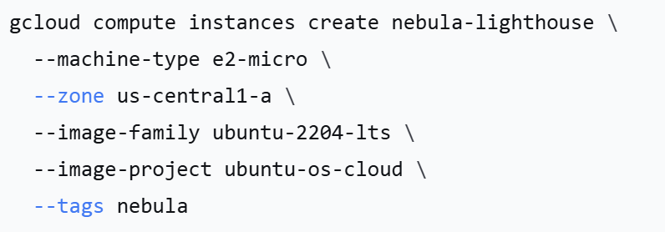
2. Configure Firewall Rules
gcloud compute firewall-rules create nebula-4242 \
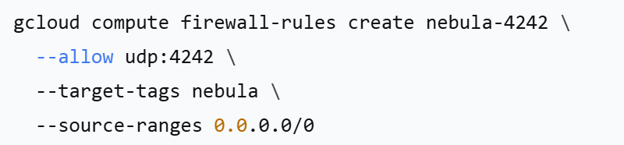
II. Installing Nebula
On the Lighthouse Server:
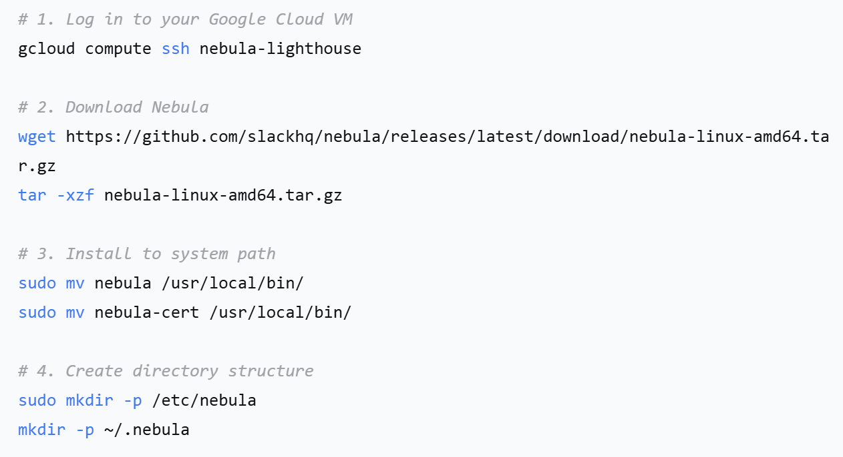
III. Generating Certificates
On any machine (recommended on your local MBP):
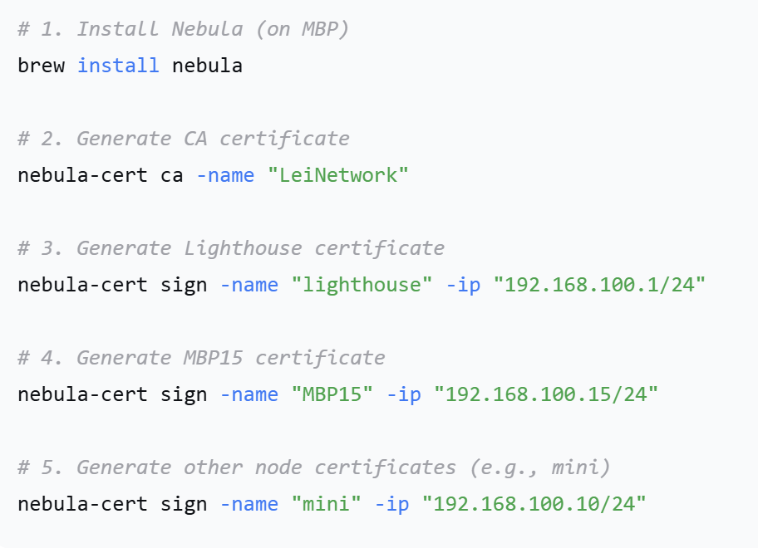
IV. Modifying Configuration Files
1. Lighthouse Configuration (on Google Cloud VM)
Create /etc/nebula/config.yaml:
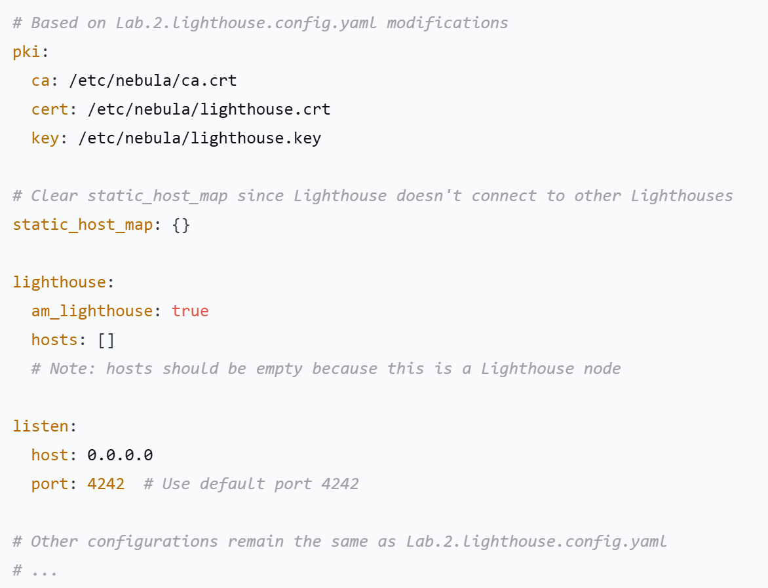
2. Transfer Certificates to Lighthouse
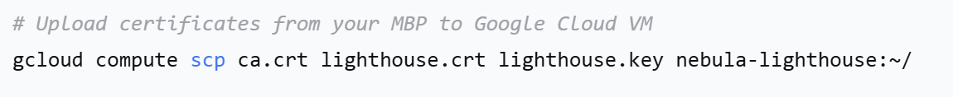
Then on the Lighthouse VM:
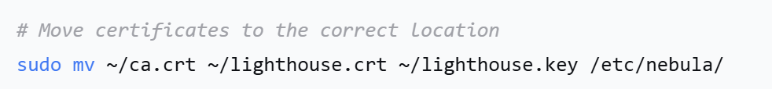
3. MBP15 Configuration
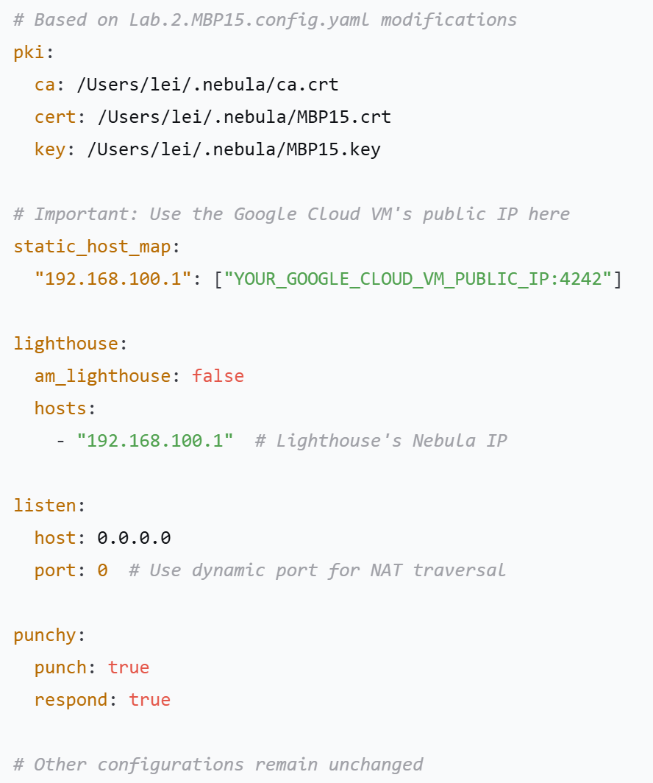
4. Other Node Configurations
For other nodes (e.g., mini), the configuration files are similar, just:

Modify certificate paths

Modify node IP (e.g., 192.168.100.10)

Use the same static_host_map pointing to the Lighthouse

V. Starting Services
1. On the Lighthouse:
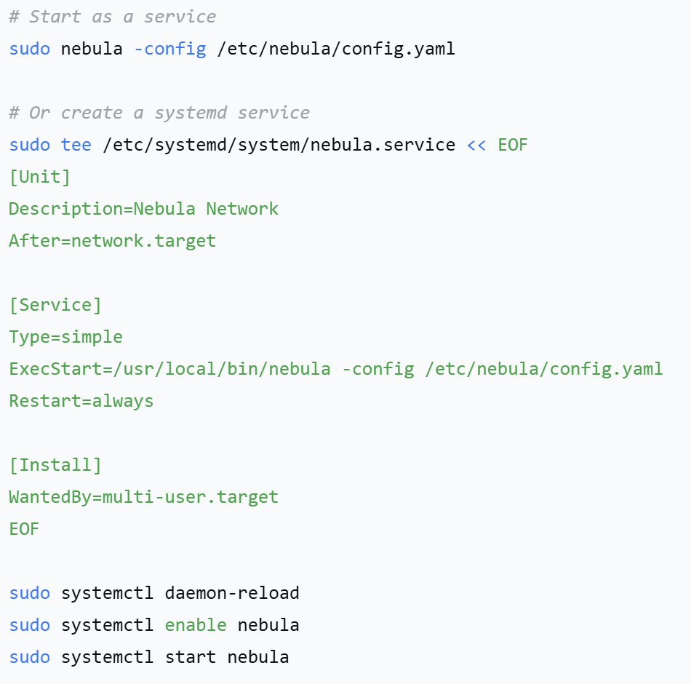
On MBP15:
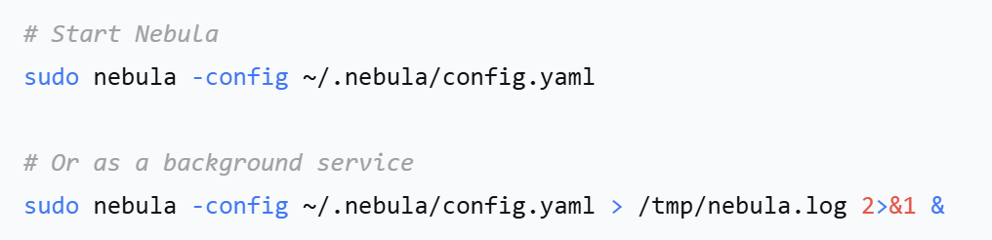
3. On Other Nodes:
Start Nebula service in a similar way.
VI. Verifying Connections
1. Check Connection Status:
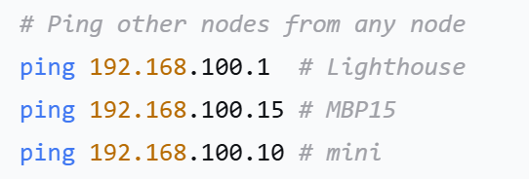
2. View Nebula Interface:
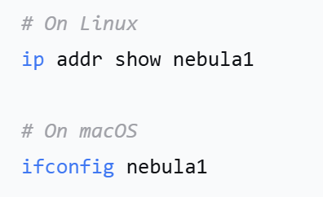
VII. Troubleshooting
Common Issues:
Cannot Connect:

Check if firewall has port 4242 open

Confirm certificate paths are correct

View logs: sudo journalctl -u nebula -f

NAT Traversal Failure:

Ensure punchy is set to true

Check Lighthouse's respond setting

Certificate Issues:

Confirm all nodes use the same CA certificate

Check if certificate IPs are in the same subnet (192.168.100.0/24)

VIII. Optimization Suggestions
1. Security Hardening:
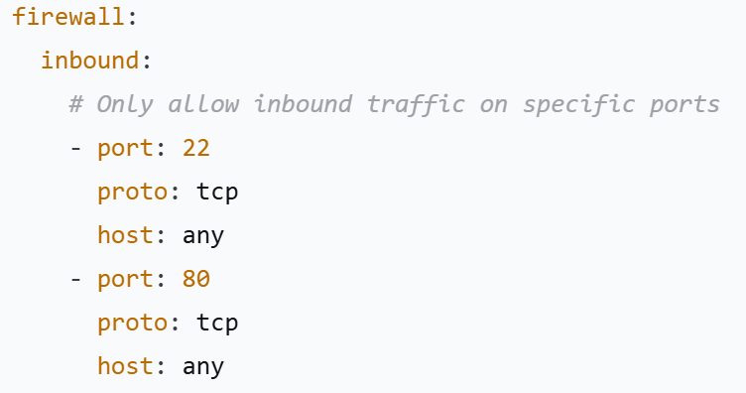
2. Performance Optimization:
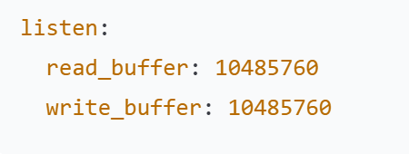
3.Monitoring:
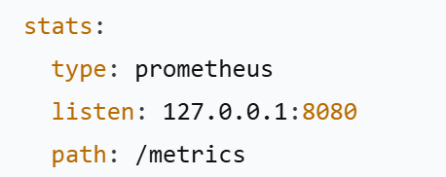

By following these steps, you will establish a Nebula VPN network using a Google Cloud free-tier virtual machine as the central Lighthouse. All nodes (including devices behind NATs) can connect to each other through it.

