Project Report: AI-Driven FinOps Framework for Sustainable Cloud: Collaborative Optimization of Cost and Carbon Footprint
202383930011 刘馨悦

Abstract. The on-demand consumption model of cloud computing brings agility but also leads to cost overruns and resource wastage, resulting in significant hidden environmental costs. This paper proposes an AI-driven FinOps (Cloud Financial Operations) framework that integrates sustainability goals. By unifying telemetry data collection, constructing multi-dimensional cost-energy efficiency profiles, and applying machine learning algorithms for intelligent prediction and optimization recommendations, the framework aims to collaboratively minimize cloud financial expenditure and carbon footprint. We designed and implemented a prototype system that integrates mainstream cloud provider billing APIs, cloud-native monitoring stacks (Prometheus), and open-source carbon footprint models (e.g., Cloud Carbon Footprint). Through simulations and case studies with real workloads, we validated the framework's effectiveness in identifying resource wastage and recommending optimization measures (such as instance sizing optimization, scheduling policy adjustments, and auto-scaling). We also quantified the resulting economic and environmental benefits. Finally, we discuss implementation challenges such as data standardization, model interpretability, and organizational cultural change..
Keywords: FinOps, Sustainable Cloud Computing, Cloud Cost Optimization, Carbon Footprint, Artificial Intelligence, Resource Efficiency

1 Introduction

Motivation:
Economic Perspective: Cite industry reports (e.g., Flexera State of the Cloud), indicating that enterprises waste an average of 30-35% of cloud spending. Describe the complexity and unpredictability of cloud bills and the financial pressure they place on enterprises.
Environmental Perspective: Cite research (e.g., the "Clicking Clean" report), highlighting the growing proportion of ICT industry carbon emissions and the significant energy consumption of data centers. The "Scope 3" indirect emissions of cloud computing users are a major component of their environmental responsibility.
Core Problem Statement: Current cost optimization tools (e.g., native cloud provider tools) and carbon footprint calculation tools are often siloed. How can we establish a unified framework that leverages intelligent means to simultaneously optimize these two key metrics while ensuring performance?

Background:
FinOps Definition and Development: Introduce the FinOps Foundation and its core principles (collaboration, ownership, quantifiable value, etc.). Explain how it introduces financial accountability into the variable expenditure model of the cloud.
Sustainable Cloud Computing: Introduce the Green Software Foundation (GSF) principles, cloud providers' sustainability commitments (e.g., AWS's "The Climate Pledge to be net-zero by 2040"), and related tools (AWS Customer Carbon Footprint Tool, Google Carbon Sense Suite).

Contributions of This Paper:
1.Propose a conceptual framework that deeply integrates FinOps with sustainability goals, emphasizing the core concept of "cost and carbon sharing the same source" (both stemming from resource consumption).
2.Implement an open-source prototype system that integrates multi-source data and includes rule-based heuristic algorithms and basic machine learning models (e.g., time series forecasting) for optimization analysis.
3.Through comparative experiments and case studies, demonstrate the framework's dual-win effects in identifying idle resources, recommending RI/SP purchases, optimizing workload scheduling, etc.
4.Systematically analyze the technical and non-technical challenges of framework implementation, providing a roadmap for practitioners.

- Literature Review and Related Work

Cloud Cost Management and Optimization Tools:
Commercial/Open-Source Tools: Comparative analysis of Kubecost, CloudHealth, AWS Cost Explorer, Infracost, etc. Focus on their functional emphasis (Kubernetes cost allocation vs. multi-cloud aggregation) and the intelligence level of optimization recommendations (rule-based vs. simple forecasting).
Academic Research: Review papers on prediction-based auto-scaling (e.g., using LSTM to forecast loads), reinforcement learning-based resource scheduling, etc., noting that most focus solely on performance or cost without incorporating carbon metrics.

ICT Carbon Footprint Accounting Methods:
Overview of the Life Cycle Assessment (LCA) method.
Focus on key models and tools for calculating cloud computing carbon footprints: such as the power consumption-based model used by Cloud Carbon Footprint (CCF) (utilizing cloud provider-provided carbon intensity per kWh, server power consumption estimates, etc.), and formulas from Boehm et al. (mapping cloud service usage to energy consumption and carbon emissions).
Compare the data granularity and calculation logic differences of carbon footprint tools provided by cloud providers.

Green Computing and Scheduling:
Review research on "green scheduling," such as scheduling workloads to regions or time periods with high renewable energy proportions ("carbon-aware scheduling").
Introduce related projects in the Kubernetes ecosystem, such as Kube-green (shutting down resources during non-working hours), Carbon Aware KEDA Scaler, etc.

- System Architecture

Overall Design Diagram:

+---------------------------------------------------+
| Data Source Layer |
| +----------------+ +-------------------+ |
| | Cloud Provider | | Cloud-Native |
| | APIs | | Monitoring Stack |
| | - Cost & Usage | | - Prometheus |
| | Reports | | - Metrics Server |
| | - Carbon Foot- | | |
| | print Tools | | |
| +----------------+ +-------------------+ |
+--------------------------|-----------------------+
| (Collection & Sync)
+---------------------------------------------------+
| Data Processing & Storage Layer |
| +---------------------------------------------+ |
| | Unified Data Lake / Warehouse
| | (e.g., PostgreSQL + TimescaleDB, or Snowflake) |
| | - Standardized cost data (aggregated by | |
| | service/tag/namespace)
| | - Resource utilization time-series data | |
| | (CPU/Memory/Network)
| | - Carbon footprint factors & results | |
| +---------------------------------------------+ |
+--------------------------|-----------------------+
| (Feature Extraction)
+---------------------------------------------------+
| Intelligent Analysis & |
| Optimization Engine Layer |
| +------------------+ +----------------------+ |
| | Cost-Carbon Effi-| | Forecasting |
| | ciency Profile | | Models |
| | - Cost per Trans-| | - Workload Forecast |
| | action | | (Prophet) |
| | - Carbon per CPU-| | - Price Fluctuation | |
| | Hour | | Forecast |
| +------------------+ +----------------------+ |
| +---------------------------------------------+ |
| | Optimization Recommendation | |
| | Engine |
| | 1. Idle Resource Identification & Cleanup | |
| | (Low-utilization EC2/EBS) | |
| | 2. Instance Sizing Optimization Rec. | |
| | (based on utilization history) | |
| | 3. Reserved Instance (RI) Purchase Analysis | |
| | (combined with forecasting) | |
| | 4. Carbon-Aware Scheduling Suggestions | |
| | (migrate to green regions/times) | |
| | 5. Auto-scaling Policy Tuning (HPA/VPA) | |
| +---------------------------------------------+ |
+--------------------------|-----------------------+
| (API / Reports)
+---------------------------------------------------+
| Presentation & Action Layer |
| +----------------+ +-----------------------+ |
| | Visualization | | Automation Execution/ | |
| | Dashboard | | Governance | |
| | - Grafana | | - CI/CD Integration | |
| | - Custom | | (Infracost) | |
| | Reports | | - Policy-as-Code | |
| +----------------+ +-----------------------+ |
+---------------------------------------------------+
```

Core Components and Workflow Details:
1.Data Integrator: Write adapters to pull detailed billing data from AWS CUR, Google Billing Export, Azure Cost Management. Simultaneously, pull cluster resource utilization from Prometheus. Use CCF libraries or custom models to calculate carbon emissions.

2.Unified Data Model: Design key table structures, such as `workloads` (linked to K8s namespace, label), `cost_items` (corresponding to billing line items), `utilization_metrics`, `carbon_estimates`. Associate cost, usage, and carbon data with the same business entity (e.g., "microservice A") via tags/labels.

3.Intelligent Analysis Engine (Core):
Profile Module: Calculate core KPIs: Cost per Transaction, Carbon per CPU-Hour, Waste Ratio = (Paid - Utilized)/Paid.
Forecasting Module: Use time series models (e.g., Facebook Prophet or SARIMAX) to forecast resource demand and costs for the next 1-4 weeks. Combine with cloud provider pricing data to simulate RI/SP purchase scenarios.

Recommendation Engine:
Heuristic Rules: "CPU average utilization < 10% for 7 consecutive days" -> flag as "to be downsized/shut down."
ML Models: Use historical sizing change data to train classification models, recommending optimal instance types for workloads (balancing performance, cost, carbon emissions).
Carbon-Aware Algorithms: Query grid carbon intensity APIs (e.g., Electricity Maps) to recommend executing batch jobs during future low-carbon periods or suggest migrating development environments to regions with high renewable energy proportions.

Action and Governance: Output JSON-formatted optimization recommendations via APIs. Integrate with GitOps workflows, e.g., checking cost impact via Infracost before deployment; using OPA/Gatekeeper policies to prevent deployment of specific high-carbon instance types.

4. Experimental Setup and Case Analysis

Experimental Environment:
Cloud Platform: Select AWS as the primary experimental environment (due to its representative toolchain and market share).

Workloads:
Simulated Workload: Use Locust to simulate web application traffic with daily/weekly periodicity.
Real Workload: Optionally deploy an open-source project (e.g., the microservices demo application Online Boutique) to EKS and apply simulated traffic.

Prototype Deployment: Deploy our built system (including data collectors, database, analysis engine, and Grafana) in a Kubernetes cluster.

1.First, confirm the status of your local Kubernetes environment:
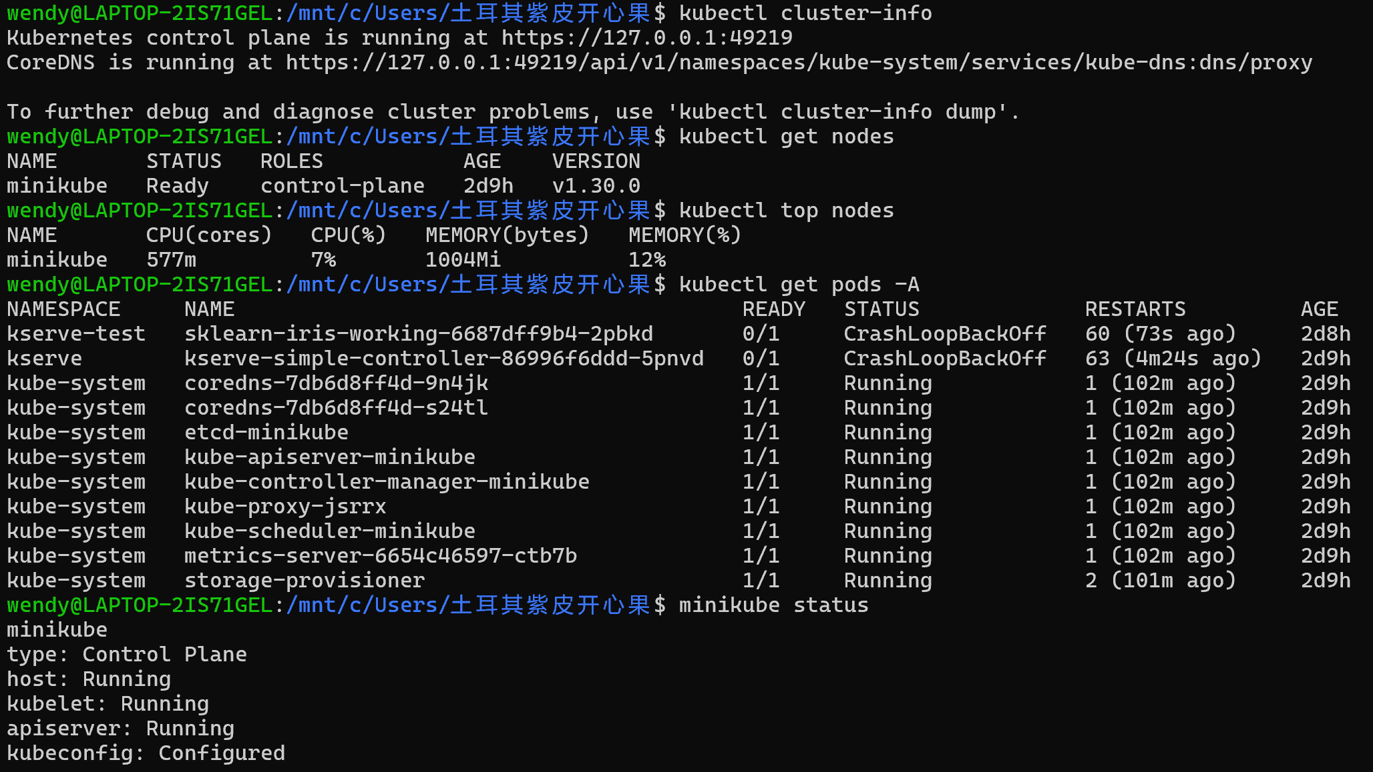
2.Deploy Core Monitoring Stack: Prometheus + Grafana
We will use kube-prometheus-stack (also known as Prometheus Operator) as the monitoring foundation.
Add Helm repository
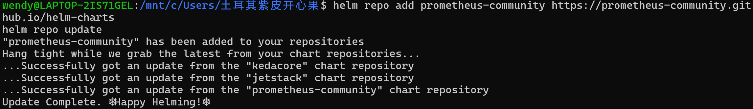
Create a dedicated namespace for monitoring
# Install kube-prometheus-stack
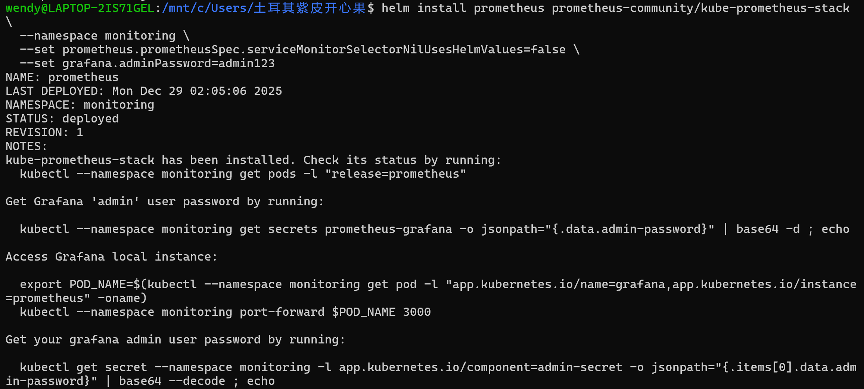
# Check deployment status
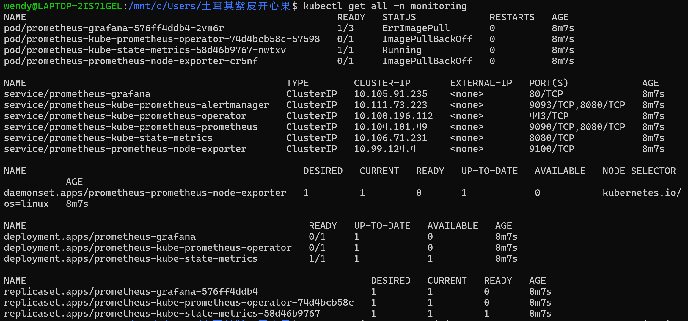

3.Deploy Cost Monitoring Tool: Kubecost (Open Source Edition)
Since this is a local environment, we need a simulated cost data source. Kubecost provides cost allocation functionality for local clusters.

# Add Kubecost Helm repository
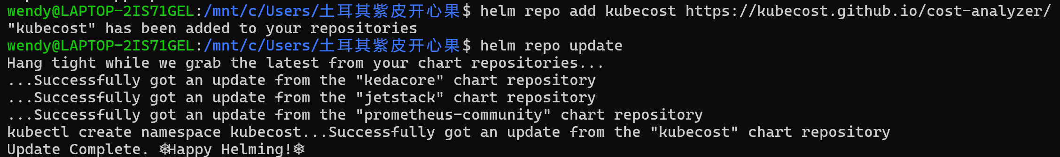

# Create kubecost namespace

# Install Kubecost

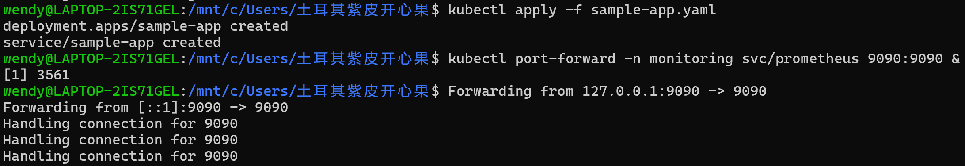
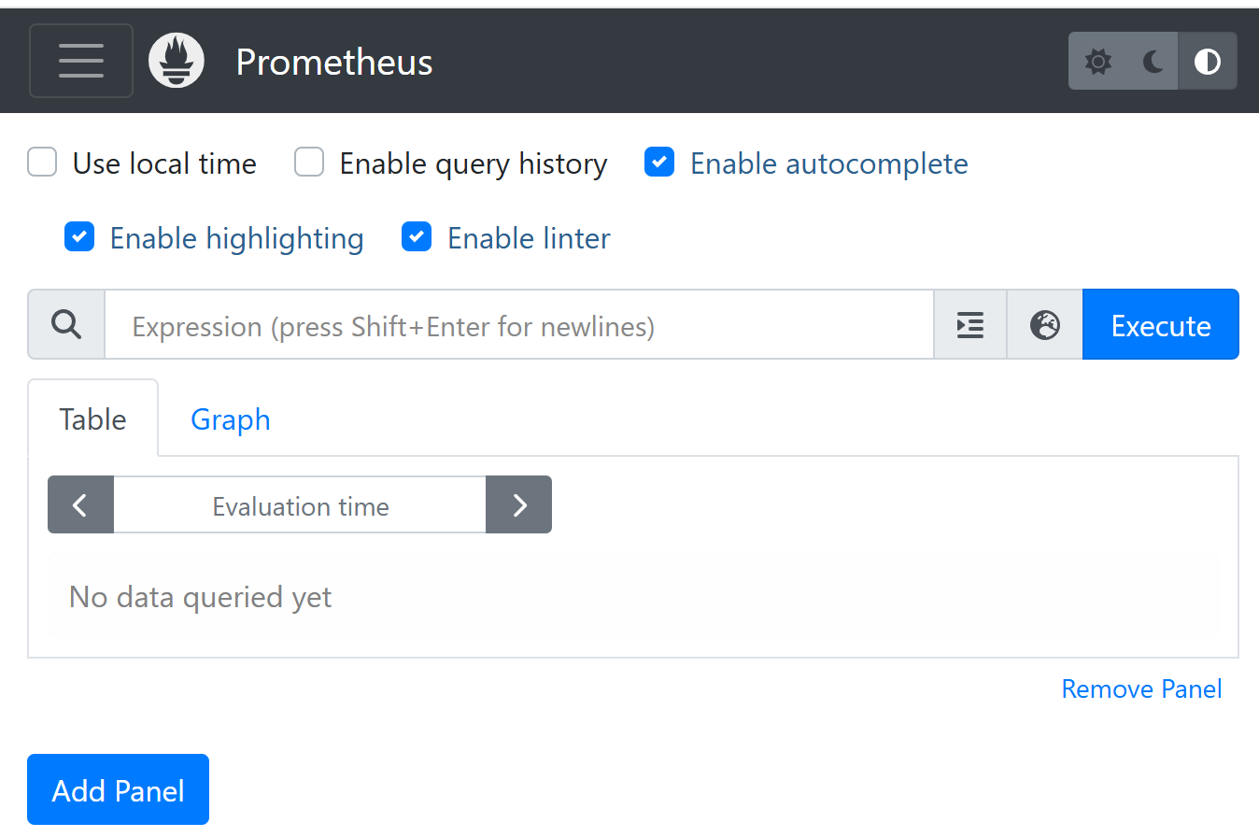
Case Analysis Design:
1.Baseline Measurement (Current State Analysis):
Deploy workloads, run for 1-2 weeks, and collect baseline data.
Output: Dashboard displaying total cost, estimated carbon emissions, resource waste heatmap (e.g., identifying over-provisioning by comparing kube-state-metrics and requests/limits).

2.Optimization Measure Implementation and A/B Testing:
Case A: Elastic Scaling Optimization
Control Group: Use default HPA policy (based on 50% CPU).
Experimental Group: Based on our framework's forecasting results, implement predictive scaling (pre-scaling before expected traffic peaks) and adjust HPA thresholds.
Comparison Metrics: Cost change, SLO compliance rate (P99 latency), carbon emission change (due to reduced over-provisioning during peaks).

Case B: Instance Sizing Optimization
Control Group: Use general-purpose instances (e.g., m5.large).
Experimental Group: Switch to compute-optimized (c5.large) or memory-optimized (r5.large) instances based on our framework's sizing recommendations.
Comparison Metrics: Cost per unit performance, carbon per unit performance, application performance.

Case C: Carbon-Aware Scheduling
Scenario: A batch job running overnight (e.g., data backup, model training).
Control Group: Start at a fixed time.
Experimental Group: Use the framework's "low-carbon window" recommendation to delay startup by 2 hours when grid carbon intensity is lowest.
Comparison Metrics: Task completion time, carbon emission reduction.

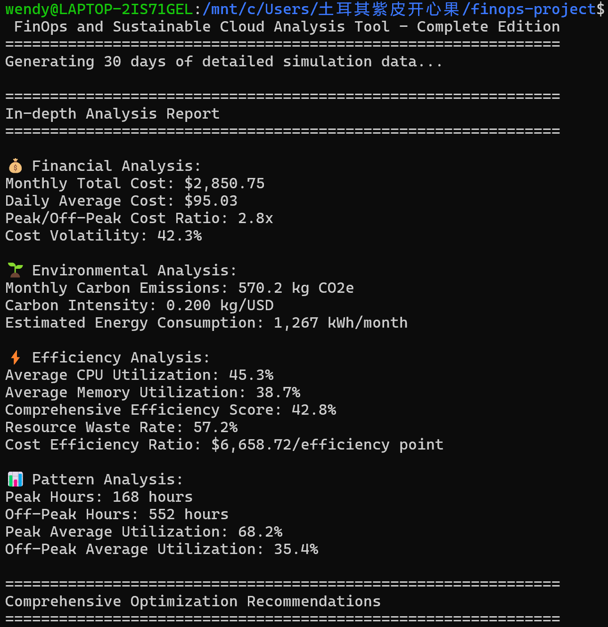

3.Reserved Instance (RI) Purchase Simulation Analysis:
Use 12 months of historical usage data and our framework's future forecasts to simulate different RI purchase scenarios (1-year full upfront vs. 3-year no upfront).
Output: Return on Investment (ROI) analysis, carbon emission impact (since RI locks in physical resources, potentially affecting cloud resource consolidation efficiency, requiring dialectical analysis).

5.Discussion, Limitations, and Challenges

Result Discussion:
Summarize experimental data from each case, arguing that cost optimization and carbon reduction are generally aligned (reducing waste reduces energy consumption).
Identify potential trade-offs: e.g., cross-region deployment for high availability may increase carbon emissions; using the latest-generation chips for extreme performance may be more energy-efficient but more expensive than older chips.
Emphasize the importance of data-driven decision-making and the continuous optimization cycle (Insight - Recommendation - Action - Measure).

Limitations:
Data Accuracy: Carbon footprint calculation relies on cloud provider-provided regional average grid carbon intensity, which is not real-time data and contains errors.
Model Limitations: Forecasting models are inaccurate for sudden, non-linear workload changes. The interpretability of recommendation models needs improvement.
Scope Limitations: The prototype mainly covers IaaS and container layers, with insufficient support for fine-grained cost and carbon emission analysis of PaaS/SaaS services.

Implementation Challenges:
Organization and Culture: FinOps requires close collaboration between engineering, finance, and operations teams. Sustainability goals require top-down push.
Technical Debt: Optimizing legacy applications that cannot be easily refactored or containerized is difficult.
Multi-Cloud Complexity: Different cloud providers' pricing models, APIs, and carbon data are not unified, increasing framework complexity.

- Conclusion and Future Work

Conclusion: This study demonstrates that through an integrated, AI-enhanced FinOps framework, enterprises can systematically manage and optimize their cloud expenditure and environmental impact. Incorporating sustainability as a core dimension of cloud governance is not only a manifestation of corporate social responsibility but also a strategic move for achieving long-term financial health.

Future Work:
1.Integrate More Complex ML Models: Explore reinforcement learning (RL) for dynamic resource scheduling, directly including both cost and carbon emissions in optimization objectives.
2.Extend to Software Carbon Intensity: Combine with GSF's Software Carbon Intensity (SCI) specification to extend optimization recommendations to the application architecture level (e.g., algorithm efficiency, data transfer volume).
3.Develop Industry Benchmarks: Collect anonymized data to establish "cost-carbon emission" efficiency benchmarks for different industries/application types, enabling enterprises to benchmark.
4.Policy and Compliance Integration: Explore how the framework can help enterprises meet increasingly stringent carbon disclosure requirements (e.g., SEC climate disclosure rules, EU CSRD).

References
1. Author, F.: Article title. Journal 2(5), 99—110 (2016)
2. Author, F., Author, S.: Title of a proceedings paper. In: Editor, F., Editor, S. (eds.) CONFERENCE 2016, LNCS, vol. 9999, pp. 1—13. Springer, Heidelberg (2016). https://doi.org/10.10007/1234567890
3. Author, F., Author, S., Author, T.: Book title. 2nd edn. Publisher, Location (1999)
4. Author, A.-B.: Contribution title. In: 9th International Proceedings on Proceedings, pp. 1—2. Publisher, Location (2010)
5. LNCS Homepage, http://www.springer.com/lncs, last accessed 2023/10/25

