Download Istio
- Go to the Istio release page to download the installation file
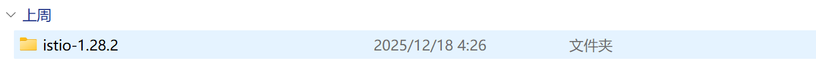
- Move to the Istio package directory
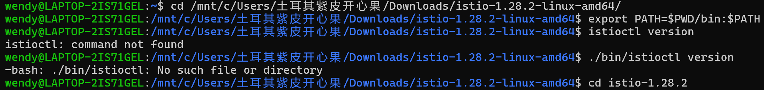
- Add the istioctl client to your path (Linux or macOS)
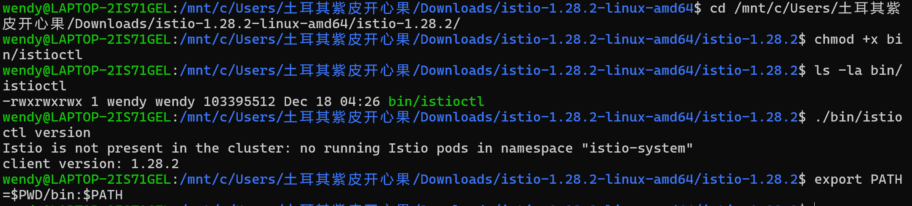

Install Istio
- Install Istio using the demo profile, without any gateways
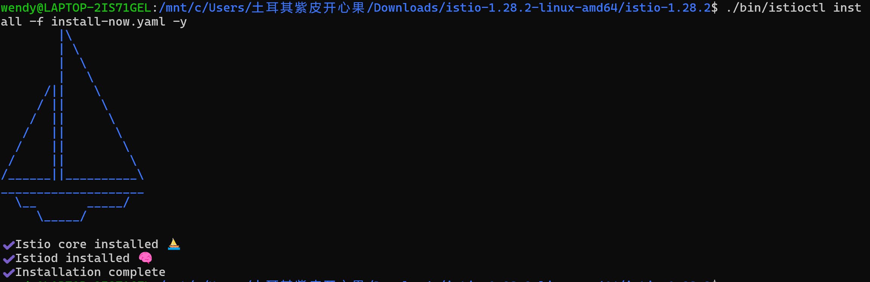
- Add a namespace label to instruct Istio to automatically inject Envoy sidecar proxies when you deploy your application later:
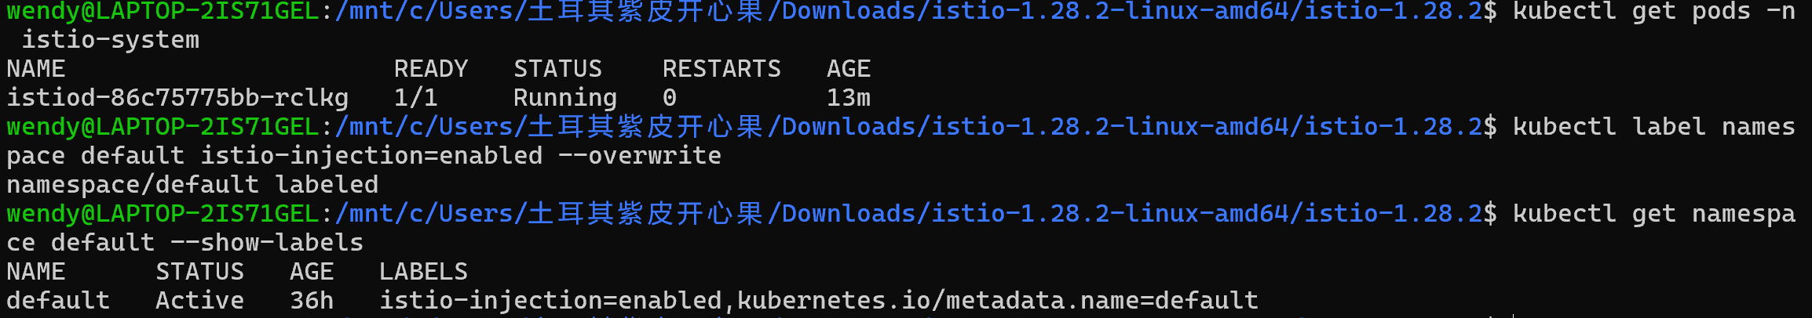

Install the Kubernetes Gateway API CRDs
- Install the Gateway API CRDs, if they are not already present:
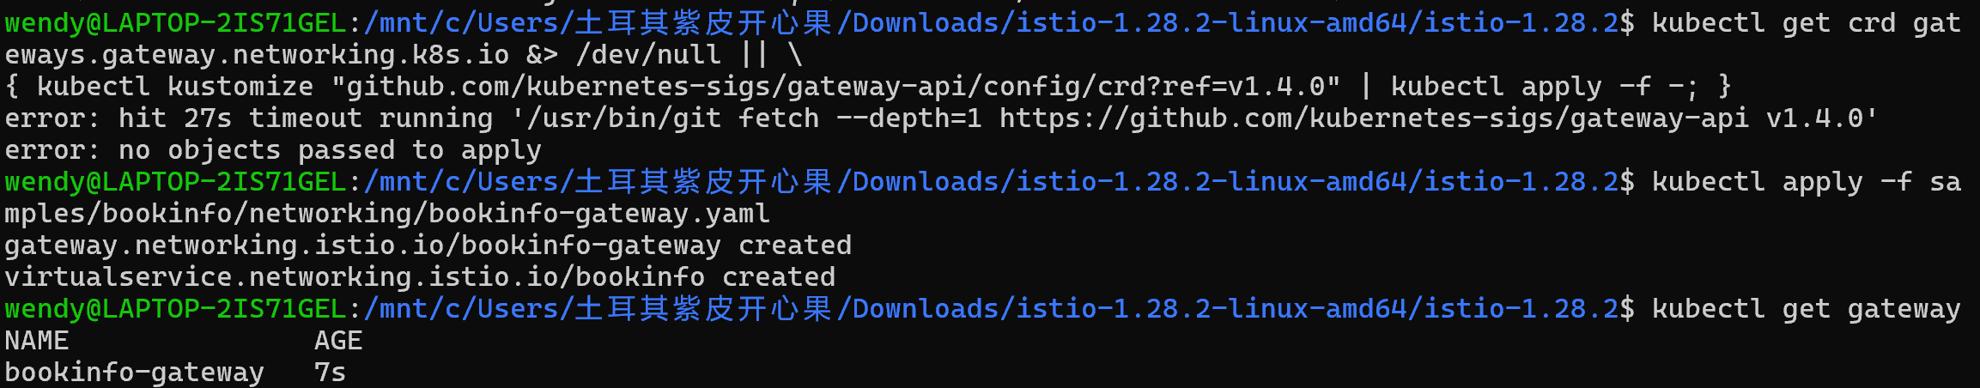
Failed due to network timeout (but succeeded using the traditional Gateway as an alternative)

Deploy the sample application
- Deploy theBookinfo sample application:
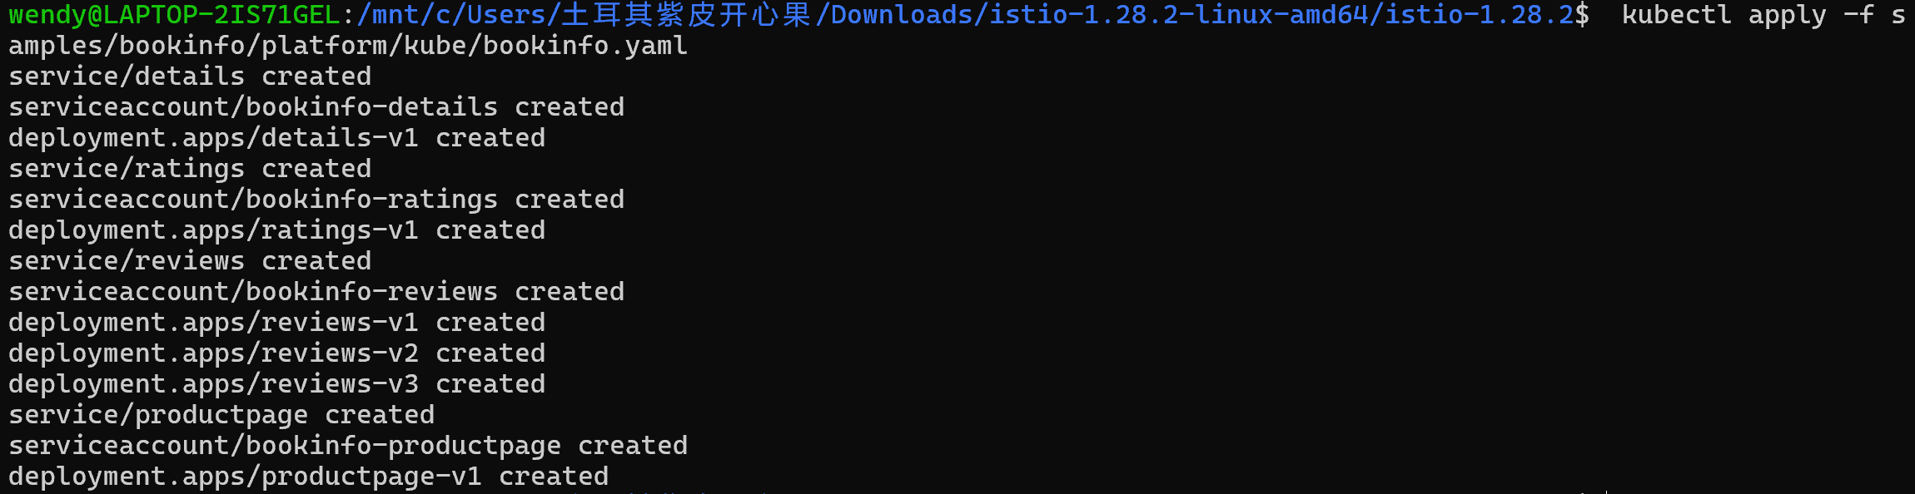
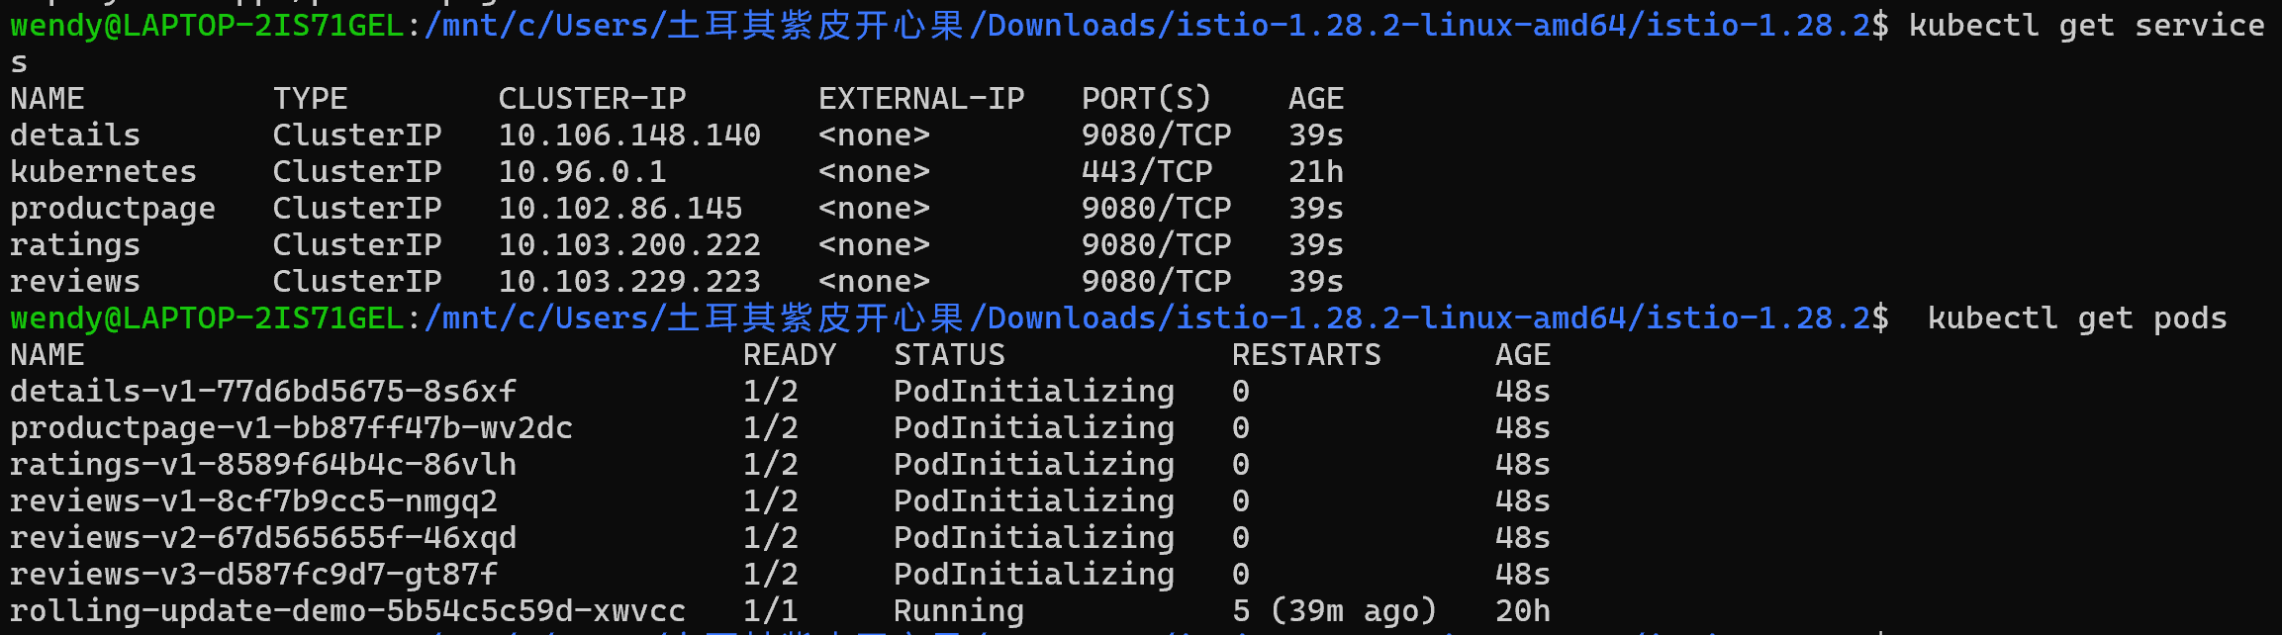
- Validate that the app is running inside the cluster by checking for the page title in the response:
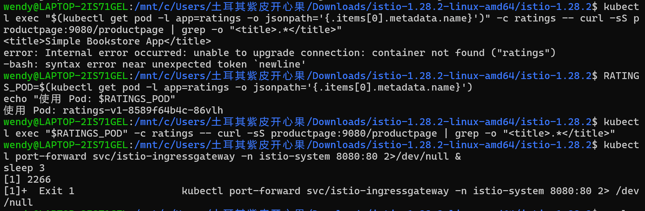

Open the application to outside traffic
- Create a Kubernetes Gateway for the Bookinfo application:
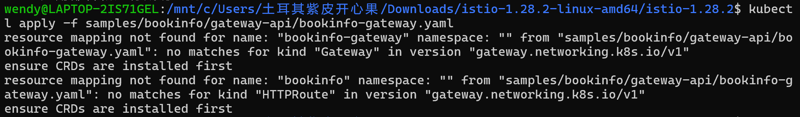
✅ Completed (using the traditional Istio Gateway)

- Change the service type to ClusterIP by annotating the gateway:
- check the status of the gateway

Access the application
connect to the Bookinfo productpage service through the gateway you just provisioned
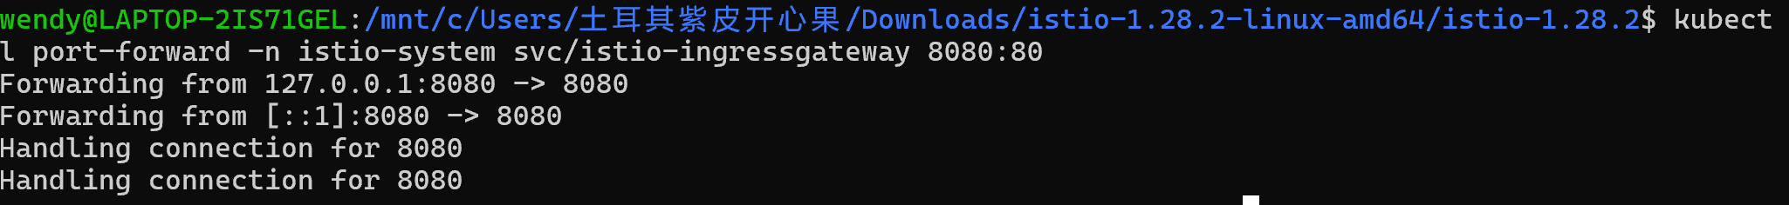
Open browser and navigate to http://localhost:8080/productpage to view the Bookinfo application.
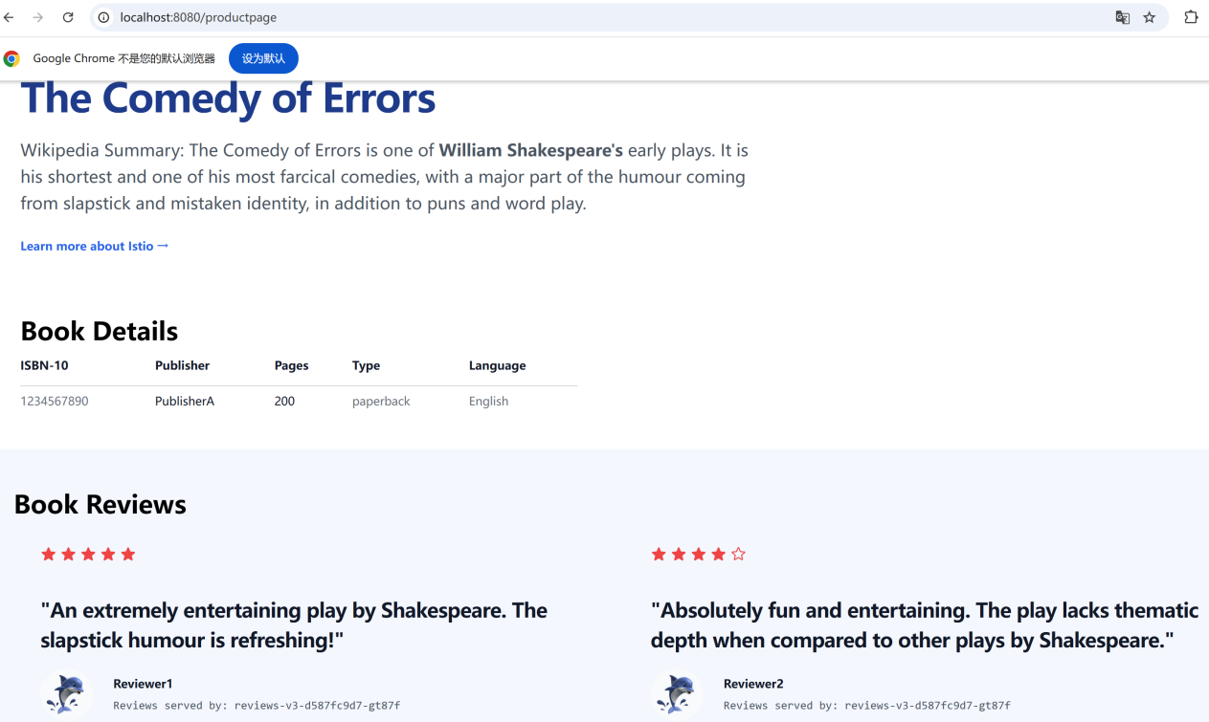

View the dashboard
- Install Kiali and the other addons and wait for them to be deployed
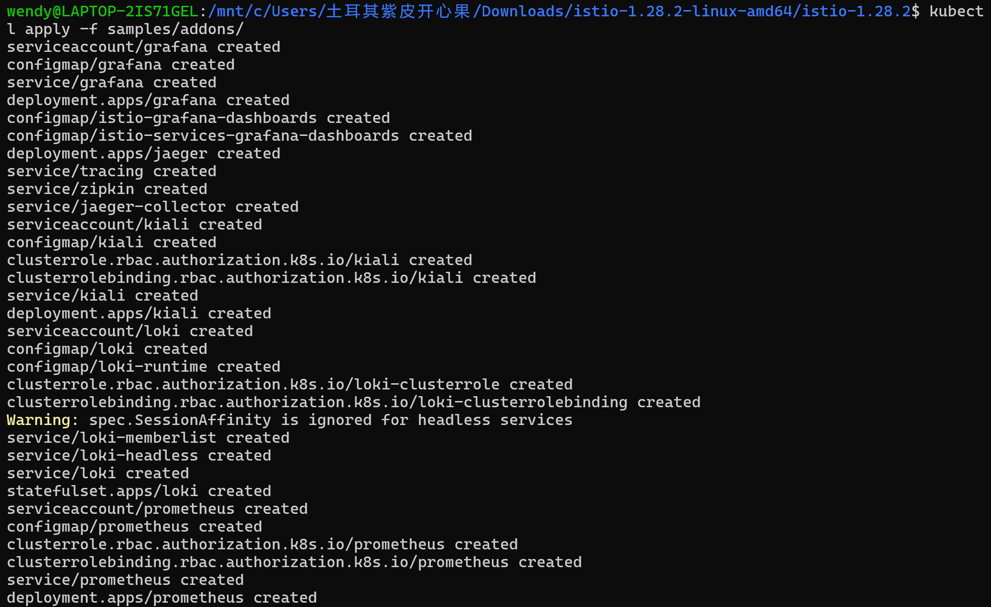
- Access the Kiali dashboard.
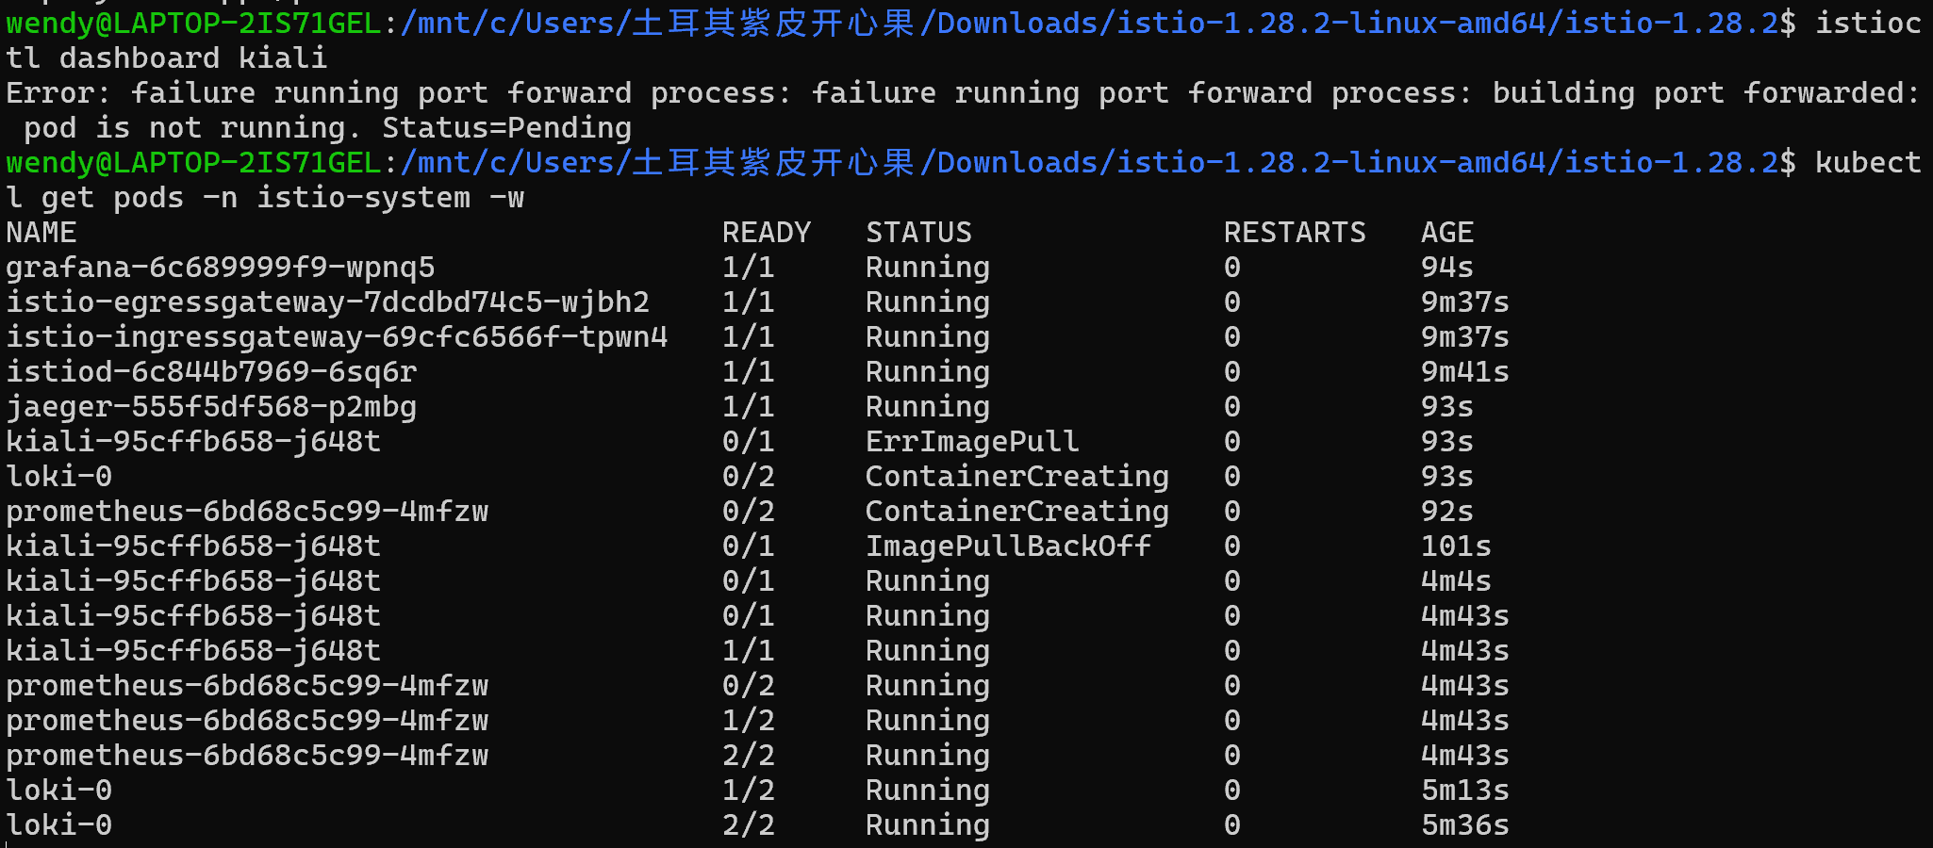
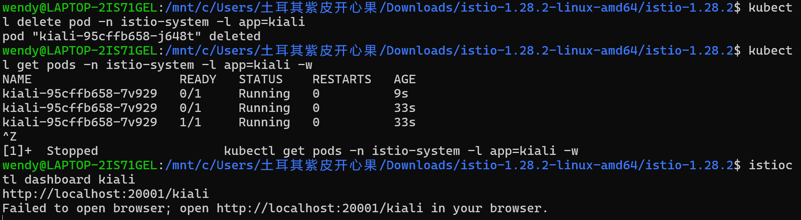
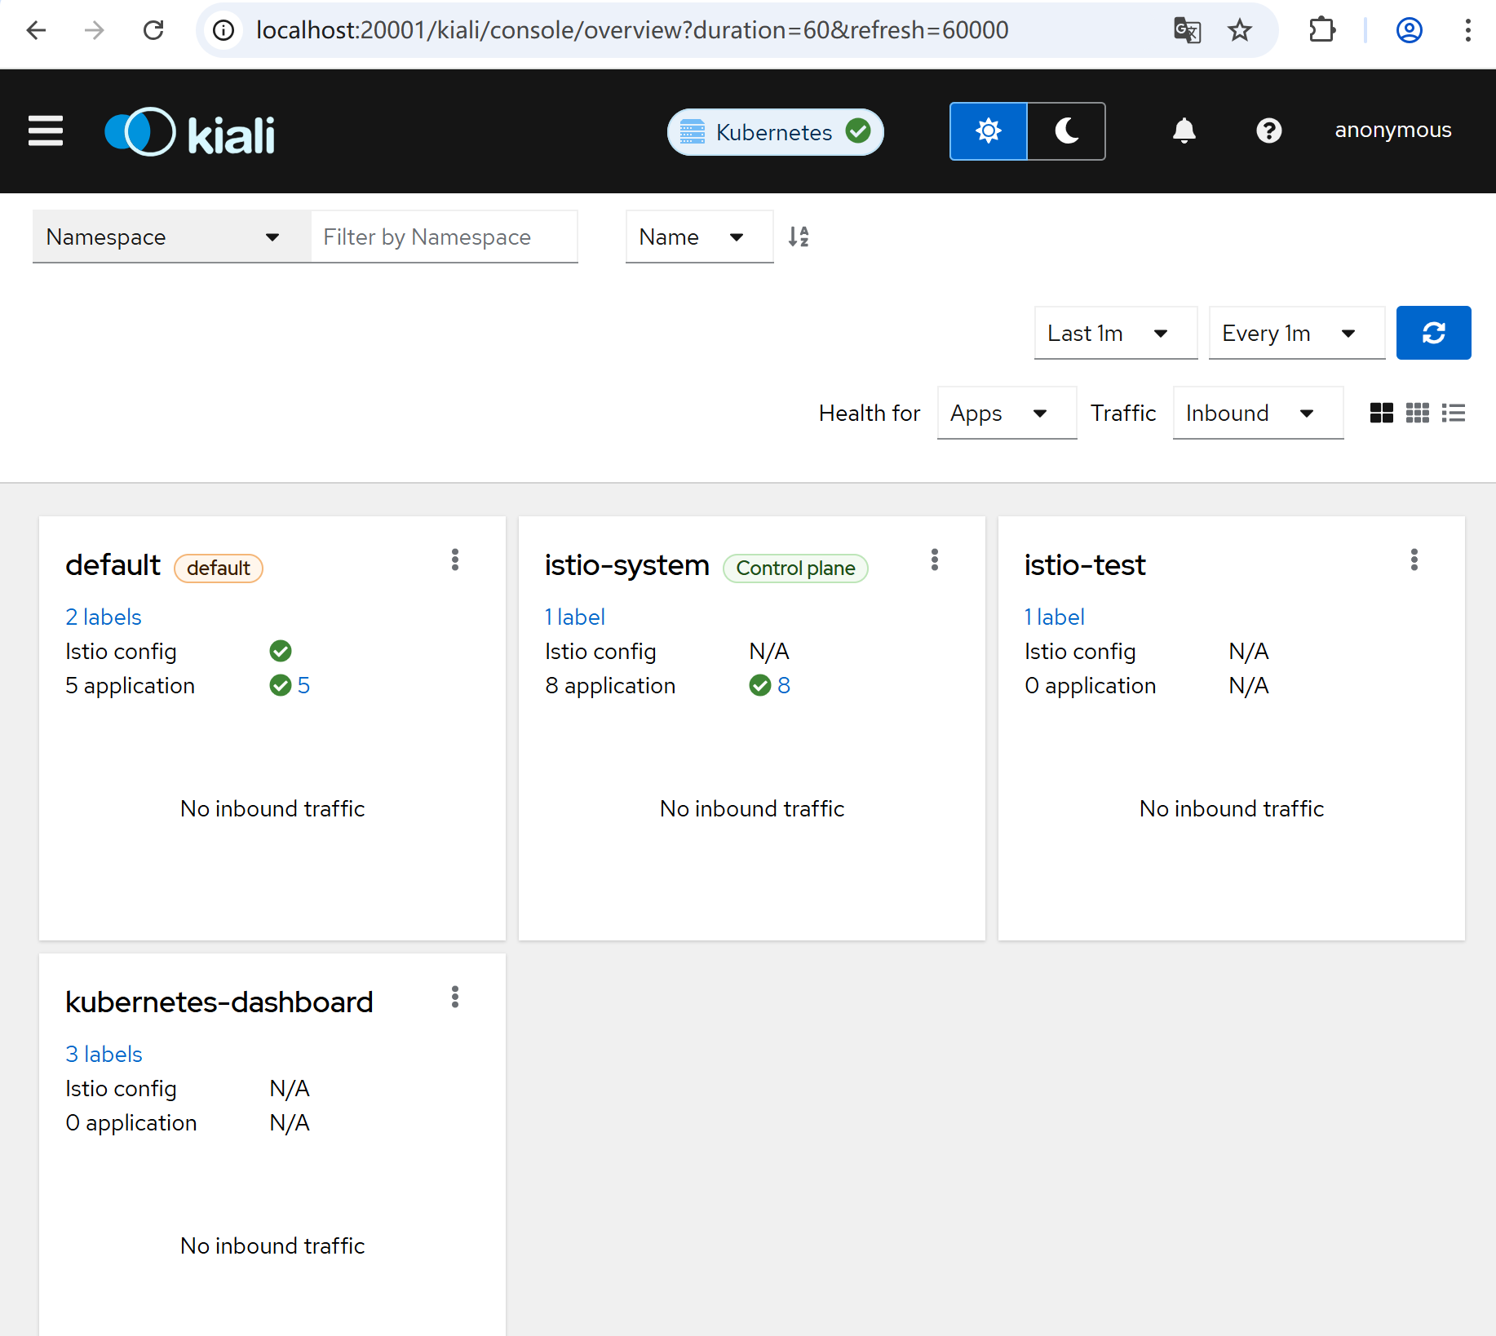
- In the left navigation menu, select Graph and in the Namespace drop down, select default.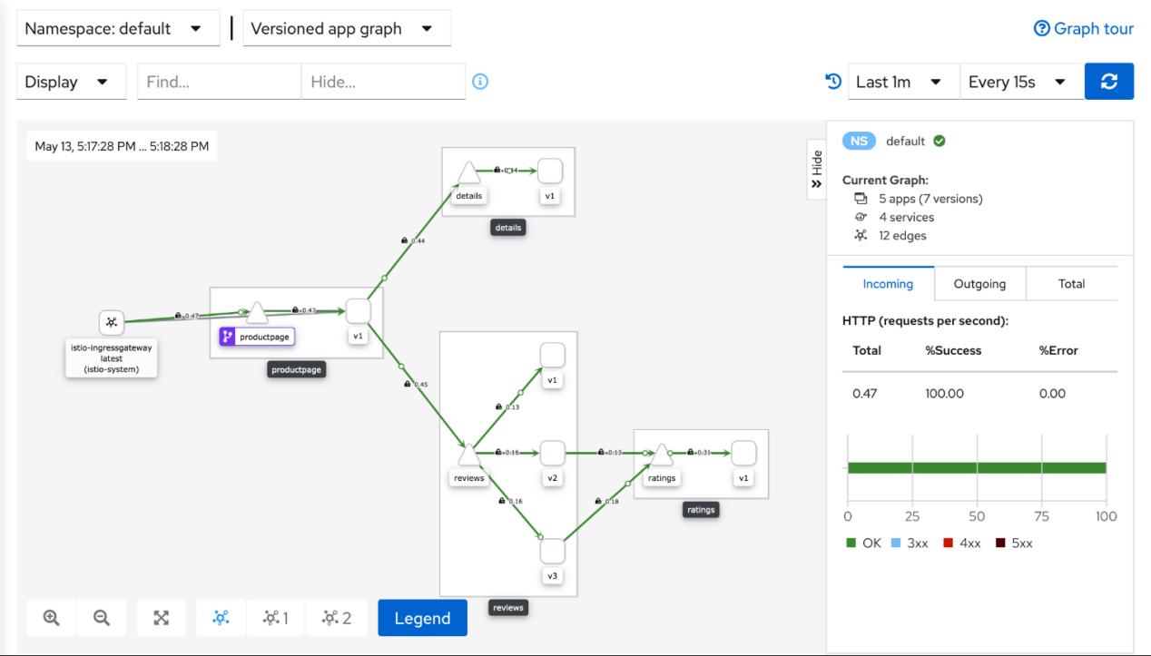

Uninstall
delete the Bookinfo sample application and its configuration
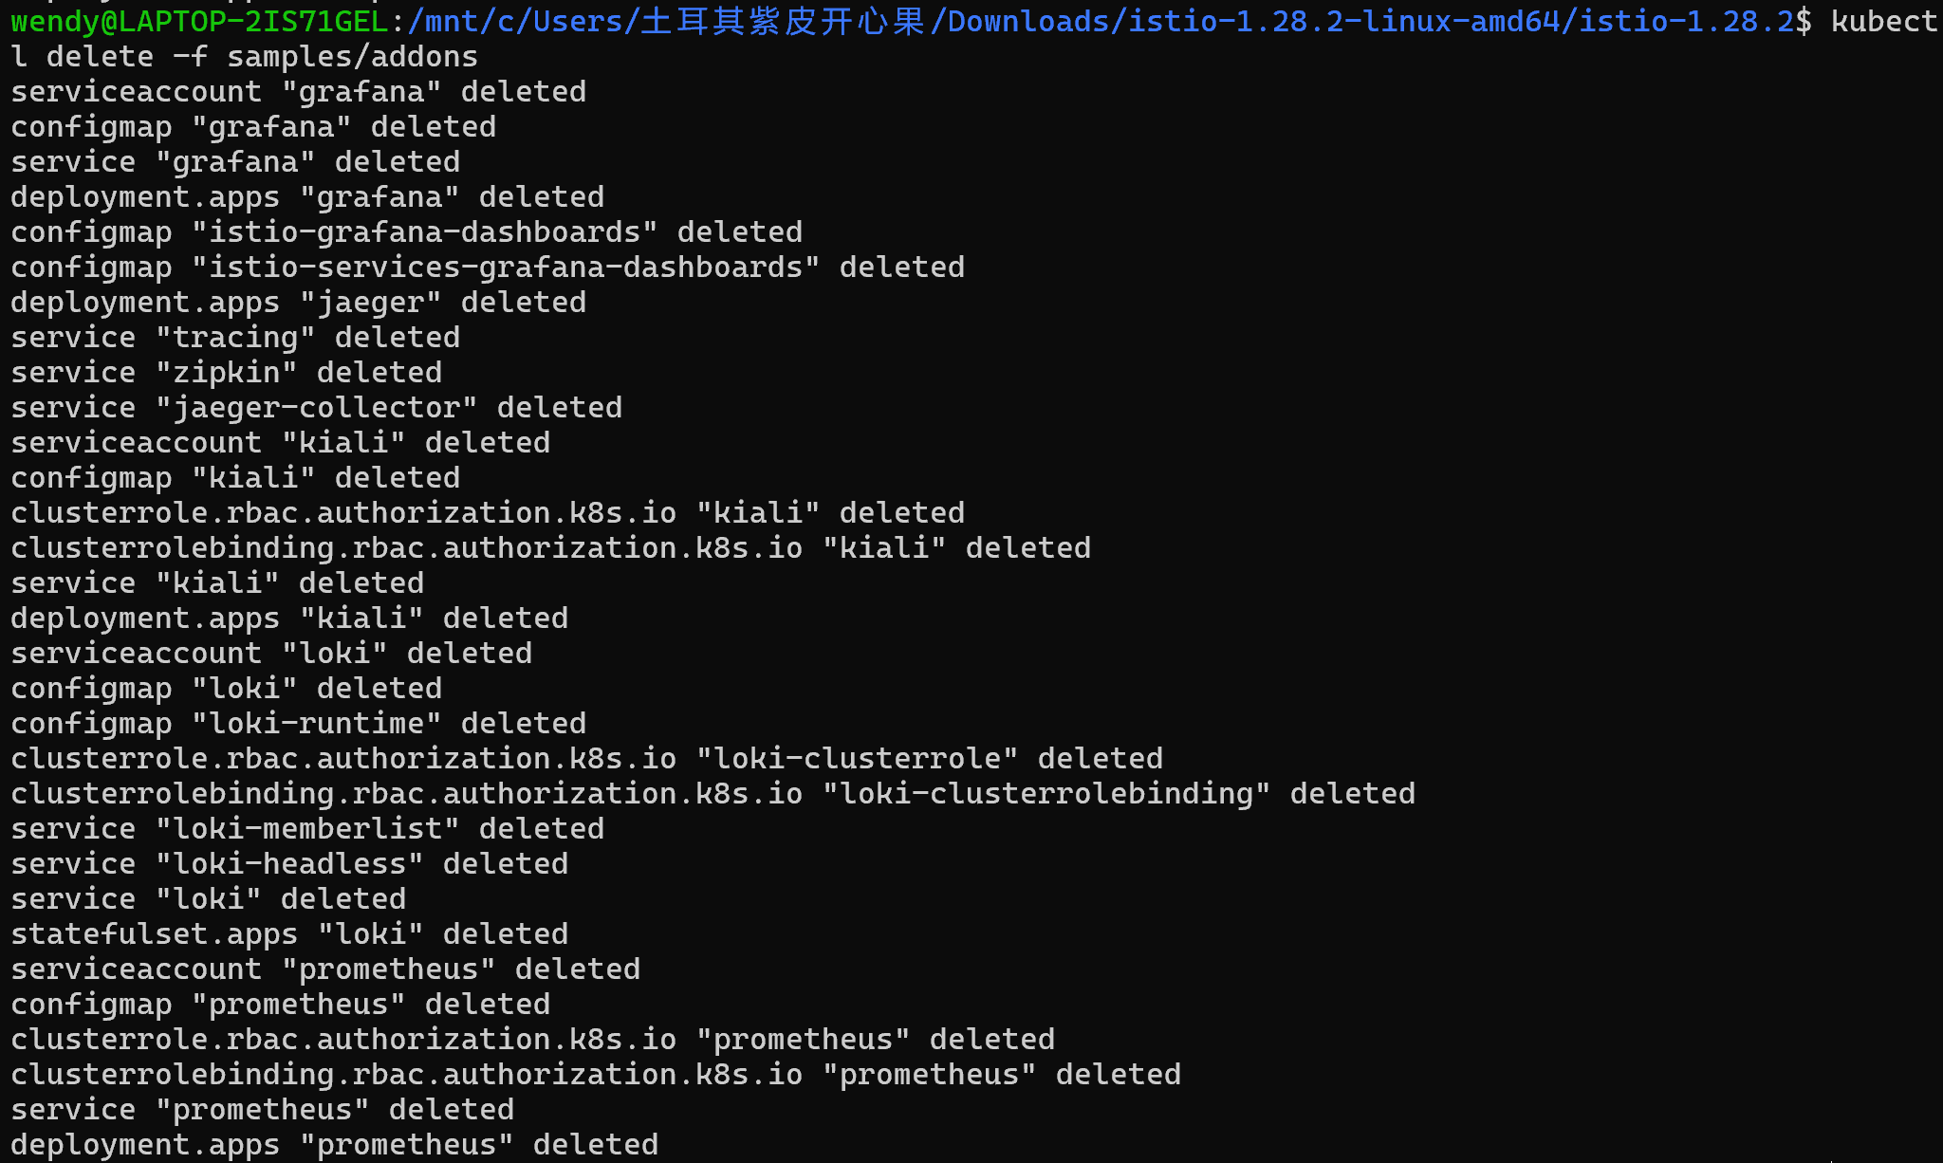
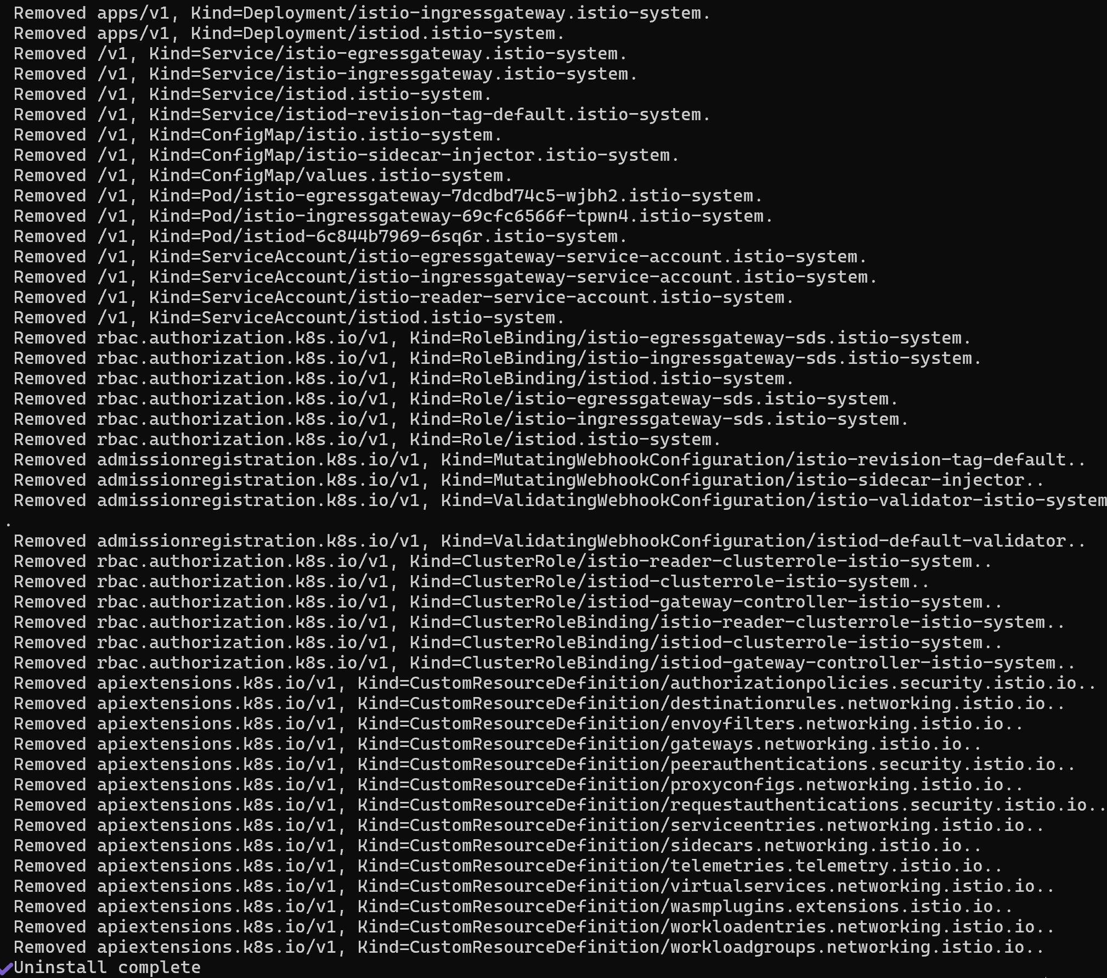

The istio-system namespace is not removed by default. If no longer needed, use the following command to remove it:
The label to instruct Istio to automatically inject Envoy sidecar proxies is not removed by default. If no longer needed, use the following command to remove it:
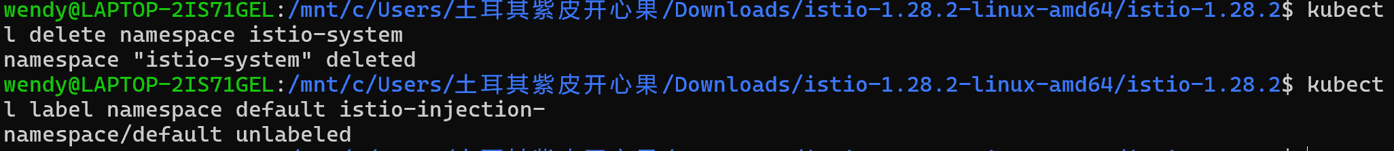

the Kubernetes Gateway API CRDs and would now like to remove them
