1.Traffic Shifting
1.Apply weight-based routing
1.To get started, run command to route all traffic to the v1 version:
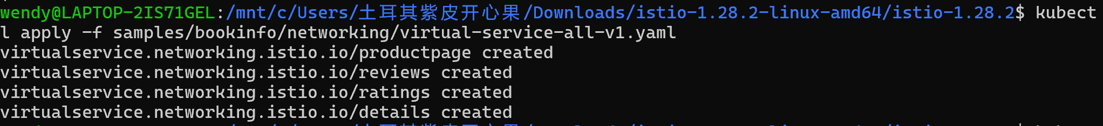
2.Open the Bookinfo site in your browser.
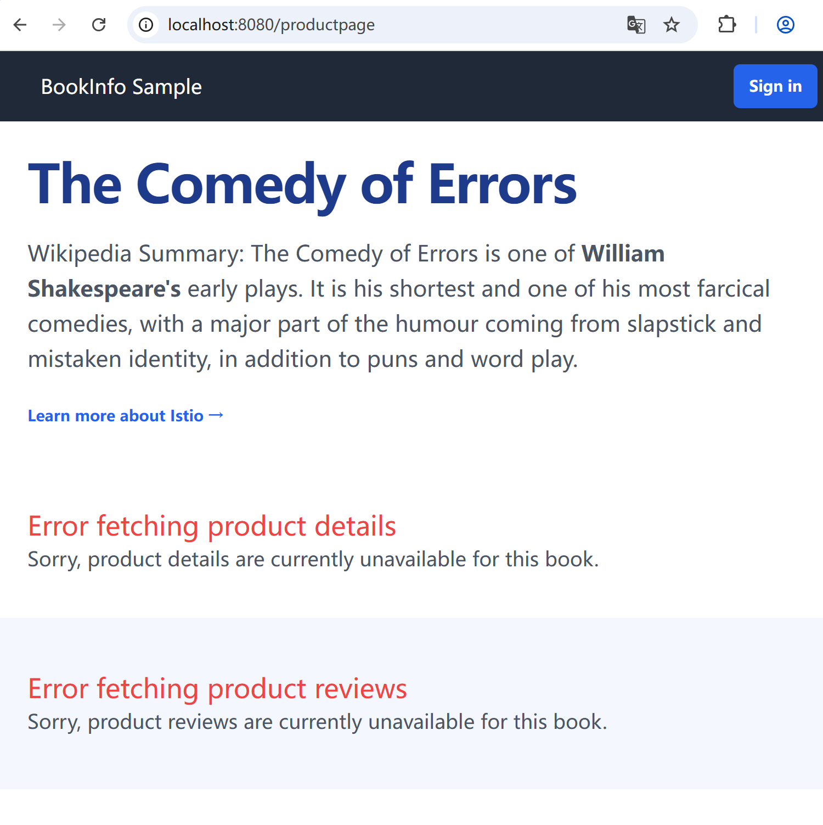
3.Transfer 50% of the traffic from reviews:v1 to reviews:v3
4.Wait a few seconds for the new rules to propagate and then confirm the rule was replaced
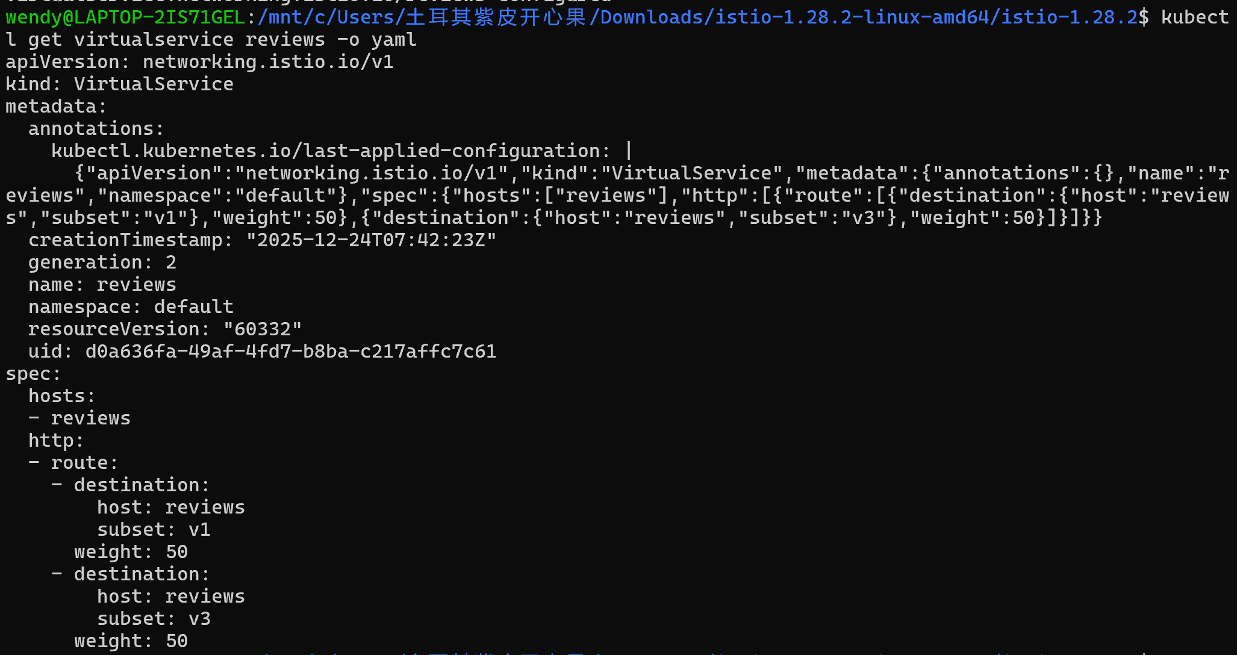 5.Refresh the /productpage in your browser and you now see red colored star ratings approximately 50% of the time.

- route 100% of the traffic to reviews:v3
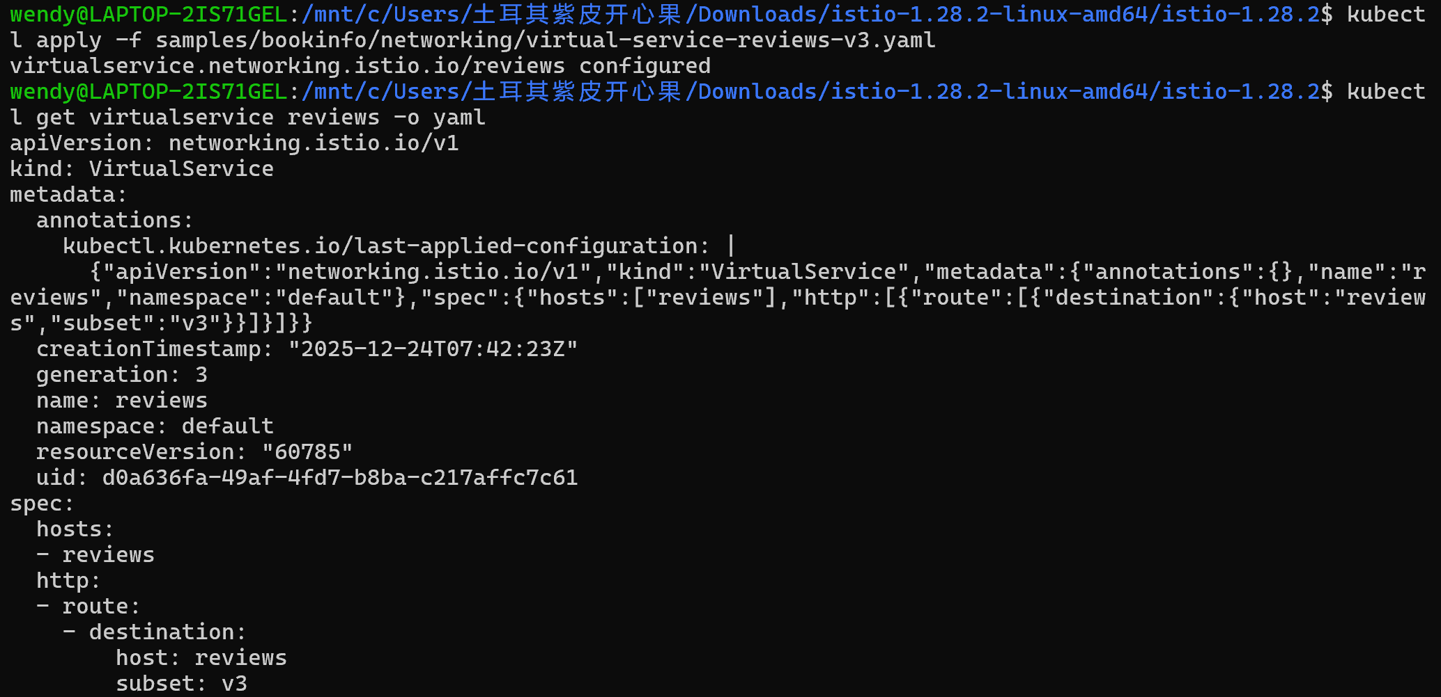
- Refresh the /productpage several times. Now you will always see book reviews with red colored star ratings for each review
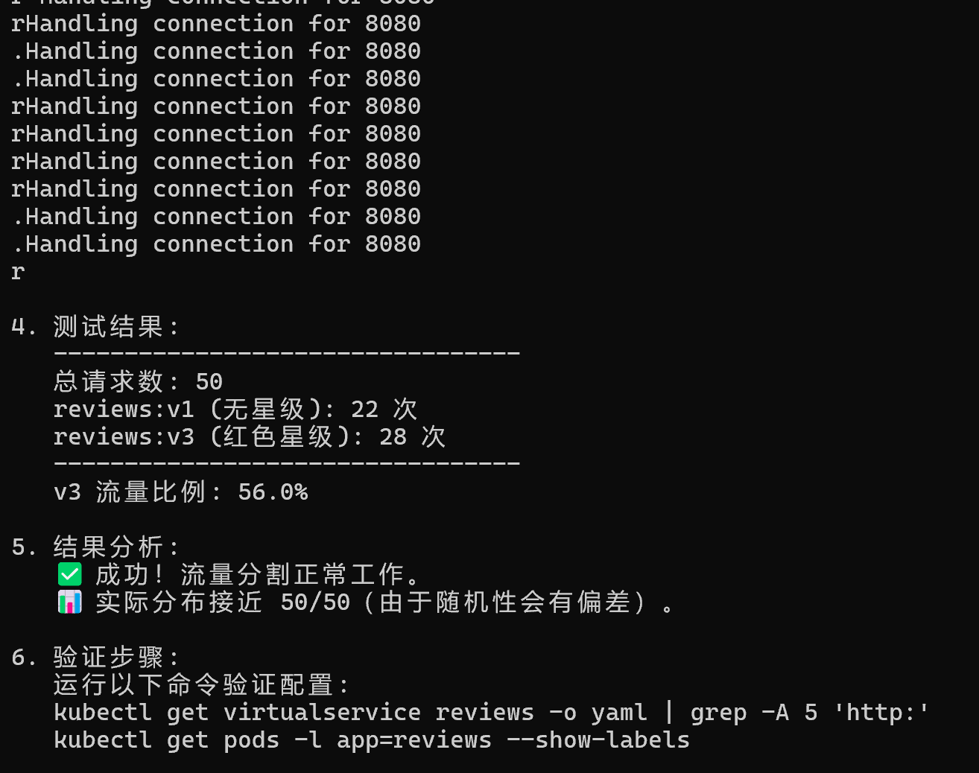


2.Cleanup
1.Remove the application routing rules
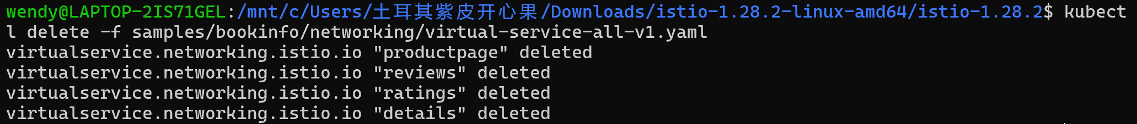
- request-routing
1.Route to version 1
1.Run the following command to create the route rules
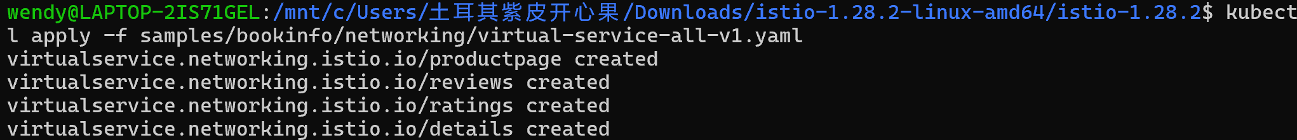
2.Display the defined routes
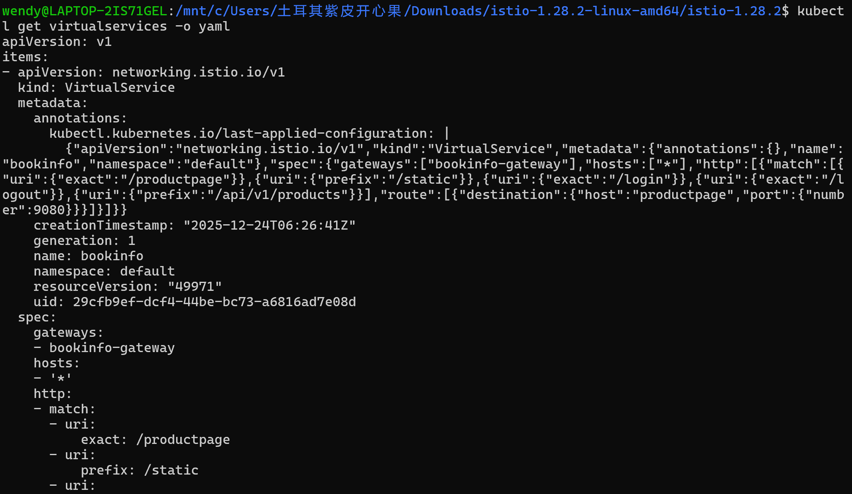
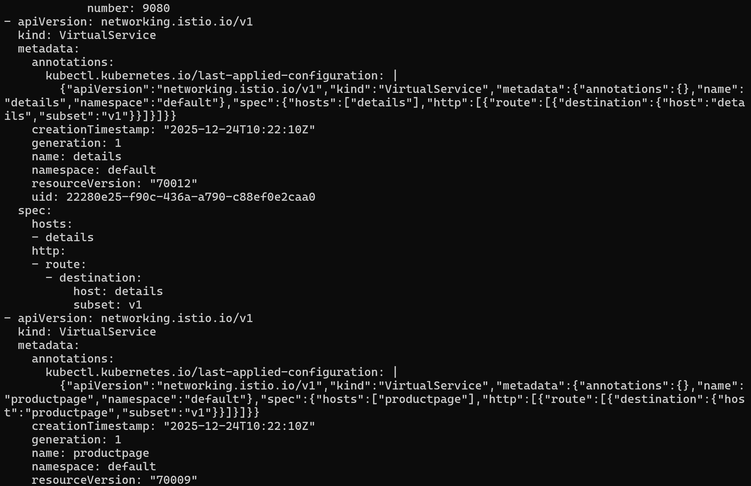
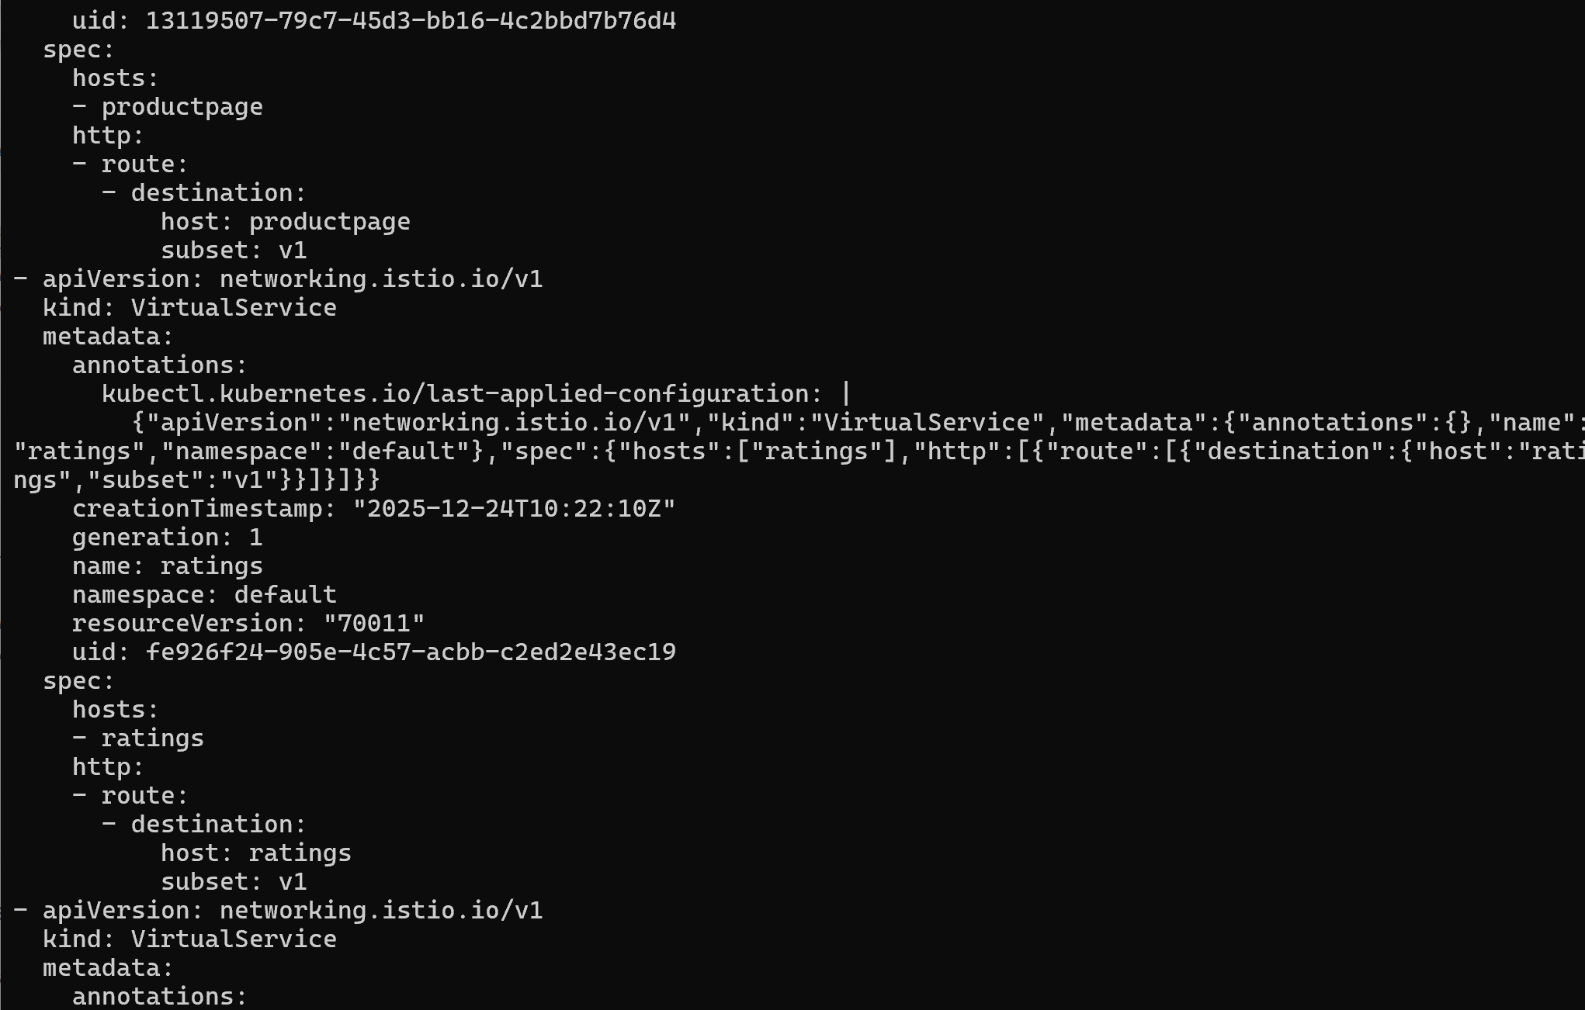

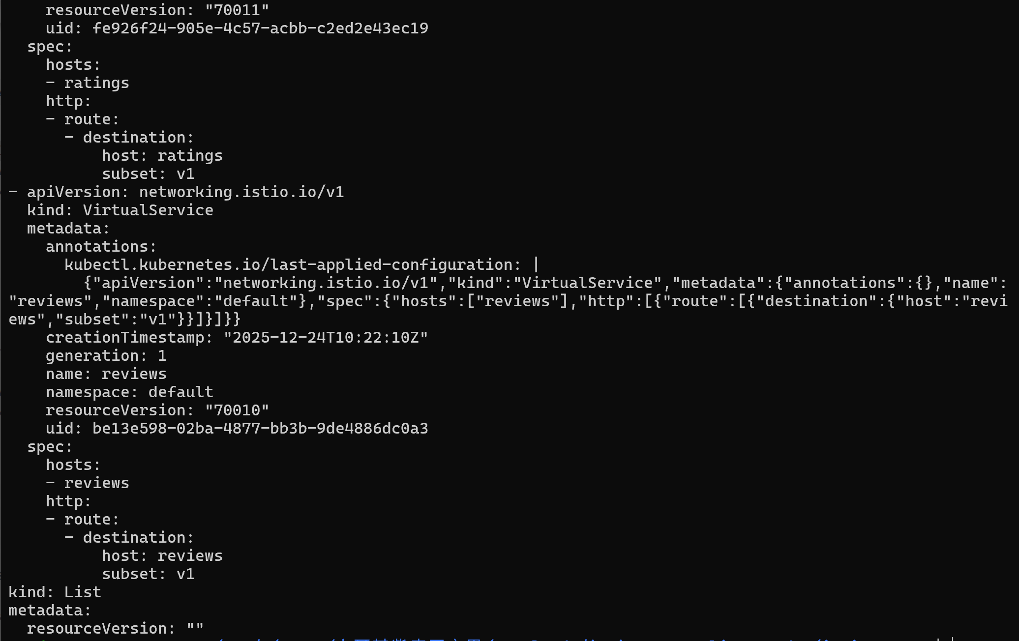
3.display the corresponding subset definitions
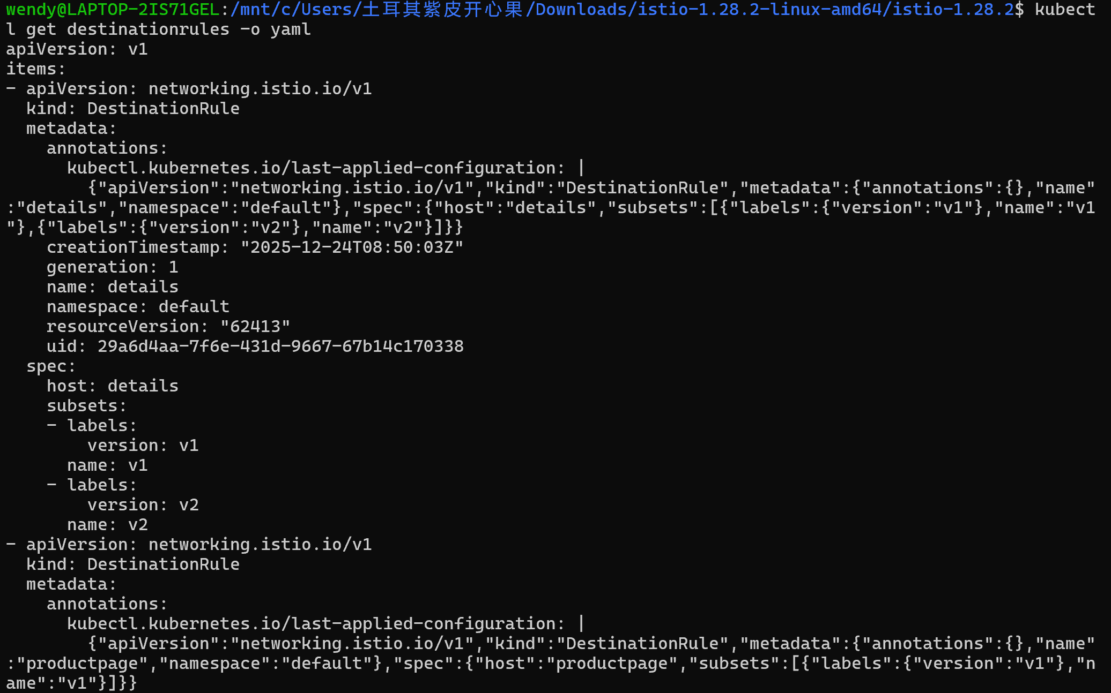
2.Test the new routing configuration
Refresh the browser
Always:
3.Route based on user identity
1.enable user-based routing
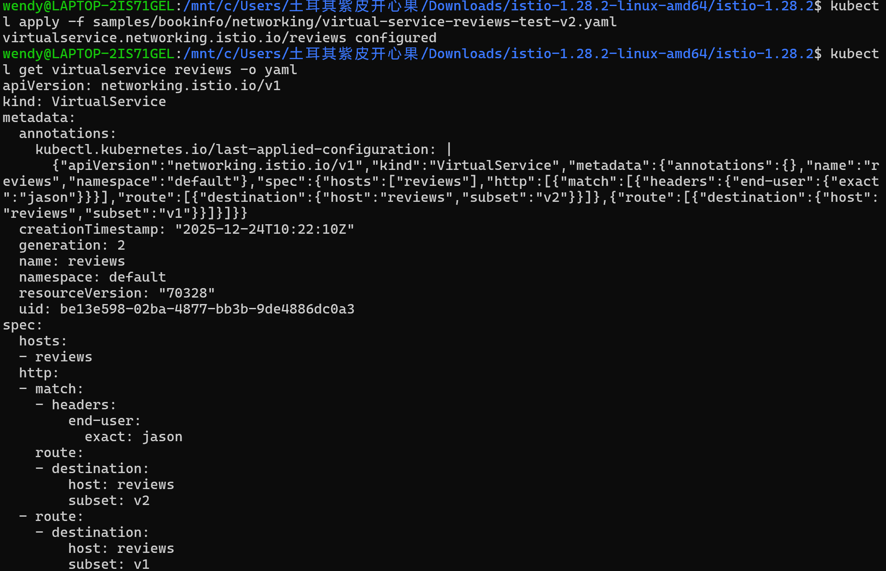
2.On the /productpage of the Bookinfo app, log in as user jason.

3.Log in as another user (pick any name you wish)

This is because traffic is routed to reviews:v1 for all users except Jason.

4.Clean up
Remove the application route rules
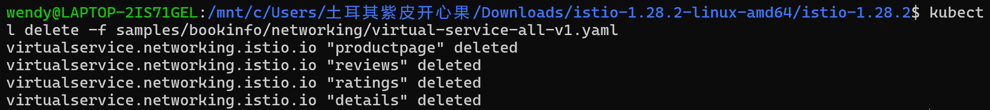

- fault-injection
1.Injecting an HTTP delay fault
1.Create a fault injection rule to delay traffic coming from the test user jason.
2.Confirm the rule was created
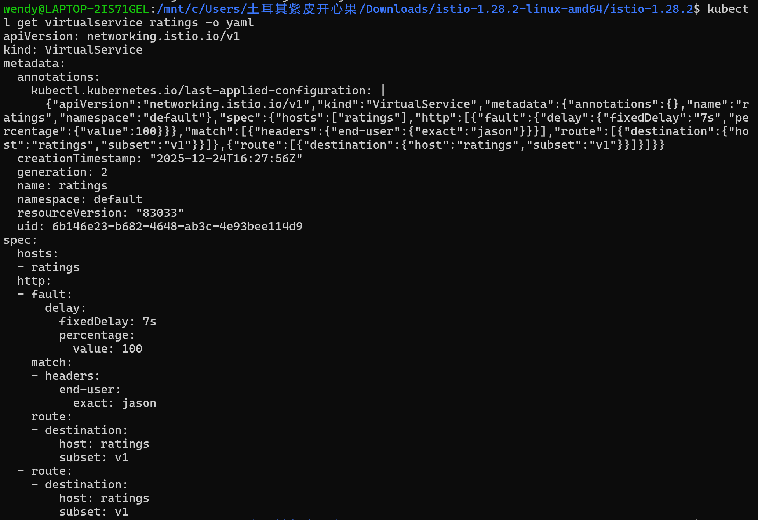
2.Testing the delay configuration
1.Open the Bookinfo web application in your browser,log in as user jason.

- View the web page response times:
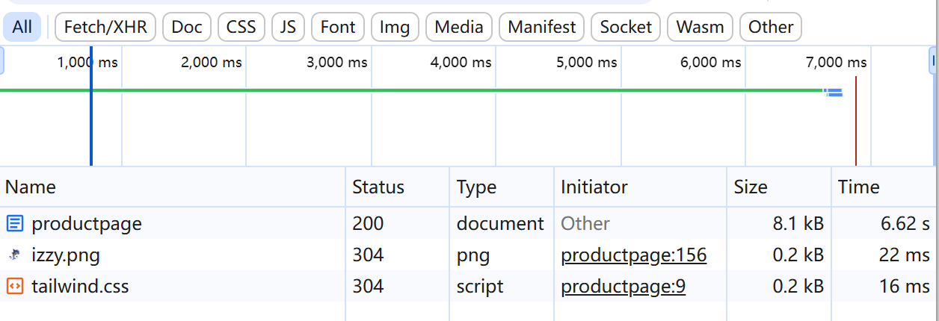
the page actually loads in about 6 seconds.
- Injecting an HTTP abort fault
1.Create a fault injection rule to send an HTTP abort for user jason:
- Confirm the rule was created:
4.Testing the abort configuration

5.Cleanup
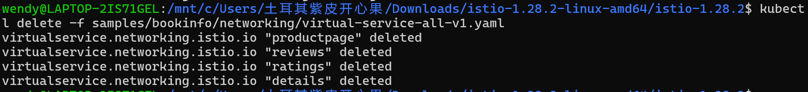

4.circuit-breaking
1.Before you begin
Start the httpbin sample.
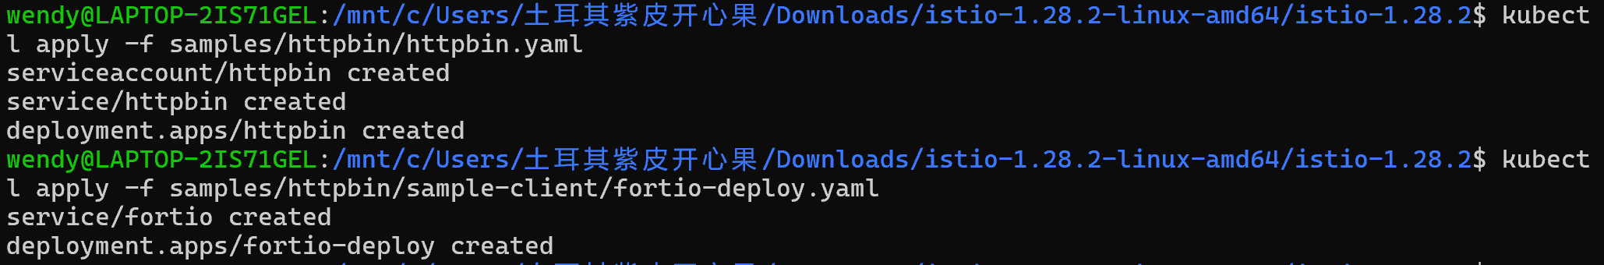
2.Configuring the circuit breaker
1.Create a destination rule to apply circuit breaking settings when calling the httpbin service
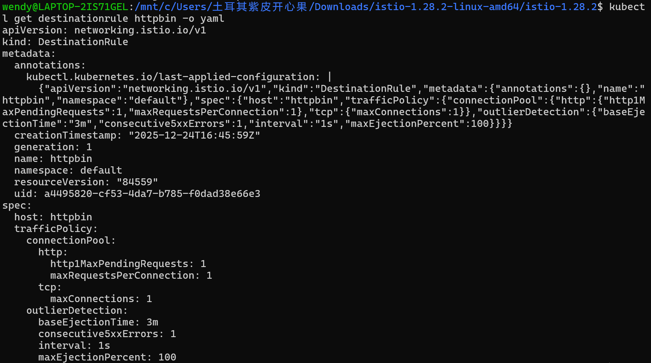
2.Verify the destination rule was created correctly:
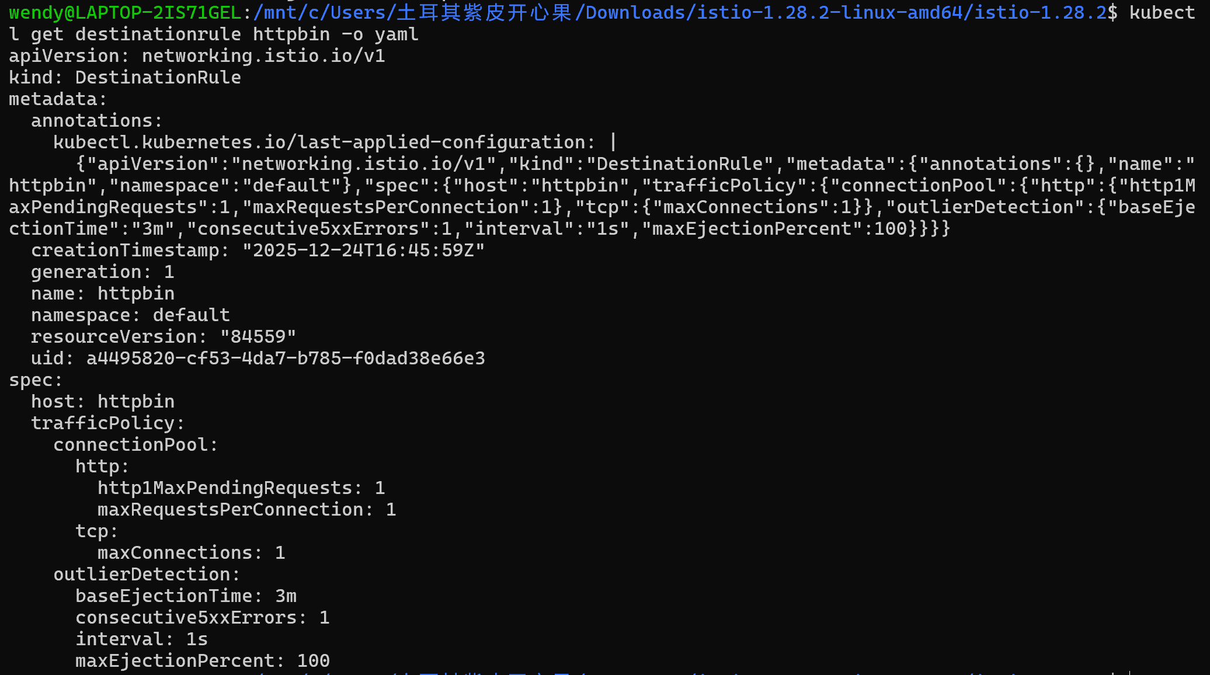
3.Adding a client
1.Inject the client with the Istio sidecar proxy so network interactions are governed by Istio
2.Log in to the client pod and use the fortio tool to call httpbin. Pass in curl to indicate that you just want to make one call
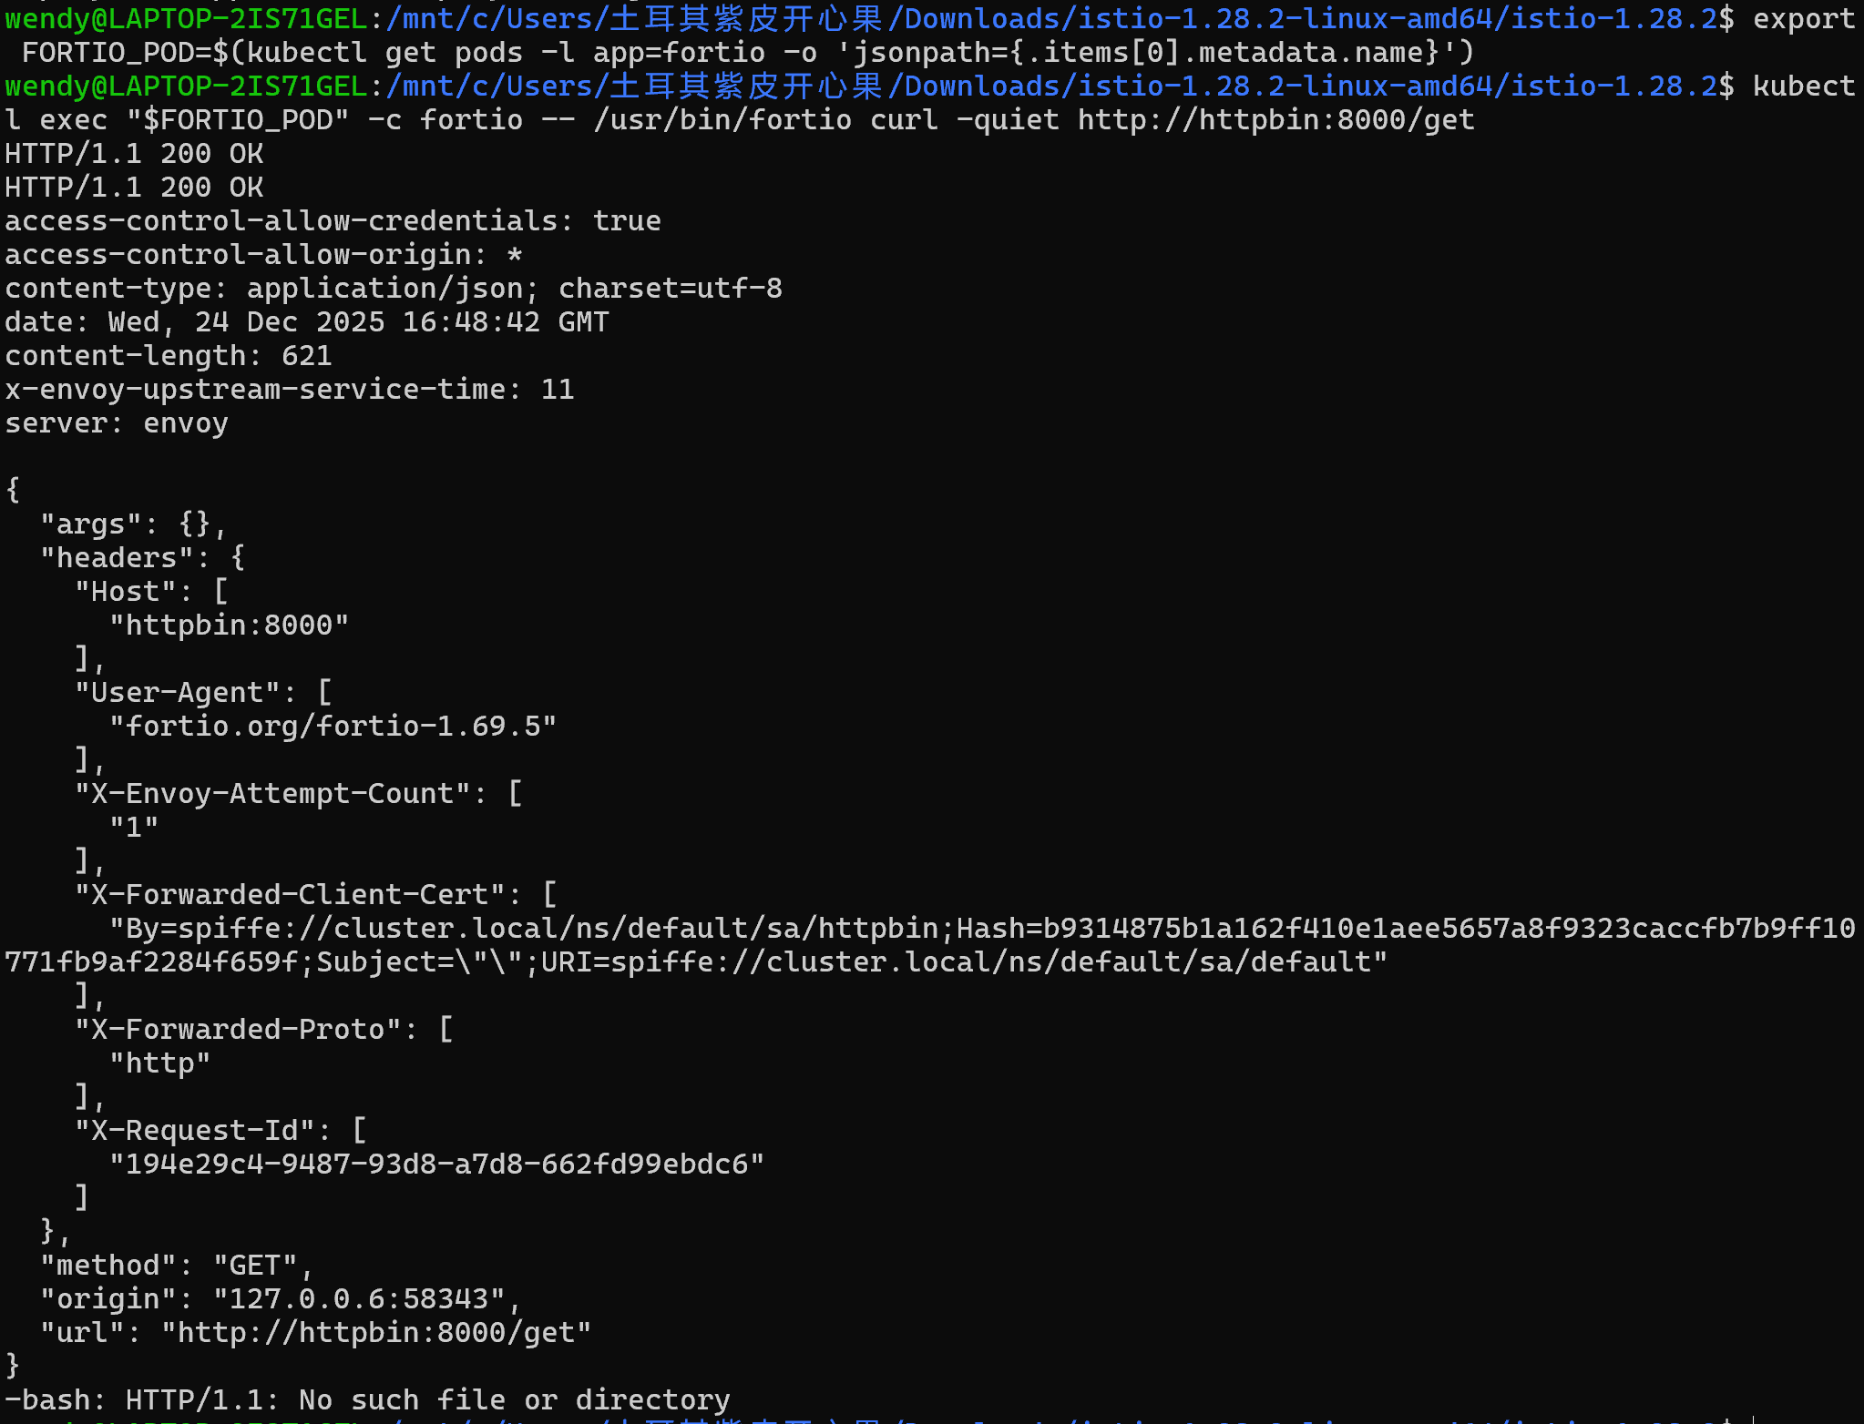
4.Tripping the circuit breaker
1.Call the service with two concurrent connections (-c 2) and send 20 requests (-n 20)
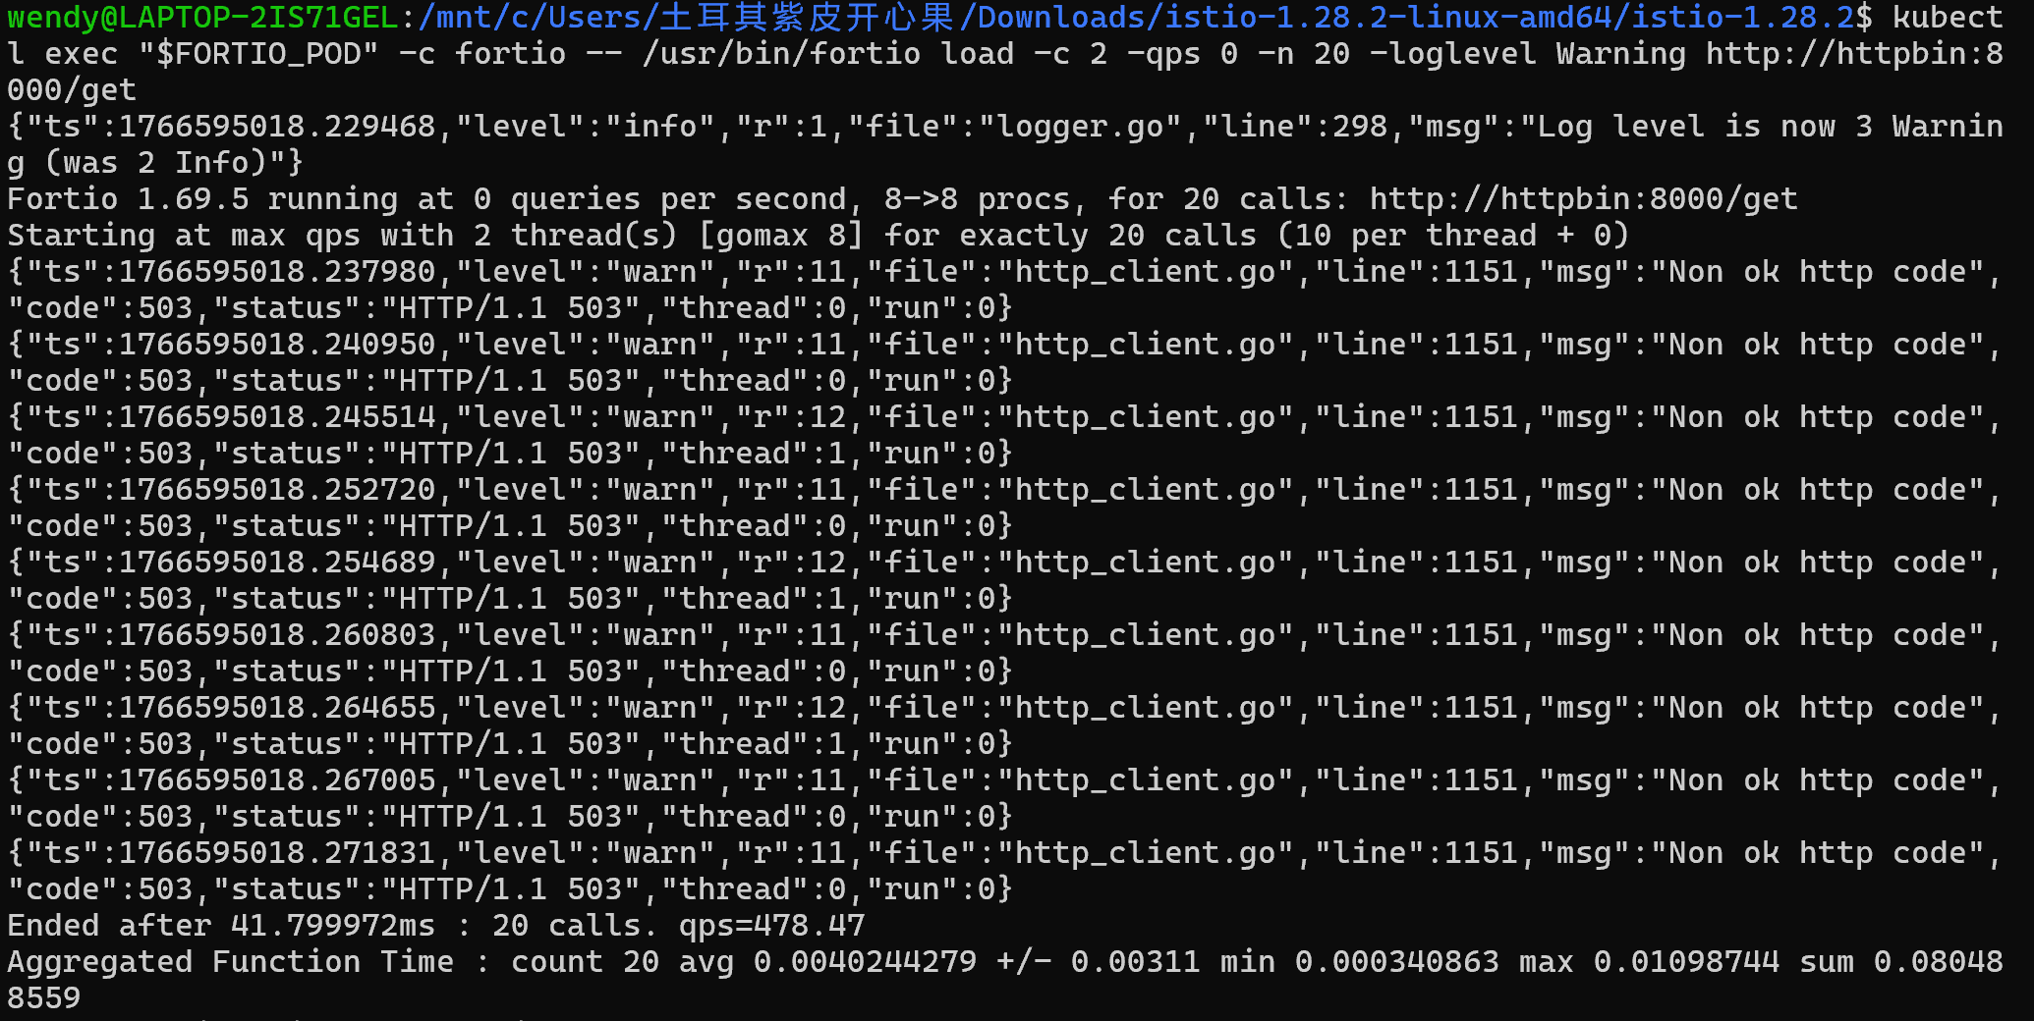
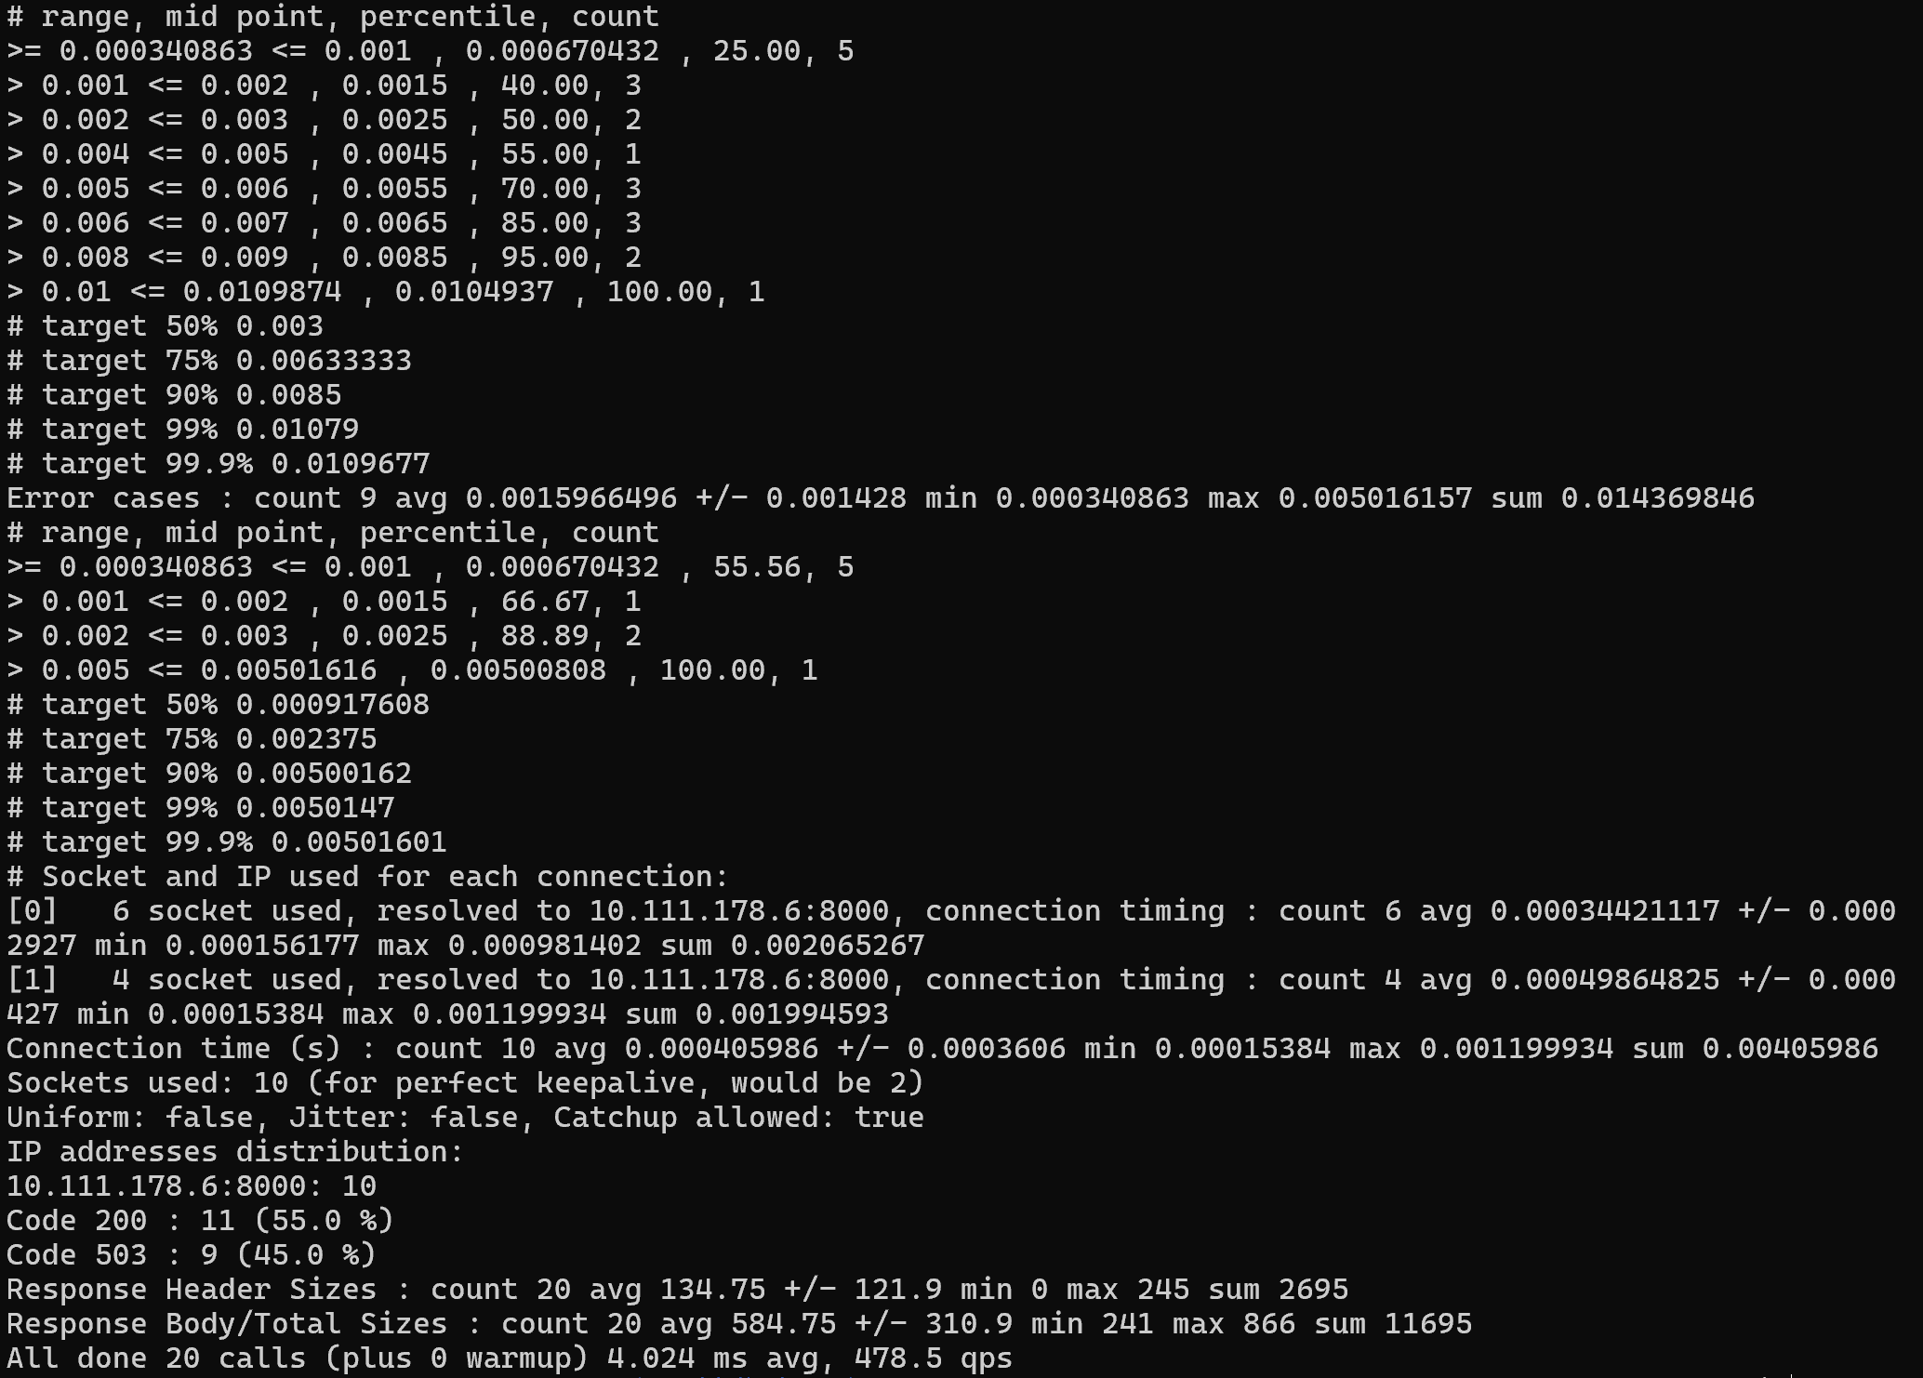
2.Bring the number of concurrent connections up to 3:
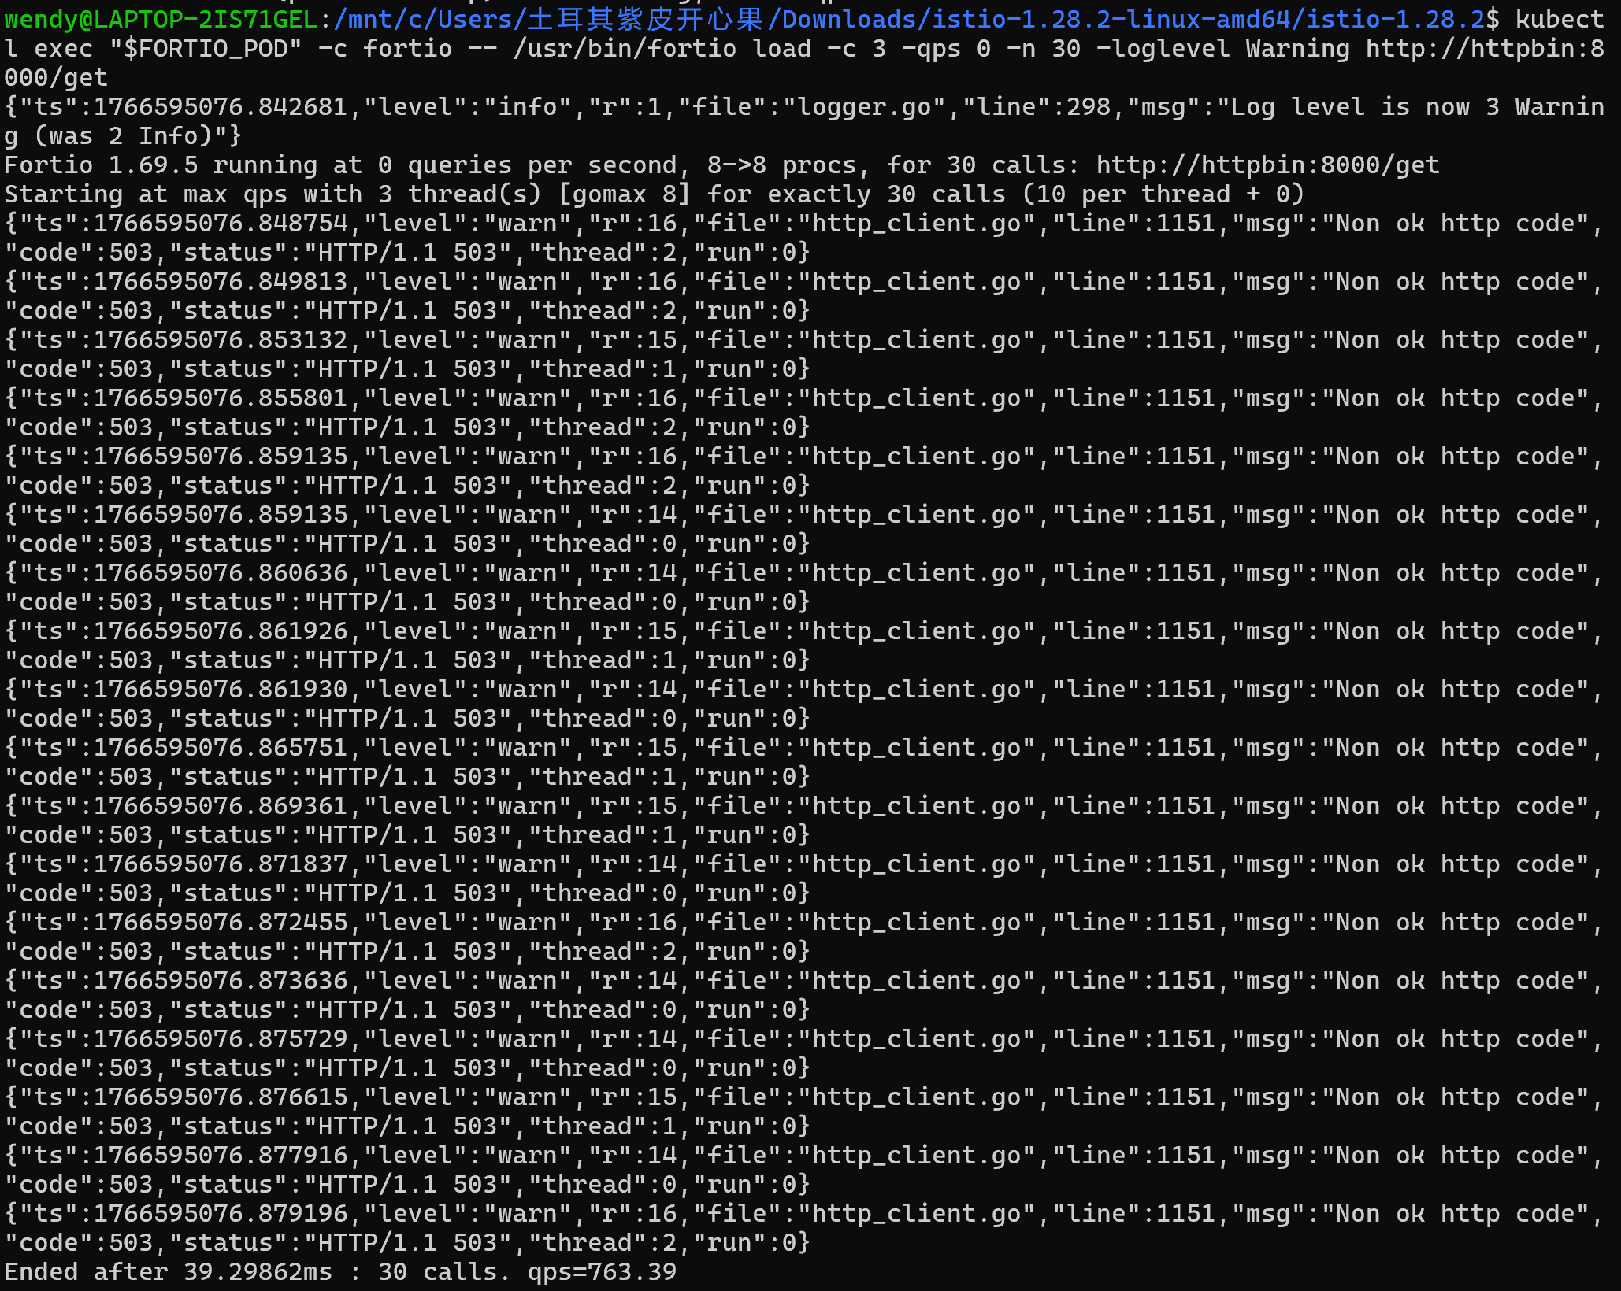
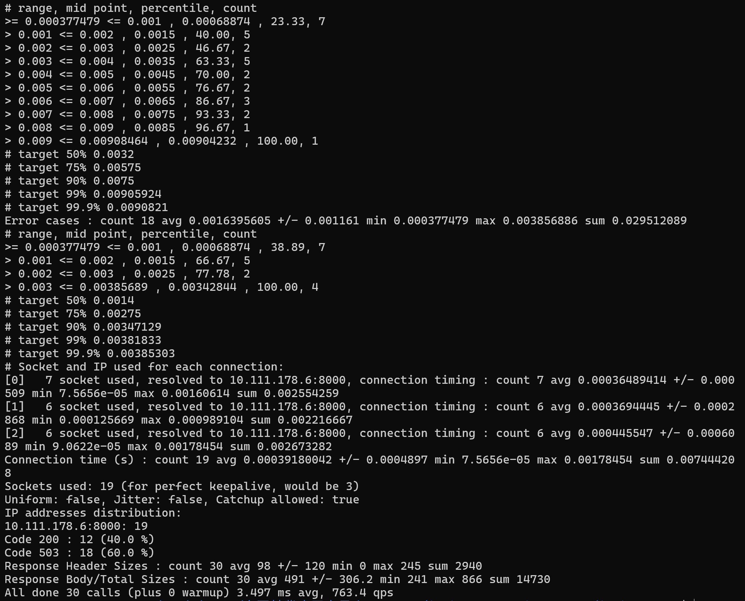
- Query the istio-proxy stats to see more:
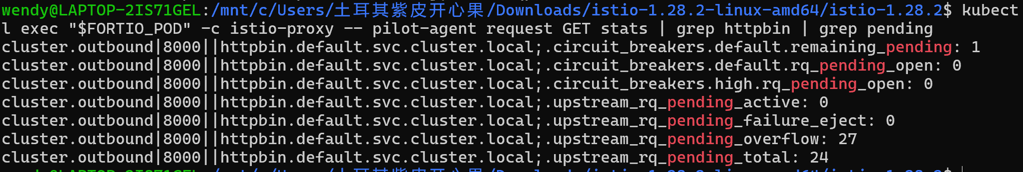
5.Cleaning up
1.Remove the rules
- Shutdown the httpbin service and client:
