1.What is a container

Step1:run a container
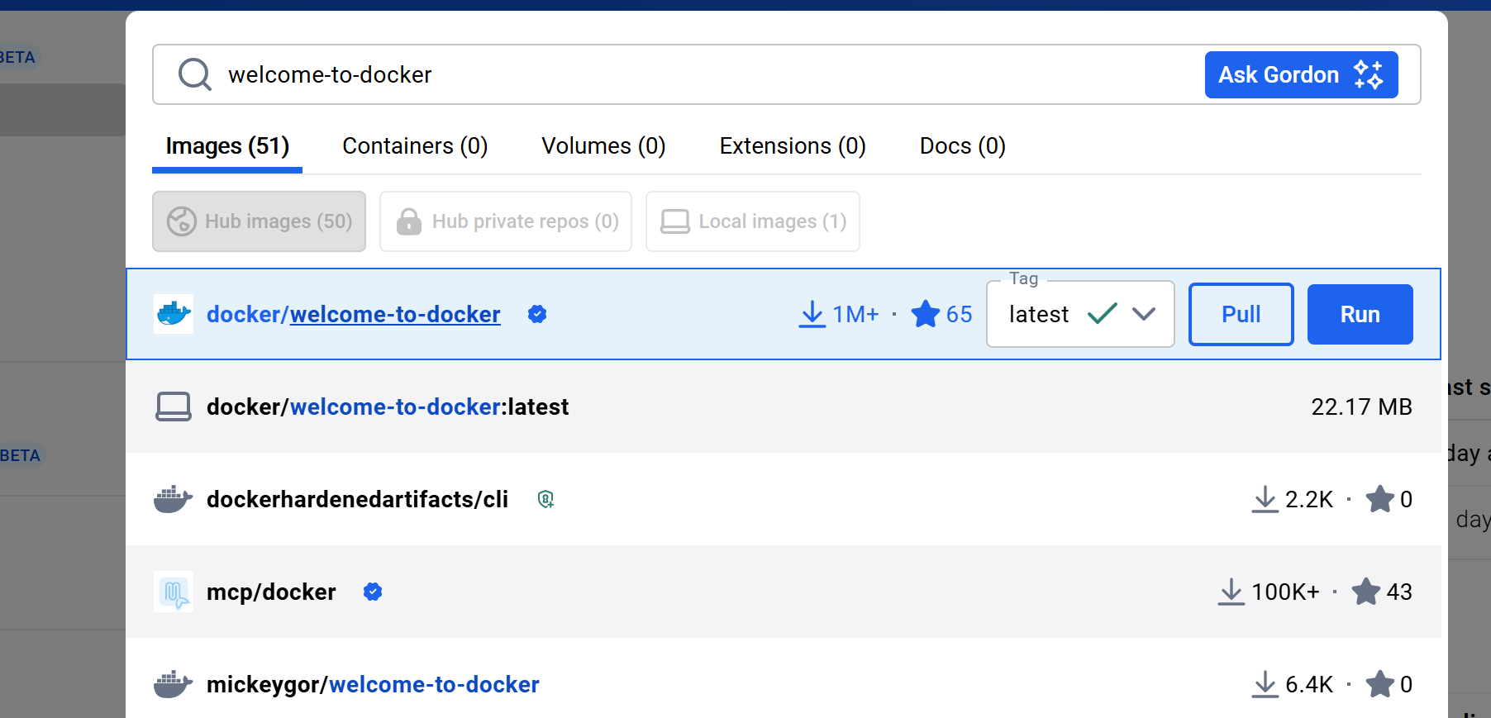
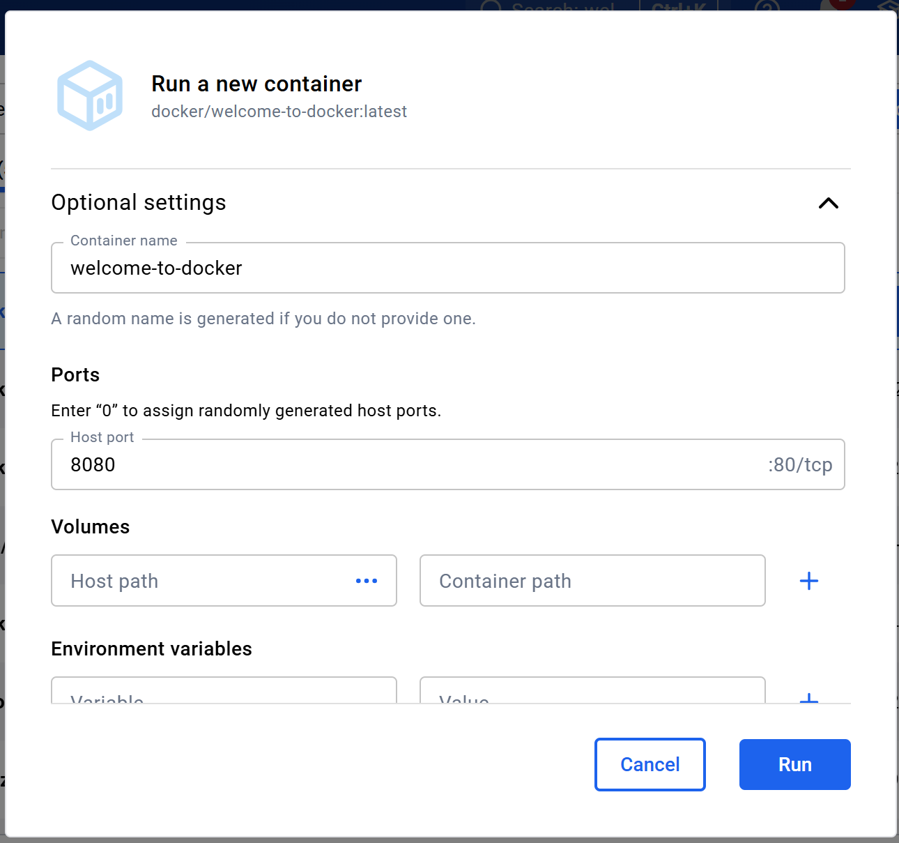

Step2:Explore my container
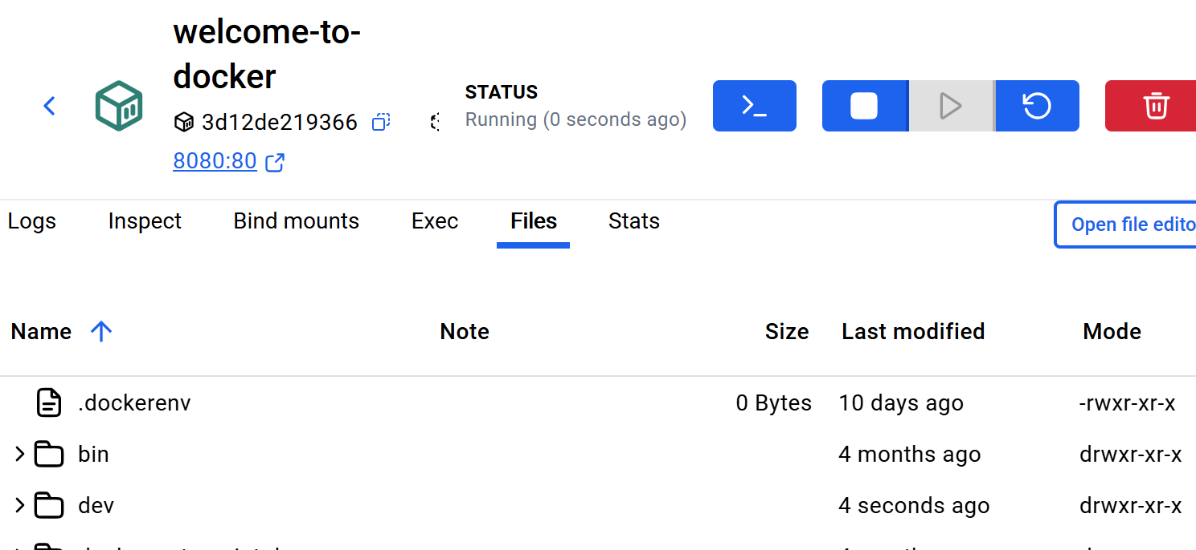
Step3:Stop my container
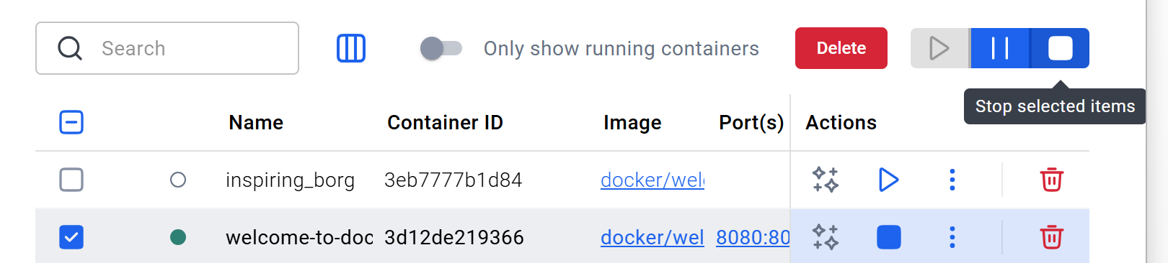
- What is an image
Step1:search and pull a container image using the Docker Desktop GUI:
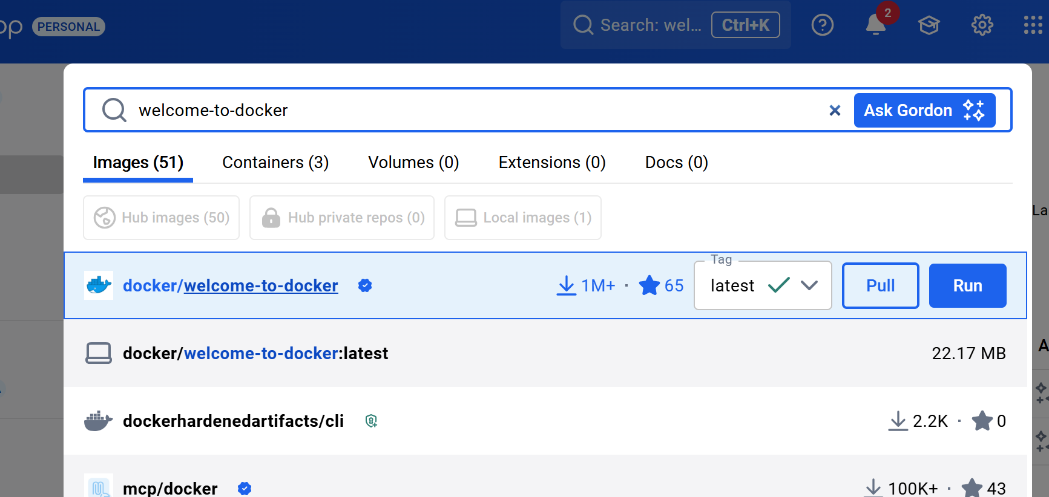
Step2:Learn about the image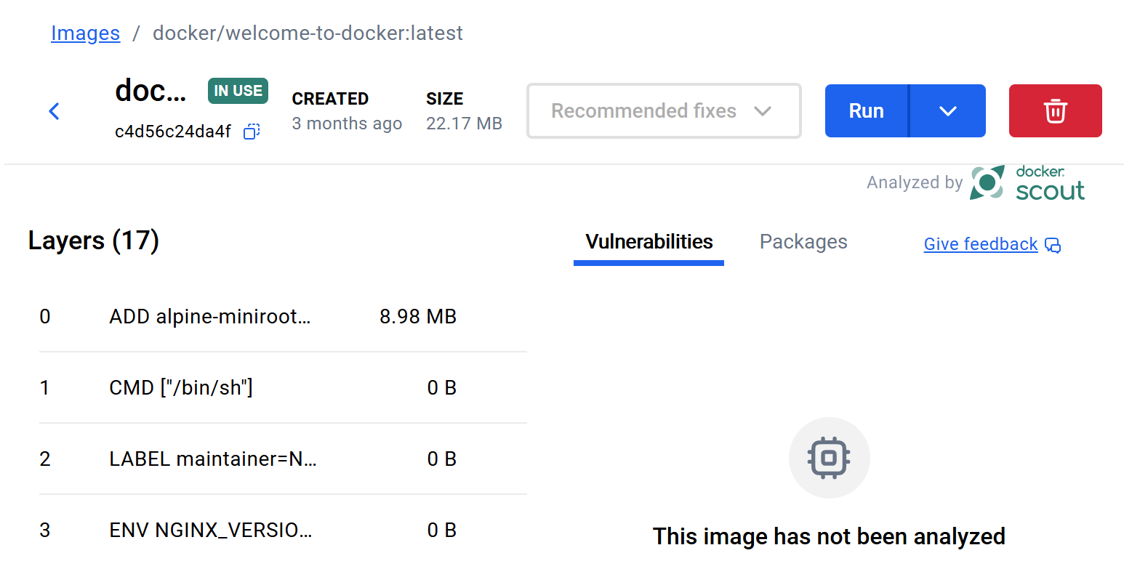

3:what is docker compose
Step1:Start the application
1.Download and install Docker Desktop.√
2.Open a terminal and clone this sample application.√
git clone https://github.com/dockersamples/todo-list-app
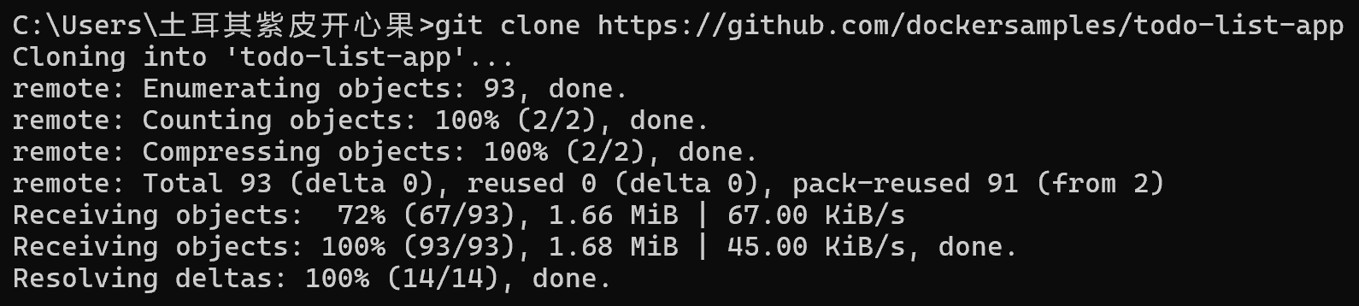
- Navigate into the todo-list-app directory:
The compose.yaml in the directory
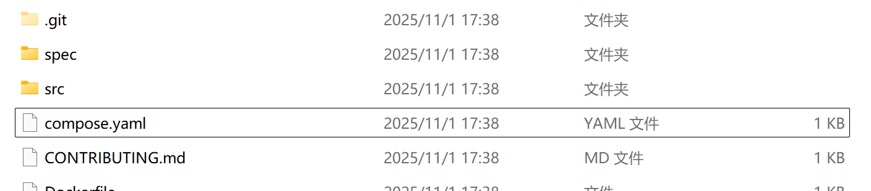
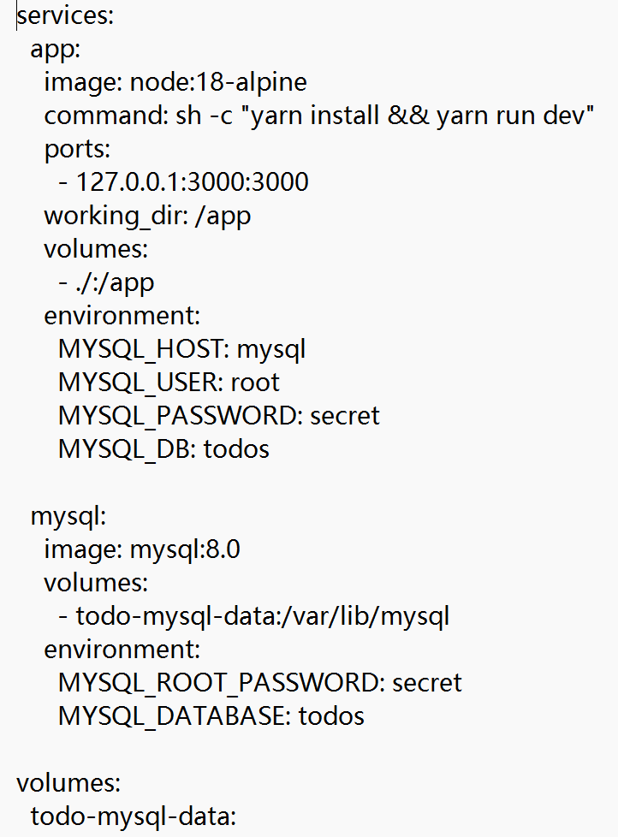
4.Use the docker compose up command to start the application:
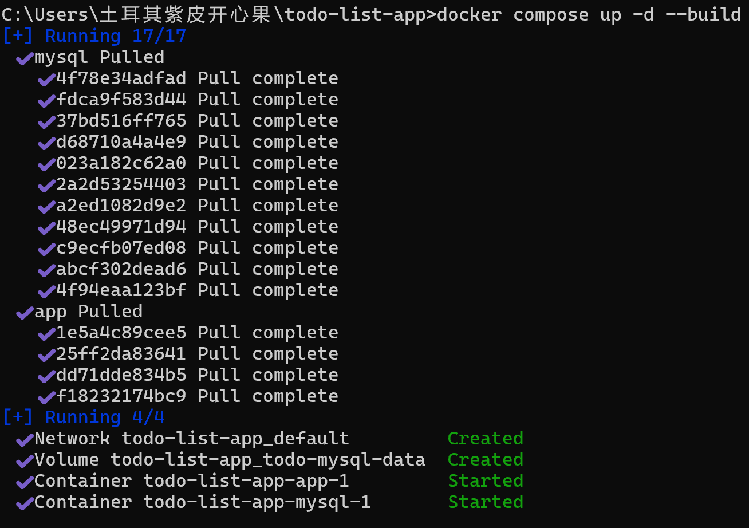
5.open http://localhost:3000
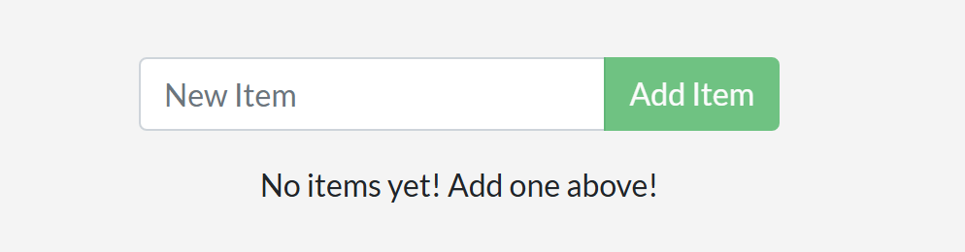
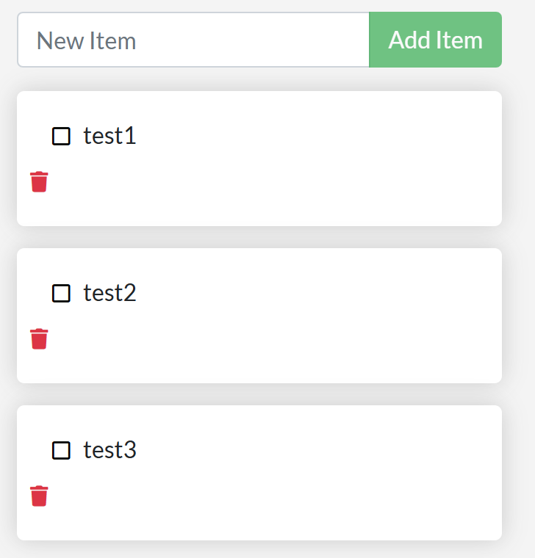
- in the Docker Desktop GUI
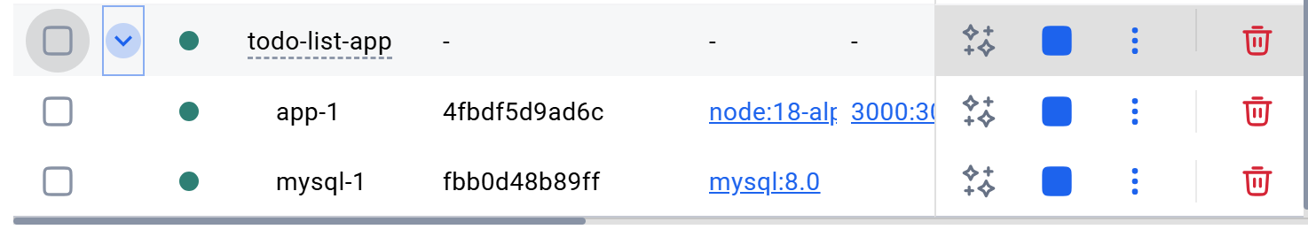
Step2:Tear it down
- In the CLI, use the docker compose down command to remove everything:
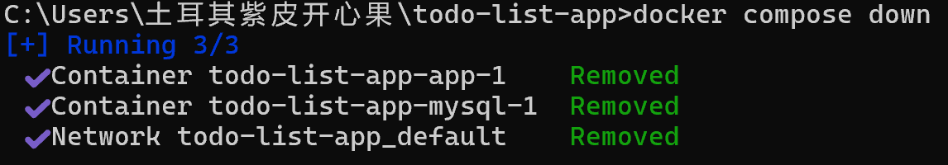
- use the Docker Desktop GUI to remove the containers by selecting the application stack and selecting the Delete button

4.running-containers/publishing-ports/
1.publish container ports using the CLI for deploying a web application
1.1Download and install Docker Desktop.√
1.2start a new container:

1.3Verify the published port by going to the Containers view of the Docker Desktop Dashboard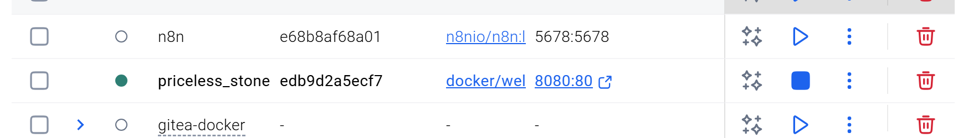
1.4visiting http://localhost:8080
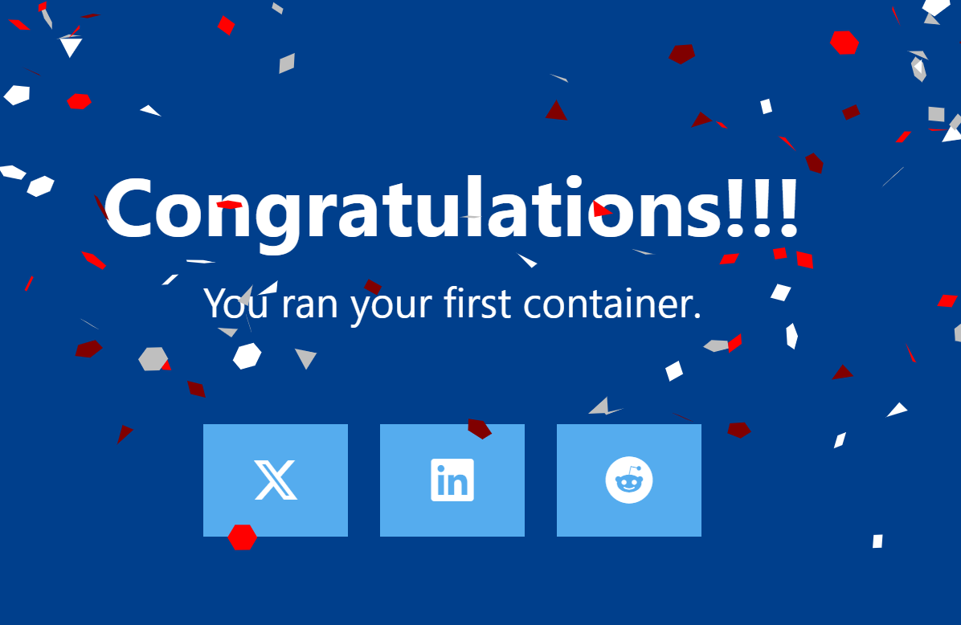
2.publish container ports using Docker Compose for deploying a web application
2.1Create a new directory and inside that directory, create a compose.yaml file
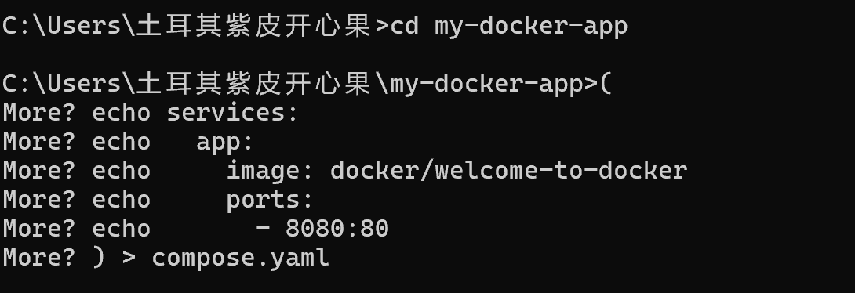
2.2Use the docker compose up command to start the application.

2.3Openbrowserto http://localhost:8080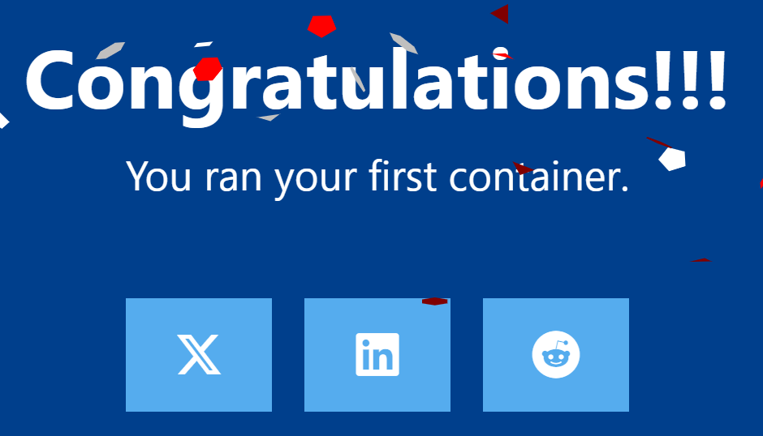
5.Overriding-container-defaults
5.1Run multiple instances of the Postgres database
- Start a container using the Postgres image
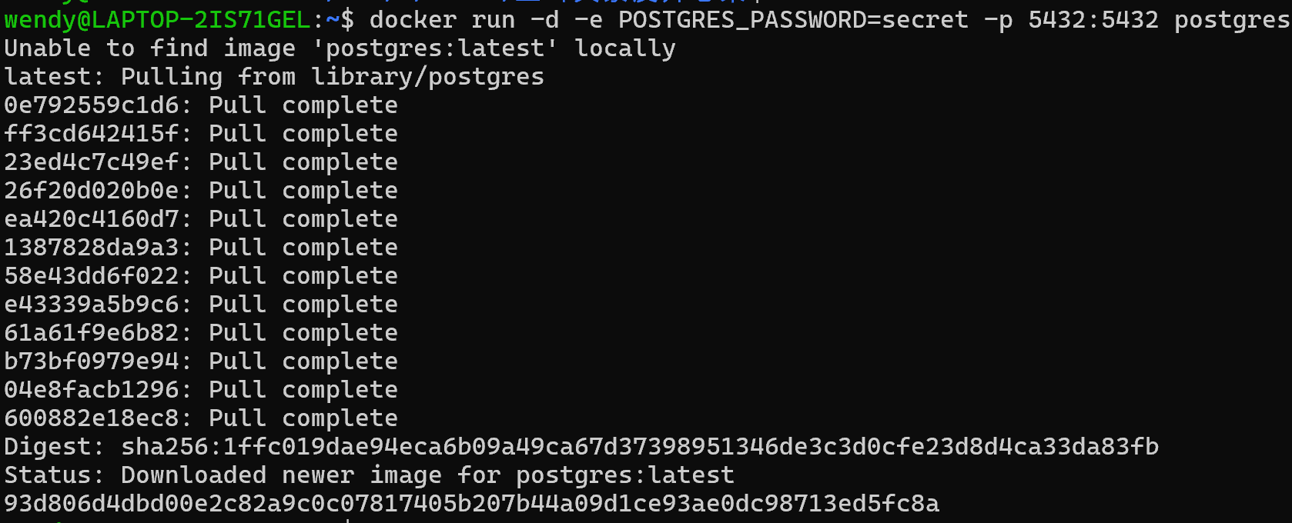
- Start a second Postgres container mapped to a different port.
- Verify that both containers are running by going to the Containers view in the Docker Desktop Dashboard.

5.2Run Postgres container in a controlled network
1.Create a new custom network
2,Verify the network
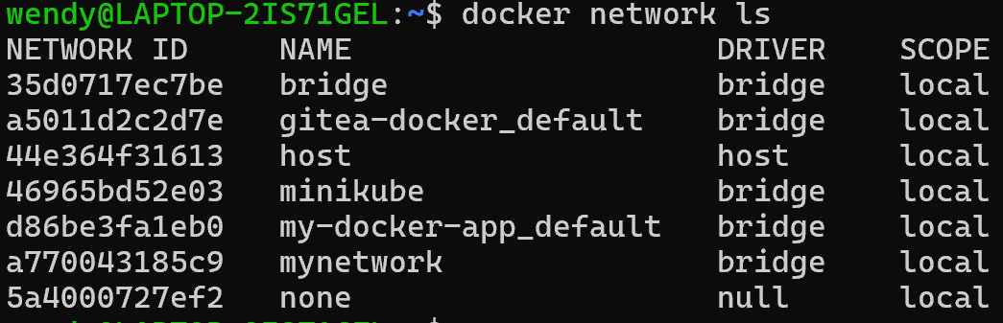
- Connect Postgres to the custom network
- use docker network inspect command to see if the container is tied to this new bridge network
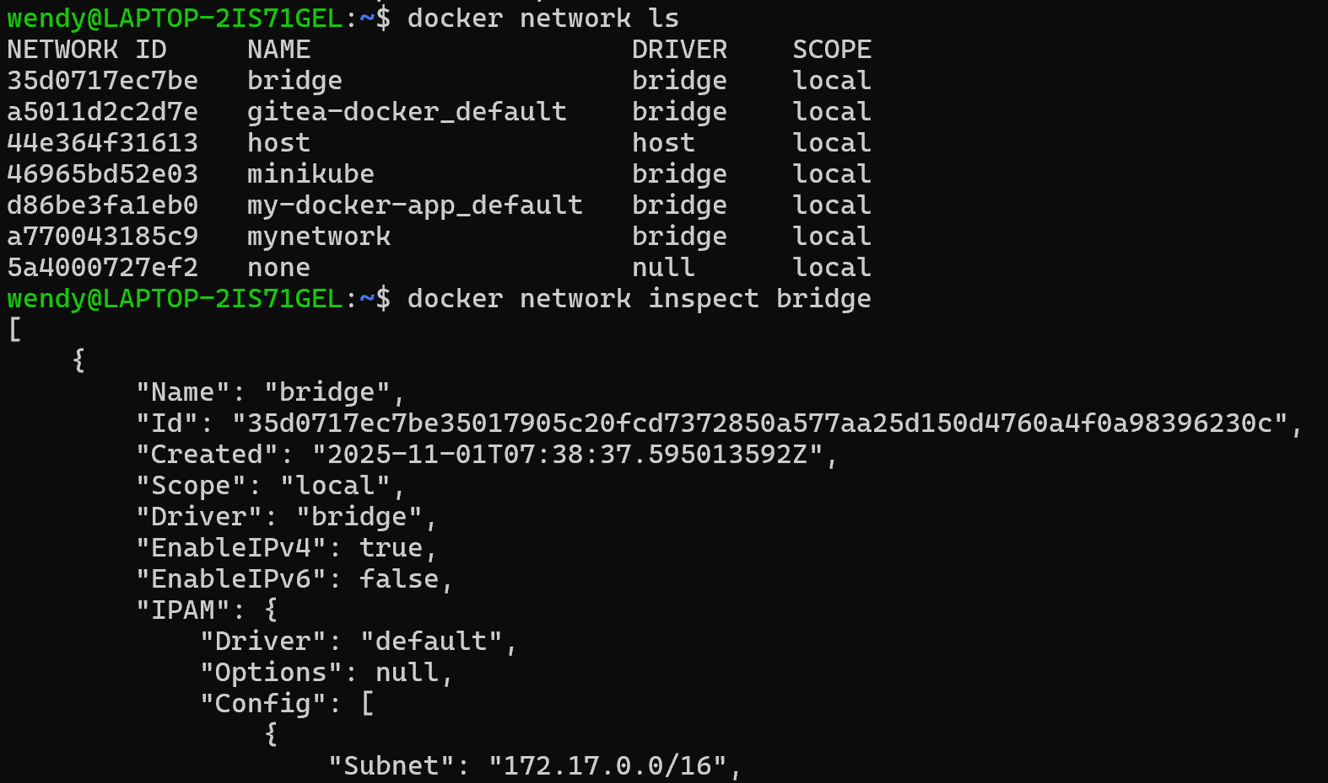
5.3Manage the resources
5.4Override the default CMD and ENTRYPOINT in Docker Compose
- Create a compose.yml file
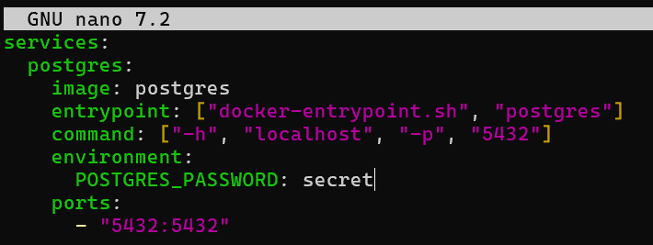
- Bring up the service
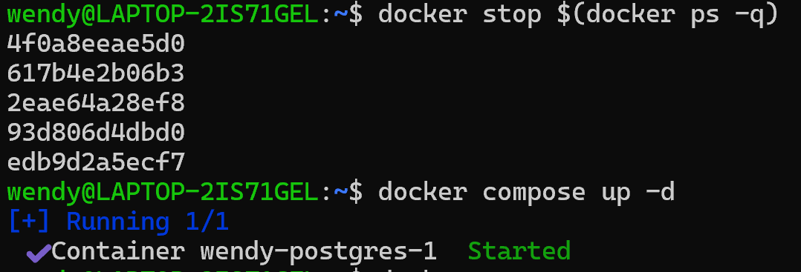
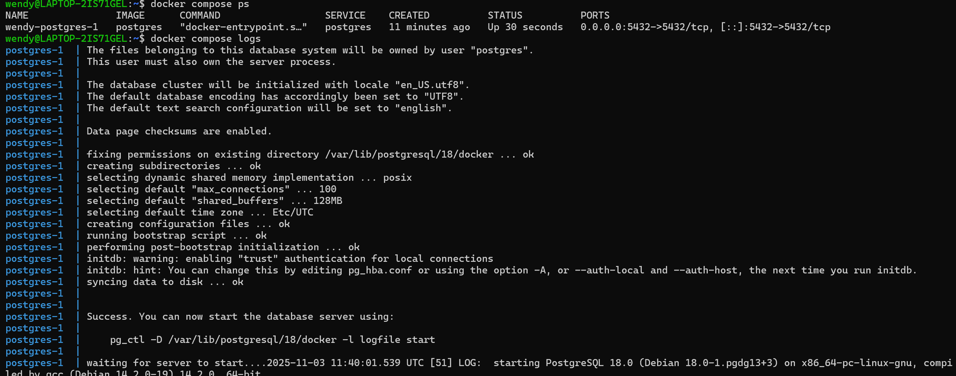
3.Verify the authentication with Docker Desktop Dashboard
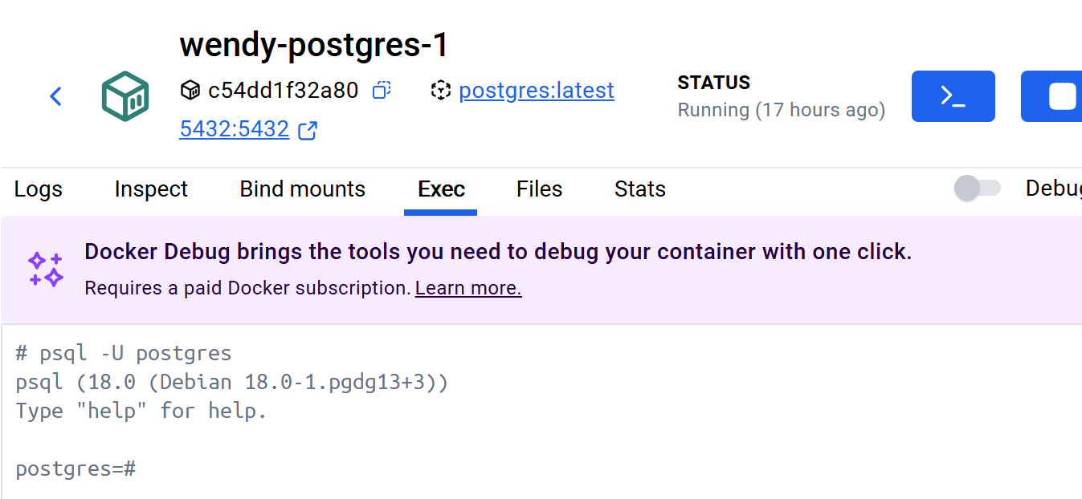
5.5Override the default CMD and ENTRYPOINT with docker run
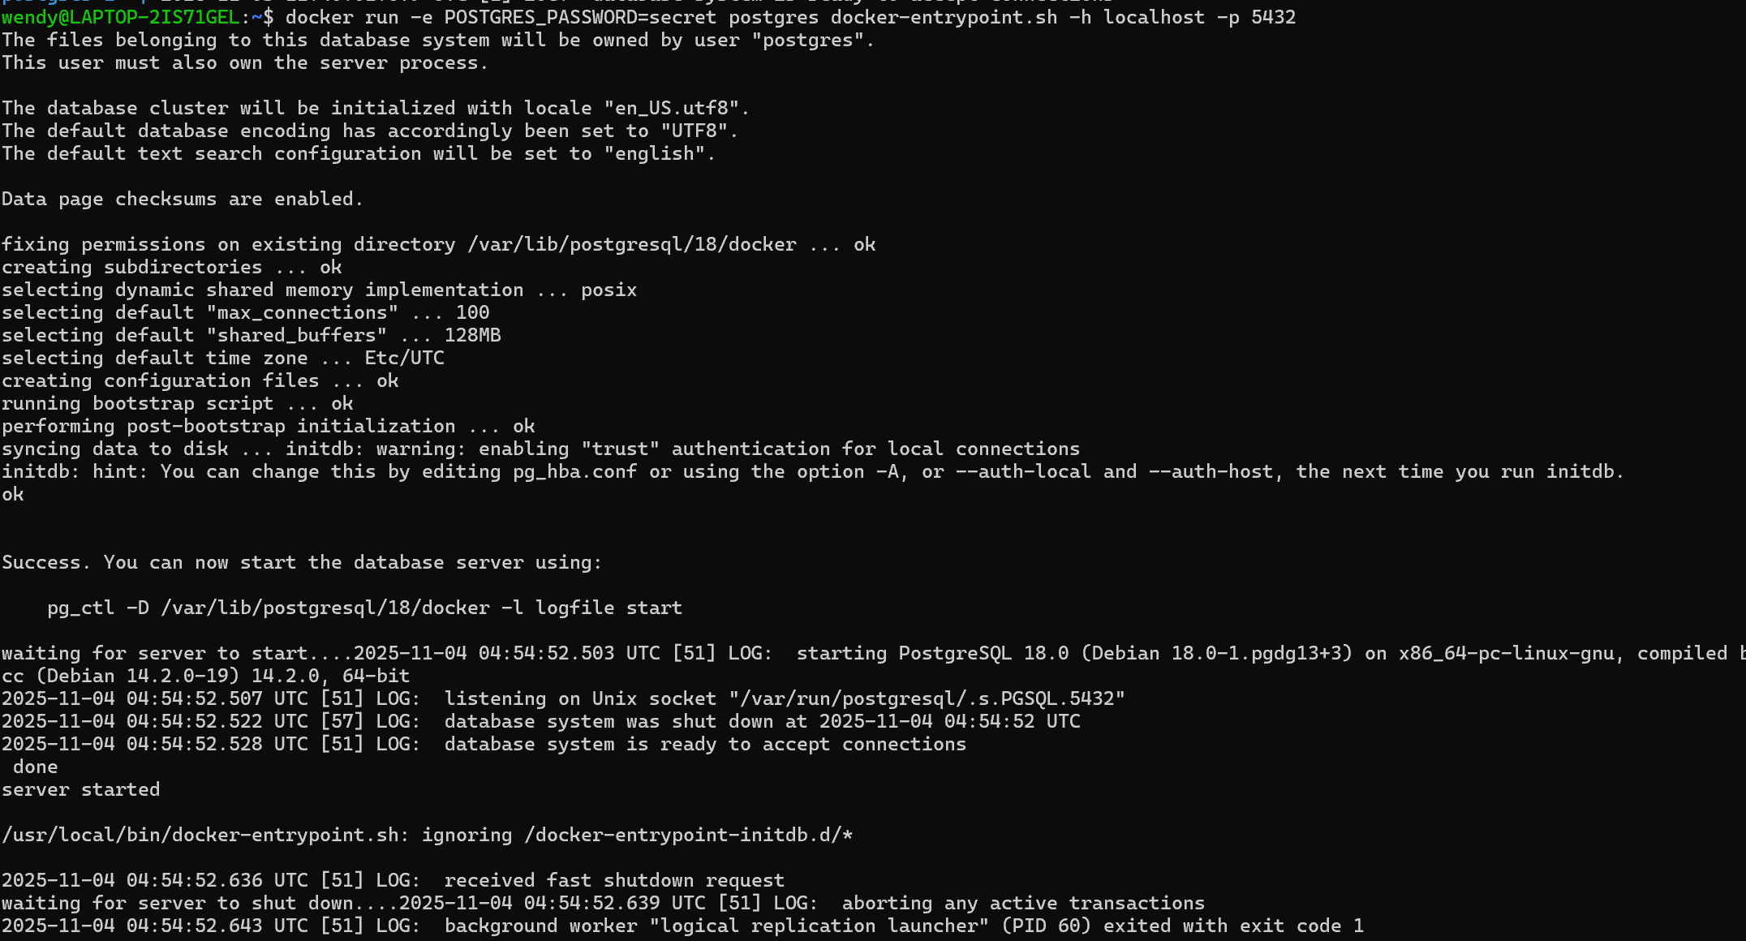
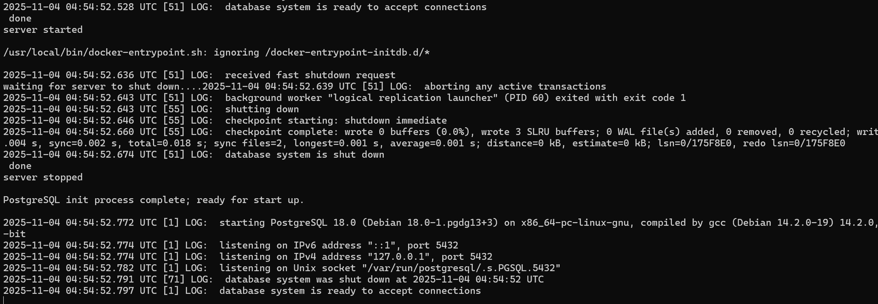
6.Persisting-container-data
6.1 Use volumes
1.Start a container using the Postgres image
2.Connect to the database
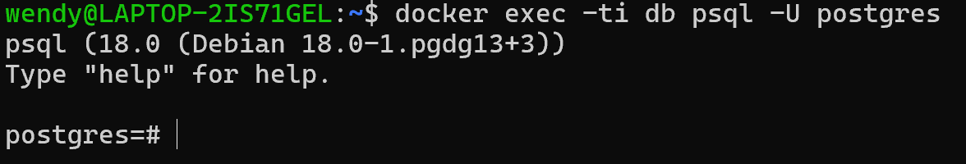
- create a database table and insert two records
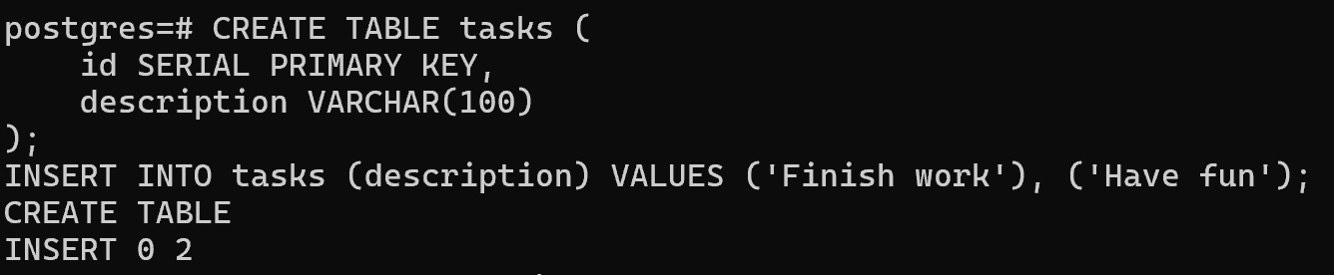
4.Verify the data is in the database
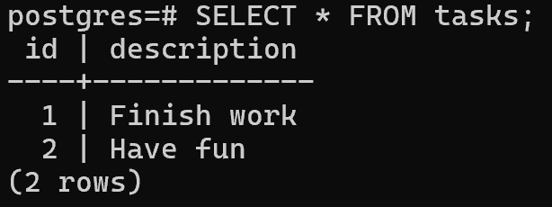
5.Exit out of the PostgreSQL shell
6.Stop and remove the database container.
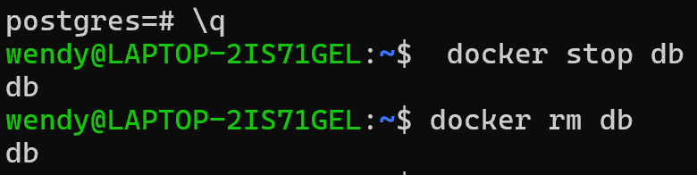
7.Start a new container , attaching the same volume with the persisted data
8.Verify the database still has the records
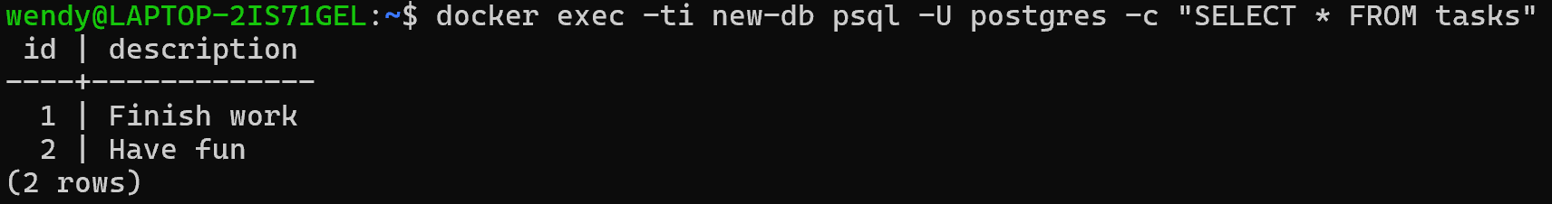
6.2View volume contents
1.Open the Docker Desktop Dashboard and navigate to the Volumes view. In this view, you should see the postgres_data volume.
2.
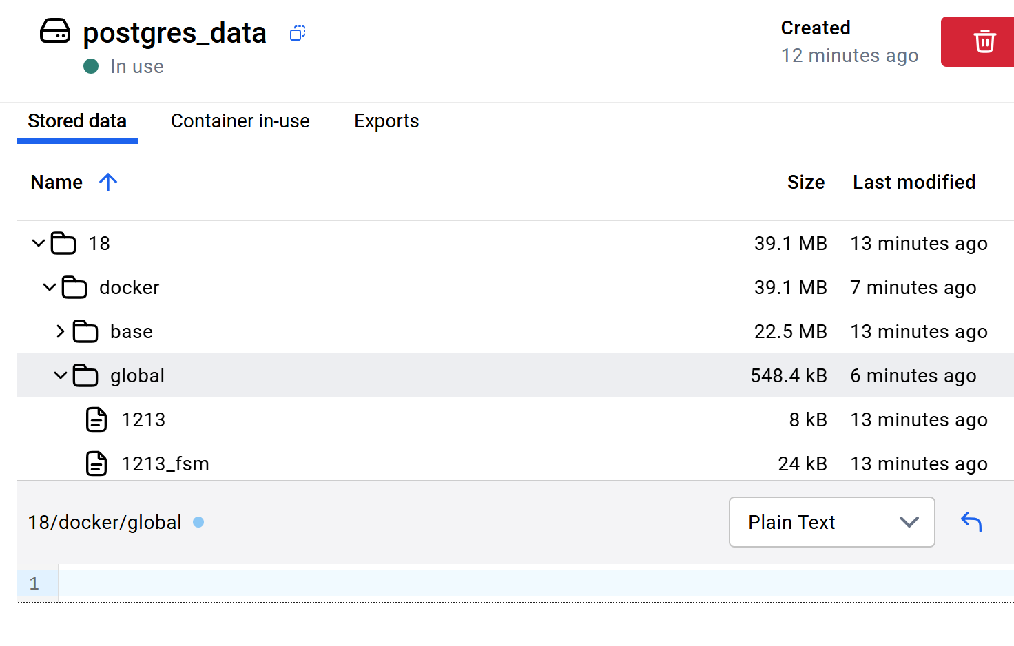
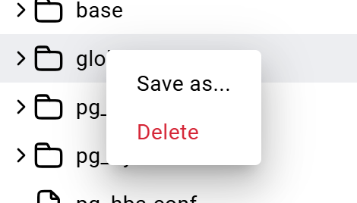
6.3Remove volumes
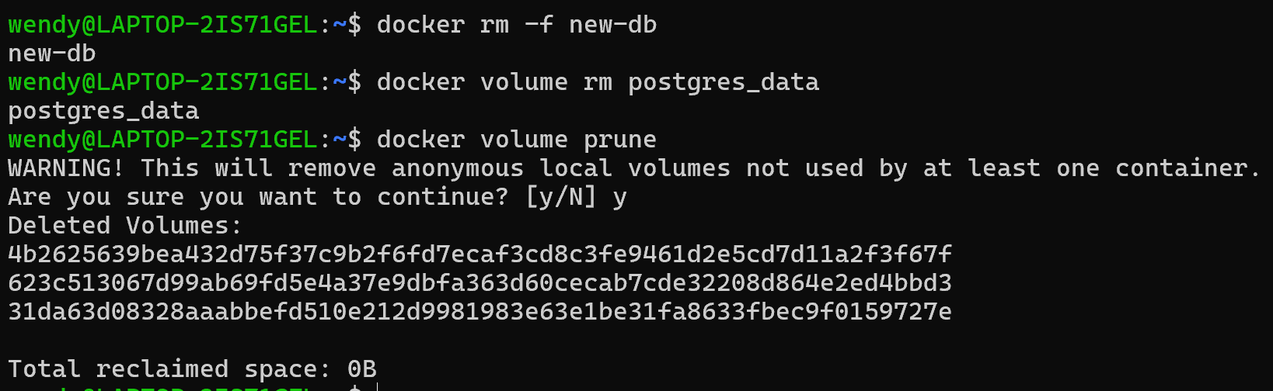

7.Sharing-local-files
Step1:Run a container
- Start a container using the httpd image
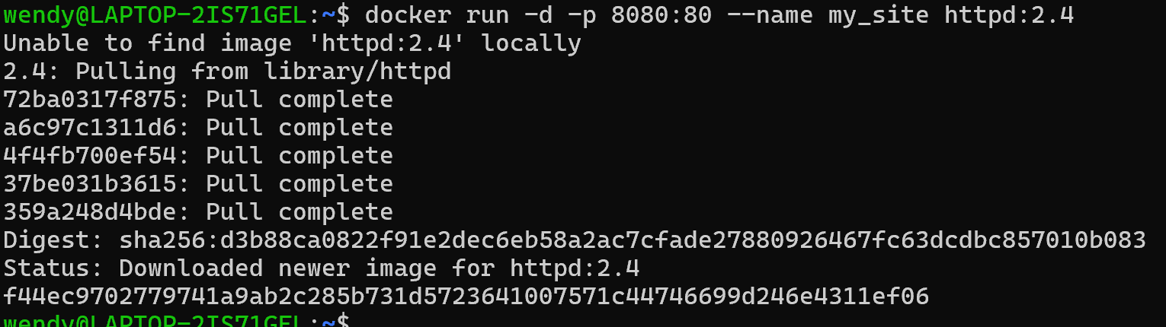
- Open the browser and access http://localhost:8080 to verify if it's working fine or not
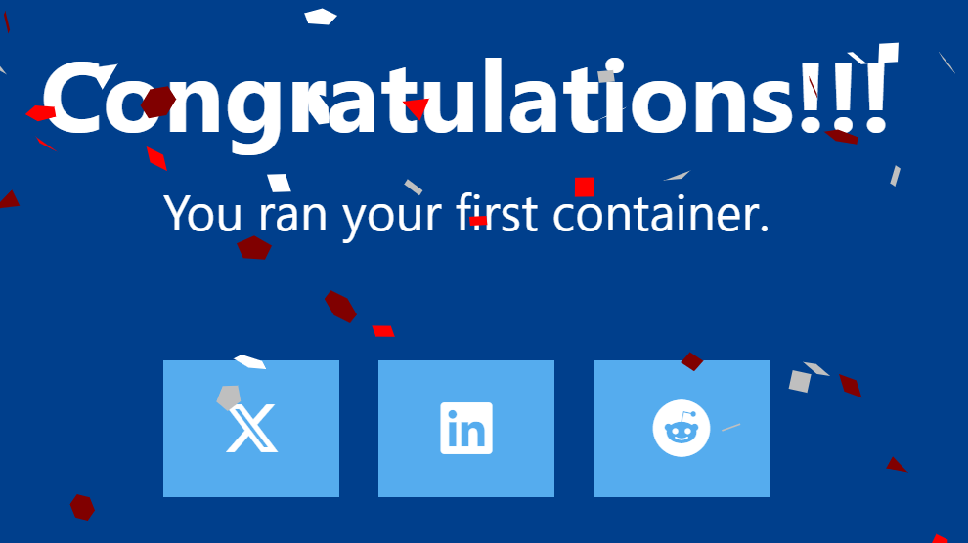
Step2:Use a bind mount
- Delete the existing container by using the Docker Desktop Dashboard
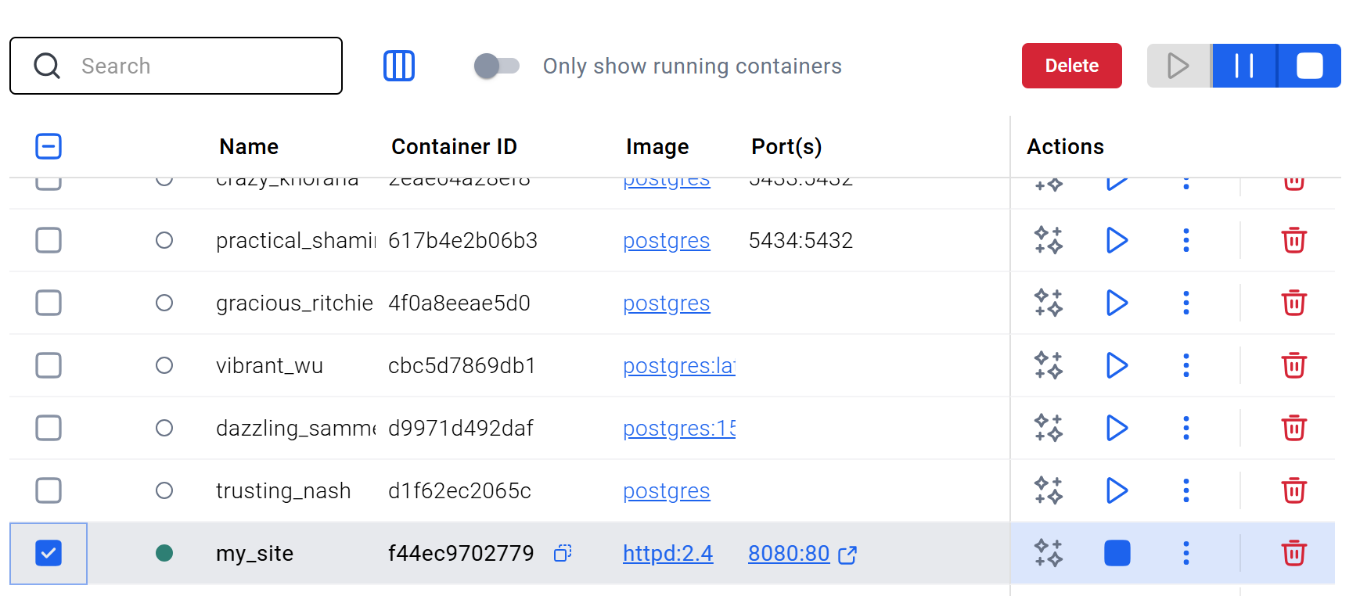
- Create a new directory called public_html on your host system
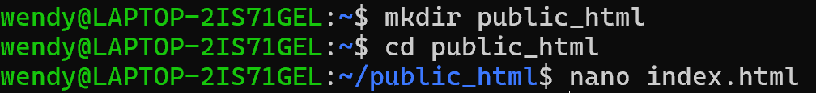
- Navigate into the newly created directory public_html and create a file called index.html with the following content.
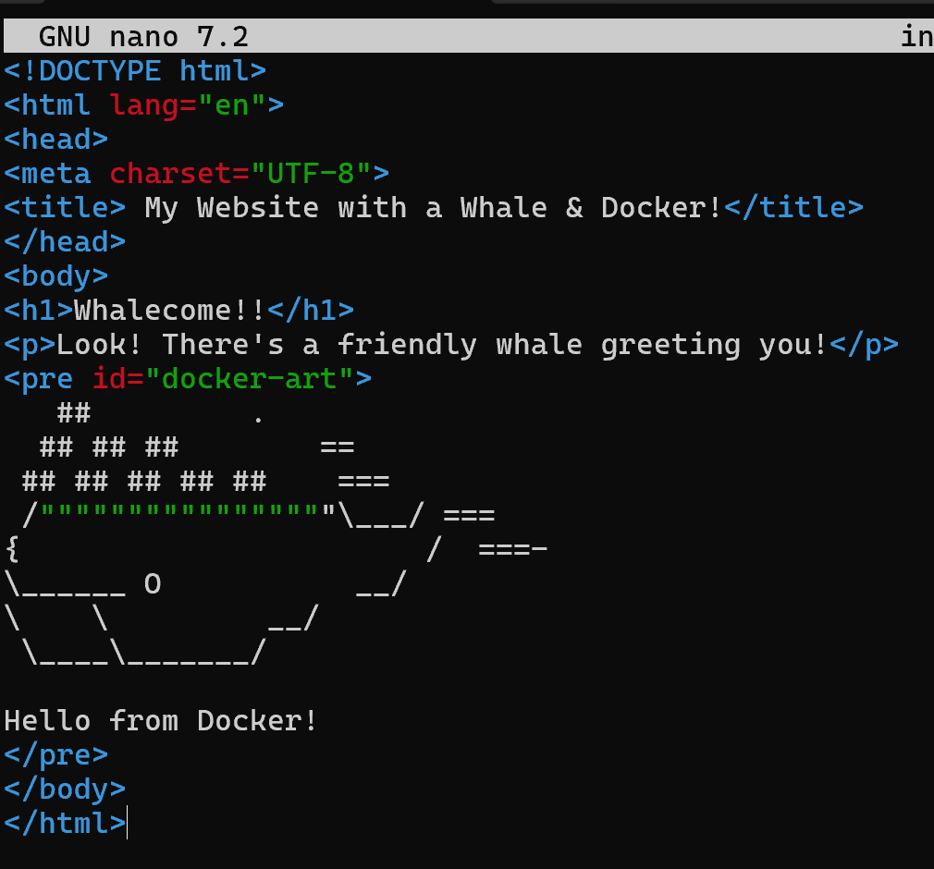
- run the container

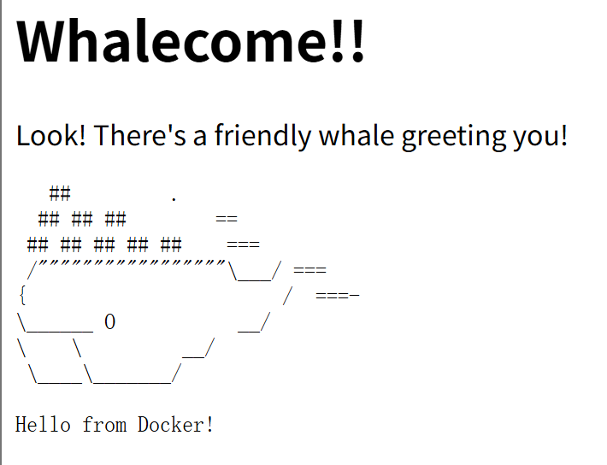
Step3:Access the file on the Docker Desktop Dashboard
- view the mounted files inside a container
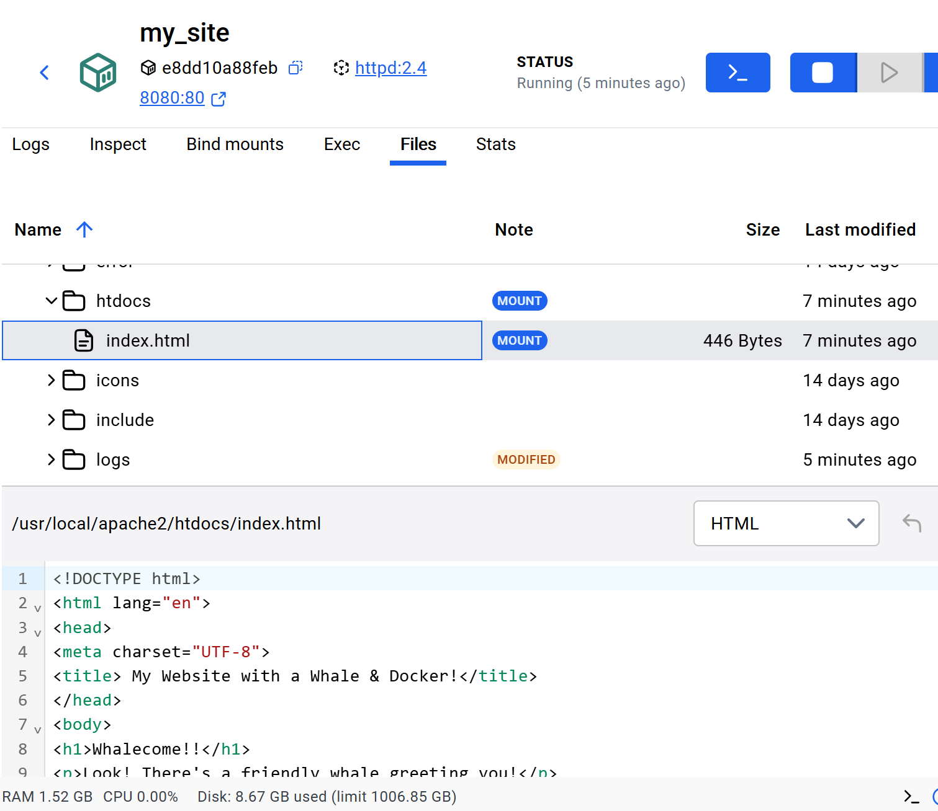
- Delete the file on the host
verify the file is also deleted in the container
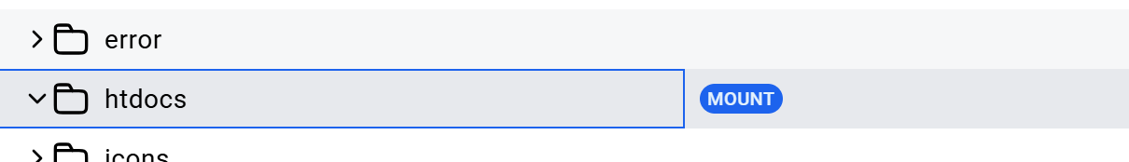
Step4:Stop the container
8.Multi-container-applications
Step1:Set up
1.Get the sample application
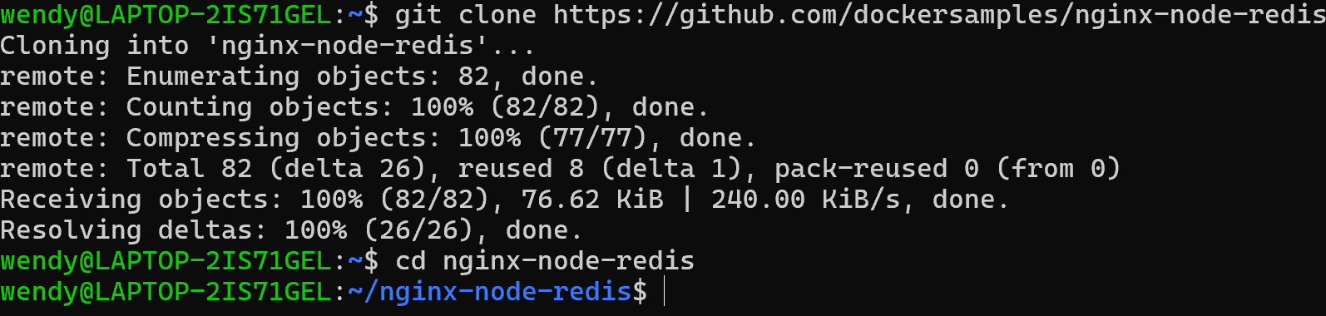
Inside this directory, you'll find two sub-directories - nginx and web.
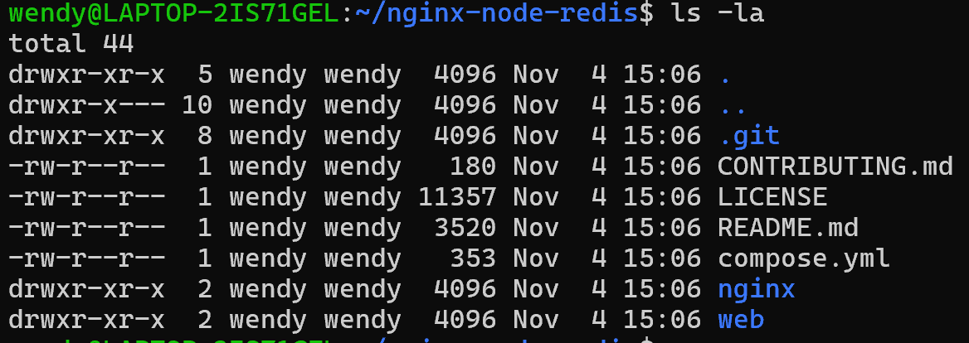
Step2:Build the images
- Navigate into the nginx directory to build the image
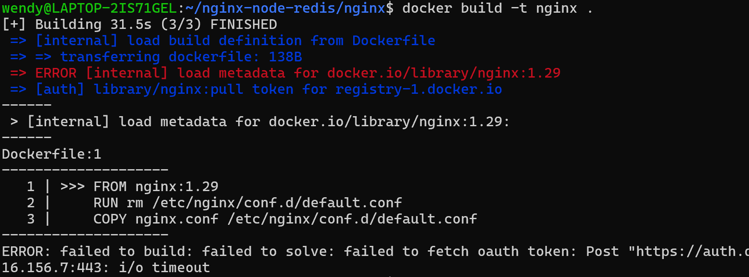
pull the image first:
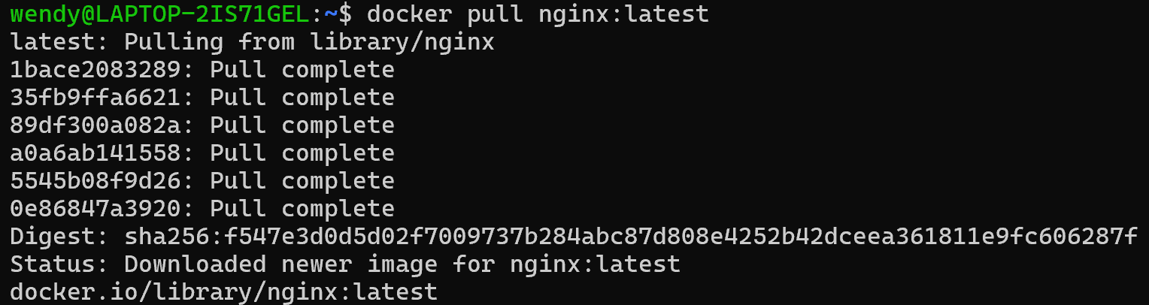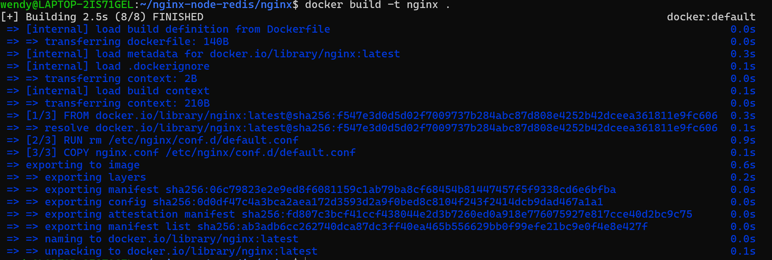
- Navigate into the web directory and build the first web image
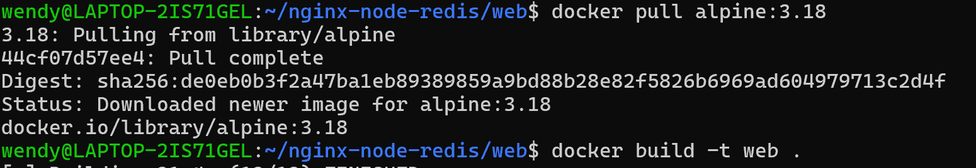
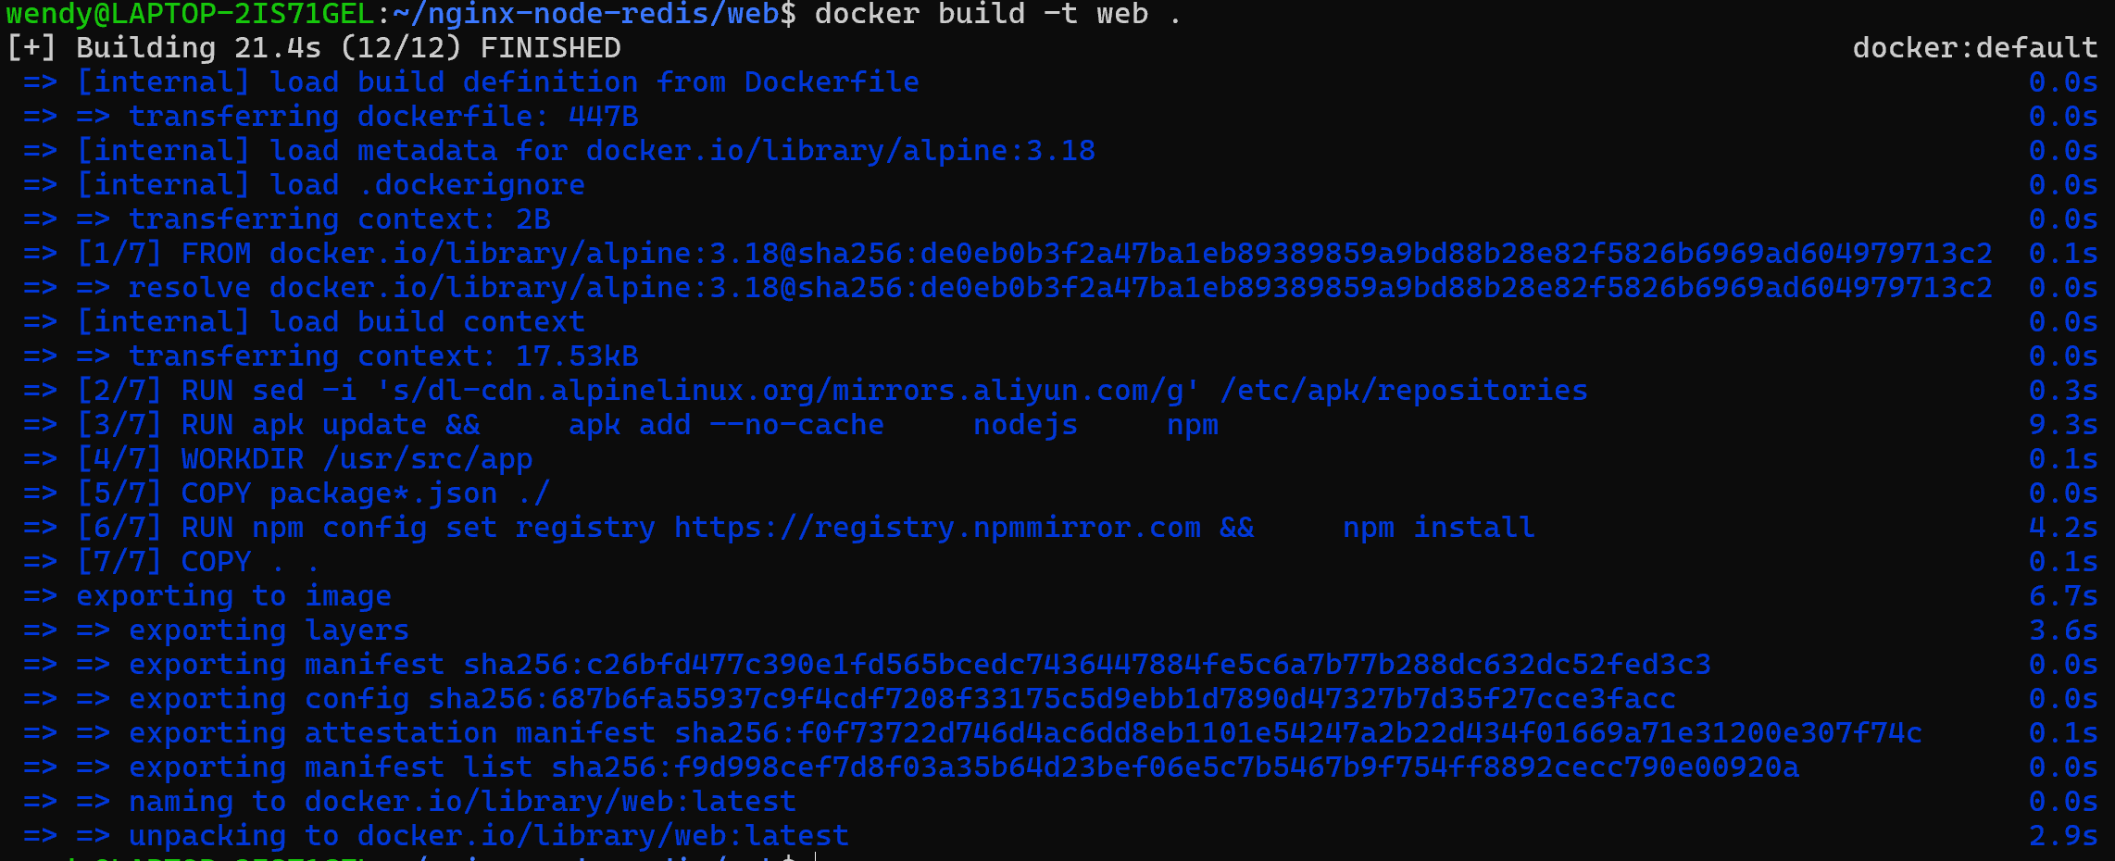
Step3:Run the containers
- Before you can run a multi-container application, you need to create a network for them all to communicate through. You can do so using the docker network create command
- Start the Redis container
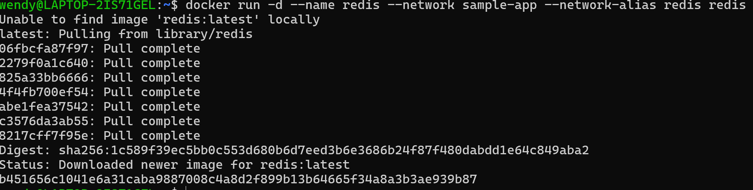
- Start the first web container
- Start the second web container
- Start the Nginx container
- Verify the containers are up
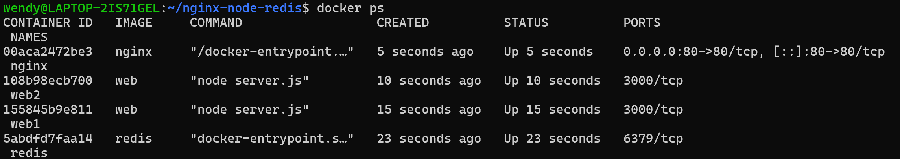
- see the containers and dive deeper into their configuration
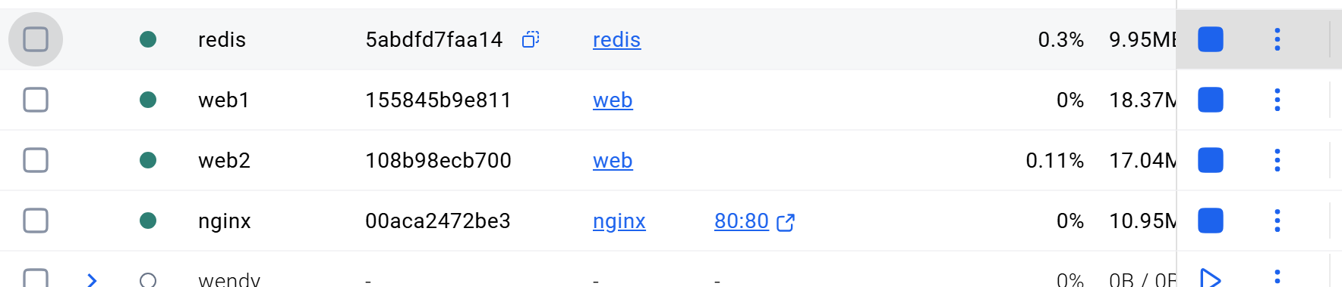
- open http://localhost in your browser to see the site.
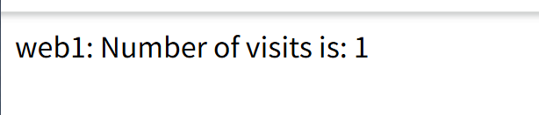
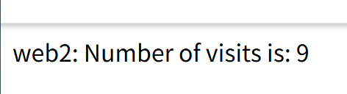
- remove the contriners
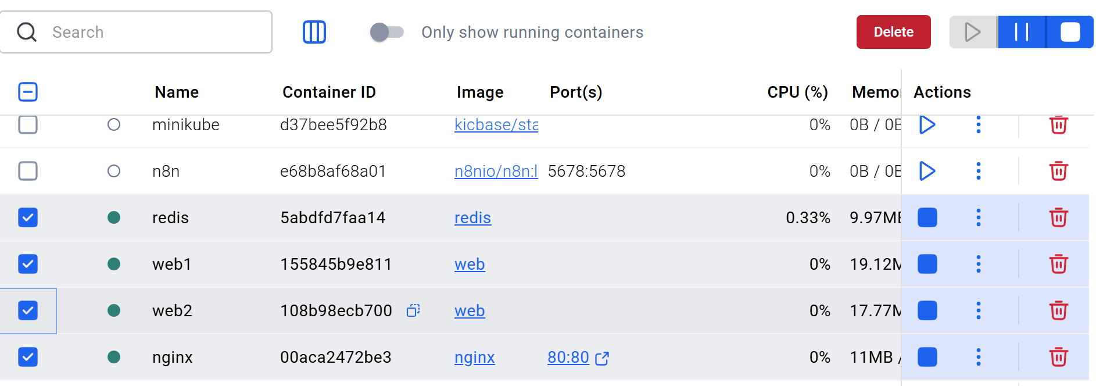
Step4:Simplify the deployment using Docker Compose
- Use the docker compose up command to start the application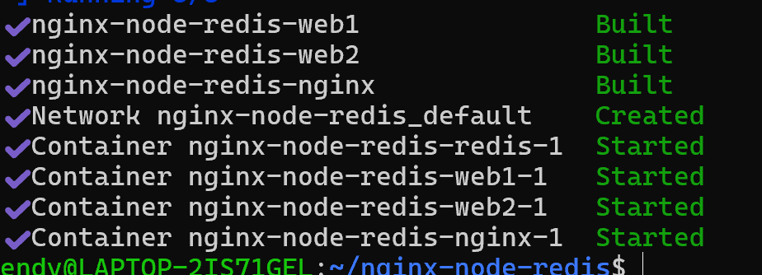
- see the containers and dive deeper into their configuration
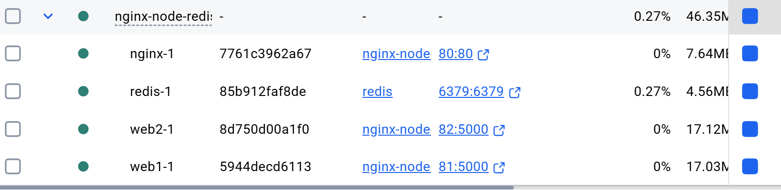
- Remove
