CA6001 – Applied AI Algorithms Project
Technical Report
Machine Learning–Guided Adaptive CPT Site Investigation and Economic Benefit Assessment
Predicting shallow cone-resistance profiles, choosing the next cone penetration tests, deciding when to stop, and pricing the result
Project Title: Machine Learning–Guided Adaptive CPT Site Investigation and Economic Benefit Assessment
Student Names: ______________________________________________
Course: CA6001 AI Algorithms Fundamentals & Application
Date: October 2026

1. Introduction
Cone penetration tests (CPTs) push an instrumented cone into the ground and record cone resistance q_{c} with depth. They are the main source of shallow ground information on most civil projects, but each test measures only one vertical line; between tests the ground is inferred. A conventional investigation fixes the number and positions of CPTs in advance and completes them all. Some of those tests add little new information, while the decision to add more is often made by judgement.
This project asks a practical question: with only a few CPTs measured, can an AI model predict the unmeasured profiles well enough to choose the next most useful CPTs and to stop once quality is adequate – and what is that worth? The motivation is twofold. Fewer CPTs reduce direct cost; finishing the investigation earlier can bring the whole programme forward, which on a large asset such as a navigation lock has a value far exceeding the cost of the tests themselves.
The objectives are to (i) compare five AI predictors under identical information, (ii) build an adaptive selection and online stopping loop around the selected predictor, (iii) audit every stop against hidden CPTs that the loop never sees, and (iv) translate the actual CPT counts into an owner-financial economic scenario. The scope is the 2–8 m depth window of public CPT data. The threshold q_{c} < 1 MPa is a research indicator of low-resistance material, not a soil classification, bearing-capacity or liquefaction criterion, and the economics are counterfactual scenarios rather than observed contract savings. Figure 1 summarises the complete loop.
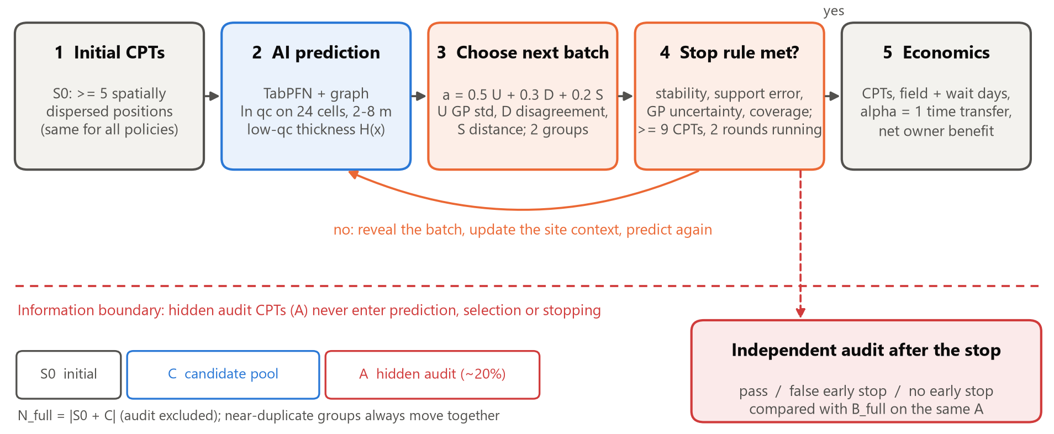
Figure 1. Investigation loop. Revealed CPTs feed prediction, batch selection and an online stop rule; the hidden audit set A is read only after the stop. All policies share S₀, C and A.

2. Problem Definition
At a site with planned positions x and the 24 depth cells z_{k} = 2.125, 2.375, …, 7.875 m (0.25 m wide), the regression target is y(x, z_{k}) = ln(q_{c}/1 MPa). The cumulative low-resistance thickness at a position is
H(x) = 0.25 · Σ_{k} 1[ y(x, z_{k}) < 0 ] (metres)
Given a revealed set S of CPTs, a model f predicts ŷ(x, z) and Ĥ(x) for every unrevealed position. The investigation is a sequential decision problem. Each site is split into an initial set S₀, a candidate pool C and a hidden audit set A. Starting from S = S₀, a policy chooses a batch B ⊂ C \ S, reveals it, and decides whether to stop. The aim is the smallest stopping count N_{stop} for which the hidden-audit quality still meets frozen targets, compared with the full plan N_{full} = |S₀ ∪ C|:
minimise N_{stop} subject to log-MAE_{A} ≤ τ_{log}, thickness-MAE_{A} ≤ τ_{H}, loss vs B_{full} ≤ tolerance
The task therefore combines spatial regression (profile prediction), binary event detection (cells below 1 MPa, evaluated with precision, recall, F1 and false-positive rate), active learning (choosing informative locations) and optimal stopping. Key constraints are:
• Information: only coordinates, planned depths and already-revealed curves may enter prediction, selection or stopping; hidden labels are read by a separate evaluator after the stop;
• Grouping: near-duplicate or repeated soundings form indivisible groups, so a nominal batch of two can be larger and counts are always actual positions;
• Small data: sites (not depth cells or random seeds) are the replicate unit; with four evaluation sites the results are descriptive and no significance tests are claimed;
• No hindsight: all thresholds are selected on development sites and frozen before evaluation; an online stop that fails audit stays a failure.

3. Dataset Description
The data come from the ISSMGE TC304 public CPT databases (ISSMGE TC304, n.d.). The Global-CPT collection holds 1,196 soundings from 59 sites or regions (Ching et al., 2023), and the NL-CPTU/98/2km² set contains the 98 soundings of the New Lock Terneuzen project in the Netherlands, fully operational since 1 August 2025 (Rijkswaterstaat, 2025). Only the subset that supports spatial prediction is used (Table 1).
Table 1. Data hierarchy after screening. Depth cells are repeated measurements within a CPT, not independent samples.
Unit | Count | Meaning
Source profiles | 503 | CPT curves with coordinates covering 2–8 m
Distinct planned positions | 495 | Repeated soundings at one coordinate merged
Usable representative positions | 492 | Complete 24-cell window (8 duplicates, 3 gaps removed)
Near-duplicate groups | 456 | 435 singletons; groups of 2–5 kept together
Sites | 31 | 8 replay sites (≥ 20 positions) + 23 source-only sites
Depth-cell records | 11,808 | 492 × 24 cells of 0.25 m

Each record carries the site, position (local x, y in metres), near-duplicate group, depth and q_{c}. Preprocessing interpolates each raw curve to the 24 cell mid-points (gaps > 0.5 m rejected), takes ln q_{c}, removes non-representative repeats and assigns groups. For New Lock, 80 of the 98 original files are retained: 15 start below 2 m and 3 end above 8 m. Neighbour features (distances, local medians, low quantiles, low-cell fractions, vertical gradients) are rebuilt from revealed CPTs only at every round.
The 0.25 m cells lose some thin layers. Against exact threshold crossings of the raw curves, the cell representation has a thickness MAE of 0.092 m (P90 0.256 m); 498 of 805 raw low intervals thinner than 0.25 m contain no cell mid-point. A 0.1 m grid would cut this to 0.033 m, but all models keep the same 0.25 m grid so that comparisons remain fair. Figure 2 shows the contrast that drives the results: Wellington Airport is uniformly stiff with no low cells, whereas New Lock has 24% low cells and strong lateral variability.
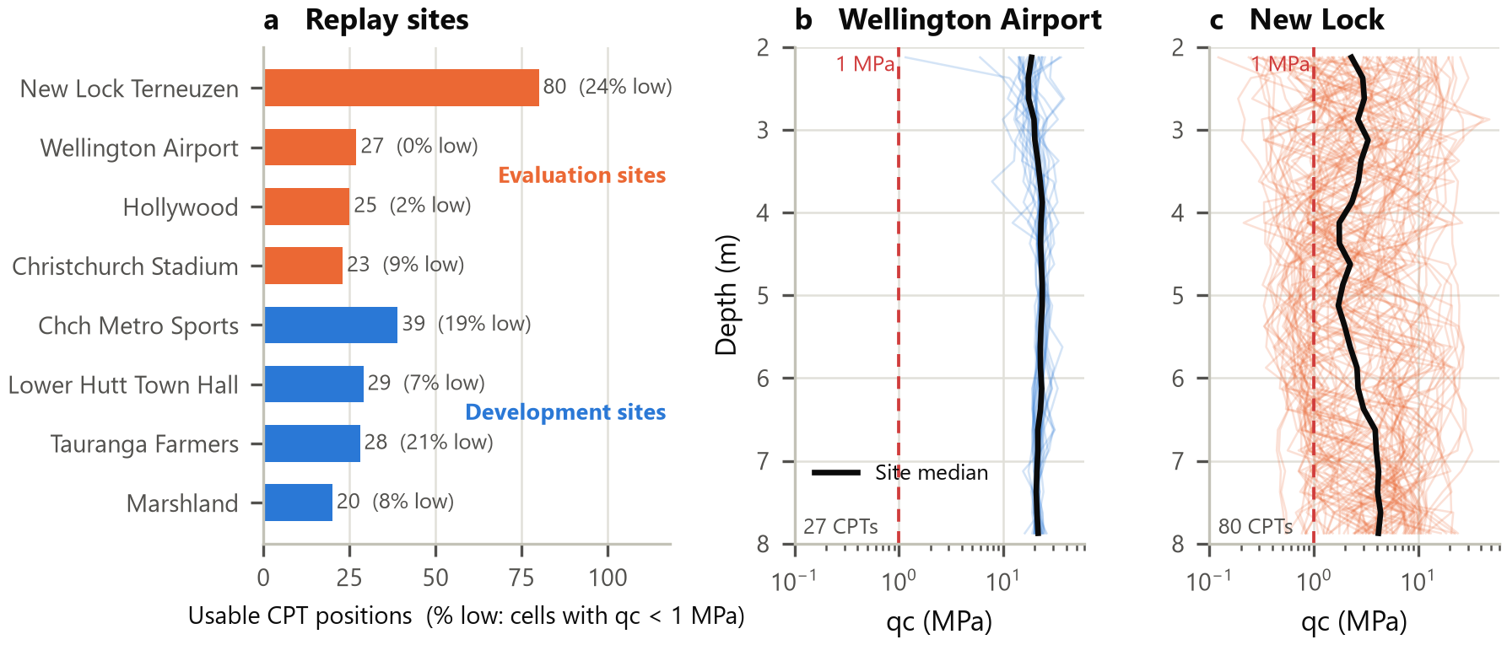
Figure 2. Replay sites and profiles. (a) Usable CPT positions at the eight replay sites and the share of cells with q_{c} < 1 MPa. (b, c) All 2–8 m profiles at the most homogeneous (Wellington Airport) and most variable (New Lock) evaluation sites; the black line is the site median.

4. Algorithm Selection and Rationale
Five predictors span the main families for small-data spatial prediction: a probabilistic kernel method, gradient-boosted trees, a neural set model and a tabular foundation model in two hybrid forms (Table 2). All receive identical revealed CPTs at every state, and all thresholds for thickness and low-cell labels are applied to the one predicted curve of each method.
Table 2. The five AI methods: principle, strengths and limitations.
Method | Principle and configuration | Strength | Limitation
GP | Matérn-3/2 anisotropic kernel on (x, y, z) plus white noise, fitted each round to revealed residuals from a source-site depth trend (Rasmussen & Williams, 2006) | Native predictive std. used for acquisition | Stationary; smooths thin low layers
XGBoost residual | 3-NN inverse-distance base + α × boosted-tree residual on 24 neighbour features; α ∈ {0, 0.25, 0.5, 1} chosen per fold (Chen & Guestrin, 2016) | Non-linear local corrections | Trees fixed after source training
CNP | Encodes revealed profiles with relative coordinates, mean/max pooling, decodes a full profile (26,817 parameters; Garnelo et al., 2018) | Learns site-to-site transfer | L1 loss favours the median; never predicts < 1 MPa
TabPFN joint | Transformer pre-trained on synthetic tables (Hollmann et al., 2025), fine-tuned 500–600 steps on source sites (CRPS + MSE); 0.5 × triangulation + 0.5 × sign-guarded residual; whole-profile low-cell decision | In-context learning from few CPTs | Hybrid: TabPFN supplies half the base
TabPFN + graph | Residual branch averaged with a k-NN graph pseudo-Huber interpolation; a cell is low if either branch says so | Highest low-cell recall | Union raises false positives

Why these fit. The data are small (tens of CPTs per site), spatially correlated and heterogeneous across sites. GP is the classical geostatistical choice and the only method with a calibrated-style variance; XGBoost is the strongest conventional learner on tabular neighbour features; CNP and TabPFN test whether meta-learning across sites helps when a new site has only five CPTs. TabPFN performs inference by conditioning on the current site context, so the loop needs no retraining per round. Alternatives considered: ordinary kriging and inverse-distance weighting are retained only as internal bases; entropy-based Bayesian compressive sampling (Guan et al., 2022) targets liquefaction rather than q_{c} profiles; reinforcement learning or full Bayesian optimisation was rejected because four evaluation sites cannot support a learned policy without over-fitting.
The primary model was chosen by a pre-registered rule – the lowest development-site-equal log-MAE over registered observation states – which selected TabPFN + graph (0.578) ahead of XGBoost (0.597) and TabPFN joint (0.598). It is used for prediction and stopping; GP supplies the uncertainty signal, and XGBoost the disagreement partner, in a division of labour rather than a stacked ensemble.

5. Methodology

5.1 Partitions, policies and evaluation design
The loop in Figure 1 is replayed on historical data. Eight sites with at least 20 usable positions are replayed: four development sites (Lower Hutt Town Hall, Tauranga Farmers, Christchurch Metro Sports, Marshland) and four evaluation sites (Wellington Airport, Christchurch Stadium, Hollywood, New Lock). For each site and seed (17, 29, 43) whole groups are assigned to A (≈20%), a spatially dispersed S₀ (≥ 5 positions) and C. Every evaluation site is predicted with the source-fold weights that excluded it from both training and checkpoint selection. Three policies share the same partition:
• B_full: complete every position in S₀ ∪ C – the engineering reference;
• B_seq: add the two candidates furthest from revealed CPTs (maximin) and apply the stop rule;
• P_adapt: add the two candidates with the highest acquisition score and apply the same stop rule.
B_full versus P_adapt measures the total benefit; B_seq versus P_adapt isolates the contribution of intelligent location choice from that of simply stopping early.

5.2 Acquisition score
For each candidate group, U is the mean GP predictive standard deviation of ln q_{c}, D the fraction of cells where the primary model and XGBoost disagree about q_{c} < 1 MPa, and S the distance to the nearest revealed CPT. Each is converted to a 0–1 rank within the pool:
a(x) = 0.5 · rank(U) + 0.3 · rank(D) + 0.2 · rank(S)
Within a batch only S is updated after each pick, so the second choice is pushed away from the first without peeking at its curve. The only alternative tried was U + S (0.7, 0, 0.3).

5.3 Online stopping and independent audit
On a fixed grid of all planned positions × 24 depths, the controller computes four signals each round: the 90th percentile of the change in predicted ln q_{c} (ΔQ₉₀) and in thickness (ΔH₉₀), a leave-group-out log-MAE on up to five initial groups, and the 90th percentile of GP standard deviation. It stops when, after at least nine CPTs with every populated quadrant covered, all four pass for two consecutive rounds. Thresholds were calibrated as quantiles (0.50/0.75/0.90) of the signals at acceptable development states; the selection score (verified saving minus false-stop rate) chose the 0.50 quantile with the full score – ΔQ₉₀ ≤ 0.082, ΔH₉₀ ≤ 0 m, support log-MAE ≤ 0.584, GP std P90 ≤ 0.461. The 0.75 and 0.90 quantiles produced false-stop rates of 17% and 58% on development sites. The audit requires log-MAE ≤ 0.626 and thickness MAE ≤ 0.881 m on A (development full-plan 75th percentiles plus margins) and no more than 0.05 / 0.25 m worse than B_full. Low-cell recall ≥ 0.5 with FPR ≤ 0.1 is audited separately as a diagnostic.

5.4 Economic model
The owner-financial benefit of a policy relative to the full plan is
B_{net} = (C_{full} − C_{policy}) + α · ΔT_{inv} · (c_{day} + b_{day}) − C_{AI,inc}
where C is investigation cost (€750 per CPT, all-in, scenario value), ΔT_{inv} the saving in calendar days (5 CPTs per rig-day, one rig, 7/5 calendar conversion, plus 0.25 day decision latency per batch transition), c_{day} = €5,000 avoidable project cost per day, b_{day} = €3,000 earlier-opening benefit per day, and C_{AI,inc} = €600 for deployment and review. The main scenario uses α = 1 (investigation days transfer fully to completion); α = 0.5 and 0.75 and one-at-a-time parameter ranges are sensitivities. A failed early stop would be repaired to the full plan with remobilisation (€560) and two days' delay. Parameters without a recovered contract are labelled as assumptions; the only quoted anchors are a 2025 Dutch CPT contractor quotation for remobilisation and review rates (MOS Grondmechanica, 2025), following cost-estimating practice (U.S. GAO, 2015, 2020).

5.5 Tools
Python 3.11, NumPy 2.4, pandas 3.0, SciPy 1.17, scikit-learn 1.9 (GP, Pedregosa et al., 2011), XGBoost 3.2, PyTorch 2.11 (CNP) and TabPFN 9.2.0 with v2 weights (Prior Labs, n.d.), run on an NVIDIA RTX 4080 (16 GB); matplotlib for figures.

6. Implementation
The code is a Python package (cpt_budget) with separate modules whose boundaries mirror the information boundary: adaptive_data (partitions and manifests), adaptive_models (one interface condition(revealed) / predict(query) for all five models; queries are stripped of every measured column), adaptive_policy (acquisition and stop rule), adaptive_replay (the loop), an independent audit evaluator, and adaptive_economics. A single command runs each stage (prepare, calibrate, freeze, evaluate, publish, economics), and the frozen configuration stores SHA-256 fingerprints of data, weights and settings. The core of batch selection is shown below.
group['rank_U'] = rank01(group.uncertainty) # GP std, fixed within batch
group['rank_D'] = rank01(group.disagreement) # low-cell disagreement
while remaining and chosen_count < batch_size:
dist = [min_distance(g, observed_xy) for g in remaining]
score = 0.5*rank_U + 0.3*rank_D + 0.2*rank01(dist)
gid = argmax(score, ties=(group_id, location_id))
chosen += members(gid) # whole near-duplicate group
observed_xy = vstack([observed_xy, xy(gid)]) # coordinates only, no curves

Key implementation decisions were: (i) TabPFN weights are frozen during replay and only the site context changes, so each round costs seconds rather than a retraining run; (ii) grouping is enforced in selection, counting and auditing; (iii) the CNP and TabPFN checkpoints were verified to differ from initialisation (all 14 CNP tensors and 129 TabPFN tensors changed), so weak CNP results cannot be blamed on an untrained model. Four automated checks guard correctness: replacing hidden audit labels leaves every decision unchanged (24 paired contexts, maximum prediction difference 0); group counts and audit exclusion are exact; models receive identical inputs; and every economic component recomputes from its parts. The project's 95 unit tests pass.

7. Results and Evaluation

7.1 Prediction quality of the five methods
Table 3. Prediction quality. Development log-MAE selected the primary model; evaluation columns are equal-site means over 63 registered states (recall excludes Wellington Airport, which has no low cells).
Method | Dev log-MAE | Eval log-MAE | Eval P90 |error| | Thickness MAE (m) | Recall (%) | FPR (%)
GP | 0.658 | 0.509 | 1.132 | 0.400 | 14.0 | 1.9
XGBoost residual | 0.597 | 0.512 | 1.150 | 0.485 | 31.2 | 6.9
CNP | 0.833 | 0.657 | 1.483 | 0.430 | 0.0 | 0.0
TabPFN joint | 0.598 | 0.497 | 1.124 | 0.491 | 33.3 | 7.8
TabPFN + graph (primary) | 0.578 | 0.503 | 1.112 | 0.595 | 36.3 | 9.6

TabPFN joint has the lowest evaluation profile error (0.497, 2.9% below XGBoost), and the development-selected TabPFN + graph is second (0.503). GP has the lowest thickness error (0.400 m) because it rarely predicts low cells: its recall is only 14%. The graph union buys the highest recall (36%) at the cost of the highest false-positive rate (9.7%) and thickness error (0.595 m). CNP never predicts q_{c} below 1 MPa, so its recall is zero – a genuine negative result for a median-trained set model on rare events. Figure 3 shows that site difficulty dominates model differences: every method scores ≈0.1 at Wellington Airport and ≈1.0 at New Lock.
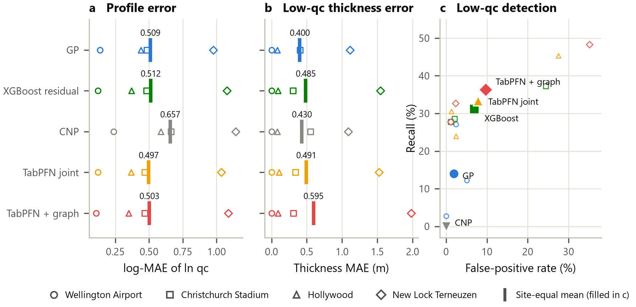
Figure 3. Five AI methods on identical observation states at the four evaluation sites. Open marks are site means; bars and filled marks are equal-site means.
Table 4. TabPFN ablation on identical states (equal-site means).
Variant | Dev log-MAE | Dev thick. (m) | Eval log-MAE | Eval thick. (m)
Residual, pretrained weights | 0.627 | 0.642 | 0.506 | 0.494
Residual, fine-tuned weights | 0.598 | 0.626 | 0.502 | 0.509
+ sign guard | 0.598 | 0.573 | 0.503 | 0.497
Joint, pretrained weights | 0.604 | 0.485 | 0.495 | 0.480
Joint, fine-tuned weights | 0.598 | 0.483 | 0.497 | 0.491

The ablation (Table 4) separates the contributions. Source-site fine-tuning reduced the raw residual's development log-MAE from 0.627 to 0.598, but on evaluation sites the pretrained and fine-tuned joint models differ by less than 0.002, with the pretrained one slightly better. Most of the thickness gain comes from the spatial blend and whole-profile decision (development thickness 0.626 → 0.483 m), not from the Transformer weights. Improvements must therefore be attributed to the hybrid, not to TabPFN alone.

7.2 Selection, stopping and audit
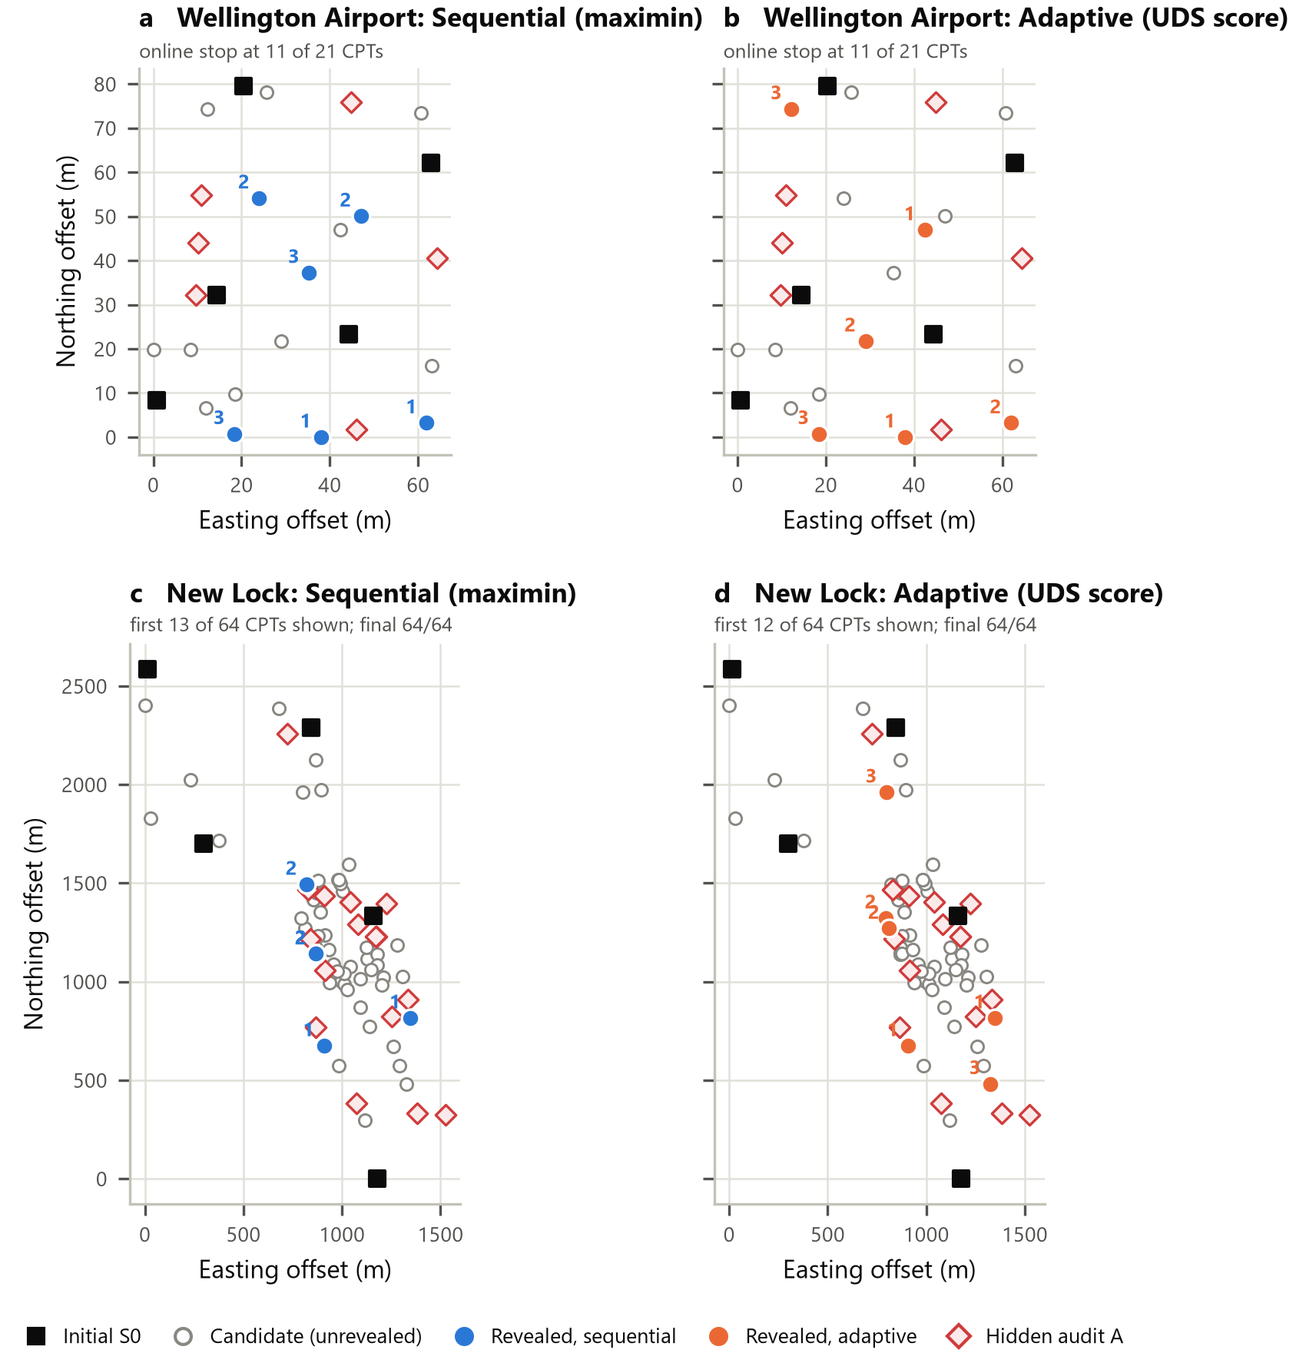
Figure 4. Selection maps, seed 17. Wellington Airport (a, b) at the online stop; New Lock (c, d) after the first 12–13 CPTs. Numbers give the round in which a position was revealed.
Figure 4 shows that the adaptive score does choose different locations from maximin: at New Lock it concentrates on the dense, variable central cluster where GP uncertainty and model disagreement are high, whereas maximin spreads out. At Wellington Airport both policies stopped after three batches with 11 of 21 CPTs. Figure 5 tracks audit quality as CPTs are added. At the three easier sites quality is below the targets from the first few CPTs and changes little afterwards; at New Lock the error falls steeply over the first 15 CPTs and then plateaus at log-MAE ≈ 0.9 and thickness MAE ≈ 1.1–1.5 m, above both targets, even with all 64 CPTs.
Table 5. Decision outcomes at the evaluation sites (means of three seeds). No policy produced a false early stop.
Site | N_full | B_seq N | P_adapt N | Saving (%) | Full-plan audit | Oracle N | Net € (P_adapt)
Wellington Airport | 21 | 11.0 | 11.0 | 47.6 | 3/3 | 9 | +23,300
Christchurch Stadium | 18 | 18.0 | 18.0 | 0.0 | 3/3 | 9–10 | -12,600
Hollywood | 20 | 18.7 | 20.0 | 0.0 | 3/3 | 9–14 | -11,933
New Lock Terneuzen | 64 | 64.0 | 64.0 | 0.0 | 0/3 | none | -55,933

Across the 24 evaluation trajectories there were no false early stops (Table 5, Figure 6). Sequential stopping saved CPTs in 4 of 12 trajectories and adaptive stopping in 3 of 12, giving equal-site savings of 13.6% and 11.9%. All the adaptive saving comes from Wellington Airport (21 → 11 CPTs, 47.6%), where sequential stopping saved exactly the same. In the paired comparison adaptive selection was never better than maximin at evaluation sites and once worse (Hollywood, seed 17: sequential stopped at 16, adaptive ran to 20). On development sites adaptive was better once and worse once. The full plan itself fails the audit at New Lock in all three seeds, and no method passes there even at its full-plan endpoint, so no stopping rule could have produced a reliable saving. Low-cell detection (recall ≥ 0.5, FPR ≤ 0.1) failed at all three sites that contain low cells.
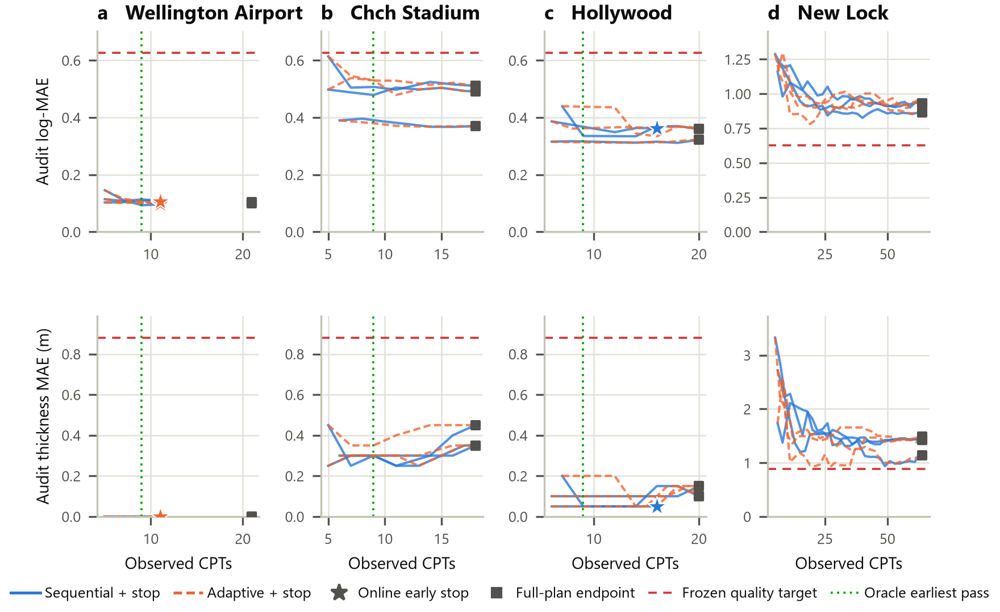
Figure 5. Hidden-audit quality as CPTs are added (three seeds per policy). Stars mark online early stops, squares the full plan, the red line the frozen target, and the green line the earliest passing count found with hindsight (oracle, diagnostic only).
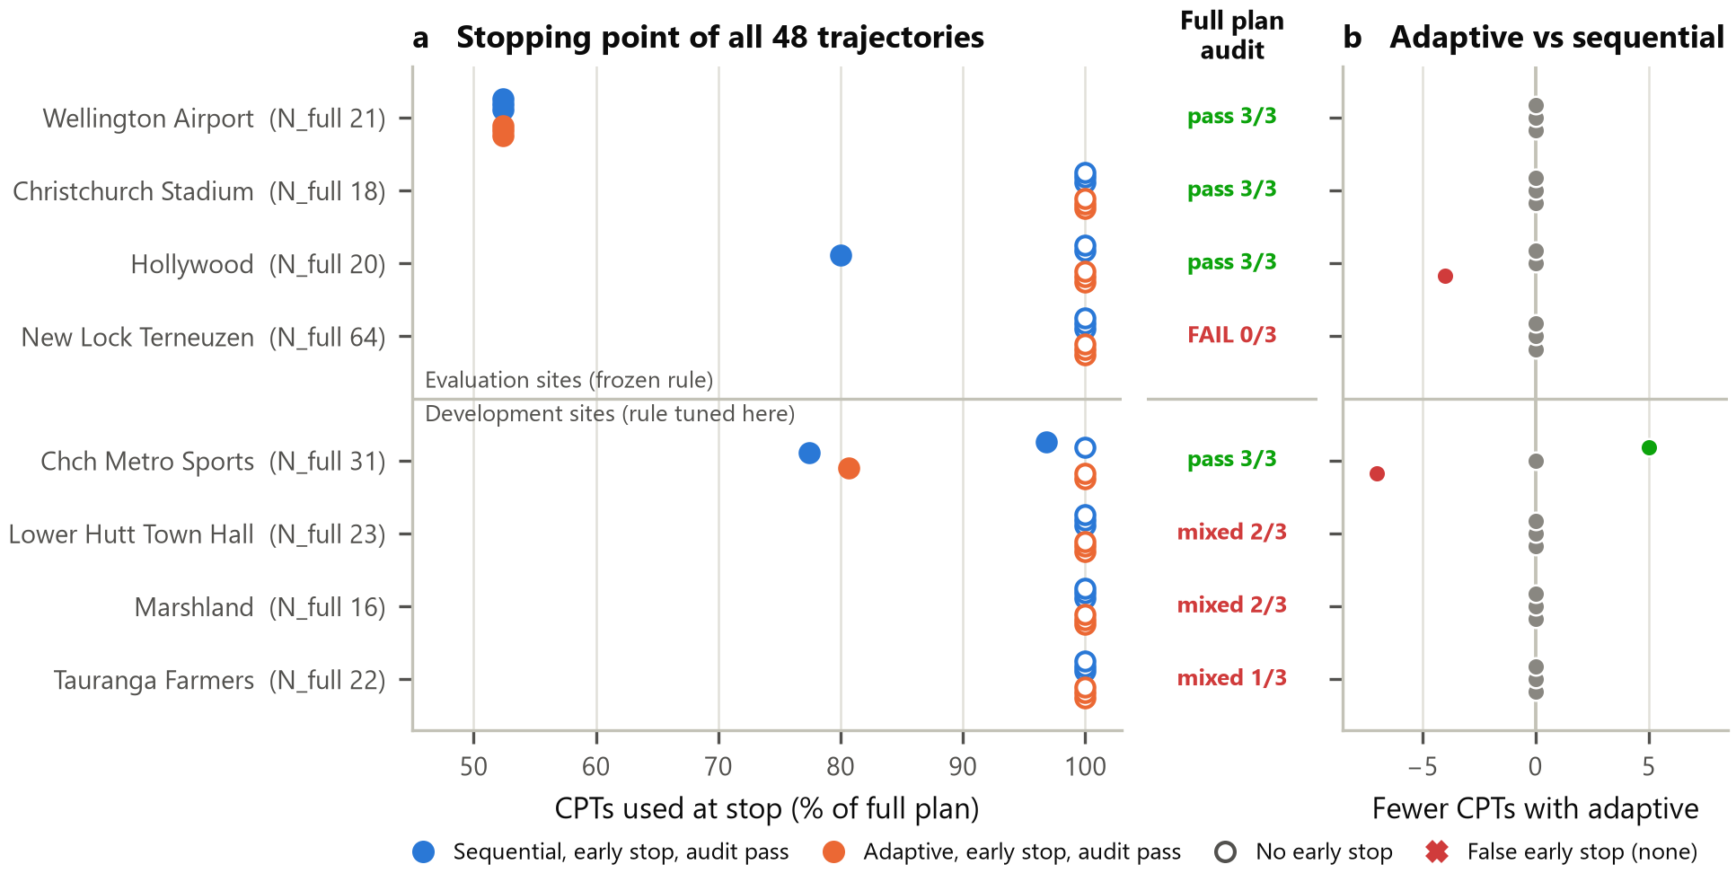
Figure 6. Decision outcomes for all 48 sequential and adaptive trajectories. (a) CPTs used at the stop and the full-plan audit verdict; (b) CPTs saved by adaptive relative to sequential, paired by seed.
The rule is safe but conservative. The oracle column shows that Christchurch Stadium already met the targets with 9–10 of 18 CPTs and Hollywood with 9–14 of 20, yet both ran to the full plan. The blocking signal is mainly ΔH₉₀ ≤ 0, which demands that predicted thickness does not change at all between rounds; at sites with a few low cells one revealed CPT can flip a cell and reset the streak. The GP uncertainty signal was also only weakly related to actual audit error at evaluation sites (mean Spearman ρ = 0.22, versus 0.60 on development sites).

7.3 Economic value
Applying the observed counts to the scenario (Figure 7), Wellington Airport gives a net owner benefit of +€23,300 for the adaptive policy: €7,500 from ten avoided CPTs, €10,250 of avoided project cost and €6,150 of earlier-opening benefit from finishing 2.05 days earlier, less €600 of AI cost. The other three sites are negative (−€11,900 to −€55,900) even though they used no extra CPTs, because the staged campaign adds a 0.25-day decision delay at every batch transition: 28–29 transitions at New Lock delay completion by 6.9 days. Setting this latency to zero reduces those losses to the €600 AI cost, whereas a one-day latency would make New Lock −€222,000. At α = 0.5 the Airport benefit falls to €15,100 and the New Lock loss to −€28,300; the sign of each result is unchanged across the tested ranges except through the latency parameter.
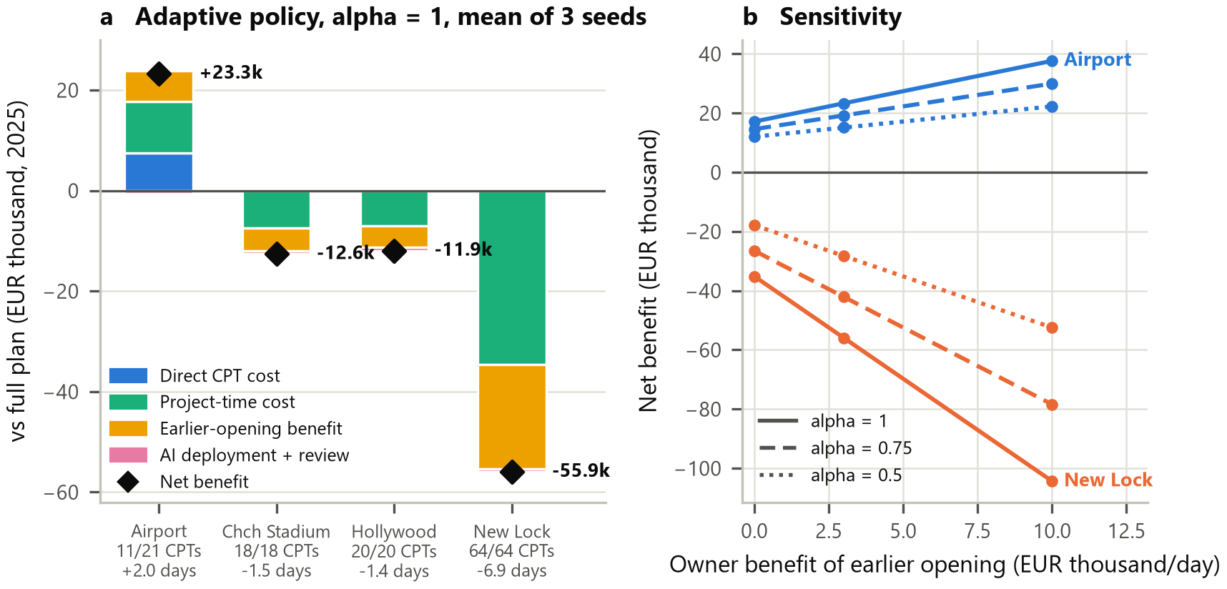
Figure 7. Owner-financial scenario, EUR 2025. (a) Benefit components of the adaptive policy relative to the full plan at α = 1 (mean of three seeds). (b) Net benefit as α and the daily earlier-opening benefit vary.

8. Discussion and Insights
What worked. The pipeline is leak-free and auditable: hidden labels never reach the controller, every stop is audited, and all 72 trajectories – including failures – are reported. The stopping rule made zero false early stops on unseen sites and halved the investigation where the ground is simple. Modern tabular AI is competitive: TabPFN-based hybrids reduced profile error by 2–3% relative to XGBoost and gave the best low-cell recall, while GP remained the best thickness estimator and the most useful uncertainty source.
What the results reveal. First, site predictability, not the acquisition rule, decides whether CPTs can be saved: savings appeared only at the site where five CPTs already describe the ground, and vanished at New Lock where even 64 CPTs leave log-MAE near 0.9. Second, adaptive location choice added nothing over maximin in this study; the benefit came from staged investigation plus a stopping rule. Third, the economics are dominated by time, not CPT price: the earlier-finish terms are larger than the direct saving, and per-batch decision latency can turn a neutral outcome strongly negative. A deployed system must therefore return decisions within the working day and should switch to the full plan quickly when the site is clearly unpredictable.
Difficulties. Four evaluation sites is a small sample, and these sites had been inspected in an earlier project stage, so this is a site-held-out re-evaluation rather than a new blind test. Low q_{c} cells are rare (≈7–10% of source cells), which explains the CNP failure and the 23–36% recall of the other models. A post-evaluation exploration (not used for any claim above) tried integrated-variance-reduction acquisition at New Lock: it lowered the GP's budget-averaged profile error by 10–13% relative to maximin but worsened thickness error, and none of 432 explored states met the targets.
Limitations. The 0.25 m grid misses some thin layers; the 1 MPa threshold is a research indicator; economic inputs other than the quoted anchors are explicit assumptions; α = 1 assumes that investigation time lies on the project's critical path; and seeds are not independent sites.
Future improvements. (i) Replace the zero-tolerance thickness-change test with a one-cell tolerance and use quality-predictive signals so that the stop at Christchurch Stadium and Hollywood is not missed; (ii) add a site-predictability check after the initial CPTs that recommends the full plan immediately for New Lock-like sites; (iii) adopt an event-weighted loss and a 0.1 m grid for low-cell detection; (iv) evaluate on genuinely new sites and real contract and programme data.

9. Conclusion
This project built and audited a complete AI-guided CPT investigation loop: five AI predictors, an uncertainty–disagreement–distance acquisition score, a multi-signal stopping rule and an owner-financial economic model. A TabPFN hybrid gave the lowest profile error (0.497 log-MAE) and the graph variant the highest low-cell recall (36%), while GP remained best for thickness. With rules frozen on development sites, the system made no false early stops, saved 47.6% of CPTs at the simplest site (+€23,300 in the main scenario) and correctly ran to the full plan elsewhere; adaptive selection did not beat simple maximin ordering, and New Lock could not reach the quality targets with any number of CPTs. The main lessons are that algorithm choice should be judged by the decision it supports, with an independent audit and honest negative results, and that in investigation planning, time and site predictability matter more than the marginal accuracy of the predictor.

10. References
Chen, T., & Guestrin, C. (2016). XGBoost: A scalable tree boosting system. In Proceedings of the 22nd ACM SIGKDD International Conference on Knowledge Discovery and Data Mining (pp. 785–794). https://doi.org/10.1145/2939672.2939785
Ching, J., Uzielli, M., Phoon, K. K., & Xu, X. J. (2023). Characterization of autocovariance parameters of detrended cone tip resistance from a global CPT database. Journal of Geotechnical and Geoenvironmental Engineering, 149(10), 04023090. https://doi.org/10.1061/JGGEFK.GTENG-11214
Garnelo, M., Rosenbaum, D., Maddison, C., Ramalho, T., Saxton, D., Shanahan, M., Teh, Y. W., Rezende, D., & Eslami, S. M. A. (2018). Conditional neural processes. Proceedings of Machine Learning Research, 80, 1704–1713. https://proceedings.mlr.press/v80/garnelo18a.html
Guan, Z., Wang, Y., & Zhao, T. (2022). Adaptive sampling strategy for characterizing spatial distribution of soil liquefaction potential using cone penetration test. Journal of Rock Mechanics and Geotechnical Engineering, 14(4), 1221–1231. https://doi.org/10.1016/j.jrmge.2022.01.011
Hollmann, N., Müller, S., Purucker, L., Krishnakumar, A., Körfer, M., Hoo, S. B., Schirrmeister, R. T., & Hutter, F. (2025). Accurate predictions on small data with a tabular foundation model. Nature, 637, 319–326. https://doi.org/10.1038/s41586-024-08328-6
ISSMGE Technical Committee 304. (n.d.). CPT databases. Retrieved October 17, 2026, from https://tc304.org/cpt_databases.html
MOS Grondmechanica B.V. (2025, May 1). Offerte A2501409: Realisatie appartementencomplex De Spiegelhoek, Bussum [Quotation]. https://www.spieghelhoek.nl/wp-content/uploads/2025/08/offerte-Mos-Realisatie-appartementencomplex-De-Spiegelhoek-010525-003.pdf
Pedregosa, F., Varoquaux, G., Gramfort, A., Michel, V., Thirion, B., Grisel, O., Blondel, M., Prettenhofer, P., Weiss, R., Dubourg, V., Vanderplas, J., Passos, A., Cournapeau, D., Brucher, M., Perrot, M., & Duchesnay, É. (2011). Scikit-learn: Machine learning in Python. Journal of Machine Learning Research, 12, 2825–2830.
Prior Labs. (n.d.). TabPFN (Version 9.2.0) [Computer software]. https://github.com/PriorLabs/TabPFN
Rasmussen, C. E., & Williams, C. K. I. (2006). Gaussian processes for machine learning. MIT Press.
Rijkswaterstaat. (2025, September 1). New Lock Terneuzen fully operational from 1 August 2025. https://www.rijkswaterstaat.nl/en/news/archive/2025/09/new-lock-terneuzen-fully-operational-from-1-august-2025
U.S. Government Accountability Office. (2015). GAO schedule assessment guide: Best practices for project schedules (GAO-16-89G). https://www.gao.gov/products/gao-16-89g
U.S. Government Accountability Office. (2020). Cost estimating and assessment guide: Best practices for developing and managing program costs (GAO-20-195G). https://www.gao.gov/products/gao-20-195g

