Thermal Circuit Analysis of Droplet Evaporation on Hot Microstructured Superhydrophobic Surfaces

Wenge Huang*, Xukun He*, Jiangtao Cheng

Abstract

In this paper, we report a thermal circuit model developed to analyze the evaporation dynamics of a water droplet dwelling on the hot surface of micro-structured superhydrophobic substrates. Droplet evaporation is divided into two distinguish parts: evaporation at the droplet top spherical cap liquid-vapor interface and evaporation at the droplet base. Evaporation process of the water droplet can be ascribed to the constant contact radius (CCR) mode, the constant contact angle (CCA) mode and the hybrid mode of CCR and CCA. Evaporation flux ratio of the spherical cap surface and the droplet base is calculated during the evaporation process. Thermal resistances from the substrate to the droplet spherical cap interface are calculated by synthesizing the thermal resistance of the substrate, the micropillars, and the water droplet itself. Conduction thermal resistance of the water droplet is calculated by dividing the water droplet into infinite water layers and integrating all the thermal resistance of the layers. Substrates with difference pillar array microstructure are used for the droplet evaporation and the substrates are heated for a large range of temperature (from 40 °C to the onset boiling temperature around 100 °C). The variations of the droplet spherical cap surface temperature on different microstructure substrates and with different substrate temperature are obtained by our analytical approach and matches pretty well with the experimental results. Evaporation flux ratios of the droplet top and bottom surface on different microstructure substrates and with different substrate temperature are predicted. Our model indicates that the water droplet temperature increases during the evaporation process on a certain hot substrate. The evaporation flux ratio of the droplet top and bottom surface decreases with the rise of the substrate temperature and increases during the evaporation process on a constant temperature substrate.

1. Introduction

Droplet evaporation is a common phenomenon in nature and is taken into attention for its important applications in ink-jet printing [1], spray cooling [2] and micro fabrication [3]. Due to the high contact angle, droplet evaporation on superhydrophobic surface is different from the evaporation on hydrophilic surfaces. Inspired by nature structures such as lotus leaf, substrates with micro or nanoscale roughness are manufactured and can exhibit large contact angles. There are mainly two kinds of wettings states for droplet on the microstructured substrates [4]. Cassie state: droplet contacts with the top surface of the microstructures and leaves air cavities underneath the droplet; Wenzel state: droplet completely contacts the substrates. The important difference between these two wetting states also causes large difference in heat transfer process from the substrate to the droplet.

Heat will transfer from the hot substrate to the droplets placed on it. Evaporation occurs at the liquid-vapor interface. Liquid-vapor interface can be divided into two different part: the droplet spherical cap surface and droplet base surface. We might only consider the evaporation on the spherical cap surface for sessile droplet evaporation on smooth surface. For droplet evaporation on microstructure surface at room temperature, the evaporation from the droplet base is always neglected because of the small surface area and large pressure resistance between the micropillars. Diffusion driven model which considers only the evaporation at the droplet spherical cap surface match well with the experiment data for droplet evaporation at room temperature on micropillar surface. However, as the substrate temperature increase, more evaporation would happen at the droplet base and the ratio of evaporation from the droplet base cannot be neglected. No previous studies had explored this point.

In this study, we explored the evaporation dynamic of water droplet on heated superhydrophobic microstructured substrates. We developed a thermal circuit model and calculated the droplet surface temperature and evaporation ratio from the droplet base for water droplet evaporation on heated superhydrophobic surface from 40 °C to 100 °C.

**2. Experimental methodology**

2.1 Substrates

Substrates in this experiment are manufactured from silicon wafer with standard photolithography process and deep reactive ion etching. All the substrates were composed of cylindrical micropillar arrays with varying diameter (D), periodicity (P) and height (H). Fig. 1 shows the scanning electron microscope (SEM) image of the microstructured substrate and the data for the cylindrical micropillar arrays are listed in Table 1. All the substrates were conformally coated with silane (Trichloro (1H,1H,2H,2H-per fluoroethyl)-silane, Sigma-Aldrich) using standard chemical vapor deposition (CVD) process. Then the substrates were placed on a 90°C hot plate for 60 min backing. Water droplet exhibits a contact angle about 155° on all the substrates. To mitigate the sample edges effect on the droplet evaporation process, samples were cut into square pieces with 2 cm length of side and water droplets were deposited at the center of the substrates.

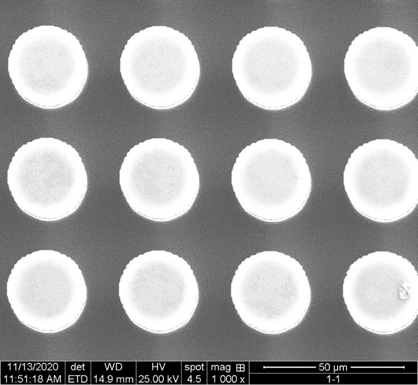

Figure 1. SEM image of S1 sample

Table 1 Geometry information of substrate micropillar

|  |  |  |  |
| --- | --- | --- | --- |
| Sample name | D (μm) | P (μm) | H (μm) |
| S1 | 20 | 30 | 40 |
| S2 | 20 | 40 | 40 |
| S3 | 20 | 50 | 40 |
| S4 | 20 | 60 | 40 |

2.2. Experiment setup

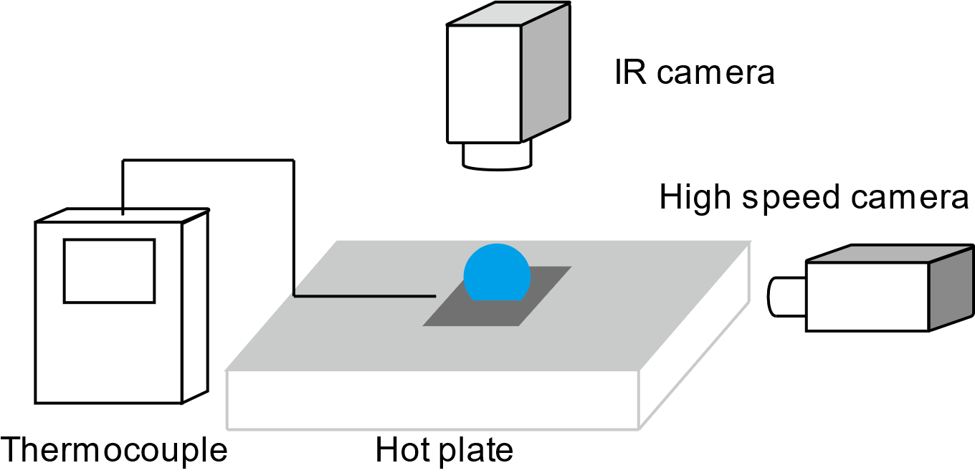

Figure 2. Experimental setup including hot plate, high speed camera, IR camera and thermocouple.

The experiment setup of this study is shown in Fig. 2. Droplets were placed on the superhydrophobic substrate for evaporation. Substrate was heated by hot plate from 40 °C to 100 °C. The surface temperature of the hot plate was tested by thermocouple. Two cameras were used to record the data of the droplet during the evaporation process. An IR camera was used to test the surface temperature of the droplet and a high-speed camera was used to record the geometry information, such as droplet contact radius and droplet height.

2.3 Experiment model

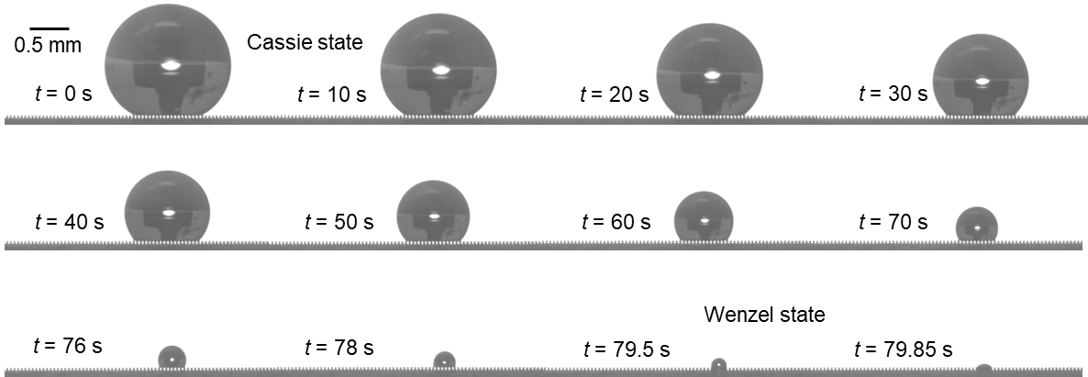

Figure 3. Snapshots of droplet evaporation on superhydrophobic surface.

When placed on the substrate, the droplet is in a Cassie state with the base interface contacting with the top surface of the micropillars. Air cavities can be observed underneath the water droplet. During most time of the evaporation process, the droplet is in Cassie state and at the very end of the evaporation wetting state transition happens and the droplet is then in Wenzel state.

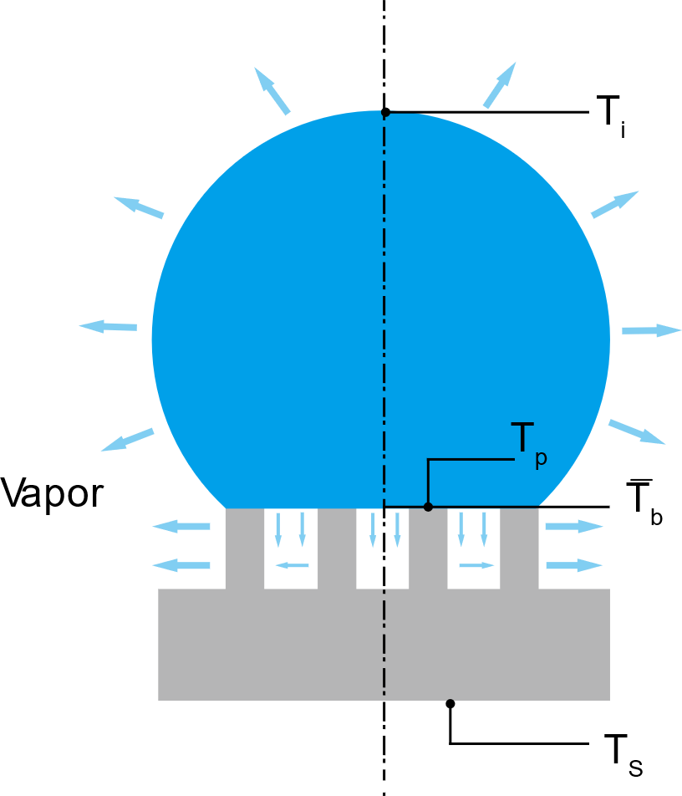

Figure 4. Diagram of droplet evaporation on substrate

2.3.1. Energy balance model

An energy balance model can be developed for the heat and mass transfer process of the droplet.

$q_{s}=q_{temp}+q_{conv}+q_{rad}+q_{evap}$ (1)

where qs the total energy transferred from the substrate; qtemp is the energy required for the water temperature increase; qconv is the convective heat transfer from the water droplet to the ambient air; qrad is the radiation heat transfer from water droplet to the ambient air; qevap is the heat released to the ambient air through evaporation.

$q_{temp}=c_{p}ρ_{w}V\frac{dT_{w}}{dt}$ (2)

$q_{rad}=εσS\left(T_{w}^{4}-T_{∞}^{4}\right)$ (3)

$q_{conv}=h_{conv}S\left(T_{w}^{ }-T_{∞}^{ }\right)$ (4)

$q_{evap}=h_{fg}ρ_{w}\frac{dV}{dt}$ (5)

where cp, , Tw V and hfg are the specific heat capacity, density, temperature, volume and latent heat of the droplet water respectively; $ε$ is the emissivity of the water droplet interface and $σ$ is the Boltzmann constant; S is the liquid-vapor interface area and hconv is the natural convection heat transfer coefficient of the ambient air.

It can be estimated that at relative high temperature (T > 40°C) the $q_{evap}$ is much larger than the summation of the other three types of heat transfer [4]. Thus, in a quasi-steady state the heat transfer from the substrate to the water droplet is approximately equal to the heat released to the ambient air through evaporation.

$q_{s}=q_{evap}$ (6)

2.3.2. Thermal resistance model

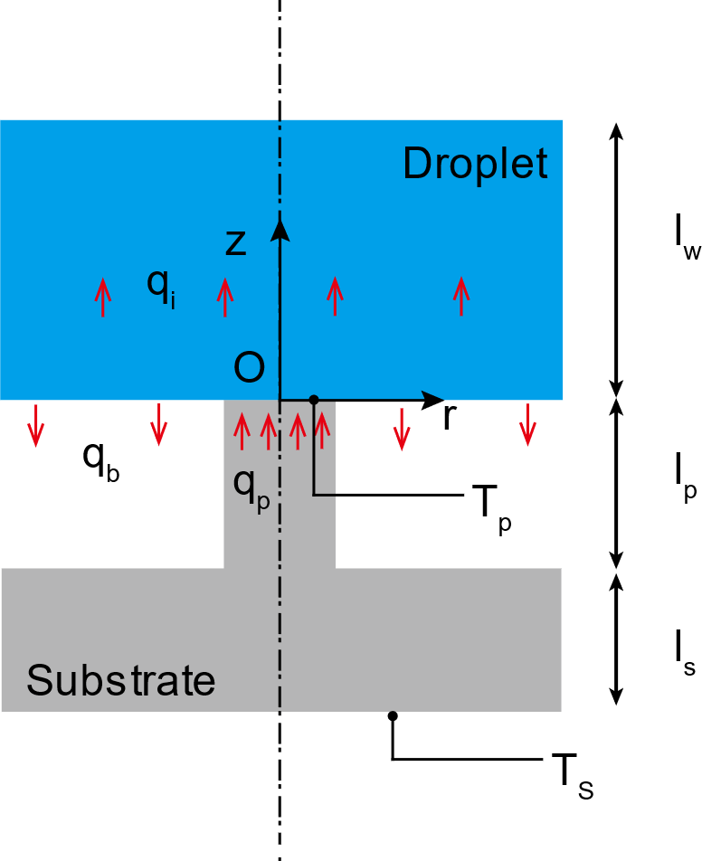

Figure 5. Diagram of heat transfer process from micropillar to water droplet.

Heat transfers from the substrate to the micropillars and the vapor cavities. However, because of the large difference between the thermal conductivity of silicon pillars (100 Wm­-1K-1) and water vapor (0.025 Wm­-1K-1), thermal resistance of the vapor is much larger than that of the silicon pillars. As a result, heat primarily conducts from the pillar to the water droplet and vapor cavities can be regarded as adiabatic parts.

Considering the periodicity of the pillar arrays, we can focus on one unit cell of the pillar array consisting of one pillar and one vapor cavity as shown in Fig. 5. As we mention before, heat transferred from the substrate is equal to that released to the ambient air. We can calculate the substrate heat flux with the evaporation flux of the water droplet which can be obtained by the decrease of the droplet volume (Eq. 5). We assume the heat flux is uniform from the substrate. Thus, we can calculate the heat flux in one unit cell:

$q_{p}=\frac{q_{s}}{N}$ (7)

where N is the number of the micropillar underneath the droplet.

The thermal resistance of the silicon substrate per unit cell is calculated as:

$R_{s}=\frac{l_{s}}{k_{Si}P^{2}}$ (8)

where kSi is the thermal conductivity of silicon, P is the width of the periodicity; ls is the thickness of the silicon substrate.

The thermal resistance of the silicon micropillar is calculated as:

$R_{p}=\frac{4l_{p}}{k_{Si}{πD}^{2}}$ (9)

where D is the diameter of the pillar; lp is the height of the silicon pillar.

Now we know the substrate temperature $T_{s}$, heat flux from the substrate $q_{p}$ and the thermal resistances of the substrate $R_{s}$ and the micropillar $R_{p}$. We can now calculate the top surface temperature of the micropillar:

$T_{p}=T_{s}-\frac{q_{p}}{R_{p}+R_{s}}$ (10)

Heat transfer from the micropillar to the water droplet. We focus on the water layer with thickness of lw in one unit cell as shown in Fig. 5. The conductive heat transfer equation in this water layer is:

$\frac{∂^{2}T_{ }}{{∂r}^{2}}+\frac{1}{r}\frac{∂T_{ }}{∂r}+\frac{∂^{2}T_{ }}{{∂z}^{2}}=0$ (11)

Due to the small size of the micropillar, we assume there is uniform heat flux at the cross-section area of the micropillar-water contact interface. Evaporation happens at the liquid vapor interface. Thus, we assume a uniform heat flux flows from water the vapor cavity. As a result, we have the first boundary condition:

$k_{w}\frac{∂T_{ }}{∂z}=\left\{\begin{aligned}\frac{q_{p}}{πa^{2}} 0<r<a; z=0 \\ -\frac{q_{b}}{π(b^{2}-a^{2})} a<r<b; z=0\end{aligned}\right.$ (12)

where kw is the thermal conductivity of water, a is the radius of the micropillar, b is the radius of the water cylinder in one unit cell.

Considering a constant temperature boundary in the water layer at thickness lw:

(13)

Also, considering the periodicity of the unit cell, we can assume there is no heat transfer between the water layer in one unit cell with its neighbor water layer. Thus, we obtain the adiabatic boundary condition:

$\frac{∂T_{ }}{∂r}=0 r=b; 0<z<l_{w}$ (14)

Solving the heat transfer equation Eq. (11) with the three boundary conditions Eq. (12), Eq. (13), Eq. (14), we can obtain the temperature distribution inside the water layer:

$T_{b}=T_{w}+\frac{q_{p}\left(l_{w}-z\right)}{k_{w}}\left(\frac{a^{2}}{b^{2}}\left(1+φ\right)-φ\right)+\frac{2aq_{p}\left(1+φ\right)}{k_{w}l_{w}}\sum_{n=1}^{∞}{\left[J_{1}\left(\frac{a}{b}α_{n}\right)J_{0}\left(\frac{r}{b}α_{n}\right){/\left(α_{n}^{2}J_{0}^{2}\left(α_{n}\right)\right)}\right]}\frac{\sinh\left(\frac{α_{n}}{b}{(l}_{w}-z)\right)}{\cosh\left(\frac{α_{n}}{b}l_{w}\right)}$ (15)

where $φ$ is the evaporation ratio from the droplet base , J0(x) and J1(x) are the first kind Bessel functions with order of 0 and 1 respectively, $α_{n}$ is the n-th root of J1(x)=0.

The temperature at the droplet base at z=0 is calculated as:

$T_{b}=T_{w}+\frac{q_{p}l_{w}}{k_{w}}\left\{\frac{a^{2}}{b^{2}}\left(1+φ\right)-φ+\frac{2a\left(1+φ\right)}{l_{w}}\sum_{n=1}^{∞}{\left[J_{1}\left(\frac{a}{b}α_{n}\right)J_{0}\left(\frac{r}{b}α_{n}\right){/\left(α_{n}^{2}J_{0}^{2}\left(α_{n}\right)\right)}\right]}\tanh\left(\frac{α_{n}}{b}l_{w}\right)\right\}$ (16)

The average temperature of the droplet base is:

${\overline{T}}_{b}=\frac{\int_{0}^{b}{2πr}T_{b}\left(r\right)dr}{πb^{2}}$ (17a)

${\overline{T}}_{b}=T_{w}+\frac{q_{p}l_{w}}{k_{w}}\left\{\frac{a^{2}}{b^{2}}\left(1+φ\right)-φ\right\}$ (17b)

The average temperature of the micropillar pillar interface is:

$T_{b,p}=\frac{\int_{0}^{a}{2πr}T_{b}\left(r\right)dr}{πa^{2}}$ (18a)

$T_{b,p}={\overline{T}}_{b}+\left\{\frac{q_{p}2a\left(1+φ\right)}{k_{w}}\sum_{n=1}^{∞}{\left[J_{1}^{2}\left(\frac{a}{b}α_{n}\right){/\left(α_{n}^{3}J_{0}^{2}\left(α_{n}\right)\right)}\right]}\tanh\left(\frac{α_{n}}{b}l_{w}\right)\right\}$ (18b)

Since water is in contact with the micropillar, we assume water has the same temperature as the micropillar at the micropillar-water interface:

$T_{b,p}=T_{p}$ (19)

Thus, we can obtain the base average temperature of the water droplet:

${\overline{T}}_{b}=T_{p}-\frac{q_{p}2a\left(1+k\right)}{k_{w}}\sum_{n=1}^{∞}{\left[J_{1}^{2}\left(\frac{a}{b}α_{n}\right){/\left(α_{n}^{3}J_{0}^{2}\left(α_{n}\right)\right)}\right]}$ (20)

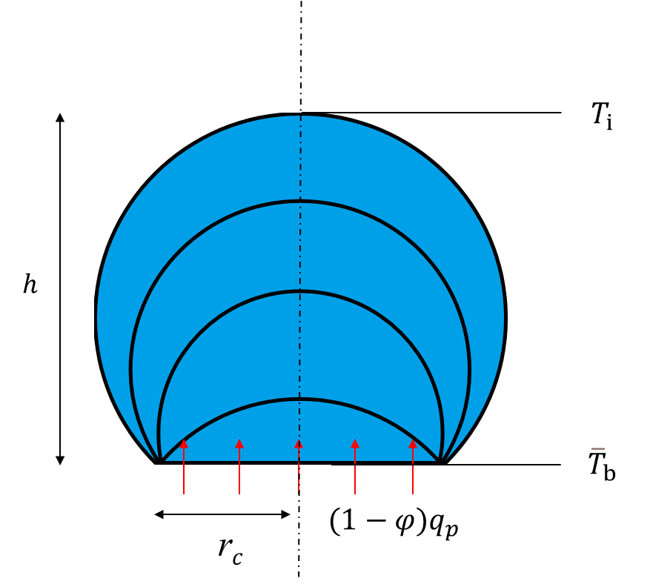

Figure 6. Diagram of heat transfer through the water droplet

The thermal resistance of the water droplet is

$R_{w}=\frac{arctan⁡(\frac{h}{r_{c}})}{2πk_{w}r_{c}}$ (21)

where h is the height of the water droplet, rc is the contact radius of the water droplet.

Then we can calculate the interface temperature of the water droplet:

${T_{i}={\overline{T}}_{b}-(1-φ)q_{p} R}_{w}$ (22)

With the water droplet interface temperature, we can then calculate the evaporation from the droplet spherical cap surface based on the diffusion-driven model:

$q_{e}=\frac{πr_{c}D_{d}\left(c_{s}-H_{h}c_{∞}\right)f\left(θ\right)}{h_{fg}}$ (23)

where Dd is the coefficient of vapor diffusion, cs is the saturated vapor concentration of the droplet surface, $c_{∞}$ is the saturated vapor concentration of the environment. Hh is the relative humidity. $f\left(θ\right)$ is a function of the droplet contact angle.

$f\left(θ\right)=\frac{sin\left(θ\right)}{1+cos\left(θ\right)}+4\int_{0}^{∞}{\frac{1+cosh\left(2θτ\right)}{sinh\left(2πτ\right)}tanh⁡[\left(π-θ\right)τ]}dτ$ (24)

Since the energy for the evaporation is transferred from the substrate, the evaporation flux from the droplet cap should be the same as the heat flux transferred through the water droplet. Thus, we have the relation:

$q_{e}=(1-φ)q_{p}$ (25)

Solving Eq. (25), we can obtain the droplet interface temperature $T_{i}$ and the evaporation ratio from the droplet base $φ$.

**3. Results and discussion**

3.1 Droplet evaporation process

In this study, we analyzed the evaporation process of small water droplet with 4 $μ$ L. The variation of water droplet volume with respect to evaporation time is shown in Fig. 7. During the evaporation process, liquid water absorbed heat from the heated substrate and then transferred to water vapor, causing the decrease of the volume of water droplet. The inset of Fig. 7 shows the variation of total evaporation with respect to the substrate temperature. With the increase of the substrate temperature, the total evaporation time decreased. Moreover, the evaporation time $t_{e}$ can be fitted with a power law function as the substrate temperature $T_{s}$, $t_{e}=mT_{s}^{n}$ where m = 1028380, n= ­­­-2.01.

Figure 7. Variation of droplet volume and total evaporation time.

Evaporation rate of water droplet is shown in Fig. 8. As shown in the figure, the evaporation rate of water droplet increases with the increase of the substrate temperature. The rise of the substrate temperature would lead to a higher surface temperature of the water droplet, which as a result cause the increase of the evaporation rate. During the evaporation process, the evaporation rate decreases with the evaporation time which is shown in Fig. 8 as the nondimensional time. This is because the decrease of the droplet volume. The decrease of the droplet volume caused the decrease of the liquid-vapor interface of the water droplet which leads to the decrease of the evaporation rate.

Figure 8. Variation of droplet evaporation rate

The variation of droplet contact angle and nondimensional contact radius with respect to nondimensional time is shown in Fig. 9. It is observed that during the first 65% of the evaporation process, the contact angle decreases continuously and the nondimensional contact radius keeps unchanged. In this period of time, droplet evaporates in a constant contact radius (CCR) model. After that, contact angle keeps constant at around 115° and the nondimensional contact radius starts to decrease. In this period of time of $τ$ from 0.65 to 0.9, droplet evaporates in a constant contact angle (CCA) model. After that both the contact angle and the nondimensional contact radius decrease with the evaporation time. In this vary last period of time, droplet evaporates in a mixed model.

Figure 9. Variation of droplet contact angle and nondimensional contact radius

3.2 Droplet surface temperature and evaporation ratio

We have discussed the thermal circuit model of the droplet and calculated the surface temperature and evaporation ratio from the droplet base in the experiment model part. Droplet interface temperature calculated from the thermal circuit model is shown in Fig. 10. Droplet surface temperature tested by the IR camera is also shown in Fig. 10. It can be observed from both the experiment data and the thermal circuit model that droplet temperature increases with respect to the evaporation time. Moreover, the surface temperature of the water droplet is lower than the temperature of the substrate, which is caused by the evaporative cooling. Thermal circuit model matches well with the experiment data in relative low temperature (from 40 °C to 60 °C). When the substrate temperature is high, surface temperature of the droplet calculated by the thermal circuit is lower than that test by the IR camera.

Evaporation ratio of the droplet base calculated by the thermal circuit model is shown in Fig. 11. The evaporation ratio of the droplet base decreases with the droplet evaporation time. This is caused by the increase of the droplet surface temperature. In the evaporation process, droplet surface temperature increases and mode heat is released from the droplet spherical cap. Thus, less heat is released from the droplet base. Also, the evaporation ratio of the droplet base increases with the substrate temperature.

Figure 10. Variation of droplet surface temperature.



Figure 11. Evaporation ratio of droplet base

**4. Conclusion**

This paper has reported experiments of water droplets evaporation on heated superhydrophobic surface. We developed a thermal circuit model to analysis the evaporation dynamics and calculated the droplet surface temperature and evaporation ratio of the droplet base. Droplet surface is much lower than the substrate temperature and increase during the evaporation process. Evaporation ratio of the droplet base increases with the substrate temperature.

**5.Reference**

[1] P. Calvert, Inkjet printing for materials and devices, Chem. Mater. 13 (10) (2001) 3299–3305.

[2] W. Jia, H.H. Qiu, Experimental investigation of droplet dynamics and heat transfer in spray cooling, Exp. Therm. Fluid Sci. 27 (2003) 829–838.

[3] D. Xia, S.R.J. Brueck, Strongly anisotropic wetting on one-dimensional nanopatterned surfaces, Nano Lett. 8 (9) (2008) 2819–2824.

[4] A. Cassie, S. Baxter, Wettability of porous surfaces, Trans. Faraday Soc. 40 (1944) 546–551