**Proceedings of the ASME 2021**

**International Mechanical Engineering Congress and Exposition**

**IMECE2021  
November 1-5, 2021, Virtual, Online**

IMECE2021-73012

Thermal Circuit Analysis of Droplet Evaporation on Hot Microstructured Superhydrophobic Surfaces

|  |  |  |
| --- | --- | --- |
| Wenge Huang  Department of Mechanical Engineering  Virginia Tech  Blacksburg, VA 24061 | Xukun He  Department of Mechanical Engineering  Virginia Tech  Blacksburg, VA 24061 | Jiangtao Cheng  Department of Mechanical Engineering Virginia Tech  Blacksburg, VA 24061 |

Abstract

*In this paper, the evaporation dynamics of solitary water droplet dwelling on the hot microstructured superhydrophobic surfaces is experimentally and theoretically investigated. For the first time, two distinguished components of heat and mass transfer, i.e., from droplet cap and base surface, during the droplet evaporation are systematically studied. Considering all the thermal resistances from the heated substrate to the droplet cap surface, a comprehensive thermal circuit model is developed to analyze the effects of micropillars and substrate temperature on the sessile droplet evaporation. As substrate temperature increases, a more apparent temperature mismatch between droplet cap surface and heated substrate is experimentally observed, which could be explained by the increasing droplet cap surface evaporation rate and its evaporative cooling effect. Moreover, the increasing temperature of droplet cap during the evaporation could be successfully predicted by our model indicating the component of evaporation ratio from droplet base surface (𝜑) is decreasing. This work could advance our understanding of droplet evaporation on heated superhydrophobic surfaces and further provide us a new tool to accurately predict droplet temperature and evaporation rate during the evaporation process*.

Keywords: Evaporation, Thermal circuit model, Superhydrophobic surface

Nomenclature

*a* radius of micropillar

*b* radius of water layer

*D* diameter of the micropillar

*D­*d diffusion coefficient

*h* height of the water droplet

*H* height of the micropillar

*H*h relative humidity

*k* thermal conductivity

*l* thickness

*q* heat transfer rate

*R* thermal resistance

*T* temperature

*θ* contact angle

$φ$ evaporation ratio of the droplet base

1. INTRODUCTION

Droplet evaporation is a common natural phenomenon with various applications including ink-jet printing [1], spray cooling [2] and micro fabrication [3]. Droplets reside on substrates (sessile droplet) show different characteristics during the evaporation process corresponding to the distinct properties of the substrates. The surface energy of the substrates determines the wetting morphology of the sessile droplets (hydrophilic and hydrophobic). In the past two decades, inspired by natural structures such as lotus leaf, “superhydrophobic” surfaces with micro or nanoscale roughness were invented to exhibit larger hydrophobicity. Generally, there are two kinds of wettings states for droplet on the micro-structured substrates [4]: (a) Cassie state: the droplet touches only the top surface of the microstructures and leaves air cavities underneath the droplet; and (b) Wenzel state: droplet completely penetrates the cavities between micropillars. It has been found the distinct pinning/depinning mechanism and wetting/nonwetting contact in these two wetting states would lead to completely different heat and mass transfer dynamics during sessile droplet evaporation on superhydrophobic surfaces [5] [6].

For the evaporation of droplets in Wenzel state on superhydrophobic surfaces, all the heat and mass transfer between the droplet and surrounding air happens at the liquid-vapor interface of droplet cap surface which is same as the sessile droplet evaporation on smooth surface [7-9]. However, due to the existence of air/vapor cavities between droplet base and substrate, heat and mass transfer between Cassie state droplet and surrounding air can be divided into two different components which are the evaporation from the droplet cap surface and droplet base surface. Evaporation from droplet base surface for droplet evaporation in Cassie state at room temperature is always neglected because of the small base liquid-vapor interface area and the large pressure resistance between the micropillars. Previous studies considered only the evaporation at the droplet cap surface successfully predicted the evaporation dynamics of Cassie state droplet evaporation on microstructured superhydrophobic surfaces at room temperature [10]. In the case of droplet evaporation on hot microstructured surfaces, the temperature increase of the substrate will result in the temperature increase of the droplet base surface which contacts with the substrate. Due to the high temperature of the droplet base surface, the component of evaporation from the droplet base surface is important and should not be neglected anymore. Nevertheless, the effect of large evaporation component from droplet base on droplet evaporation in Cassie state has been limited studied.

In this study, the evaporation dynamic of solitary water droplet on hot microstructured superhydrophobic substrates will be experimentally and theoretically investigated. Based on a comprehensive thermal resistance analysis, a thermal circuit model would be developed to predict the droplet cap surface temperature. Furthermore, the evolution of evaporation ratio of the droplet base during drop evaporation on hot superhydrophobic surface from 40 °C to 80 °C will be explored.

1. **MATERIALS AND METHODS**.

**2.1 Substrates fabrication**

Silicon-based microstructured substrates in this work are fabricated by the standard photolithography process and deep reactive ion etching (DRIE). The microstructure of substrate is characterized by the scanning electron microscope (SEM) as shown in Fig. 1. All the substrates are composed of cylindrical micropillar arrays, and the geometry information of the micropillar substrates is listed in Table 1.

**TABLE 1**. MICROPILLAR DIAMETER, PERIODICITY AND HEIGHT OF DIFFERENT SAMPLE SUBSTRATES

|  |  |  |  |
| --- | --- | --- | --- |
| Substrate | Diameter D (μm) | Periodicity P (μm) | Height H (μm) |
| Sample 1 | 20 | 40 | 40 |
| Sample 2 | 20 | 50 | 40 |
| Sample 3 | 20 | 60 | 40 |

Subsequently, all the substrates are conformally coated with silane (Trichloro (1H,1H,2H,2H-per fluoroethyl)-silane, Sigma-Aldrich) using standard chemical vapor deposition (CVD) process [14]. Then the substrates are baked at 90°C for 60 min to generate the superhydrophobicity. The static contact angle of water droplet on all the substrates is 155° $±$ 2°. To mitigate the sample edge effect on the droplet evaporation process, substrate samples are cut into square pieces with 2 cm length of side and water droplets are deposited at the center of the substrates.

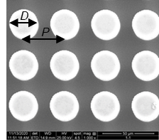

**FIGURE 1:** SEM IMAGE OF S1 SAMPLE

**2.2 Experiment setup**

The experiment setup of this study is shown in Fig. 2. A $4μL$ droplet is placed on the superhydrophobic substrate for evaporation. Substrate is heated by a hot plate from 40 °C to 80 °C. The surface temperature of the hot plate is measured by a thermocouple. An infrared (IR) camera is used to measure the surface temperature of the droplet from the top view and a high-speed camera is used to record the sessile droplet evaporation from side view in a frame rate of 1.14 frame /s. The contact angle, contact radius and height of evaporating droplet are obtained by analyzing the transient images.

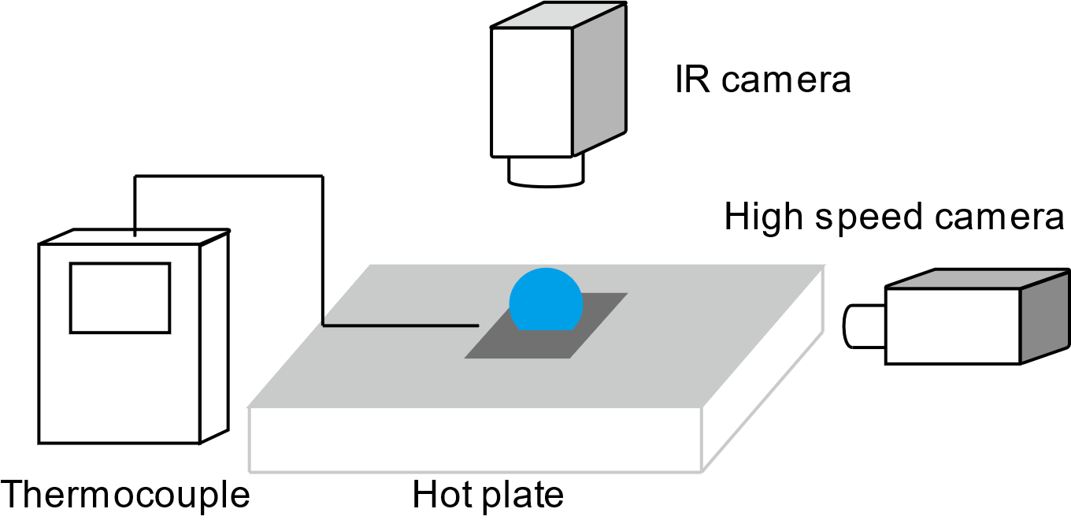

**FIGURE 2:** EXPERIMENTAL SETUP INCLUDING HOT PLATE, HIGH SPEED CAMERA, IR CAMERA AND THERMOCOUPLE

**2.3 Theoretical model**

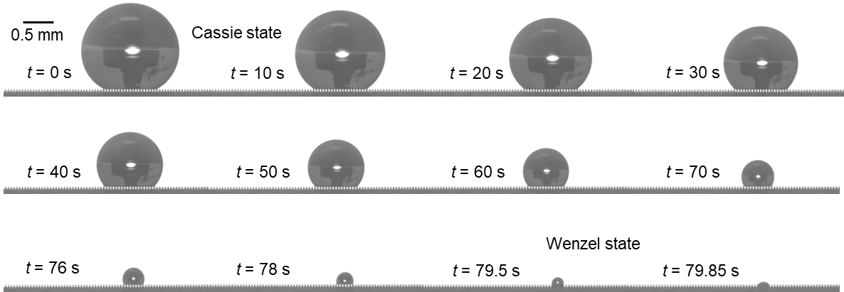

**FIGURE 3:** SNAPSHOTS OF DROPLET EVAPORATION ON SUPERHYDROPHOBIC SURFACE.

When placed on the superhydrophobic surfaces, the sessile droplet touches only the top surface of the micropillars, which could be evidenced by air/vapor cavities observed underneath the water droplet as shown in Fig. 3. During majority time of the evaporation, the sessile droplet stays in Cassie state and transfers to Wenzel state at the very end of the evaporation. Thus, it is assumed that the droplet is always in Cassie state in the following theoretical analysis.

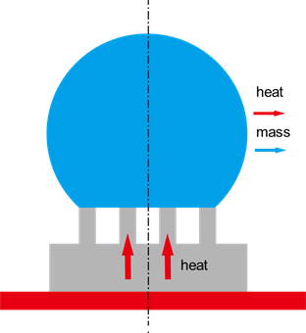

**FIGURE 4:** DIAGRAM OF DROPLET EVAPORATION ON SUBSTRATE

During the evaporation of droplet on the hot microstructured substrate, heat will transfer from the hot plate through the substrate into the droplet. This heat transfer process will cause the temperature increase of the droplet and improve the heat and mass transfer between the droplet and the surrounding air. The energy balance of the droplet can be derived as:

$q_{s}=q_{temp}+q_{conv}+q_{rad}+q_{evap}$ (1)

where $q_{s}$ is the total heat transfer rate from the substrate to droplet; $q_{temp}$ is the energy transfer rate required for the water temperature increase; $q_{conv}$ is the convective heat transfer rate from the water droplet to the ambient air; $q_{rad}$ is the radiation heat transfer rate from water droplet to the ambient air; $q_{evap}$ is the heat released to the ambient air through evaporation.

$q_{temp}=c_{p}ρ_{w}V\frac{dT_{w}}{dt}$ (2)

$q_{rad}=εσS\left(T_{w}^{4}-T_{∞}^{4}\right)$ (3)

$q_{conv}=h_{conv}S\left(T_{w}^{ }-T_{∞}^{ }\right)$ (4)

$q_{evap}=h_{fg}ρ_{w}\frac{dV}{dt}$ (5)

where $c_{p}$, $ρ_{w}$, $T_{w}^{ }$*V* and $h_{fg}$ are the specific heat capacity, density, temperature, volume and latent heat of the droplet water, respectively; $ε$ is the emissivity of the water droplet interface and $σ$ is the Stefan-Boltzmann constant; *S* is the liquid-vapor interface area and $h_{conv}$ is the natural convection heat transfer coefficient of the ambient air.

Due to the high efficiency of the phase change heat transfer process, at a relatively high substrate temperature ($T_{s}$ > 40°C), evaporation-induced heat transfer rate $q_{evap}$ is dominant over the other three types of heat transfer rate [5]. Thus, the overall heat transfer rate from the substrate to the water droplet can be estimated as the heat released from droplet to the ambient air. The energy balance equation can be rewritten as:

$q_{s}=q_{evap}$ (6)

In general, heat will transfer through both the micropillars and the air/vapor cavities from the substrate to the droplet base. However, the thermal resistance of the water vapor is much larger than that of the silicon micropillars due to the significant ratio between the thermal conductivity of silicon pillars(100 Wm­-1K-1) [15] [16] and water vapor (0.025 Wm­-1K-1) [17]. Therefore, it is reasonable to assume that heat primarily conducts from the micropillar to the water droplet whereas the vapor-solid interface of cavities boundary can be regarded as adiabatic.

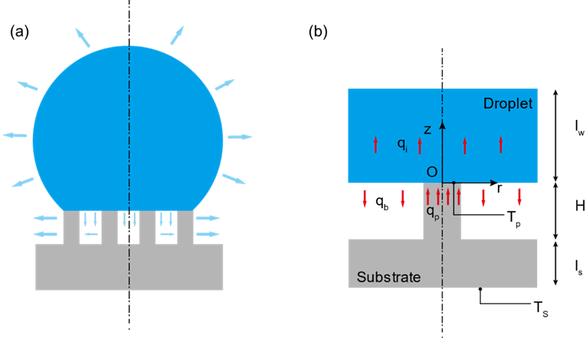

**FIGURE 5:** (a) DIAGRAM OF EVAPORATION FROM DROPLET CAP SURFACE AND BASE SURFACE. (b) DIAGRAM OF HEAT TRANSFER PROCESS FROM MICROPILLAR TO WATER DROPLET

Considering the periodicity of the micropillar arrays, the heat transfer process in one unit micropillar cell can represent the characteristic of heat transfer between the substrate and droplet. Thus, we can focus on one unit cell of the pillar array consisting of one pillar and one vapor cavity as shown in Fig. 5 (b). As is mentioned before, heat transfer rate from the substrate to the droplet can be estimated by the evaporation rate. Thus, we can calculate the substrate heat flux by obtaining the evaporation flux of the water droplet based on the decreasing droplet volume (Eq. 5). We assume the heat flux is uniform from the substrate. Thus, heat flux across one unit cell could be calculated as:

$q_{p}=\frac{q_{s}}{N}$ (7)

where *N* is the number of the micropillar underneath the droplet which can be calculated by the ratio of the droplet apparent contact area and unit cell area.

The thermal resistance of the silicon substrate per unit cell could be calculated as:

$R_{s}=\frac{l_{s}}{k_{Si}P^{2}}+\frac{4H}{k_{Si}{πD}^{2}}$ (8)

where $k_{Si}$ is the thermal conductivity of silicon micropillar and *l*s is the thickness of the silicon substrate excluding the height of micropillars.

Based on the energy balance relation inside the silicon substrate, the temperature on the top surface of the micropillar can be calculated as:

$T_{p}=T_{s}-\frac{q_{p}}{R_{s}}$ (9)

To study the temperature distribution near the liquid-solid interface, i.e., the top surface of micropillar inside the water droplet, a thin water layer with a thickness of *l*w in a unit cell (Fig. 5 (b)) would be considered. The conductive heat transfer equation in this water layer is:

$\frac{∂^{2}T_{ }}{{∂r}^{2}}+\frac{1}{r}\frac{∂T_{ }}{∂r}+\frac{∂^{2}T_{ }}{{∂z}^{2}}=0$ (10)

Due to the small size of the micropillar, the heat flux across the liquid-solid interface and liquid-vapor interface in a unit cell could be assumed as uniform. As a result, we have the first boundary condition:

$k_{w}\frac{∂T_{ }}{∂z}=\left\{\begin{aligned}\frac{q_{p}}{πa^{2}} 0<r<a; z=0 \\ -\frac{q_{b}}{π(b^{2}-a^{2})} a<r<b; z=0\end{aligned}\right.$ (11)

where $k_{w}$ is the thermal conductivity of water, *a* is the radius of the micropillar and *b* is the radius of the water cylinder in one unit cell.

Temperature inside the water layer will soon become uniform. Hence, a uniform temperature boundary could be assumed at $z=l_{w}$:

$T_{ }\left(r;z\right)=T_{w} 0<r<b; z=l_{w}$ (12)

Moreover, considering the periodicity of the unit cell, we can assume that it is adiabatic at the side boundary of the unit cell. Thus, we obtain the adiabatic boundary condition:

$\frac{∂T_{ }}{∂r}=0 r=b; 0<z<l_{w}$ (13)

Solving the conductive heat transfer equation Eq. (10) with the three boundary conditions Eq. (11), Eq. (12), Eq. (13), we can obtain the temperature distribution inside the water layer as:

$T_{b}(r,z)=T_{w}+\frac{q_{p}\left(l_{w}-z\right)}{πk_{w}}\left(\frac{\left(1-φ\right)}{b^{2}}\right)+\frac{2aq_{p}}{πk_{w}}\left(\frac{1}{a^{2}}+\frac{φ}{b^{2}-a^{2}}\right)\sum_{n=1}^{∞}{\left[J_{1}\left(\frac{a}{b}α_{n}\right)J_{0}\left(\frac{r}{b}α_{n}\right){/\left(α_{n}^{2}J_{0}^{2}\left(α_{n}\right)\right)}\right]}\frac{\sinh\left(\left.\frac{α_{n}}{b}{\left(l\right.}_{w}-z\right)\right)}{\cosh\left(\frac{α_{n}}{b}l_{w}\right)}$ (14)

where $φ$ is the evaporation ratio, which is defined as the heat transfer rate from the droplet base surface over the overall heat transfer rate from substrate to droplet:. *J*0(*x*) and *J*1(*x*) are the first kind Bessel functions with order of 0 and 1, respectively, $α_{n}$ is the n-th root of *J*1(*x*)=0.

The temperature at the droplet base at z=0 is calculated as:

$T_{b}(r,0)=T_{w}+\frac{q_{p}l_{w}}{πk_{w}}\left(\frac{\left(1-φ\right)}{b^{2}}\right)+\frac{2aq_{p}}{πk_{w}}\left(\frac{1}{a^{2}}+\frac{φ}{b^{2}-a^{2}}\right)\sum_{n=1}^{∞}{\left[J_{1}\left(\frac{a}{b}α_{n}\right)J_{0}\left(\frac{r}{b}α_{n}\right){/\left(α_{n}^{2}J_{0}^{2}\left(α_{n}\right)\right)}\right]}\tanh\left(\frac{α_{n}}{b}l_{w}\right)$ (15)

Thus, the average temperature of the droplet base can be obtained as:

${\overline{T}}_{b}=\frac{\int_{0}^{b}{2πr}T_{b}\left(r\right)dr}{πb^{2}}$ (16a)

${\overline{T}}_{b}=T_{w}+\frac{q_{p}l_{w}}{πk_{w}}\left(\frac{\left(1-φ\right)}{b^{2}}\right)$ (16b)

The average temperature of the solid-liquid interface at droplet base could be estimated as:

$T_{b,p}=\frac{\int_{0}^{a}{2πr}T_{b}\left(r\right)dr}{πa^{2}}$ (17a)

$T_{b,p}={\overline{T}}_{b}+\left\{\frac{2aq_{p}}{πk_{w}}\left(\frac{1}{a^{2}}+\frac{φ}{b^{2}-a^{2}}\right)\sum_{n=1}^{∞}{\left[J_{1}^{2}\left(\frac{a}{b}α_{n}\right){/\left(α_{n}^{3}J_{0}^{2}\left(α_{n}\right)\right)}\right]}\tanh\left(\frac{α_{n}}{b}l_{w}\right)\right\}$ (17b)

Due to temperature continuity at the solid-liquid interface, we should have:

$T_{b,p}=T_{p}$ (18)

Thus, the base average temperature of the water droplet could be obtained as:

${\overline{T}}_{b}=T_{p}-\frac{q_{p}2a\left(1+k\right)}{k_{w}}\sum_{n=1}^{∞}{\left[J_{1}^{2}\left(\frac{a}{b}α_{n}\right){/\left(α_{n}^{3}J_{0}^{2}\left(α_{n}\right)\right)}\right]}$ (19)

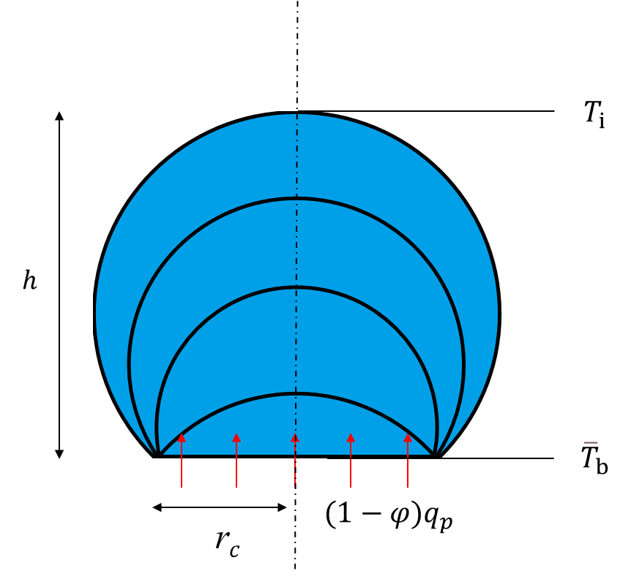

**FIGURE 6:** DIAGRAM OF HEAT TRANSFER THROUGH THE WATER DROPLET

Considering the heat balance inside the droplet, the shape of sessile droplet should be assumed to spherical cap. Thus, the thermal resistance of the water droplet could be calculated as: [18] [19]

$R_{w}=\frac{arctan⁡(\frac{h}{r_{c}})}{2πk_{w}r_{c}}$ (20)

where *h* is the height of the water droplet, $r_{c}$ is the contact radius of the water droplet.

Thus, the temperature at the cap of the water droplet could be estimated as:

${T_{i}={\overline{T}}_{b}-(1-φ)q_{p} R}_{w}$ (21)

With the water droplet interface temperature, we can calculate the evaporation rate from the droplet cap surface based on the diffusion-driven model:

$q_{e}=\frac{πr_{c}D_{d}\left(c_{s}-H_{h}c_{∞}\right)f\left(θ\right)}{h_{fg}}$ (22)

where $D_{d}$ is the coefficient of vapor diffusion, $c_{s}$ is the saturated vapor concentration of the droplet surface, $c_{∞}$ is the saturated vapor concentration of the environment, $H_{h}$ is the relative humidity and $f\left(θ\right)$ is a function of the droplet contact angle:

$f\left(θ\right)=\frac{sin\left(θ\right)}{1+cos\left(θ\right)}+4\int_{0}^{∞}{\frac{1+cosh\left(2θτ\right)}{sinh\left(2πτ\right)}tanh⁡[\left(π-θ\right)τ]}dτ$ (23)

Since the energy for the evaporation is transferred from the substrate, the evaporation flux from the droplet cap should be the same as the heat flux transferred through the water droplet. Thus, we have the relation:

$q_{e}=(1-φ)q_{p}$ (24)

Solving Eq. (24), we can obtain the droplet interface temperature $T_{i}$ and the evaporation ratio from the droplet base $φ$.

1. **RESULTS AND DISCUSSION**

In this study, we analyzed the evaporation process of small water droplet with 4 $μ$ L volume. The evolution of water droplet volume with respect to evaporation time for droplet evaporation on different sample substrates with different base temperature is shown in Fig. 7. Droplet volume decreases nonlinearly during the evaporation on the hot microstructured superhydrophobic substrates. It is observed from Fig. 7 that the total evaporation time decreases with the rise of the substrate base temperature (from 40 °C to 80 °C). Meanwhile, the total evaporation time increases with the increase of the substrate periodicity (from 40 µm to 60 µm) when the substrate base temperature is kept as the same. This increase of the total evaporation time is credited to the increase of the thermal resistance between the droplet base and substrate, which will also be confirmed by the total evaporation rate as shown in Fig. 9.

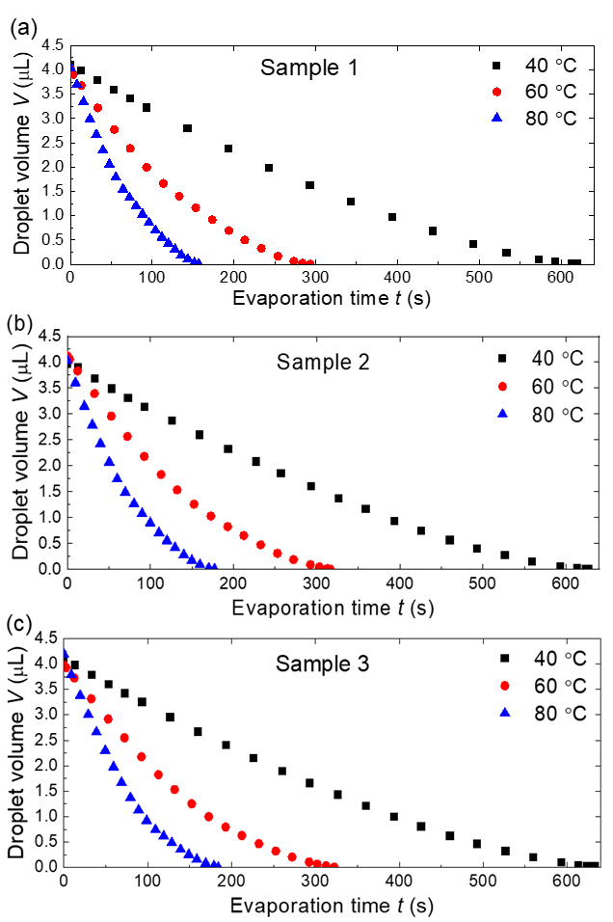

**FIGURE 7:** TEMPRAL EVOLUTION OF DROPLET VOLUME ON DIFFERENT SUBSTRATES. THE SUBSTRATES ARE HEATED TO 40 °C, 60 °C AND 80 °C.

The variation of droplet contact angle and nondimensional contact radius with versus nondimensional time is shown in Fig. 8. Here, the nondimensional contact radius is defined as the ratio of transient contact radius and initial contact radius, and the nondimensional time is defined as the evaporation time and total evaporation time. For droplet evaporation on sample 1 substrate, the contact angle decreases continuously in the first 68% of the total evaporation process. During this period, the contact radius is kept unchanged as shown in Fig. 8 (a). This is the constant contact radius (CCR) mode for the droplet evaporation. After reaching the receding contact angle, the droplet contact angle stops decreasing and keeps unchanged. At the same time, the droplet contact radius begins to decrease. This is the constant contact angle (CCA) mode for the droplet evaporation. The droplet is in CCA mode during the evaporation till the nondimensional time approaches 0.9. Then both the contact angle and the contact radius decrease, and this is the mixed for the droplet evaporation. For droplet evaporation on the same substrate with different substrate base temperatures, the evaporation process has almost the same composition of the CCR mode, CCA mode and mixed mode. That means it is the substrate structure that affect the evaporation mode transition and the substrate temperature is not that important.

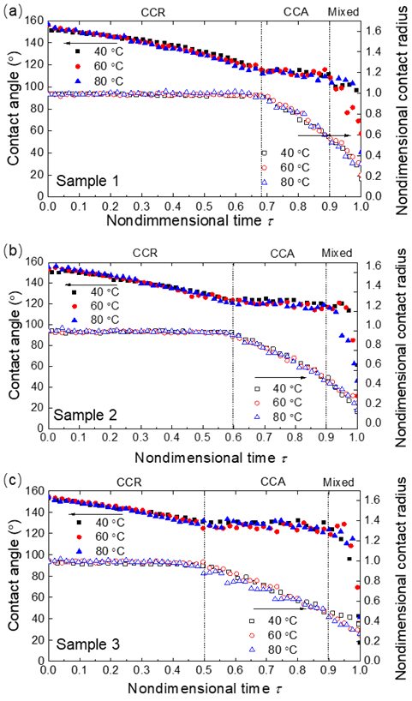

**FIGURE 8:** EVOLUTION OF DROPLET CONTACT ANGLE AND NONDIMENSIONAL CONTACT RADIUS VERSUS NONDIMENSIONAL TIME ON DIFFERENT SUBSTRATES. THE SUBSTRATES ARE HEATED TO 40 °C, 60 °C AND 80 °C.

The variations of droplet contact angle and nondimensional contact radius on sample 2 (Fig. 8(b)) and sample 3 (Fig. 8 (c)) substrates are similar to the variation for droplet evaporation on sample 1. The receding contact angle on different substrates increases with the increase of the periodicity of the substrate. The receding contact angles on sample 1, sample 2 and sample 3 are about 112°, 120° and 128° respectively. Since the initial contact angles of droplet on these three sample substrates are almost the same (about 155°), larger receding contact angle results in the shorter time of the CCR mode. The nondimensional evaporation time for CCR mode on sample 1, sample 2 and sample 3 is about 0.68, 0.6 and 0.5, respectively.

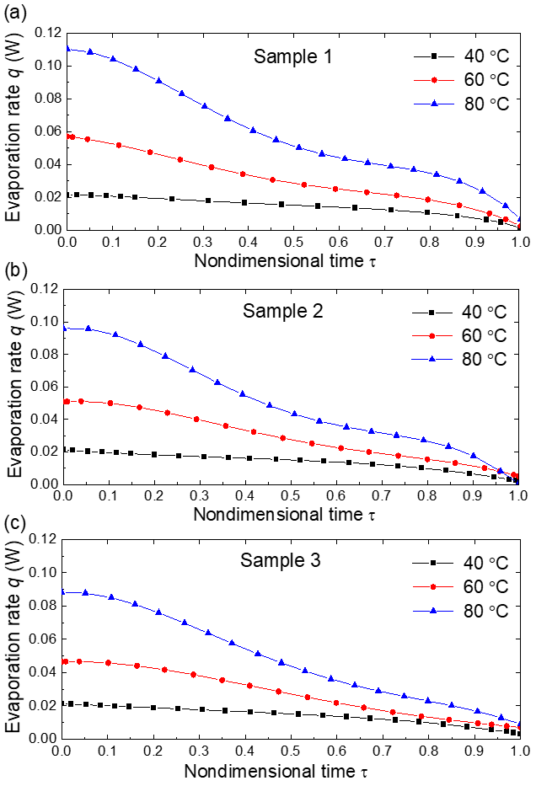

**FIGURE 9:** EVOLUTION OF TOTAL EVAPORATION RATE FOR DROPLET EVAPORATION ON DIFFERENT SUBSTRATES. THE SUBSTRATES ARE HEATED TO 40 °C, 60 °C AND 80 °C.

The total evaporation rates are not the same for droplet evaporation on different substrates with the same substrate base temperature, as shown in Fig. 9. The total evaporation rate decreases during the evaporation process. Droplet evaporation on sample 1 (40 μm periodicity) substrate has the maximum evaporation rate and on sample 3 (60 μm periodicity) substrate has the minimum evaporation rate. Because of the different substrate periodicity, the solid-liquid interface areas are different for droplets evaporation on different sample substrates. Since droplets evaporation on different sample substrates have essentially the same apparent contact area (base area of the droplet), small substrate periodicity means fewer vapor cavities between the droplet and the substrate and more solid-liquid interface area. The larger solid-liquid interface area results in the higher droplet evaporation rate for evaporation with the same substrate base temperature

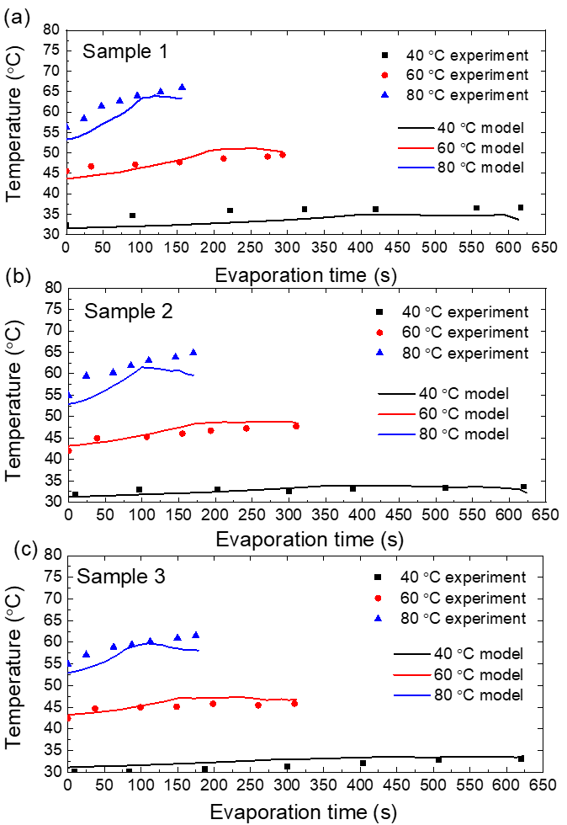

**FIGURE 10:** EVOLUTION OF DROPLET CAP SURFACE TEMPERATURE.

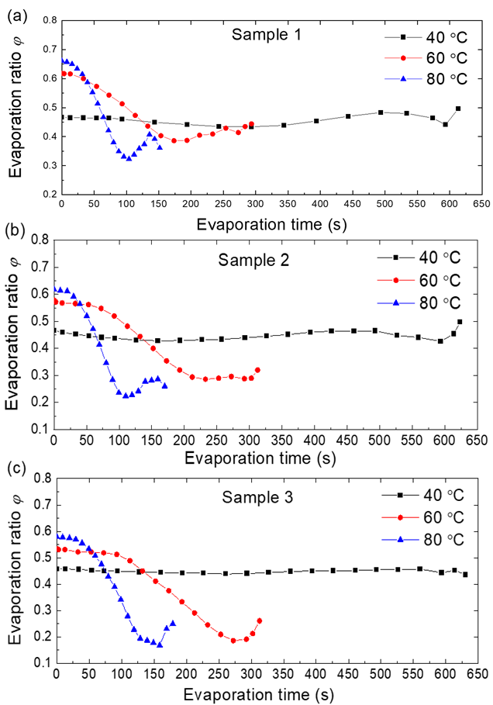

**FIGURE 11:** EVAPORATION RATIO OF DROPLET BASE

The evolution of droplet cap surface temperature versus the nondimensional time is shown in Fig. 10. The droplet cap surface temperature calculated by the thermal circuit model matches well with the droplet cap surface temperature tested by the IR camera for the solitary droplet evaporation on substrates with base temperature at 40 °C, 60 °C and 80 °C. It can be observed from both the experimental values and the calculating values that droplet cap surface temperature increases during the evaporation. There is a large temperature difference between the droplet cap surface and the substrate base temperature. This temperature drop is caused by the thermal resistances of the water droplet, the silicon substrate. As the substrate temperature increases, the temperature mismatch between the droplet cap surface and the substrate base temperature increases from 7 °C to 18 °C. The validity of the thermal circuit model can be verified by the good agreement between the experimental measured values and the predicted values.

The evolution of evaporation ratio φ of an evaporating droplet on a substrate with different temperatures is shown in Fig. 11. As substrate temperature increases, the evaporation ratio φ increases, which means the larger portion of evaporation heat dissipation would occur at the droplet base. The evaporation ratio of the droplet base keeps on decreasing during the most part of the evaporation process which may be induced by the increase of the droplet cap temperature. At the very end of the evaporation process, there is an increase of the evaporation ratio which can be explained by the rapid decrease of the droplet cap surface and base surface area.

1. **CONCLUSION**

In this work, the water droplets evaporation on heated superhydrophobic surfaces is experimentally and theoretically investigated. We developed a thermal circuit model to analyze the evaporation dynamics, calculated the droplet surface temperature and the ratio of evaporation across the droplet base. The larger extent of temperature mismatch between droplet cap and substrate was firstly explained by the increasing ratio of evaporation from the droplet base as substrate temperature increases.

**ACKNOWLEDGEMENTS**

This work is financially supported by NSF CBET under grant number 1550299 and NSF ECCS under grant number 1808931.

**REFERENCES**

[1] P. Calvert. *Chem. Mater*, 2001

[2] W. Jia, H.H. Qiu. *Exp. Therm. Fluid Sci*, 2003

[3] D. Xia, S.R.J. Brueck. *Nano Lett*, 2008

[4] A. Cassie, S. Baxter. *Trans. Faraday Soc,* 1944

[5] R. Hays, D. Maynes, J. Crockett. *Int. J. Heat Mass Transfer,* 2016

[6] K. Sefiane, R. Bennacer. *J. Fluid Mech*, 2011

[7] T. A. H. Nguyen, S. R. Biggs, A. V. Nguyen. *Langmuir,* 2018

[8] Y. O. Popov. *Phys. Rev. E*, 2000

[9] S. Dash, S. V. Garimella. *Phys. Rev. E*, 2014

[10] G. McHale, S. Aqil, N. J. Shirtcliffe, M. I. Newton, H. Y. Erbil. *Langmuir,* 2005

[11] S. Adera, R. Raj, R. Enright, E. N. Wang. *Nat. Commun*, 2013

[12] M. Wei, Y. Song, Y. Zhu, D. Preston, C. S. Tan, E. N. Wang. *Appl. Phys. Lett*, 20202

[13] H. Kim, B. Truong, J. Buongiorno, L. Hu. *Appl. Phys. Lett*, 2011

[14] M. Badv, I. H. Jaffer, J. I. Weitz, T. F. Didar. *Sci. Rep*, 2017

[15] P. Maycock. *Solid-state Electron*, 1967

[16] C. Glassbrenner, G. A. Slack. *Phys. Rev.* 1964

[17] A. L. Biance, C. Clanet, D. Quere. *Phys. Fluids*, 2003

[18] S. Kim, K. Kim. *J. Heat Transfer*. 2011

[19] N. Miljkovic R. Enright. E. N. Wang. *ACS Nano*, 2012