Responding letter

Reviewer 1:

1. In figure 9, data points should be reduced to show a clear trend of constant contact radius mode and constant contact angle mode. Meanwhile, the authors need to plot the calculated contact angle (equation 23) with the measured contact angle in figure 9. If the model could not fit the measured contact angle, the authors need to use the measured contact angle to calculate the evaporation rate to match the experimental data.

**Response:** We appreciate the reviewer for the suggestions. We have reduced the data points of the contact angle and contact radius. Constant contact radius mode and constant contact angle mode have been specified in the figure. The old figure 9 now is changed to figure 8.

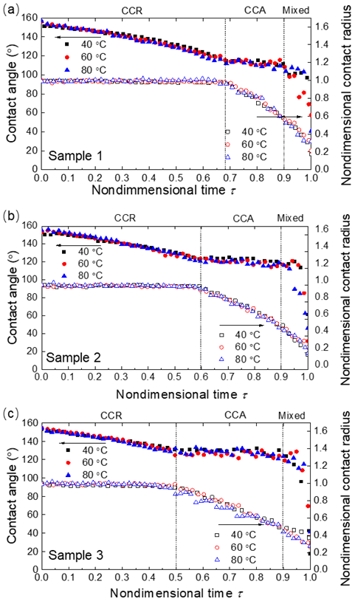

**FIGURE 8:** EVOLUTION OF DROPLET CONTACT ANGLE AND NONDIMENSIONAL CONTACT RADIUS VERSUS NONDIMENSIONAL TIME ON DIFFERENT SUBSTRATES. THE SUBSTRATES ARE HEATED TO 40 °C, 60 °C AND 80 °C.

When calculating the droplet cap surface temperature, we did not use the calculated contact angle. In the study, the thermal circuit is used to calculate the droplet cap surface temperature and it cannot be used to calculate the contact angle. We measured the droplet transient contact angle, contact radius and total evaporation rate and use these measured data to calculate the evaporation rate from the droplet cap surface and droplet base surface, separately. Equation (23) is not used to calculate the contact angle. It is used to calculate the evaporation rate from the droplet cap surface based on the diffusion-driven evaporation model. We need to put the measured contact angle data into equation 23 to calculate the droplet cap surface evaporation rate.

2. The contact radius will change during droplet evaporation at the stage of constant contact angle (Xu, Wei, et al. Langmuir 29.20 (2013): 6032-6041.). However, the model did not include the contact radius with a time function similar to the function of the contact angle. Otherwise, the authors need to show the parameters they used to calculate the evaporation rate of the base. The reviewer thinks that the measured contact angle and contact radius could be used directly to calculate the evaporation rate based on the model.

**Response:** We appreciate the reviewer for the suggestions. In this study, we used the measured transient contact radius to calculate the evaporation rate. We have plot the measured transient nondimensional contact radius in Fig. 8 and these are the data we used to calculate the evaporation rate. We cannot calculate the evaporation rate from the droplet base directly because of the complex structure of the micropillar. Instead, we used the measured contact angle and contact radius to calculate the evaporation rate from the droplet cap surface based on the diffusion-driven evaporation model. Then we measured the total evaporation rate of the droplet. The difference of the total evaporation rate and the evaporation rate from the droplet cap surface is the evaporation rate from the droplet base surface based on the energy balance model.

3. When the droplet is close to the transition to Wenzel state, the difference of surface temperature and base temperature will be small. This, as mentioned by the authors, will decrease the evaporation rate of the base as the surface has a larger area for evaporation. However, in figure 11, for high temperatures (i.e., 80 and 100 °C), the evaporation ratio of the droplet base increases. The authors need to explain the increase of the evaporation ratio on the droplet base.

**Response:** We appreciate the reviewer for the suggestions. The increase of the evaporation ratio of the droplet base at the end of the evaporation is because of the decrease of the surface area ratio of the droplet cap surface and droplet base area. The droplet cap surface area is calculated as: $S_{cap}=2πr^{2}\frac{(1-cosθ)}{\sin^{2}θ}$. The droplet base area is calculated as $S_{base}=2πr^{2}$. (*r* is the contact radius and $θ$ is the contact angle). Because of the rapid decrease of the contact angle at the very end of the evaporation, the surface area ratio between the droplet cap surface and droplet base surface decreases. Thus, the evaporation ratio will increase at the end of the evaporation.

4. In figure 10, the experimental temperature has a large difference from the theoretical temperature. The authors need to explain the difference especially for the case of 100 °C. The huge difference cannot support the statement made by the authors as ‘good agreement between the experimental measured value and model predicted value’.

**Response:** We appreciate the reviewer for the suggestions. We have limited our results for the substrate base temperature from 40 °C to 80 °C. The large derivation between the calculating results and the experimental results is due to the internal convective motion of the fluid. As the substrate temperature increases, the motion inside the droplet becomes rapid. In the high temperature substrate evaporation case, the effect of convection heat transfer inside droplet cannot be neglected. In this study, the thermal circuit model is a one-dimensional conduction model and the convection heat transfer inside the droplet is not considered. The convection heat transfer inside the droplet will reduce the thermal resistance of the droplet and thus leads to a higher droplet cap surface temperature. We cannot consider the effect of fluid motion for the droplet cap surface temperature in this study. We will explore this point in our future work.

5. In figure 1, adding a definition of diameter and periodicity in the image will be helpful to understand the parameters of the micropillar.

**Response:** We appreciate the reviewer for the suggestions. We have added the definition of diameter and periodicity in the image.

Reviewer 2:

1. What is the purpose behind choosing the specific pillar dimensions? The authors should explain the basis behind the dimension optimization.

**Response:** We appreciate the reviewer for the suggestions. We have used three samples with different periodicity in this study.

2. Did the authors also test their case with micro-nano hierarchical surfaces?

**Response:** We don’t consider the case with micro-nano hierarchical surface. The nanostructure on the substrate will cause the existence of nanoscale vapor cavity underneath the droplet, which will make the thermal resistance of the substrate hard to calculate.