Project1: A spinning crown

Wenjie Zhang (netID: wzm416)

What I designed is a rotating crown that has many interesting features.

User’s Guide:

As you can see on the screen, the crown is spinning around the Y axis. In order to make it more fun, there are some instructions to follow:

1. On the screen, you can click on the spin up button to make the crown rotate faster clockwise.
2. You can also click on spin down button to make the crown become slow, or make it spin faster anticlockwise.
3. When you click on run/ stop button, you can make the crown rotate or not rotating.
4. When the crown is moving around the canvas, clicking on the go back button, it will make the crown go to the original point.
5. For mouse interaction, if you drag the mouse, you are able to see the crown from 360 angle, and with the movement of the crown the color of decoration will change.
6. For keyboard interaction, when you press up arrow, left arrow, down arrow and right arrow, the crown will go up, left, down and right.

Result section:

The crown is spinning around the Y-axis automatically:

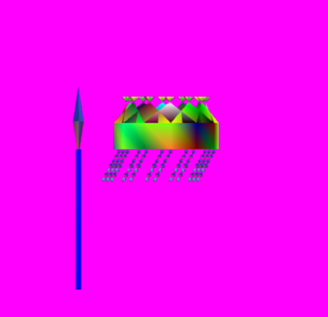

As we drag the mouse the angle we view the crown is changed:

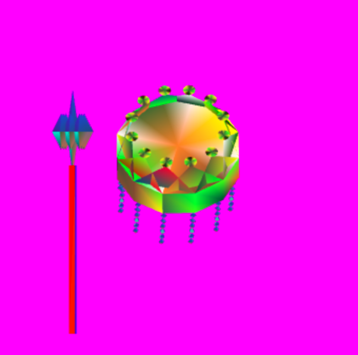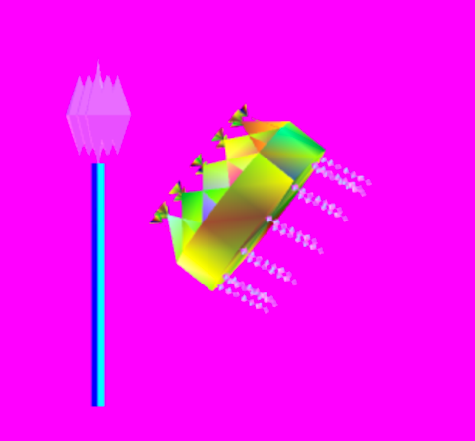

if we drag the mouse vertically the size of the decoration next to the crown is changed:

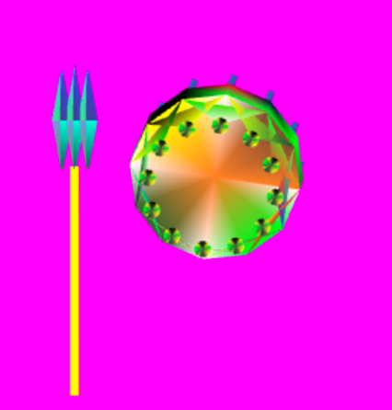

If we drag the mouse horizontally, the color of the decoration below the crown is changed:

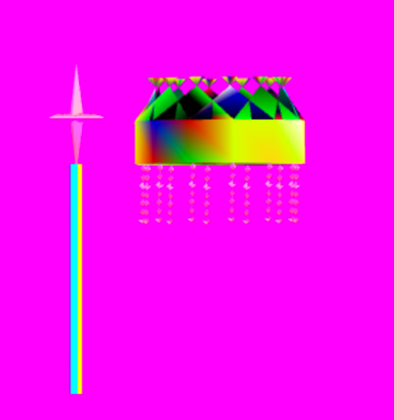

you can compare with the picture before the drag:

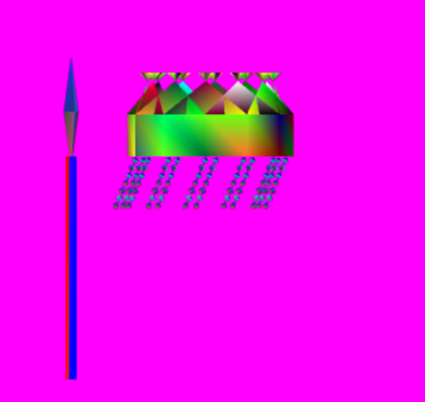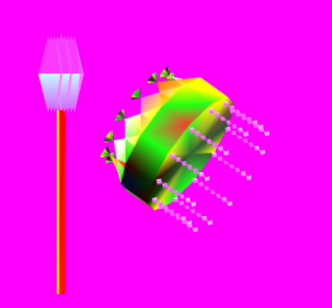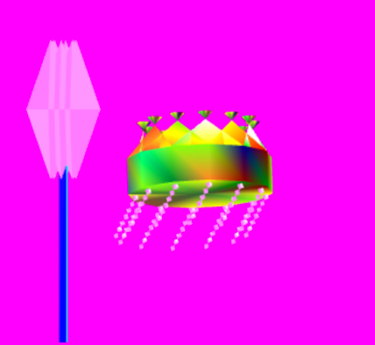

Also we can use the keyboard to let the crown move around the canvas:

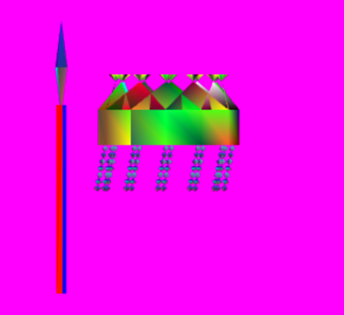

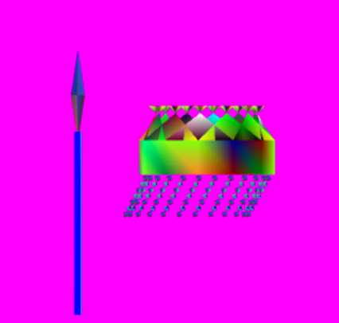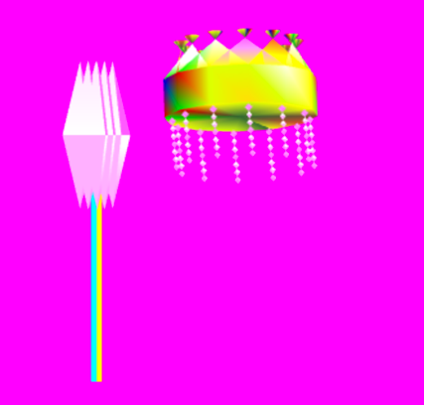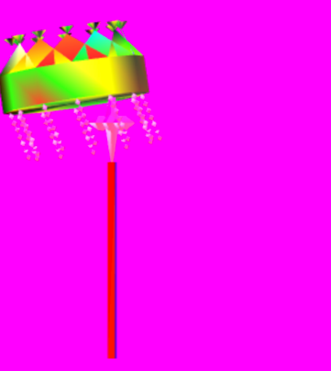

And as the crown is rotating its color is changing:

