Project1: Observing 3D Objects from many perspective

Wenjie Zhang (netID: wzm416)

Goal: To draw Ground-Plane Grid, 3D Axes. To make light effects to objects. To attain Perspective and Orthographic Camera.

User’s Guide:

<1> Use up arrow, left arrow, down arrow, right arrow on the keyboard to move ahead, left, backward, right.

<2> Use W, A, S, D to look up, left, down, right.

<3> Click-and-drag the mouse on the canvas, to make the cube move.

Result Pictures:

Observe from long distance:

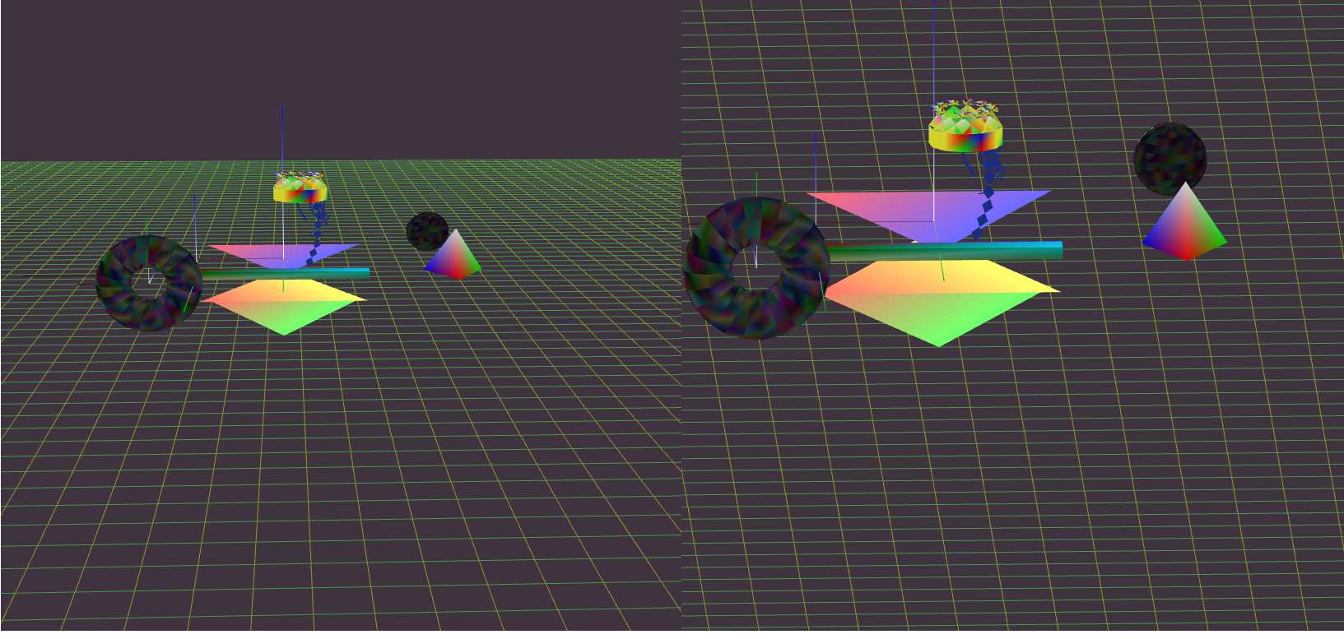

Observe from short distance:

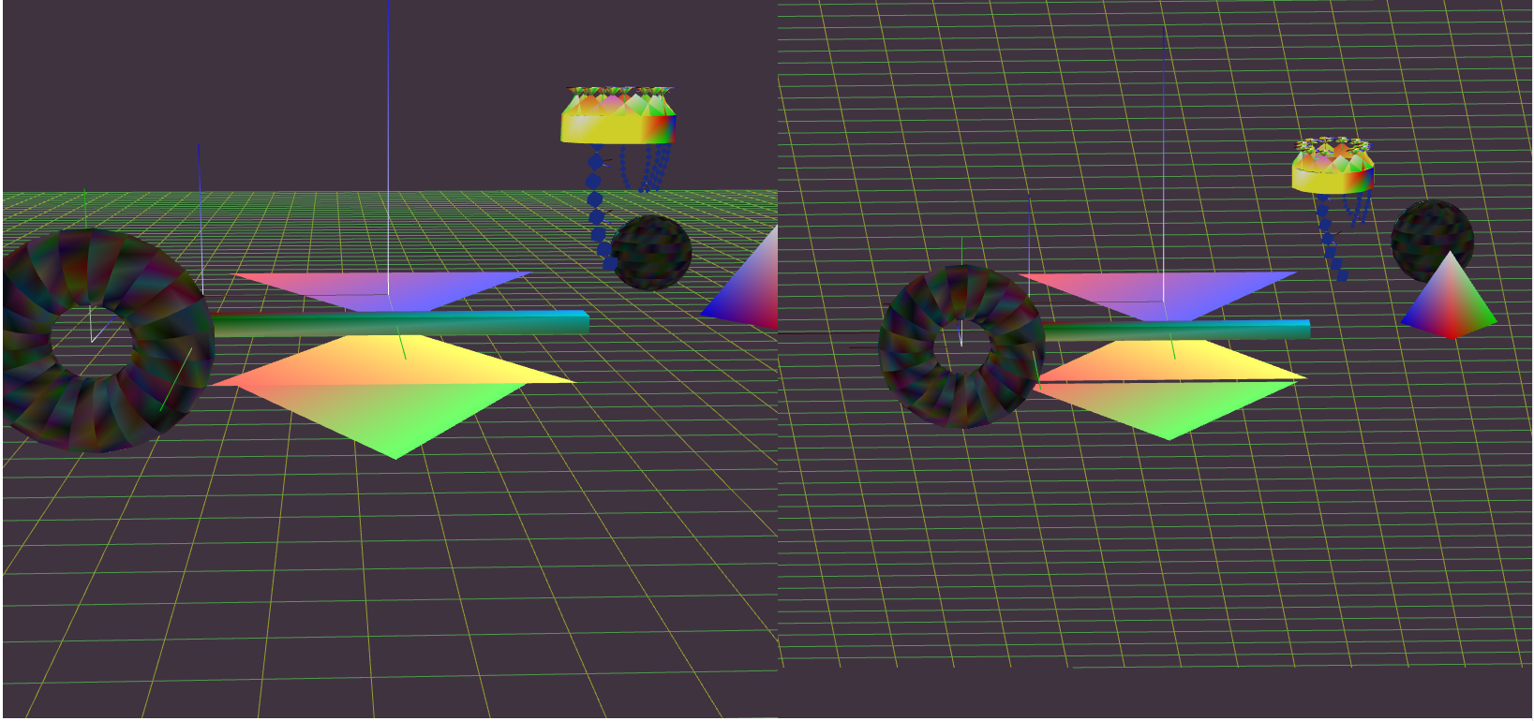

Observe from left:

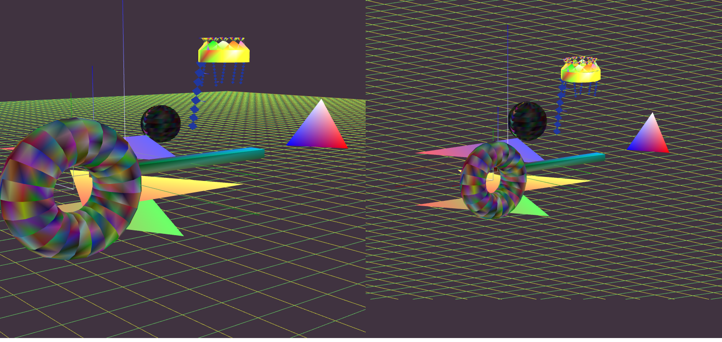

Move camera up:

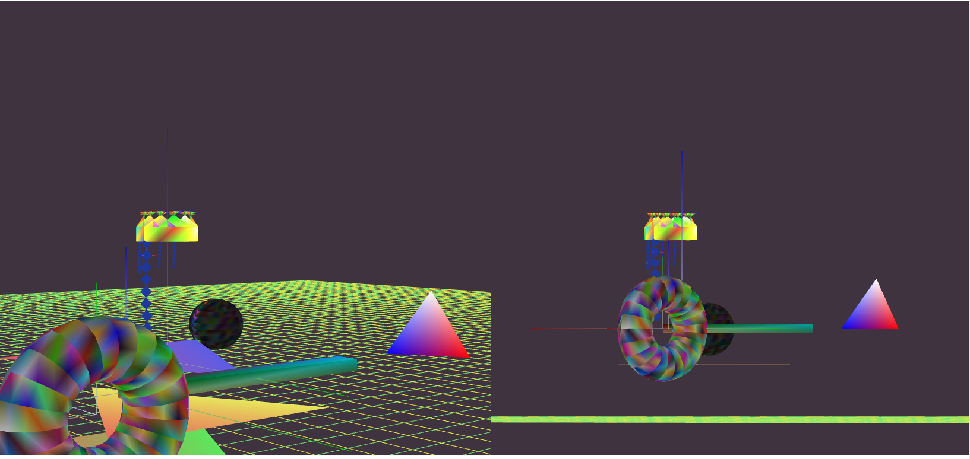

Observe from right and left effect:

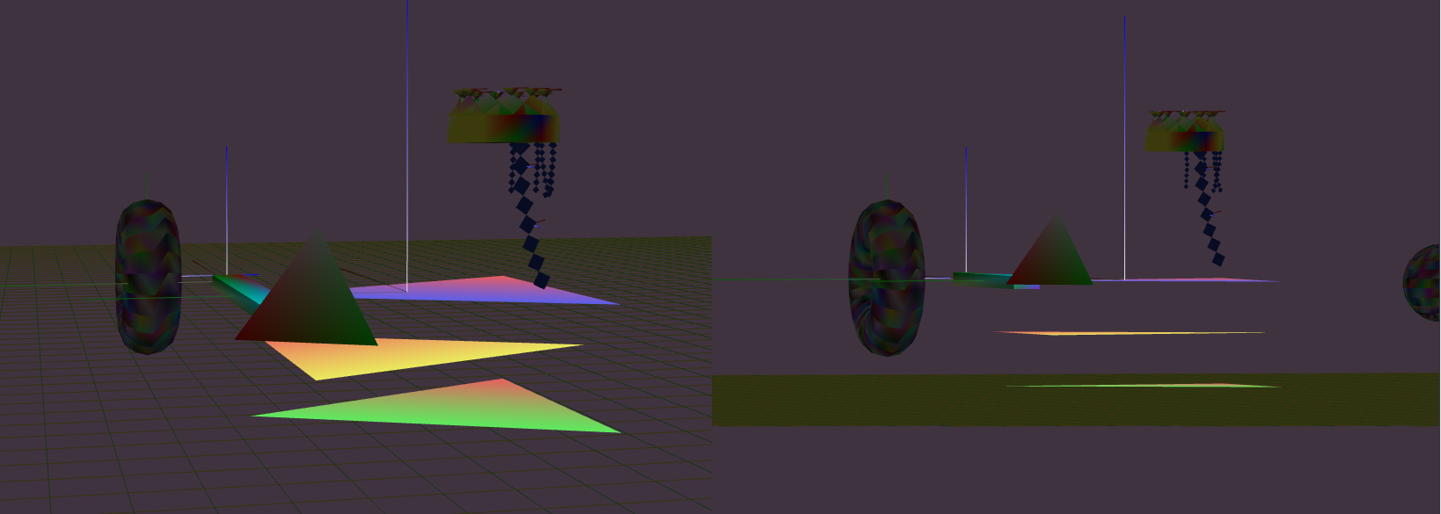

Scene Graphs:

