functions

**run_raw_mnist:**

evaluate KM, SAE+KM, DCN on raw MNIST.

1) It first run K-means for 10 times to get [nmi, ari, ac] for K-means.

2) Then it run test_SdC to build a stacked denoising autoencoder

**multi_layer_km:**

It contains 2 classes: **dA2, SdC.**

It also contains 5 function: **load_data, load_data_shared, shared_dataset, batch_km, test_SdC**

**dA2(dA)**

It is a 2-layer denoising autoencoder. It inherits class dA, but overwrite some function. For example: “get_hidden_values”, “get_reconstructed_input” computes the hidden layer value by relu instead of sigmoid. “get_cost_update” changes the loss function from cross-entropy loss to squared loss.

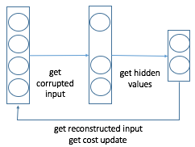

Now that we are able to get cost and update, we can define a function to train the deep learning model. It is important to learn how to define a function in theano:

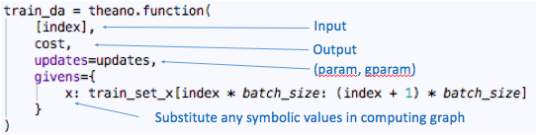

**SdC**