深 圳 大 学

实 验 报 告

课程名称： 数据库系统

实验序号： 实验2

实验名称： SQL的多表连接查询以及视图

学 号： 2021155015

姓 名： 叶茂林

实验完成日期： 2023年 10 月 25 日

一、实验目的：
- 了解DBMS系统的功能、软件组成；
2、掌握利用SQL语句定义、和简单操纵数据库的方法。

二、实验要求：
1、在课外安装相关软件并浏览软件自带的帮助文件和功能菜单，了解DBMS的功能、结构；
2、创建一个有两个关系表的数据库；（建议采用ORACLE ISQLPLUS）
3、数据库、关系表定义；
4、学习定义关系表的约束(主键、外键、自定义)；
5、了解SQL的数据定义功能；
6、了解SQL的操纵基本功能；
8、了解视图的概念；

三、实验设备：
计算机、数据库管理系统如MYSQL,DB2，Oracle 等软件。

四、实验内容

1、使用SQL DDL语句建立关系数据库模式，并用DML数据如下；
EMPNO | ENAME | JOB | MGR | HIREDATE | SAL | COMM | DEPTNO
7369 | SMITH | CLERK | 7902 | 17-Dec-90 | 13750 |  | 20
7499 | ALLEN | SALESMAN | 7698 | 20-FEB-89 | 19000 | 6400 | 30
7521 | WARD | SALESMAN | 7698 | 22-FEB-93 | 18500 | 4250 | 30
7566 | JONES | MANAGER | 7839 | 02-APR-89 | 26850 |  | 20
7654 | MARTIN | SALESMAN | 7698 | 28-SEP-97 | 15675 | 3500 | 30
7698 | BLAKE | MANAGER | 7839 | 01-MAY-90 | 24000 |  | 30
7782 | CLARK | MANAGER | 7839 | 09-JUN-88 | 27500 |  | 10
7788 | SCOTT | ANALYST | 7566 | 19-APR-87 | 19500 |  | 20
7839 | KING | PRESIDENT |  | 17-NOV-83 | 82500 |  | 10
7844 | TURNER | SALESMAN | 7698 | 08-SEP-92 | 18500 | 6250 | 30
7876 | ADAMS | CLERK | 7788 | 23-MAY-96 | 11900 |  | 20
7900 | JAMES | CLERK | 7698 | 03-DEC-95 | 12500 |  | 30
7902 | FORD | ANALYST | 7566 | 03-DEC-91 | 21500 |  | 20
7934 | MILLER | CLERK | 7782 | 23-JAN-95 | 13250 |  | 10
3258 | GREEN | SALESMAN | 4422 | 24-Jul-95 | 18500 | 2750 | 50
4422 | STEVENS | MANAGER | 7839 | 14-Jan-94 | 24750 |  | 50
6548 | BARNES | CLERK | 4422 | 16-Jan-95 | 11950 |  | 50

DEPT+(学生自己的学号):
DEPTNO | DNAME | LOC
10 | ACCOUNTING | LONDON
20 | RESEARCH | PRESTON
30 | SALES | LIVERPOOL
40 | OPERATIONS | STAFFORD
50 | MARKETING | LUTON

以下为学生实验填写部分：
3．完成实验指导书的以下题目.（要有题目语句和运行结果截屏）
Exercises3第7,8题
7．List the average salary of employees that receive a salary, the average commission of employees that receive a commission, the average salary plus commission of only those employees that receive a commission and the average salary plus commission of all employees including those that do not receive a commission. (single statement)
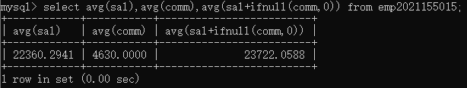
8．Compute the daily and hourly salary for employees in department 30, round to the nearest penny. Assume there are 22 working days in a month and 8 working hours in a day.
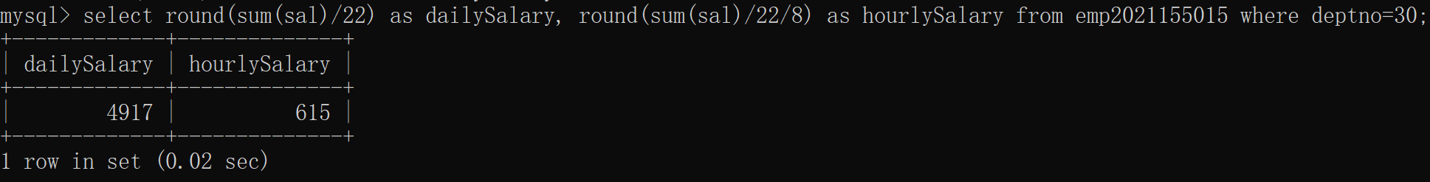
Exercises4第3,6,7,8题
3．Which employees were hired in April?
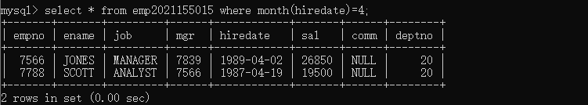
6．Show the weekday of the first day of the month in which each employee was hired. (plus their names)
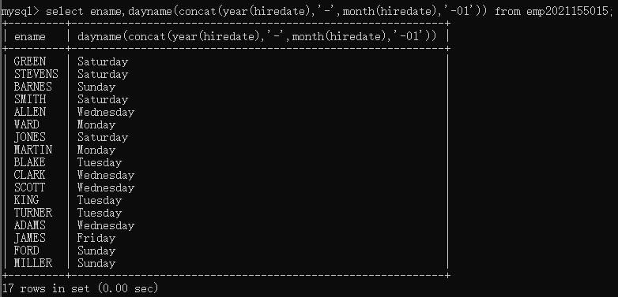
7．Show details of employee hiredates and the date of their first payday. (Paydays occur on the last Friday of each month) (plus their names)
要找出员工的首次发薪日期，那么首先得找出员工雇佣当月的最后一天是星期几，然后将当月最后一天的日期减去相应的天数得到最后一个星期五的日期，其中星期一到星期日需要减去的天数为3、4、5、6、0、1、2，这个数值可以通过最后一天的日期在本周的序数（即第几天，星期日为第一天）加一和7取余得到。
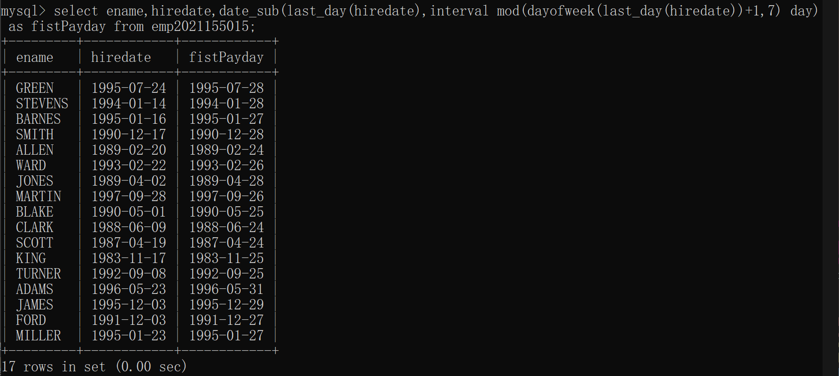
8．Refine your answer to 7 such that it works even if an employee is hired after the last Friday of the month (cf Martin)
由7的查询结果中可以看到Martin的payday在hiredate之前，这是不符合逻辑的，7的查询方式不适合那些在当月最后一个星期五之后入职的员工。
对于这种情况，我们需要找出下一个月的星期五的日期。因此我们首先判断雇佣日期是否晚于找出的payday，如果是，那么需要找出下一个月的payday。
首先把我们7的查询方式做成一个函数，返回普通情况下的payday。
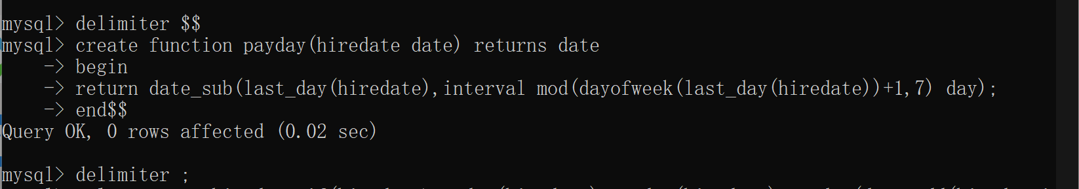
然后判断雇佣日期是否晚于找出的payday，如果是，那么需要找出下一个月的payday。
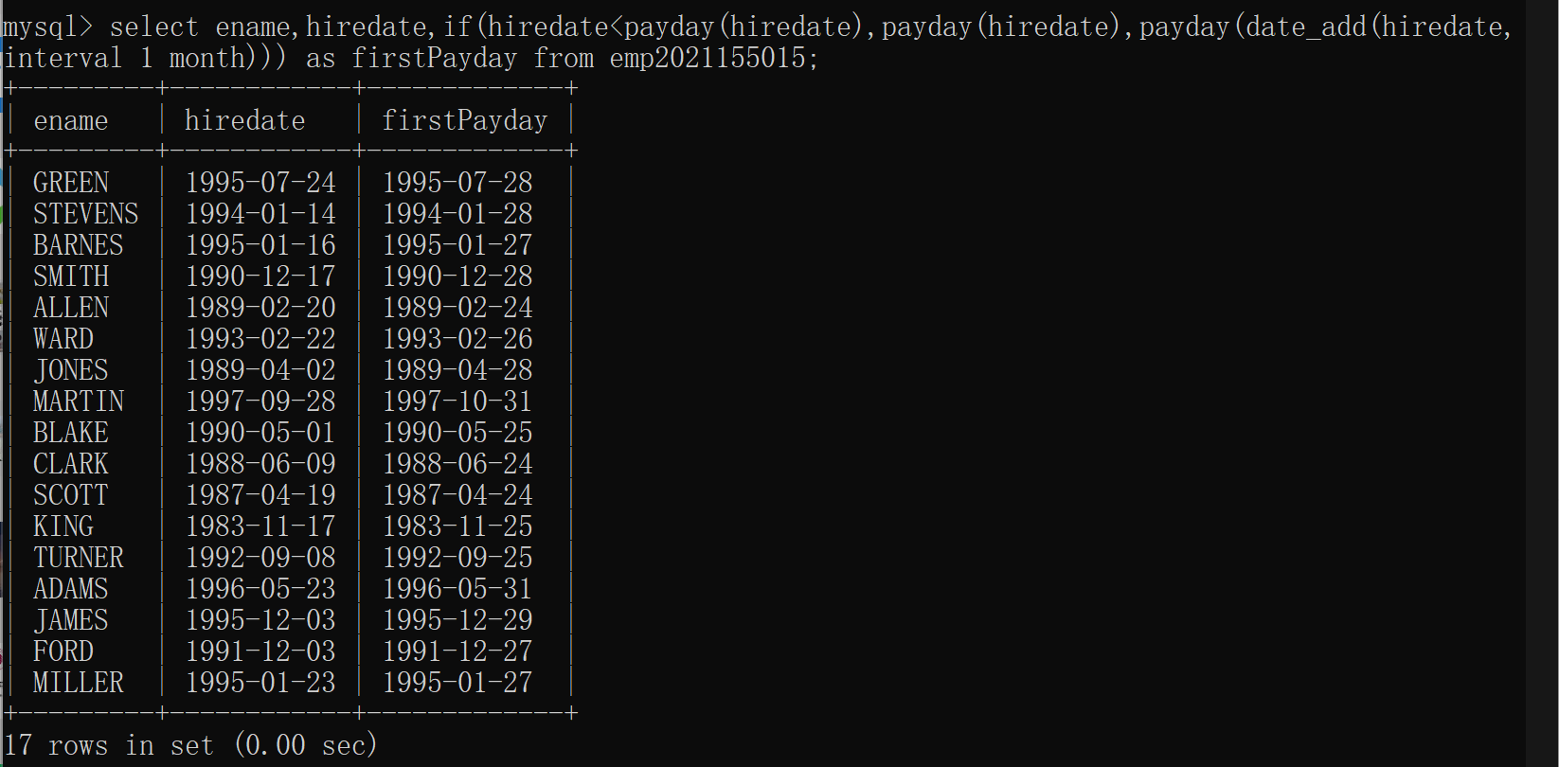
Exercises5第2,6题
2．Divide all employees into groups by department and by job within department. Count the employees in each group and compute each group's average annual salary.
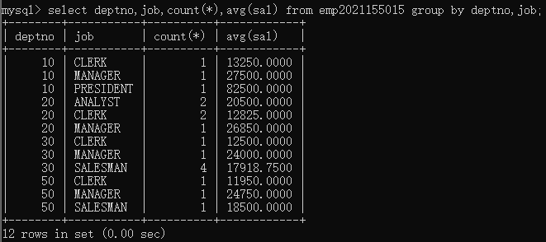
6．Find each department's average annual salary for all its employees except the managers and the president.
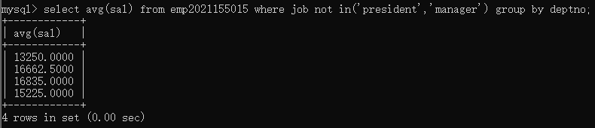
Exercises6第2,4,5,6,7题
2．Find all the employees in Department 10 that have a job that is the same as anyone in department 30.
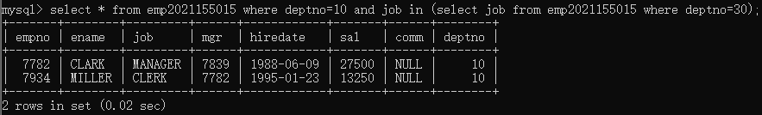
4．Find all employees in department 10 that have a job that is the same as anyone in the Sales department
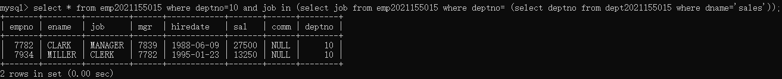
5．Find the employees located in Liverpool who have the same job as Allen. Return the results in alphabetical order by employee name.
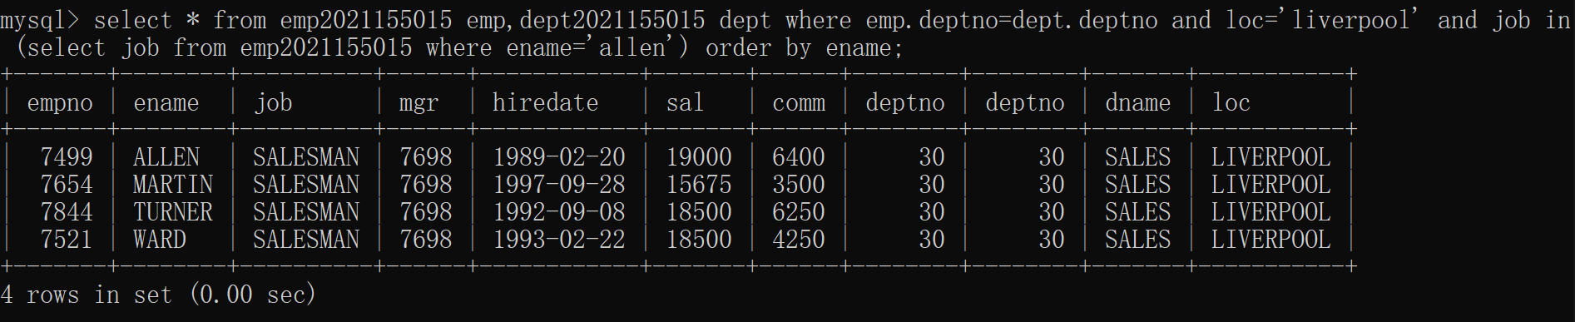
6．Find all the employees that earn more than the average salary of employees in their department.
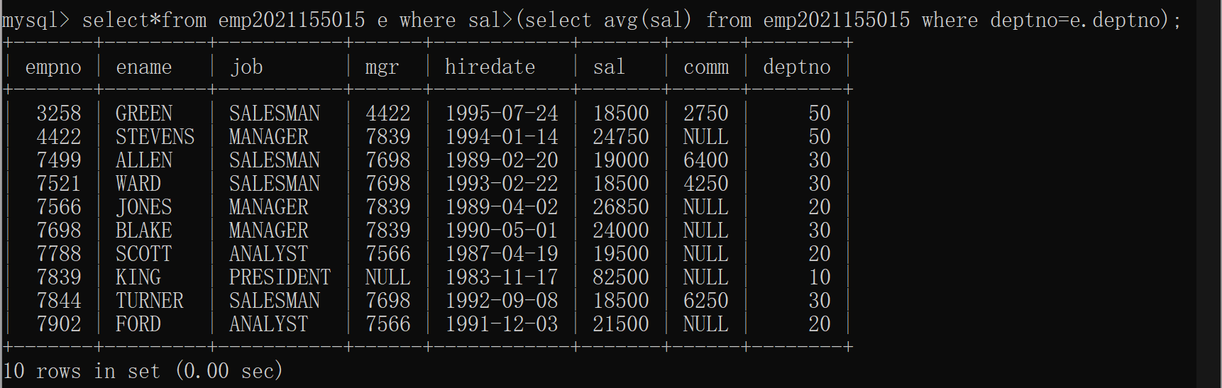
7．Find all the employees that earn more than JONES, using temporary labels to abbreviate table names.
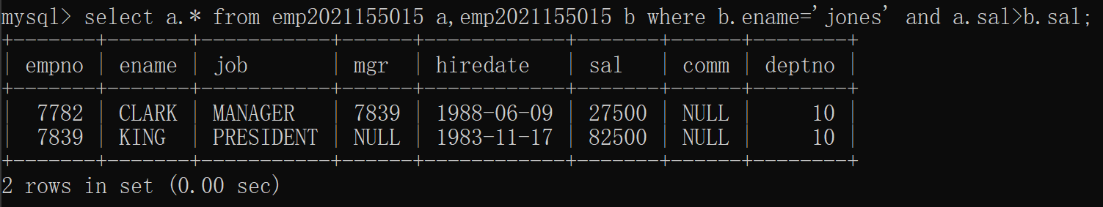
Exercises7第1,2,5,7,8,9题
1．Create a new table called loans with columns named LNO NUMERIC (3), EMPNO NUMERIC (4), TYPE CHAR(1), AMNT NUMERIC (8,2)
2．Insert the following data
LNO EMPNO TYPE AMNT
23 7499 M 20000.00
42 7499 C 2000.00
65 7844 M 3564.00
5．Add 10% interest to all M type loans
7．Change the name of loans table to accounts
8．Change the name of column LNO to LOANNO
9．Create a view for use by personnel in department 30 showing employee name, number, job and hiredate
五.实验心得
在本次实验中，我使用SQL语句对MySQL数据库中的数据进行了操控，熟悉了多表连接查询操作，五个基本函数的实验以及一些日期函数的使用，为了更好的查询数据，我学习了自定义函数和条件判断语句。
通过这次实验，我深刻理解了MySQL语句的重要性，并且掌握了多表连接查询、基本函数的使用、日期函数的应用以及函数的自定义等技能。这些技能对于我的工作和学习都非常有帮助，我会继续深入学习MySQL语句，并将其应用到实际工作中。
六.诚信承诺
本人郑重承诺在SQL实验的实施的过程中不发生任何不诚信现象，一切不诚信所导致的后果均由本人承担。

签名（手签，不得打印）： 叶茂林
指导教师批阅意见：

成绩评定：

指导教师签字：
年 月 日

备注：

