Wenkai Qin, Jasmine Yang, Lam Huynh

E101

Prof. Bright

December 6, 2016

Homework 9

**Problem 1: Pulse Train Spectra.**

A = 5

a0 = 3.2381

1. Plot the one-sided DFT magnitude |X[m]|, m 0…499.  
     
   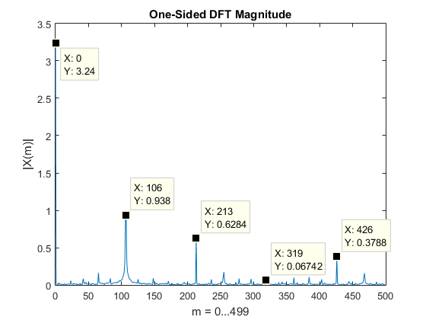  
      
   Determine the fundamental period N of the sampled pulse train. $$N=\frac{1000}{106.5}=9.340$$
2. Plot the one-sided DFT magnitude |Xhann[m]|, m 0…499.  
     
   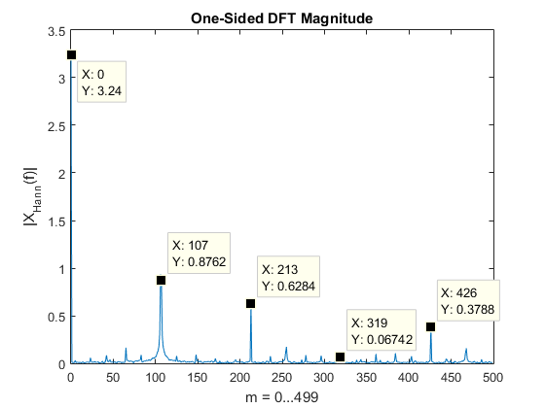
3. Tabulate and compare |ãk|, |X[kN]|, |Xhann[kN]| for k = 0…4.

|  |  |  |  |
| --- | --- | --- | --- |
| k | |ãk| | |X[kN]| | |Xhann[kN]| |
| 0 | 3.328 | 3.24 | 3.24 |
| 1 | 1.450 | 0.938 | 0.876 |
| 2 | 0.687 | 0.628 | 0.628 |
| 3 | 0.113 | 0.067 | 0.067 |
| 4 | 0.525 | 0.379 | 0.379 |

**Problem 2: Analog Filter Design**

1. Submit the derivation and plot.  
     
   Derivation attached.  
     
   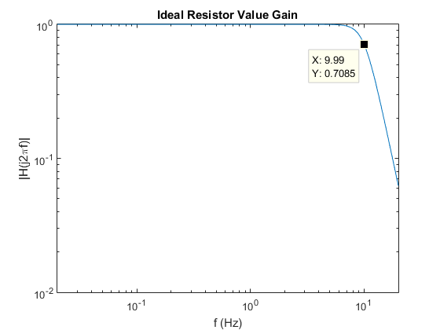
2. Submit the calculation of the design values R1I, R2I, R1II, R2II.  
     
   Calculation attached.

|  |  |  |
| --- | --- | --- |
|  | I | II |
| R1 | 4.7 kΩ | 270 kΩ |
| R2 | 27 kΩ | 100 kΩ |

1. Submit the labeled plot and the value of fp.  
     
   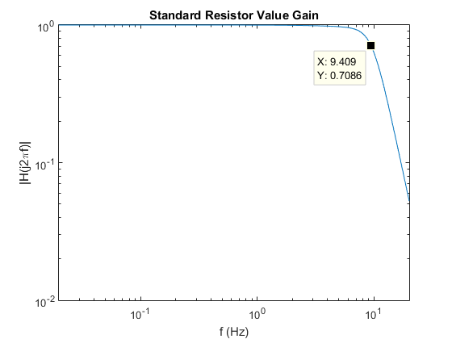

|  |  |
| --- | --- |
| fp | 9.409 Hz |

**Problem 3: Digital Filter Design.**

1. Submit the labeled plot.  
     
   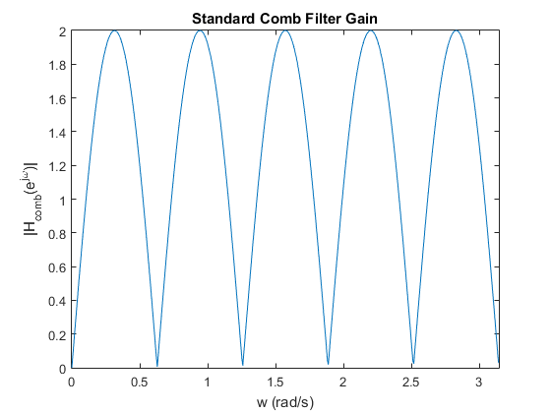
2. Submit the labeled plot and the value of |Hmodified_comb(ejπ/5)|.  
     
   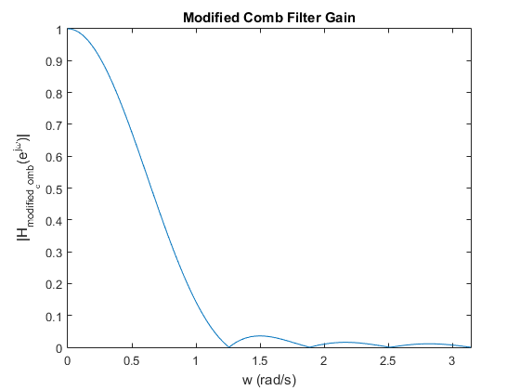
3. Submit the labeled plot.  
     
   