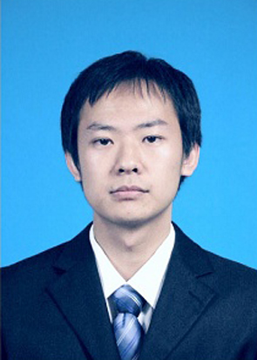
【Info】
Name： Wenlong Shen
Birth： 1988.05
Phone： 13699205352
Email： shenwl1988@163.com
Website: https://wenlongshen.github.io/

【Education】
2010.08 - 2015.07 PhD. Academy of Military Medical Sciences. Bioinformatics
2006.08 - 2010.07 BSc. Tsinghua University. Computer Science and Technology

【Experience】
2015.08 - Present Assistant Researcher. Academy of Military Medical Sciences

【Awards】
2011 - 2014 Postgraduate Scholarships in Academy of Military Medical Sciences
2015 Excellent Doctor Degree Dissertation in Academy of Military Medical Sciences

【Research Area】
Integrated analysis of multi-omics, big data and biological network models.

【Skills】
1. Excellent understanding of bioinformatics, human genomics and different genome sequencing platforms. More than 5 years’ experience with omics data generated from next generation sequencing. Familiar with common databases and tools.
2. Good knowledge of C++, Jave, scripting languages (Perl, Python) and mathematics tools (R, Matlab). Basic knowledge of MySQL. Experience in system management in a Linux environment.
3. Fluent in reading, writing and speaking Chinese and English.
4. Excellent communication and interpersonal skills, team working and self-driven.

【Publications】
1. Shen W¹, Wang D, Ye B, Shi M, Ma L, Zhang Y*, Zhao Z*. GC3-biased gene domains in mammalian genomes. Bioinformatics. 2015, 31(19):3081-3084. (IF=5.8)
2. Shen W¹, Wang D, Ye B, Shi M, Zhang Y*, Zhao Z*. A possible role of Drosophila CTCF in mitotic bookmarking and maintaining chromatin domains during the cell cycle. Biological Res. 2015, 48:27. (IF=1.3)
3. Zhang Y¹, Shen W¹, Shi M¹, Zhang L, Zhang Z, Li P, Xing LY Luo F, Sun Q*, Zheng X, Yang X*, Zhao Z*. Involvement of aberrant miR-139/Jun feedback loop in human gastric cancer. Biochim Biophys Acta. 2015, 1853(2):481-488. (Co-first author, IF=5.3)
4. Ye B¹, Shen W, Wang D, Li P, Zhang Z, Shi M, Zhang Y, Zhang F*, Zhao Z*. ZNF143 is involved in CTCF-mediated chromatin interactions by cooperation with cohesin and other partners. Mol Biol. 2016, 50(3):496-503. (IF=0.6)
5. Zhang Z¹, Zhang Y, Shi M, Ye B, Shen W, Li P, Xing L, Zhang X, Hou L, Xu J*, Zhao Z*, Chen W*. Anthrax Susceptibility: Human Genetic Polymorphisms Modulating ANTXR2 Expression. Toxins. 2016, 8(1). (IF=3.6)
6. Zhang Y¹, Fan K¹, Sun Q^{1,*}, Chen A, Shen W, Zhao Z, Zheng X*, Yang X*. Functional screening for miRNAs targeting Smad4 identified miR-199a as a negative regulator of TGF-β signalling pathway. Nucleic Acids Res. 2012, 40(18):9286-9297. (IF=9.2)

