Regression lineaire dans R avec wbstats

AIME wennther,DESHOMMES Rodolphe RACINE Jhon Peterson, LAGUERRE Jennine Gemima

2023-06-15

## (1) interet du modele

Dans la comprehension de l’evolution ou la tendance d’un phenomene,il s’averera necessairement utile d’explorer ses differents facteurs causaux pour pouvoir le mieux cerner.puis,dans une dynamique de long termiste de realiser des perspectives previsionnelles.Dans cette veine,il importe de mettre en relation quatre (4) variables macroeconomiques:inflation.taux de change, importation et exportation. Dans ce cas-ci,l’objectiif est de voir comment l’inflation,comme variable endogene ou reponse,est influence par les trois (3) variables: taux de change, importation et exportation comme variable explicative ou exogene.

## Downloading data from an API

library(wbstats)  
library(reshape)  
library(reshape,warn.conflicts = FALSE)  
library(dplyr,warn.conflicts = FALSE)  
inflation=wbsearch("inflation,consumerprices(annual%)")

## Warning: `wbsearch()` was deprecated in wbstats 1.0.0.  
## ℹ Please use `wb_search()` instead.  
## This warning is displayed once every 8 hours.  
## Call `lifecycle::last_lifecycle_warnings()` to see where this warning was  
## generated.

## Warning in wbsearch("inflation,consumerprices(annual%)"): no matches were found  
## for the search term inflation,consumerprices(annual%). Returning an empty data  
## frame.

taux_change=wbsearch("official exchange rate,period average")

## Warning in wbsearch("official exchange rate,period average"): no matches were  
## found for the search term official exchange rate,period average. Returning an  
## empty data frame.

import=wbsearch("imports Merchandise,Customs,current US$,millions")

## Warning in wbsearch("imports Merchandise,Customs,current US$,millions"): no  
## matches were found for the search term imports Merchandise,Customs,current  
## US$,millions. Returning an empty data frame.

export=wbsearch("Merchandise exports (current US$)")

## Warning in wbsearch("Merchandise exports (current US$)"): no matches were found  
## for the search term Merchandise exports (current US$). Returning an empty data  
## frame.

download=wb(country ="HTI",  
 indicator = c("FP.CPI.TOTL.ZG",   
 "DPANUSLCU",  
 "DMGSRMRCHNSCD",  
 "TX.VAL.MRCH.CD.WT"), startdate = 1993, enddate = 2013)

## Warning: `wb()` was deprecated in wbstats 1.0.0.  
## ℹ Please use `wb_data()` instead.  
## This warning is displayed once every 8 hours.  
## Call `lifecycle::last_lifecycle_warnings()` to see where this warning was  
## generated.

long=dplyr::select(download,date,indicator,country,value)  
temp=melt(long,id=c("date","indicator","country"))  
data=cast(temp, country+date~indicator)  
names(data)

## [1] "country"   
## [2] "date"   
## [3] "Imports Merchandise, Customs, current US$, millions, not seas. adj."  
## [4] "Inflation, consumer prices (annual %)"   
## [5] "Merchandise exports (current US$)"   
## [6] "Official exchange rate, LCU per USD, period average,,"

y=data$`Inflation, consumer prices (annual %)`  
x1=data$`Official exchange rate, LCU per USD, period average,,`  
x2=data$`Imports Merchandise, Customs, current US$, millions, not seas. adj.`  
x3=data$`Merchandise exports (current US$)`

##(2) nuage de point ajuste a une droite de regression lineaire

plot(x1,y,ylab="inflation",xlab="taux de change")  
cor(x1,y)

## [1] -0.4625418

abline(lm(y~x1))

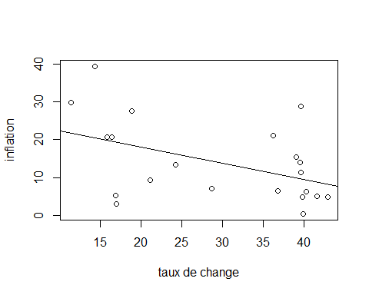

plot(x2,y,ylab="inflation",xlab="importation")  
cor(x2,y)

## [1] -0.6043266

abline(lm(y~x2))

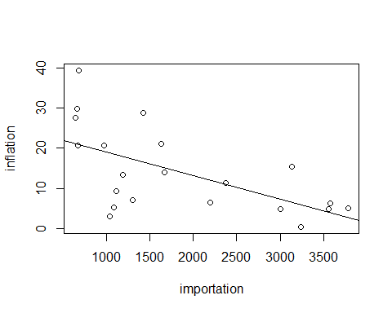

plot(x3,y,ylab="inflation",xlab="exportation")  
cor(x3,y)

## [1] -0.6906087

abline(lm(y~x3))

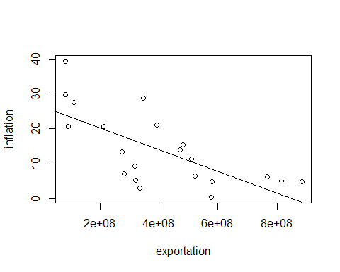

## (3) tableau de resultats de la regression lineaire multiple

modele=lm(y~x1+x2+x3)  
summary(modele)

##   
## Call:  
## lm(formula = y ~ x1 + x2 + x3)  
##   
## Residuals:  
## Min 1Q Median 3Q Max   
## -12.3063 -4.5369 -0.8474 5.0046 15.6584   
##   
## Coefficients:  
## Estimate Std. Error t value Pr(>|t|)   
## (Intercept) 2.133e+01 5.173e+00 4.124 0.000708 ***  
## x1 3.801e-01 3.049e-01 1.247 0.229409   
## x2 2.291e-03 4.992e-03 0.459 0.652132   
## x3 -5.675e-08 2.311e-08 -2.456 0.025106 *   
## ---  
## Signif. codes: 0 '***' 0.001 '**' 0.01 '*' 0.05 '.' 0.1 ' ' 1  
##   
## Residual standard error: 7.813 on 17 degrees of freedom  
## Multiple R-squared: 0.539, Adjusted R-squared: 0.4577   
## F-statistic: 6.627 on 3 and 17 DF, p-value: 0.003638

resultat_reg=summary(modele)  
resultat_reg

##   
## Call:  
## lm(formula = y ~ x1 + x2 + x3)  
##   
## Residuals:  
## Min 1Q Median 3Q Max   
## -12.3063 -4.5369 -0.8474 5.0046 15.6584   
##   
## Coefficients:  
## Estimate Std. Error t value Pr(>|t|)   
## (Intercept) 2.133e+01 5.173e+00 4.124 0.000708 ***  
## x1 3.801e-01 3.049e-01 1.247 0.229409   
## x2 2.291e-03 4.992e-03 0.459 0.652132   
## x3 -5.675e-08 2.311e-08 -2.456 0.025106 *   
## ---  
## Signif. codes: 0 '***' 0.001 '**' 0.01 '*' 0.05 '.' 0.1 ' ' 1  
##   
## Residual standard error: 7.813 on 17 degrees of freedom  
## Multiple R-squared: 0.539, Adjusted R-squared: 0.4577   
## F-statistic: 6.627 on 3 and 17 DF, p-value: 0.003638

resultat_reg$coefficients

## Estimate Std. Error t value Pr(>|t|)  
## (Intercept) 2.133345e+01 5.172502e+00 4.1243970 0.0007083467  
## x1 3.801376e-01 3.049130e-01 1.2467086 0.2294093349  
## x2 2.290677e-03 4.991866e-03 0.4588819 0.6521316069  
## x3 -5.674661e-08 2.310548e-08 -2.4559804 0.0251056384

resultat_reg$coefficients[,1]

## (Intercept) x1 x2 x3   
## 2.133345e+01 3.801376e-01 2.290677e-03 -5.674661e-08

resultat_reg$coefficients[,4]

## (Intercept) x1 x2 x3   
## 0.0007083467 0.2294093349 0.6521316069 0.0251056384

resultat_reg$adj.r.squared

## [1] 0.4577045

resultat_reg$fstatistic

## value numdf dendf   
## 6.626755 3.000000 17.000000

resultat_reg$fstatistic[1]

## value   
## 6.626755

coefficients=c(2.133345e+01, 3.801376e-01, 2.290677e-03, -5.674661e-08)  
prob_test_student=c(0.0007083467, 0.2294093349, 0.6521316069, 0.0251056384)  
R2_ajuste=c(0.4577045)  
Fstat.=0.4577045  
p_value=c(0.003638)  
tableau_resultats=cbind(coefficients,prob_test_student,R2_ajuste,p_value)

## (4) Graphique en nuage de point ajuste a une droite de regression lineaire

## etablissant le lien entre les residues (erreurs) et valeurs estimees (fitted values)

modele$residuals

## 1 2 3 4 5 6   
## 7.0821925 15.6583856 3.8886968 -3.2045979 2.7627404 -6.8266498   
## 7 8 9 10 11 12   
## -8.1929745 -4.5369036 -4.4201650 -12.3063491 8.7160537 4.3888303   
## 13 14 15 16 17 18   
## 0.4647780 -1.6015943 -4.1505144 -0.8474406 -10.8278358 -5.6658735   
## 19 20 21   
## 5.0045634 5.4354670 9.1791908

residuals=modele$residuals  
residuals

## 1 2 3 4 5 6   
## 7.0821925 15.6583856 3.8886968 -3.2045979 2.7627404 -6.8266498   
## 7 8 9 10 11 12   
## -8.1929745 -4.5369036 -4.4201650 -12.3063491 8.7160537 4.3888303   
## 13 14 15 16 17 18   
## 0.4647780 -1.6015943 -4.1505144 -0.8474406 -10.8278358 -5.6658735   
## 19 20 21   
## 5.0045634 5.4354670 9.1791908

modele$fitted.values

## 1 2 3 4 5 6 7   
## 22.6237790 23.6732340 23.7194884 23.7881941 17.7962670 12.0956853 11.1973687   
## 8 9 10 11 12 13 14   
## 13.8701255 17.7368872 19.3392232 19.9835241 16.6430037 13.5082303 12.9468096   
## 15 16 17 18 19 20 21   
## 10.7077421 16.1292150 11.2217218 10.4932154 1.3282315 -0.4174255 -4.4141667

fitted.values=modele$fitted.values  
fitted.values

## 1 2 3 4 5 6 7   
## 22.6237790 23.6732340 23.7194884 23.7881941 17.7962670 12.0956853 11.1973687   
## 8 9 10 11 12 13 14   
## 13.8701255 17.7368872 19.3392232 19.9835241 16.6430037 13.5082303 12.9468096   
## 15 16 17 18 19 20 21   
## 10.7077421 16.1292150 11.2217218 10.4932154 1.3282315 -0.4174255 -4.4141667

plot(residuals,fitted.values)

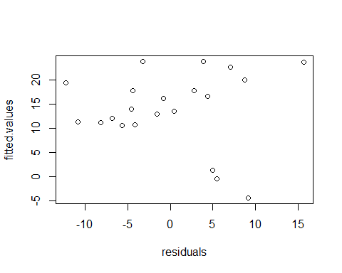

## (5) commentaire :

Les points qui forment le diagramme de dispersion sont tres eloignes. Les erreurs sont alors importantes. par consequent, avec le modele de regression lineaire, les valeurs du taux de change,de l’importation et de l’exportation ne permettront pas de mieux predire l’inflation,c-a-d le niveau general des prix en Haiti,allant de 1993 a 2013.