Reference:

1. [Kinetic proofreading: a new mechanism for reducing errors in biosynthetic processes requiring high specificity.](https://www.ncbi.nlm.nih.gov/pmc/articles/PMC434344/pdf/pnas00073-0345.pdf)

Kinetic Proofreading Mechanism.

1. [The case for absolute ligand discrimination : modeling information processing and decision by immune T cells](https://arxiv.org/pdf/1505.03095.pdf)

Adaptive Sorting and introduce the phase diagram for T-cell response.

3. https://journals.aps.org/pre/pdf/10.1103/PhysRevE.94.022425

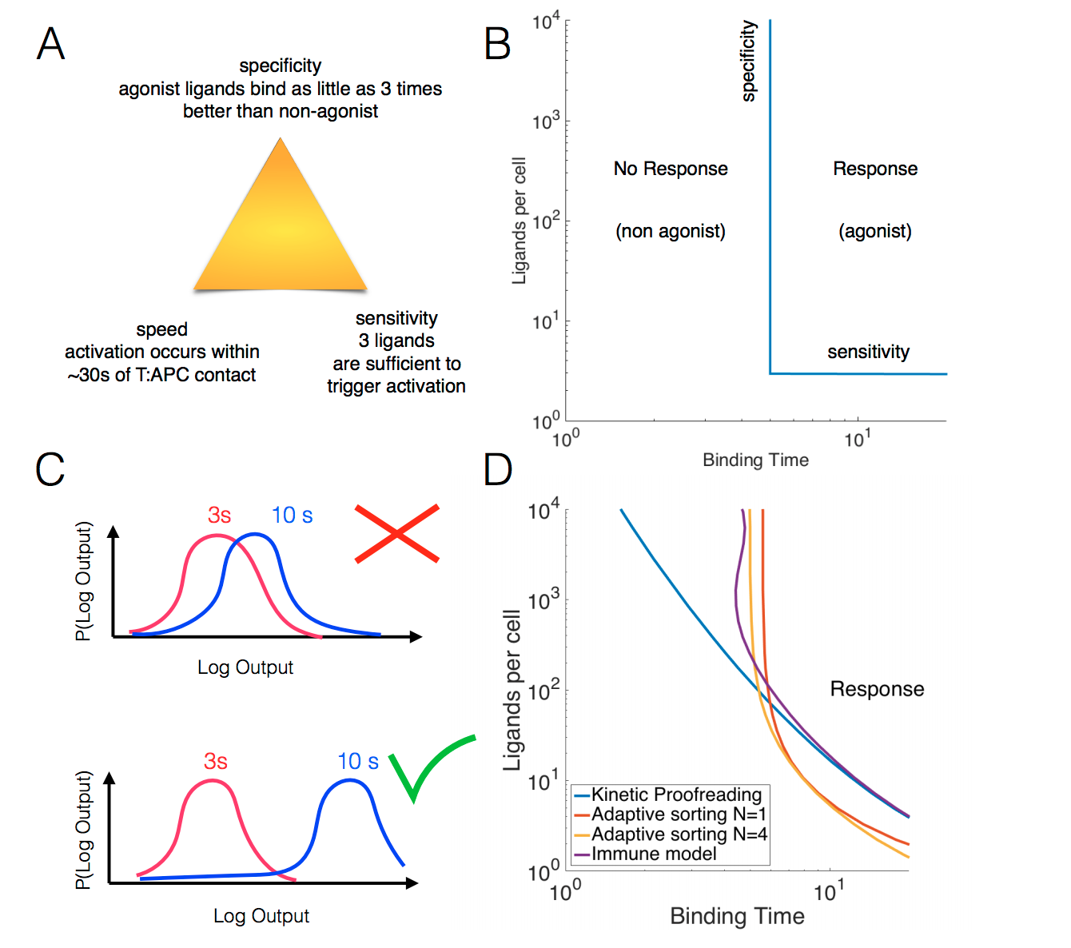

Input parameter:

Number of kinds of ligands: , Kind_si, Kind_fi

Number of ligands: Lg_s_i =; Lg_f_i =

Binding time of ligands: bt_s_i.bt_f_i

Model parameter:

Number of receptors: Rn

Foward Rate: k0

Backward Rate: bk0

Foward Rate: k1

Backward Rate: bk1

Number of steps: N_step

Output signal:

Final products:

df[‘Lg_Ns][Kind_s_i]