Name (NUID)

**Program Structures & Algorithms**

**Fall 2021**

**Assignment No. 3**

* **I. Task**
* **1. Implement height-weighted Quick Union with Path Compression.**
* **2. Using your implementation of UF_HWQUPC, develop a UF ("union-find") client that takes an integer value n from the command line to determine the number of "sites." Then generates random pairs of integers between 0 and n-1, calling connected() to determine if they are connected and union() if not. Loop until all sites are connected then print the number of connections generated. Package your program as a static method count() that takes n as the argument and returns the number of connections; and a main() that takes n from the command line, calls count() and prints the returned value. If you prefer, you can create a main program that doesn't require any input and runs the experiment for a fixed set of n values. Show evidence of your run(s).**
* **3. Determine the relationship between the number of objects (n) and the number of pairs (m) generated to accomplish this (i.e. to reduce the number of components from n to 1). Justify your conclusion in terms of your observations and what you think might be going on.**
* **II. Relationship Conclusion: (For ex : z = a * b)**

**Y= 0.5235 n ln(n) +45.21**

* **III. Evidence to support the conclusion:**

1. **Output (Snapshot of Code output in the terminal)**

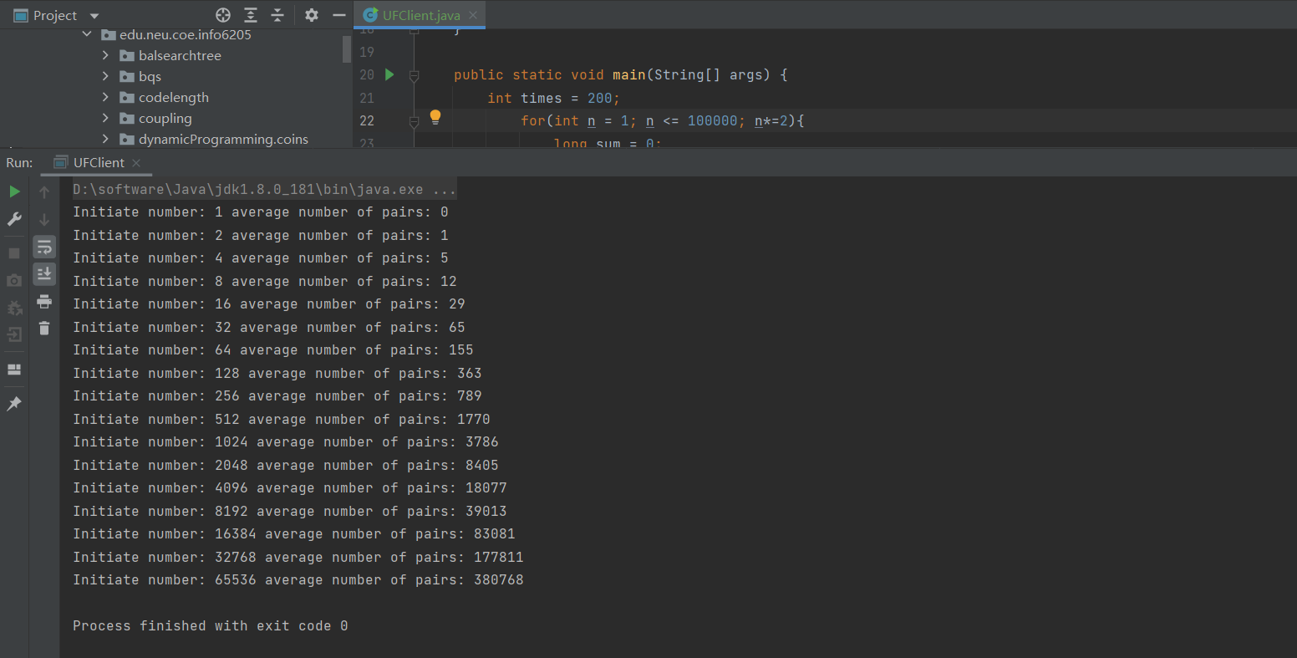

1. **Graphical Representation(Observations from experiments should be tabulated and analyzed by plotting graphs(usually in excel) to arrive on the relationship conclusion)**

**Data:**

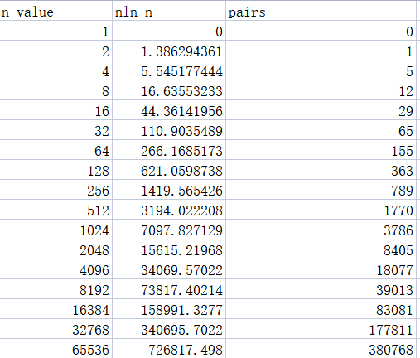

**Graph:**

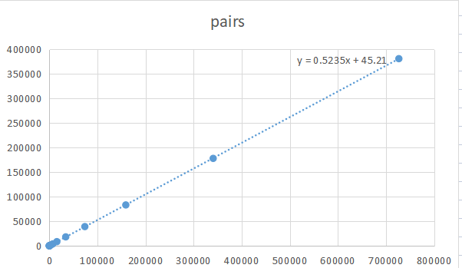

* **Unit tests result:(Snapshot of successful unit test run)**

