Name Wenqi Yang (NUID 001586011)

**Program Structures & Algorithms**

**Fall 2021**

**Assignment No. 4**

* **I. Task**

Your task is to implement a parallel sorting algorithm such that each partition of the array is sorted in parallel. You will consider two different schemes for deciding whether to sort in parallel.

1. A cutoff (defaults to, say, 1000) which you will update according to the first argument in the command line when running. It's your job to experiment and come up with a good value for this cutoff. If there are fewer elements to sort than the cutoff, then you should use the system sort instead.
2. Recursion depth or the number of available threads. Using this determination, you might decide on an ideal number (t) of separate threads (stick to powers of 2) and arrange for that number of partitions to be parallelized (by preventing recursion after the depth of lg t is reached).
3. An appropriate combination of these.

You must prepare a report that shows the results of your experiments and draws a conclusion (or more) about the efficacy of this method of parallelizing sort. Your experiments should involve sorting arrays of sufficient size for the parallel sort to make a difference. You should run with many different array sizes (they must be sufficiently large to make parallel sorting worthwhile, obviously) and different cutoff schemes.

* **II. Relationship Conclusion:**

1. If the cutoff value is very low, the system sort is more efficient than the parallel sort.
2. If the size of array is not very big, the value of cutoff does not play an important role in our efficient, but when the size of array becomes larger, the efficiency will be lower with the increase of the cutoff value. We can parallel sort it first and then use system sort.
3. When the number of threads is 4, the efficient is pretty good.
4. When the number of threads is 4, the efficient is the best while the cutoff value is less than 1280000 and more than 160000.

* **III. Evidence to support the conclusion:**

1. **Output (Snapshot of Code output in the terminal)**

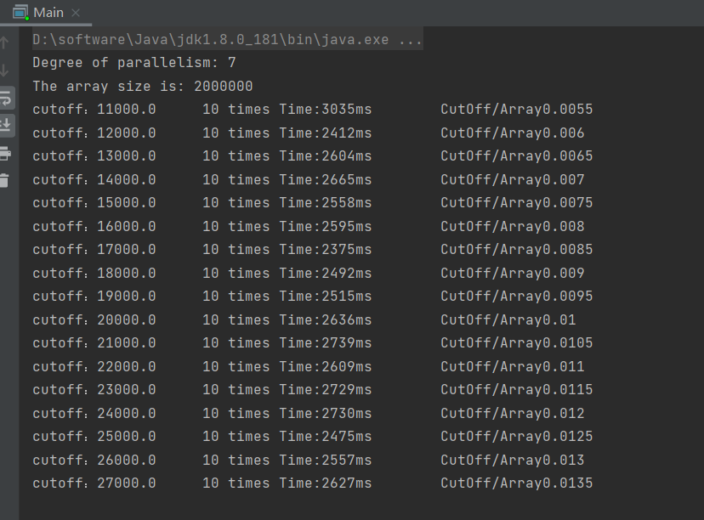

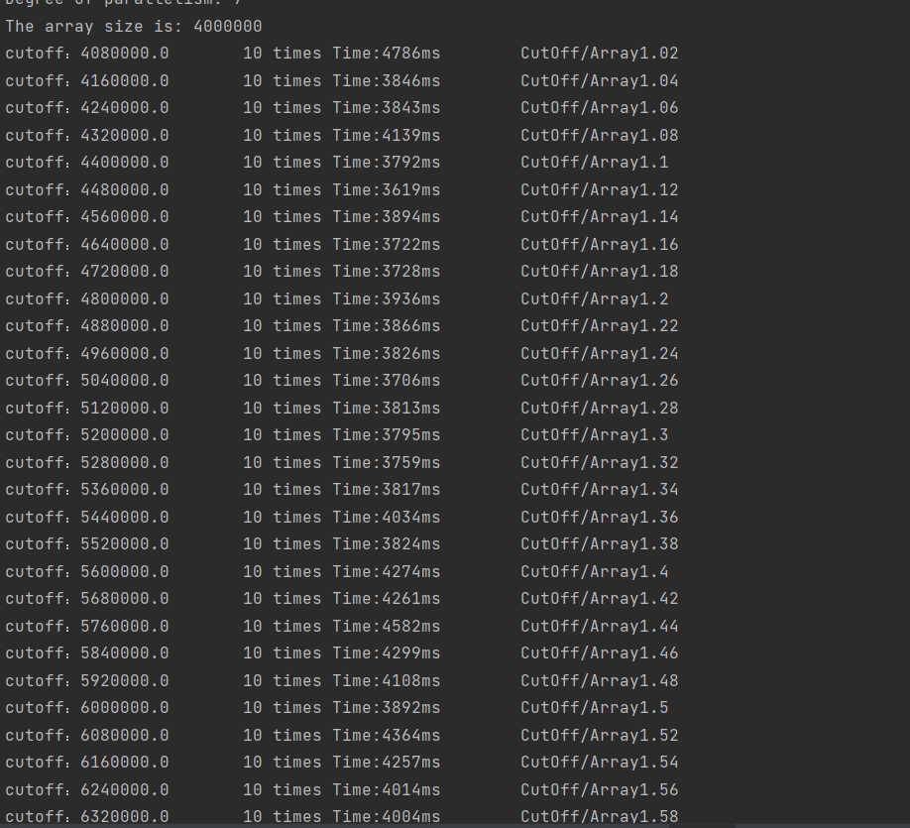

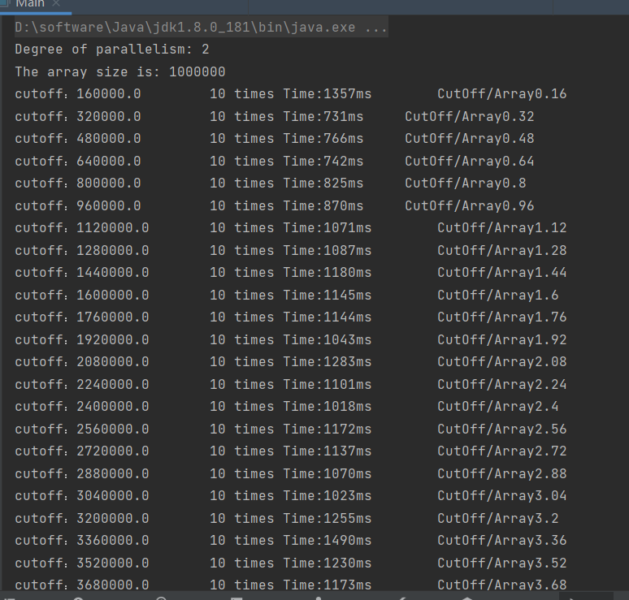

1. **Graphical Representation(Observations from experiments should be tabulated and analyzed by plotting graphs(usually in excel) to arrive on the relationship conclusion)**

**Data:**

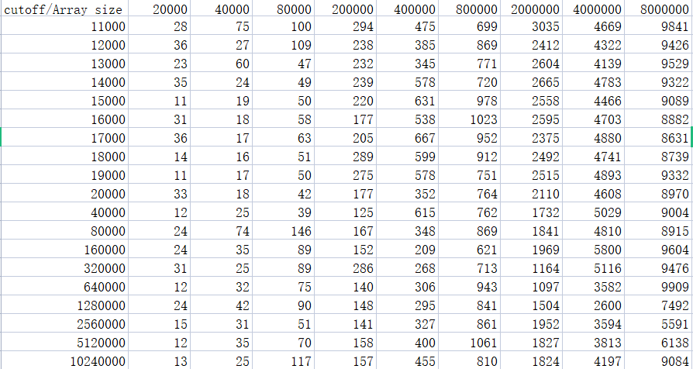

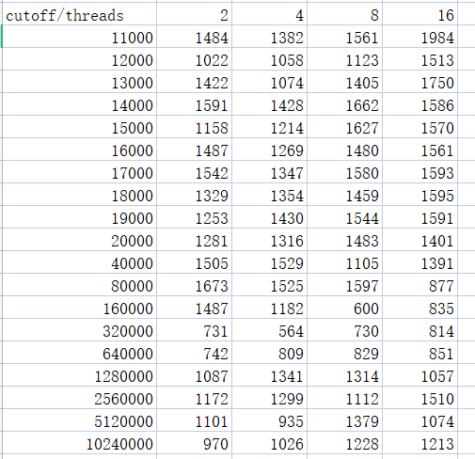

**Graph:**

