Modify the following parameters and discuss the effect of changing parameters on loss and accuracy.

Small epochs will cause under fitting with large loss. When the epochs get bigger, the accuracy will become better, the loss will decrease. With the increase of epochs, the growth rate will become slow. Finally, the accuracy of train sets reach the limit, and the accuracy of testing sets begin concussion. Large epochs need more computing cost, small epochs can’t reach the limit of a model, so we need find an appropriate number of epochs.

Small batch size will cost less time per step, but if the batch is too small, we may need more epochs to find the convergence. Little batch sometimes will cause navigate growth of the accuracy, because of the batch is randomized, while big batch need more time per step, so we’d better choose a moderate batch size.

Keep other parameters constant, complex network have stronger learning ability than simple network. But complex network sometimes can cause serious over fitting. That was because too strong learning ability lead the model memorize the detail and noise of the train data. Sometimes we can adjust other parameters to fix it, like drop rate. We need different neural network in different case.

Appropriate learning rate will find the limit quickly and accurately. Small learning rate waste more computing cost, while bigger learning rate can’t reach the limit. If the learning rate was too big, it will cause large loss and oscillatory accuracy.

Different activation function have different feature. Appropriate activation function help us reduce time cost and improve accuracy.

Dropout rate help us solve over fitting. The model with lower dropout rate may over fitting, and the model with higher dropout rate may under fitting. I think we’d better adjust this parameter by testing.

You are expected to provide a recommendation for the best model you would recommend for classification. Which model (with parameter values) would you choose and why?
Here is my recommend model:
model = Sequential()
model.add(Dense(2048, activation='relu', input_shape=(3072,)))
model.add(Dropout(0.3))
model.add(Dense(1024, activation='relu'))
model.add(Dense(512, activation='relu'))
model.add(Dropout(0.3))
model.add(Dense(256, activation='relu'))
model.add(Dropout(0.3))
model.add(Dense(128, activation='relu'))
model.add(Dense(num_classes, activation='softmax'))
batch_size = 128
num_classes = 10
epochs = 100
learning_rate = 0.003

I tried several models, and this one got the best accuracy 0.5313. I find that the limit of MLP accuracy is about up to 0.55, that means complex network is useless, and may cause serious overfitting and wasting of computational cost . The number of epochs is 100, because if it too small, the model will underfitting, and if it too large,the model will overfitting.The learning rate is 0.003, because the learning speed is slow with small learning rate, and the accuracy can’t reach the top with large learning rate. The dropout rate is 0.3, I had tried small dropout rate before, but that will cause overfitting.

Comment on how good your model is ? Does it overfit/underfit data ? What could you do to improve the model?
Here is the visualization of my model out put:
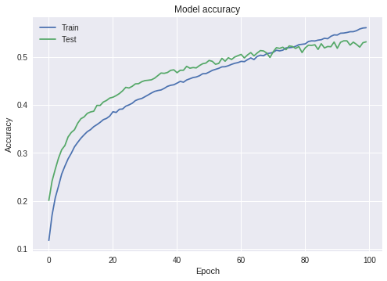
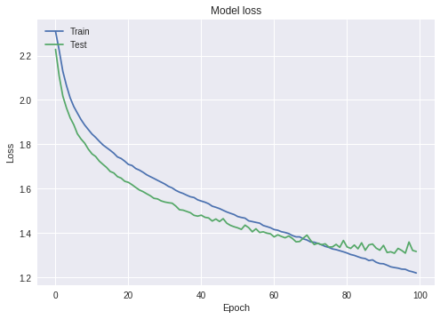
We can find lots of information from the graph. My model is overfitting after about 80 epochs, but not serious. The accuracy of predicting testing data convergent to 0.53. I was tried to add more layers to improve the accuracy, and use larger drop rate to prevent overfitting, but I think that the limit of MLP model restrict the accuracy, we need more efficient model, like CNN.

