Report
The best model I used is like below:
model = Sequential()
model.add(Conv2D(32, (3, 3), padding='same',
input_shape=x_train.shape[1:]))
model.add(Activation('relu'))

model.add(Conv2D(128, (3, 3), padding='same'))
model.add(Activation('relu'))
model.add(MaxPooling2D(pool_size=(2, 2)))
model.add(Dropout(dropout_rate))

model.add(Conv2D(64, (3, 3)))
model.add(Activation('relu'))
model.add(MaxPooling2D(pool_size=(2, 2)))
model.add(Dropout(dropout_rate))

model.add(Conv2D(32, (3, 3), padding='same'))
model.add(Activation('relu'))
model.add(MaxPooling2D(pool_size=(2, 2)))
model.add(Dropout(dropout_rate))

model.add(Flatten())
model.add(Dense(512))
model.add(Activation('relu'))
model.add(Dropout(dropout_rate))
model.add(Dense(num_classes))
model.add(Activation('softmax'))

I use several conv-relu-pooling-dropout patterns, and a softmax activation layer at the end to get the probability.

I use configparser package to load parameters, here is the code:
from configparser import ConfigParser
cfg = ConfigParser()
cfg.read('cifar.config')
batch_size = cfg.getint('parameter','batch_size')
epochs = cfg.getint('parameter','epochs')
learn_rate = cfg.getfloat('parameter','learn_rate')
dropout_rate = cfg.getfloat('parameter','dropout_rate')

I tried several sets of parameters, here are some examples:
- Batch_size=128 epochs=100 learn_rate=0.0003 dropout_rate=0
In this model, the network overfit after about 30 epochs, so I need to increase dropout rate to increase the accuracy

- Batch_size=128 epochs=30 learn_rate=0.0001 dropout_rate=0.2
In this model, I increase dropout rate, decrease the learning rate and epochs. By testing, I got that this model was underfit.

- Batch_size=128 epochs=30 learn_rate=0.0003 dropout_rate=0.2
This is the best model I used. After 100 epochs, the accuracy reached 0.8011, the visualization of the accuracy loss here:
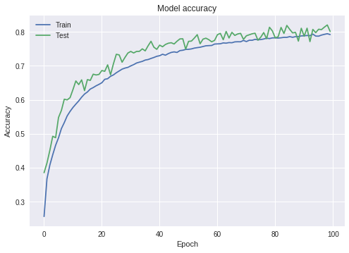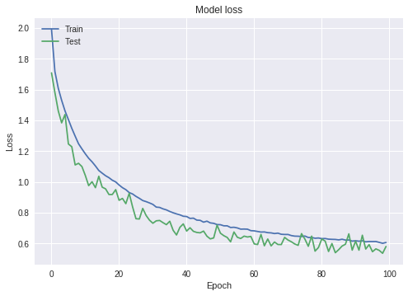
We can find that the model is pretty good that its training accuracy fit testing accuracy good, don’t have any overfitting. I think it’s a pretty good model. The output of the model is here:
Test loss: 0.5812655837535858
Test accuracy: 0.8011

My code:

# coding: utf-8

# In[1]:

from __future__ import print_function
import keras
from keras.datasets import cifar10
from keras.preprocessing.image import ImageDataGenerator
from keras.models import Sequential
from keras.layers import Dense, Dropout, Activation, Flatten
from keras.layers import Conv2D, MaxPooling2D
import os
from sklearn.cross_validation import StratifiedKFold, cross_val_score
from sklearn import grid_search
from sklearn.metrics import classification_report
import multiprocessing
import matplotlib.pyplot as plt
from configparser import ConfigParser

# In[6]:

from configparser import ConfigParser
cfg = ConfigParser()
cfg.read('cifar.config')
batch_size = cfg.getint('parameter','batch_size')
epochs = cfg.getint('parameter','epochs')
learn_rate = cfg.getfloat('parameter','learn_rate')
dropout_rate = cfg.getfloat('parameter','dropout_rate')

# In[7]:

num_classes = 10

data_augmentation = True
num_predictions = 20

model_name = 'keras_cifar10_trained_model.h5'

# In[8]:

# The data, split between train and test sets:
(x_train, y_train), (x_test, y_test) = cifar10.load_data()
print('x_train shape:', x_train.shape)
print(x_train.shape[0], 'train samples')
print(x_test.shape[0], 'test samples')

# Convert class vectors to binary class matrices.
y_train = keras.utils.to_categorical(y_train, num_classes)
y_test = keras.utils.to_categorical(y_test, num_classes)

# In[9]:

model = Sequential()
model.add(Conv2D(32, (3, 3), padding='same',
input_shape=x_train.shape[1:]))
model.add(Activation('relu'))

model.add(Conv2D(128, (3, 3), padding='same'))
model.add(Activation('relu'))
model.add(MaxPooling2D(pool_size=(2, 2)))
model.add(Dropout(dropout_rate))

model.add(Conv2D(64, (3, 3)))
model.add(Activation('relu'))
model.add(MaxPooling2D(pool_size=(2, 2)))
model.add(Dropout(dropout_rate))

model.add(Conv2D(32, (3, 3), padding='same'))
model.add(Activation('relu'))
model.add(MaxPooling2D(pool_size=(2, 2)))
model.add(Dropout(dropout_rate))

model.add(Flatten())
model.add(Dense(512))
model.add(Activation('relu'))
model.add(Dropout(dropout_rate))
model.add(Dense(num_classes))
model.add(Activation('softmax'))

# In[10]:

# initiate RMSprop optimizer
opt = keras.optimizers.rmsprop(lr=learn_rate, decay=1e-6)

# In[11]:

# Let's train the model using RMSprop
model.compile(loss='categorical_crossentropy',
optimizer=opt,
metrics=['accuracy'])

x_train = x_train.astype('float32')
x_test = x_test.astype('float32')
x_train /= 255
x_test /= 255

if not data_augmentation:
print('Not using data augmentation.')
model.fit(x_train, y_train,
batch_size=batch_size,
epochs=epochs,
validation_data=(x_test, y_test),
shuffle=True)
else:
print('Using real-time data augmentation.')
# This will do preprocessing and realtime data augmentation:
datagen = ImageDataGenerator(
featurewise_center=False, # set input mean to 0 over the dataset
samplewise_center=False, # set each sample mean to 0
featurewise_std_normalization=False, # divide inputs by std of the dataset
samplewise_std_normalization=False, # divide each input by its std
zca_whitening=False, # apply ZCA whitening
zca_epsilon=1e-06, # epsilon for ZCA whitening
rotation_range=0, # randomly rotate images in the range (degrees, 0 to 180)
# randomly shift images horizontally (fraction of total width)
width_shift_range=0.1,
# randomly shift images vertically (fraction of total height)
height_shift_range=0.1,
shear_range=0., # set range for random shear
zoom_range=0., # set range for random zoom
channel_shift_range=0., # set range for random channel shifts
# set mode for filling points outside the input boundaries
fill_mode='nearest',
cval=0., # value used for fill_mode = "constant"
horizontal_flip=True, # randomly flip images
vertical_flip=False, # randomly flip images
# set rescaling factor (applied before any other transformation)
rescale=None,
# set function that will be applied on each input
preprocessing_function=None,
# image data format, either "channels_first" or "channels_last"
data_format=None,
# fraction of images reserved for validation (strictly between 0 and 1)
validation_split=0.0)

# Compute quantities required for feature-wise normalization
# (std, mean, and principal components if ZCA whitening is applied).
datagen.fit(x_train)

# Fit the model on the batches generated by datagen.flow().
history = model.fit_generator(datagen.flow(x_train, y_train,
batch_size=batch_size),
epochs=epochs,
validation_data=(x_test, y_test),
workers=4)

plt.plot(history.history['acc'])
plt.plot(history.history['val_acc'])
plt.title('Model accuracy')
plt.ylabel('Accuracy')
plt.xlabel('Epoch')
plt.legend(['Train', 'Test'], loc='upper left')
plt.show()

# Plot training & validation loss values
plt.plot(history.history['loss'])
plt.plot(history.history['val_loss'])
plt.title('Model loss')
plt.ylabel('Loss')
plt.xlabel('Epoch')
plt.legend(['Train', 'Test'], loc='upper left')
plt.show()

# Save model and weights
if not os.path.isdir(save_dir):
os.makedirs(save_dir)
model_path = os.path.join(save_dir, model_name)
model.save(model_path)
print('Saved trained model at %s ' % model_path)

# Score trained model.
scores = model.evaluate(x_test, y_test, verbose=1)
print('Test loss:', scores[0])
print('Test accuracy:', scores[1])

