ABSTRACT

KEYWORDS
Participatory Sensing Security; Reputation System; Machine learning
- INTRODUCTION AND BACKGROUND
Recent mobile phones are equipped with a plethora of embedded sensors, and integrate widespread wireless technologies and complex processing capabilities. These technological features have contributed to the emergence of a new paradigm known as participatory sensing ( Areputation page1).
In participatory sensing, ordinary citizens collect data from their surrounding environment using their mobile devices and upload them to a campaign administrator using existing communication infrastructure (e.g., 3G service or WiFi access points). (reputation system page 1). After the centralized storage and processing process, end users or other applications can access the results of the sensing tasks made by the application server. For example, the results may be displayed locally on the carriers’ mobile phones or accessed by the larger public through web-portals depending on the application needs. (privacy survey page2)
The core idea about PSN is users two-side roles. Except the user character to enjoy the result of centralized processing. They are also expected to contribute and share sensed data from their surrounding environments using their mobile phone. With more consumers, PS system can have much boarder spatial coverage. The broader the participation, the better the results. (Panos page1). However, the inherent openness of PSN (participatory sensing network) makes it easy to collect corrupted data. For instance, users may inadvertently position their devices such that incorrect measurements are recorded, e.g., storing the phone in a bag while being tasked to acquire urban noise information. [reputation system page 1] Besides, malicious users may pollute the sensor data by manipulating for their own benefits.
Threat
Participatory sensing system can be abused both by external and internal adversaries. External attackers are entities without any established connection with the system. They may attempt to gain insights about the participants or the end users. Internal adversaries are active stakeholders of participatory sensing applications, i.e., participants, campaign administrators, and end users. (Privacy in mobile PS)
Without some scheme to process the usability of participants contributed data, the resulting summary statistics will be of little use to the end users. There are two main mechanisms can deal have this function – Reputation system and SHIELD.
Shield
SHIELD is a Verification scheme to classify data sent from a given device based on measurement correlation with other devices to identify malicious nodes polluting the final result. [2017 IoT SENTINEL page7]
Reputation system
Reputation system empowers the campaign administrators to mark reputation scores to contributing devices, evaluating the trustworthiness so that corrupted/malicious contributions are identified. A high reputation scores indicates that a particular device has been reporting highly reliable measurements in the past. Therefore, the administrator can reply more on sensor readings from that device in the future. [reputation system page]

Structure

- MOTIVATION OF ADDING REPUTATION SYSTEM IN SHIELD
SHIELD operates on the reporting service in participatory sensing system, to assess and remove invalid, faulty data. As a good verification framework, ‘the deemed correct data can accurately represent the sensed phenomena, even when 45% of the reports are faulty, intelligently selected by coordinated adversaries and targeted optimally across the system’s coverage area.’[panos page 1] Nevertheless, SHIELD owns two short boards. 1) it is agnostic to the cause of faulty reports. Some bad reports may be due to benign impairments of the PS honest clients, but SHIELD does not distinguish deliberately and unintentionally bad reports. 2) If the statistical properties of the sensed phenomenon change, SHIELD need to retrain or bootstrap again to build new classifier model. SHIELD uses predefined threshold to alert the system make the refreshing decision, which only based on single report from different device. [panos page6] This refreshing mechanism is vulnerable, when there are some unstable honest users in the system. In this scenario, the alert may be triggered easily, the system will be trapped in the bootstrapping or training phase. These two phases use efficient clustering method, so the system response capability will be affected.
Reputation system compute device reputation scores based on the device historical information as a reflection of the trustworthiness of the contributed data. [reputation system page1]. Making the refreshing decision based on device report history could enhance the robustness of the SHIELD. Fig.1 shows the main difference of SHIELD and reputation system.
Fig.1 Difference between SHIELD and SHIELD+
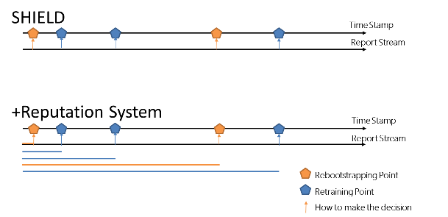
- SYSTEM AND ADVERSARY MODEL
  - SYSTEM
In this paper, we use the basic Participatory Sensing (PS)[trustworthy] system consisting of:
Users: Participants using mobile devices (e.g., smart-phones, smart-vehicles, wearable sensor vests and armbands), equipped with multiple embedded sensors and navigation modules.
Campaign Administrators: Organization, public authorities or individuals [panos page 2 ref 33], initiating data collection campaigns, by recruiting users and distributing sensing tasks to them.
Identity & Credential Management Infrastructure: It is responsible for the Authentication, Authorization and Access Control services by registering users and providing cryptographic credentials. [panos page2 ref 19 22]
Reporting Service (RS): The RS is a access control module that enable registered users to submit data and query the results of a sensing task. SHIELD+ the same as SHIELD operates on the RS. SHIELD+ analyze and remove invalid faulty data with the help of machine learning classifiers and users’ trustworthiness scores.

  - ADVERSARY MODEL
Focus on the internal attack detection.

- SHIELD+ FRAMEWORKD
Fig.2大图 两列
Data flow

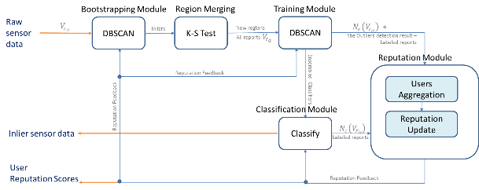
  - High-Level Overview
Compared with the original SHIELD, the new SHIELD+ system add the Reputation Updating Phase to mark reputation scores to contributing devices. Based on the reputation scores, we improve the Classification Phase and the Concept Drift Detection Module
  - Data Preprocessing

  - Bootstrapping Phase

  - Region Merging Phase

  - Training Phase

  - Reputation Updating Phase
  - Classification Phase
  - Concept Drift Detection Module

