Author: Wenqing Zhang

Subject: COM1008 Web and Internet Technology

Part 1- “Mobile First Responsive Web Design”

1. Overall overview:
2. General ethos: Whole website will centre on requirement of COM1008 assignment.
3. Design mock-ups and Site Map:

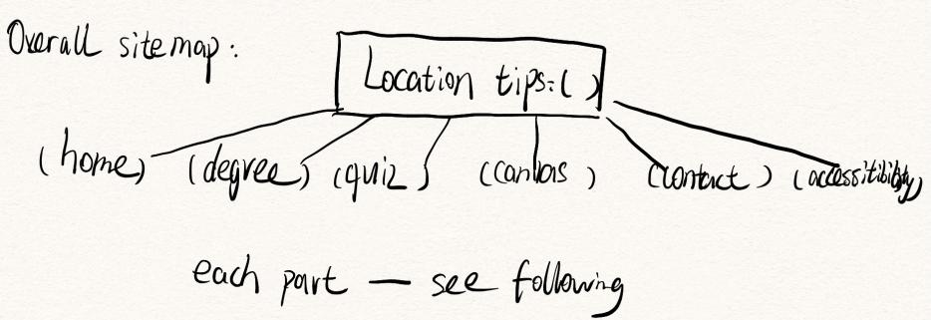13-overallSiteMap

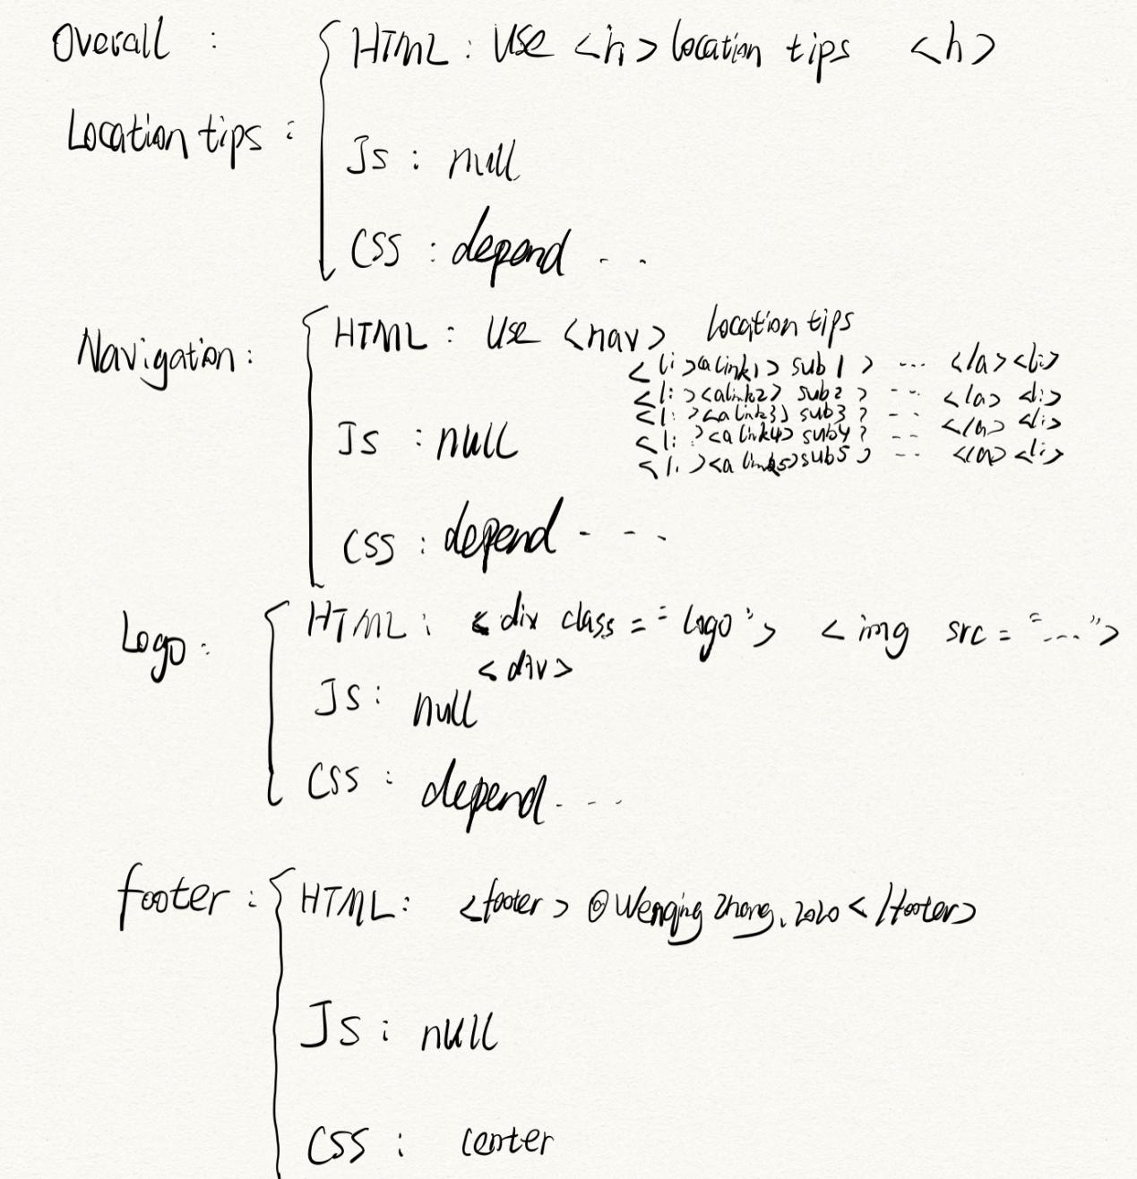

1. Accessibility: a)Age-related and Vision: increase “text size + contrast in text and background”.

b)Hearing: signing avatars.

c)Movement: support keyboard and voice inputs.

d)Cognition: Screen reader.

1. Legal issues: 100% design by myself + have the copyright of my signature.
2. Muse System:Location tips will show which sub-page you are in.
3. Canvas and JavaScript: null

Page1-Home

1)General ethos:It is a welcome page to make reader know some basic information about me and my degree with he main purpose to let reader feel warm in this page.

1. Design mock-ups and Site Map:

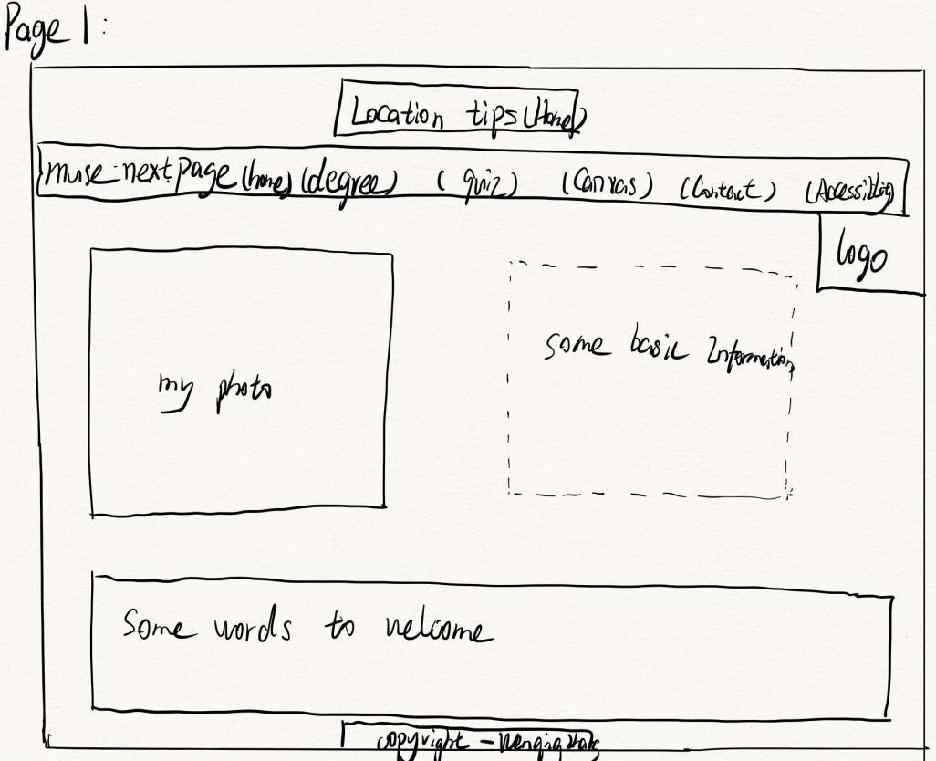1-page1

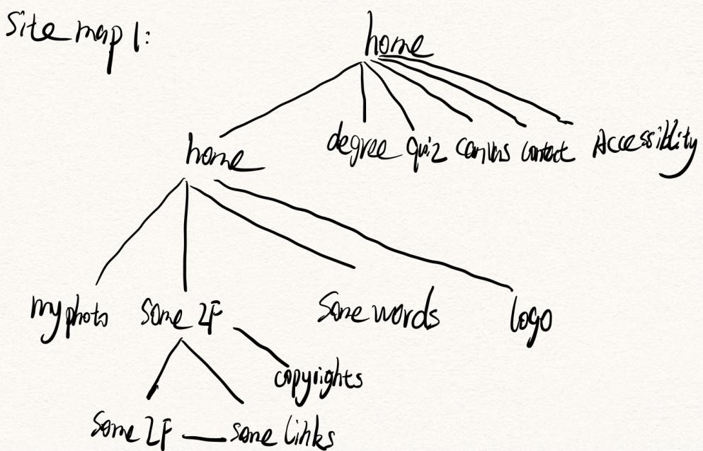2-siteMap1

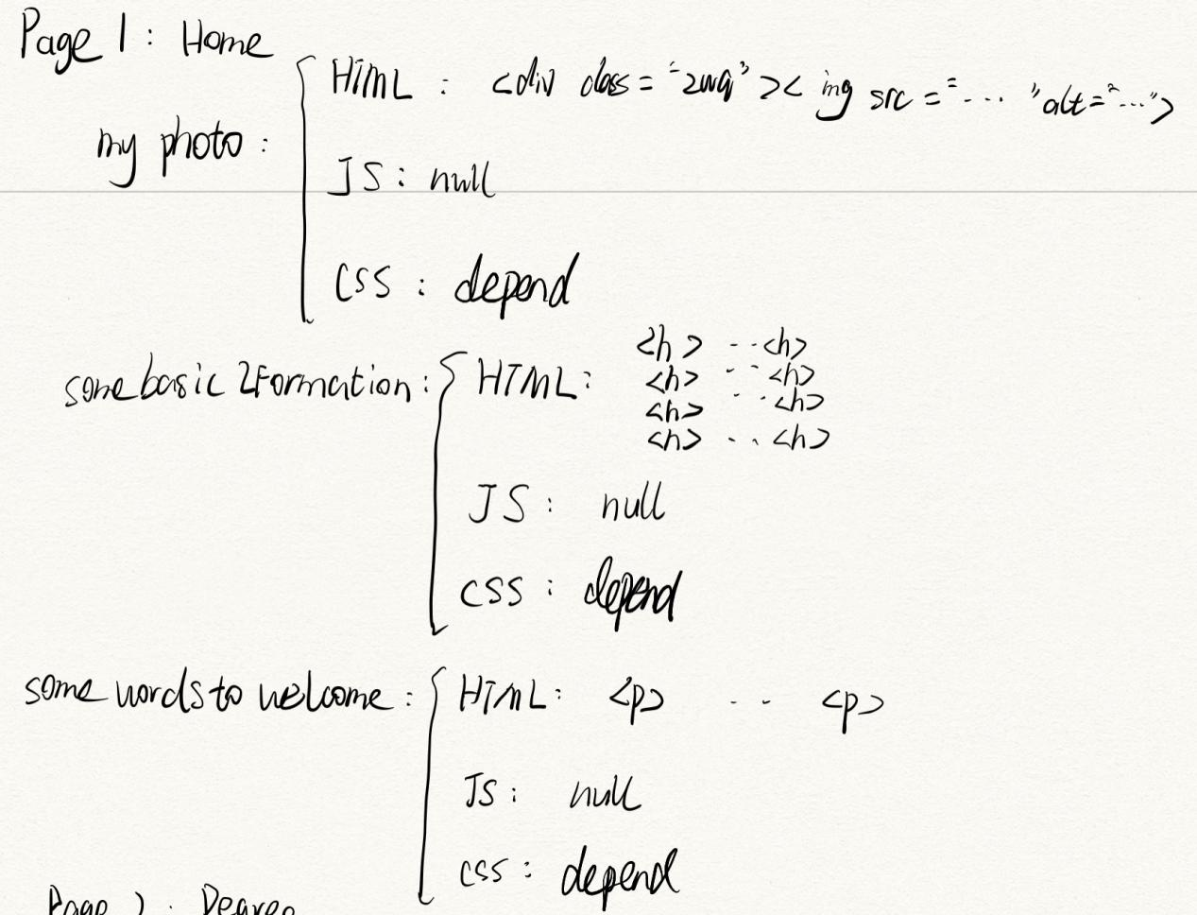

1. Accessibility: Age-related and Vision: increase “text size + contrast in text and background”.

4)Legal issues: have a citation of department’s relevant details + have the copyright of my signature.

5)Muse System:Location tips will show which sub-page you are in.

6)Canvas and JavaScript:null

1. Page2-dgree

1)General ethos:This page is to show the a brief introduction of degree and modules I have learned in semester1. And you could view the relevant further information by clicking the link line-see more.

2)Design mock-ups and Site Map:

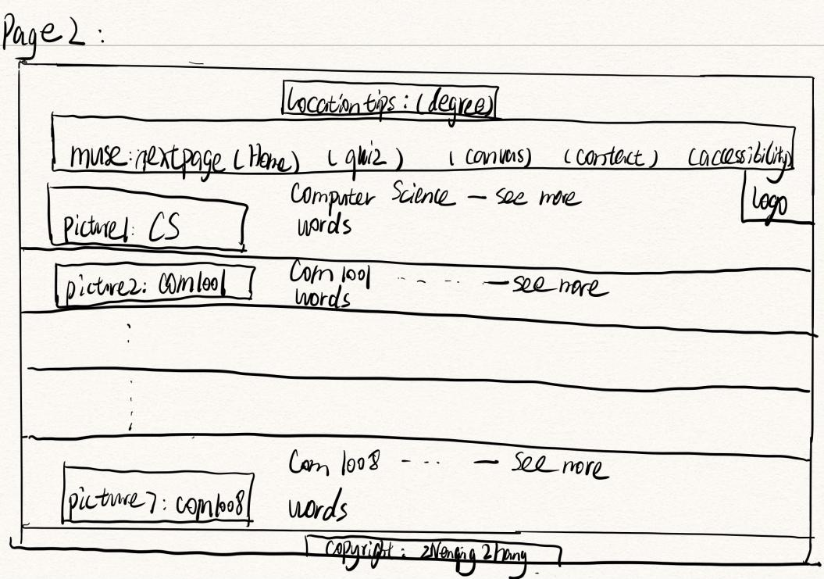3-page2

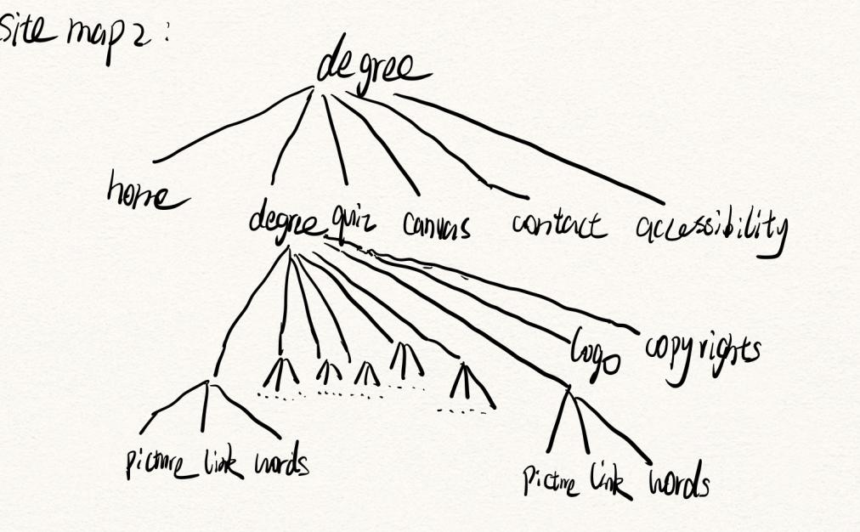4-siteMap2

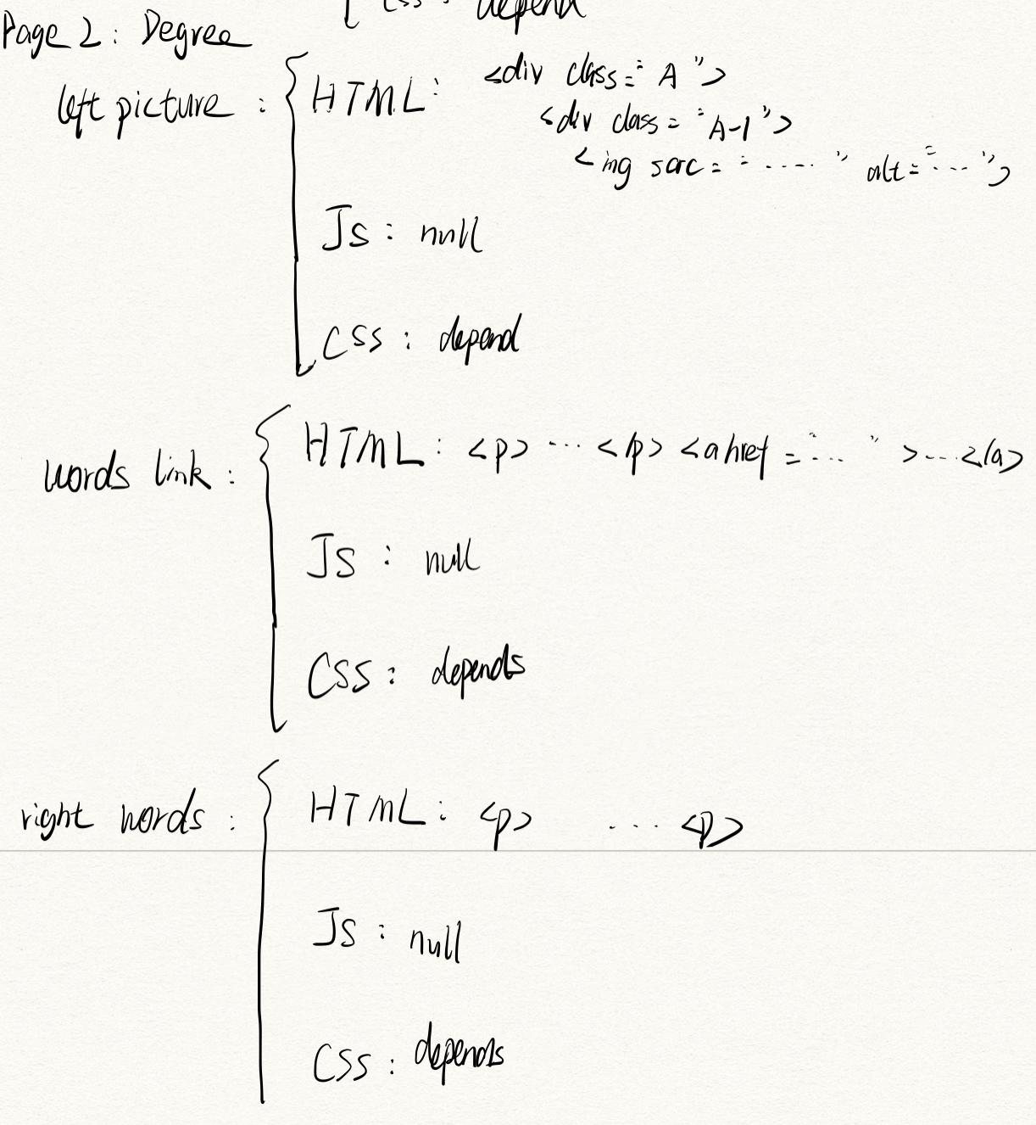

1. Accessibility: Age-related and Vision: increase “text size + contrast in text and background”.

4)Legal issues: have a citation of each modules’ detail+ have the copyright of my signature.

5)Muse System:Location tips will show which sub-page you are in.

6)Canvas and JavaScript:null

1. Page3-quiz

1)General ethos:This page is main to give an interaction with users which means users could see the question and get the answer.

2)Design mock-ups and Site Map:

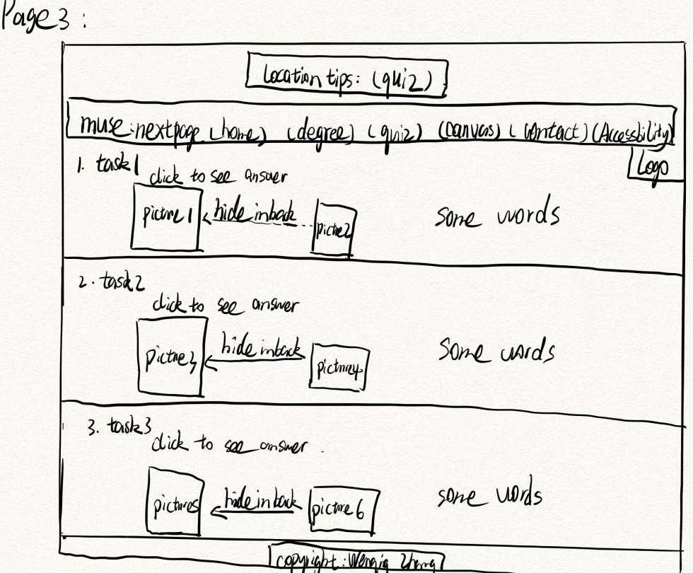5-page3

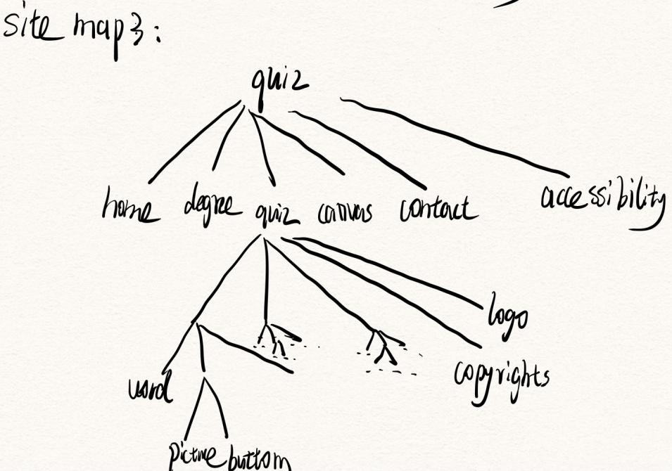6-siteMap3

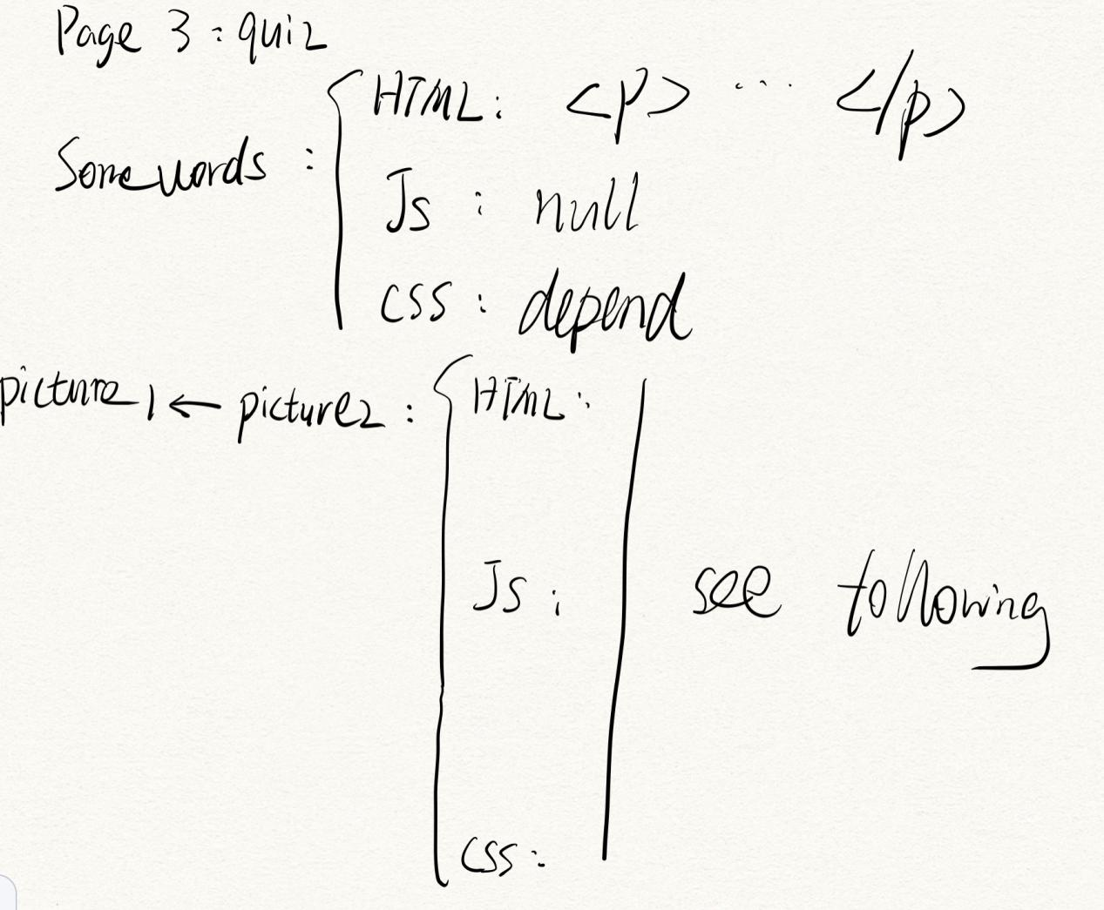

3)Accessibility: Age-related and Vision: increase “text size + contrast in text and background”.

4)Legal issues: 100% design by myself + have the copyright of my signature.

5)Muse System:Location tips will show which sub-page you are in.

1. Page4-Canvas

1)General ethos:This is to show the three graphics.

2)Design mock-ups and Site Map:

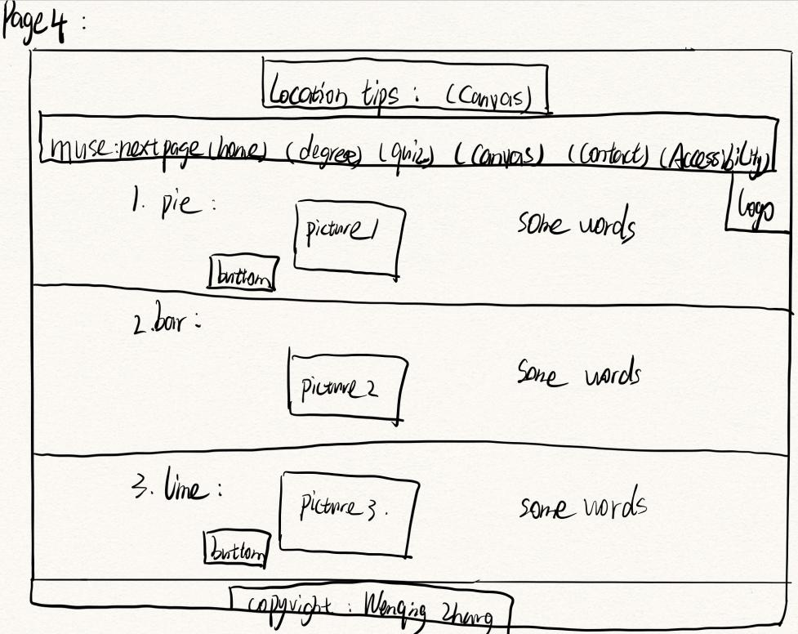7-page4

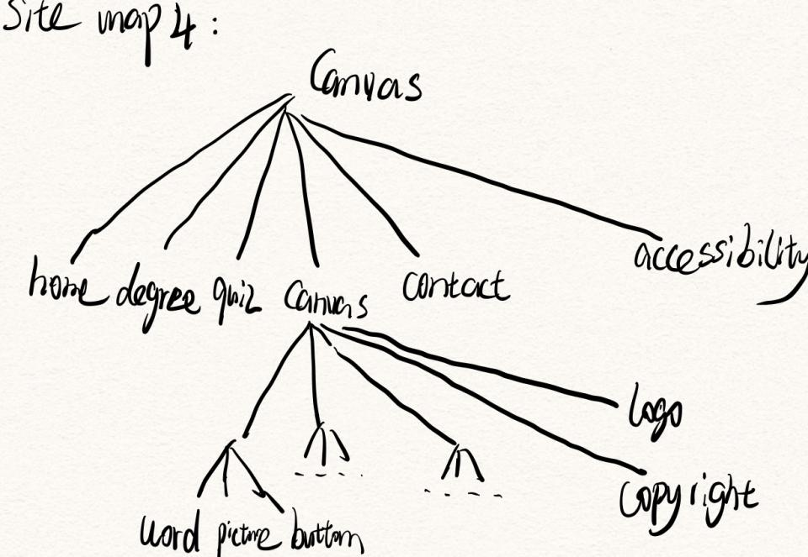8-siteMap4

3)Accessibility: Age-related and Vision: increase “text size + contrast in text and background”.

4)Legal issues: 100% design by myself + have the copyright of my signature.

5)Muse System:Location tips will show which sub-page you are in.

1. Page5-Contact

1)General ethos:

2)Design mock-ups and Site Map:

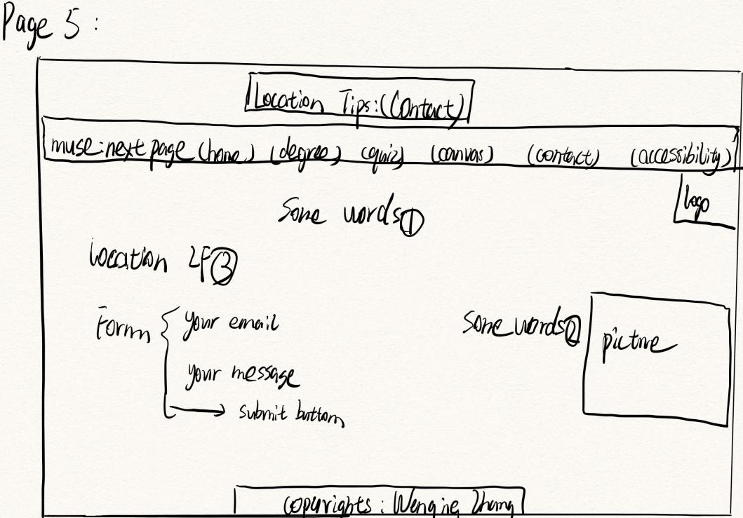9-page5

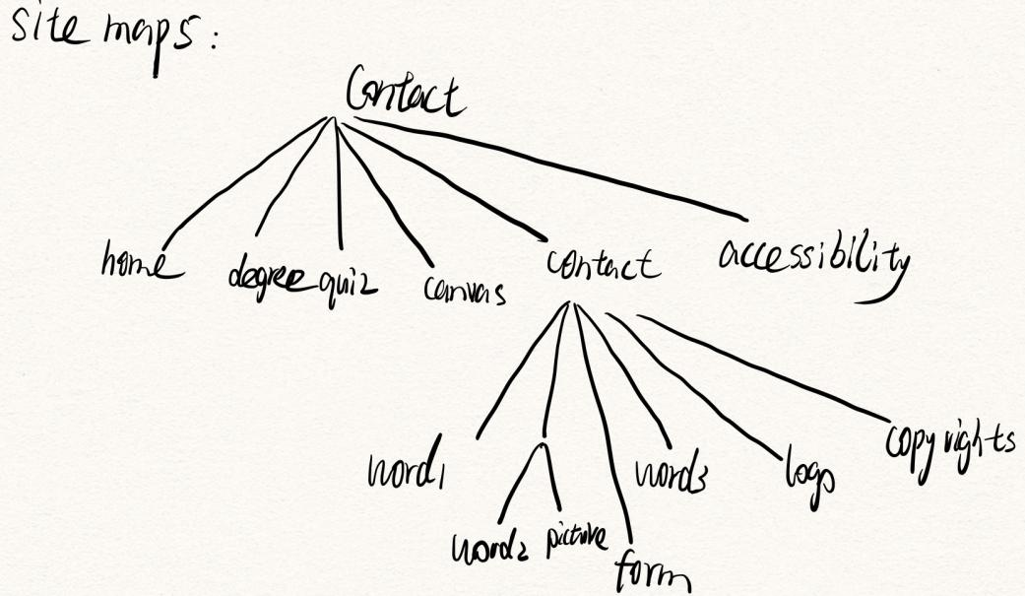10-siteMap5

3)Accessibility: Age-related and Vision: increase “text size + contrast in text and background”.

4)Legal issues: 100% design by myself + have the copyright of my signature.

5)Muse System:Location tips will show which sub-page you are in.

7.Page6-Accessibility

1)General ethos:This is to give an explanation of some special change for those who has some special need in website.

2)Design mock-ups and Site Map:

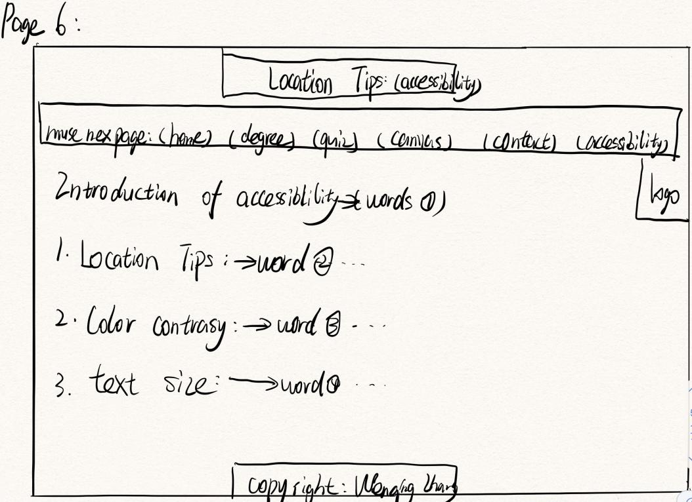11-page6

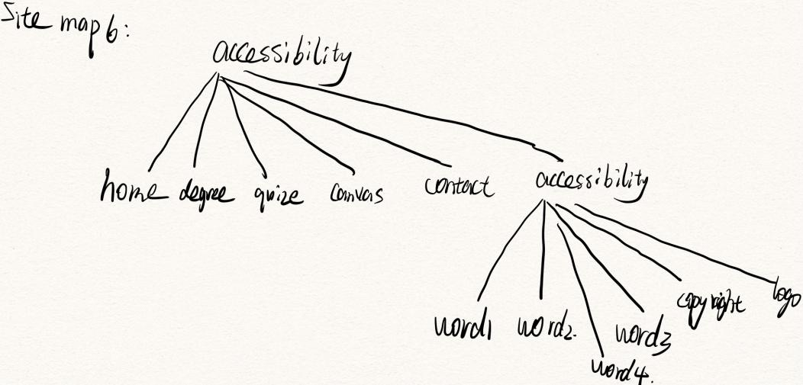12-siteMap6

3)Accessibility: Age-related and Vision: increase “text size + contrast in text and background”.

4)Legal issues: 100% design by myself + have the copyright of my signature.

5)Muse System:Location tips will show which sub-page you are in.