Author: Wenqing Zhang

Subject :COM1008 Web and Internet Technology

Part3-testing document

1. Changes:
2. Page1-Home: Change the order of photo and personal information with brief introduction-->Reason: Give the reader a brief introduction maybe better.

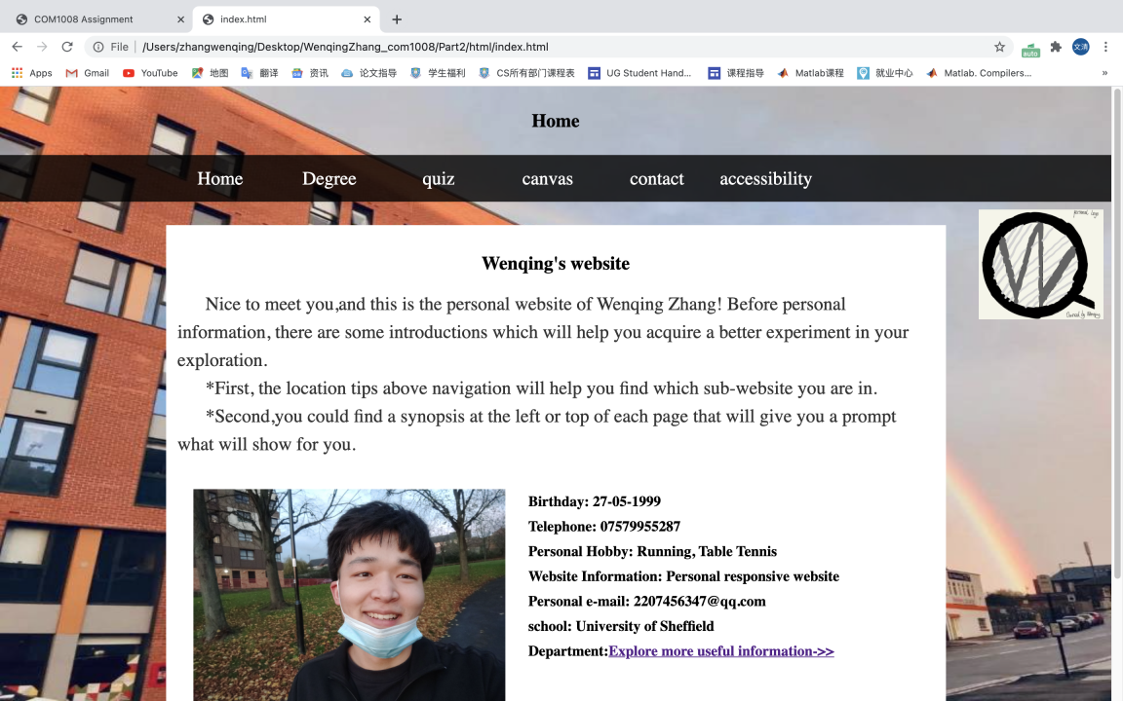

1. Page2-Degree: At the beginning, I try to create the link in the modules’ name, and however it changes to the link in reference.-->Reason: The requirement of writing makes me exchange the modules’ name with reference.

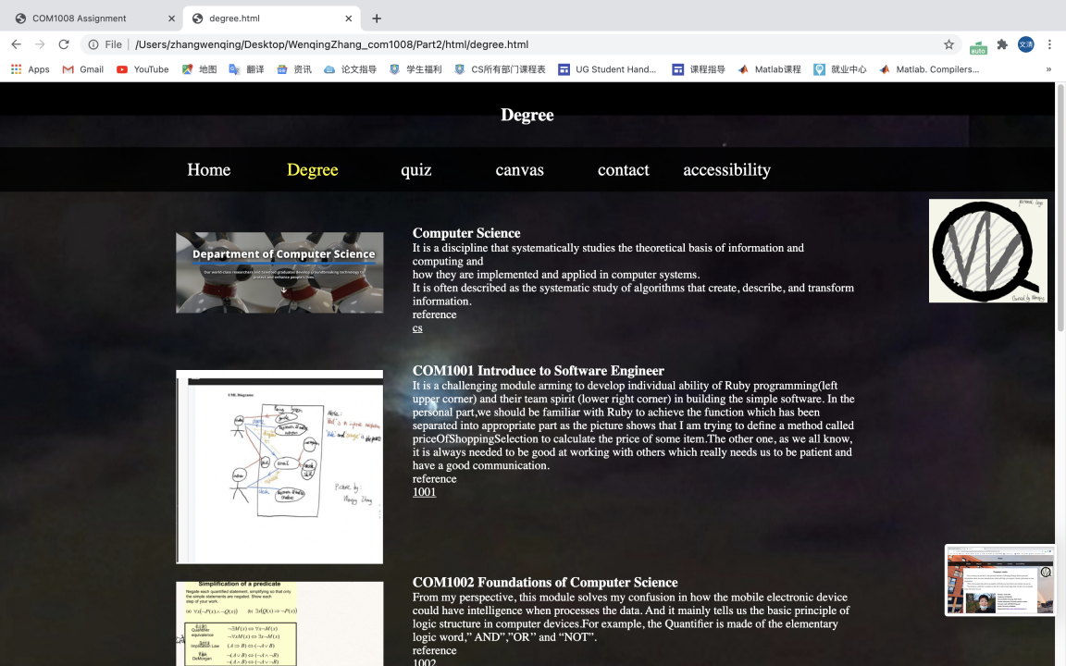

1. Page3-Quiz: It should be that the answer picture is covered with the question picture. At last,I changed the question picture and answer picture segregated with each other.-->Reason:It goes wrong with the original plan after adding a background, which forces me to change that.

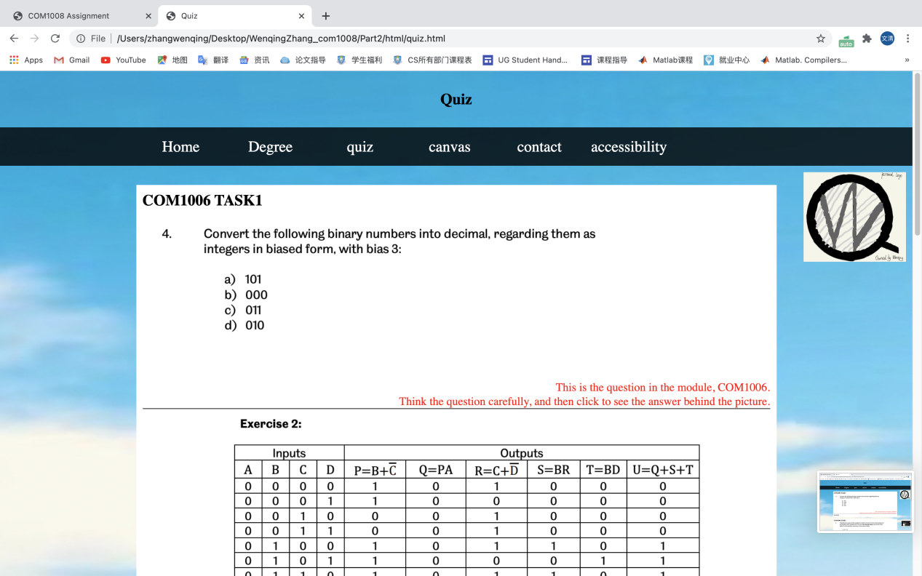

1. Organization:

The answer might be positive because I use the templates, such as the location tips, navigation, logo, and footer. Using the templates, I could create the unified style in whole website. I just use the template those in html, css which is almost the same and I just need to replace somewhere specified. When I done that, I also debug for it, there shows lot of problems and I fixed that as possible as I could. I did not use the js in templates, which just contain some css and html in muse.

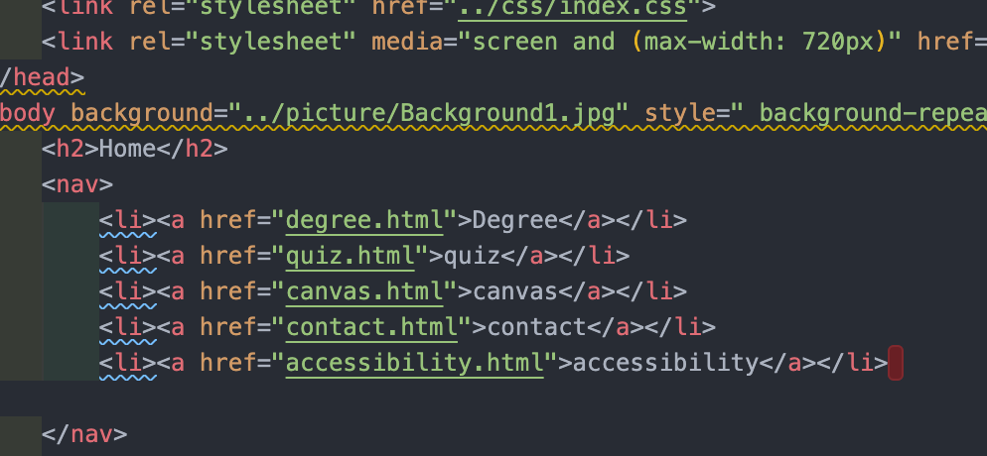

1. Optimization:

Yes,I have already considered it.

1. Page4-quiz: I used to consider putting the question picture on the answer picture. However, it is not easy for readers to compare the question picture with the answer picture at the same time. So I changed the model adding another picture to cover the answer.
2. Page5-canvas: I used to just put only one table near the bar. And then I thought it would be better to add another table near the pie for the reason that the pie is independent from the bar which shows the same time arrangement with line.

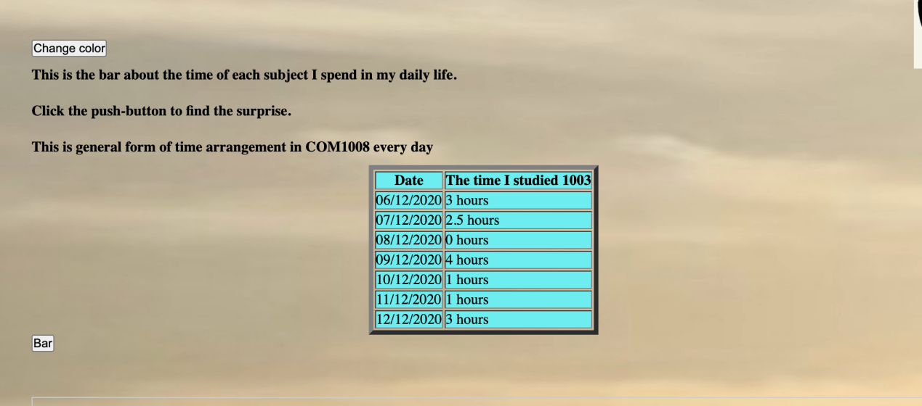

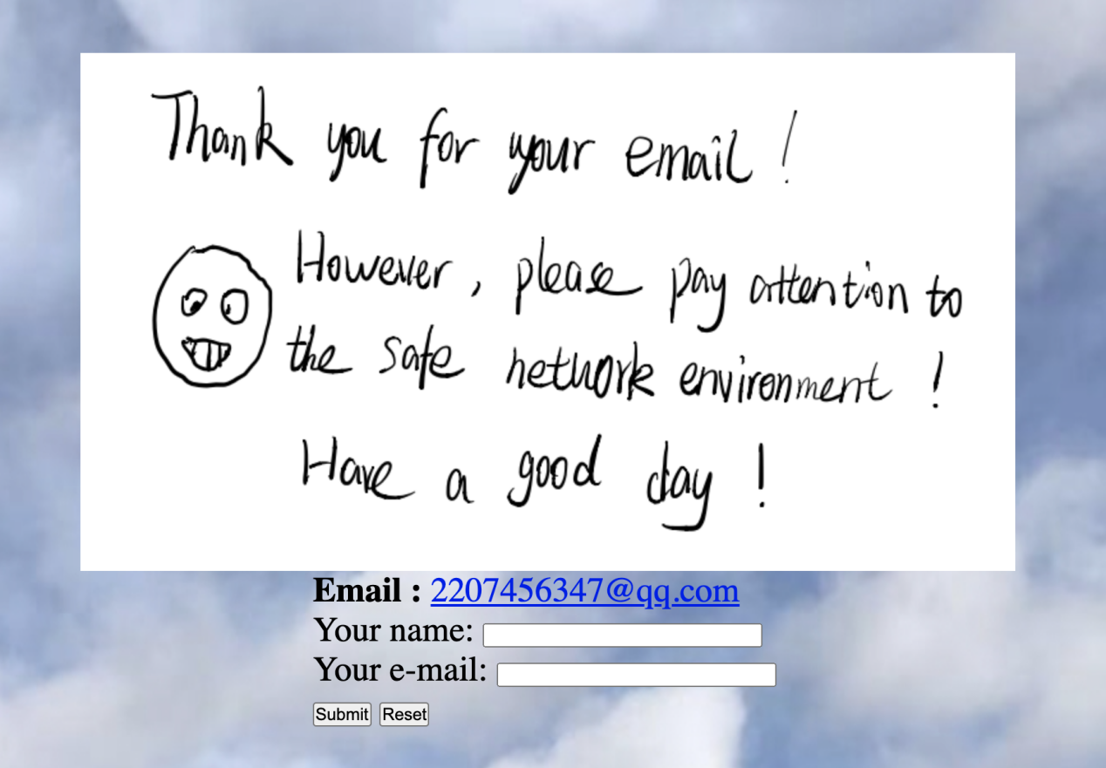4.security issue and Solution:

1. General problem:

A)website be attacked:

->Use HTTP cookies to remember the users’ details conformed to regulations in order to take responsibility for the accident; Sufficient logging and monitor;

B)XXS:

->Use specified programmer to check the website whether be tracked and added other sensitive information.

2)Information Security:

A)Hacker could pretend users to send me email with virus:

->add an programmer which could check whether emails are credible ;Make back-ups of files.

B)Hacker may use DoS, “Denial of service attack”, to my website or my email;

->Fixed quantity of emails that the same user could send me per day and I could receive ;Only me could check users emails;

1. Network and communication:
2. Hacker could steal the users’ information(content in their emails) in public network environment.

->When the users fill the contact form, my website will remind them to be careful of the network environment, which someone maybe revealed your information now.

1. Debugging:

Yes,I have used it which gave me many problems existing in html and javascript files.I tried to fix some of them, and however there is still some problems I could not deal with it easily. For the reason that something in website will be changed and will not show correctly like the original version.(website used:<https://validator.w3.org/#validate_by_upload> )

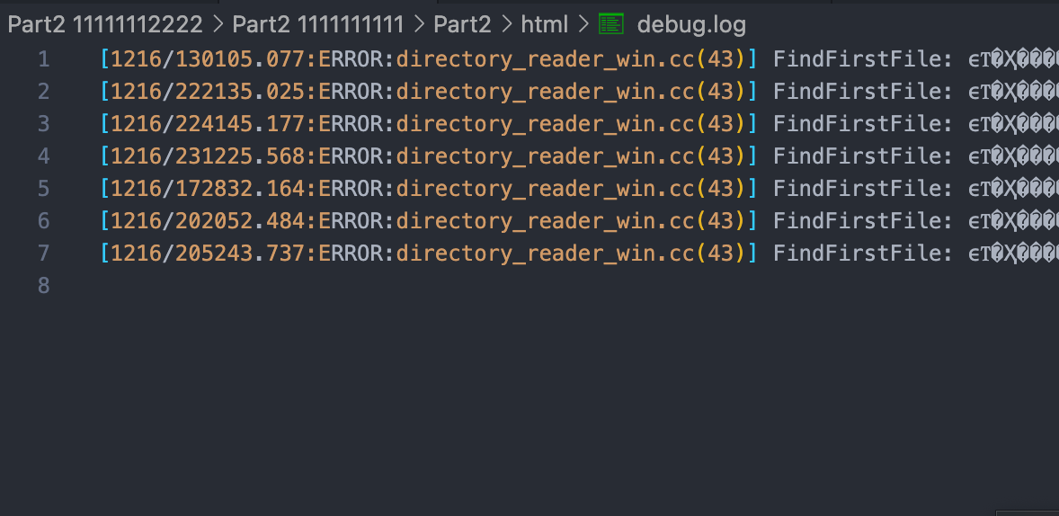

1. Testing:

I have tested it in different devices and the result shows that it is not seem perfect still have some little problem, however it is fine in most page.After that I try to fix the problem which seems to have a good reflect.They all could be display in different device well.

