**RBF-- Radial basis functions**

Radial basis functions (RBFs) are a modern generalized form of spline interpolation. In computer graphics they are used for implicit surfaces, representation of scanned data, deformations, skinning, various sorts of mappings, and so on. RBFs were popularized in machine learning, where they provided a predictable alternative to neural networks, and are a close cousin to Gaussian Processes.

**Guassion:**

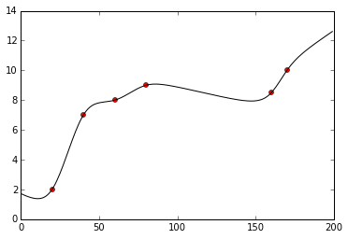

**Ndimension Guassion:**

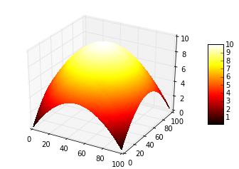

**Eigenfaces**

Eigenfaces is the name given to a set of eigenvectors when they are used in the computer vision problem of human face recognition.The eigenvectors are derived from the covariance matrix of the probability distribution over the high-dimensional vector space of face images. The eigenfaces themselves form a basis set of all images used to construct the covariance matrix. This produces dimension reduction by allowing the smaller set of basis images to represent the original training images. Classification can be achieved by comparing how faces are represented by the basis set.

**Eigenfaces:**

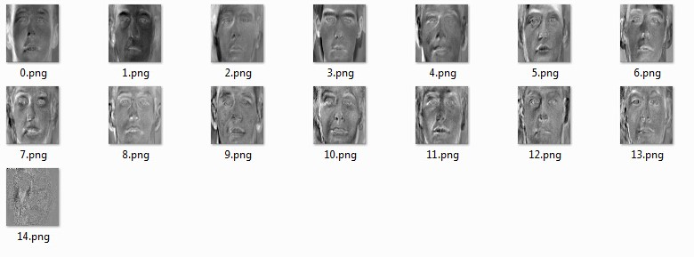

**Fourier approximation:**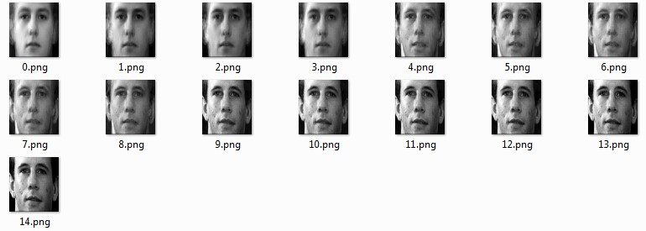

**Spline**

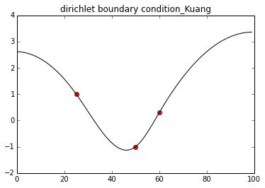

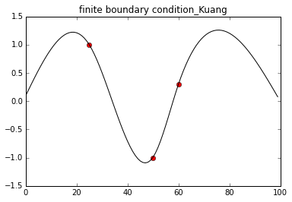

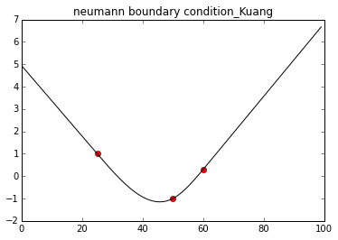

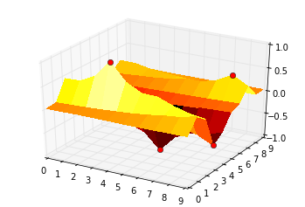

**DEATHSTAR or ANGRY BIRDS:**

