**Lab Assignment for Week #2 (WP - Access - Part 1)**

**(Project Questions from Chapter 1 of the textbook)**

Student: Wentao Lu

Student ID:040991469

Course: CST2355-302

**Screen Shot #1: Displaying the Department Table**

**Questions #1.66 to 1.71 (Page 35 of the textbook – 15th edition)**

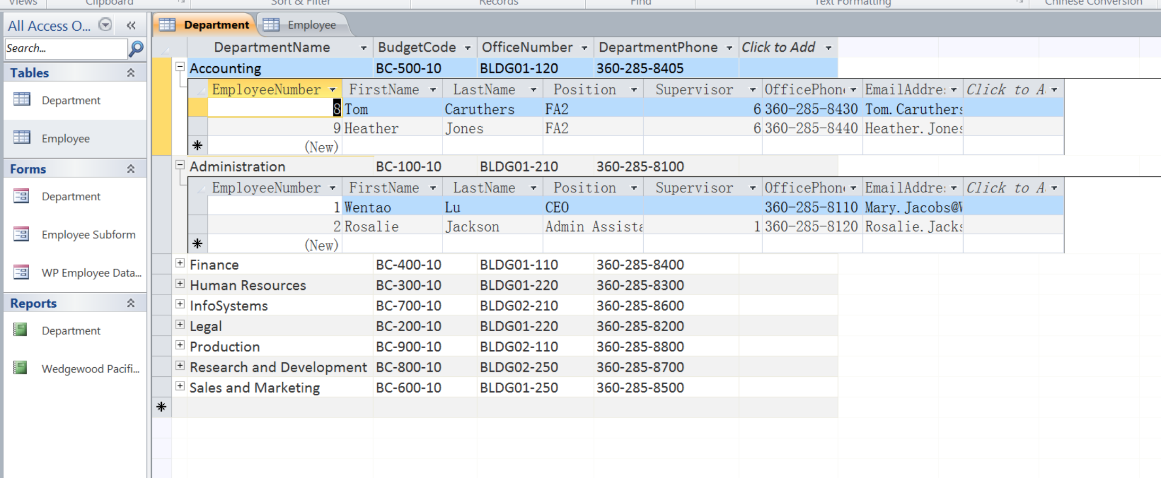

**Screen Shot #2: Displaying the Department/Employee Form**

**Question # 1.74 (Page 36 of the textbook – 15th edition)**

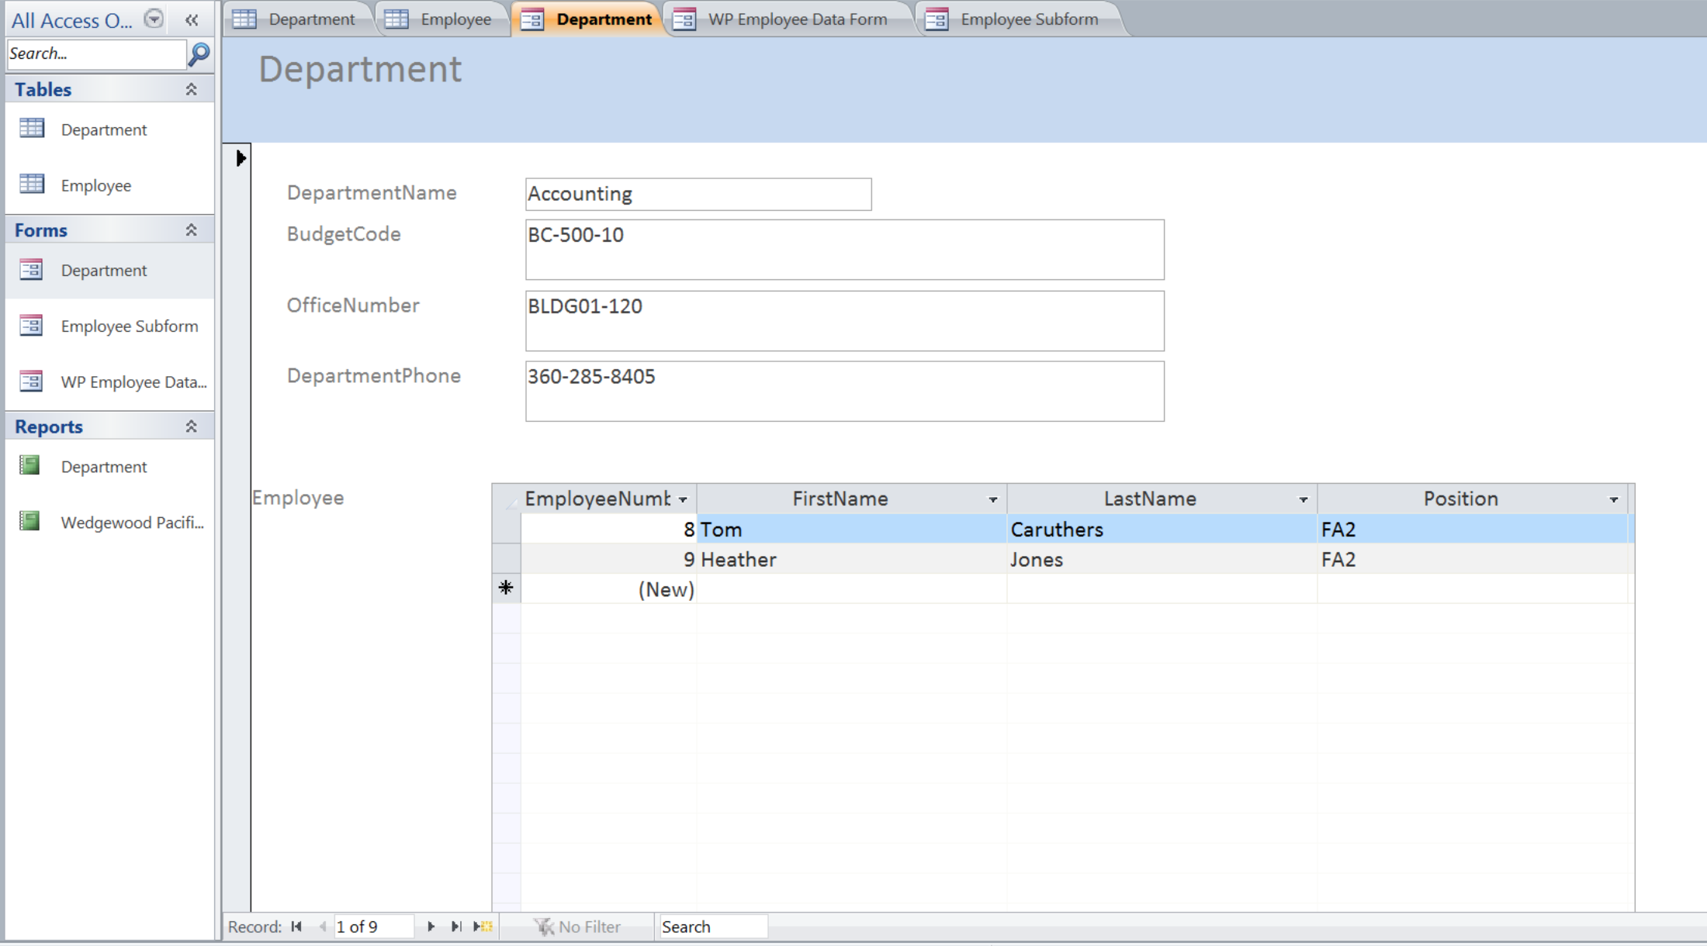

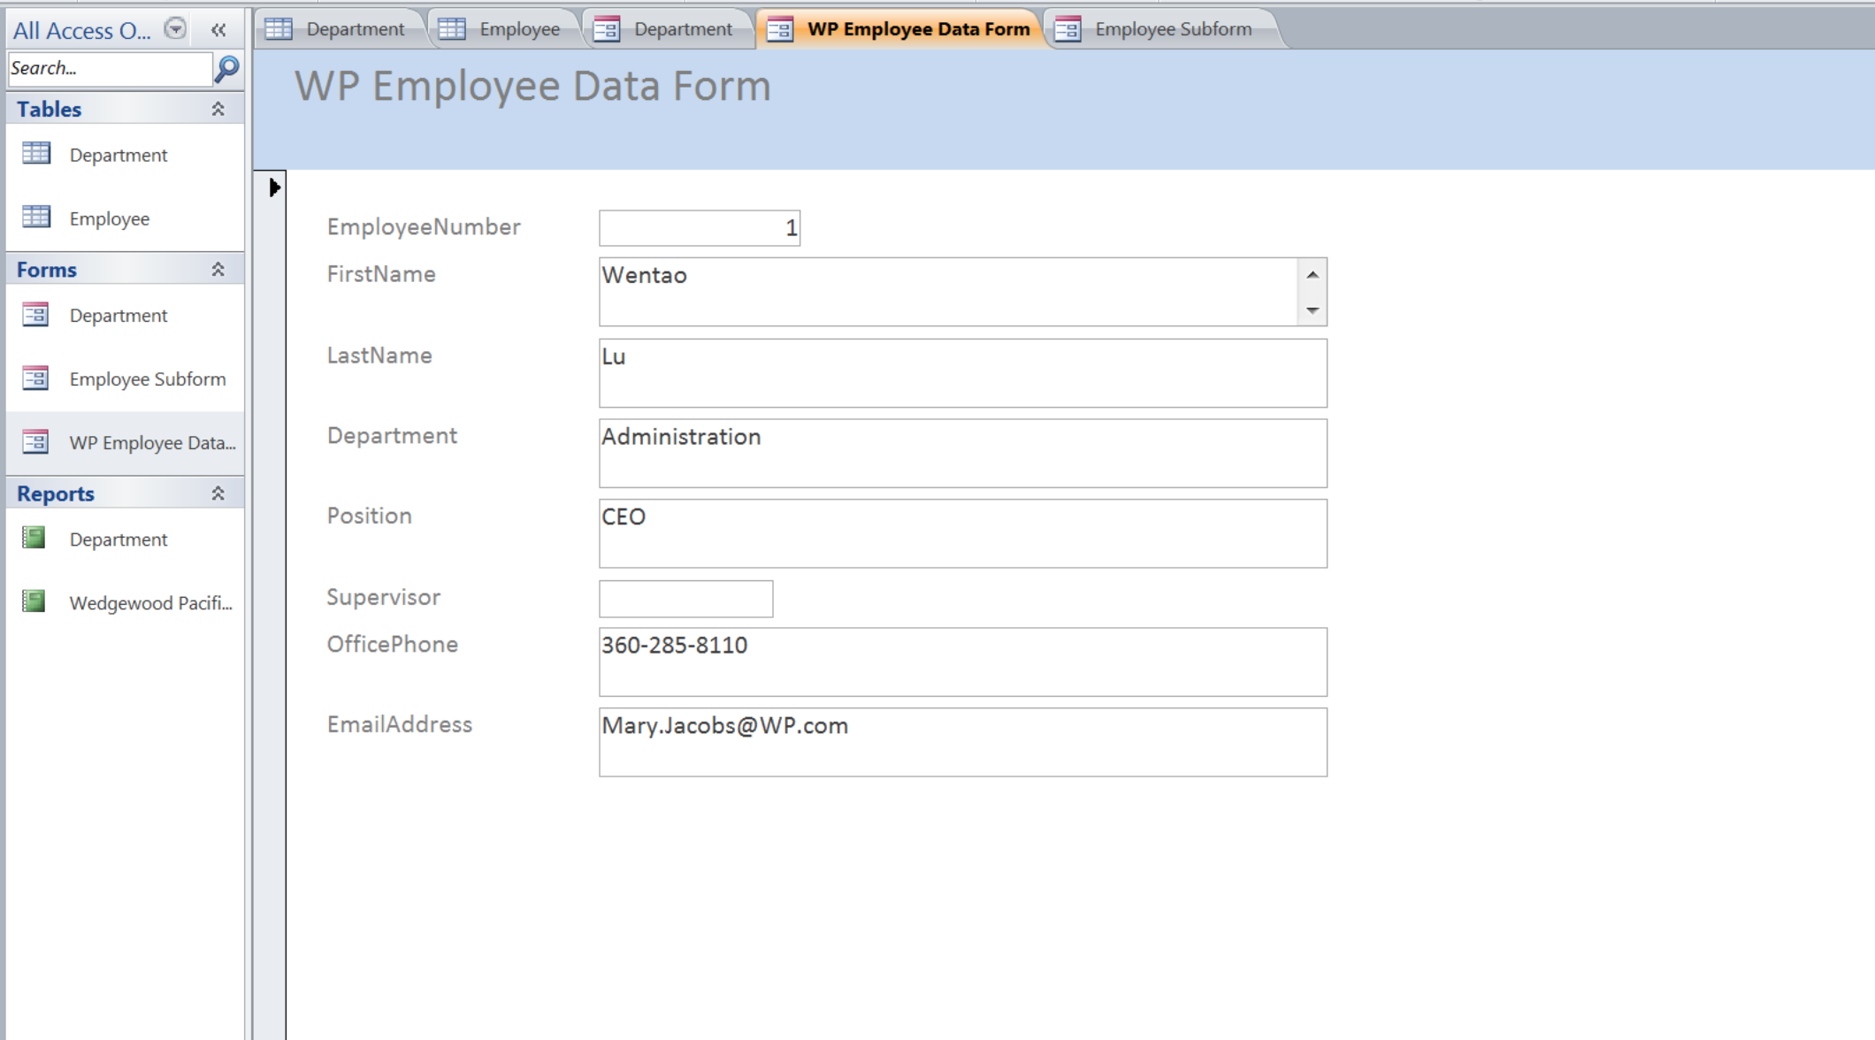

**Screen Shot #3: Displaying the Employee Report**

**Question # 1.73 (Page 36 of the textbook – 15th edition)**

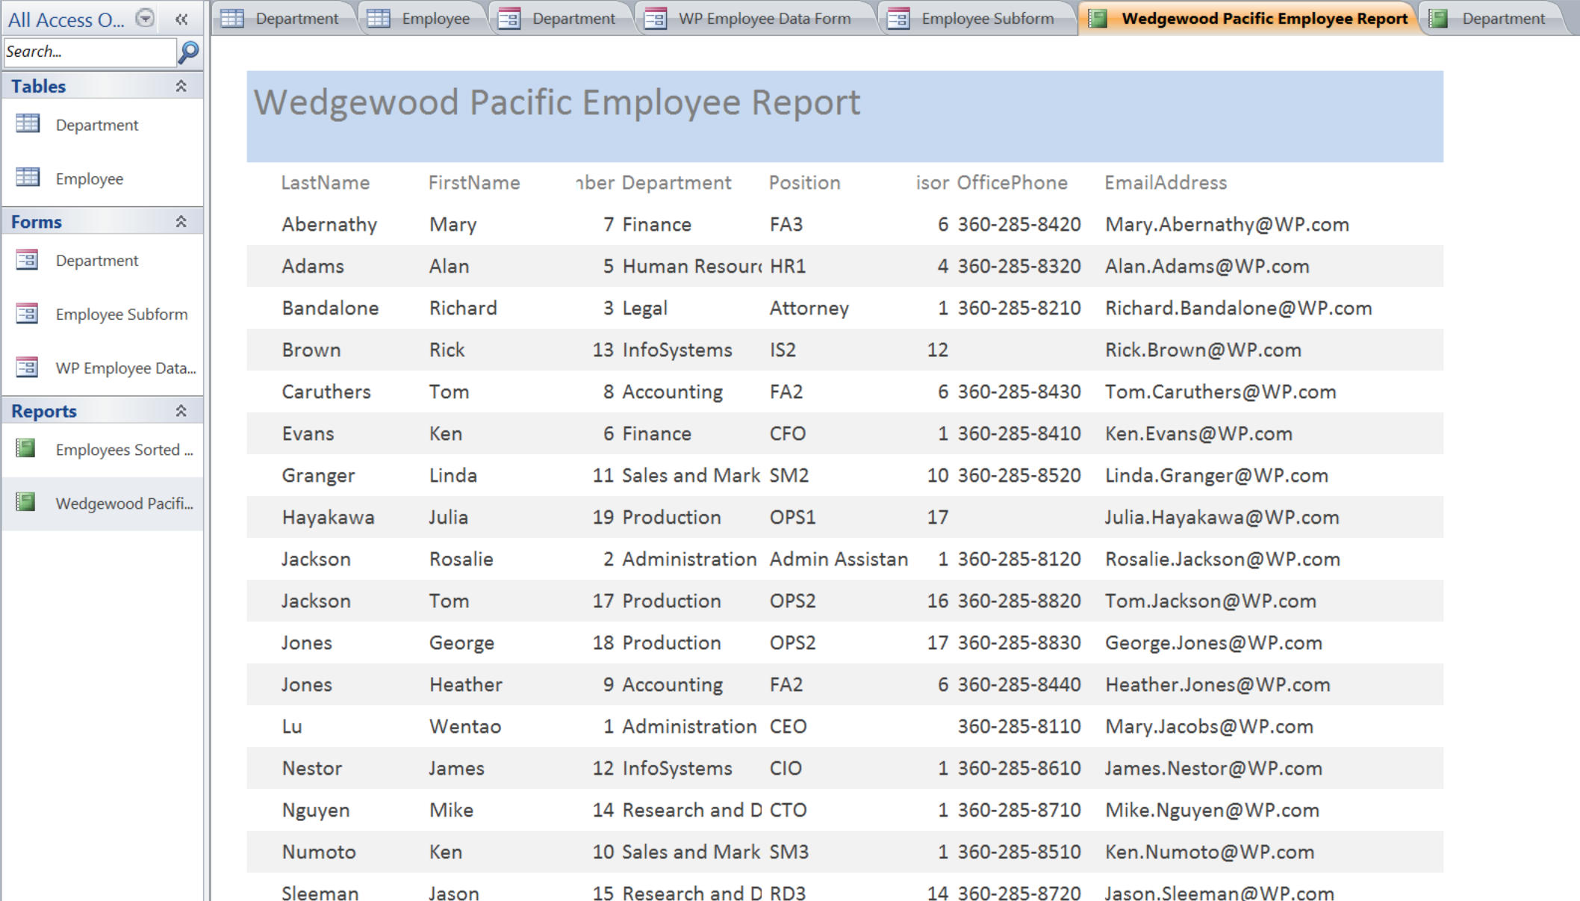

**Screen Shot #4: Displaying the Department/Employee Report**

**Question # 1.75 (Page 37 of the textbook – 15th edition)**

