**Lab Assignment for Week #3 (WP - Access - Part 2)**

**(Project Questions from Chapter 2 of the textbook)**

**(NOTE: Screen shot examples in these instructions may be different than your screen shot values)**

**Screen Shot #1: Displaying the Employee Table**

**Questions #2.61 to 2.67 (Page 126 of the textbook – 15th edition)**

Display the Employee Table, with your Employee record expanded to display the projects in which you are involved. (click on the “+” expansion icon to the left of your record).

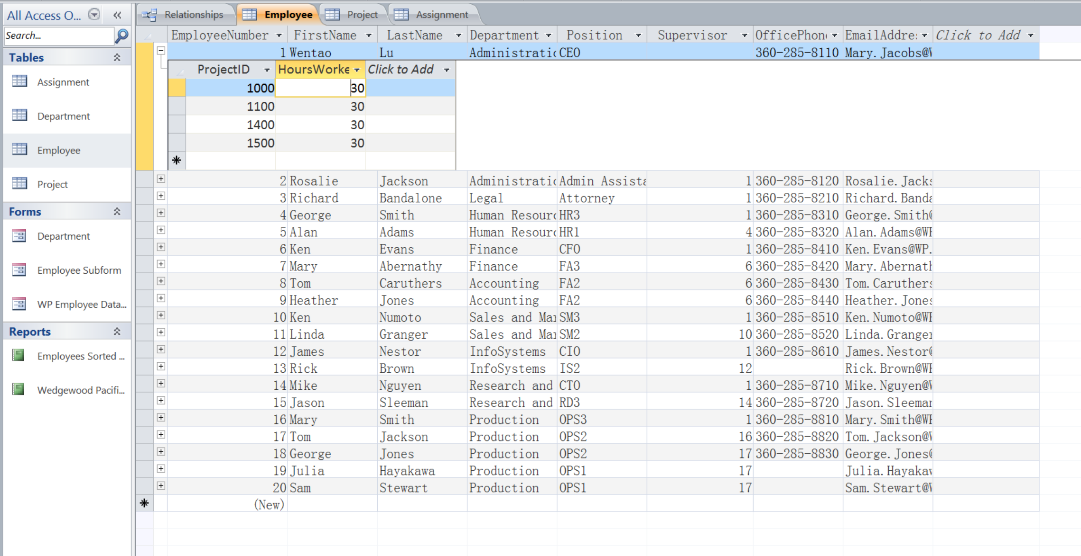

**Screen Shot #2: Displaying the Project Table**

**Questions #2.61 to 2.67 (Page 126 of the textbook – 15th edition)**

Display the Project Table, with the first project record expanded to display the employees working on that project (click on the “+” expansion icon to the left of the project record).

**IMPORTANT – Ensure that all four tables are listed in the object panel on the left (i.e. the ASSIGNMENT, DEPARTMENT, EMPLOYEE and PROJECT tables)**

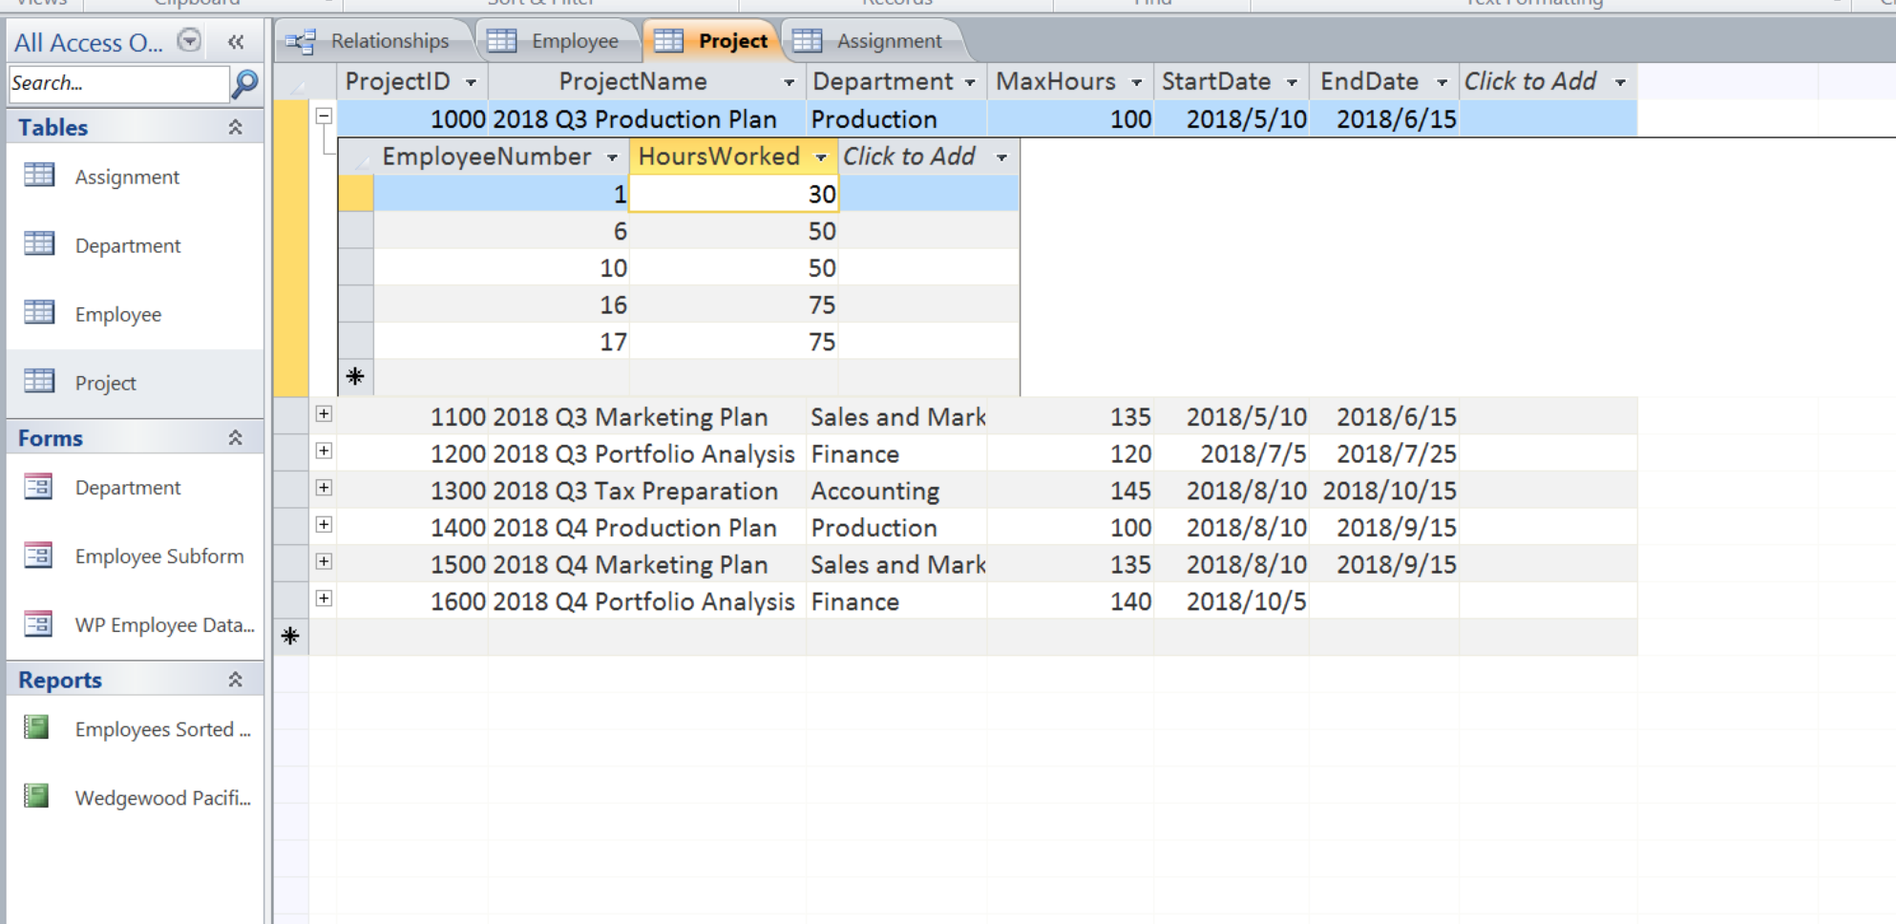

**Screen Shot #3: Displaying the projects in the PROJECT table**

**Question # 2.70 - A (Page 128 of the textbook – 15th edition)**

Display the results of the SQL query for 2.70 – Question A (include all columns in the query result).

**IMPORTANT – When creating your queries, please label the queries with your initials, followed by the appropriate query letter. For example, for student John Tyler, the SQL queries would be labelled JT-A, JT-B, JT-C, etc. For student Mary Smith, the SQL queries would be labelled MS-A, MS-B, MS-C, etc.**

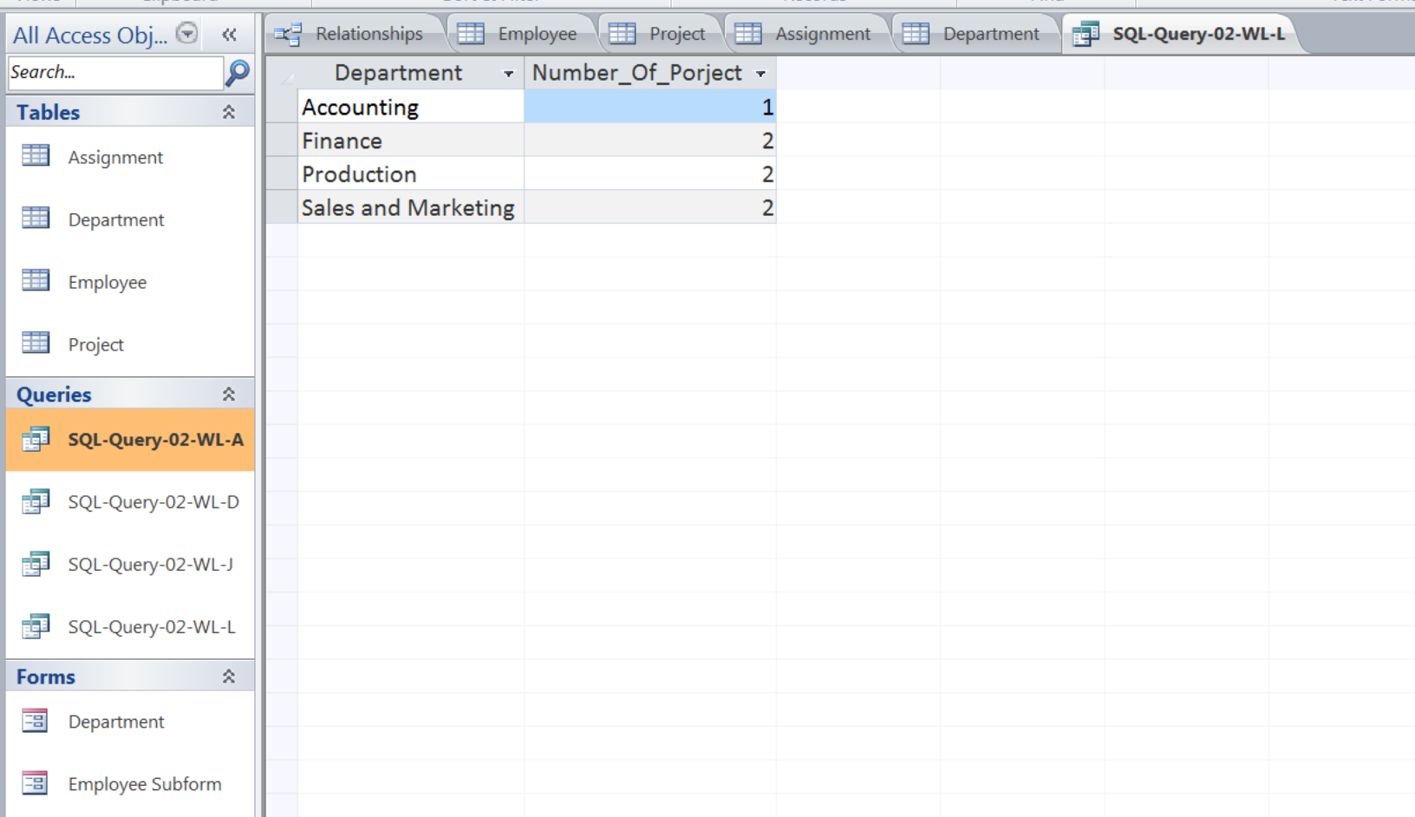

**Screen Shot #4: Displaying the projects which have not been completed**

**Question # 2.70 - D (Page 128 of the textbook – 15th edition)**

Display the results of the SQL query for 2.70 – Question D (include all columns in the query result).

(Hint: search for projects with no end date)

**IMPORTANT – When creating your queries, please label the queries with your initials, followed by the appropriate query letter. For example, for student John Tyler, the SQL queries would be labelled JT-A, JT-B, JT-C, etc. For student Mary Smith, the SQL queries would be labelled MS-A, MS-B, MS-C, etc.**

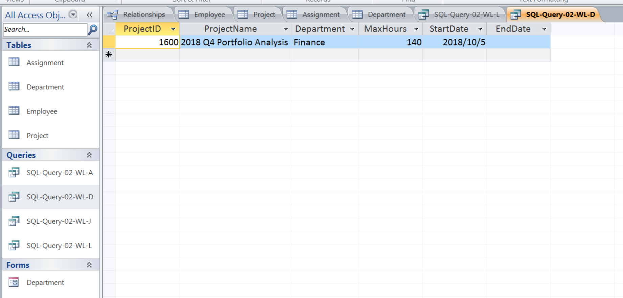

**Screen Shot #5: Displaying the toeal maximum hours of projects run by the Marketing department**

**Question # 2.70 - J (Page 128 of the textbook – 15th edition)**

Display the results of the SQL query for 2.70 – Question J

(Hint: This query involves the use of an aggregate function, resulting in a single value for the query result)

**IMPORTANT – When creating your queries, please label the queries with your initials, followed by the appropriate query letter. For example, for student John Tyler, the SQL queries would be labelled JT-A, JT-B, JT-C, etc. For student Mary Smith, the SQL queries would be labelled MS-A, MS-B, MS-C, etc.**

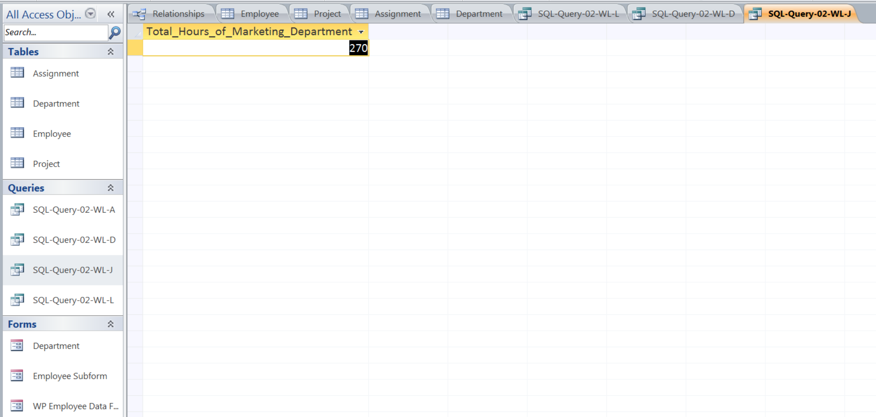

**Screen Shot #6: Display the departments which are running projects (with the number of projects also being displayed)**

**Question # 2.70 - L (Page 128 of the textbook – 15th edition)**

Display the results of the SQL query for 2.70 – Question L

(Hint: Only include those departments which are running projects – do not include those that have the number of projects equal to zero)

**IMPORTANT – When creating your queries, please label the queries with your initials, followed by the appropriate query letter. For example, for student John Tyler, the SQL queries would be labelled JT-A, JT-B, JT-C, etc. For student Mary Smith, the SQL queries would be labelled MS-A, MS-B, MS-C, etc.**

