**Lab Assignment for Week #4 (MDC – MS SQL Server)**

**(Project Questions from Chapter 2 of the textbook)**

**(NOTE: Screen shot examples in these instructions may be different than your screen shot values)**

**Screen Shot #1: Displaying the records of all 3 tables (CUSTOMER, INVOICE and INVOICE_ITEM**

**Questions A (Page 132 of the textbook – 15th edition)**

Display the records of the three tables created.

(Hint: Create 3 SELECT statements within a single query to display all 3 tables)

**IMPORTANT – Ensure that the “First Name” and “Last Name” customer record for “Kathy Miller” is changed to reflect your first and last name (you are not required to alter the corresponding “Email” field of the record (i.e. it will remain as “Kathy Miller@somewhere.com). This is accomplished by editing the record in the corresponding “Insert-Data” SQL file before executing it to populate the CUSTOMER table.**

**IMPORTANT – When creating your queries, please label the queries with your initials, followed by the appropriate query letter. For example, for student John Tyler, the SQL queries would be labelled JT-A, JT-B, JT-C, etc. For student Mary Smith, the SQL queries would be labelled MS-A, MS-B, MS-C, etc.**

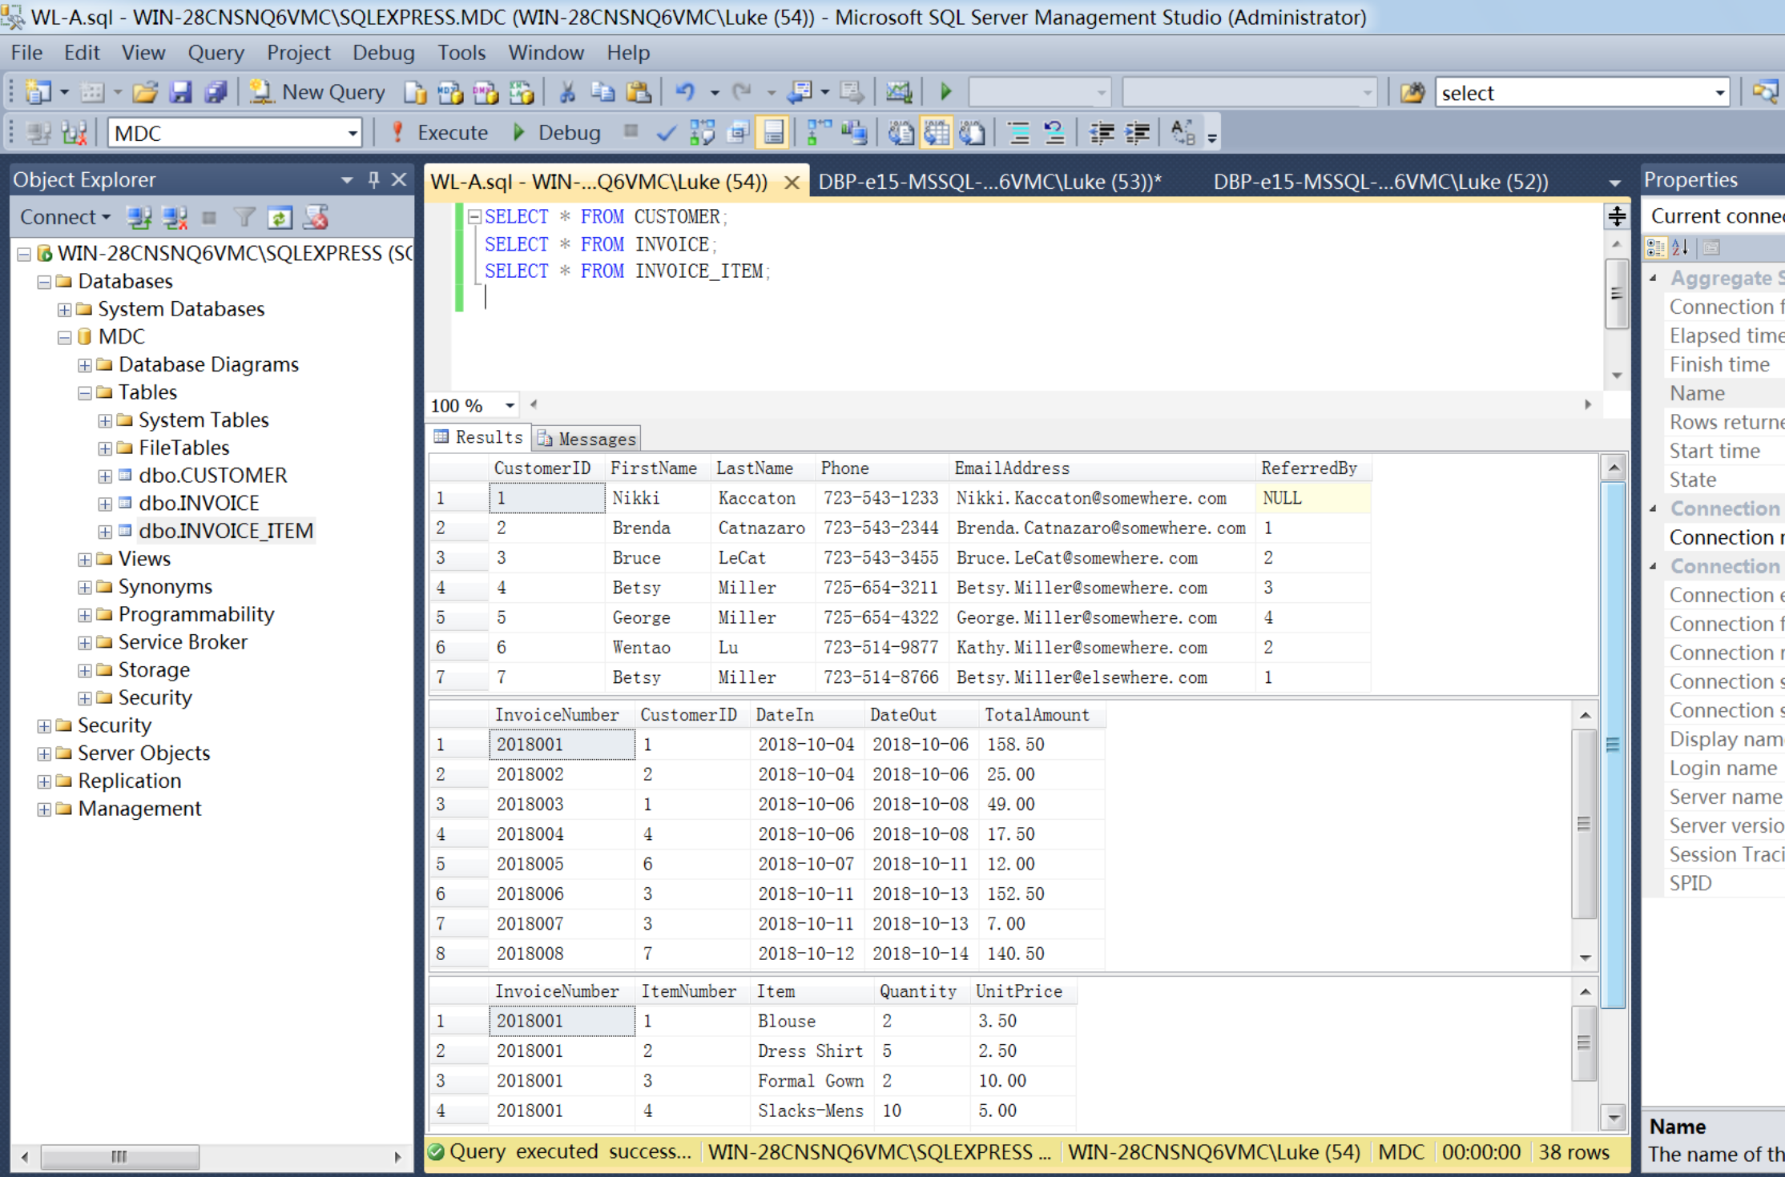

**Screen Shot #2: Displaying the phone numbers**

**Questions G (Page 132 of the textbook – 15th edition)**

Display the phone number, first and last name columns for each customer in the query result.

**IMPORTANT – Ensure that your name is visible in the screen shot result.**

**IMPORTANT – When creating your queries, please label the queries with your initials, followed by the appropriate query letter. For example, for student John Tyler, the SQL queries would be labelled JT-A, JT-B, JT-C, etc. For student Mary Smith, the SQL queries would be labelled MS-A, MS-B, MS-C, etc.**

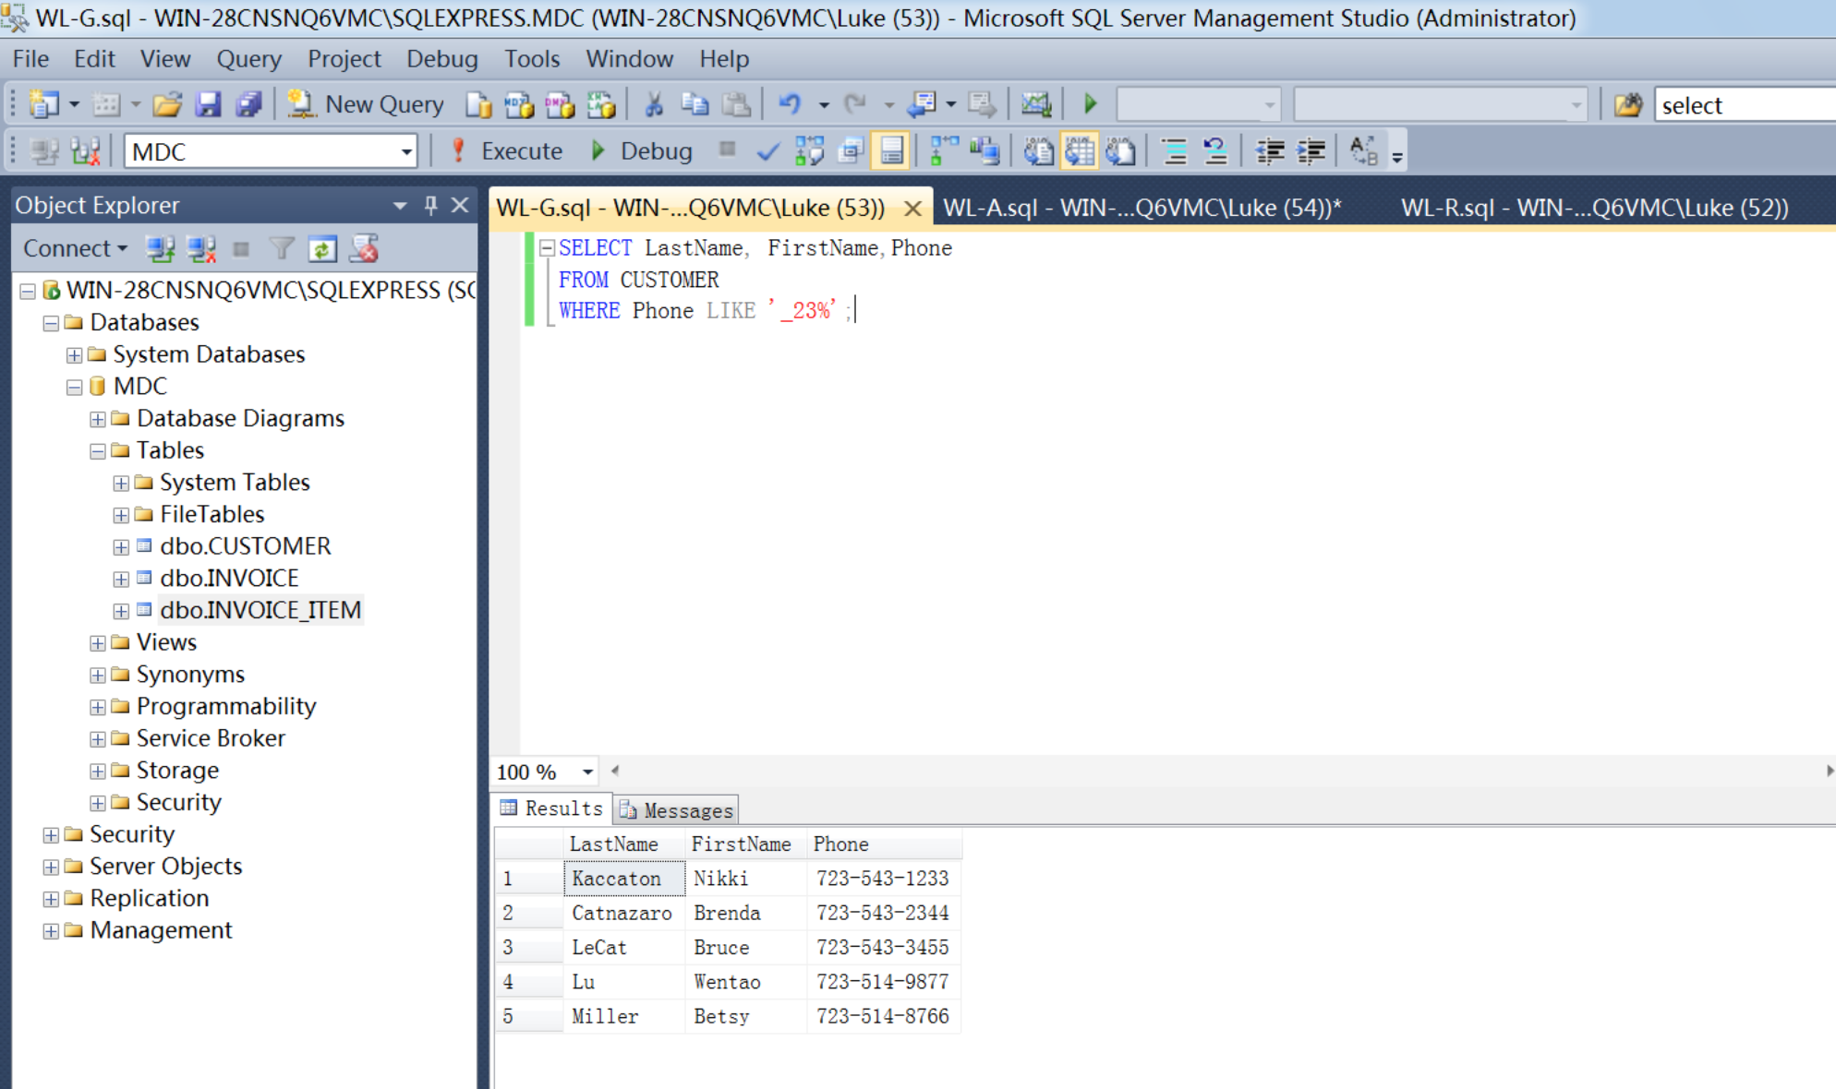

**Screen Shot #3: Displaying the query results using nested sub-queries**

**Question P (Page 132 of the textbook – 15th edition)**

Display the phone number, first and last name columns for each customer in the query result. Results are to be sorted first by last name in ascending order and then by first name in descending order

**IMPORTANT – Ensure that your name is visible in the screen shot result. Additionally, the SQL coding can only use subqueries – DO NOT USE ANY JOINS!**

**IMPORTANT – When creating your queries, please label the queries with your initials, followed by the appropriate query letter. For example, for student John Tyler, the SQL queries would be labelled JT-A, JT-B, JT-C, etc. For student Mary Smith, the SQL queries would be labelled MS-A, MS-B, MS-C, etc.**

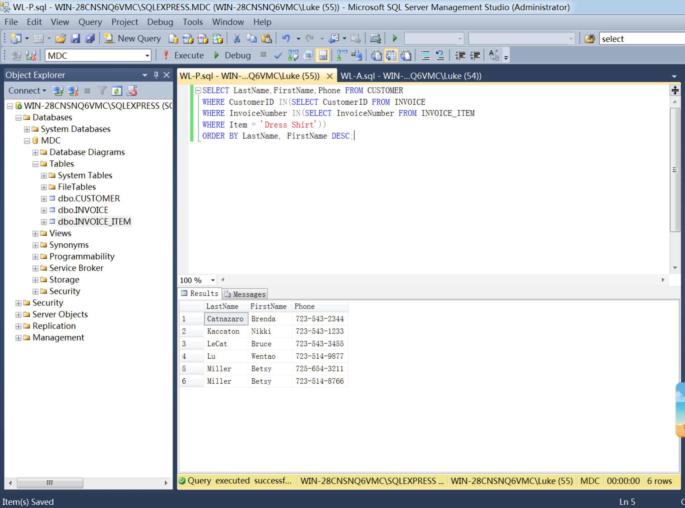

**Screen Shot #4: Displaying the query results using JOIN ON syntax**

**Question R (Page 132 of the textbook – 15th edition)**

Display the phone number, first and last name columns for each customer in the query result. Results are to be sorted first by last name in ascending order and then by first name in descending order

**IMPORTANT – Ensure that your name is visible in the screen shot result. Additionally, the SQL coding can only use the “JOIN ON” syntax – DO NOT USE SUB-QUERIES!**

**IMPORTANT – When creating your queries, please label the queries with your initials, followed by the appropriate query letter. For example, for student John Tyler, the SQL queries would be labelled JT-A, JT-B, JT-C, etc. For student Mary Smith, the SQL queries would be labelled MS-A, MS-B, MS-C, etc.**

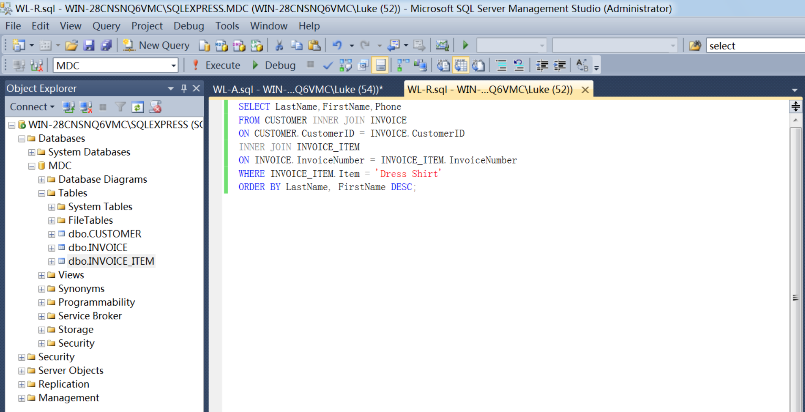

**Screen Shot #5: Displaying the query results using JOIN ON and subquery syntax**

**Question T (Page 132 of the textbook – 15th edition)**

Display the phone number, first and last name columns for each customer in the query result. Results are to be sorted first by last name in ascending order and then by first name in descending order

**IMPORTANT – Ensure that your name is visible in the screen shot result. Additionally, the SQL coding must use a combination of “JOIN ON” and sub-query syntax.**

**IMPORTANT – When creating your queries, please label the queries with your initials, followed by the appropriate query letter. For example, for student John Tyler, the SQL queries would be labelled JT-A, JT-B, JT-C, etc. For student Mary Smith, the SQL queries would be labelled MS-A, MS-B, MS-C, etc.**

