**Lab Assignment for Week #5 (MI – MS SQL Server)**

**(Project Questions from Chapter 2 of the textbook)**

**(NOTE: Screen shot examples in these instructions may be different than your screen shot values)**

**Screen Shot #1: Displaying shipments leaving on the tenth day of any month**

**Questions F (Page 143 of the textbook – 15th edition)**

Display all the required columns, **PLUS THE DEPARTURE DATE**, of the search result records.

(Hint: One solution is to use the “LIKE” command in the WHERE clause)

**IMPORTANT – When creating your queries, please label the queries with your initials, followed by the appropriate query letter. For example, for student John Tyler, the SQL queries would be labelled JT-A, JT-B, JT-C, etc. For student Mary Smith, the SQL queries would be labelled MS-A, MS-B, MS-C, etc.**

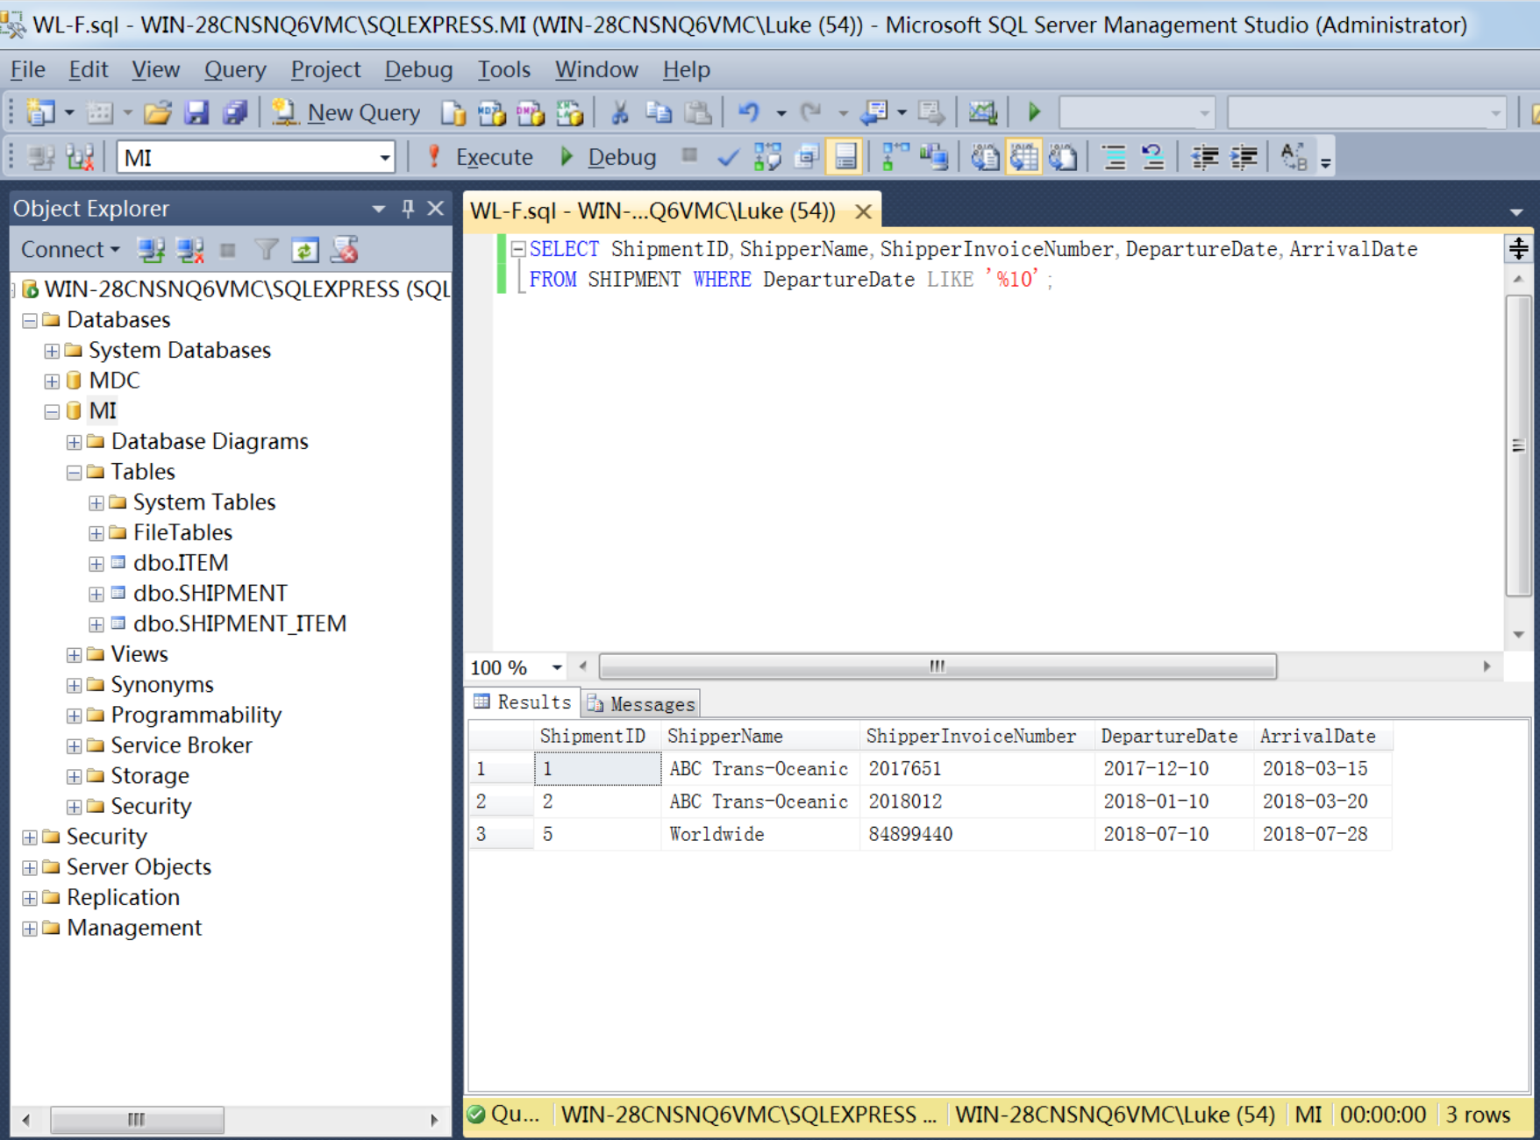

**Screen Shot #2: Using aggregate functions**

**Questions G (Page 143 of the textbook – 15th edition)**

Display the maximum and minimum insured values.

**IMPORTANT – Ensure that the maximum and minimum columns have appropriate column titles.**

**IMPORTANT – When creating your queries, please label the queries with your initials, followed by the appropriate query letter. For example, for student John Tyler, the SQL queries would be labelled JT-A, JT-B, JT-C, etc. For student Mary Smith, the SQL queries would be labelled MS-A, MS-B, MS-C, etc.**

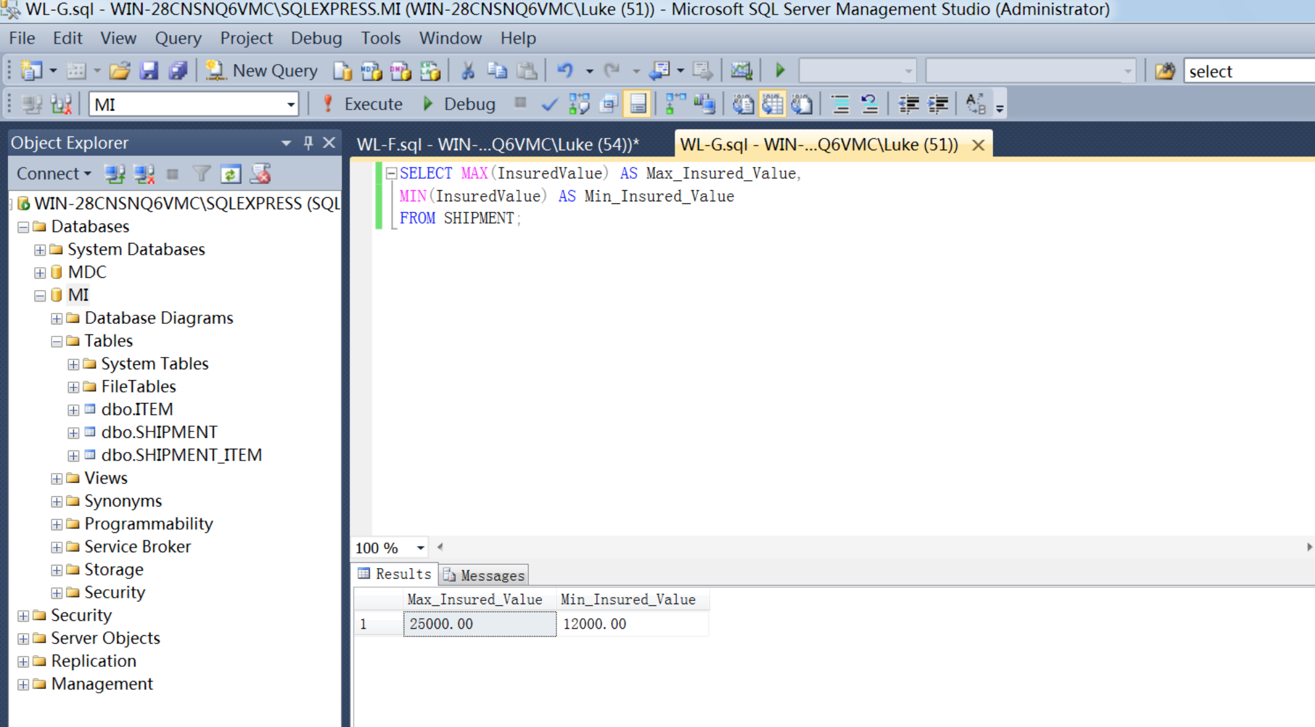

**Screen Shot #3: Displaying the query results using nested sub-queries**

**Question O (Page 143 of the textbook – 15th edition)**

Display all required columns. Results are to be sorted first by ShipperName in ascending order and then by DepartureDate in descending order

**IMPORTANT – The SQL coding can only use subqueries – DO NOT USE ANY JOINS!**

**IMPORTANT – When creating your queries, please label the queries with your initials, followed by the appropriate query letter. For example, for student John Tyler, the SQL queries would be labelled JT-A, JT-B, JT-C, etc. For student Mary Smith, the SQL queries would be labelled MS-A, MS-B, MS-C, etc.**

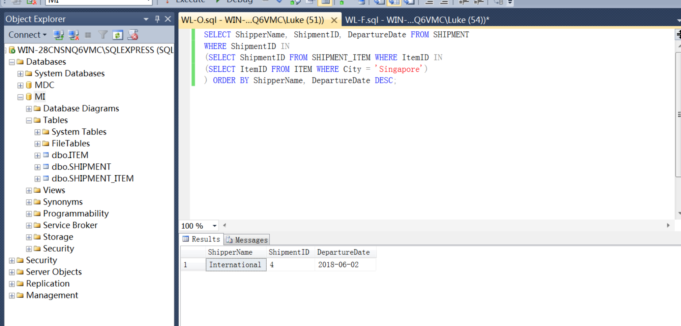

**Screen Shot #4: Displaying the query results using JOIN ON syntax**

**Question Q (Page 143 of the textbook – 15th edition)**

Display all required columns. Results are to be sorted first by ShipperName in ascending order and then by DepartureDate in descending order

**IMPORTANT – The SQL coding can only use the “JOIN ON” syntax – DO NOT USE SUB-QUERIES!**

**IMPORTANT – When creating your queries, please label the queries with your initials, followed by the appropriate query letter. For example, for student John Tyler, the SQL queries would be labelled JT-A, JT-B, JT-C, etc. For student Mary Smith, the SQL queries would be labelled MS-A, MS-B, MS-C, etc.**

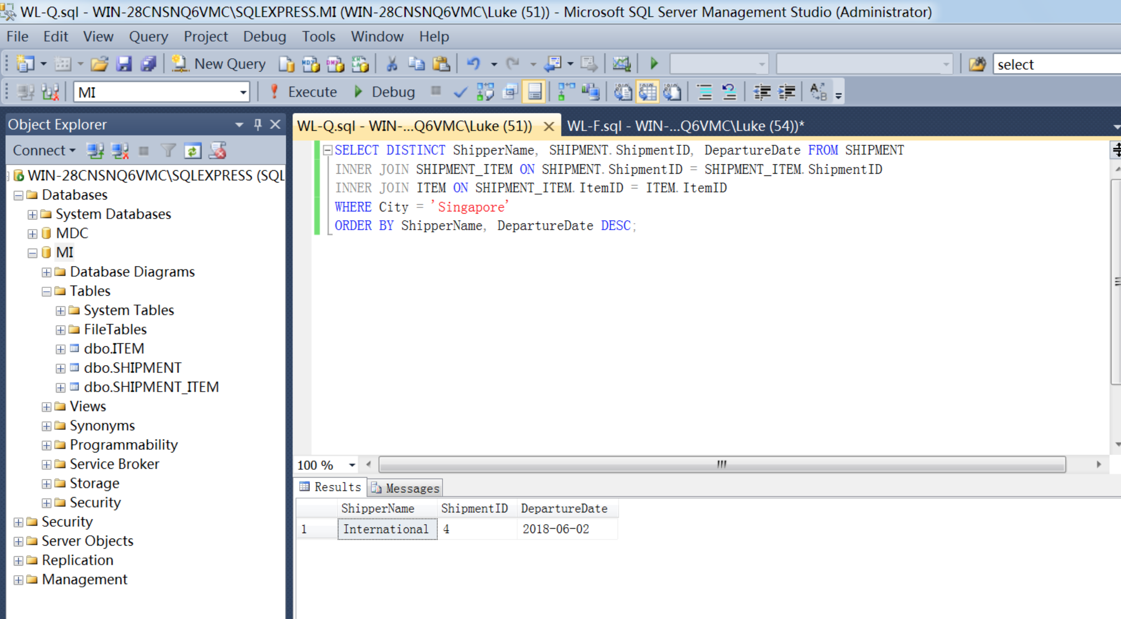

**Screen Shot #5: Displaying the query results using JOIN ON and subquery syntax**

**Question R (Page 143 of the textbook – 15th edition)**

Display all required columns. Results are to be sorted first by ShipperName in ascending order and then by DepartureDate in descending order

**IMPORTANT – The SQL coding must use a combination of “JOIN ON” and sub-query syntax.**

**IMPORTANT – When creating your queries, please label the queries with your initials, followed by the appropriate query letter. For example, for student John Tyler, the SQL queries would be labelled JT-A, JT-B, JT-C, etc. For student Mary Smith, the SQL queries would be labelled MS-A, MS-B, MS-C, etc.**

