**Lab Assignment for Week #7 (VRG – MySQL – Part 2)**

**(Project Questions from Online Chapter 10C of the textbook)**

**(NOTE: Screen shot examples in these instructions may be different than your screen shot values)**

**Screen Shot #1: Displaying the CUSTOMER table records**

**Read pages 42 through 79 of online chapter 10C (from the textbook – 15th edition)**

Display **only two records**: one for Michael Bench (which has been changed to your name) and the record for Melinda Gliddens (make sure all columns are displayed).

**IMPORTANT – Ensure that the record which contains the name “Michael Bench” has been changed to reflect your first and last name (you are not required to alter the corresponding “Email” field of the record (i.e. it will remain as “Michael Bench@somewhere.com)**

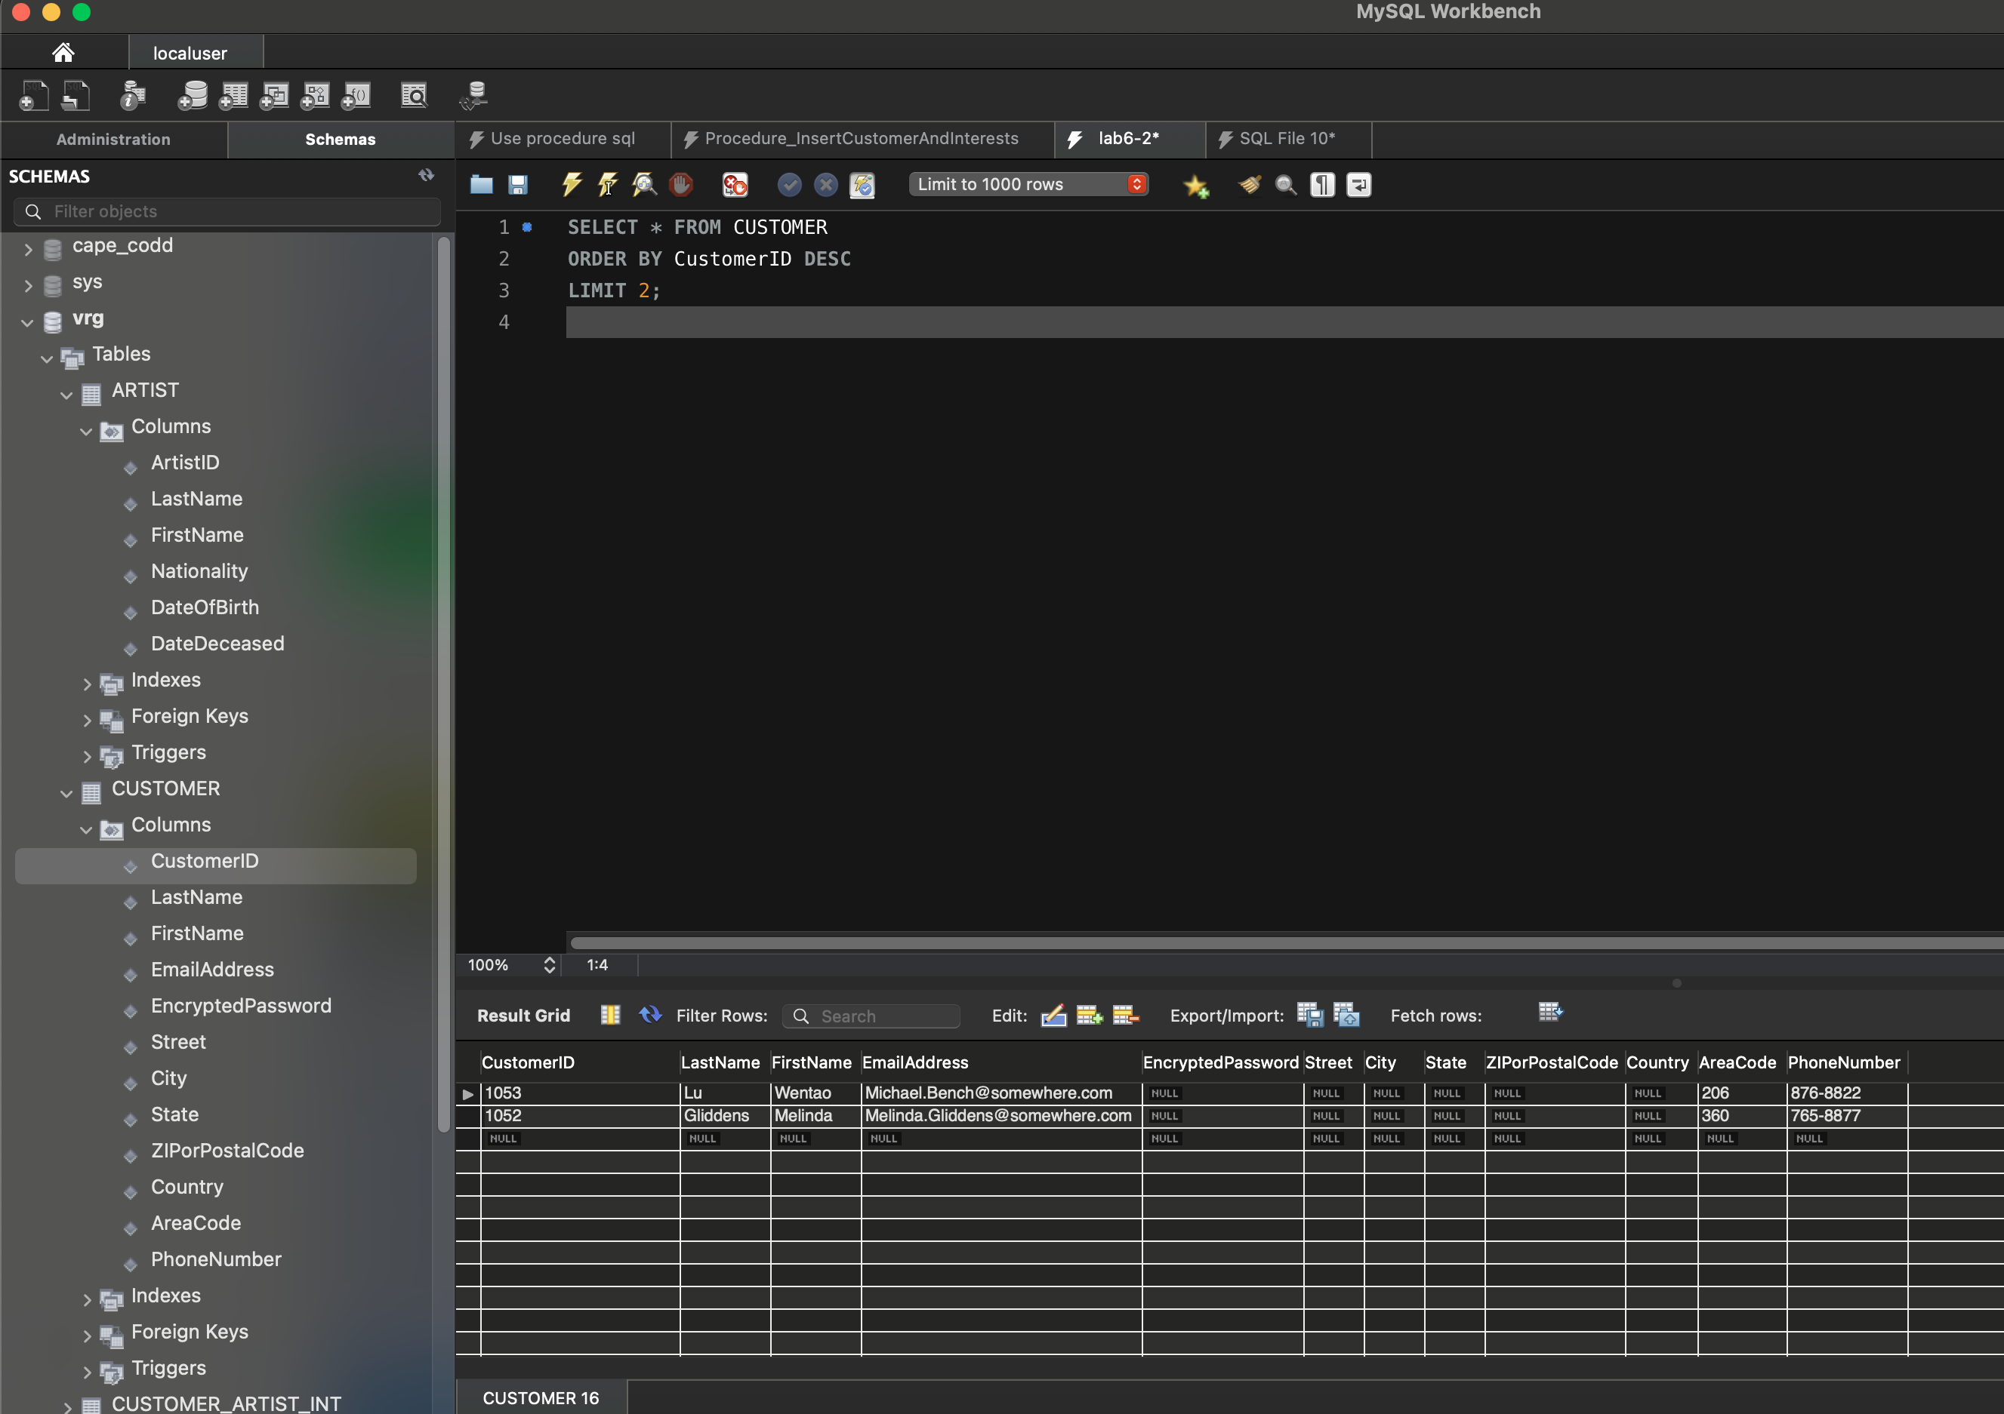

**Screen Shot #2: Displaying records from the CustomerInterestsView**

**Read pages 42 through 79 of online chapter 10C (from the textbook – 15th edition)**

Display **only three records**: two for Michael Bench (which has been changed to your name) and the record for Melinda Gliddens (display the customer last name, customer first name and artist name columns).

**IMPORTANT – Ensure that the records which contain the name “Michael Bench” have been changed to reflect your first and last name (you are not required to alter the corresponding “Email” field of the records (i.e. it will remain as “Michael Bench@somewhere.com)**

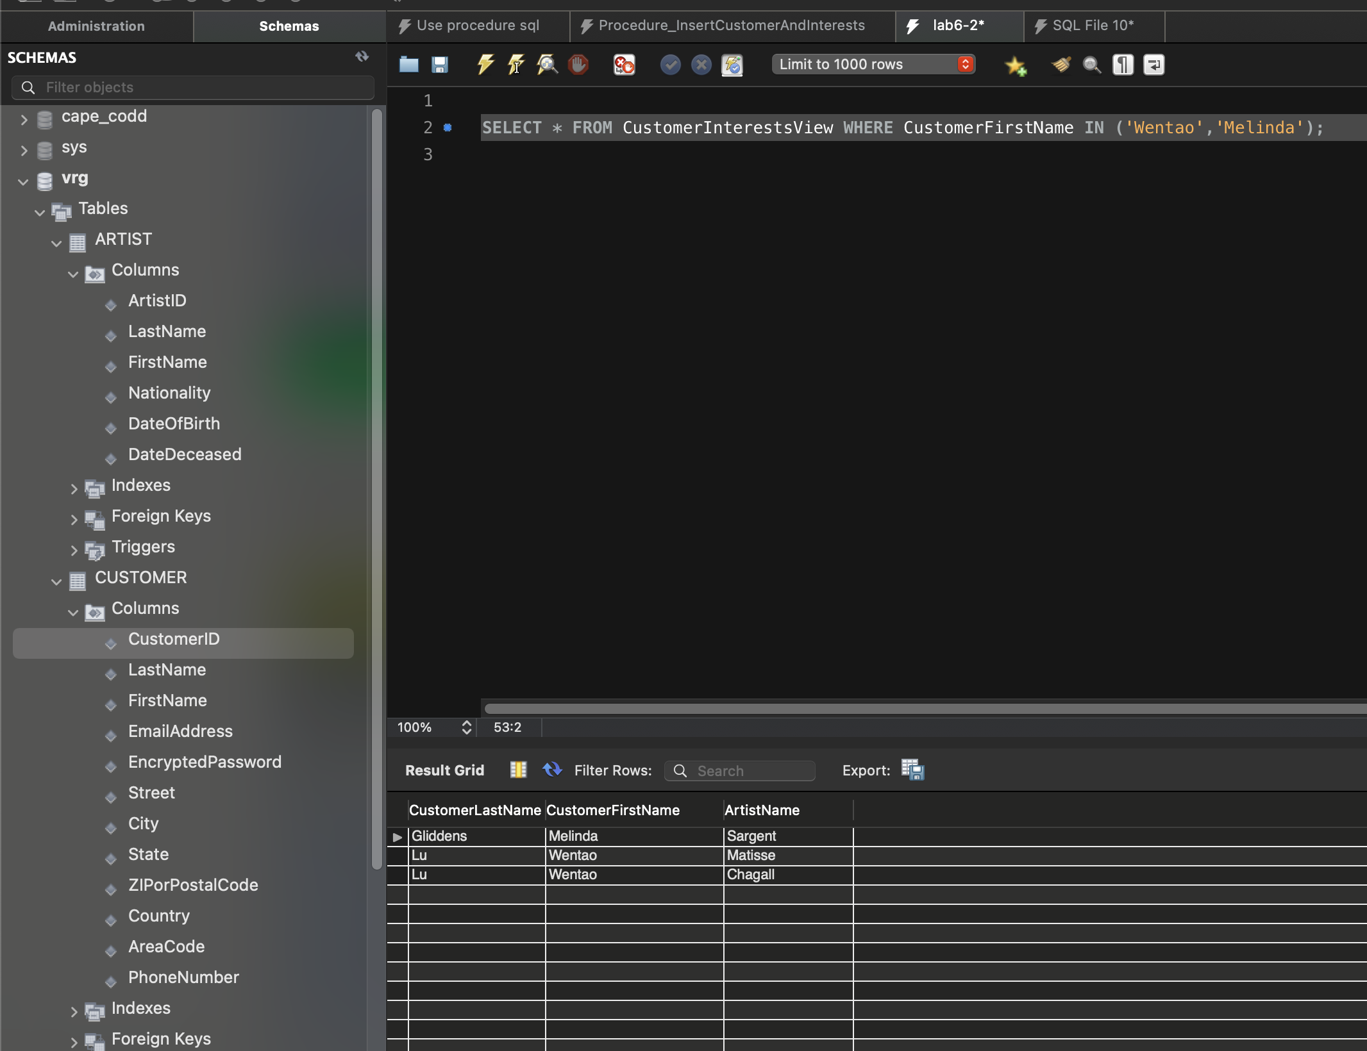

**Screen Shot #3: Displaying records from the CustomerPhoneView**

**Read pages 42 through 79 of online chapter 10C (from the textbook – 15th edition)**

Display **only two records**: one for Michael Bench (which has been changed to your name) and the record for Melinda Gliddens (display the customer last name, customer first name and customer phone columns)

**IMPORTANT – Ensure that the record which contains the name “Michael Bench” has been changed to reflect your first and last name (you are not required to alter the corresponding “Email” field of the record (i.e. it will remain as “Michael Bench@somewhere.com)**

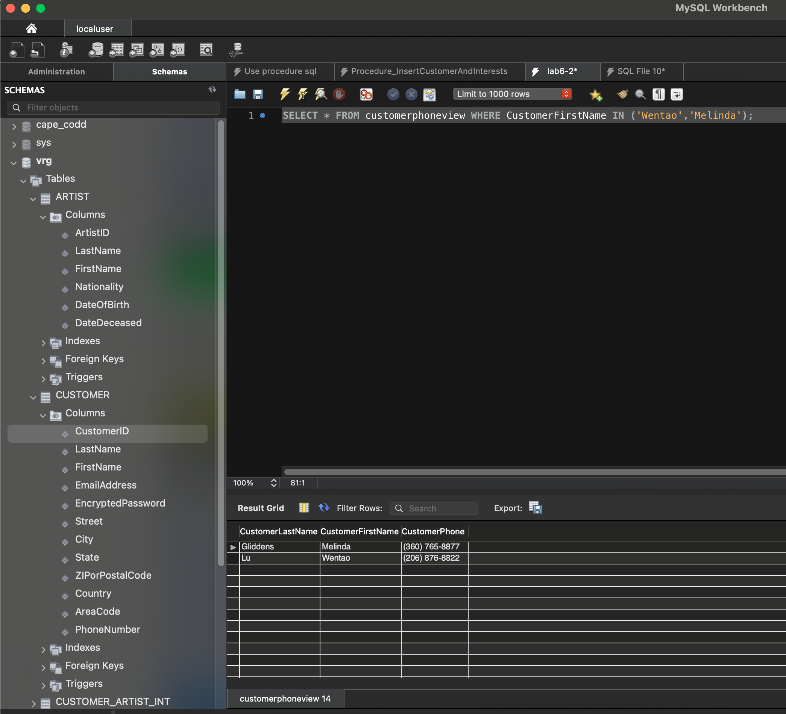

**Screen Shot #4: Executing the FirstNameFirst function**

**Read pages 42 through 79 of online chapter 10C (from the textbook – 15th edition)**

Display two columns only. The first column will be the concatenation of the customer’s first and last name. The second column will be the concatenation of the artist’s first and last name**. Ensure that the customer record containing your name is visible.**

**IMPORTANT – Ensure that the record which contains the name “Michael Bench” has been changed to reflect your first and last name (you are not required to alter the corresponding “Email” field of the record (i.e. it will remain as “Michael Bench@somewhere.com)**

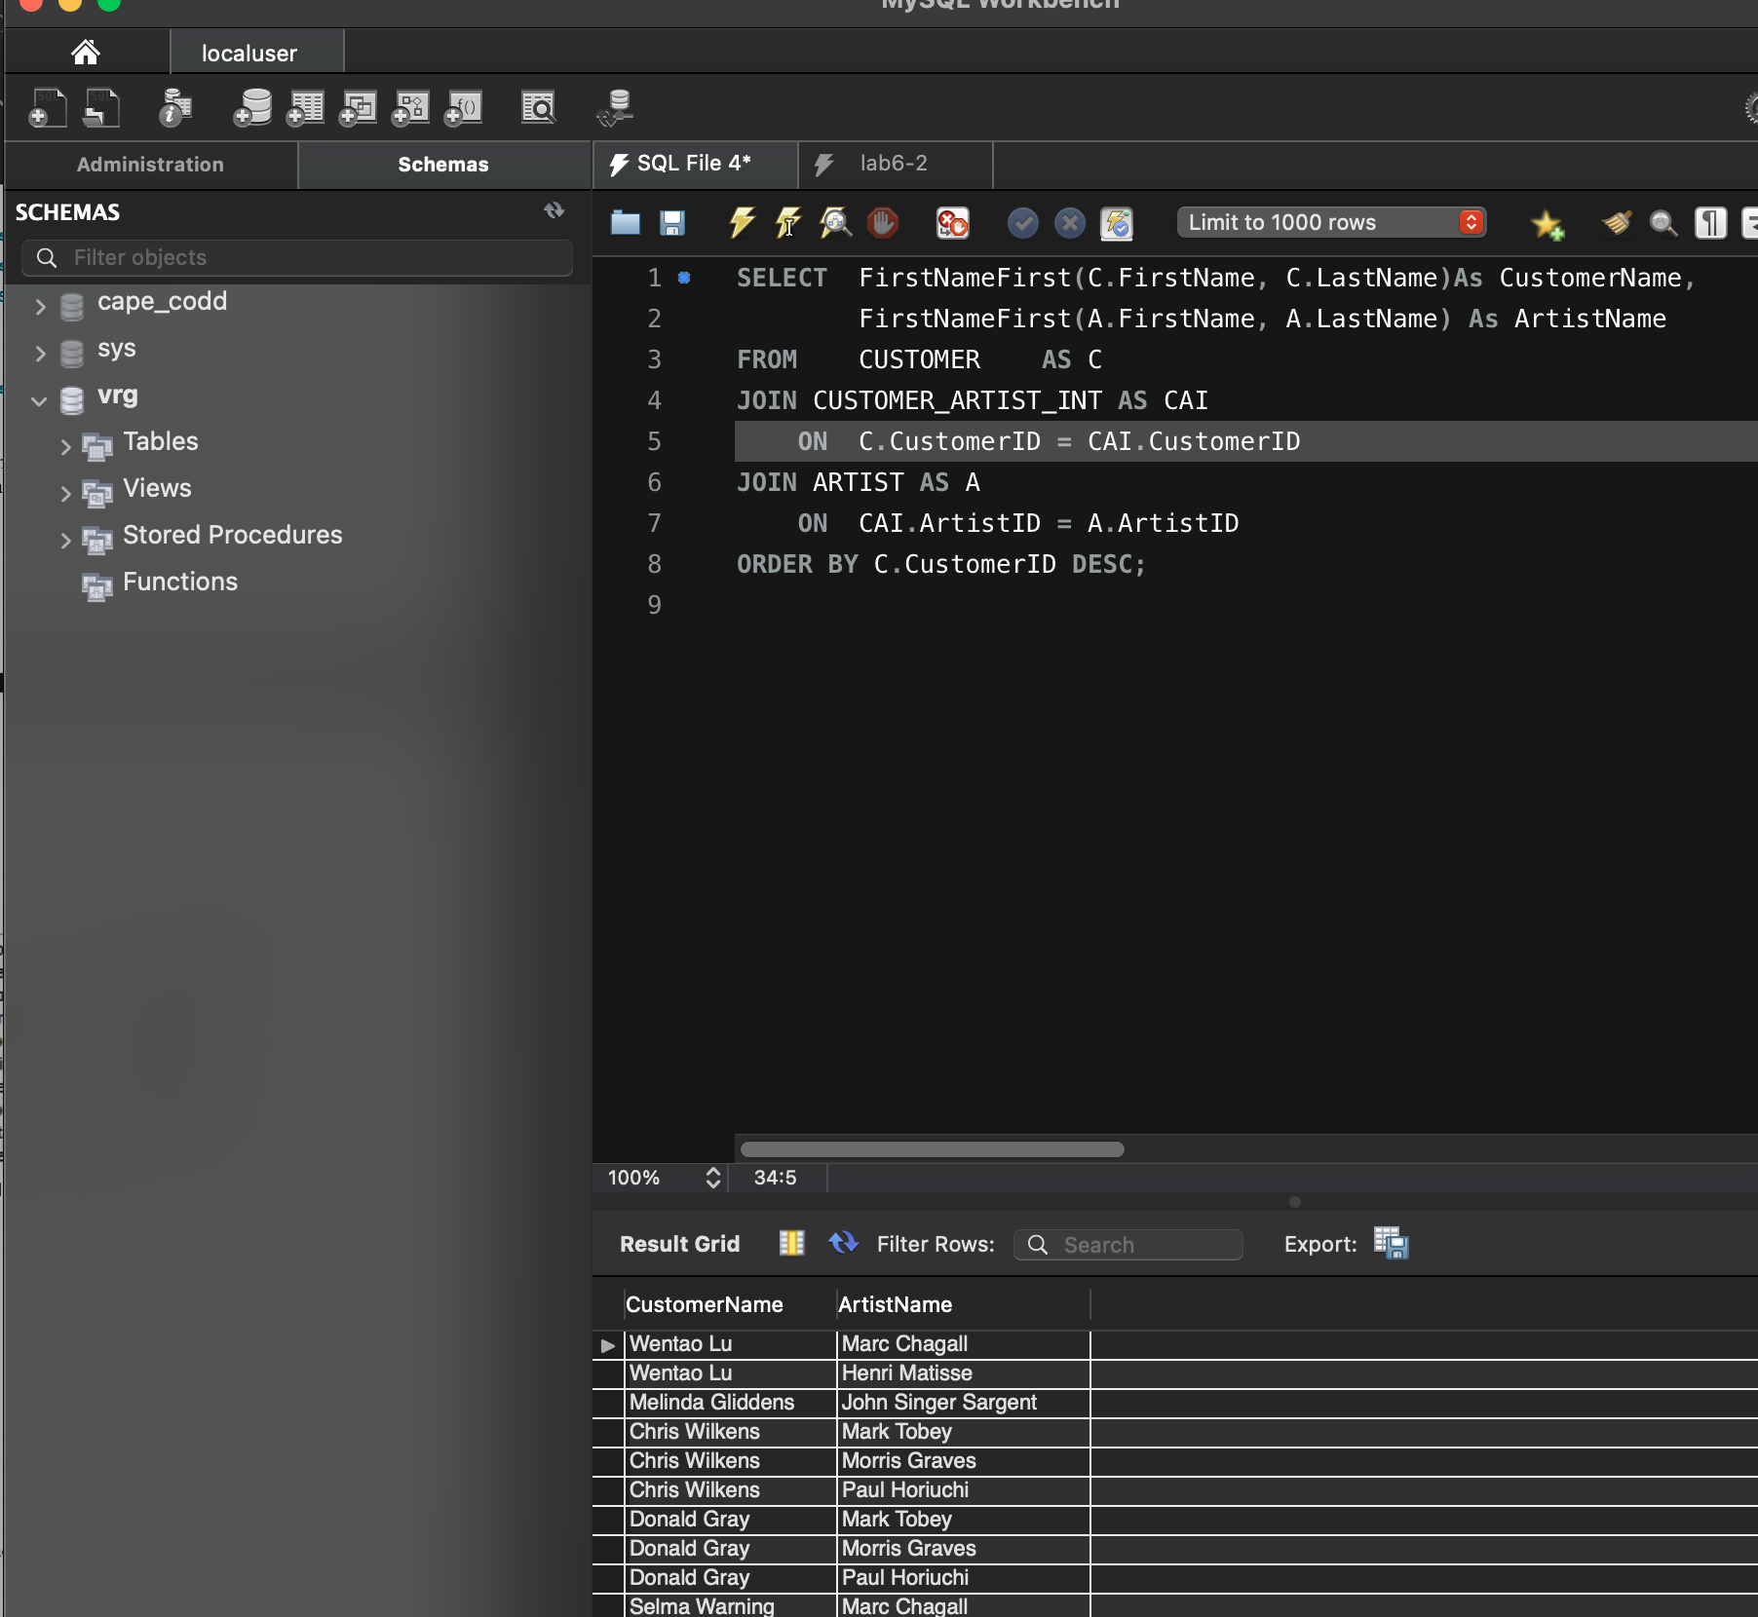

Thank you!